4

÷ 4

2

× 3

start

1

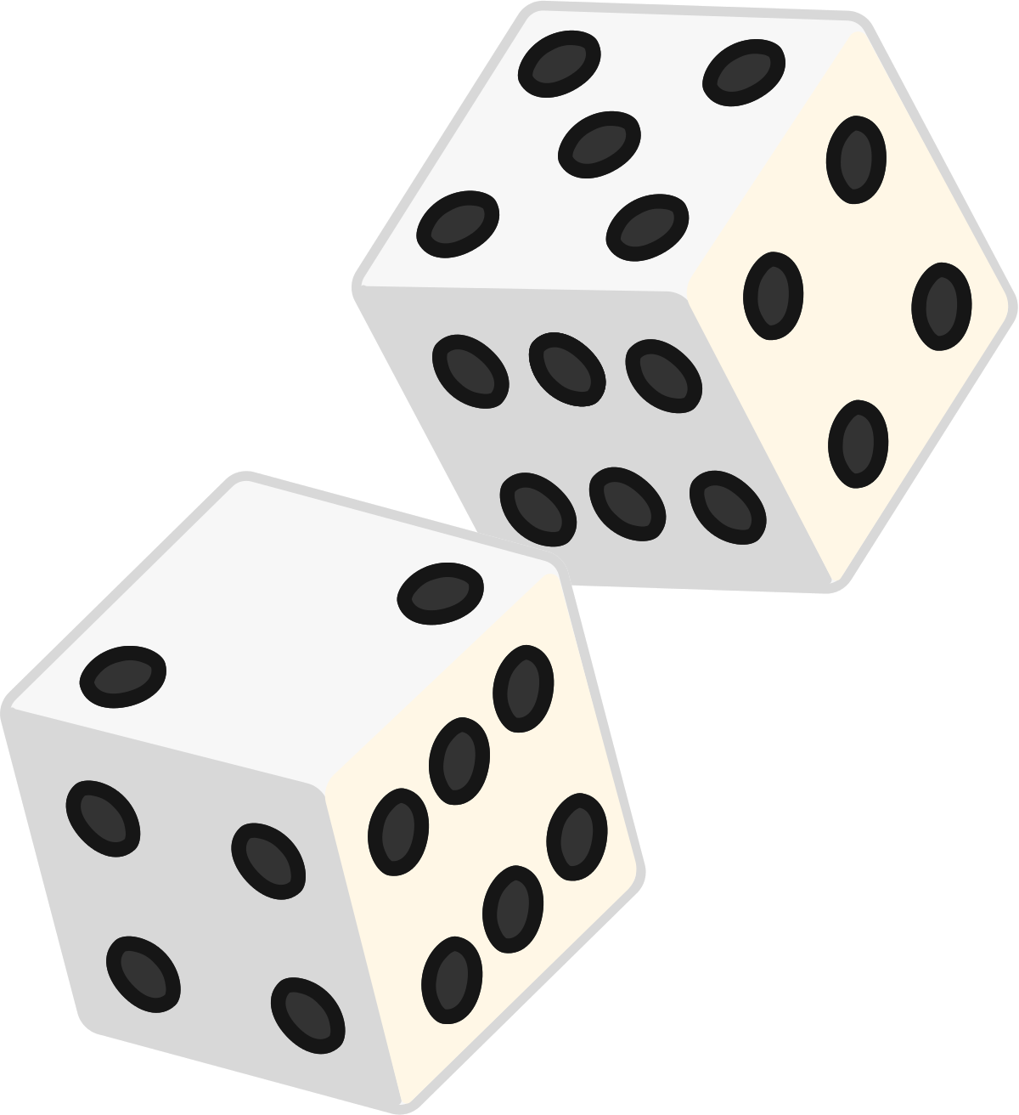

**BY USING DICE AND CUTOUTS OF CIRCLE START THE GAME FROM No.1**

**SOLVE & WIN**