**SQL Server Instructions -**

1. Make sure the system you are going to run for this project should have Visual Studio and Microsoft SQL Server Management Studio.
2. Launch Microsoft SQL Server Management Studio and connect with Windows Authentication.

Also remember Server name pointed here -

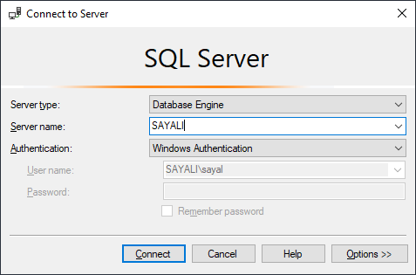

Right click on Databases option in object explorer window then click on Restore Database option

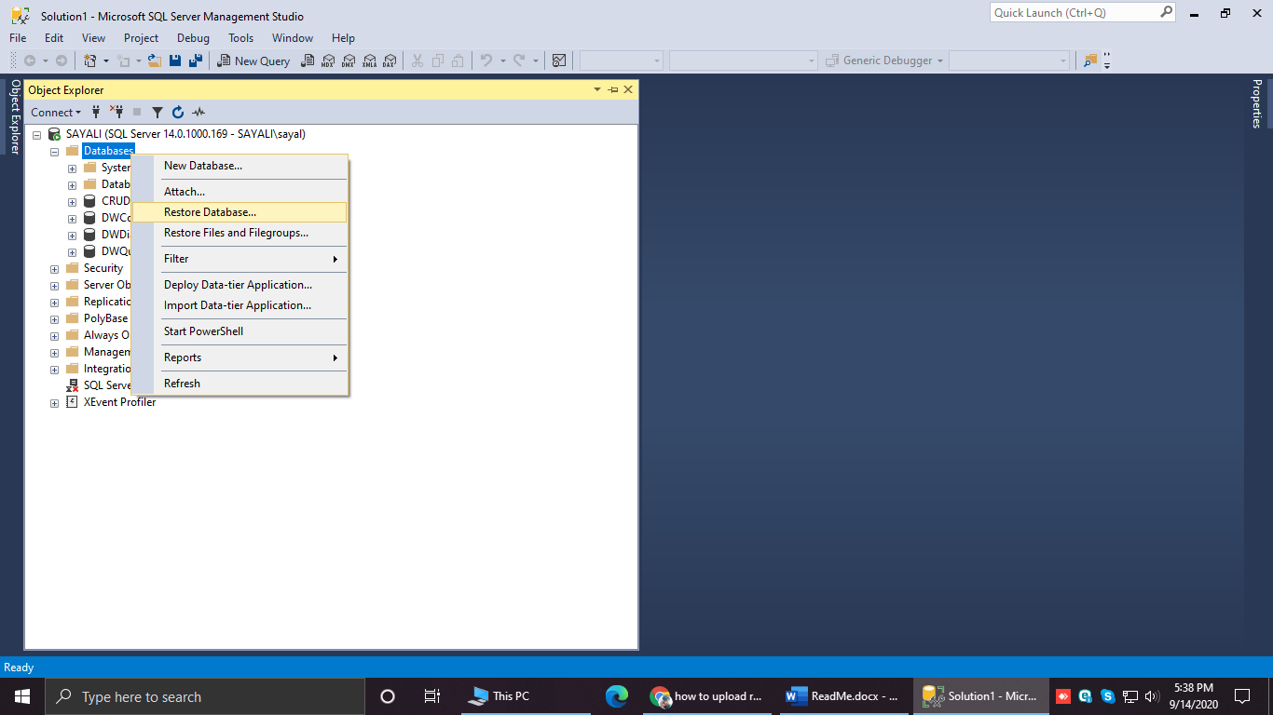

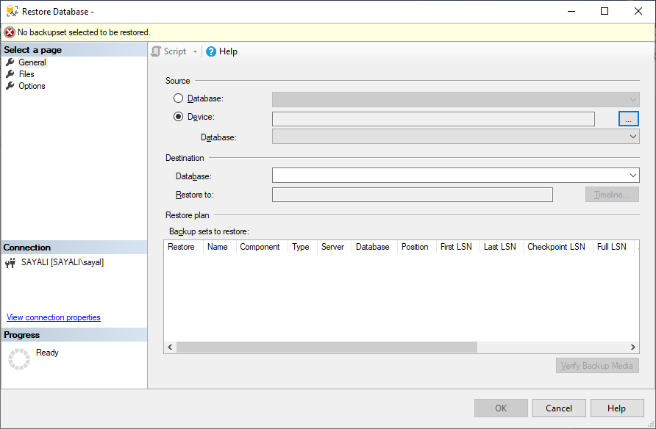

2

1

Select the Device radio button. Then click to browse to the location of ‘.bak’ file. In this project, where the file you downloaded saved. Please refer below screenshots to get ‘.bak’ file.

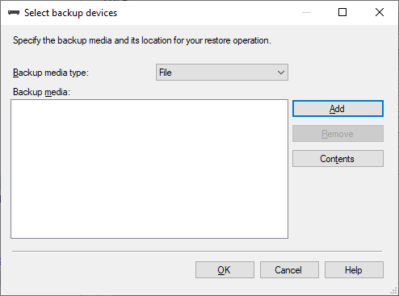

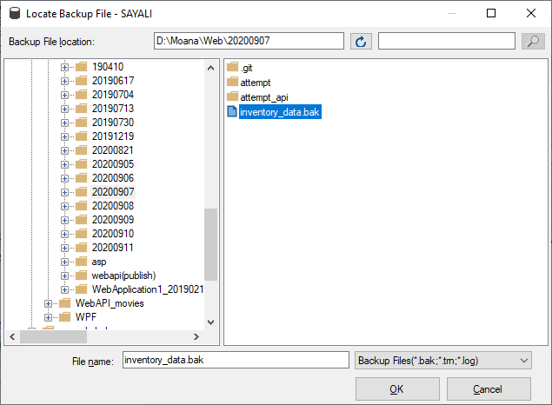

2

1

After clicking on OK, you’ll see as follows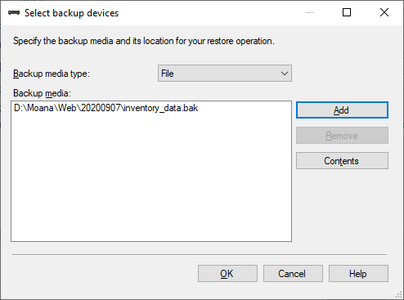

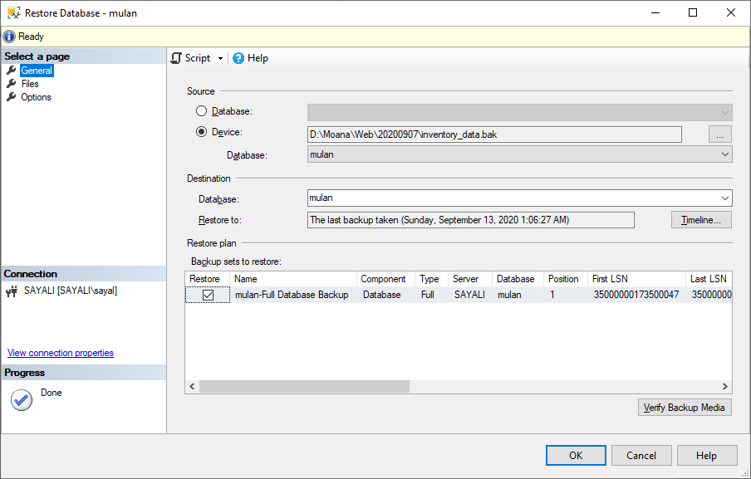

Click on OK button. Database backup will be attached.

Please Remember Server name. Here name of server **‘SAYALI’**.

**Instructions to follow for running web API**

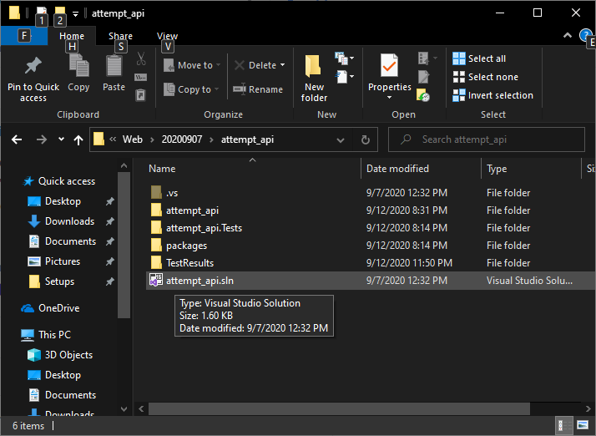

Double click on ‘.sln’ file which opens to Visual studio project.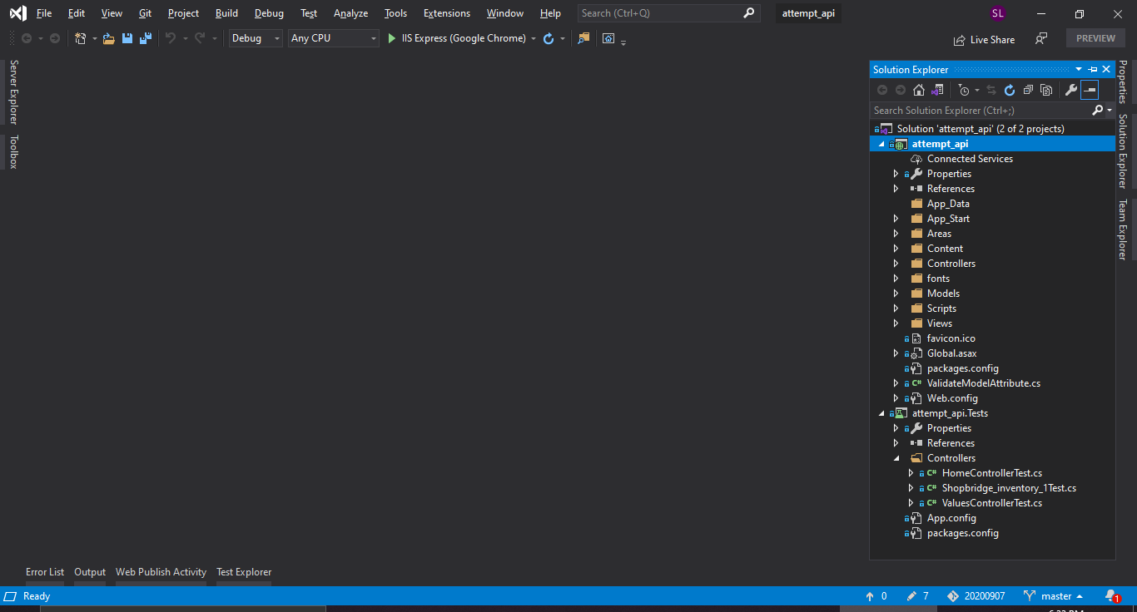

We need to edit web.config file. Open file by clicking on it.

The Web.config file has following connection strings. According to your Server name we need to edit.

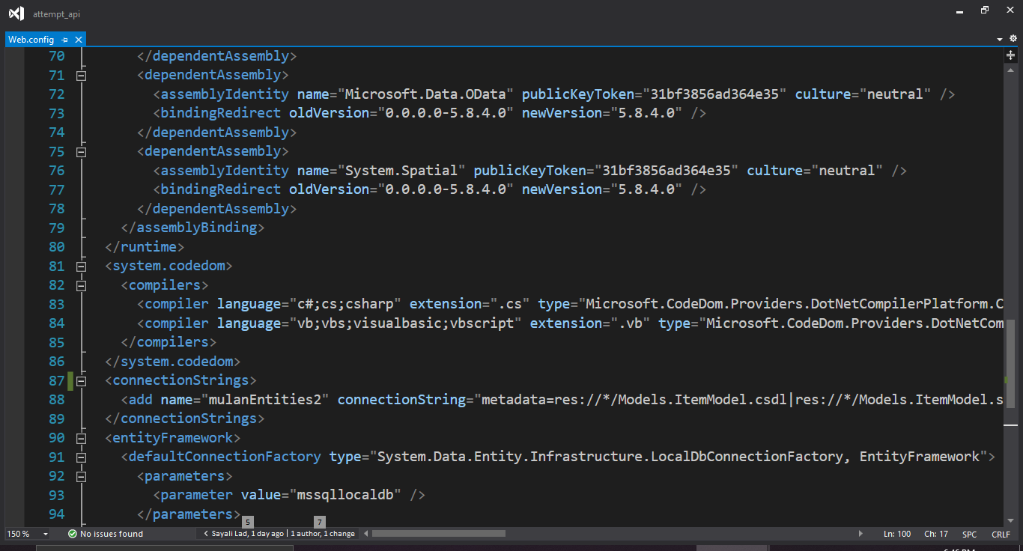

<connectionStrings>

<add name="mulanEntities2" connectionString="metadata=res://*/Models.ItemModel.csdl|res://*/Models.ItemModel.ssdl|res://*/Models.ItemModel.msl;provider=System.Data.SqlClient;provider connection string=&quot;data source=SAYALI;initial catalog=mulan;integrated security=True;MultipleActiveResultSets=True;App=EntityFramework&quot;" providerName="System.Data.EntityClient" />

</connectionStrings>

Edit SQL server name here as per your SQL server.

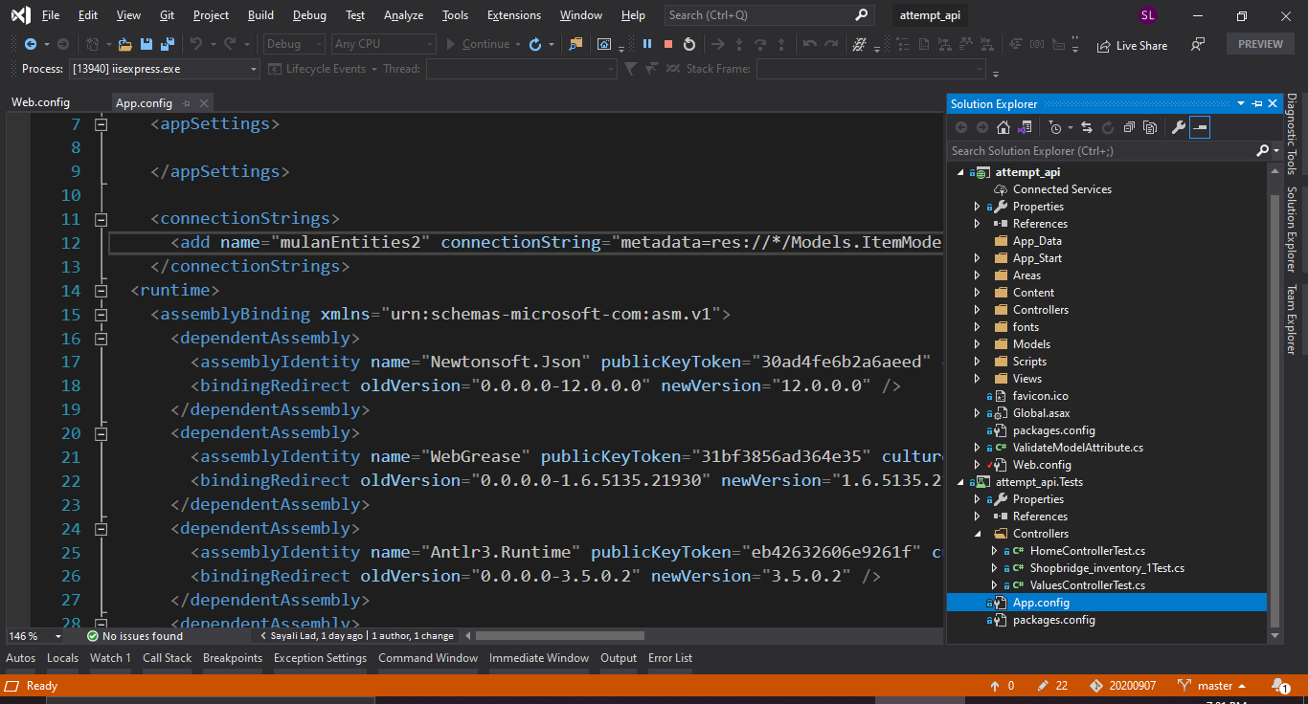

One needs to edit App.config file same way as Web.config for the same value.

<connectionStrings>

<add name="mulanEntities2" connectionString="metadata=res://*/Models.ItemModel.csdl|res://*/Models.ItemModel.ssdl|res://*/Models.ItemModel.msl;provider=System.Data.SqlClient;provider connection string=&quot;data source=SAYALI;initial catalog=mulan;integrated security=True;MultipleActiveResultSets=True;App=EntityFramework&quot;" providerName="System.Data.EntityClient" />

</connectionStrings>

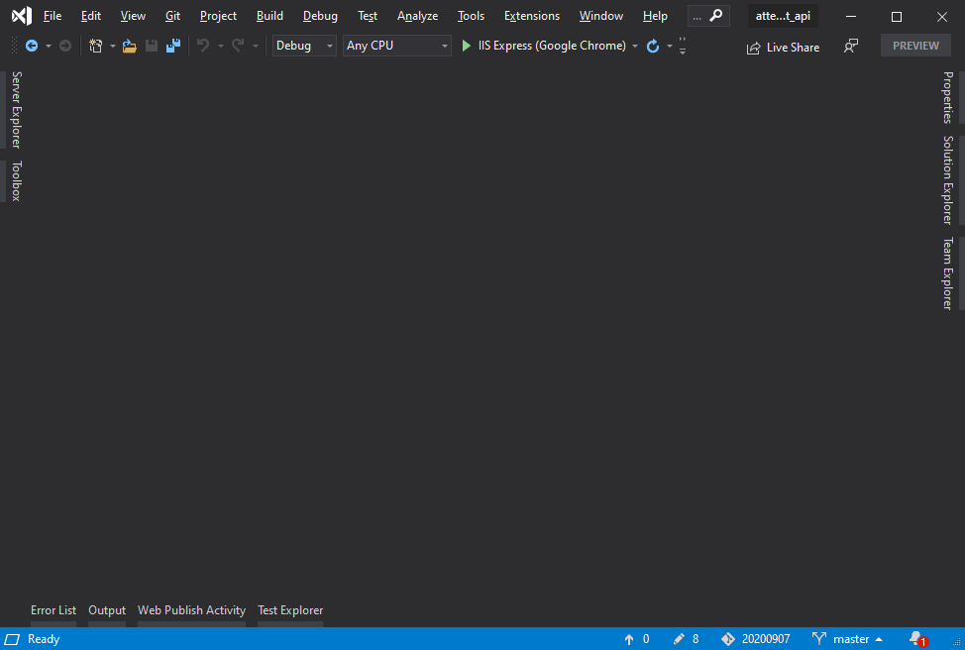

Click on play button icon.

Run program by clicking on above button.

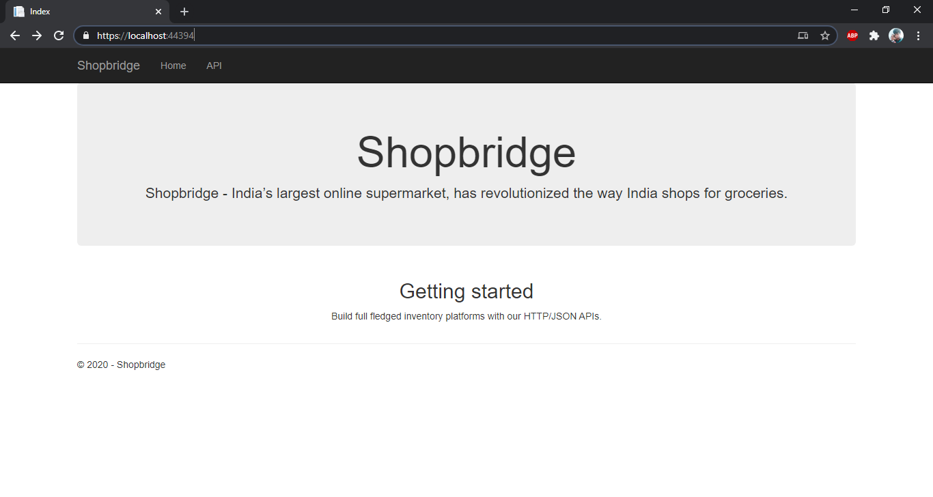

The url in address bar of Web api is to be noted.

In my screenshot it is https://localhost:44394/

One can see initial web api screen as above. We need to replace that URL in website with the URL of yours.

**Website to run Instructions –**

Click on ‘.sln’ file of website project as below

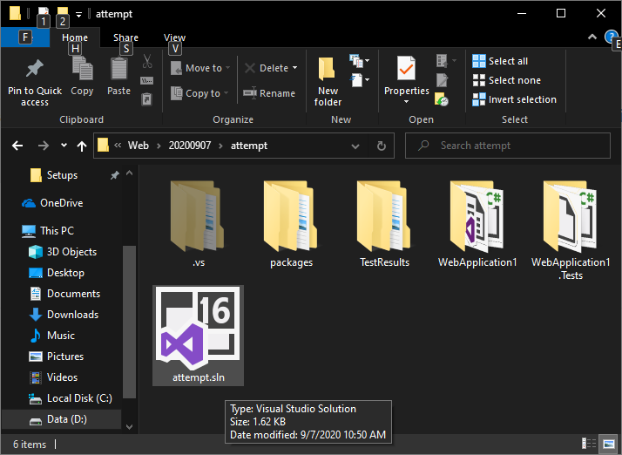

After opening solution, open ShopBridge_InventoryController.cs file from Controller folder.

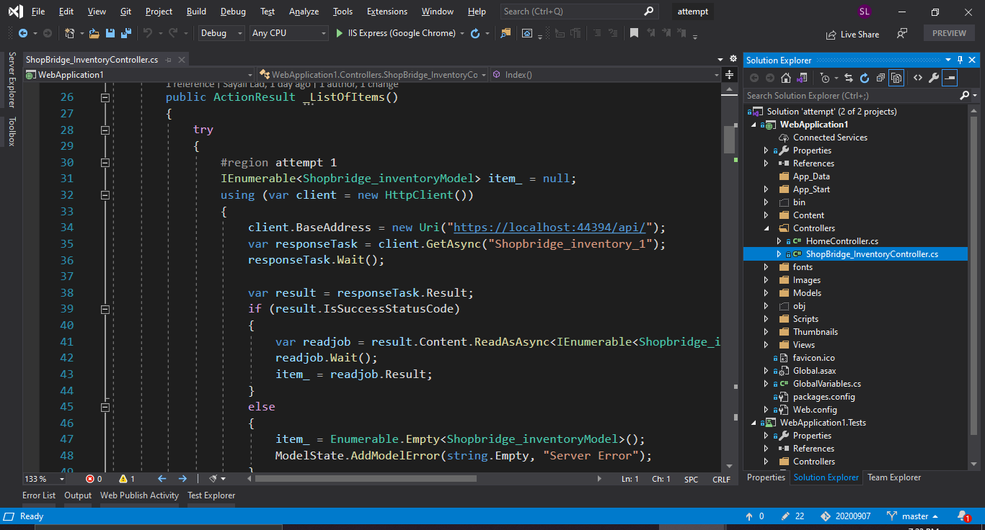

3

2

1

In this file wherever you find "https://localhost:44394/api/" replace with your API URL.

Then by clicking on Run button website will run.