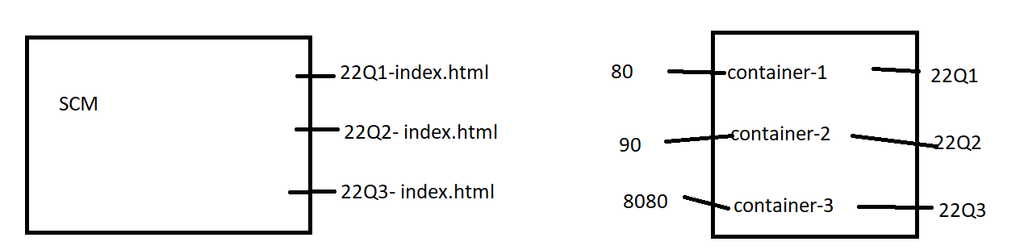**Problem statement:** using Jenkins Declarative pipeline.

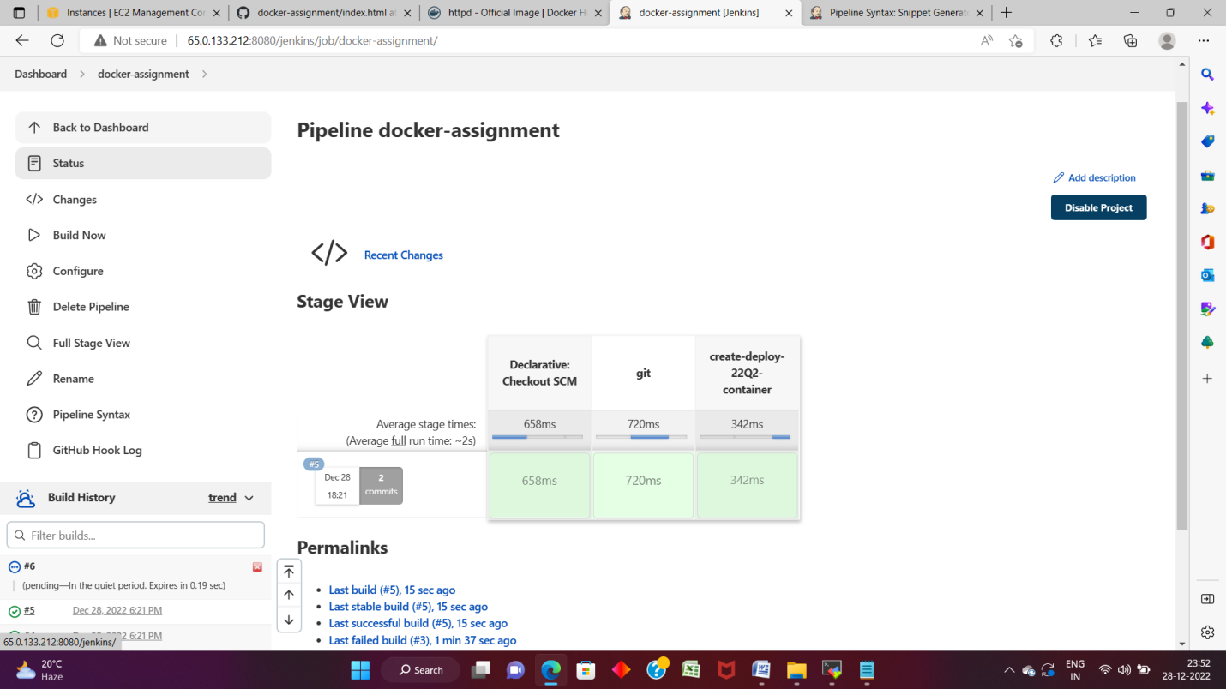

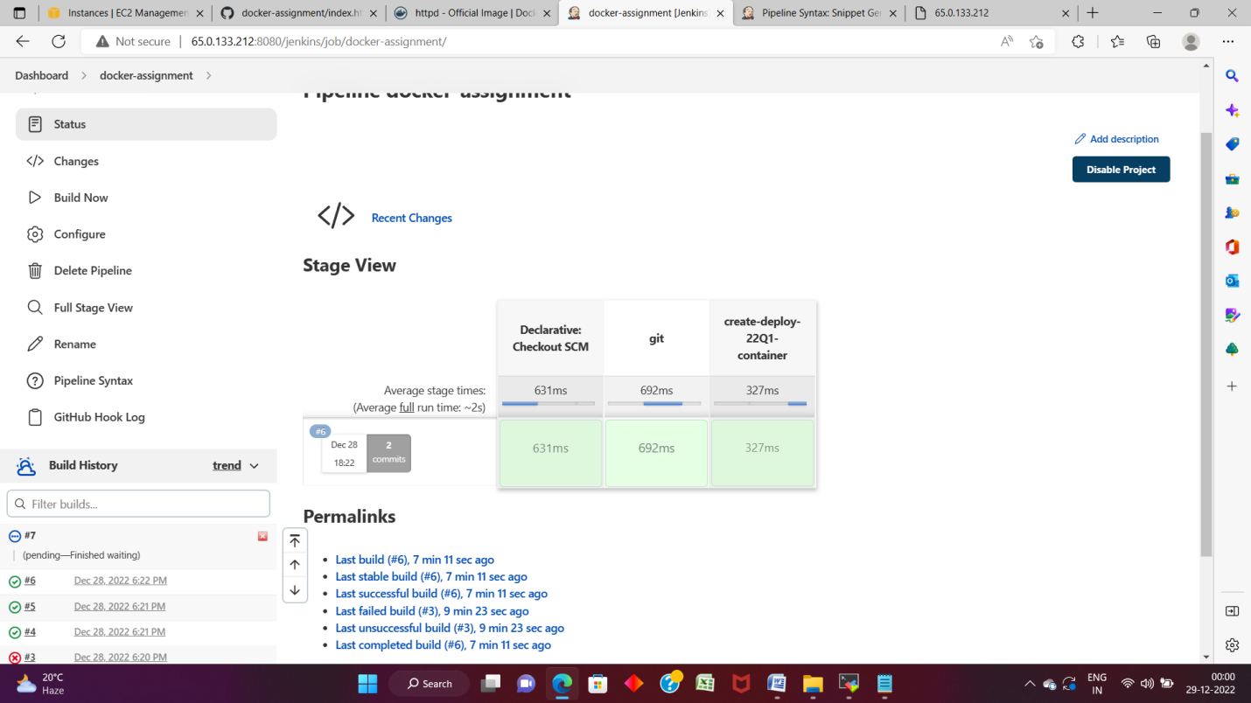

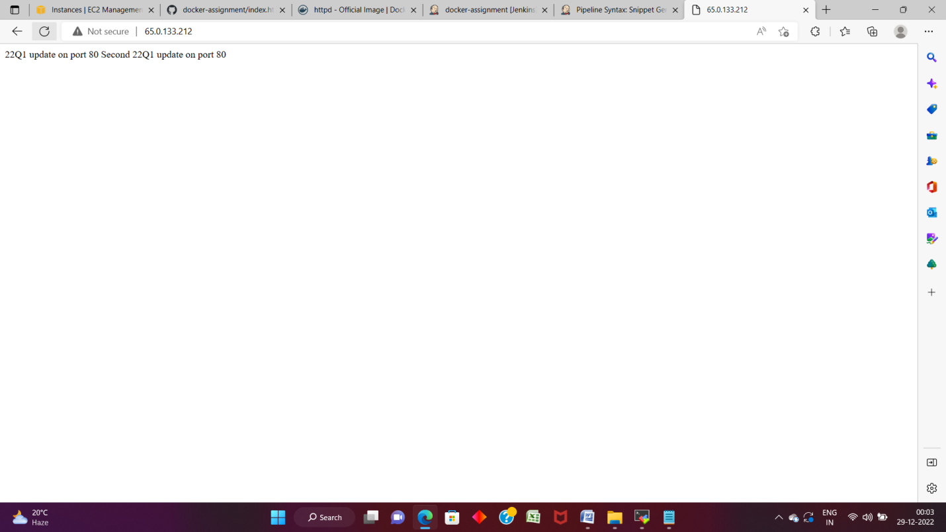

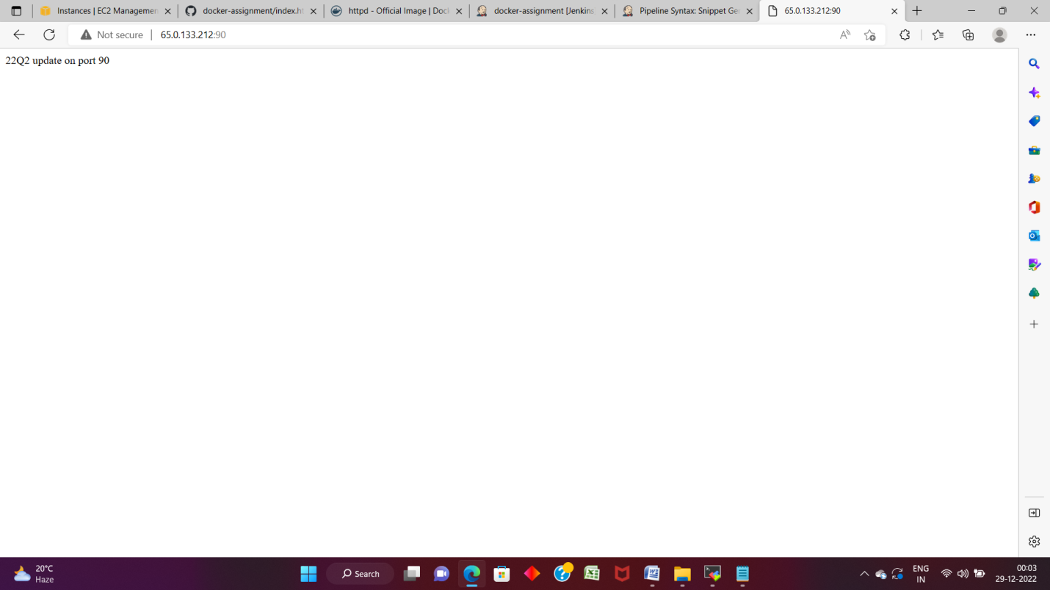

|  |  |  |  |  |  |  |  |  |  |  |  |  |  |  |  |  |  |  |  |  |  |  |  |  |  |  |  |  |  |  |  |  |  |  |  |  |  |  |  |
| --- | --- | --- | --- | --- | --- | --- | --- | --- | --- | --- | --- | --- | --- | --- | --- | --- | --- | --- | --- | --- | --- | --- | --- | --- | --- | --- | --- | --- | --- | --- | --- | --- | --- | --- | --- | --- | --- | --- | --- |
| |  | | --- | |  | |  |  | |  |  | |  |  | |  |  | |  |  | |  |  | |  |  | |  |  | |  |  | |  |  | |  |  | |  |  | |  |  | |  |  | |  |  | |  |  | |  |  | |  |  | |  |  | |
|  |  |
|  |  |
|  |  |
|  |  |
|  |  |
|  |  |
|  |  |
|  |  |
|  |  |
|  |  |
|  |  |
|  |  |
|  |  |
|  |  |
|  |  |
|  |  |
|  |  |
|  |  |
|  |  |

pipeline {

agent {

label {

label ‘built-in’

customWorkspace ‘/mnt/docker’

}

}

stages {

stage ('git') {

steps {

git url: 'https://github.com/sayalip848/docker-assignment.git'

}

}

stage ('create-deploy-22Q1-container') {

steps {

sh “chmod –R 777 /mnt/docker”

sh "docker cp index.html 22Q1:/usr/local/apache2/htdocs/"

}

}

}

}