**Problem statement:** create centos:8 container and install httpdand deploy index

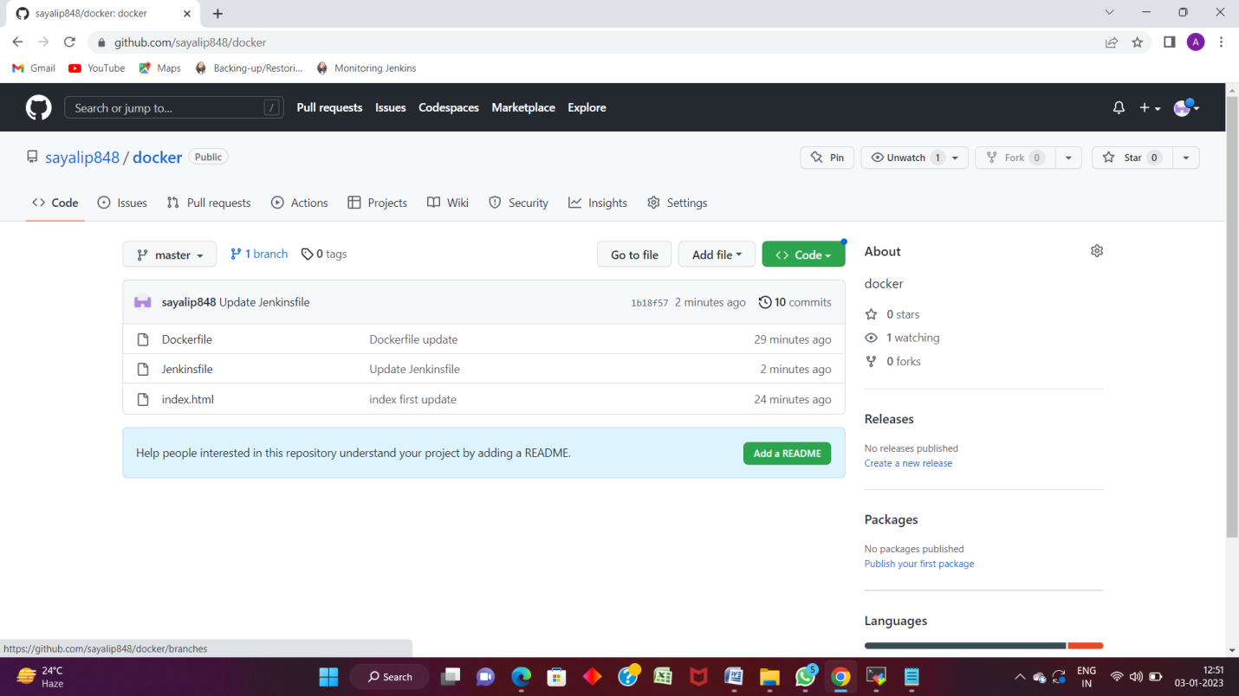

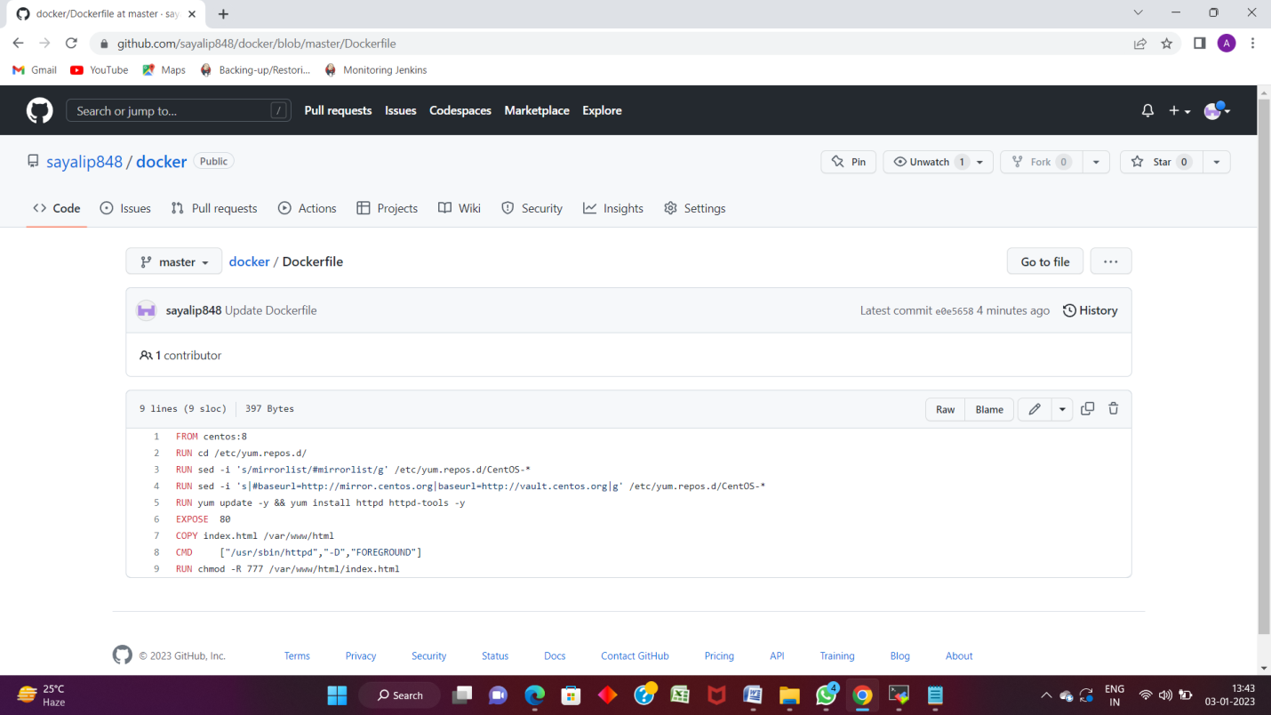

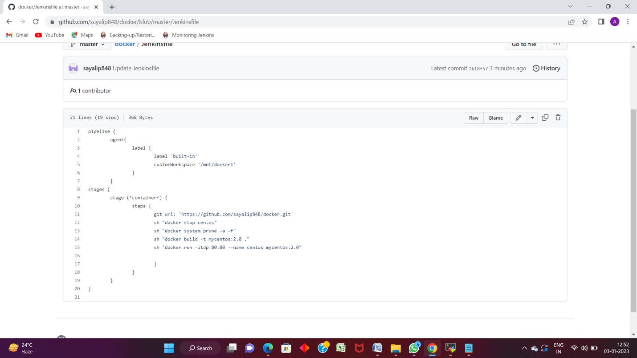

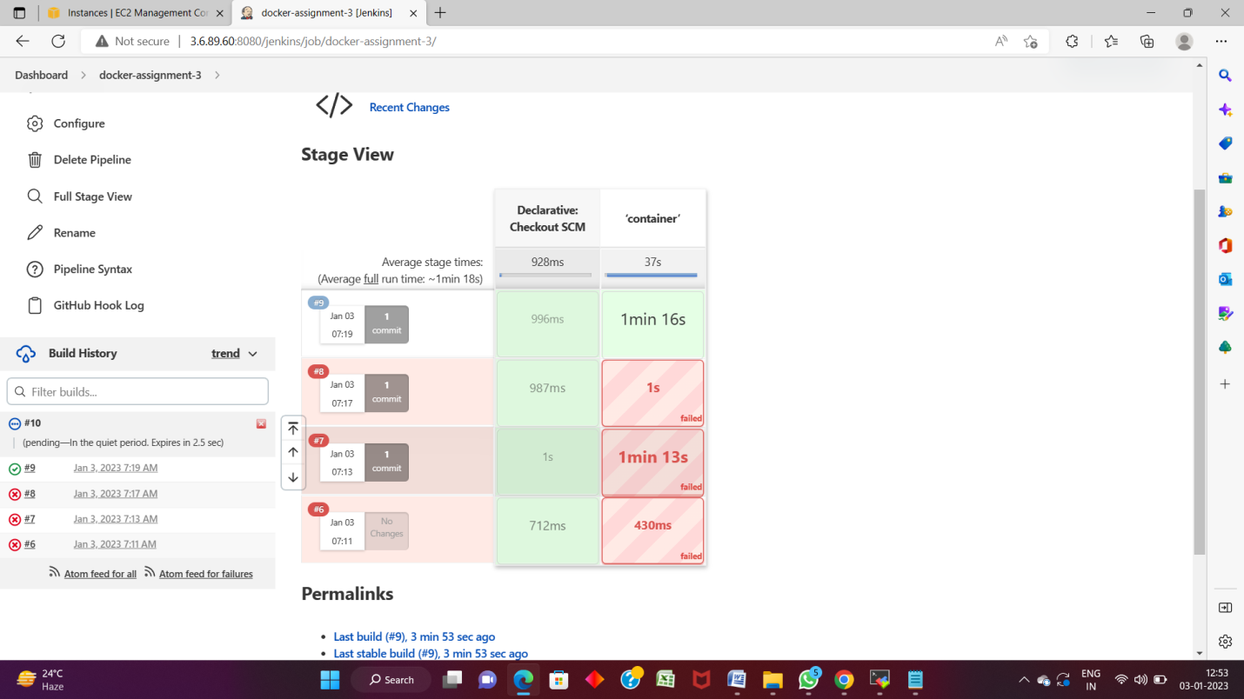

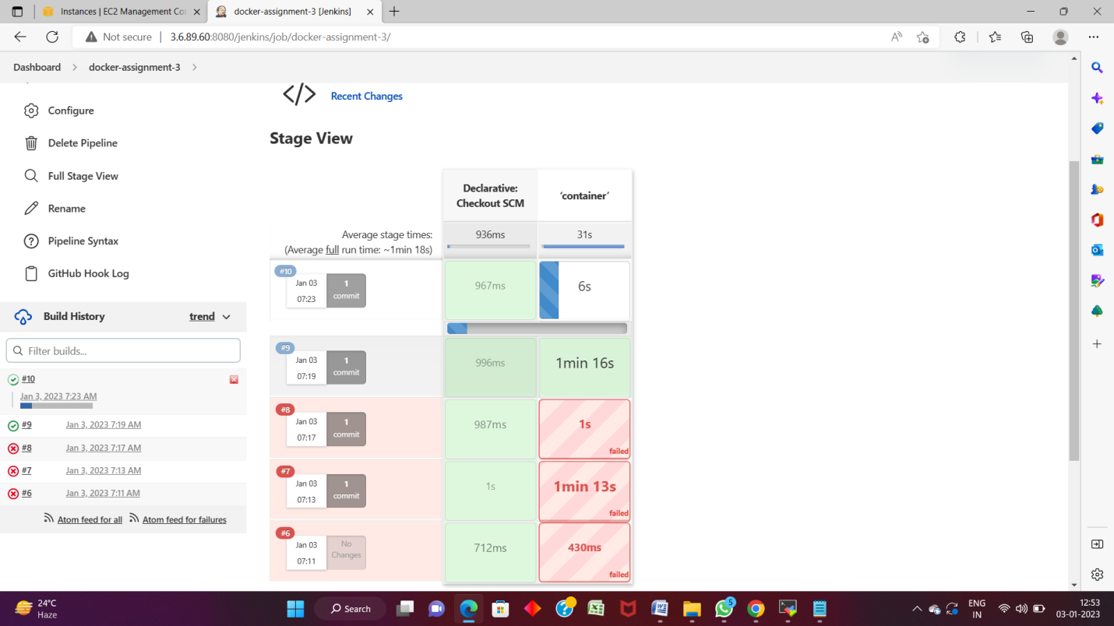

Dockerfile: /mnt/docker and index.html

FROM centos:8

RUN cd /etc/yum.repos.d/

RUN sed -i 's/mirrorlist/#mirrorlist/g' /etc/yum.repos.d/CentOS-*

RUN sed -i 's|#baseurl=http://mirror.centos.org|baseurl=http://vault.centos.org|g' /etc/yum.repos.d/CentOS-*

RUN yum update -y && yum install httpd httpd-tools -y

EXPOSE 80

COPY index.html /var/www/html

CMD ["/usr/sbin/httpd","-D","FOREGROUND"]

RUN chmod -R 777 /var/www/html/index.html

|  |
| --- |
|  |
|  |  |
|  |  |
|  |  |
|  |  |
|  |  |
|  |  |
|  |  |

----------------------------------------------------------------------------------------------------------

pipeline {

agent{

label {

label 'built-in'

customWorkspace '/mnt/docker1'

}

}

stages {

stage (‘container’) {

steps {

git url: 'https://github.com/sayalip848/docker.git'

sh "docker stop centos"

sh "docker system prune -a -f"

sh "docker build -t mycentos:2.0 ."

sh "docker run -itdp 80:80 --name centos mycentos:2.0"

}

}

}

}