**Problem Statement:** create tomcat container and deploy game-of-life

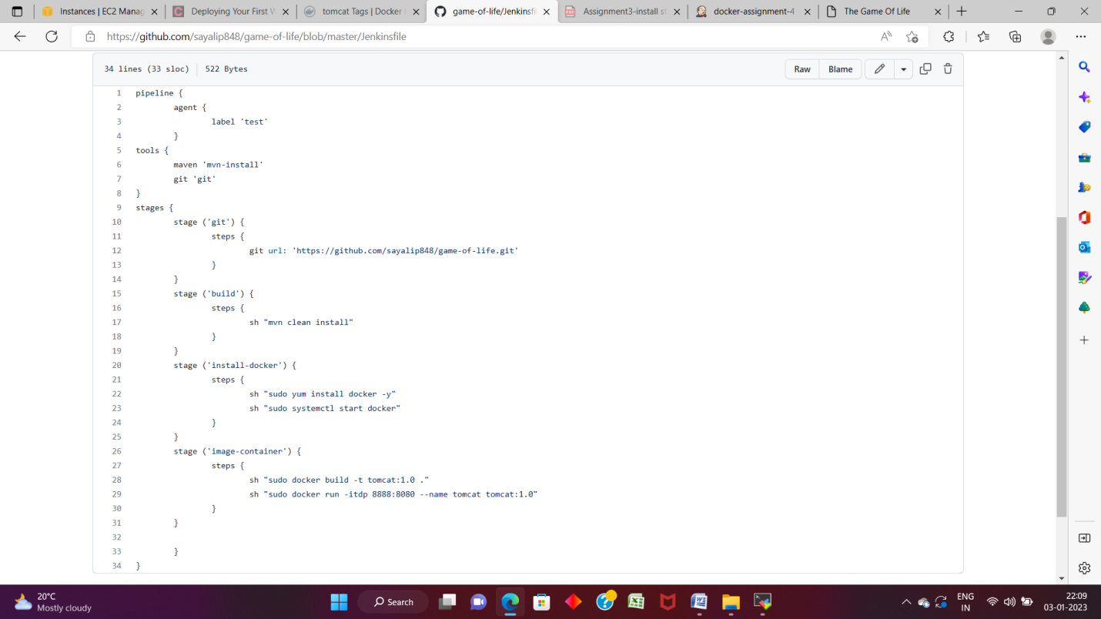

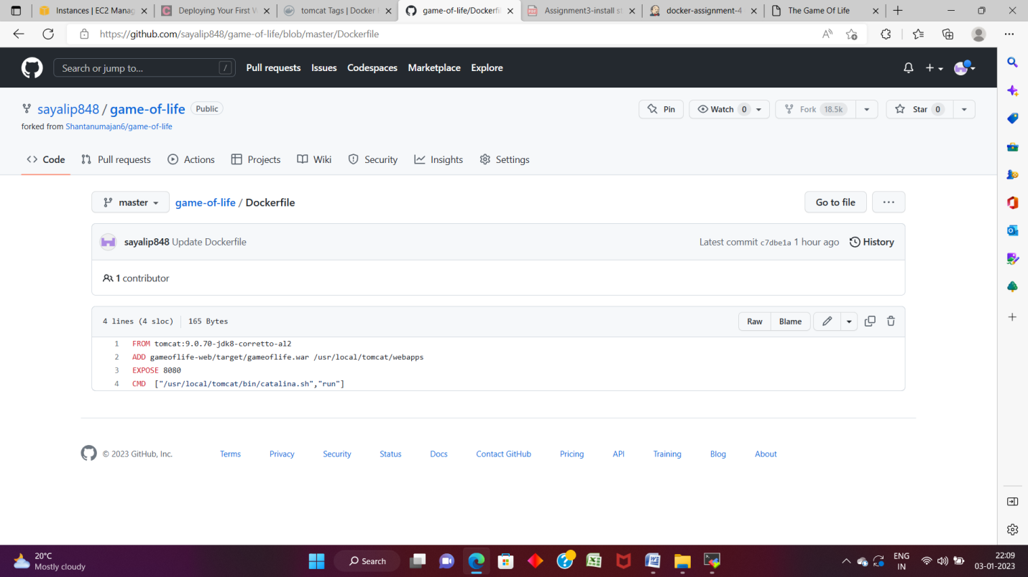

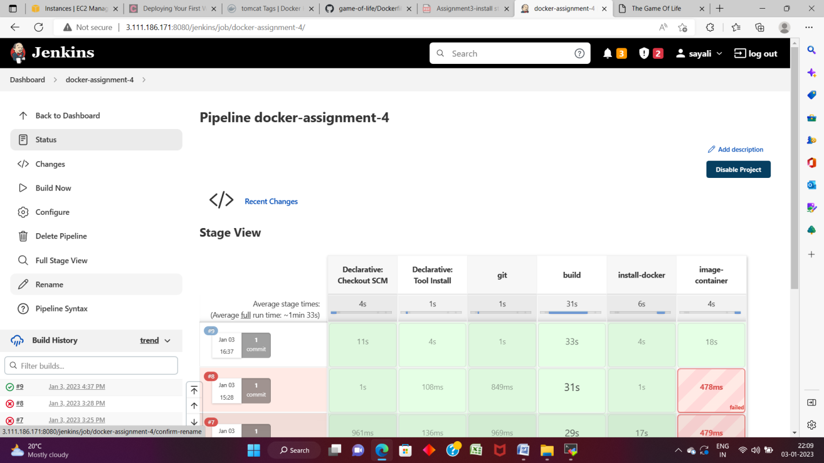

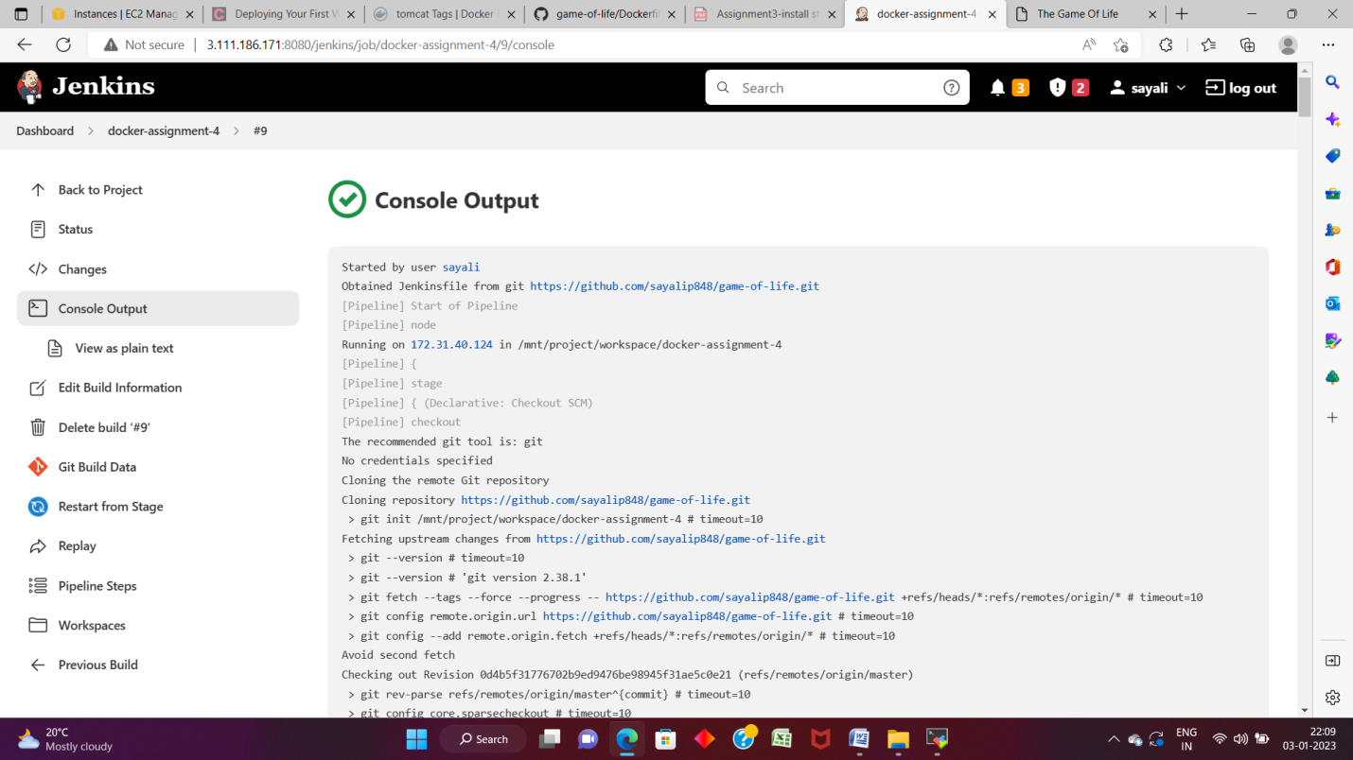

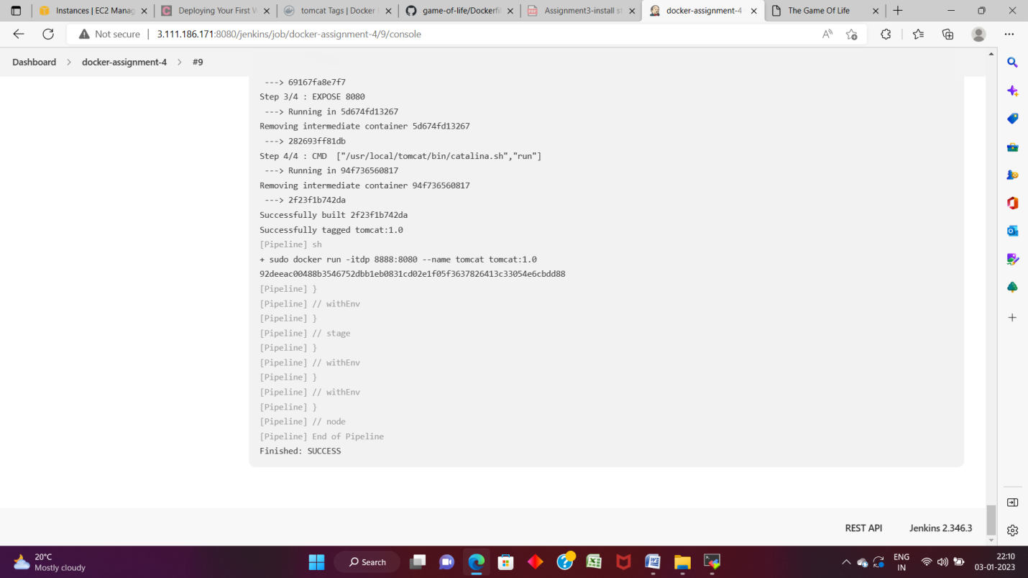

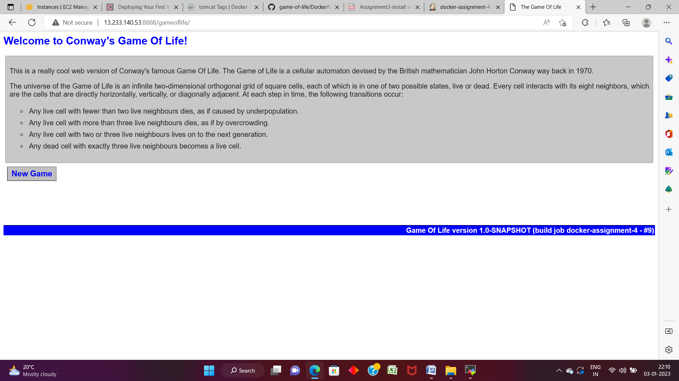

Dockerfile:

FROM tomcat:9.0.70-jdk8-corretto-al2

ADD gameoflife-web/target/gameoflife.war /usr/local/tomcat/webapps

EXPOSE 8080

CMD ["/usr/local/tomcat/bin/catalina.sh","run"]

Jenkinsfile:

pipeline {

agent {

label 'test'

}

tools {

maven 'mvn-install'

git 'git'

}

stages {

stage ('git') {

steps {

git url: 'https://github.com/sayalip848/game-of-life.git'

}

}

stage ('build') {

steps {

sh "mvn clean install"

}

}

stage ('install-docker') {

steps {

sh "sudo yum install docker -y"

sh "sudo systemctl start docker"

}

}

stage ('image-container') {

steps {

sh "sudo docker build -t tomcat:1.0 ."

sh "sudo docker run -itdp 8888:8080 --name tomcat tomcat:1.0"

}

}

}

}