Problem Statement: deploy game of life on dev env (on two container) and QA env (on two container)

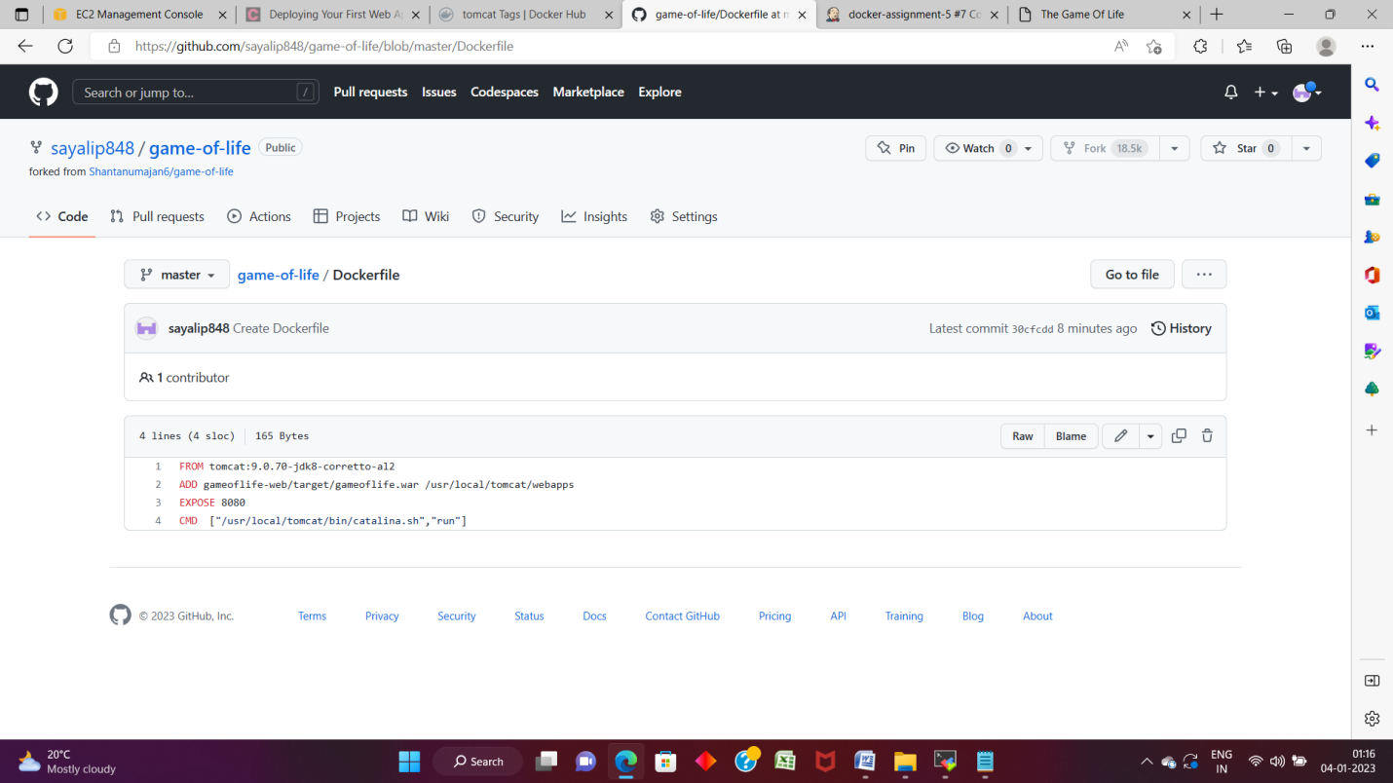

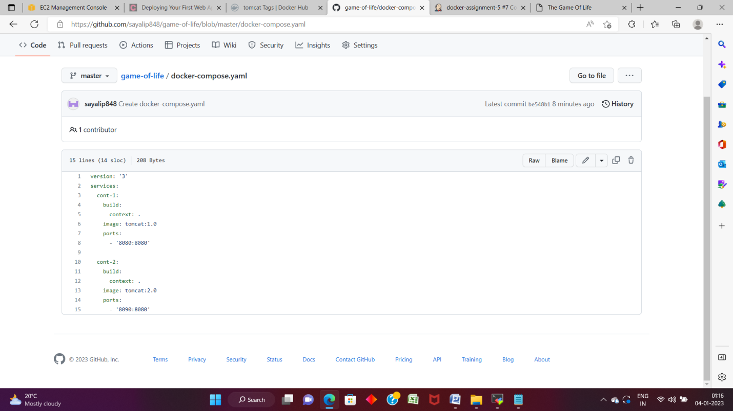

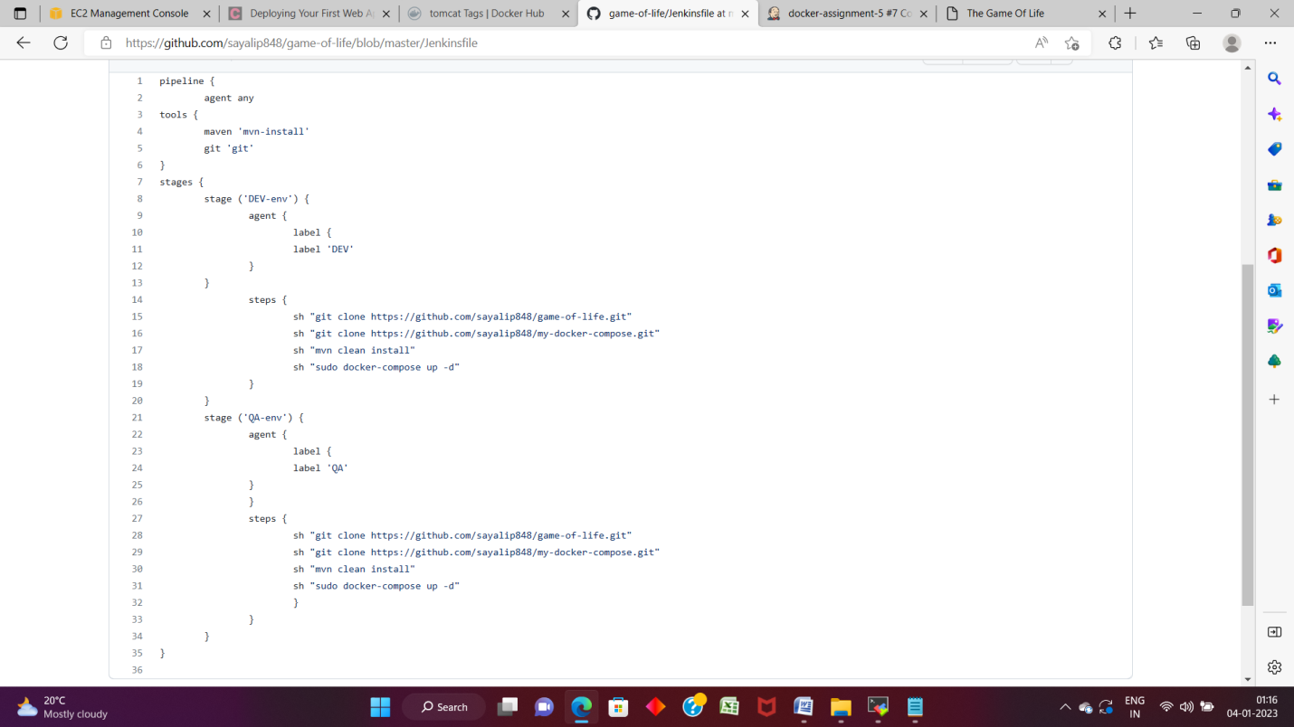

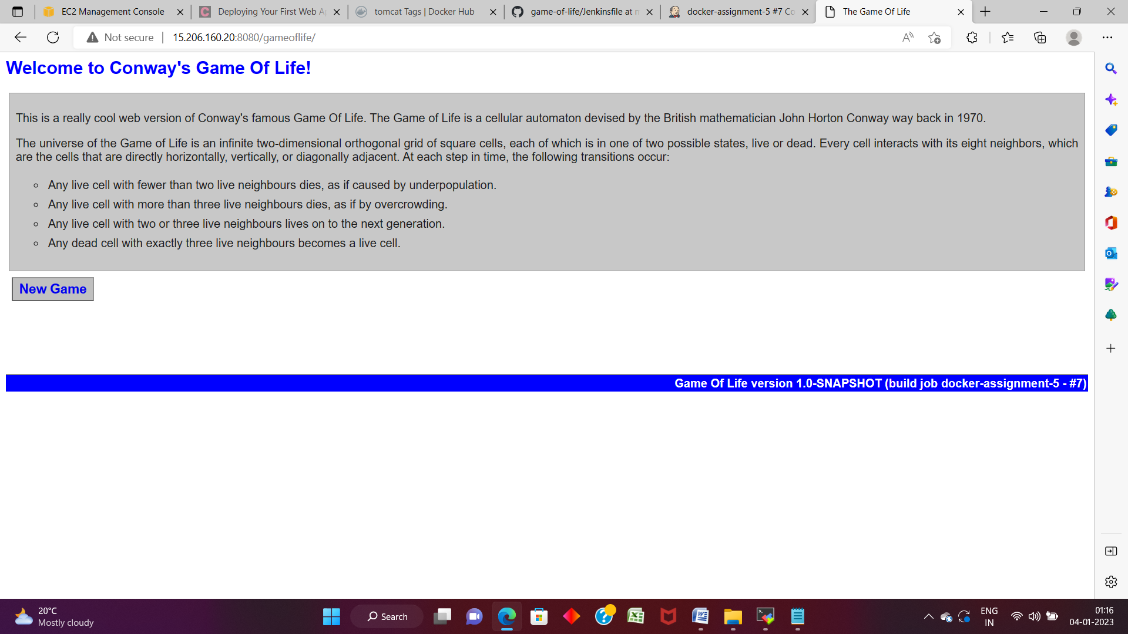

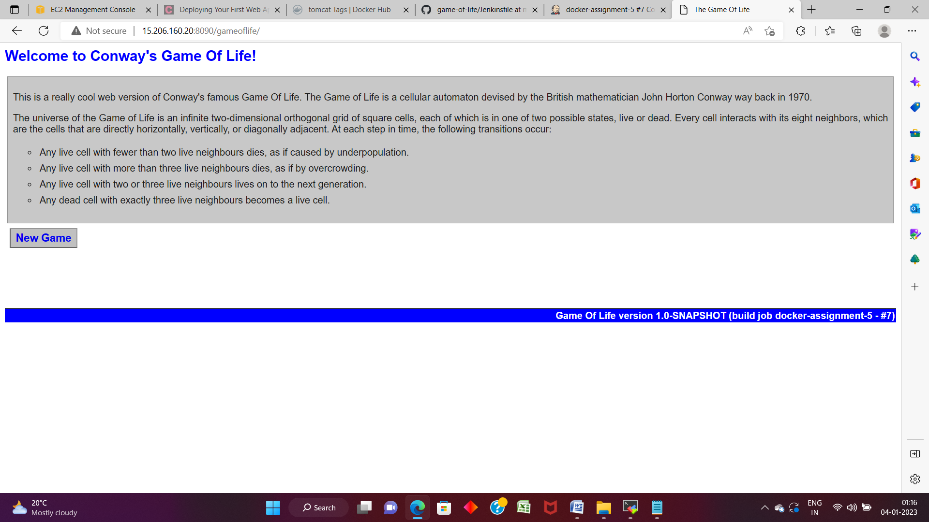

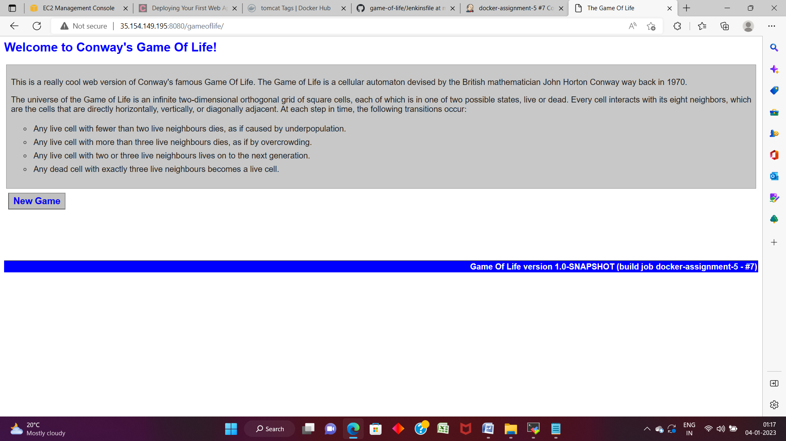

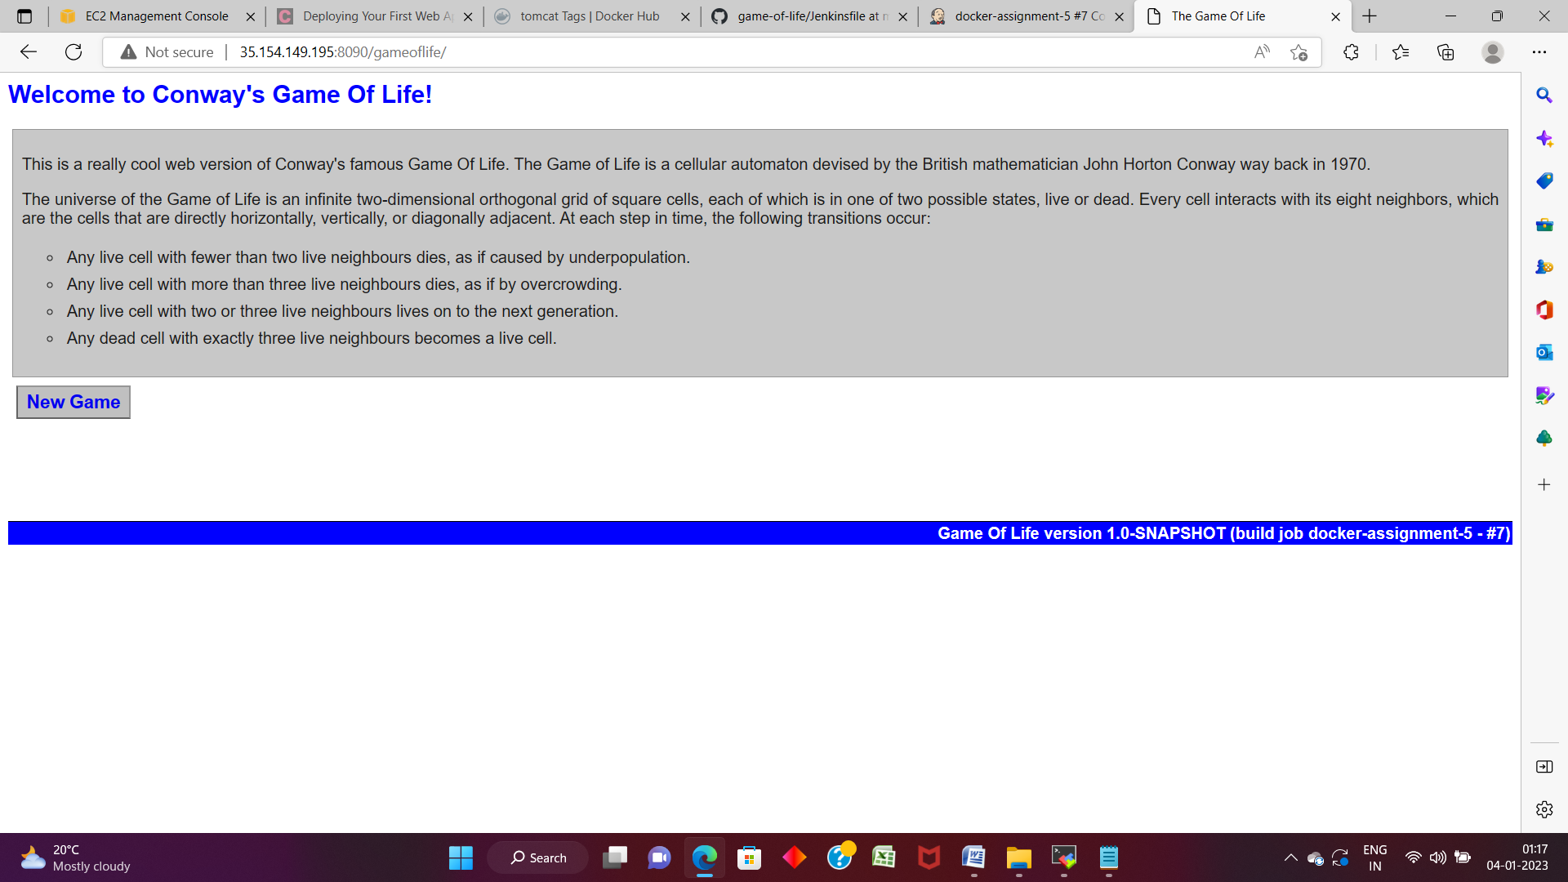

pipeline {

agent {

label 'test'

}

tools {

maven 'mvn-install'

git 'git'

}

stages {

stage ('git') {

steps {

git url: 'https://github.com/sayalip848/game-of-life.git'

git url: ‘https://github.com/sayalip848/my-docker-compose.git’

}

}

stage ('build') {

steps {

sh "mvn clean install"

}

}

stage ('install-docker') {

steps {

sh "sudo yum install docker -y"

sh "sudo systemctl start docker"

}

}

stage ('image-container') {

steps {

sh “docker-compose up -d”

}

}

}

}