**Configure SMTP in localhost.**

Using an outgoing SMTP server is the traditional method of sending emails. SMTP server sends email using the SMTP(Simple Mail Transfer Protocol). We will configure SMTP in our localhost by following these steps:

1. Start by installing *postfix*. Note, login as root user. An alternative to postfix is *sendmail*. Install the *mailutils* package along with postfix using the command,

***apt install mailutils postfix***

During installation, choose the *‘internet site’* mail configuration.

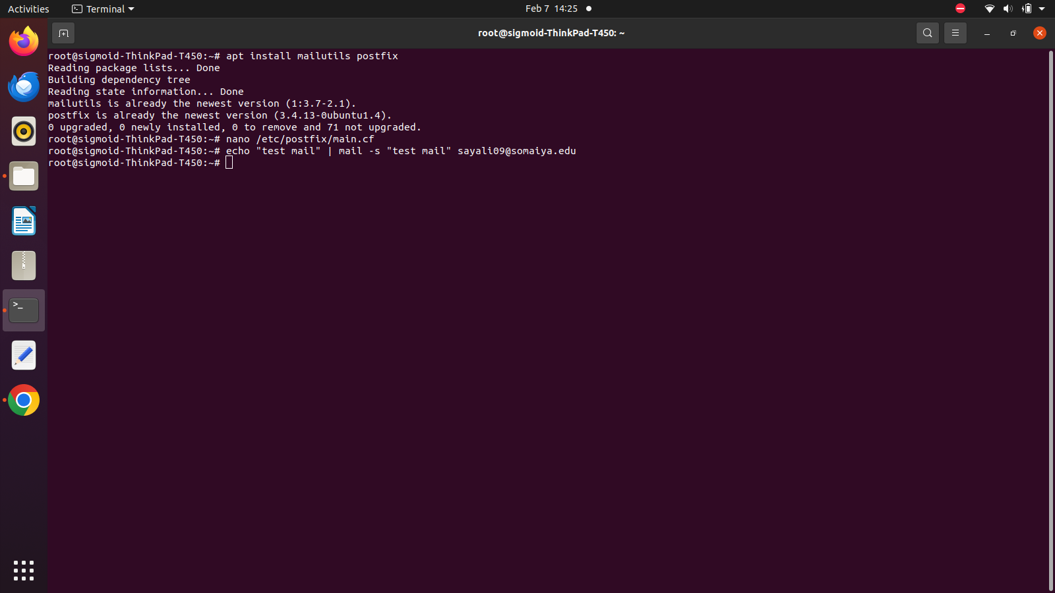

1. Edit the postfix main configuration file. You can use VI editor for the same. To access the configuration file, use command,

***nano /etc/postfix/main.cf***

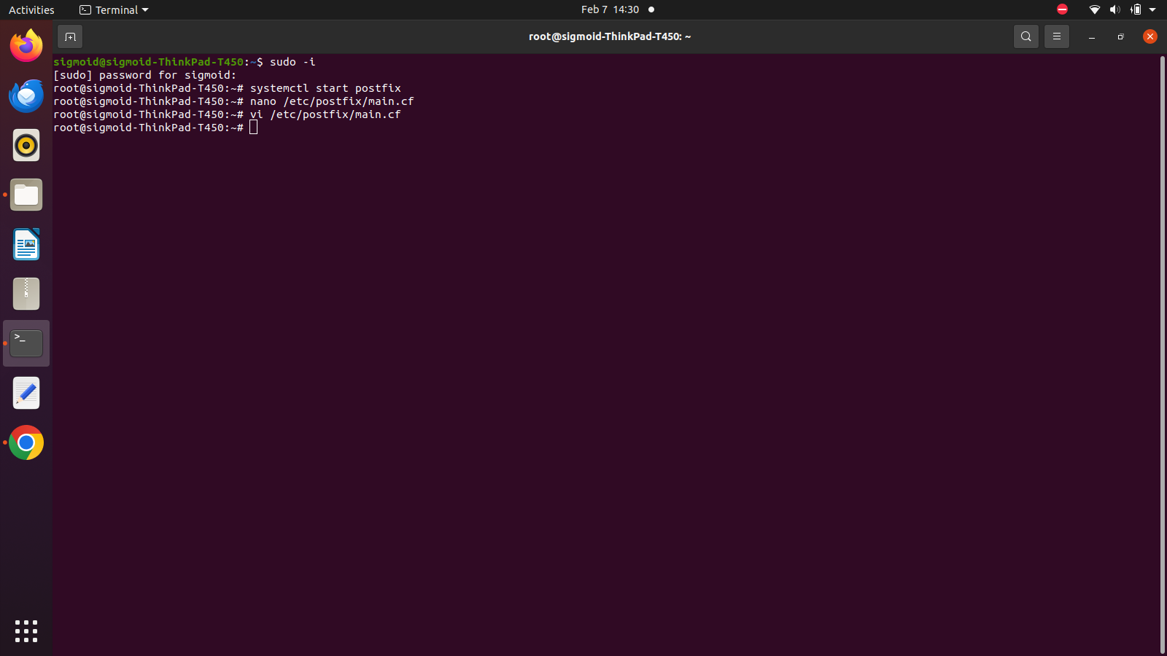

1. Make changes to the parameters *myhostname*, *mydestination*, *inet*_*interfaces*, etc as shown in the image. 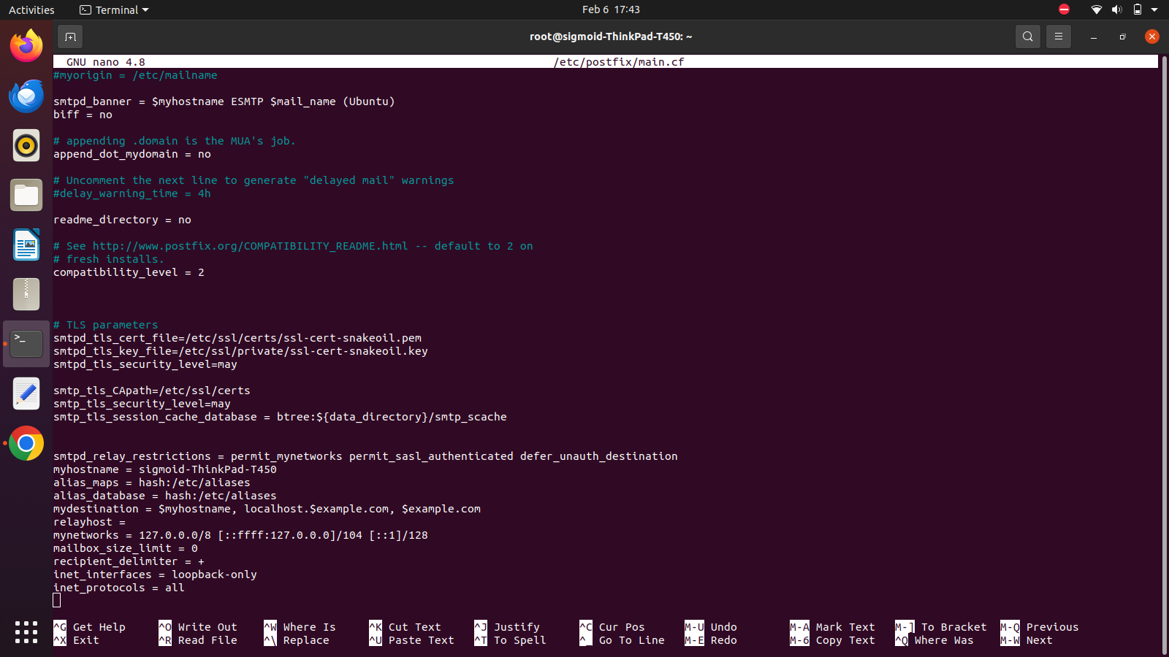
2. Use the following commands to restart the postfix service after making the changes and then check its status.

***systemctl restart postfix***

***systemctl status postfix***

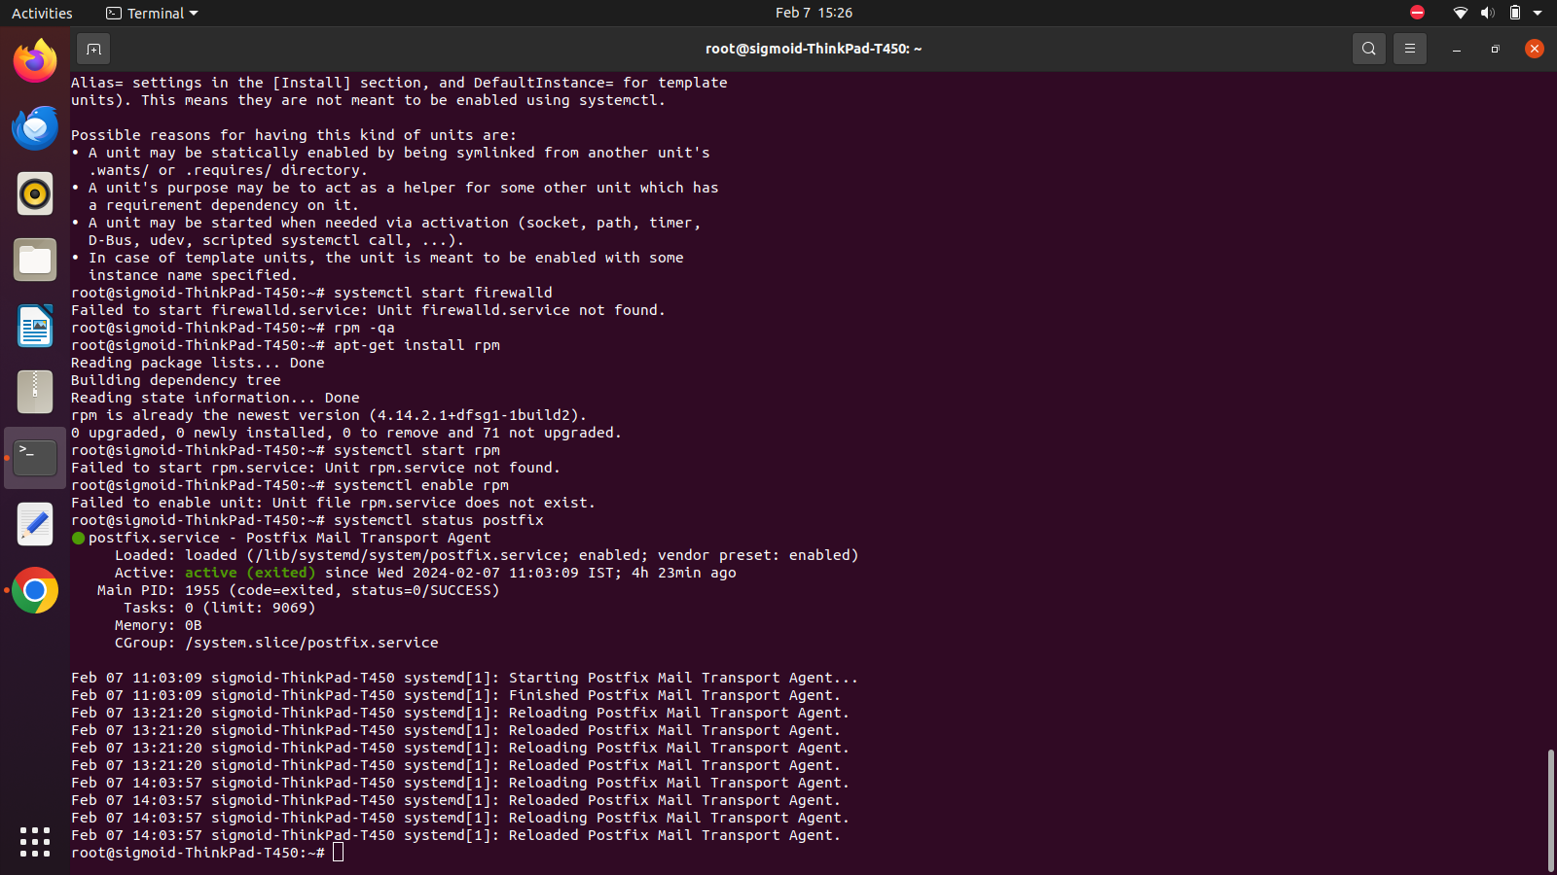

1. Use the *echo* command to send the mail to an email address. An email address without two-factor authentication makes a better option.

***echo “test mail” | mail –s “test mail” email_address***

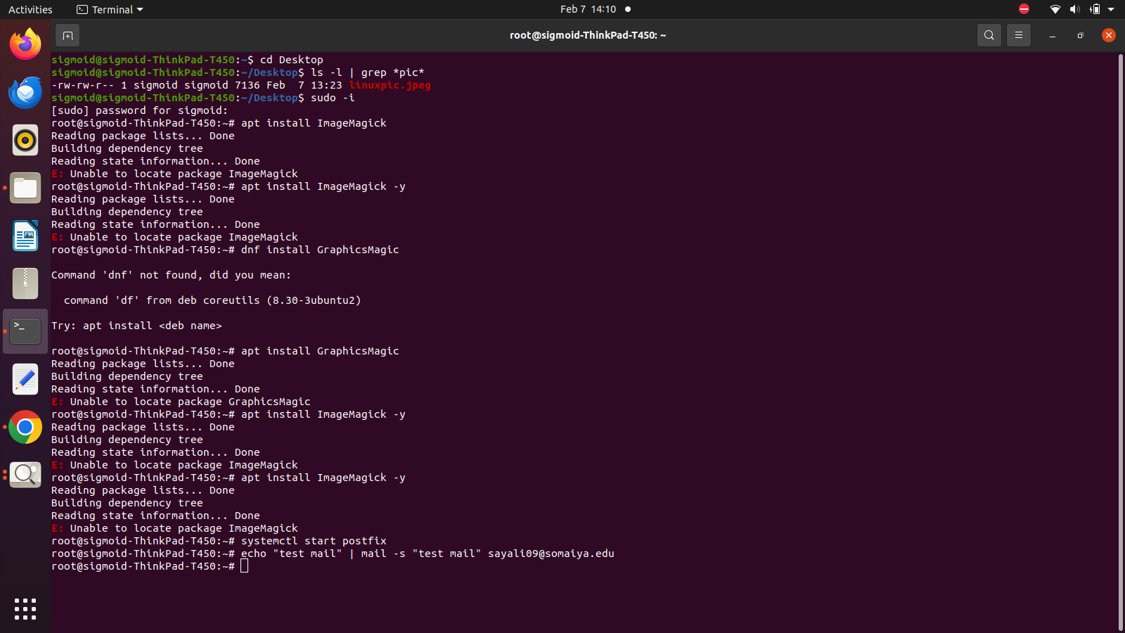

1. Log in to the email address to check if the mail was received.

