**Create a user in your localhost, which should not be able to execute the sudo command.**

**What does sudo access to command mean?**

Sudo stands for either "substitute user do" or "super user do" and it allows you to temporarily elevate your current user account to have root privileges. This means that a user who is granted sudo access can perform tasks that would normally require root privileges, such as installing software or modifying system configurations. On the other hand, the root user, also known as the superuser, is a special user account that has complete control over the system.

Below listed are the steps to give or remove sudo access from a user.

1. Checking which users have sudo privileges by running the below command as the root user.

***cat /etc/group | grep ^sudo***

This gives the names of the users with sudo privileges. In our system, users *‘sigmoid’* and *‘sigmoid02’* can access sudo commands.

‘*cat’* command reads the */etc/group* file and, piped with ‘*grep’* command gives the lines starting with the word *‘sudo’*.

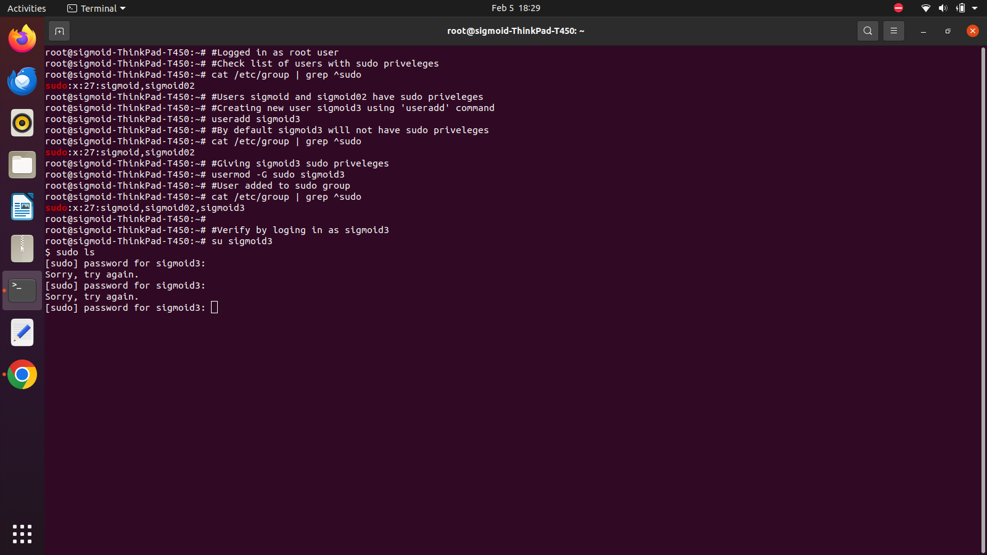

1. Now, we will add a new user using the *‘useradd’* command. Note that *‘adduser’* can also be used for the same.

***useradd sigmoid3***



By default, when you create a new user, they will not have sudo access to commands. However, based on your system configuration or specific commands used during user creation, there might be variations.

By default, user *‘sigmoid3’* does not have sudo access. You can check the same by running the command in the above step again.

1. To grant sudo privileges to a new user, you need to explicitly add them to the sudo group. You can also do it by editing the sudoers file.

Adding the user to sudo group,

***usermod –G sudo sigmoid3***



Run the following command to see if user ‘sigmoid3’ is added to sudo group.

***cat /etc/group | grep ^sudo***



User *‘sigmoid3’* now has sudo access to commands.

1. To remove sudo access from a user, in this case user *‘sigmoid3’*, we run the following command.

***deluser sigmoid3 sudo***

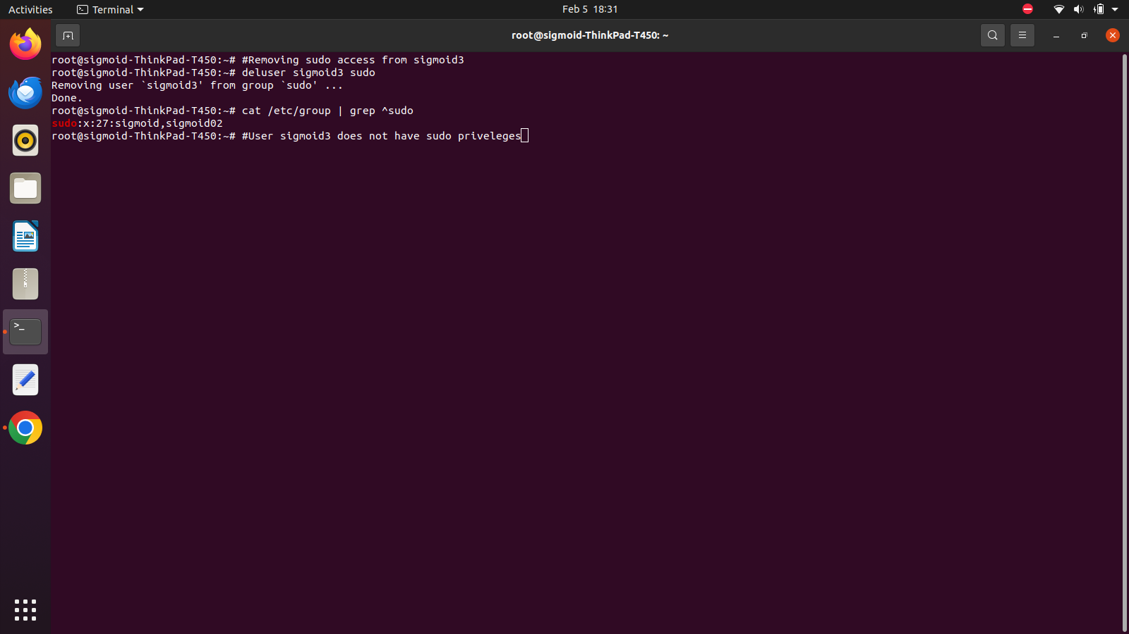

This command will remove the user from the group *‘sudo’*. We can verify the same by running the *‘cat’* command.

