**Configure your system in such a way that when a user type and executes a describe command from anywhere of the system it must list all the files and folders of the user's current directory.**

Ex:- $ **describe**

$ content1 content2

Content3 content 4

We will use alias to solve the above problem.

An alias in Linux is a user-defined shortcut for a command or a group of commands. You can create an alias using the 'alias' command followed by the name of the alias and the command it should execute.

1. Use *sudo* access to make changes to the *~/.bashrc file*. You can use nano or vi for the same.

***sudo vi ~/.bashrc***

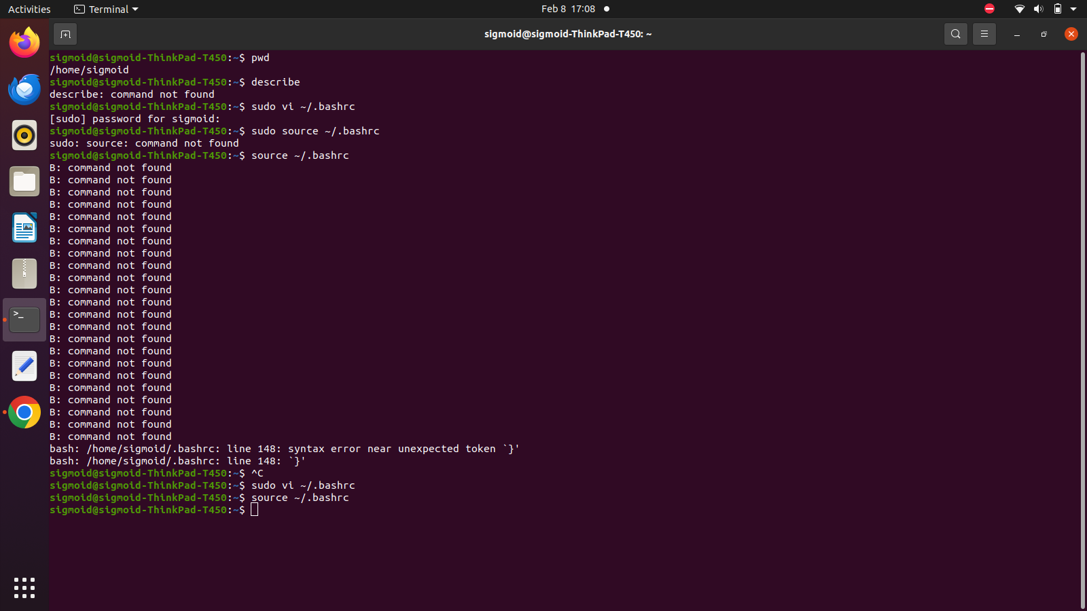

1. Add the following lines to the *~/.bashrc* file. This will simply execute the *ls* command with the *alias describe*. It will list all files and directories in the present working directory.

***describe()*** ***{ ls }***

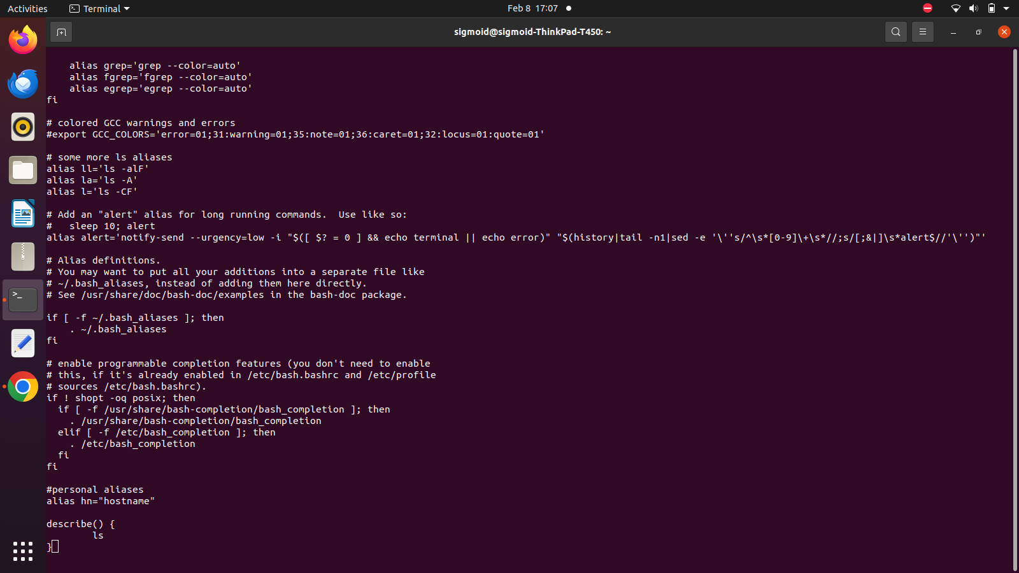

You can also use the following syntax:

***alias describe******=“ls”***

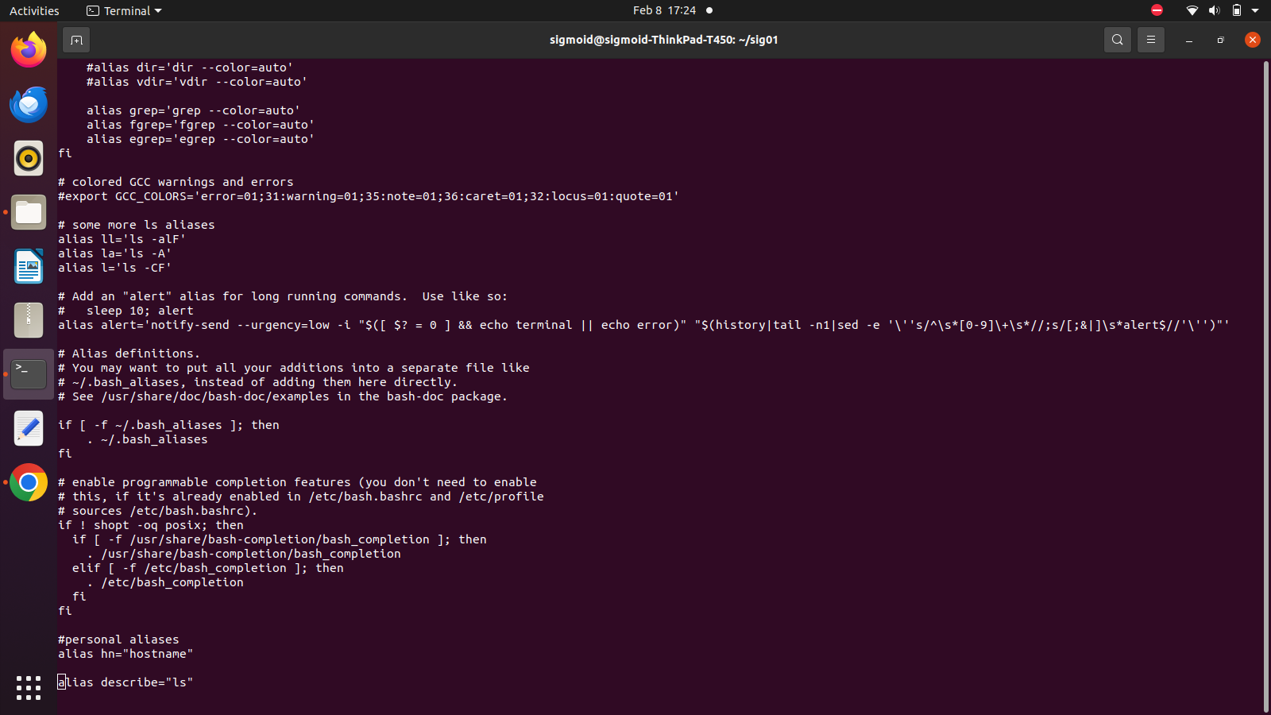

1. You can *reload* the shell configuration by running the following command,

***source ~/.bashrc***



You can also do this by logging out and then logging back in.

1. We can verify the changes made by running the describe command (or alias).

