**Users can put a compressed file at any path of the Linux file system. The name of the file will be research and the extension will be of compression type, example for gzip type extension will be .gz. You have to find the file and check the compression type and uncompress it.**

This script searches for files named “research” with various compression extensions in the Linux file system. It iterates over each found file, identifies its compression type, uncompresses it accordingly, and optionally renames it to “research.txt” after confirmation from the user.

1. We create the script using the *vi* editor. The script will have the .*sh* extension. Let us name the script *uncompress.sh*

***vi uncompress.sh***

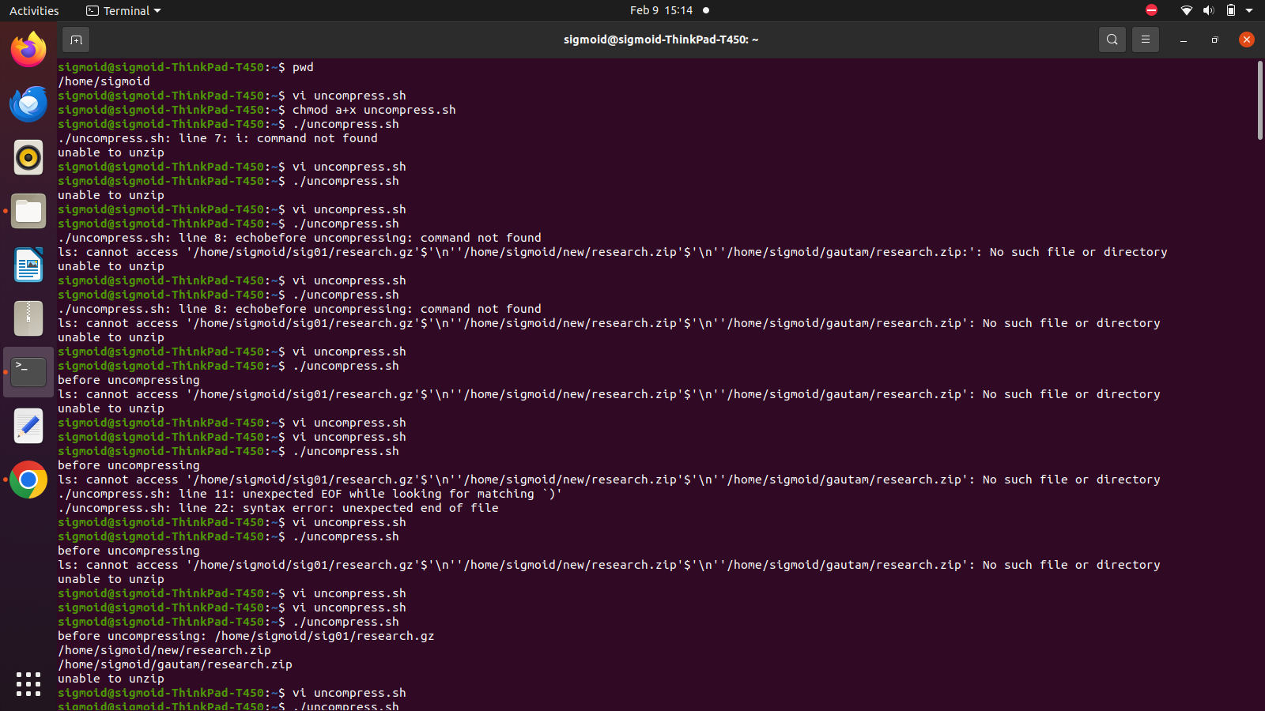

1. We write the following lines in the script.

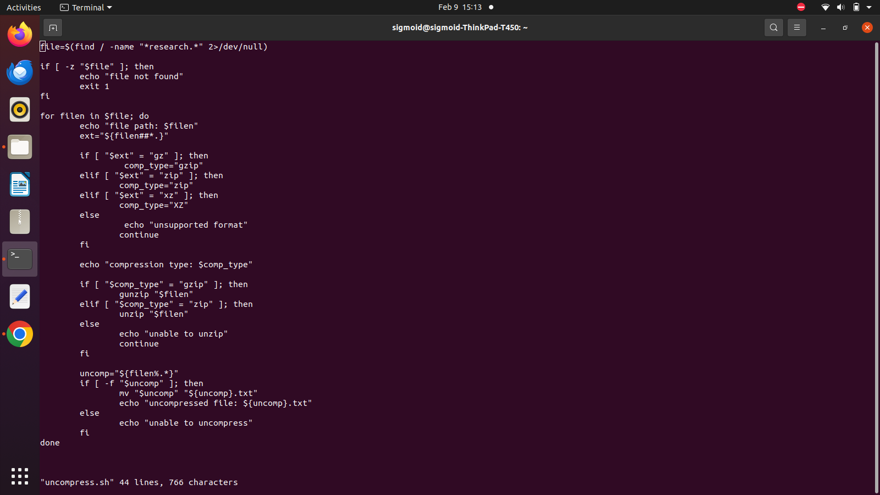



**file=$(find / -name "\*****research.*" 2>/dev/null)**

**if [ -z "$file****" ]; then**

**echo "file not found"**

**exit 1**

**fi**

**for filen in $file; do**

**echo "file path: $filen"**

**ext="${filen##*.}"**

**if [ "$ext" = "gz****" ]; then**

**comp_type="gzip"**

**elif [ "$ext" = "zip****" ]; then**

**comp_type="zip"**

**elif [ "$ext" = "xz****" ]; then**

**comp_type="XZ"**

**else**

**echo "unsupported format"**

**continue**

**fi**

**echo "compression type: $comp_type"**

**if [ "$comp_type" = "gzip****" ]; then**

**gunzip "$filen"**

**elif [ "$comp_type" = "zip****" ]; then**

**unzip "$filen"**

**else**

**echo "unable to unzip"**

**continue**

**fi**

**uncomp="${filen****%.*}"**

**if [ -f "$uncomp****" ]; then**

**mv "$uncomp" "${uncomp}.txt"**

**echo "uncompressed file: ${uncomp}.txt"**

**else**

**echo "unable to uncompress"**

**fi**

**done**

Explanation:

* + First, search for files with the word ‘research’ in the name.
  + If file is found, the variable file, stores the file paths as strings. If the file is not found, the screen shows “file not found”.
  + Using for loop, iterate over files to give file path, extension type and uncompressed output for every file.

1. Change the permissions to access the file so that anyone can execute the script. Use the command,

***chmod a+x uncompress.sh***



1. To execute the script, use the command:

***./uncompress.sh***

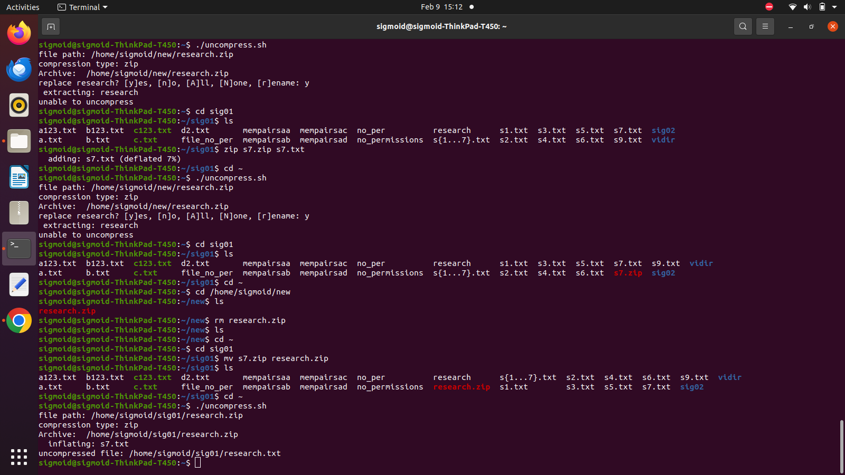

1. Another method:

***sudo find / -type f -name "research.zip" -exec zip -g {} +***