**Configure your system in such a way that any user of your system creates a file then there should not be permission to do any activity in that file.**

Note: Don’t use the chmod command.

We can use the *umask* command to change file permissions. On using *umask 077*, any file created in the selected directory will have restricted permissions without manually adjusting the permissions using the *chmod* command.

You can use *umask 022* to set the permissions back to the default umask value.

1. To demonstrate, we create a new directory by the name ‘*no_permissions’*. For this we use the command,

***mkdir no_permissions***

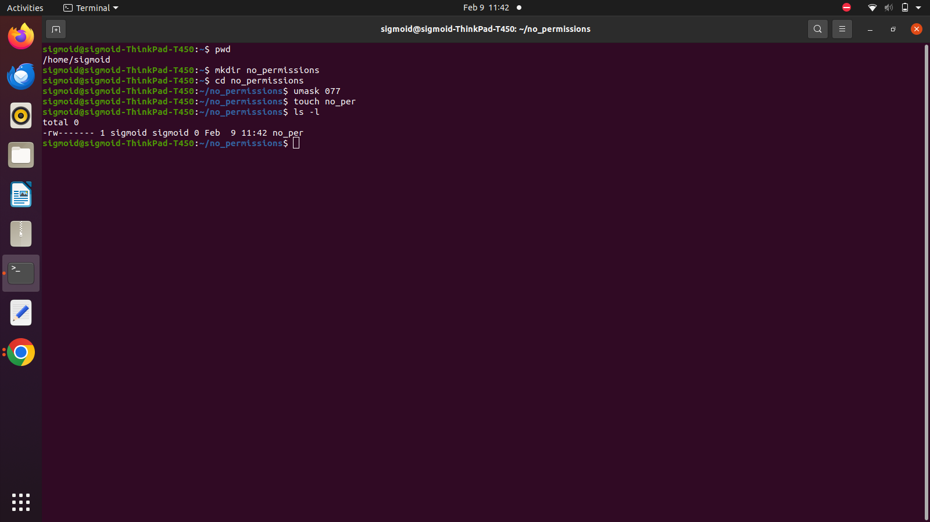

1. Change to this directory using the command,

***cd no_permissions***



Use the *umask* command to set default permissions to the directory.

***umask 077***

This prevents any access from other users to the files in that directory.

1. Now, create an empty file in the directory using the command,

***touch no_per***



1. Check if the permission changes made are effective by the running the command,

***ls -l***



Explanation:

`-` : It is a normal text file

`rw-`: The owner of the file has only read and write permissions. No execution permission.

`---`: No permissions for group.

`---`: No permissions for others.

The permissions for the owner cannot be completely removed. After using *umask 077*, the user will still have read and write permissions.

1. To get back to the default *umask* values, run the following command,

***umask 022***

