**Create a service with the name showtime, after starting the service, every minute it should print the current time in a file in the user home directory.**

Ex:-

sudo service showtime start -> It should start writing in file.

sudo service showtime stop -> It should stop writing in file.

sudo service showtime status -> It should show status.

1. Log in as root user to access the */etc/systemd/system* directory. Make *showtime.service* file within this directory using the following commands.

***cd /etc/systemd/system***

***vi showtime.service***

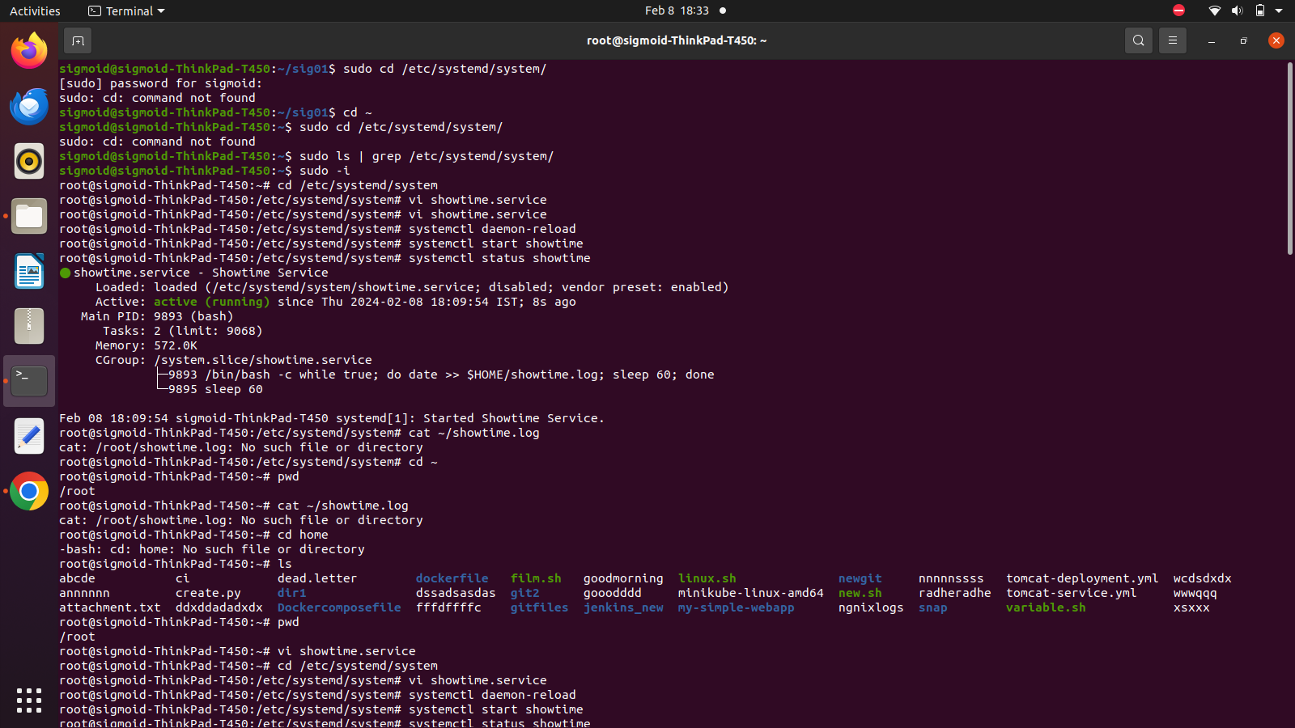

1. Write the following lines into the *showtime.service* file. When the service is started or stopped it will output to the */showtime.log* file.

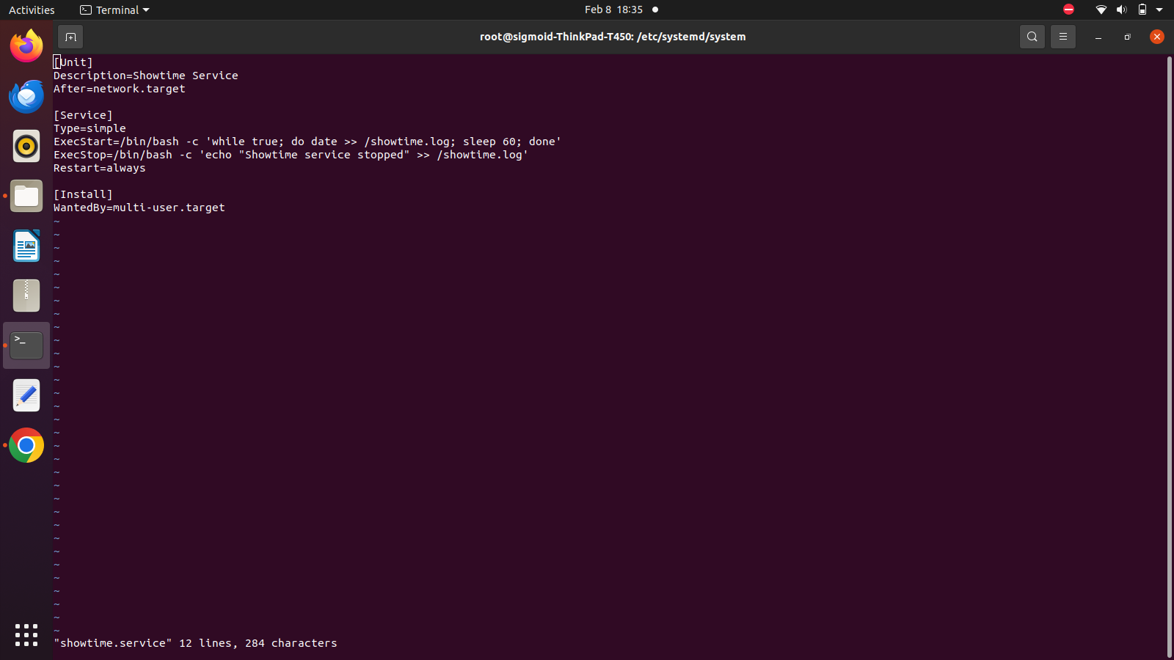

1. In case of error during saving output into the root directory, try the following commands.

***touch /showtime.log***

***chmod 666 /showtime***

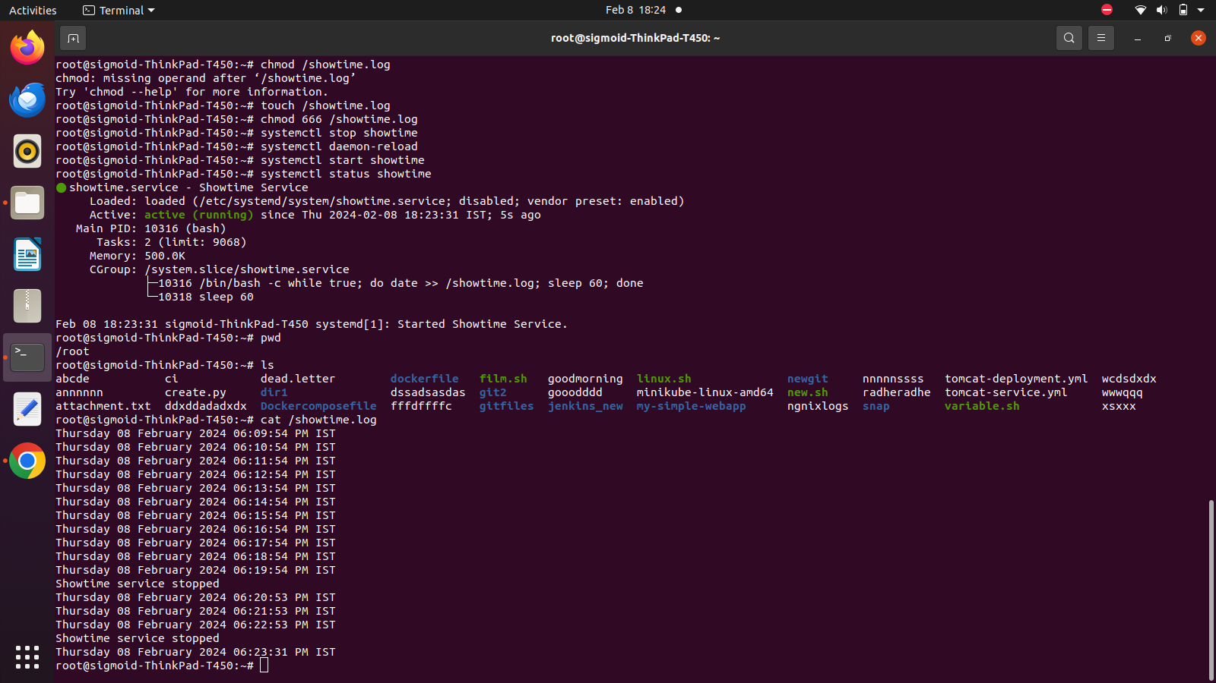

1. Now, reload the *daemon* and restart the showtime service. The status can be checked using the command,

***systemctl status showtime***



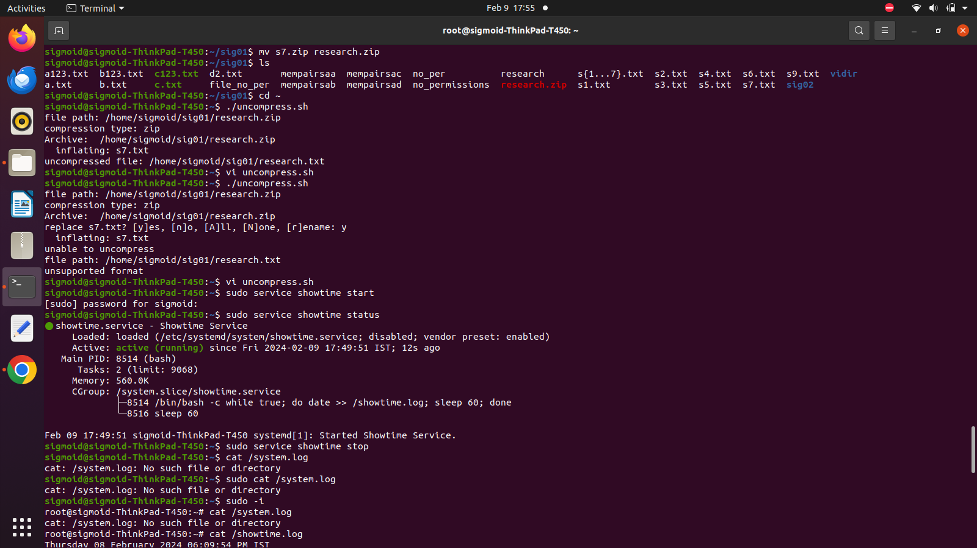

1. The output of the service can be checked by reading the */system.log* file.

***cat /system.log***

