<Sayali Subodh Shinde>

<February 27 2022>

<Foundations of Programming (Python)>

<Assignment 05>

To Create a CD Inventory Program with a Menu Structure for user to select with Dictionary as inner data structure

# Introduction

Brief overview about this module is I learnt about the list reading and the * operator overloading when dealing with list of list or list of dictionaries. There are also different dictionary functions I learnt like dict.items() or dict.keys().Also dictionary is like a list but the indexes to reference the values in dictionaries are unique identifiers called keys whereas in list the indexing starts from 0 The important aspect I learnt is the variables values have in memory and saving differences as memory contents lost when program terminated.

There were different ways of programming using SOC” Separation of Concerns” using data, processing and presentation styles for which functions, templates styles, error handling aid to it was demonstrated on the Basic Math script

This Module also describes working with Github and creating your code for different developers to review and work on.

# Menu selection based on users’ choice and implementation

The aim of this assignment is to display the menu and perform the tasks of adding CD data, loading current data from file into the memory, saving data to the CD Inventory.txt , deleting a entry user wants or exiting based on the user’s choice and name the program CDInventory.py which from Module5 was CDInventory_starter.py.Here 3 aspects are important:

1. **Inner data structure to be dictionaries means to create a list of dictionaries**
2. **Deleting the dictionary that user wants from lsttbl which is collection of dictionaries**
3. **Loading the data from file into memory is reading the data file**

As this data to be in Memory and not lose its content, it should be in while loop, to execute the data contents like displaying or saving in txt file.

## Declaration of variables and Display Menu

In the While loop True all time as its condition is true, the menu will be displayed asking for users to choose. Based on what to select from below like **a** to add CD data**, i** to display current CD data**, s** to save Cd data , and **d** to delete the dict in the list that the user wants,and **l** to load the data from a text file into the memory and **x** to exit.

Here the imp point to note is lstbl which is going to hold all individual cd dict is initialized outside while loop to empty list. If this is in the while loop being empty at every iteration of add we would get a extra empty list appended, so it must be out of while.

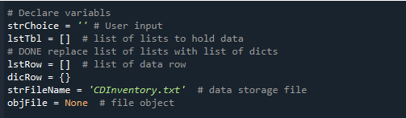

Figure Assignment05 Screenshot of variables declaration

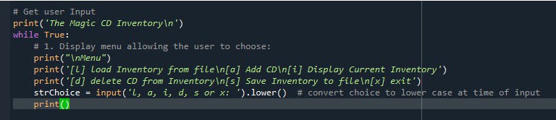

Figure 2 Assignemnt05 Screenshot to display Menu

## Add Data to the Table when user has data to add CD Inventory

Now to add the data to the list we use append to the empty list after taking the required inputs from the user like ID, CD Title and Artist Name. the dicRow is the dictionary of inputs from the user and that’s the dictionary I append to the lstTbl , if the user has chosen option **a**.

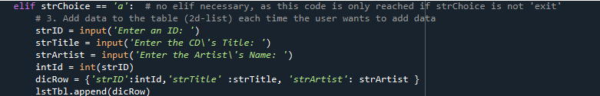

Figure 3 Assignemnt05 Screenshot to add CD data

## Display the current CD Inventory data added if user wishes to see the current Inventory of CD

Now as we have learnt in this module to display the data either using for or while loop, I have here used for loop to show the current memory data, if the user has chosen option **i**.

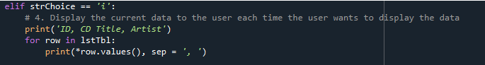

Figure 4 Assignemnt05 Notepad Screenshot to Display the Current CD Data

## Save the CD data added to the CDInventory.txt file if user has selected it from the menu

Now we need to save the data to the file CdInventory.txt if user chose option s. To save data we will be using the knowledge from the Module 4 Listing 20 to remove the **trailing ‘, ‘** and adding the newline so next row of CD data writes onto the next line of the text file.Here factor to consider is initialization of the strrow. One another factor to consider is to open file only when you need to preform any operation on it, as you can corrupt it unnecessary if opened earlier.Also as its dictionary we need to work on its values using row.values().

Here the choice of writing is suitable rather than appending to a file as we will add redundant data and can have duplicates.

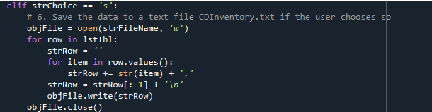

Figure 5 Assignemnt05 Screenshot of saving the data in the file

## Exit the program if user selects that option from the menu

Here to exit from the loop the user should enter x then we have used break to come out of the while loop.



Figure 6 Assignemnt05 Screenshot to exit the loop or menu using break

## If user selects something other than the Menu flag and display the message to select a valid option

If user has selected anything rather than what’s requested from the menu the message is displayed to select something from the menu and it’s not a valid option.



Figure 7 Assignemnt05 Screenshot if any other input

## Deleting a dictionary row from lstTbl if user selects

I have stored the value the user wants to delete in the entry_input and I search if that’s in the values of the dictionary I remove that row of dictionary from the list. Here the assumption is all values are strings and are unique for any key based deletion (ex, StrID, ArtistName, ArtistTitle)

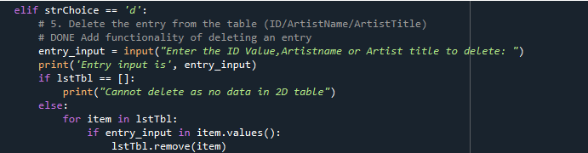

Figure 8. Assignment05 Screenshot of deleting from a row in a 2D List table of dictionaries

## Loading data in the Memory from the CDInventory.txt

For loading data into the memory, I read that from the file. Here the lstTbl.clear() is important or you add same data twice. As you want the data to be in memory you read it in memory have it in the lstTbl and not print it.

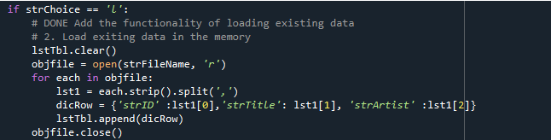

Figure 9 Assignemnt05 Screenshot of Loading data from file to memory

## Script

Below is the script from Spyder the consolidated and filled in for CDInventory_starter.py filled in for the required asks and renamed to CDInventory.py.

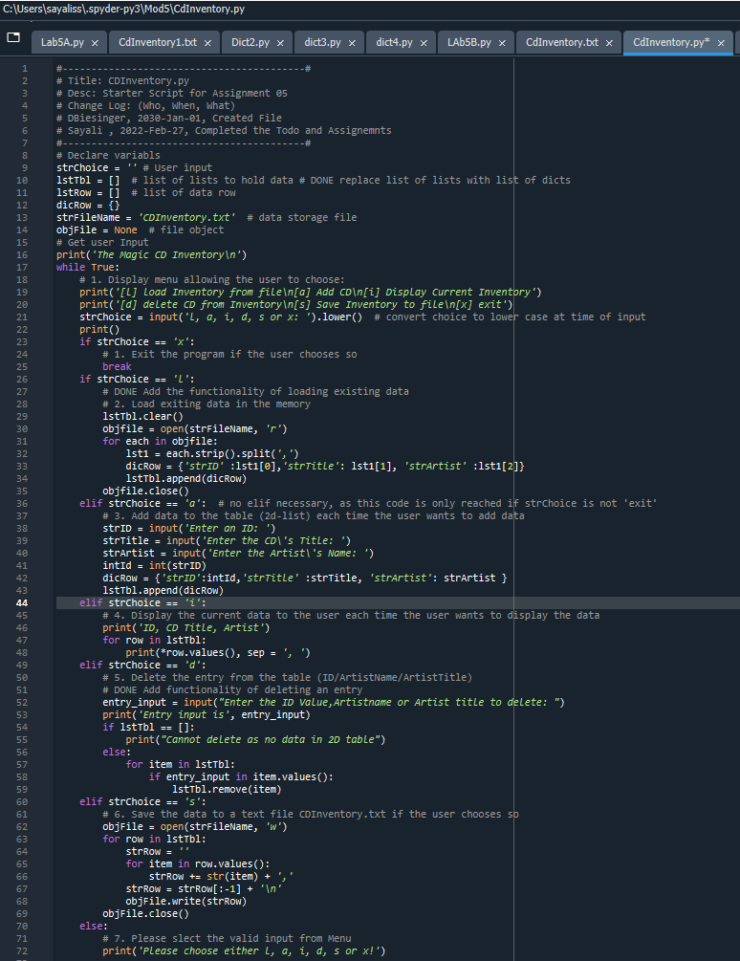

Figure10 Assignemnt05 Script in Spyder

## Execution of Program

As requested in the assignemnt05 I have executed the script in Spyder and in Command Prompt. I have also excluded snippets of display the current inventory and if the user has entered any other menu option apart from the menu given to the user.

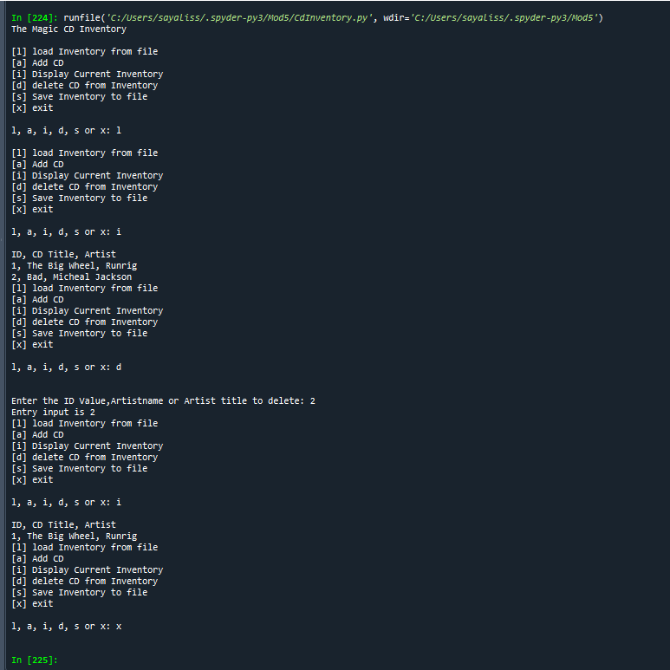

Figure 11 Assignment05 Screenshot on Execution of CDInventory.py on Console window to load data into memory,display data and delete an row and then display data again

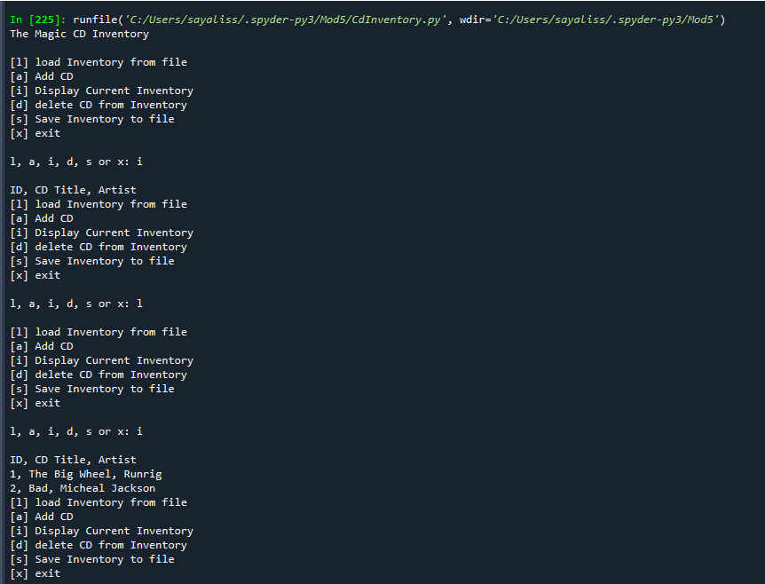

Figure 12 Assignment05 Screenshot demonstrating Spyder execution on console window to display the current Cd Inventory if not loaded and when loaded in memory

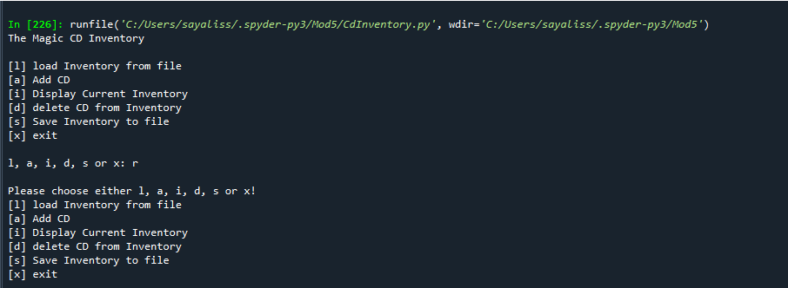

Figure 13 Assignment 05 Screenshot demonstrating execution if user chose option as r

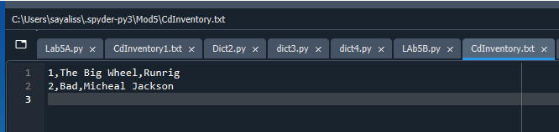

Figure 14 Assignemnt05 The text file Screenshot of CDInventory.txt

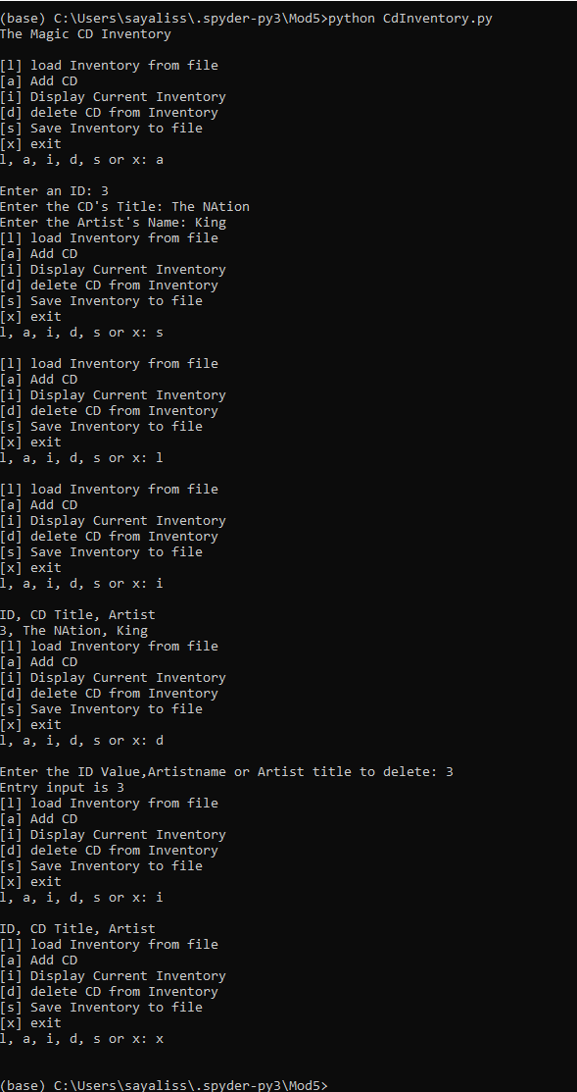

Figure 15. Assignemnt05 Screenshot of the Code Execution on the Command Prompt

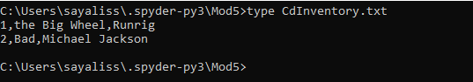

Figure 16 Assignment05 Screenshot of written contents in the CdInventory.txt on the command Prompt

I have used [Syntax Highlighters](https://saravjishut.org/syntax) (External Reference) [1]webpage, to standardize and it displays text, especially script, in different colors and fonts according to the Language.

# Summary

I learnt different types of methods are available for writing the code, but selection of right parameters is important like the append vs write mode for the file Also in deleting the row contents using a trick to find that values in **dic.values()** then **remove()** function to remove that row from the list. The functions I used are not self-created ones.

One needs to have the added content written to the text file else they wont get saved if read operation done before writing. Also if files empty first it would be better to add data to file then read and display that data. If as soon you start the program If you display you wont have anything as you didn’t read into the memory or load into the memory

I have uploaded the Gitlab code : <https://github.com/sayalisu/PythonRepo>[2]

# Appendix

## Script

|  |  |  |  |  |  |  |  |  |  |  |  |
| --- | --- | --- | --- | --- | --- | --- | --- | --- | --- | --- | --- |
| |  |  |  |  |  |  |  |  |  |  | | --- | --- | --- | --- | --- | --- | --- | --- | --- | --- | | |  |  |  |  |  |  |  |  | | --- | --- | --- | --- | --- | --- | --- | --- | | |  |  |  |  |  |  | | --- | --- | --- | --- | --- | --- | | |  |  |  |  | | --- | --- | --- | --- | | |  |  | | --- | --- | | 1  2  3  4  5  6  7  8  9  10  11  12  13  14  15  16  17  18  19  20  21  22  23  24  25  26  27  28  29  30  31  32  33  34  35  36  37  38  39  40  41  42  43  44  45  46  47  48  49  50  51  52  53  54  55  56  57  58  59  60  61  62  63  64  65  66  67  68  69  70  71  72 | *#------------------------------------------#*  *# Title: CDInventory.py*  *# Desc: Starter Script for Assignment 05*  *# Change Log: (Who, When, What)*  *# DBiesinger, 2030-Jan-01, Created File*  *# Sayali , 2022-Feb-27, Completed the Todo and Assignemnts*  *#------------------------------------------#*  *# Declare variabls*  strChoice = '' *# User input*  lstTbl = [] *# list of lists to hold data # DONE replace list of lists with list of dicts*  lstRow = [] *# list of data row*  dicRow = {}  strFileName = 'CDInventory.txt' *# data storage file*  objFile = **None** *# file object*  *# Get user Input*  print('The Magic CD Inventory**\n**')  **while** **True**:  *# 1. Display menu allowing the user to choose:*  print('[l] load Inventory from file**\n**[a] Add CD**\n**[i] Display Current Inventory')  print('[d] delete CD from Inventory**\n**[s] Save Inventory to file**\n**[x] exit')  strChoice = input('l, a, i, d, s or x: ').lower() *# convert choice to lower case at time of input*  print()  **if** strChoice == 'x':  *# 1. Exit the program if the user chooses so*  **break**  **if** strChoice == 'l':  *# DONE Add the functionality of loading existing data*  *# 2. Load exiting data in the memory*  lstTbl.clear()  objfile = open(strFileName, 'r')  **for** each **in** objfile:  lst1 = each.strip().split(',')  dicRow = {'strID' :lst1[0],'strTitle': lst1[1], 'strArtist' :lst1[2]}  lstTbl.append(dicRow)  objfile.close()  **elif** strChoice == 'a': *# no elif necessary, as this code is only reached if strChoice is not 'exit'*  *# 3. Add data to the table (2d-list) each time the user wants to add data*  strID = input('Enter an ID: ')  strTitle = input('Enter the CD**\'**s Title: ')  strArtist = input('Enter the Artist**\'**s Name: ')  intId = int(strID)  dicRow = {'strID':intId,'strTitle' :strTitle, 'strArtist': strArtist }  lstTbl.append(dicRow)  **elif** strChoice == 'i':  *# 4. Display the current data to the user each time the user wants to display the data*  print('ID, CD Title, Artist')  **for** row **in** lstTbl:  print(*row.values(), sep = ', ')  **elif** strChoice == 'd':  *# 5. Delete the entry from the table (ID/ArtistName/ArtistTitle)*  *# DONE Add functionality of deleting an entry*  entry_input = input("Enter the ID Value,Artistname or Artist title to delete: ")  print('Entry input is', entry_input)  **if** lstTbl == []:  print("Cannot delete as no data in 2D table")  **else**:  **for** item **in** lstTbl:  **if** entry_input **in** item.values():  lstTbl.remove(item)  **elif** strChoice == 's':  *# 6. Save the data to a text file CDInventory.txt if the user chooses so*  objFile = open(strFileName, 'w')  **for** row **in** lstTbl:  strRow = ''  **for** item **in** row.values():  strRow += str(item) + ','  strRow = strRow[:-1] + '**\n**'  objFile.write(strRow)  objFile.close()  **else**:  *# 7. Please slect the valid input from Menu*  print('Please choose either l, a, i, d, s or x!') | |  | |  | |  | |  | |  |

1. Retrieved 2022-Feb-04
2. Retrieved 2022-Feb-27