**PART 4**

**Used JAVA API to import data into mongdb and the count of collections is as follows:**

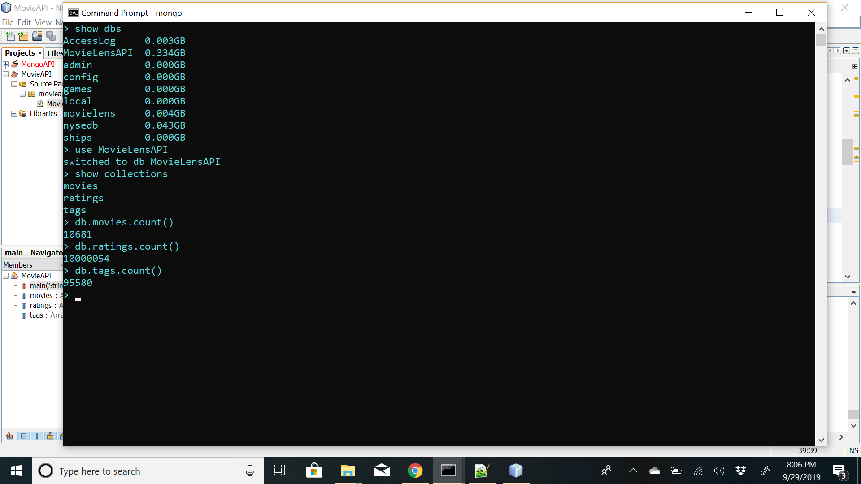

**1] Number of movies per year**

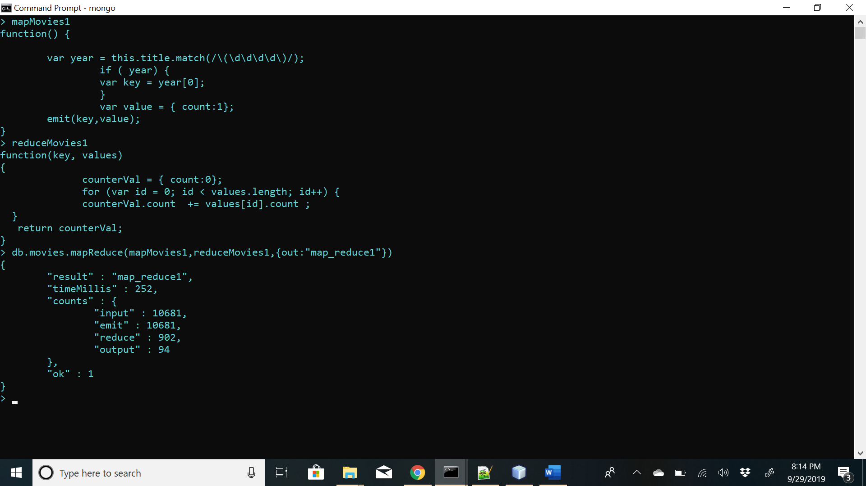

**Map function-** function() { var year = this.title.match(/\(\d\d\d\d\)/);if ( year) { var key = year[0];} var value = { count:1}; emit(key,value); }

**Reduce function-** function(key, values) { counterVal = { count:0}; for (var id = 0; id < values.length; id++) { counterVal.count += values[id].count ; } return counterVal; }

**Answer-** 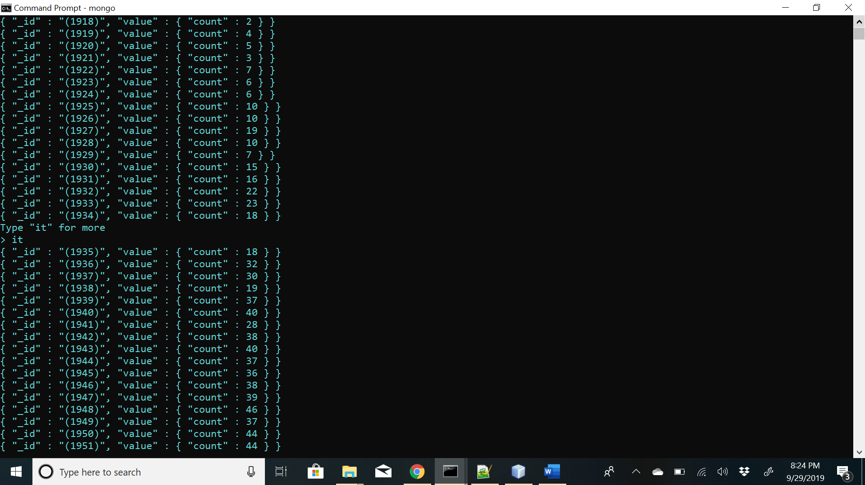

**2] Number of movies per genre-**

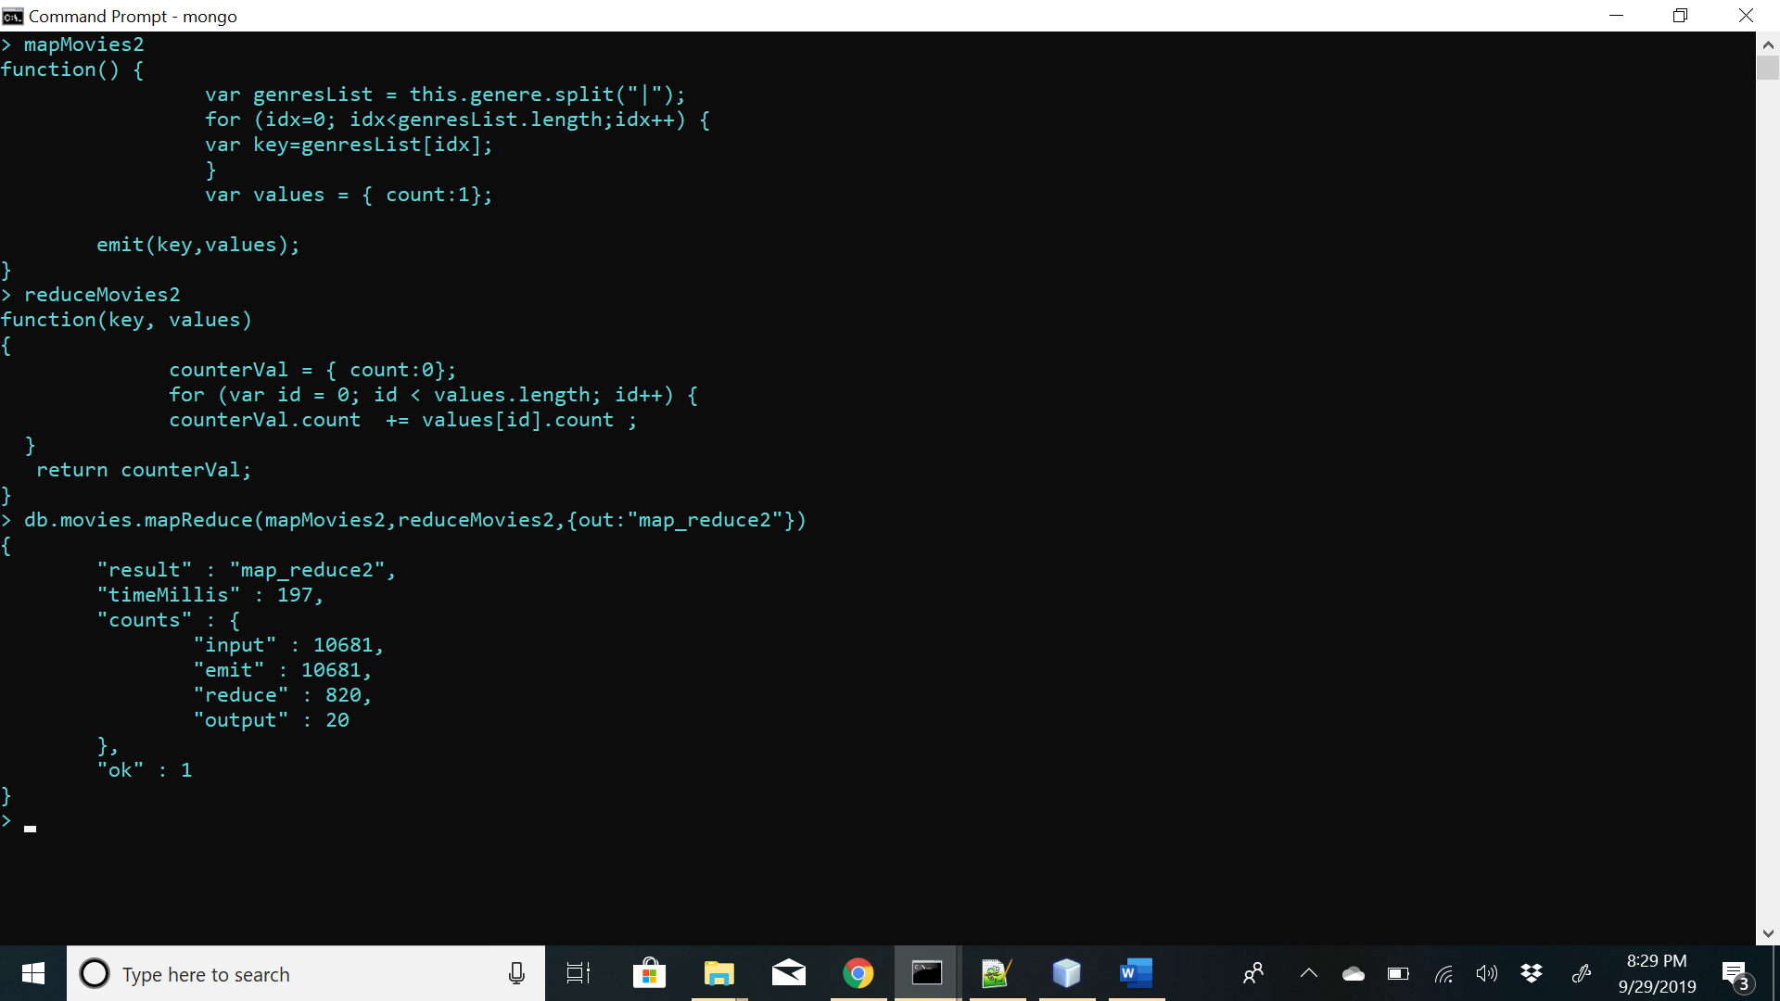

Map function- function() { var genresList = this.genres.split("|"); for (idx=0; idx<genresList.length;idx++) { var key=genresList[idx]; var values = { count:1};emit(key,values);}}

Reduce Function- function(key, values) { counterVal = { count:0}; for (var id = 0; id < values.length; id++) { counterVal.count += values[id].count ; } return counterVal;}

**Answer-**

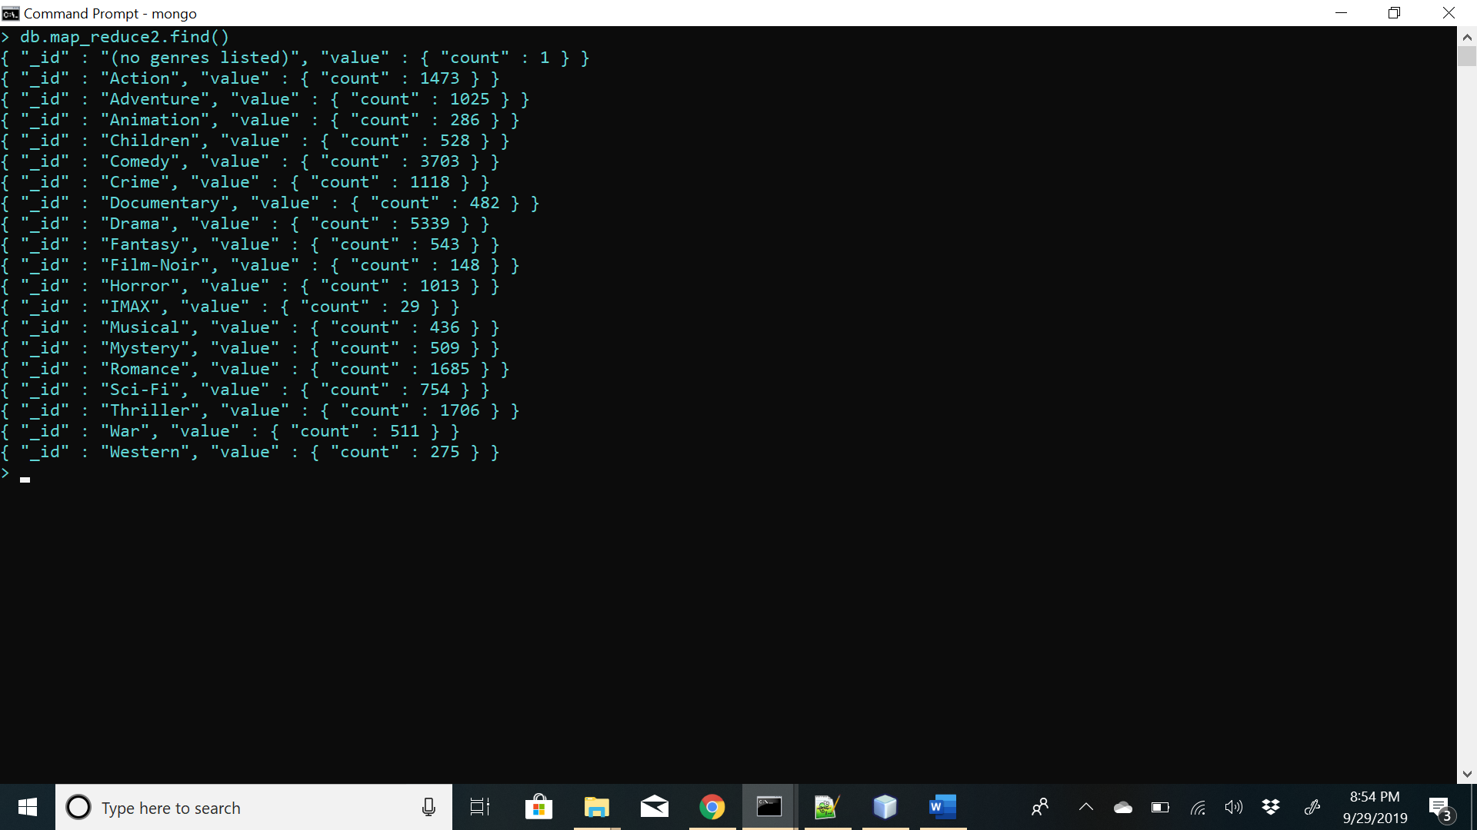

**3] Number of movies per ratings-**

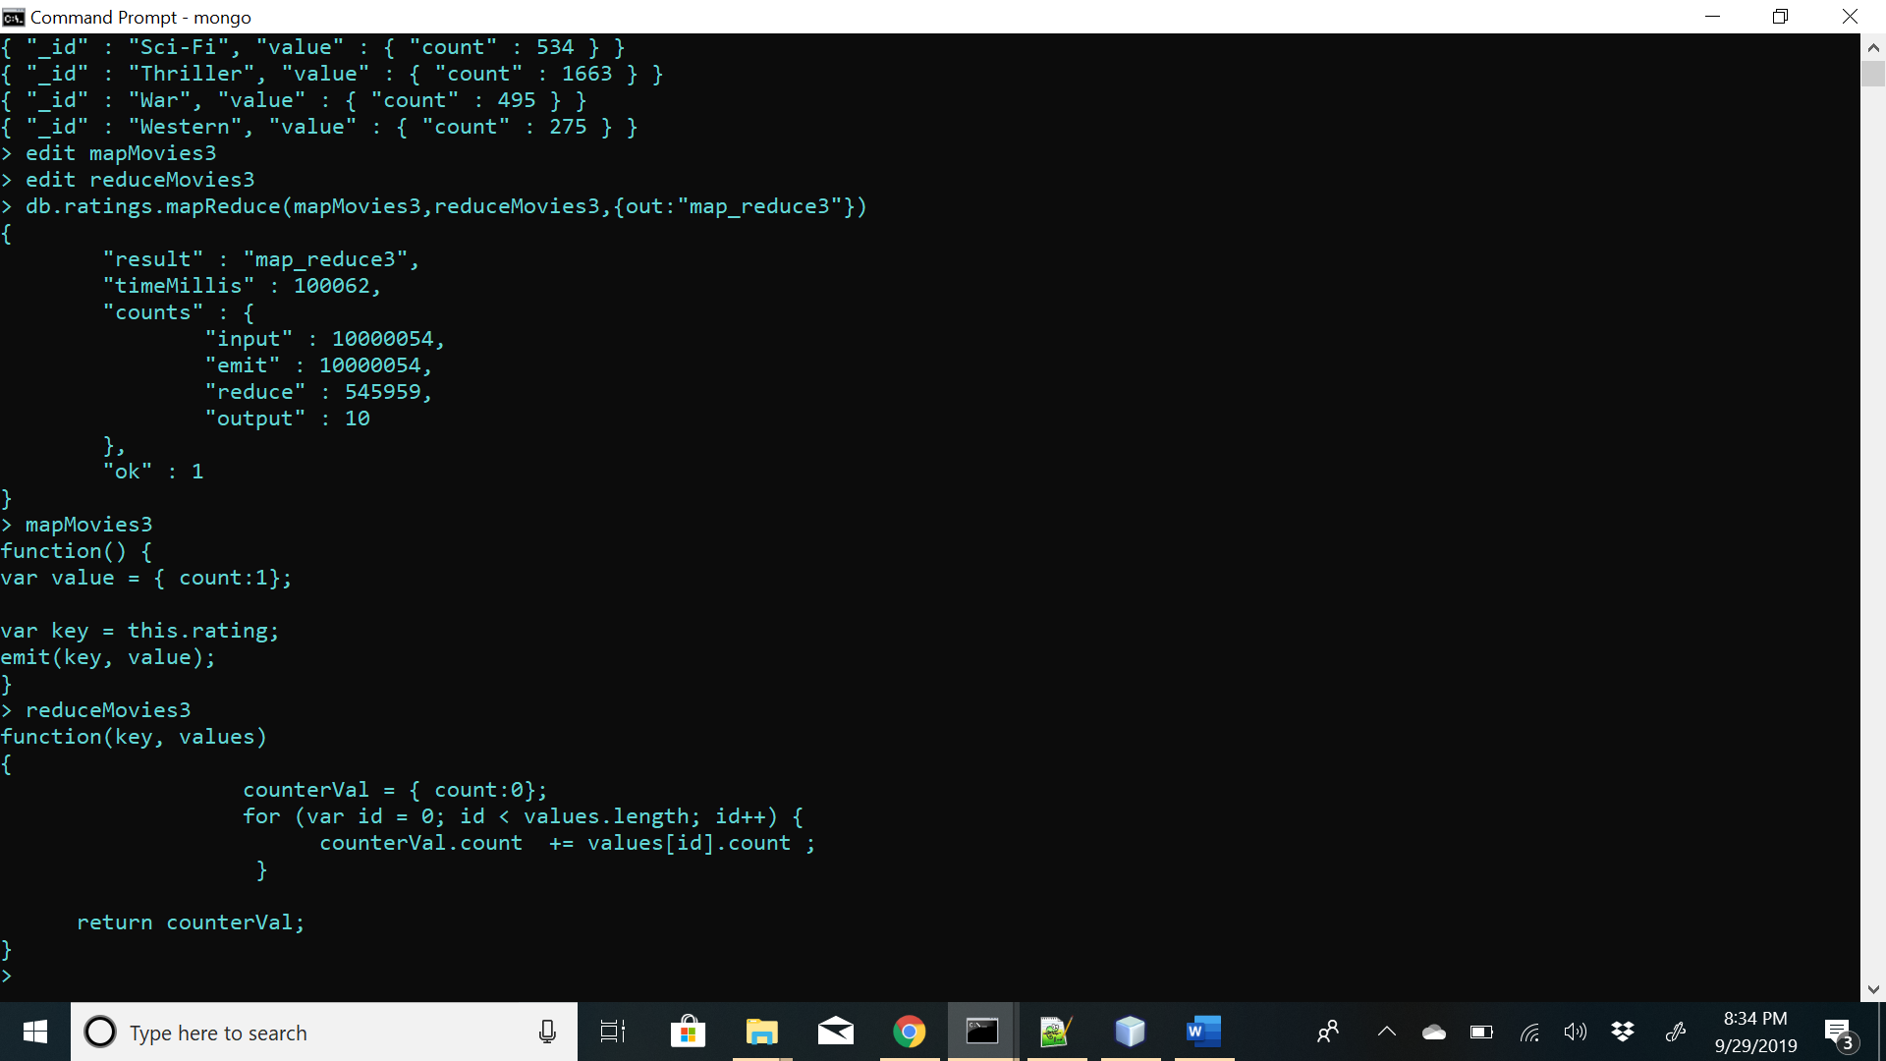

Map Function-function() { var value = { count:1}; var key = this.rating; emit(key, value); }

Reduce Function- function(key, values) { counterVal = { count:0}; for (var id = 0; id < values.length; id++) { counterVal.count += values[id].count ; return counterVal; }

**Answer-**

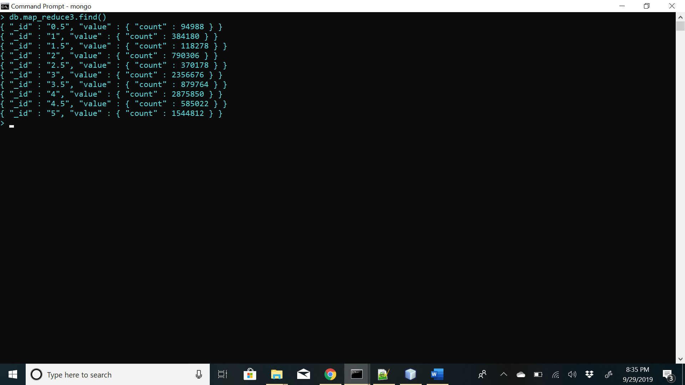

4] Number times movie tagged-

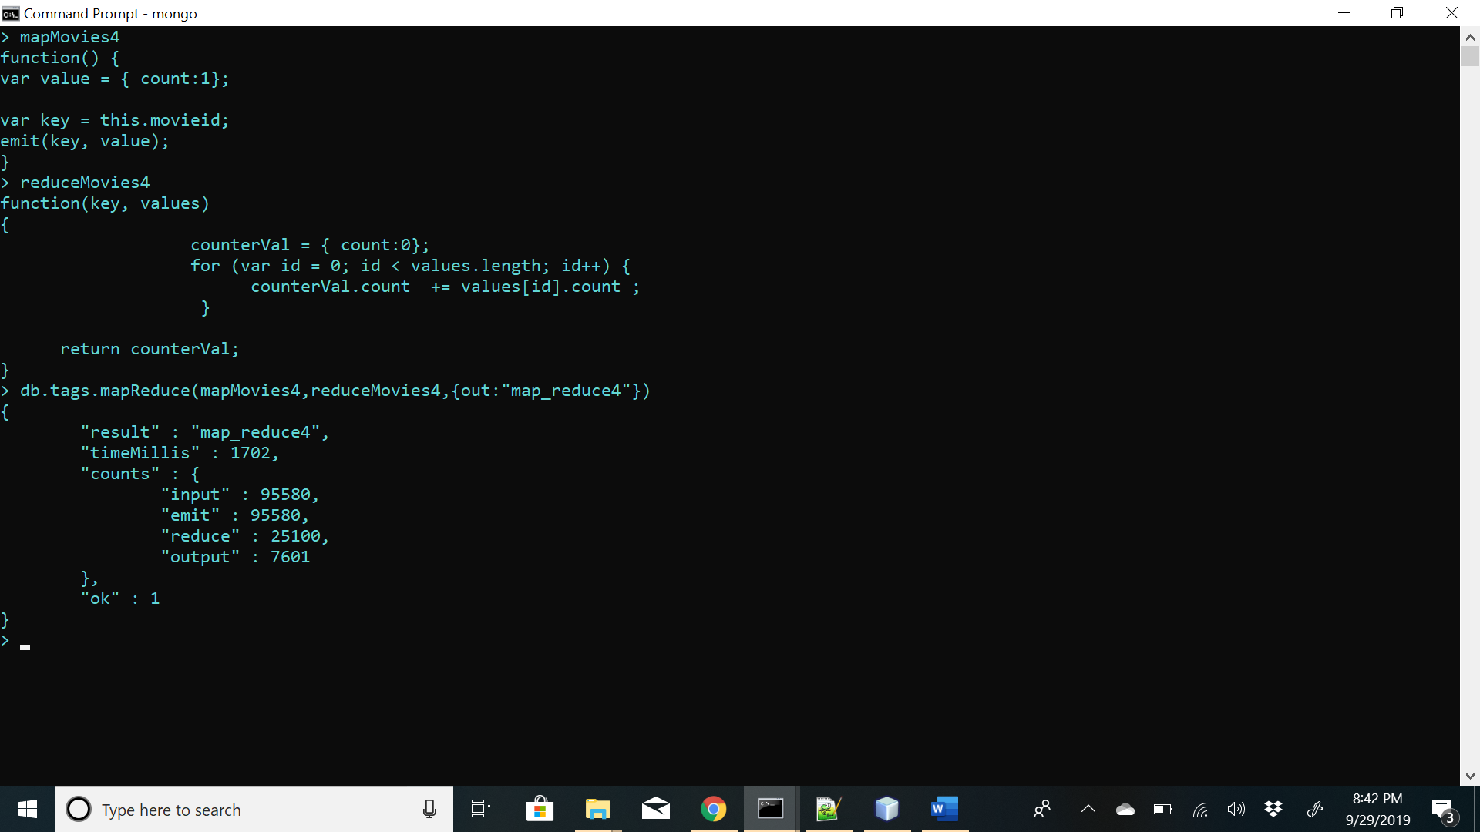

Map function – function() { var value = { count:1}; var key = this.movieid; emit(key, value);}

Reduce Function- function(key, values) { counterVal = { count:0}; for (var id = 0; id < values.length; id++) { counterVal.count += values[id].count ; } return counterVal; }

**Answer-**

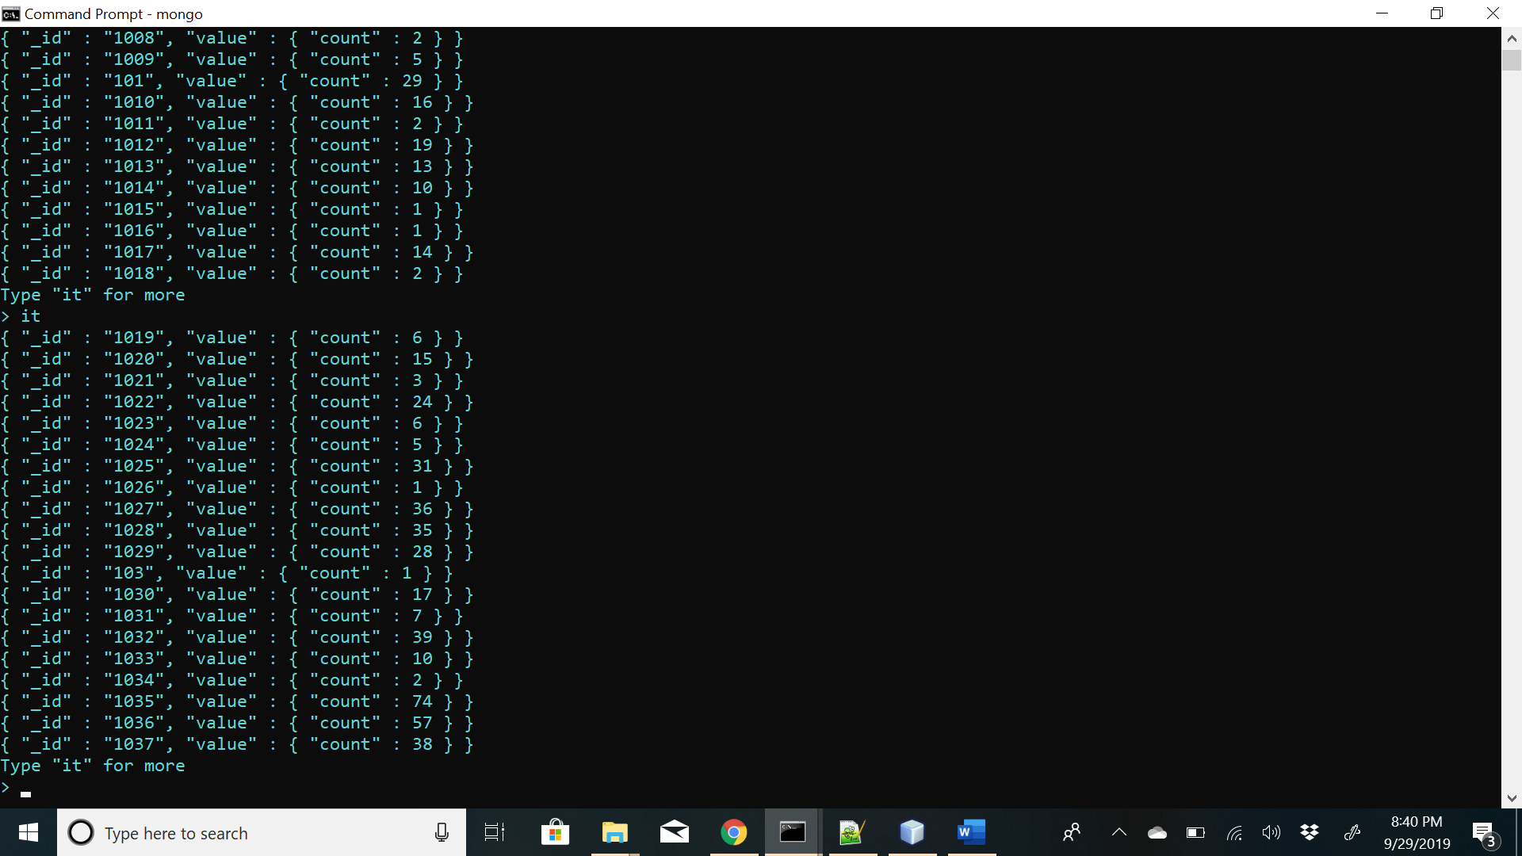

**PART 5**

**1] Number of times any webpage was visited by the same IP address.**

**Map function-**

function() {

var value = {count:1};

emit({"ip":this.IPaddress,"website":this.Website}, value);

}

**Reduce function-**

function(key, values)

{

counterVal = { count:0};

for (var id = 0; id < values.length; id++) {

counterVal.count += values[id].count ;

}

return counterVal; }

**Answer-**

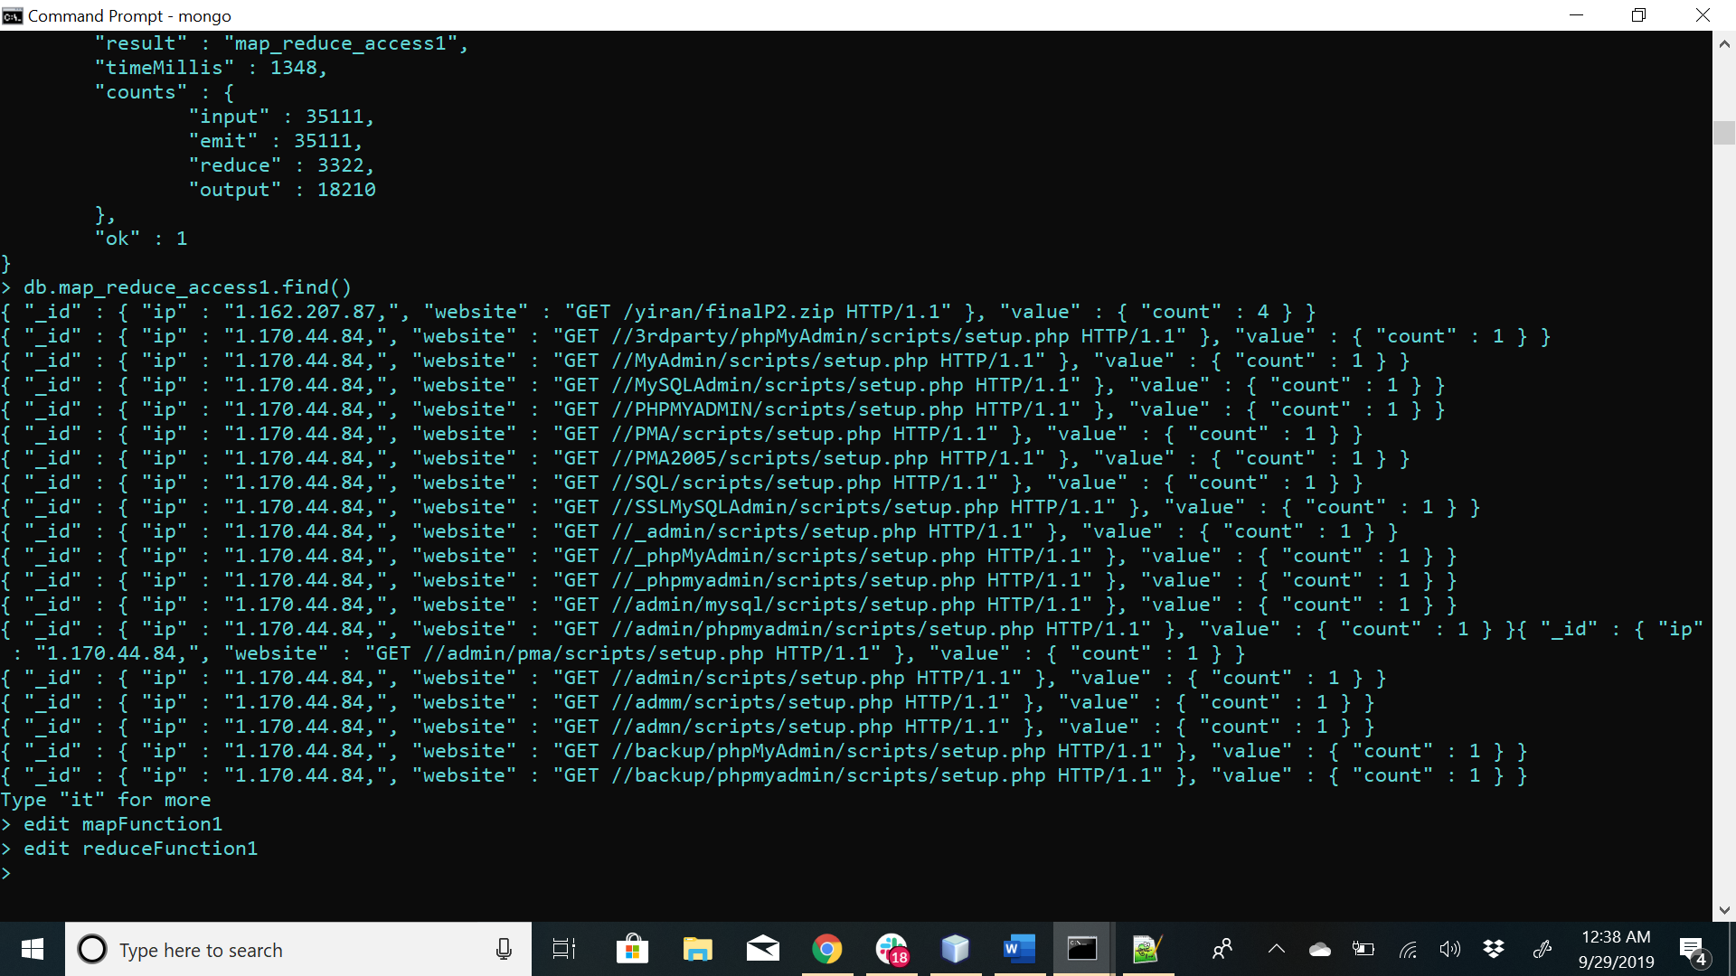

**2] Number of times any webpage was visited each month**

**Map Function-**

function() {

var value = {count:1};

var month= this.Date.split("/");

emit({"month":month[1],"website":this.Website}, value);

}

**Reduce function-**

function(key, values)

{ counterVal = { count:0};

for (var id = 0; id < values.length; id++) {

counterVal.count += values[id].count ; }

return counterVal; }

**Answer-**

