School of Computer Science and Artificial Intelligence

Lab Assignment # 4.2

Program : B. Tech (CSE)
Specialization :
Course Title : AI Assisted coding
Course Code :
Semester : II
Academic Session : 2025-2026
Name of Student : Mukkera Manikanta
Enrollment No. : 2403A51L12
Batch No. : 51
Date :20-01-2026

Submission Starts here

Task Description-1
- Zero-shot: Prompt AI with only the instruction. Write a Python function to determine
- whether a given number is prime

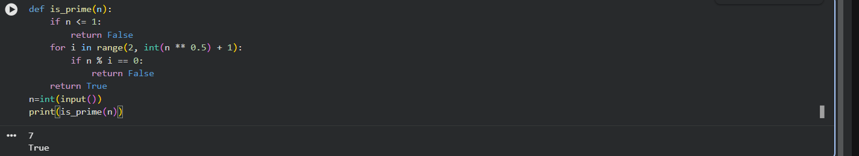

Step-by-step explanation:
- Function Definition
  - def is_prime(n):
  - This function takes an integer n as input and checks whether it is a prime number.
- Check for invalid prime numbers
  - if n <= 1:
  - Numbers less than or equal to 1 are not prime, so the function returns False.

- Optimized loop for checking factors
  - for i in range(2, int(n ** 0.5) + 1):
  - A number only needs to be checked for divisibility up to its square root.
  - If n has a factor greater than its square root, it must also have a smaller factor.
- Divisibility test
  - if n % i == 0:
  - If n is divisible by any number i in the loop, it is not prime, so return False.
- Prime confirmation
  - return True
  - If no divisors are found, the number is prime.

Example:
- is_prime(7) → True (7 has no divisors other than 1 and itself)
- is_prime(10) → False (10 is divisible by 2)

- Task2:One-shot:
- Provide one example: Input: [1, 2, 3, 4], Output: 10 to help AI generate a function that calculates the sum of elements in a list.
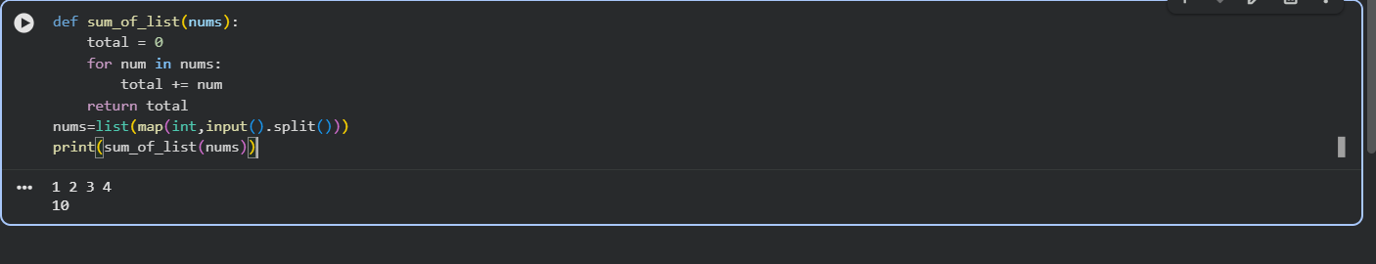

Step-by-step explanation:
- Function Definition
  - def sum_of_list(nums):
  - This function accepts a list of numbers called nums.
- Initialize the sum
  - total = 0
  - A variable total is created to store the running sum of the elements.
- Loop through the list
  - for num in nums:
  - The loop goes through each element (num) in the list.
- Add each element
  - total += num
  - Each number in the list is added to total.
- Return the result
  - return total
  - After all elements are processed, the function returns the final sum.

Example using the one-shot input:
- Input: [1, 2, 3, 4]
- Calculation: 1 + 2 + 3 + 4 = 10
- Output: 10

- Task3:Few-shot:
- Give 2–3 examples to create a function that extracts digits from a alphanumeric string.
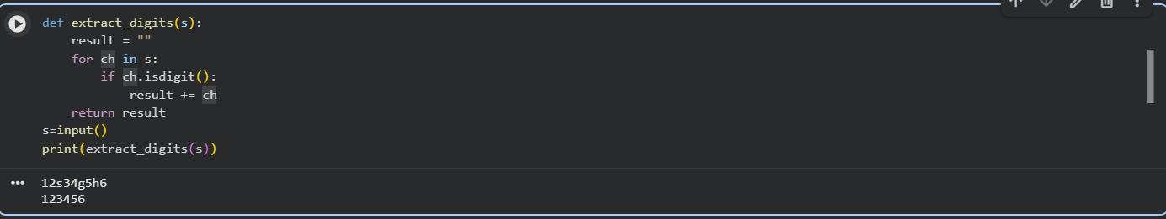

Explanation:
- The function takes a string s as input.
- An empty string result is initialized to store digits.
- The function loops through each character in the string.
- isdigit() checks whether the character is a digit (0–9).
- If it is a digit, it is added to result.
- Finally, the function returns all extracted digits as a string.
- Task4:Compare zero-shot vs few-shot prompting for generating a function that counts the number of vowels in a string.
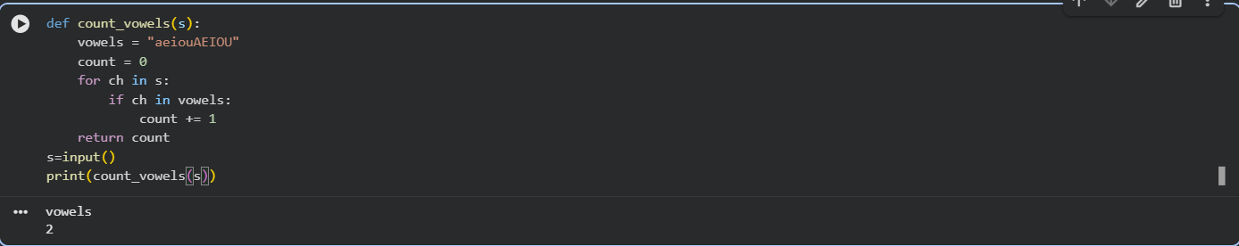

Step-by-step explanation:
- Function definition
  - def count_vowels(s):
  - Defines a function named count_vowels that takes a string s as input.

- Vowel list
  - vowels = "aeiouAEIOU"
  - Stores all lowercase and uppercase vowels.
  - This ensures the function counts vowels regardless of case.
- Initialize counter
  - count = 0
  - A variable to keep track of how many vowels are found.
- Loop through the string
  - for ch in s:
  - Iterates over each character (ch) in the input string.
- Check for vowels
  - if ch in vowels:
  - Checks whether the current character is a vowel.
- Increase count
  - count += 1
  - Increments the counter whenever a vowel is found.
- Return result
  - return count
  - Sends back the total number of vowels in the string.
- User input
  - s = input()
  - Takes a string input from the user.

- Print output
  - print(count_vowels(s))
  - Calls the function and prints the number of vowels

- Task5:Use few-shot prompting with 3 sample inputs to generate a function that determines the minimum of three numbers without using the built-in min() function.
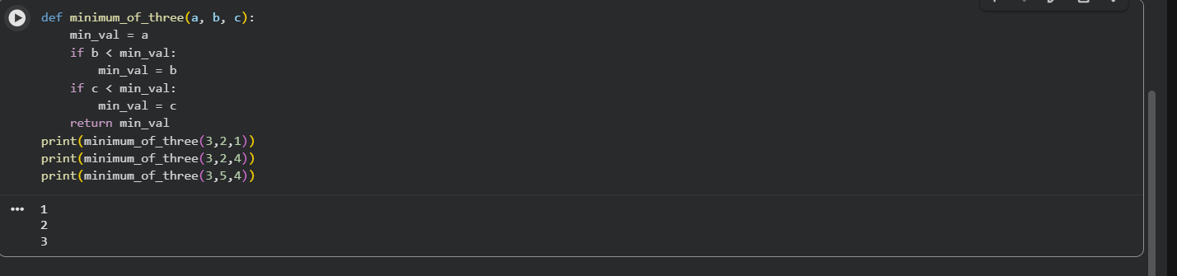

Explanation:
- The function starts by assuming a is the smallest.
- It compares b with the current minimum and updates if needed.
- It then compares c with the updated minimum.
- Finally, it returns the smallest of the three numbers.

