School of Computer Science and Artificial Intelligence

Lab Assignment # 2

Program : B. Tech (CSE)
Specialization :
Course Title : AI Assisted coding
Course Code : 23CS201PC302
Semester : II
Academic Session : 2025-2026
Name of Student : Mohammed Hashir Sayam Hussain
Enrollment No. : 2403A51L27
Batch No. : 51
Date :09-01-2026

Submission Starts here

OUTPUT :
SCREENSHOTS:

Task1:without using functions

Prompt:# Fibonacci number series without using functions

Code Screenshot:
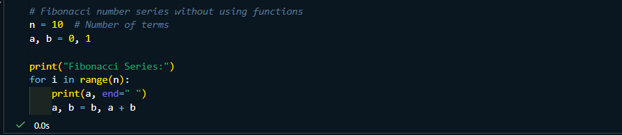

Output Screenshot:
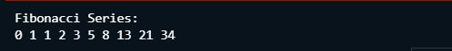

Explanation of code:
- The program prints the Fibonacci series up to 10 numbers.
- It starts with 0 and 1, which are the first two Fibonacci values.
- In each loop, the current number is printed.
- Then the next number is created by adding the previous two numbers.
- This repeats until all 10 numbers are printed.

Task 2:Optimised Code
Prompt:# Optimised Fibonacci number series without using functions
Code Screenshot:
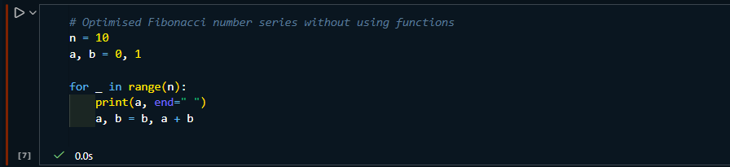
Output Screenshot:
Explanation of code:
- It uses constant memory (O(1)) — only two variables are used.
- No extra lists or arrays are created.
- Python’s tuple assignment updates values in a single step, making it fast and clean.

Task 3:with using functions
Prompt:# Fibonacci number series with using functions
Code Screenshot:
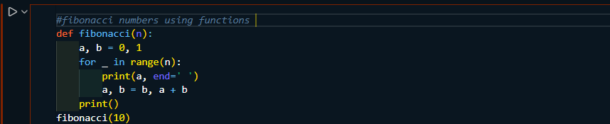
Output Screenshot:
Explanation of code:
- The function fibonacci(n) prints the first n Fibonacci numbers.
- a and b store the last two numbers of the series.
- The loop runs n times to generate n values.
- Each iteration prints a.
- Then the next Fibonacci number is calculated by a + b.
- Tuple assignment updates both values efficiently in one step

Task4:with and without using functions

Prompt:# Fibonacci number series with vs without using functions

Code Screenshot:
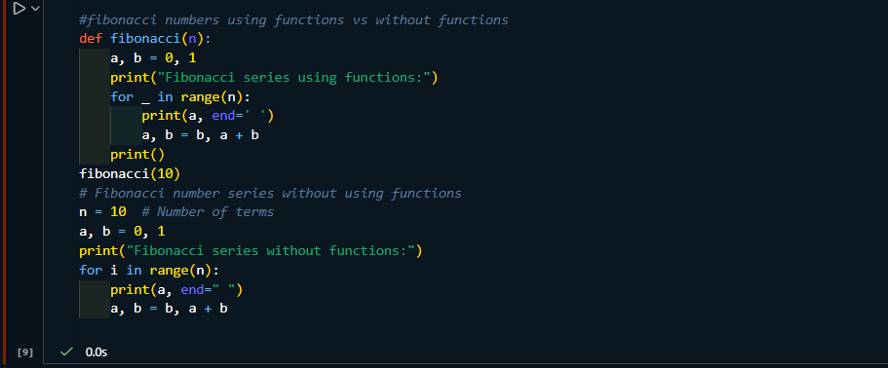

Output Screenshot:
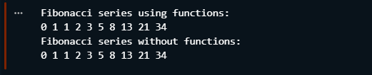

Explanation of code:

Using functions
- The Fibonacci logic is wrapped inside a function.
- n is passed as a parameter, so the function can be reused for any value.
- Code is organized, modular, and reusable.
- Best for large programs and real projects.

Without using functions
- The logic is written directly in the program.
- Simple and easy to understand for beginners.
- Not reusable; code must be rewritten if needed again.
- Suitable for small programs or learning basics.

Task5:Using recursion

Prompt:# #fibonacci numbers using recursion

Code Screenshot:
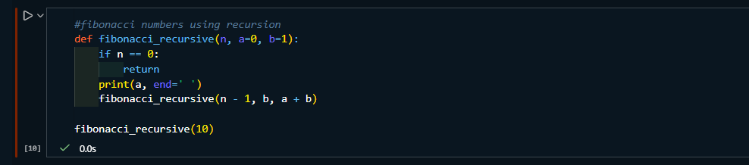

Output Screenshot:

Explanation of code:
- The function prints the current Fibonacci number.
- It calls itself with updated values.
- Stops when n becomes 0.
- No loops are used → pure recursion.

