School of Computer Science and Artificial Intelligence
Lab Assignment # 3.2

Program | : B. Tech (CSE)
Specialization | :
Course Title | : AI Assisted coding
Course Code | :
Semester | : II
Academic Session | : 2025-2026
Name of Student | : M . Manikanta
Enrollment No. | : 2403A51L12
Batch No. | : 51
Date | :13-01-2026

Task – 1

Prompt : Create a calculator function that performs addition, subtraction, multiplication, and division.
Include error handling for division by zero.

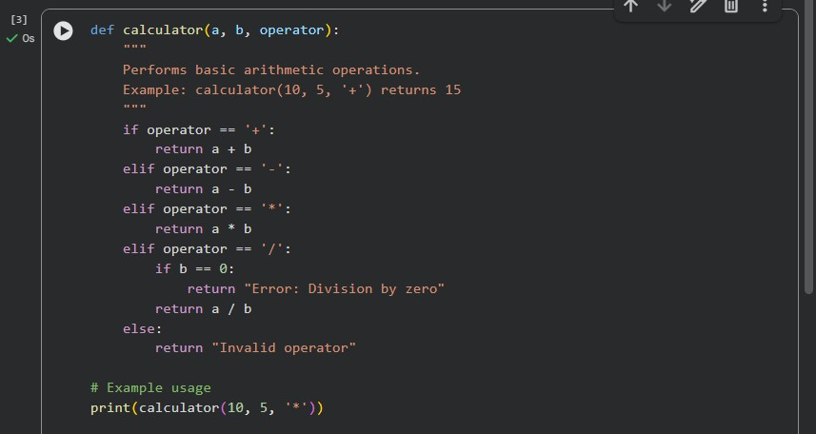

In this task, the goal was to understand how progressively improving a prompt affects the quality of AI-generated code.
- When a minimal prompt was used, the AI generated a very basic calculator function with limited operations and no error handling.

- Adding comments and context helped the AI understand the expected functionality, resulting in support for more arithmetic operations.

- Including constraints and usage examples further improved the code by adding proper error handling, documentation, and clearer structure.

Output:

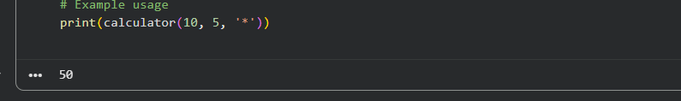

Task – 2

Prompt: Write a Python function to sort student marks in descending order. Marks should be integers between 0 and 100.

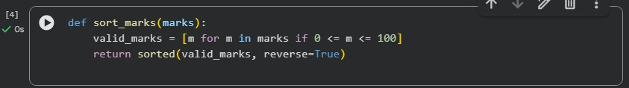

This task focused on improving AI output by refining vague prompts into specific ones.
- A vague prompt resulted in a basic sorting function without a defined order or validation.
- When sorting order and constraints (valid mark range) were explicitly mentioned, the AI produced a more accurate and meaningful solution.
- The refined prompt led to better logic, including filtering invalid values and sorting in the correct order.

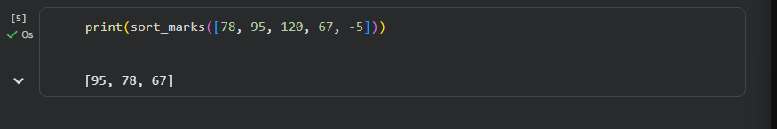
Output:

Task– 3 Prompt:
Create a Python function is_prime(n) that checks whether a given number is prime.
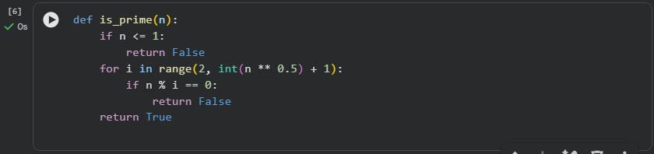
Examples: is_prime(2) → True is_prime(3) → True is_prime(4) → False is_prime(17) → True is_prime(1) → False is_prime(0) → False

Few-shot prompting involves providing example inputs and expected outputs
along with the prompt.
- By including multiple examples, the AI clearly understood how to handle edge cases such as 0 and 1.
- The generated code correctly implemented an optimized prime-checking algorithm.
- Compared to zero-shot prompting, few-shot prompting significantly improved correctness and efficiency

Output:
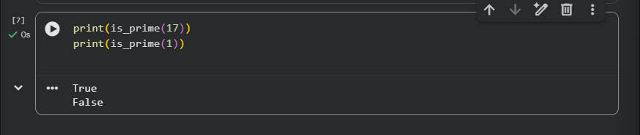

Task-4 Prompt:
Create a simple Python-based user interface for a student grading system. The program should:
- Ask the user to enter marks for 5 subjects
- Calculate total marks
- Calculate percentage
- Display grade based on percentage

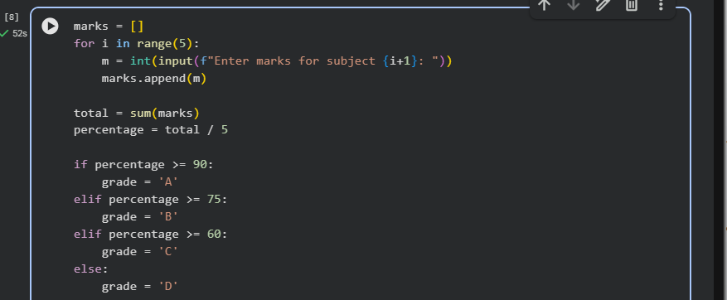

Explanation
This task demonstrated how a structured and detailed prompt can guide AI to create a complete user-interface-based program.

The prompt clearly specified user input, calculations, and output requirements.

As a result, the AI generated a well-structured program that calculates total marks, percentage, and grade.

The code followed a logical flow, making it easy to understand and user-friendly.

Output:

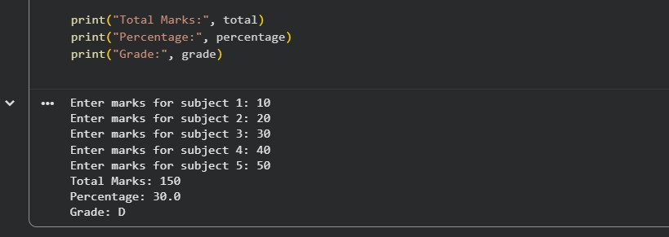

Task – 5:

Prompt:

Create two Python functions:
- Convert kilometers to miles
- Convert miles to kilometers
Use accurate conversion formulas and return the result.
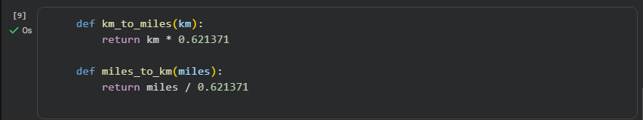

Explanation
This task analyzed how prompt specificity affects accuracy and code quality.
A vague prompt produced an unclear and inaccurate conversion function.
A more specific prompt resulted in correct and separate functions for each unit conversion.
Explicit instructions ensured the use of correct formulas and meaningful function names.

Output:

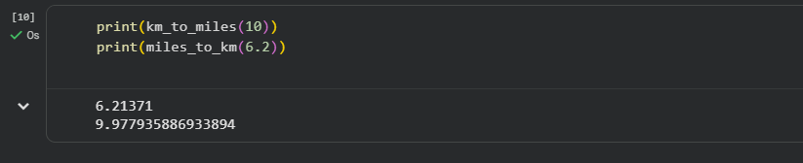

Conclusion
Across all tasks, it was observed that:
- AI performance improves with clear, structured, and specific prompts.

- Adding comments, constraints, and examples significantly enhances output quality.

- Prompt engineering is a critical skill for effective AI-assisted programming.

