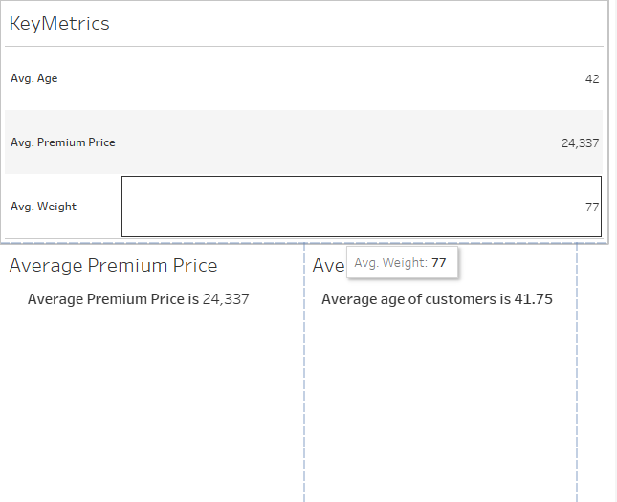

* Average Age across all the customers in the give data is 42 years
* Average Premium Price is 24,337 Rs.

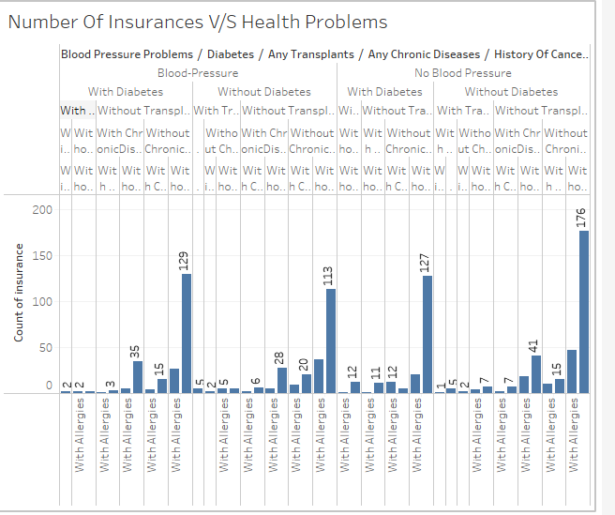

* Number of Insurances across different Health problems can be seen .
* People who only have Allergies make the major portion people of people who hold Policy.
* People with only Diabetes and Blood Pressure form second major group.

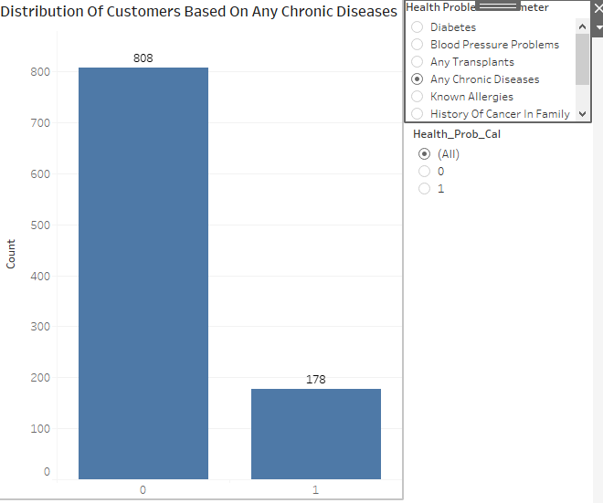

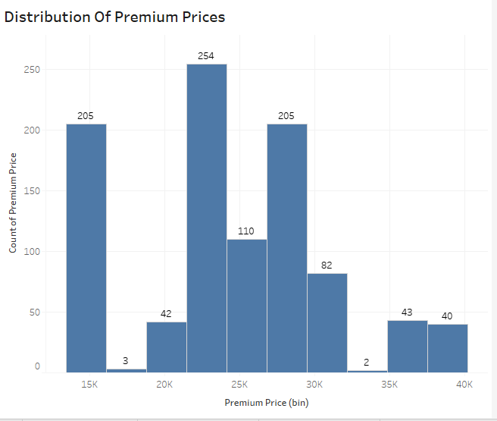

* Most people have premium either around 15k or between the range of 21k to 33k.

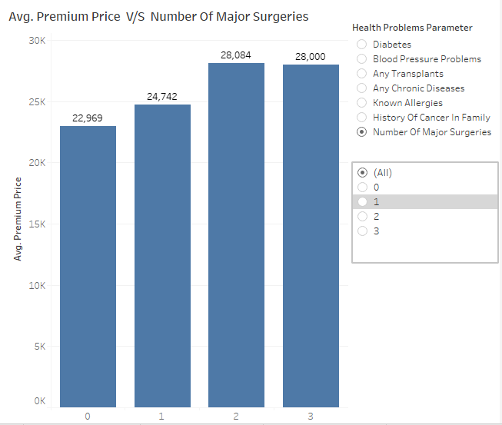

* Average Premium Price across different number of Major Surgeries can be seen with 2 number of surgeries having the highest value .

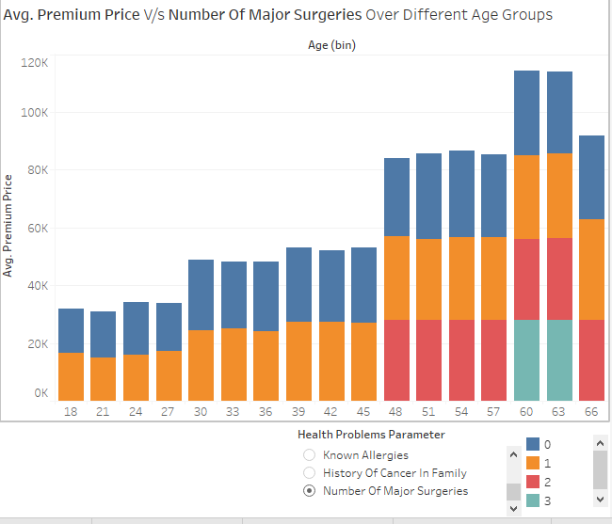

* Avg. Premium Price with respect to different health issues across different age groups can be seen .

Links of Different Charts :

* <https://public.tableau.com/views/Book2_17230659299220/KeyMetricDashboard?:language=en-US&publish=yes&:sid=&:redirect=auth&:display_count=n&:origin=viz_share_link>
* <https://public.tableau.com/views/Book2_17230659299220/KeyMetricDashboard2?:language=en-US&publish=yes&:sid=&:redirect=auth&:display_count=n&:origin=viz_share_link>
* <https://public.tableau.com/views/Book2_17230659299220/KeyMetricDashboard3?:language=en-US&publish=yes&:sid=&:redirect=auth&:display_count=n&:origin=viz_share_link>
* <https://public.tableau.com/views/Book2_17230659299220/DistributionsDashboard?:language=en-US&publish=yes&:sid=&:redirect=auth&:display_count=n&:origin=viz_share_link>
* <https://public.tableau.com/views/Book2_17230659299220/DistributionsDashboard2?:language=en-US&publish=yes&:sid=&:redirect=auth&:display_count=n&:origin=viz_share_link>
* <https://public.tableau.com/views/Book2_17230659299220/Avg_PremiumvsProblemsDashboard?:language=en-US&publish=yes&:sid=&:redirect=auth&:display_count=n&:origin=viz_share_link>
* <https://public.tableau.com/views/Book2_17230659299220/Dashboard7?:language=en-US&publish=yes&:sid=&:redirect=auth&:display_count=n&:origin=viz_share_link>