Step-by-Step Guide: Create an User in Linux Server (Redhat,Ubuntu,Centos)

Access the terminal:
Access the terminal on your Linux system through putty with server IP address and user ID and password.
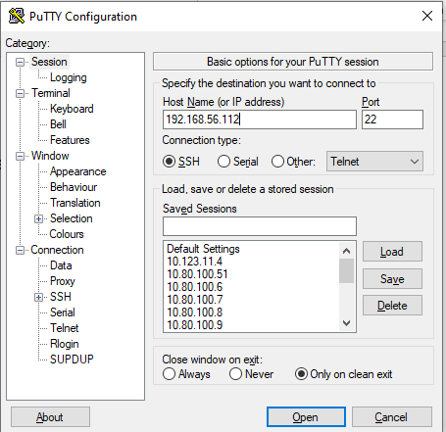
Put user id and password:
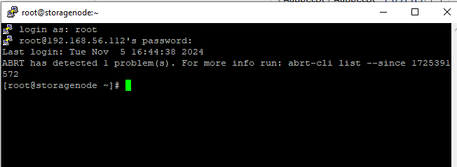

Create a new user on Linux server:
The useradd command can be used to create a user without invoking any command-line options. For example, to create a user called subha, run the command:
sudo useradd subha
The command appends an entry to the /etc/passwd, /etc/shadow, /etc/gshadow and /etc/group files.
Next, set the password using the passwd command to enable the user to login to the system. So, invoke the passwd command followed by the username.
passwd subha
Be sure to provide a strong password and confirm it.
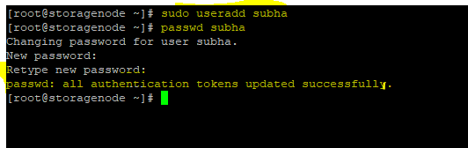
Once done, confirm that the user has been created by running the id command
id subha
Additionally, you can search for the user’s entry in the /etc/passwd file as shown.
cat /etc/passwd | grep -i subha
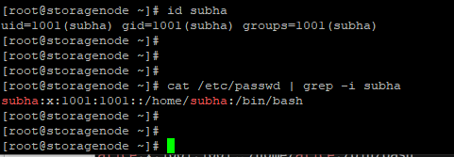

Newly create user details verify:
Invoke the chage command to confirm the user account details.
sudo chage -l subha
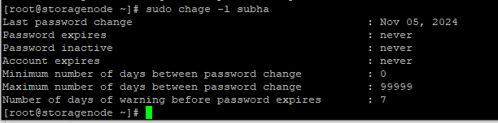

Conclusion

