Data Analytics And Optimization Project Report

Topic: Spatio-Temporal Load Estimation and Short-Term Forecasting using AI Models for Smart Grids
Project Team
Name | Registration Number
Avighyan Chakraborty | 882
Rihan Ghosh | 927
Shubhankar Kumar | 947
Sayan Mandal | 1004



Institution: Indian Institute of Information Technology Kalyani (IIIT Kalyani)
Supervisor: Dr. Debashish Bera
Academic Context: Final Year Computer Science Students Project

1.Executive Summary
This project successfully developed and evaluated an advanced estimation and forecasting system tailored for smart grid operations, focusing on environments characterized by high renewable energy integration and seasonal load variability. Multiple Artificial Intelligence (AI) models—ARIMA, Prophet, and Long Short-Term Memory (LSTM)—were implemented, benchmarked, and compared for their ability to deliver accurate 1-day and 7-day ahead load predictions.
The LSTM model demonstrated superior performance across all standard error metrics (MAE, MAPE, RMSE), confirming its effectiveness in capturing the complex, non-linear, and long-term dependencies present in real-world power consumption data. The results provide a reliable daily load forecasting capability with dynamic estimation of missing data.

2.Project Objectives and Scope
The core objectives of this project were achieved through the development of a Spatio-Temporal AI framework:
Key Objectives Achieved:
- Estimate Missing Data: Designed models to estimate missing or delayed load data from distributed meters, thereby ensuring data completeness for reliable forecasting inputs.
- Short-Term Forecasting: Built and validated models for robust 1-day and 7-day ahead load predictions, crucial for short-term operational planning.
- AI Technique Comparison: Successfully compared the forecasting performance of diverse AI techniques: ARIMA, Prophet, and LSTM.
Scope Expansion: Data Integration and Benchmarking
The project extended current modeling approaches by integrating real-time weather, socioeconomic, and high-frequency demand data. This enhanced feature set was vital for improving prediction accuracy, particularly under demanding grid scenarios:
- Seasonal Variation: Assessing model performance during summer peaks and winter troughs.
- Renewable Fluctuation: Integrating simulated solar/wind generation data to test robustness under variable renewable energy conditions.

3.Description of Data

Context of data:

Tetouan, a rapidly growing city in northern Morocco, has a population of over 550,000 and a Mediterranean climate that strongly influences electricity demand. Morocco’s overall energy consumption is relatively low compared to the North African region, with limited domestic hydrocarbon production and a heavy reliance on imported oil products, especially after the closure of the country’s only refinery in 2015.
The electricity load data used in this project comes from the SCADA system of Amendis, the operator responsible for distributing electricity in Tetouan through three main zone stations: Quads, Smir, and Boussafou.
The dataset contains time-series measurements of electrical load along with weather and environmental variables, making it suitable for analyzing and forecasting energy consumption patterns in the region.

Key Variables in the Dataset
Feature | Description
Date / Timestamp | Indicates the exact time of measurement. Used for time-series indexing.
Load (kW / MW) | The actual electrical load (target variable).
Temperature (°C) | Ambient temperature recorded at the same timestamp. Influences cooling/heating demand.
Solar Radiation (W/m²) | Amount of incoming solar energy, affects solar power generation and load.
Wind Speed (m/s) | Impacts renewable power output and cooling requirements.
Missing Values | Present in load; filled using ARIMA-based time-series imputation.

4.Data Preprocessing
Methodology and Tools
ARIMA Learns Path:
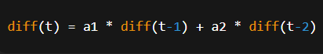
Predicting the Missing Point and converting back to original Scale:
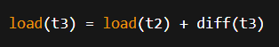
5.Forecasting Models Implemented
The following time series models were deployed and trained on the pre-processed power system dataset:
Model | Description | Advantages for Smart Grid
ARIMA | A statistical model combining AutoRegressive (AR), Integrated (I), and Moving Average (MA) components. | Effectively handles trends and standard seasonal patterns; provides robust forecasts for stationary data.
Prophet | An open-source model designed for business time series with strong seasonal effects, holiday impacts, and missing data. | Robust to missing data and outliers; easily models multiple seasonalities (daily/weekly); facilitates incorporation of external regressors (weather).
LSTM | A specialized Recurrent Neural Network (RNN) designed for sequential data and overcoming the vanishing gradient problem. | Highly effective for non-linear patterns; seamlessly integrates multiple complex features; captures subtle, long-term, multi-scale seasonal patterns crucial for high-frequency smart grid data.
6. Implementation Tools
The project was implemented entirely within the Python ecosystem, utilizing industry-standard libraries:
- Core Languages & Frameworks: Python, TensorFlow/PyTorch
- Data Manipulation: Pandas, Scikit-learn
- Time Series Libraries: Prophet
- Visualization: Matplotlib
7. Results and Analysis
Performance Metrics
Model accuracy was rigorously benchmarked using three key error metrics. The results below summarize the performance across the test set (initial run):
Model | MAE (Mean Absolute Error) | MAPE (Mean Absolute Percentage Error) | RMSE (Root Mean Squared Error)
Naive (Prev-day) | 4.435 | 7.473 | 15.417
ARIMA | 4.088 | 6.388 | 13.472
Prophet | 2.756 | 4.986 | 9.285
LSTM | 2.063 | 3.025 | 7.648
Hybrid | 12.188 | 13.928 | 46.907

8. Model Performance Summary
- LSTM Superiority: The LSTM model achieved the lowest values for all three metrics (MAE: 2.063, MAPE: 3.025, RMSE: 7.648), confirming its strong ability to handle the non-linearity and complex relationships inherent in smart grid load data, especially over short-term horizons.

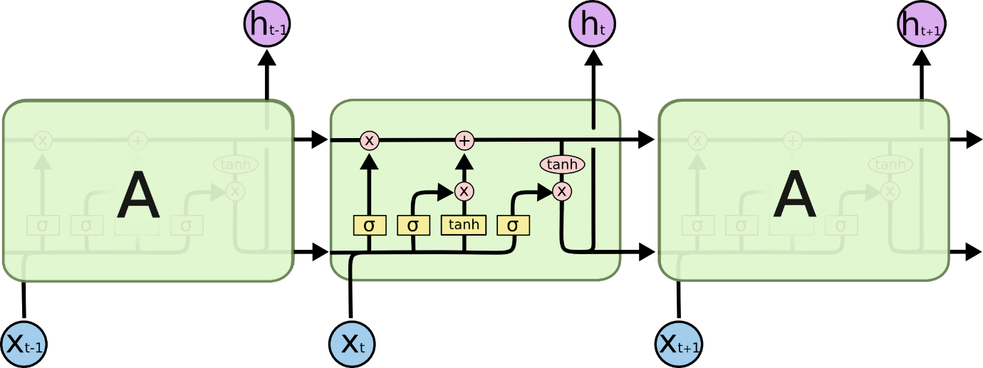

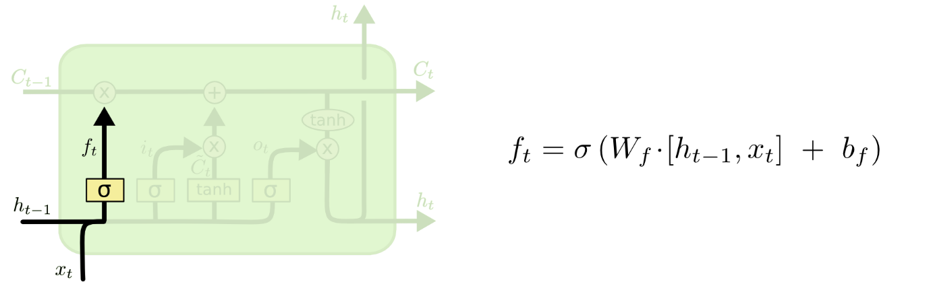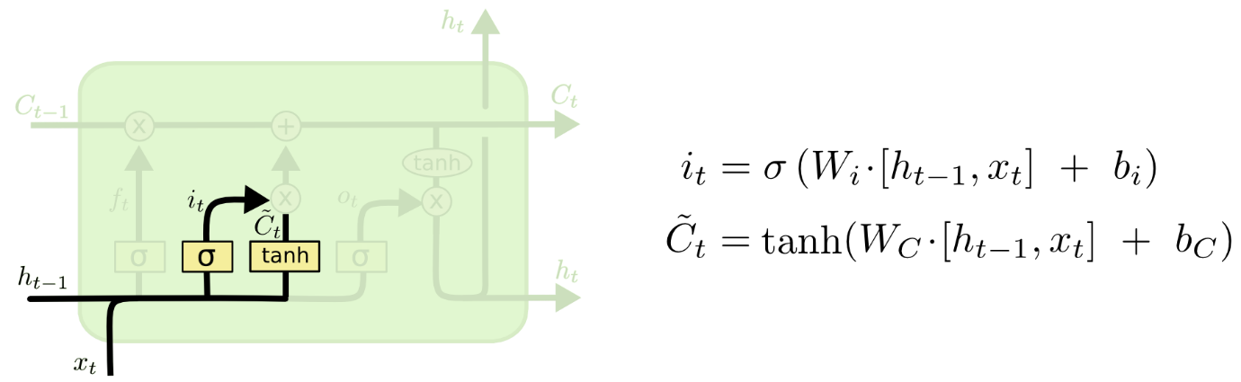

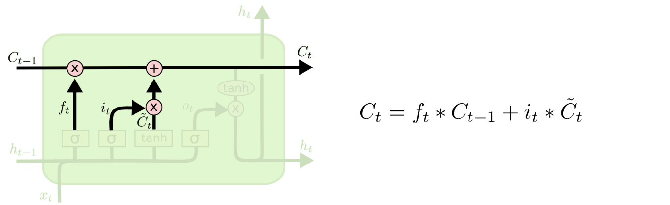
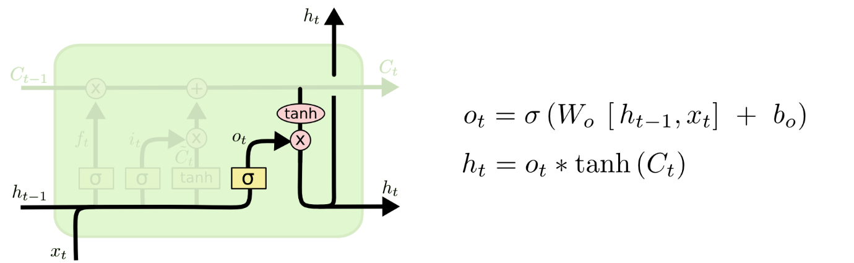
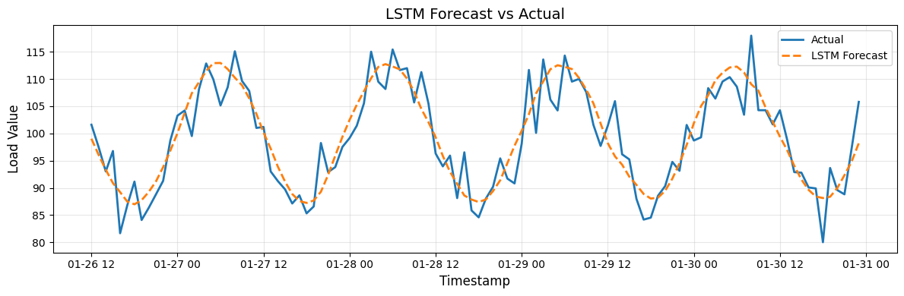

- Prophet's Strength: Prophet showed robust performance, significantly outperforming traditional models like ARIMA and the Naive benchmark. Its score (MAE: 2.756) validates its utility for time series with strong, recurring seasonal components.

Time Series = Signal + Noise
Signal consists of Growth/ Trend, Season and Holiday as parameters

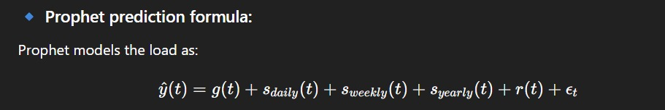

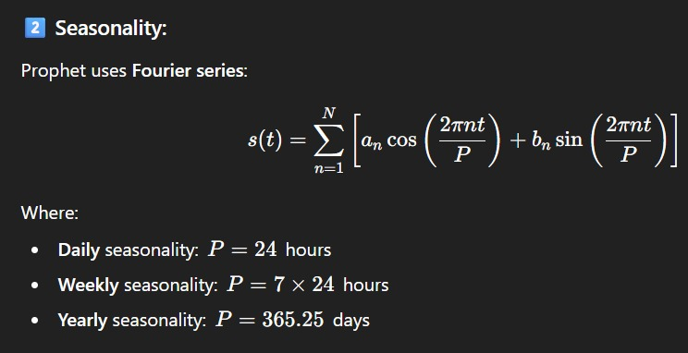

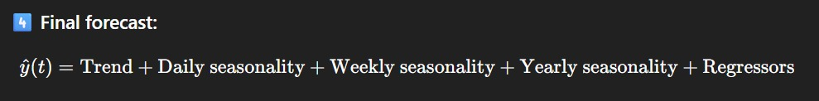

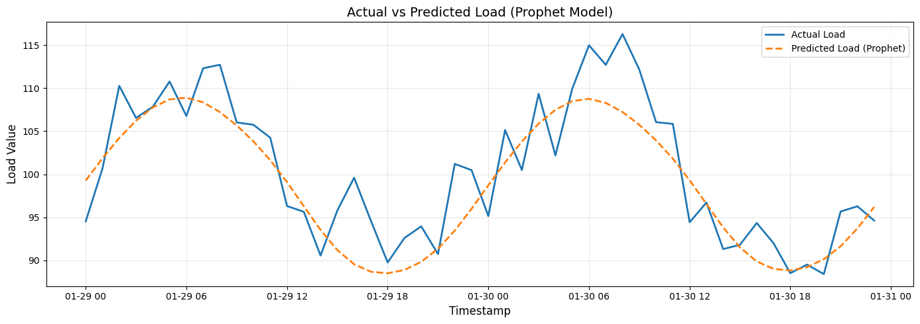

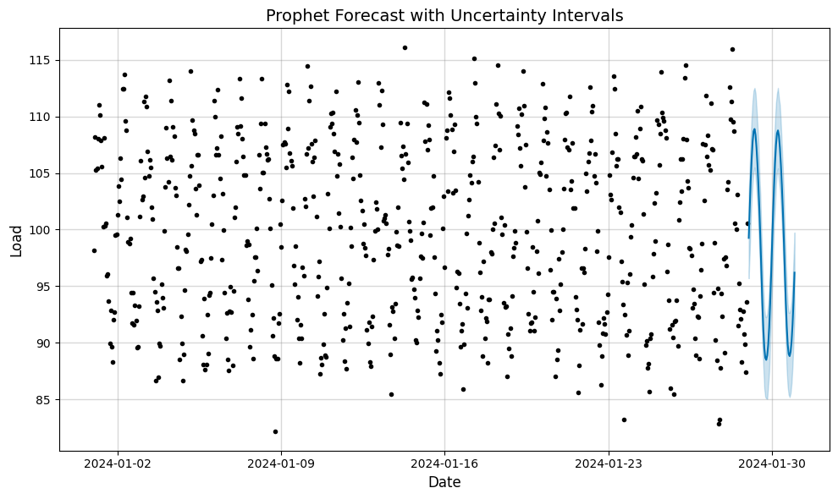
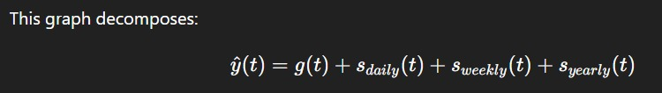
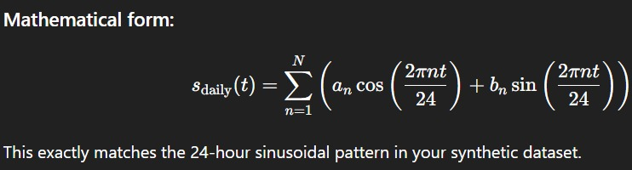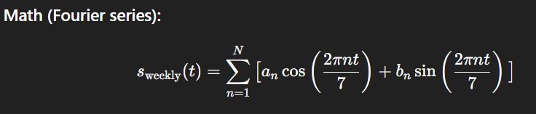
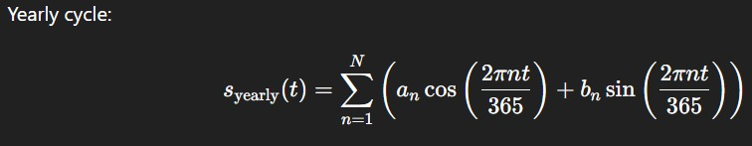

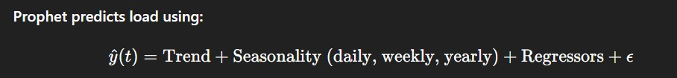

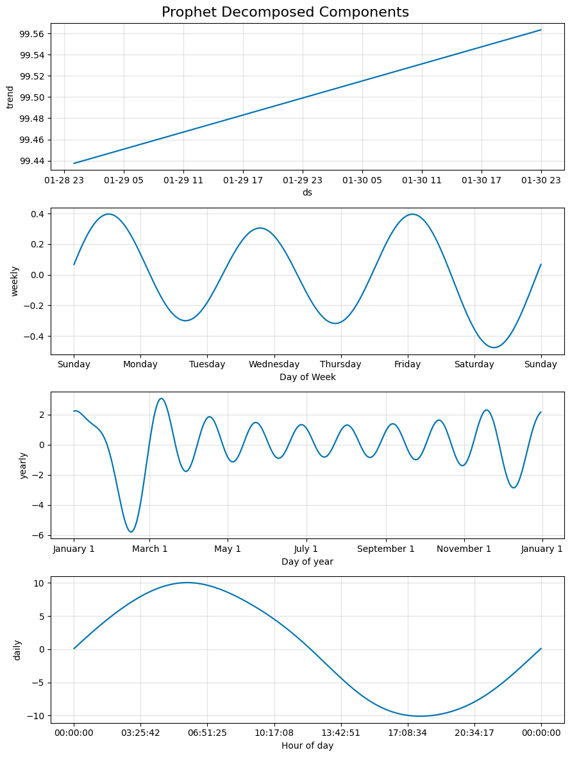

- ARIMA and Naive: While ARIMA provided an improvement over the Naive benchmark, both were surpassed by the sophisticated AI techniques, highlighting the value of non-linear modeling for this complex prediction task.


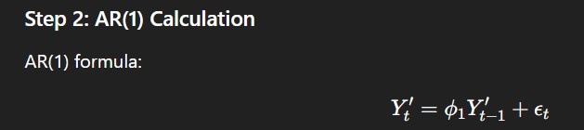
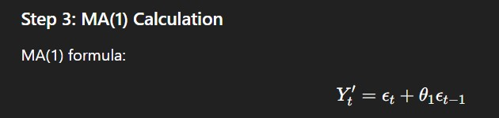


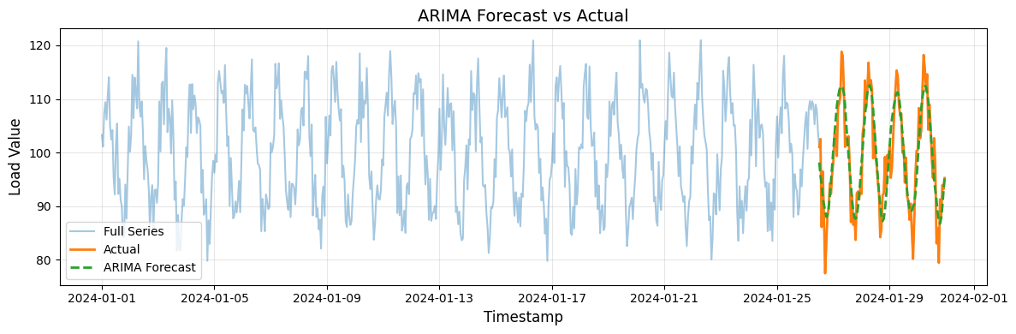

- Hybrid Model Anomaly: The Hybrid model's initial performance was poor. This is attributed to an issue encountered during the integration and debugging phase of the Prophet-LSTM pipeline, indicating an area for future work and refinement.

9. Visualization of Forecast vs. Actual Load
Visual analysis, particularly over a 7-day test period, confirmed the numerical findings.
- The LSTM and Prophet forecasts closely tracked the Actual load curve, demonstrating high fidelity to the daily and intra-day patterns.
- The LSTM model, specifically, showed the least divergence from the actual load during peak and trough periods, suggesting better handling of demand volatility.

Load
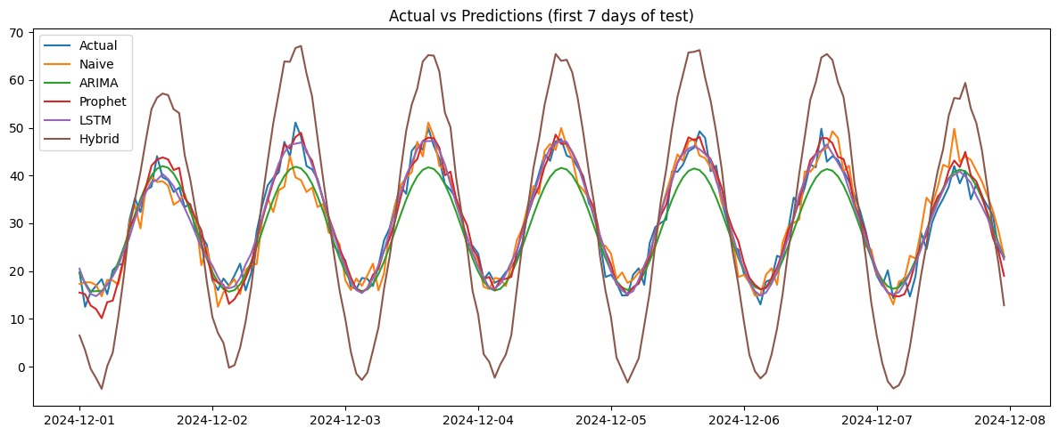

Day

10. Conclusion and Expected Outcome
The "Spatio-Temporal Load Estimation and Short-Term Forecasting using AI Models for Smart Grids" project successfully delivered a robust forecasting solution.
The implementation of advanced AI models, particularly the LSTM network, provides a reliable system for daily load forecasting, with dynamic estimation capabilities to handle missing data. This outcome directly feeds the predictive module of the ALDC, enabling more informed scheduling, resource allocation, and overall grid management.
Key Deliverables:
- Validated and benchmarked AI models for load forecasting.
- Established LSTM as the top-performing model for this specific smart grid application.
- A fully implemented Python-based forecasting pipeline ready for real-time visualization integration.
- A framework that successfully integrates external data (weather/renewables) to enhance predictive accuracy.
This advanced framework is positioned to significantly enhance operational efficiency, reduce forecasting errors, and contribute to the stability of smart grids, especially those challenged by high levels of renewable energy integration.

11. Deployed Link

https://daaproject-xmmyc8dwniphygwwdwtp88.streamlit.app/

11. References
https://www.kaggle.com/datasets/fedesoriano/electric-power-consumption
https://colah.github.io/posts/2015-08-Understanding-LSTMs/
https://www.sciencedirect.com/science/article/pii/S2352484724004566
https://www.sciencedirect.com/science/article/abs/pii/S095965262301288X

