Java

1. JDK(Java development Kit) JRE JVM
2. Compile java cod to bytecode
   1. Java platform independence (JDK platform dependent, but Java is not)
3. 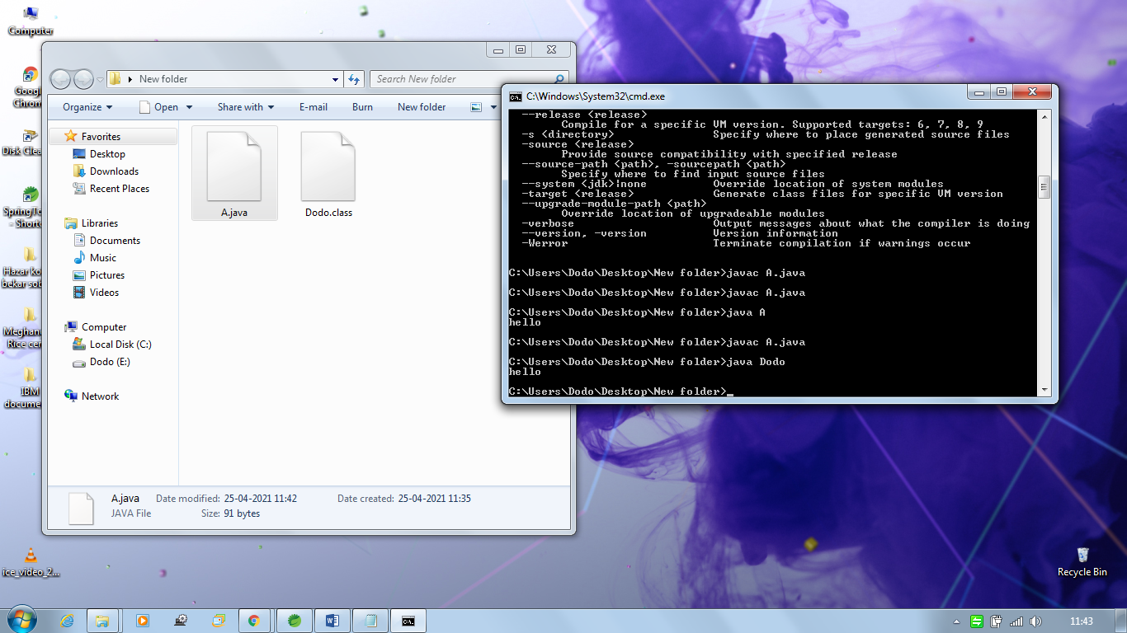
4. Project and package structure
5. Naming convention
6. Scope
7. Custom method signature
8. Key words
9. Primitive data types
10. Operators (+, -,&& ……)
11. Access modifiers
12. Method signature return types