**Mini Project Screenshots**

**Database Code Screenshot**

This is the sql code written on the mysql workbench.

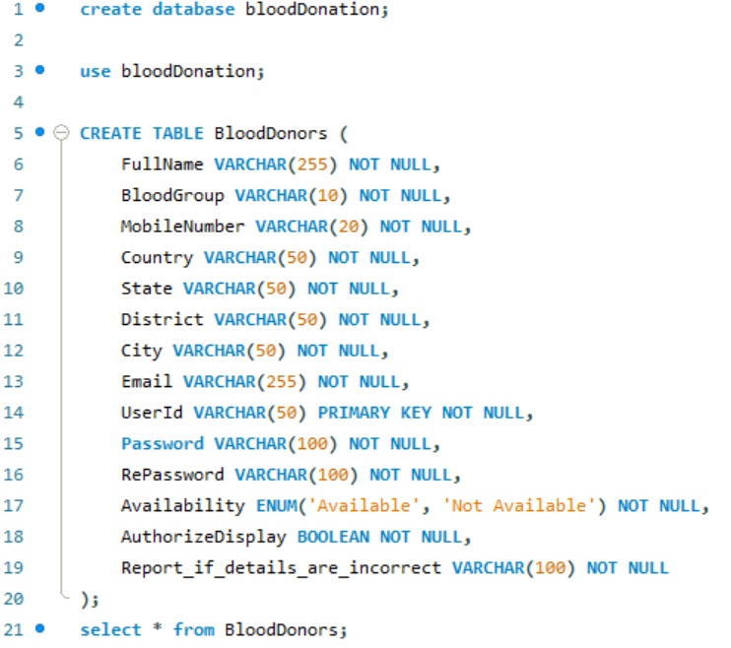

**Default Page(Search.aspx)**

Run the search.aspx file.Then the default page appears.It contains everything like search blood donor button,login button and registration button.

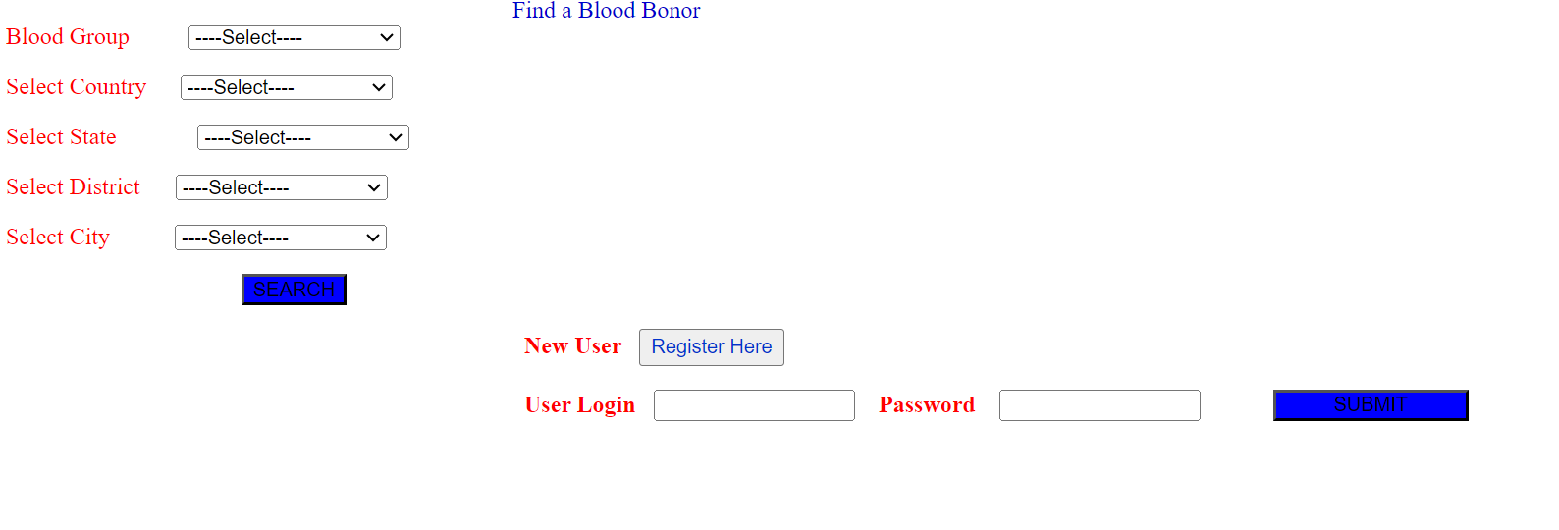

To go to registration page for new user,just click on Register Here button of the default page.Then it will redirect to registration page(whose code is on Registration.aspx file).

**Registration Page(Registration.aspx)**

Just fill the details in the registration page and click on submit button.

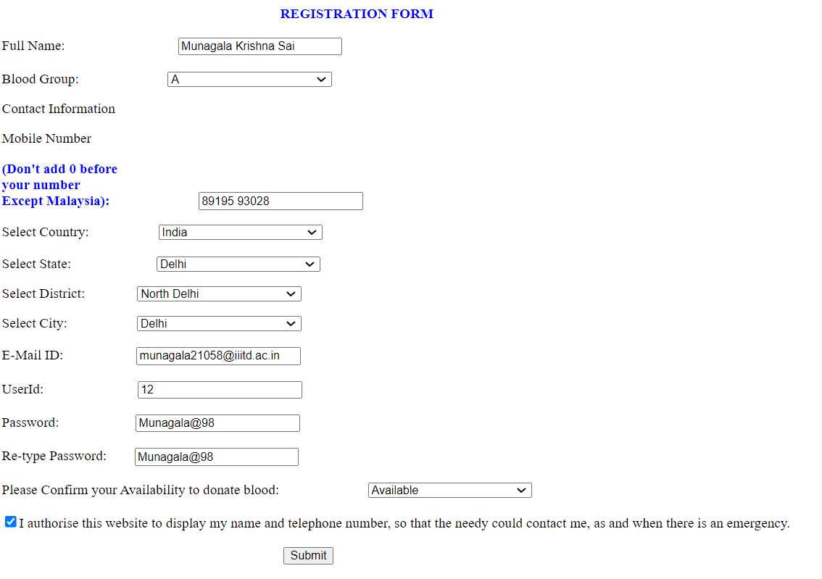

Then the browser will give an alert message with Registration Details Saved.

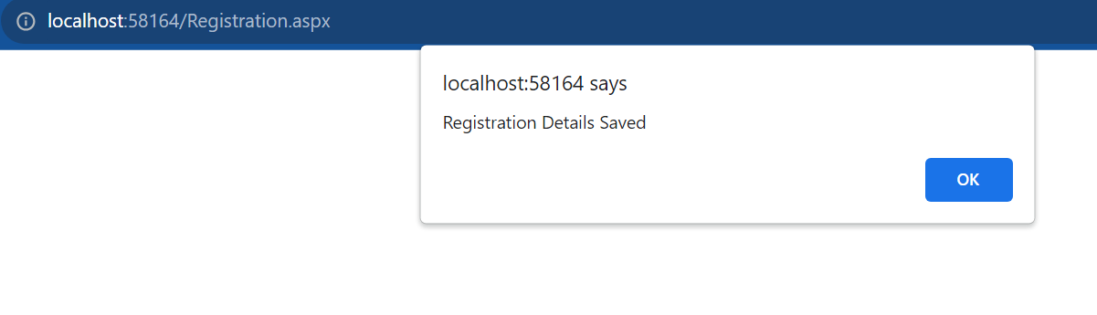

Then go to Mysql WorkBench and print the details of all users.We will see that the current detail of the user is there on the database along with the other users.(Note:As there are so many columns,so the screenshot of all the columns cannot be taken at once.)

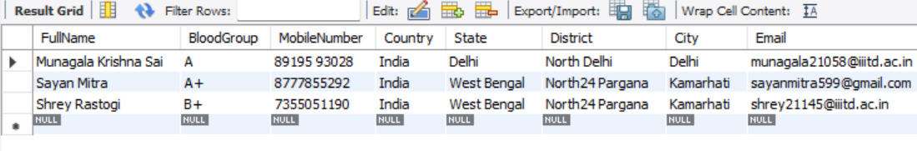

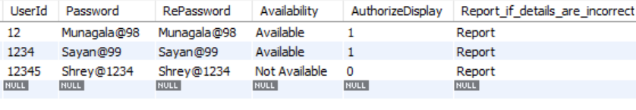

**Login Screenshot**

For login, run the search.aspx file and then the default page appears.In the default page fill the user login and password details and click on Submit button.

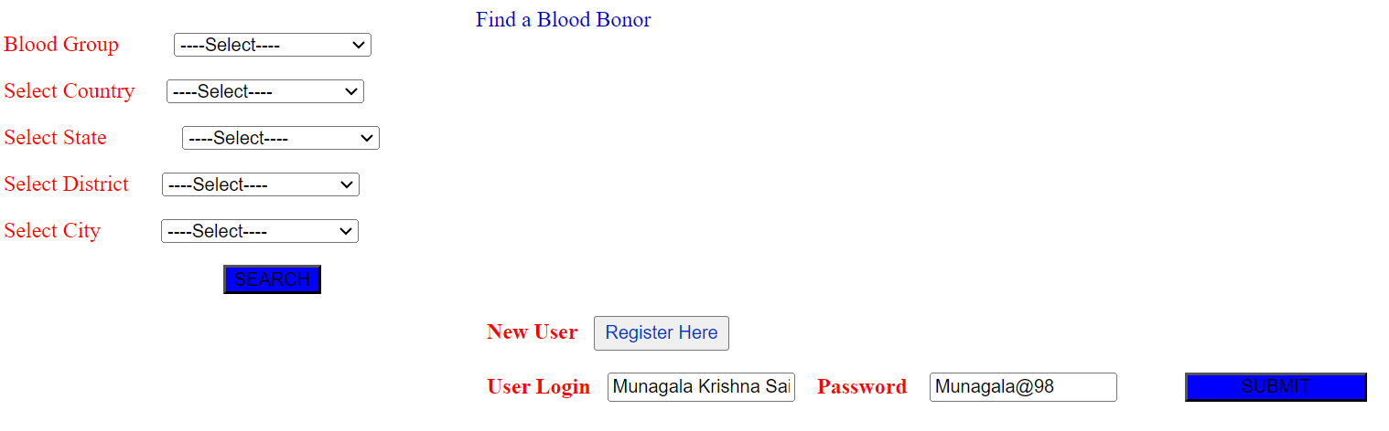

Then the browser will give an alert message with Success.(Note:The code for invalid username and password is also written whose code is shared on github).

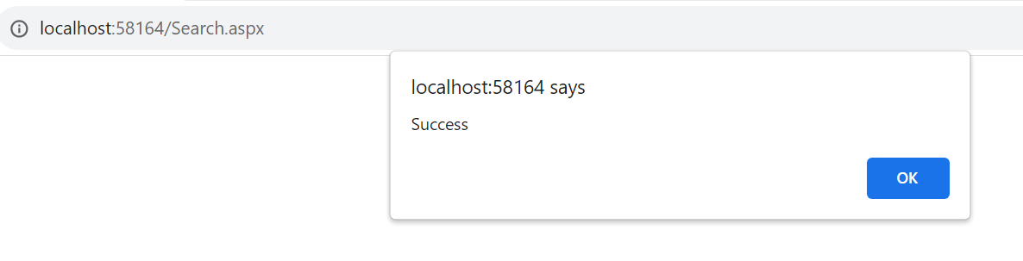

**Search Screenshot**

For search, run the search.aspx file and then the default page appears.In the default page fill the search credential details and click on search button of the default page.

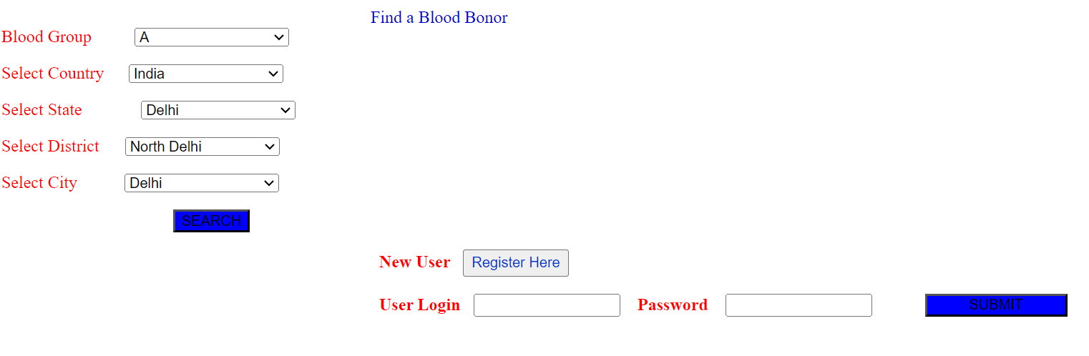

Then the browser will give an alert message with All Details Shown related to search credentials.

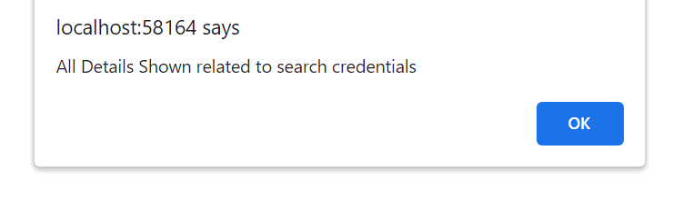

Also the searched data has appeared on the default page located inside the GridView.

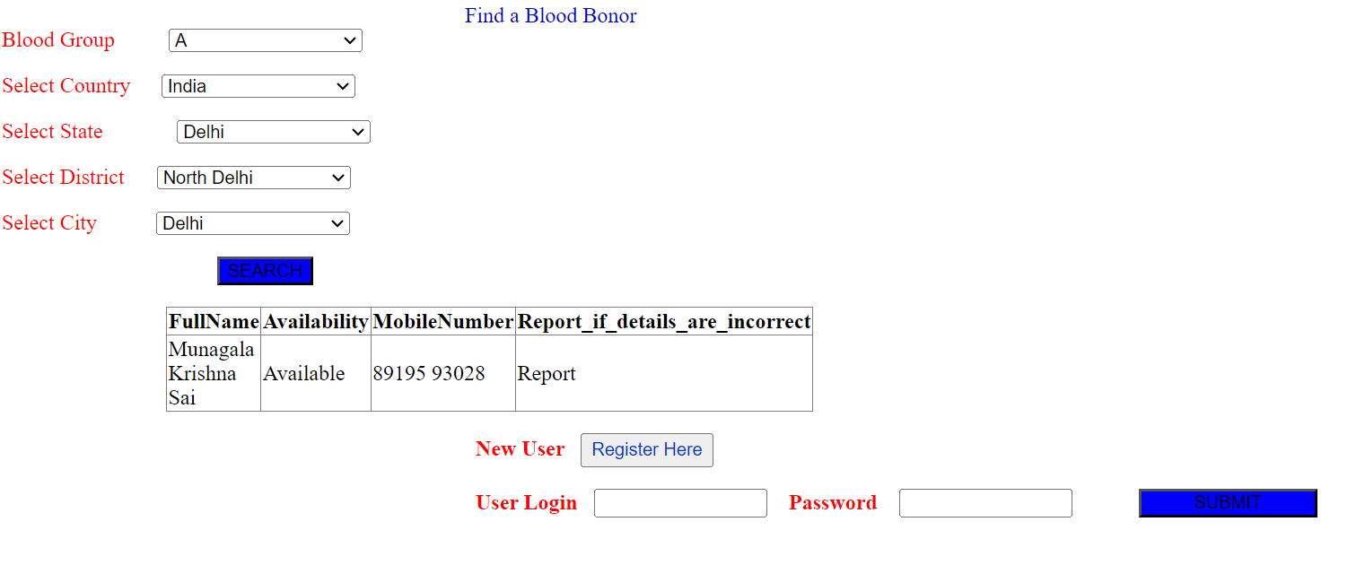

The entire code is shared on Github.

**Group Members:**

* Sayan Mitra
* Shrey Rastogi
* Krishna Thoriya
* Dhruv Gupta

Github Repo-