**Exercise 1: Control Structures**

**Solution:**

Scenario 1:

DECLARE

CURSOR cur_customers IS

SELECT CustomerID, InterestRate

FROM Loans

WHERE CustomerID IN (SELECT CustomerID FROM Customers WHERE Age > 60);

BEGIN

FOR rec IN cur_customers LOOP

UPDATE Loans

SET InterestRate = InterestRate - 1

WHERE CustomerID = rec.CustomerID;

END LOOP;

COMMIT;

END;

Scenario 2:

DECLARE

CURSOR cur_customers IS

SELECT CustomerID

FROM Customers

WHERE Balance > 10000;

BEGIN

FOR rec IN cur_customers LOOP

UPDATE Customers

SET IsVIP = 'TRUE'

WHERE CustomerID = rec.CustomerID;

END LOOP;

COMMIT;

END;

Scenario 3:

DECLARE

CURSOR cur_due_loans IS

SELECT LoanID, CustomerID, DueDate

FROM Loans

WHERE DueDate BETWEEN SYSDATE AND SYSDATE + 30;

v_customer_name VARCHAR2(100);

BEGIN

FOR rec IN cur_due_loans LOOP

SELECT Name INTO v_customer_name FROM Customers WHERE CustomerID = rec.CustomerID;

DBMS_OUTPUT.PUT_LINE('Reminder: Dear ' || v_customer_name ||

', your loan (Loan ID: ' || rec.LoanID ||

') is due on ' || TO_CHAR(rec.DueDate, 'DD-MON-YYYY') || '. Please ensure timely payment.');

END LOOP;

END;

**Output:**

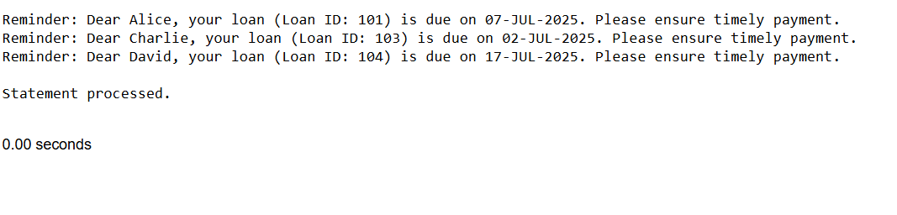

**Exercise 3: Stored Procedures**

**Solution:**

Scenario 1:

*ProcessedMonthlyInterest*:

CREATE OR REPLACE PROCEDURE ProcessMonthlyInterest AS

BEGIN

UPDATE SavingsAccounts

SET Balance = Balance + (Balance * 0.01);

COMMIT;

END;

Scenario 2:

*UpdateEmployeeBonus:*

CREATE OR REPLACE PROCEDURE UpdateEmployeeBonus (

p_DepartmentID IN NUMBER,

p_BonusPercent IN NUMBER

) AS

BEGIN

UPDATE Employees

SET Salary = Salary + (Salary * p_BonusPercent / 100)

WHERE DepartmentID = p_DepartmentID;

COMMIT;

END;

Scenario 3:

*Transfer Funds:*

CREATE OR REPLACE PROCEDURE TransferFunds (

p_SourceAccountID IN NUMBER,

p_DestinationAccountID IN NUMBER,

p_Amount IN NUMBER

) AS

v_SourceBalance NUMBER;

BEGIN

SELECT Balance INTO v_SourceBalance

FROM Accounts

WHERE AccountID = p_SourceAccountID

FOR UPDATE;

IF v_SourceBalance >= p_Amount THEN

UPDATE Accounts

SET Balance = Balance - p_Amount

WHERE AccountID = p_SourceAccountID;

UPDATE Accounts

SET Balance = Balance + p_Amount

WHERE AccountID = p_DestinationAccountID;

COMMIT;

ELSE

RAISE_APPLICATION_ERROR(-20001, 'Insufficient balance in source account.');

END IF;

END;

**Output:**

**Scenario 1:**

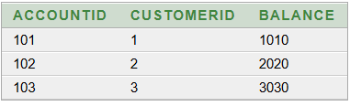

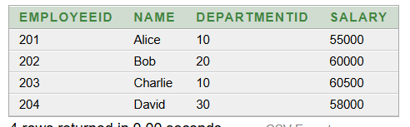**Scenario 2:**

**Scenario 3:**