**Mandatory-HandsOn:**

**Creating Microservices for account and loan:**

**1)Account:**

**AccountApplication.java:**

package com.cognizant.account;

import org.springframework.boot.SpringApplication;

import org.springframework.boot.autoconfigure.SpringBootApplication;

@SpringBootApplication

public class AccountApplication {

public static void main(String[] args) {

SpringApplication.run(AccountApplication.class, args);

}

}

**AccountController.java:**

**package** com.cognizant.account;

**import** org.springframework.web.bind.annotation.GetMapping;

**import** org.springframework.web.bind.annotation.PathVariable;

**import** org.springframework.web.bind.annotation.RestController;

**import** java.util.Map;

@RestController

**public** **class** AccountController {

@GetMapping("/accounts/{number}")

**public** Map<String, Object> getAccountDetails(@PathVariable String number) {

**return** Map.*of*(

"number", number,

"type", "savings",

"balance", 234343

);

}

}

**OUTPUT:**

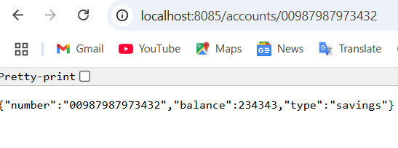

**2)LOAN:**

**LoanApplication.java:**

package com.cognizant.loan;

import org.springframework.boot.SpringApplication;

import org.springframework.boot.autoconfigure.SpringBootApplication;

@SpringBootApplication

public class LoanApplication {

public static void main(String[] args) {

SpringApplication.run(LoanApplication.class, args);

}

}

**LoanController.java:**

**package** com.cognizant.loan;

**import** org.springframework.web.bind.annotation.GetMapping;

**import** org.springframework.web.bind.annotation.PathVariable;

**import** org.springframework.web.bind.annotation.RestController;

**import** java.util.Map;

@RestController

**public** **class** LoanController {

@GetMapping("/loans/{number}")

**public** Map<String, Object> getLoanDetails(@PathVariable String number) {

**return** Map.*of*(

"number", number,

"type", "car",

"loan", 1900000,

"emi", 8958,

"tenure", 23

);

}

}

**OUTPTUT:**

