**Solution:**

**calculateScore.js:**

import './Stylesheets/mystyle.css'; // fixed import path

// Convert decimal to percentage string

const percentToDecimal = (decimal) => {

  return (decimal * 100).toFixed(2) + '%';

};

// Calculate percentage score

const calcScore = (total, goal) => {

  return percentToDecimal(total / goal);

};

// Functional component

export const CalculateScore = ({ Name, School, total, goal }) => (

  <div className="formatstyle">

    <h1 style={{ color: 'brown' }}>Student Details:</h1>

    <div className="Name">

      <b><span>Name: </span></b>

      <span>{Name}</span>

    </div>

    <div className="School">

      <b><span>School: </span></b>

      <span>{School}</span>

    </div>

    <div className="Total">

      <b><span>Total: </span></b>

      <span>{total} Marks</span>

    </div>

    <div className="Score">

      <b>Score: </b>

      <span>{calcScore(total, goal)}</span>

    </div>

  </div>

);

**mystyles.css:**

.Name {

  font-weight: 300;

  color: blue;

}

.School {

  color: crimson;

}

.Total {

  color: darkmagenta;

}

.Score {

  color: forestgreen;

}

.formatstyle {

  text-align: center;

  font-size: large;

}

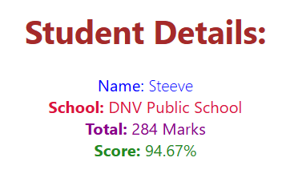**OUTPUT:**