**Solution:**

**ListOfPlayers.js:**

import React from "react";

const ListofPlayers = () => {

  const players = [

    { name: "Rohit", score: 85 },

    { name: "Virat", score: 92 },

    { name: "Gill", score: 65 },

    { name: "Shreyas", score: 58 },

    { name: "Jadeja", score: 71 },

    { name: "Pant", score: 45 },

    { name: "Hardik", score: 78 },

    { name: "Bumrah", score: 38 },

    { name: "Kuldeep", score: 55 },

    { name: "Shami", score: 80 },

    { name: "Surya", score: 95 },

  ];

  const lowScorers = players.filter(p => p.score < 70);

  return (

    <div>

      <h2>All Players</h2>

      <ul>

        {players.map((player, index) => (

          <li key={index}>{player.name} - {player.score}</li>

        ))}

      </ul>

      <h3>Players with score below 70</h3>

      <ul>

        {lowScorers.map((player, index) => (

          <li key={index}>{player.name} - {player.score}</li>

        ))}

      </ul>

    </div>

  );

};

export default ListofPlayers;

**IndianPlayers.js:**

import React from "react";

const IndianPlayers = () => {

  const team = ["Rohit", "Virat", "Gill", "Shreyas", "Jadeja", "Pant", "Hardik", "Bumrah", "Kuldeep", "Shami", "Surya"];

  const oddTeam = team.filter((_, index) => index % 2 !== 0);

  const evenTeam = team.filter((_, index) => index % 2 === 0);

  const T20players = ["Rohit", "Pant", "Hardik", "Surya"];

  const RanjiTrophyPlayers = ["Gill", "Shreyas", "Jadeja"];

  const mergedPlayers = [...T20players, ...RanjiTrophyPlayers];

  return (

    <div>

      <h2>Odd Team Players</h2>

      <ul>{oddTeam.map((player, i) => <li key={i}>{player}</li>)}</ul>

      <h2>Even Team Players</h2>

      <ul>{evenTeam.map((player, i) => <li key={i}>{player}</li>)}</ul>

      <h2>Merged T20 and Ranji Trophy Players</h2>

      <ul>{mergedPlayers.map((player, i) => <li key={i}>{player}</li>)}</ul>

    </div>

  );

};

export default IndianPlayers;

**App.js:**

import React, { useState } from "react";

import ListofPlayers from "./ListOfPlayers";

import IndianPlayers from "./IndianPlayers";

function App() {

  const [flag, setFlag] = useState(true);

  return (

    <div style={{ padding: "20px" }}>

      <button onClick={() => setFlag(!flag)}>

        Show {flag ? "Indian Players" : "List of Players"}

      </button>

      {flag ? <ListofPlayers /> : <IndianPlayers />}

    </div>

  );

}

export default App;

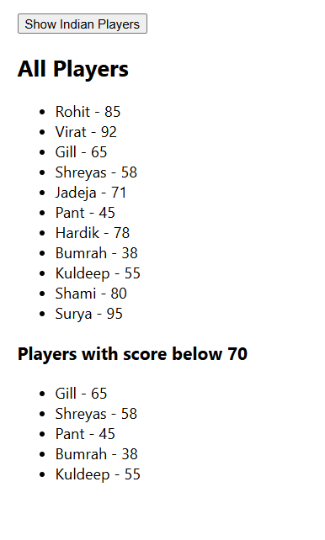**OUTPUT:**

