* Airfares don’t change frequently. Instead they increase gradually..
* Customers should try to buy tickets as early as possible to get the tickets at lower price.
* Prices increase as the date of departure comes nearby.

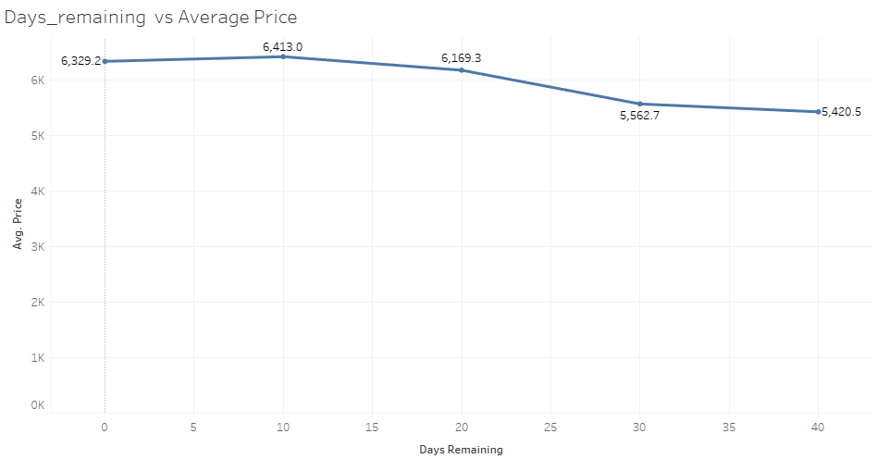

* Indigo ticket prices are lower than jet airways. Jet airways is no longer operational. So no data is available currently.
* Morning ticket prices are slightly more expensive.

