**Exercise 1: Configuring a Basic Spring Application**

1. **Set Up a Spring Project:**

Set up a new project, and added spring core dependencies in pom.xml

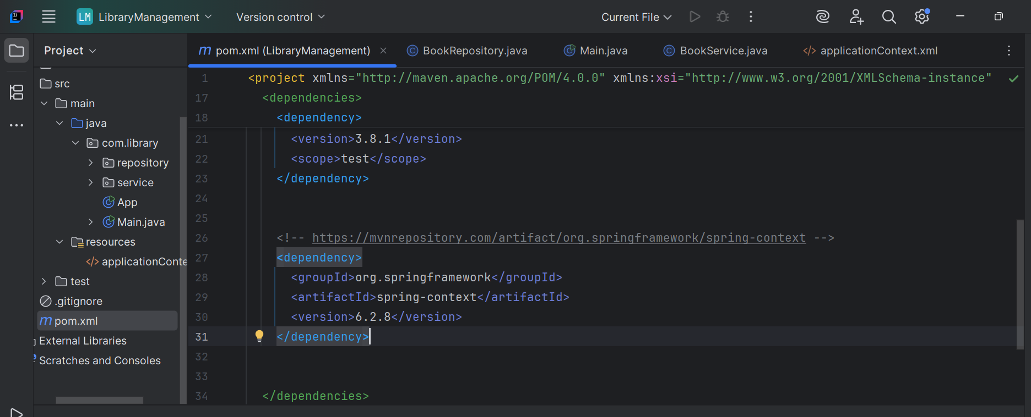

1. **Configure the Application Context:**

Created the applicationContext.xml file and defined the beans as mentioned.

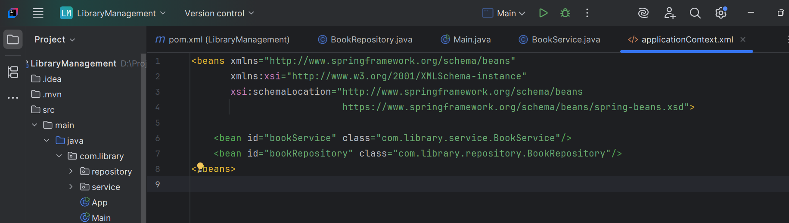

1. **Define Service and Repository Classes:**

Created package **com.library.service** and added a class **BookService**.

Created package **com.library.repository** and added a class **BookRepository.**

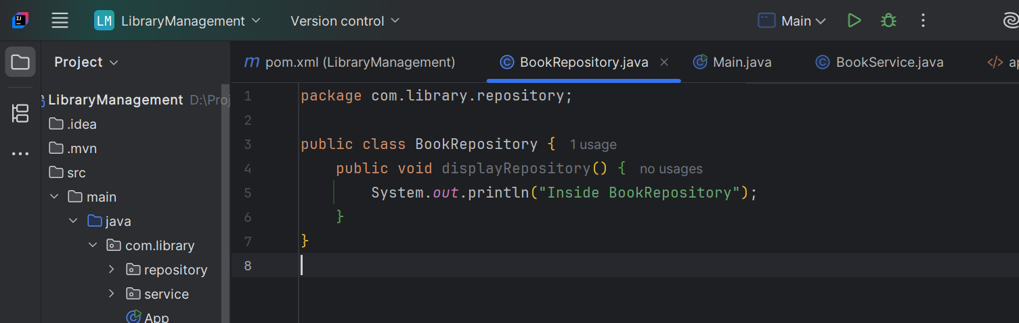

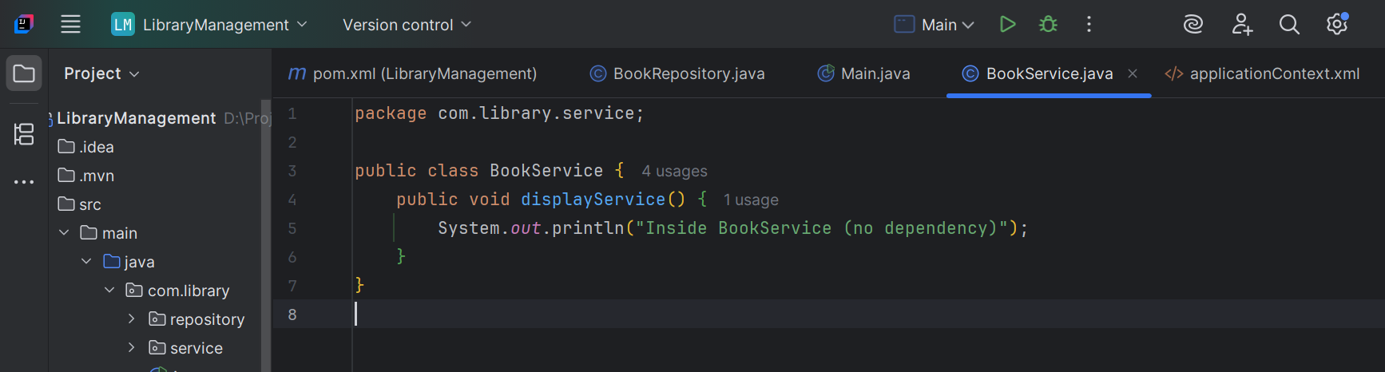

1. **Run the Application:**

Created the Main class to load spring context, and run the app.

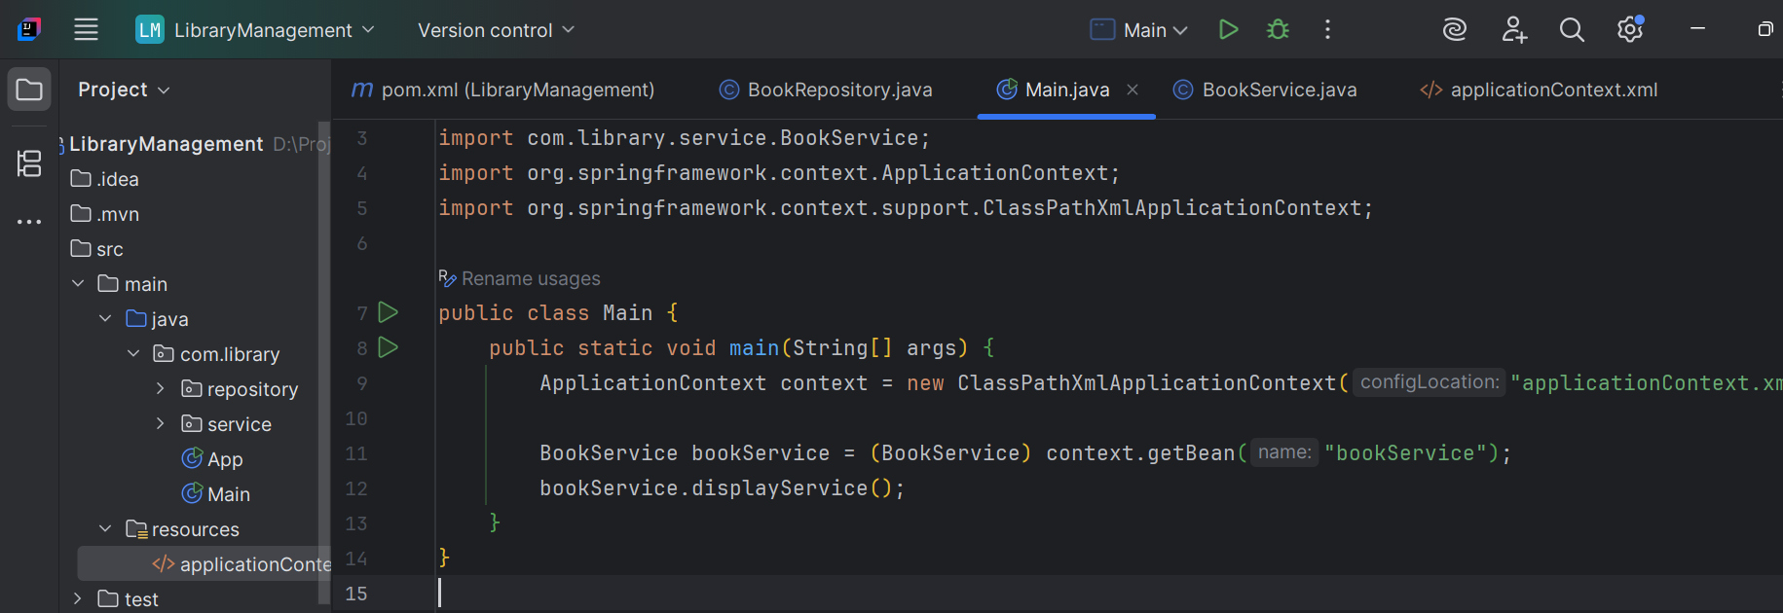

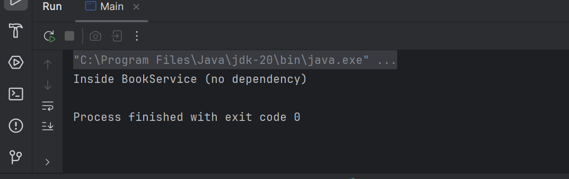

**Exercise 2: Implementing Dependency Injection**

1. Updating **applicationContext.xml** to wire **BookRepository** into **BookService**.

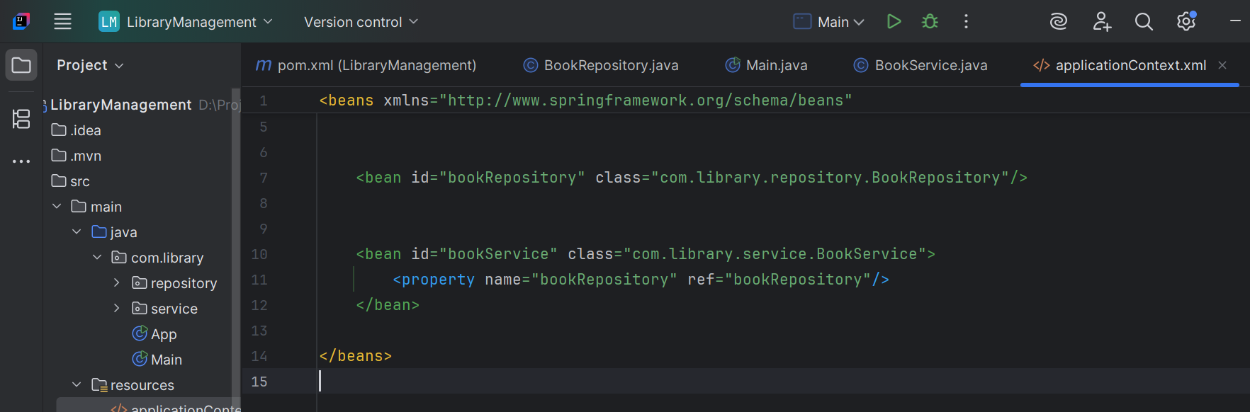

1. Ensuring BookService has setter for BookRepository

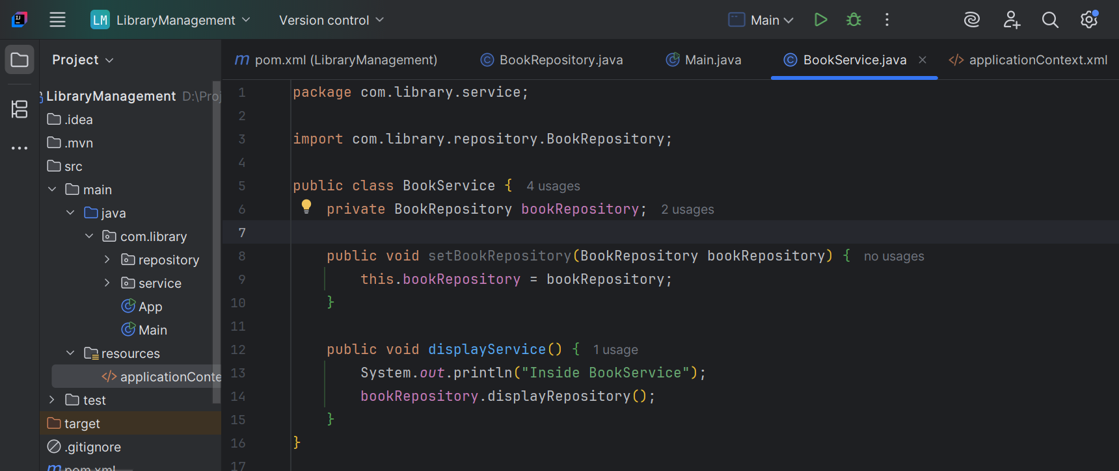

1. Running the main class to verify the DI

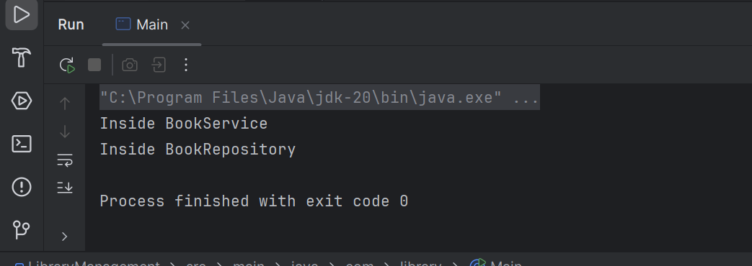

**Exercise 4: Creating and Configuring a Maven Project**

1. Creating a new maven project named LibraryManagement

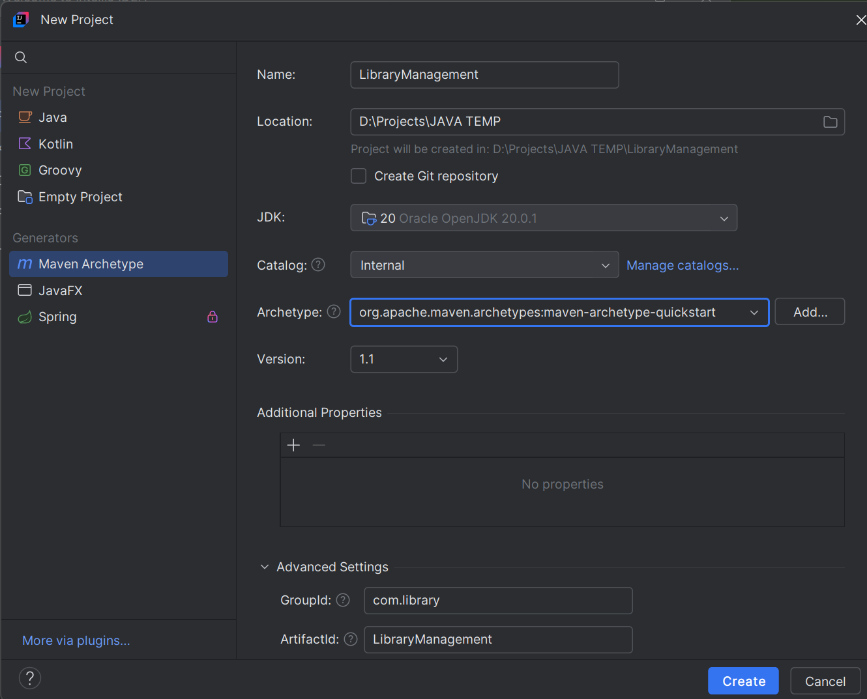

1. Added the mentioned Spring dependencies

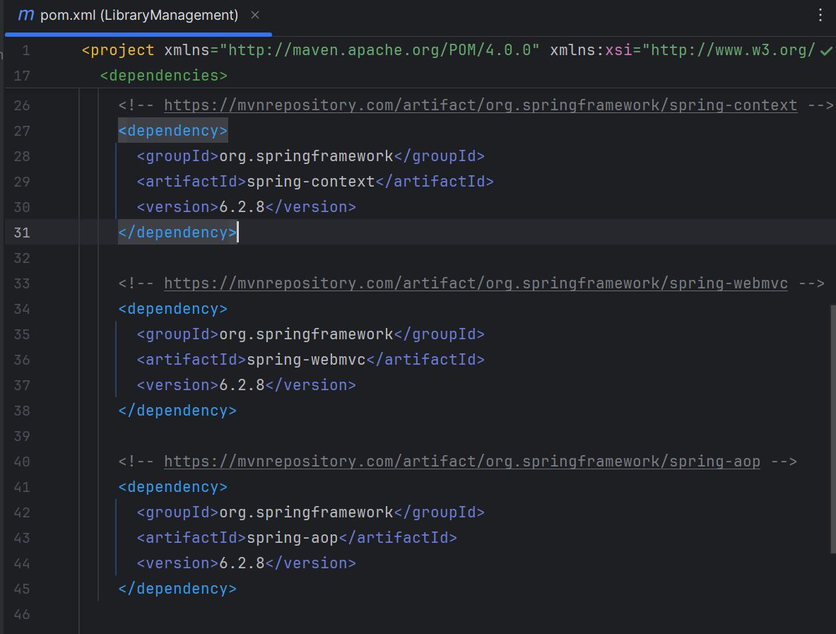

1. Configure the Maven Compiler Plugin for Java version 1.8 in the pom.xml file.

