**Creating Microservices for account and loan**

1. **Accounts Microservice,**
2. Created the asked folder structure,

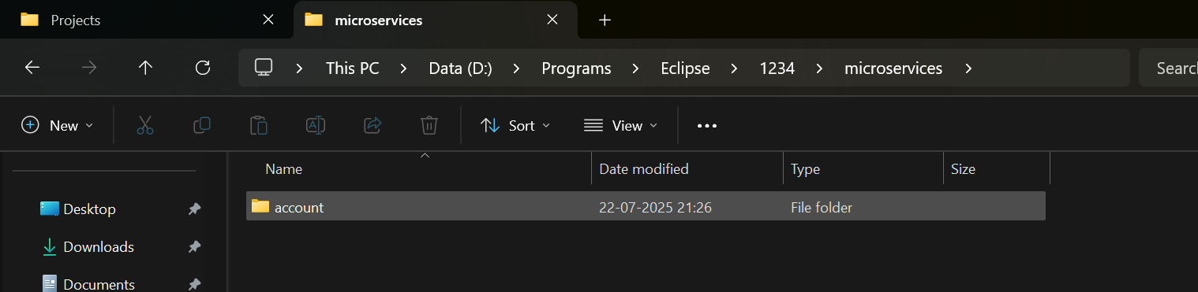

1. Created the maven project using spring initializr

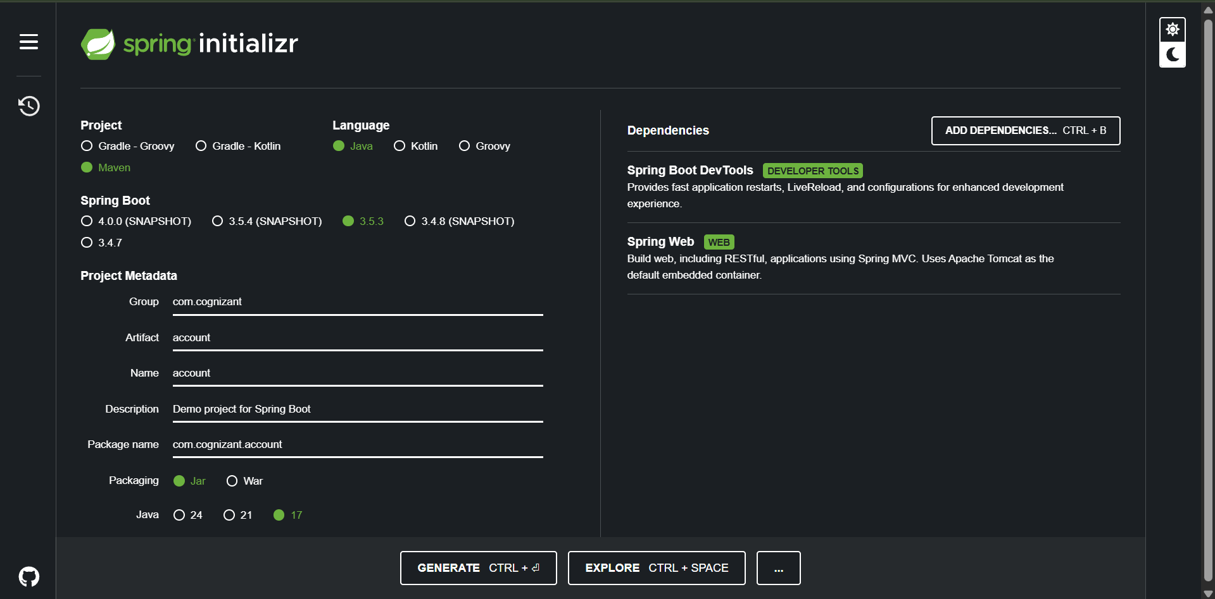

1. Put the generated folder into the given folder, and ran “mvn clean package” and got no errors

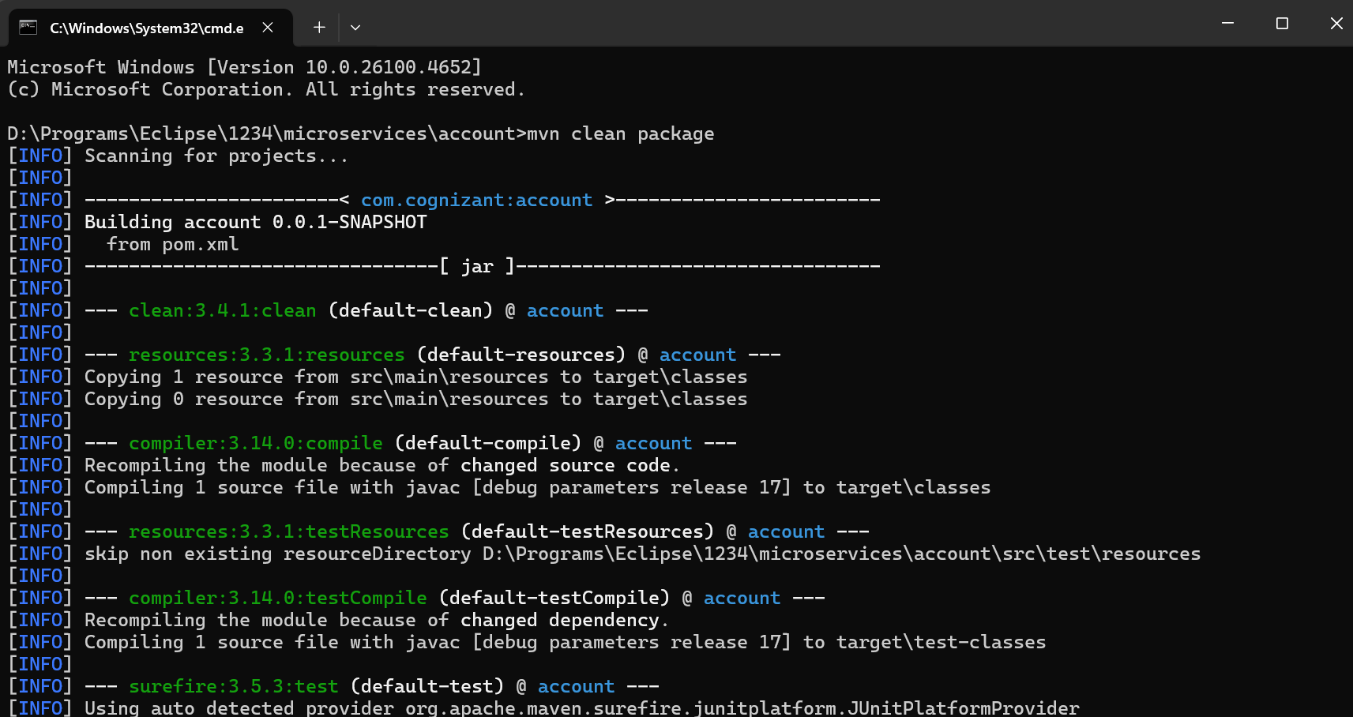

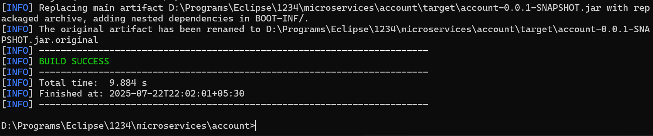

1. 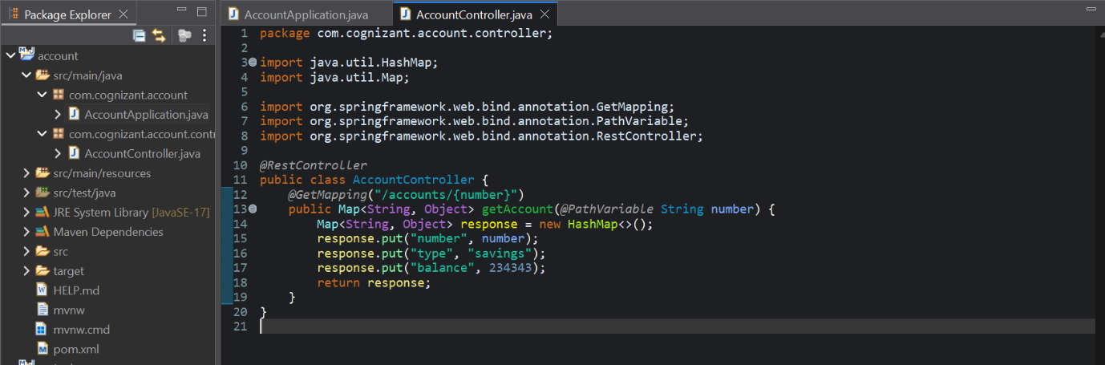Imported the project into eclipse, and defined AccountController.java file
2. 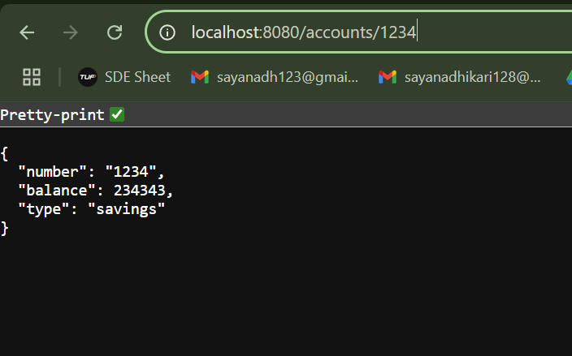Ran the server (on default port 8080, and checked the endpoint is working),

1. **Loans Microservice**
2. Created the asked folder structure and in exact similar way, created the loans project using spring initializr

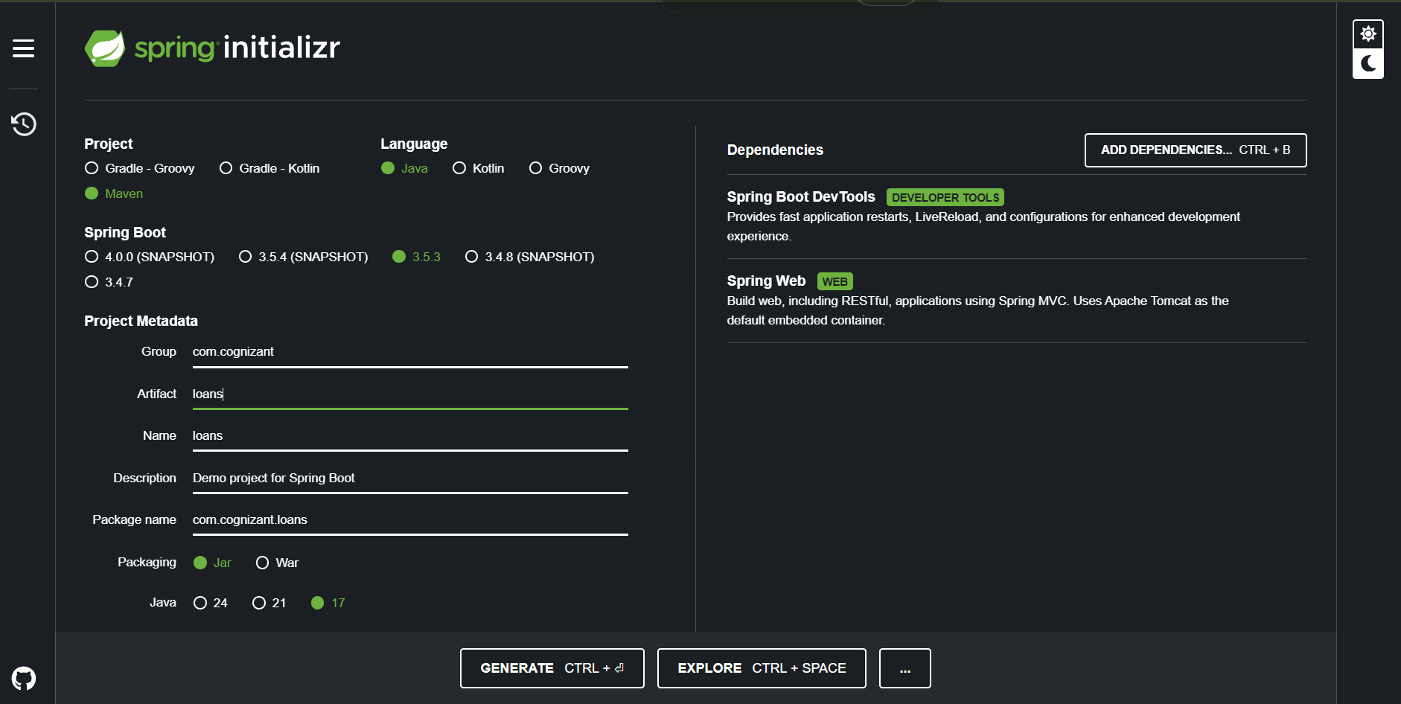

1. Similarly ran “mvn clean package” and got no errors

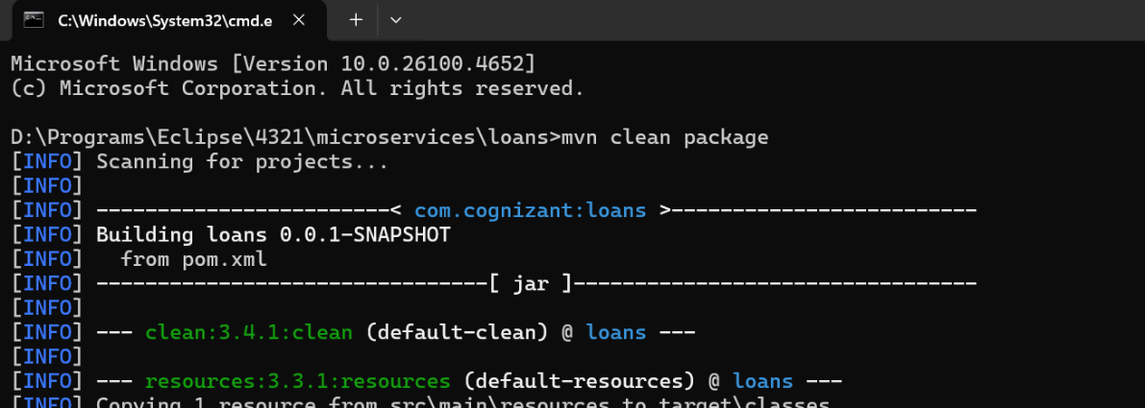

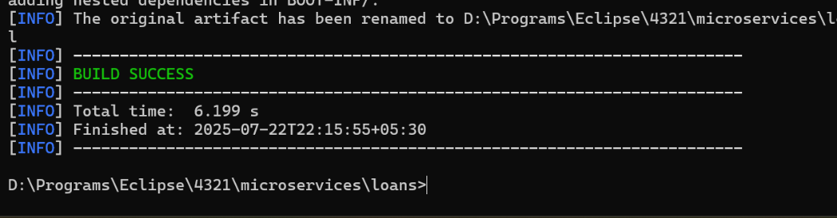

1. Similarly imported this loans project into eclipse, and here also defined the LoanController.java file

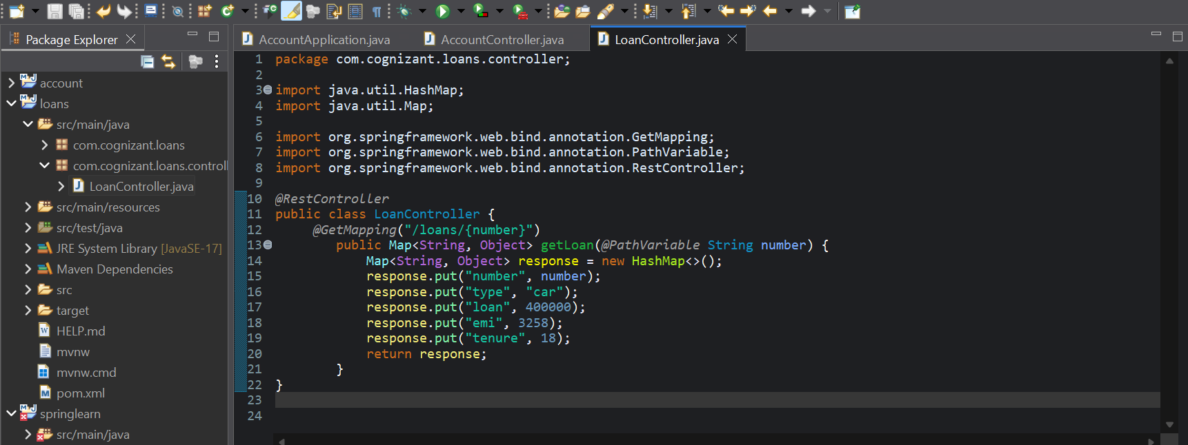

1. Tried running the server on default but got an error!

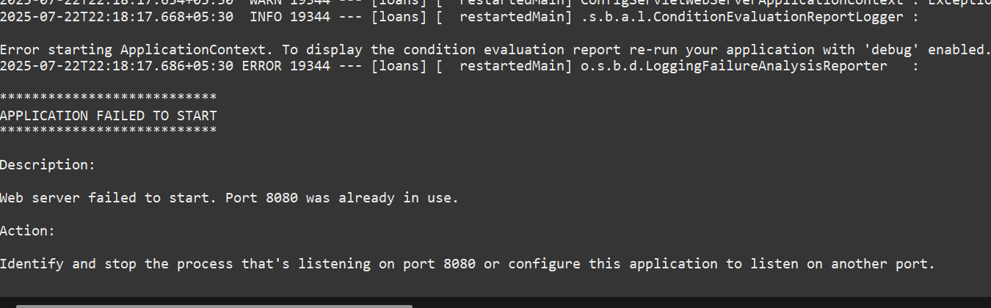

1. Changed in application.properties file to change the port to 8081 on which the server will be running

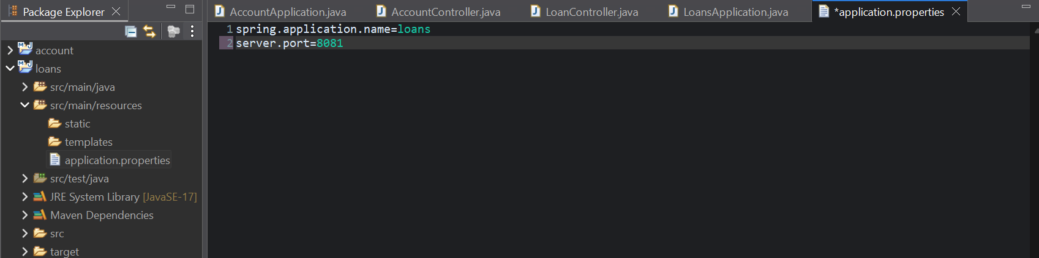

1. Ran the server again, got no errors this time. Both the servers are now running on different ports - port 8080 and 8081.

