**React JS Assignments - 1,**

1. Installed npm and nodejs from the given link.
2. 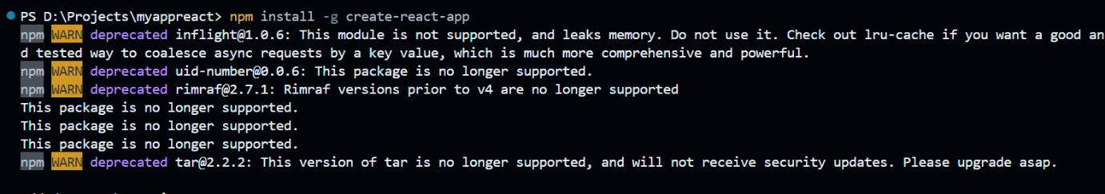Installed create-react-app
3. 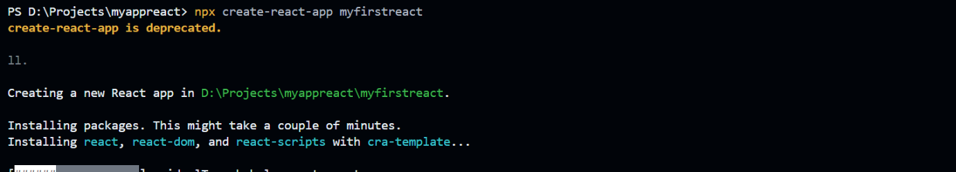Created a new app named “myfirstreact”
4. Changed App.js file,

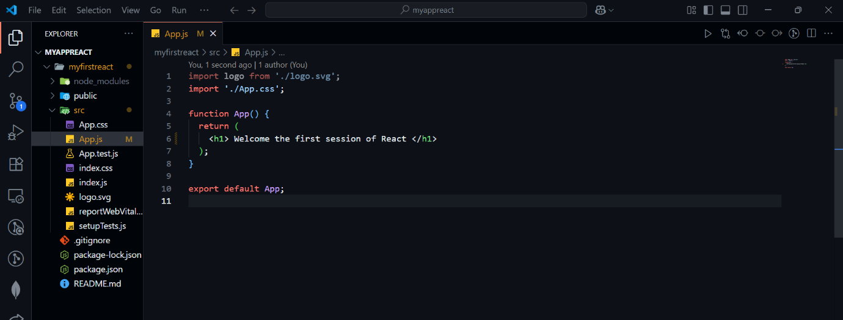

1. 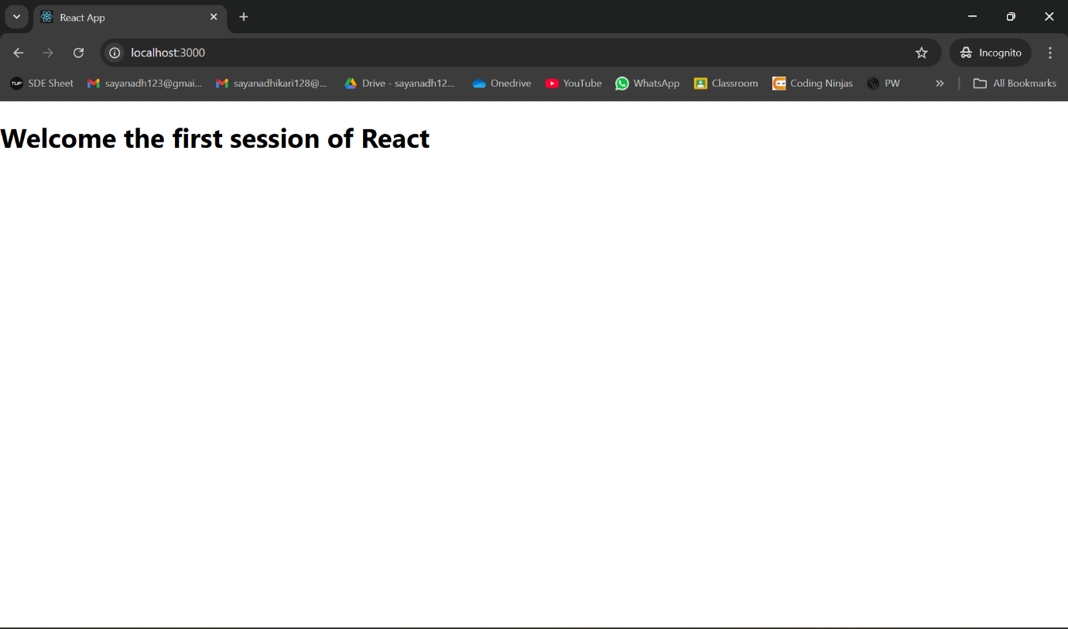Server is running successfully

**React JS Assignments - 2,**

1. Created a new react project named “studentapp”

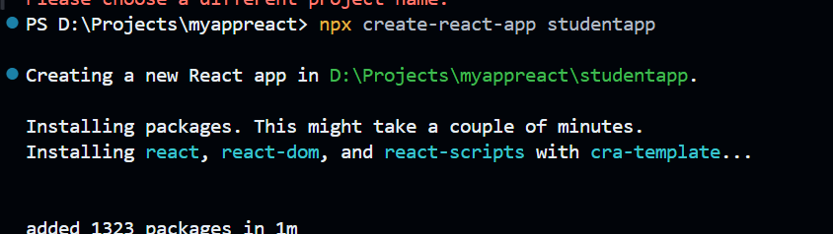

1. Added a components folder, and placed “Home.js” inside it

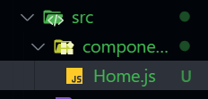

1. Added the given code to Home.js (corrected the code wherever necessary)

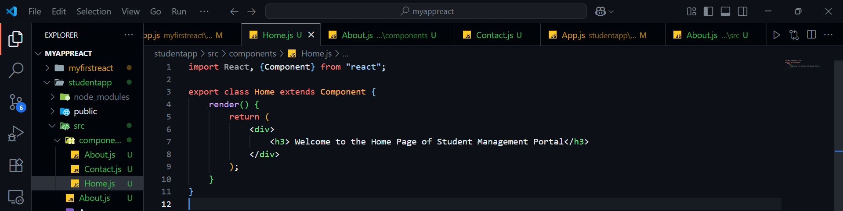

1. Added About.js file

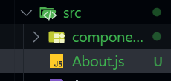

1. Similarly created Contacts and About Components

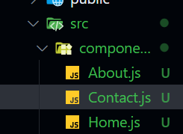

1. Added code to those files accordingly like in Home.js (corrected version)

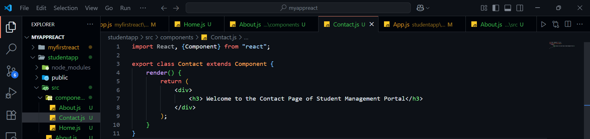

1. Edited App.js file accordingly

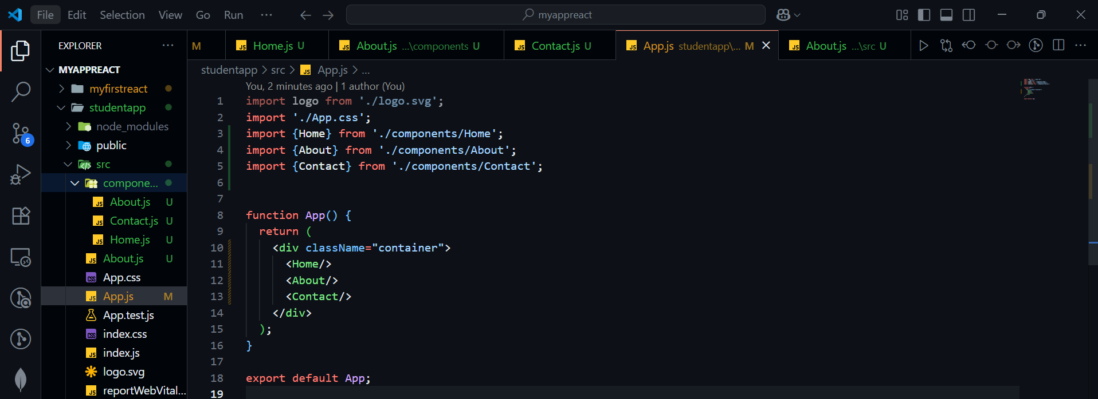

1. Ran the server successfully

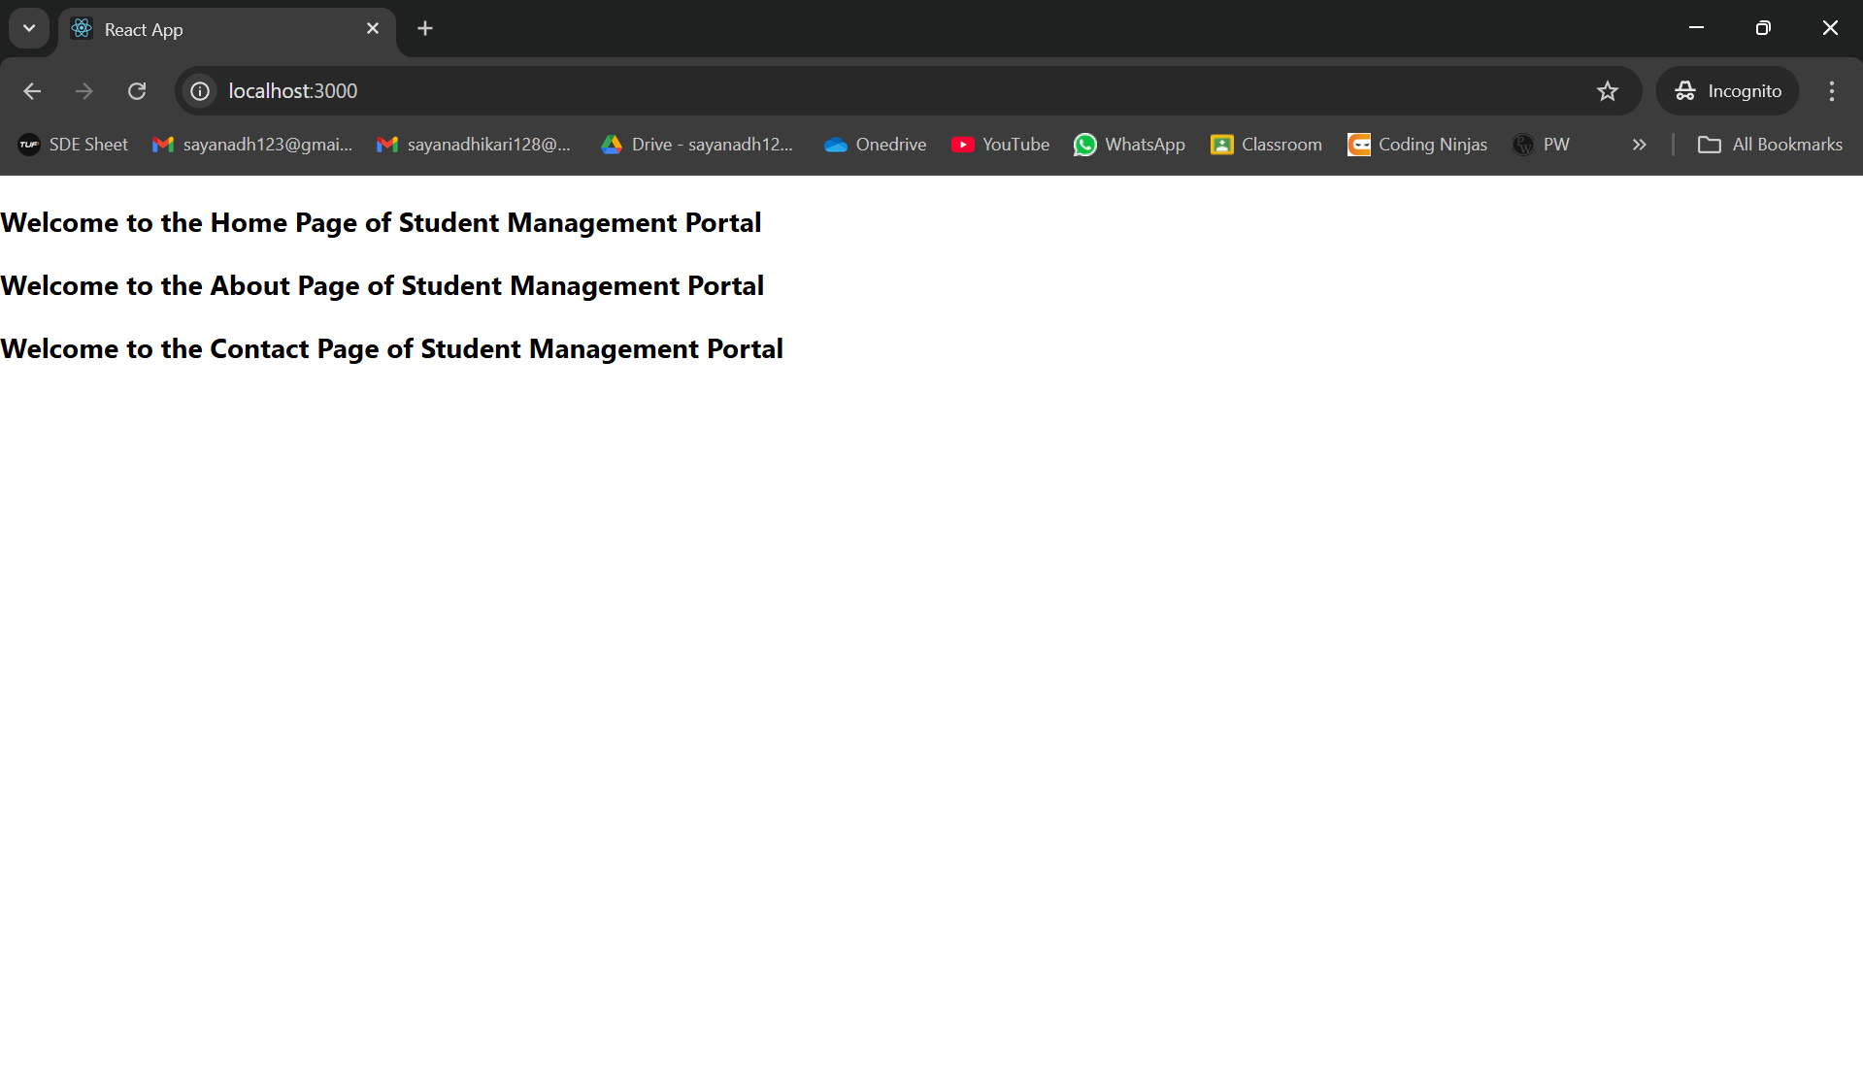

**React JS Assignments - 3,**

1. Created a new react project named “scorecalculatorapp”

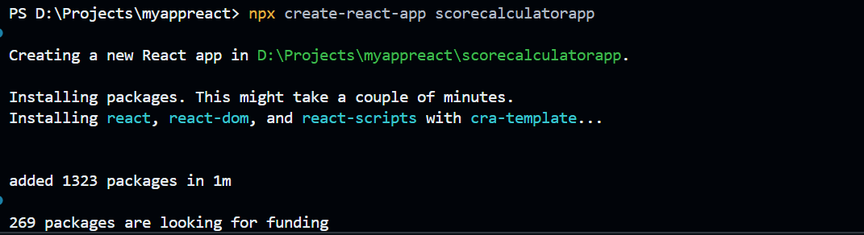

1. Created the given folder structure

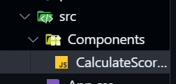

1. 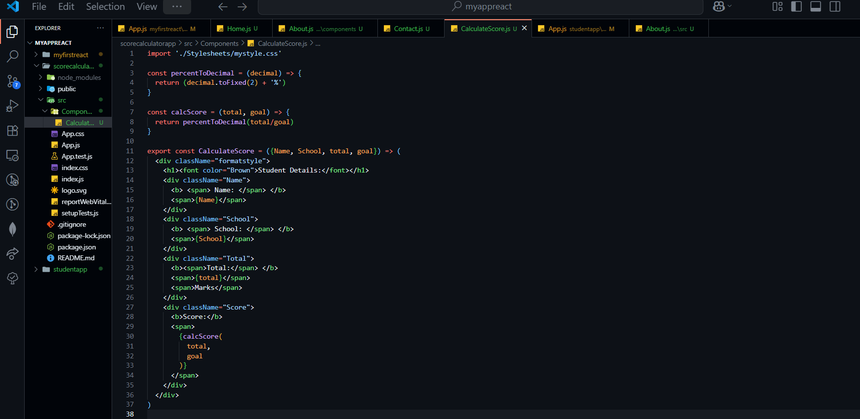Added the given code to that file CalculatesScore.js
2. Created the folder Stylesheets and added myStyle.css to it

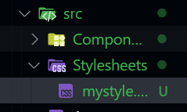

1. 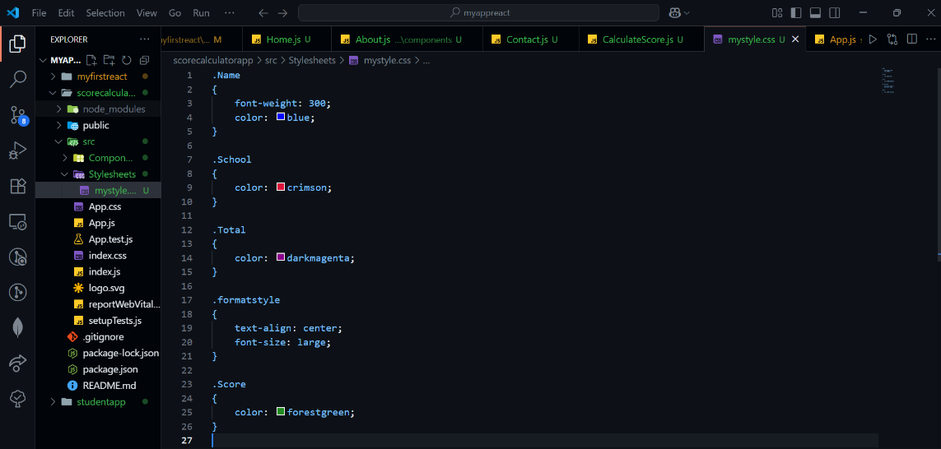Added the css code
2. Changed App.js

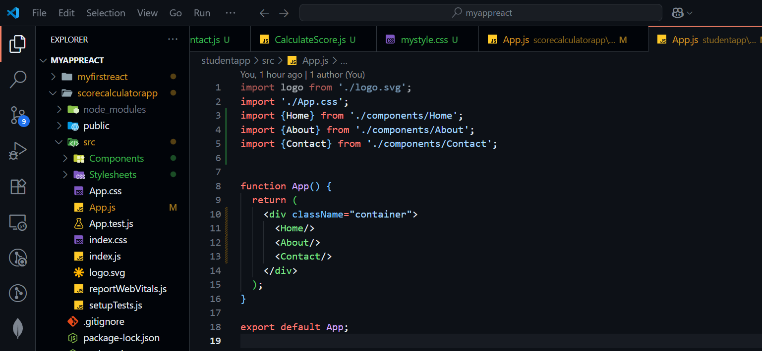

1. Ran the app and it is working as expected

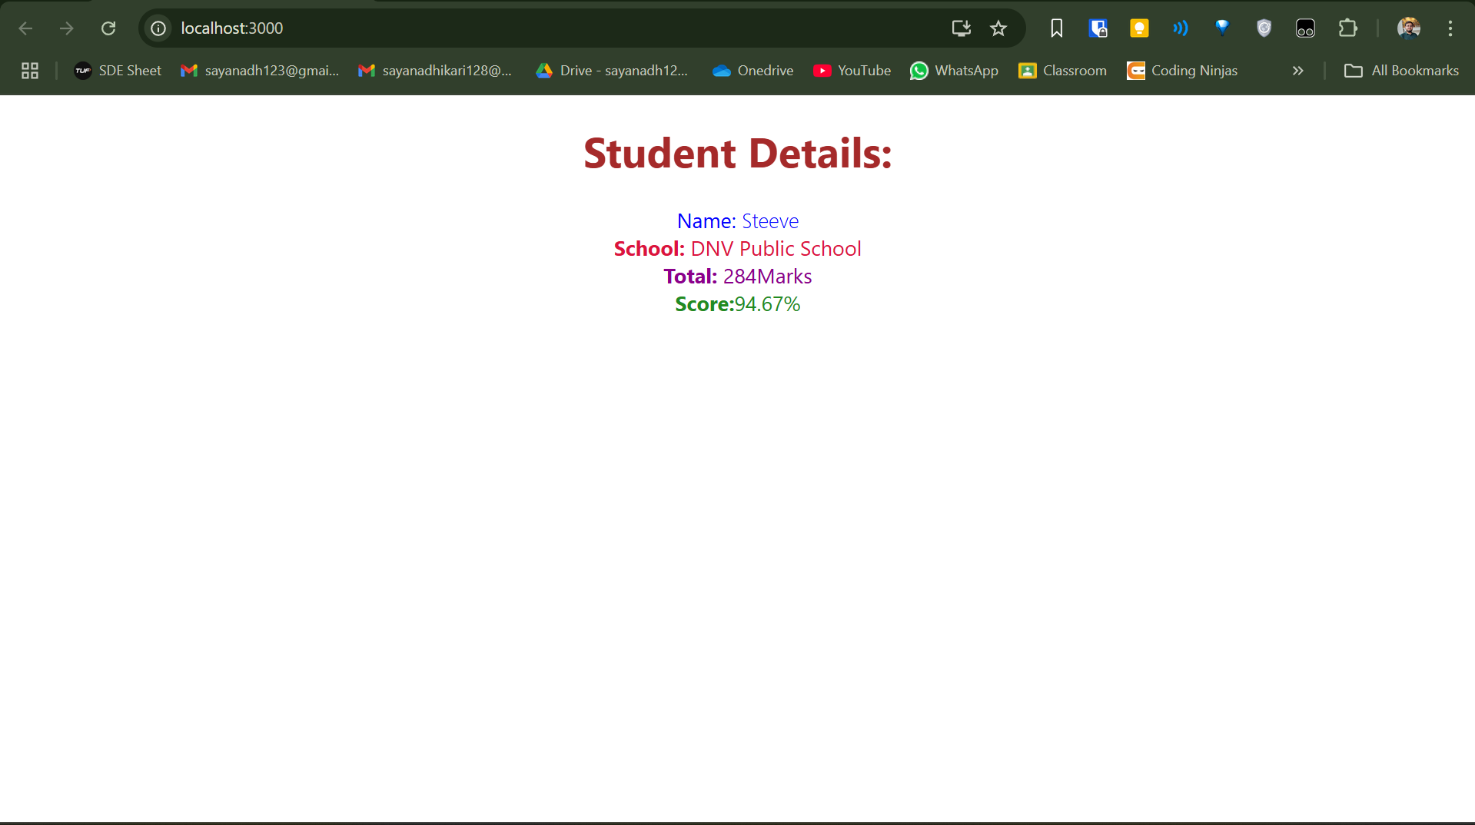

**React JS Assignments - 4,**

1. 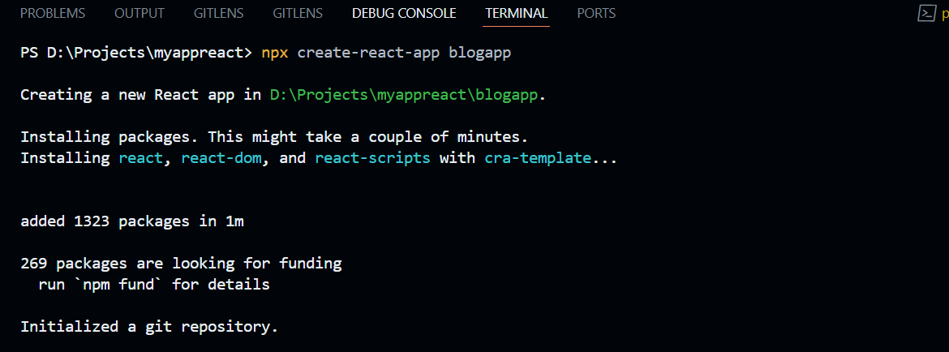Created a new react app named “blogapp”
2. Created Post.js as instructed, and added the given code to it

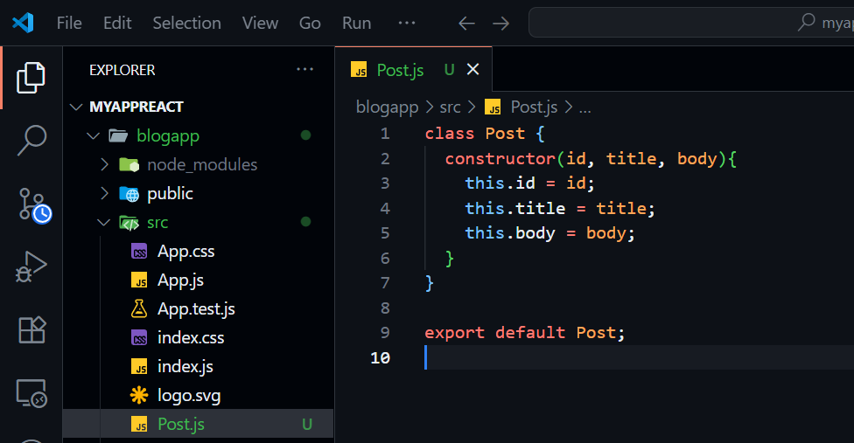

1. Created a new class based component named Posts in Posts.js file

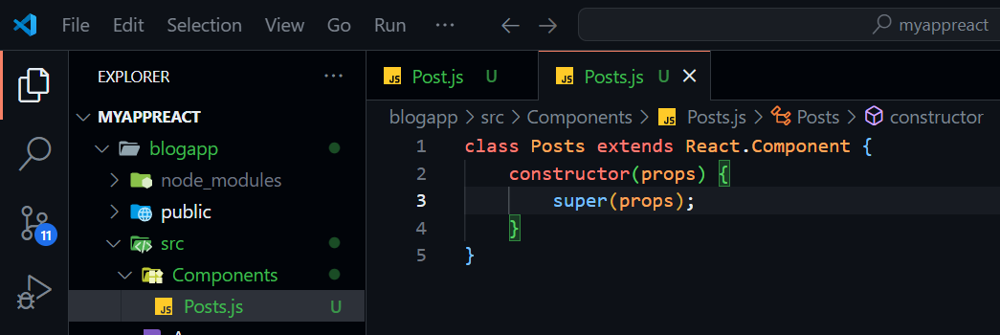

1. Initilised the component with a list of dummy Posts in state of the component using the constructor

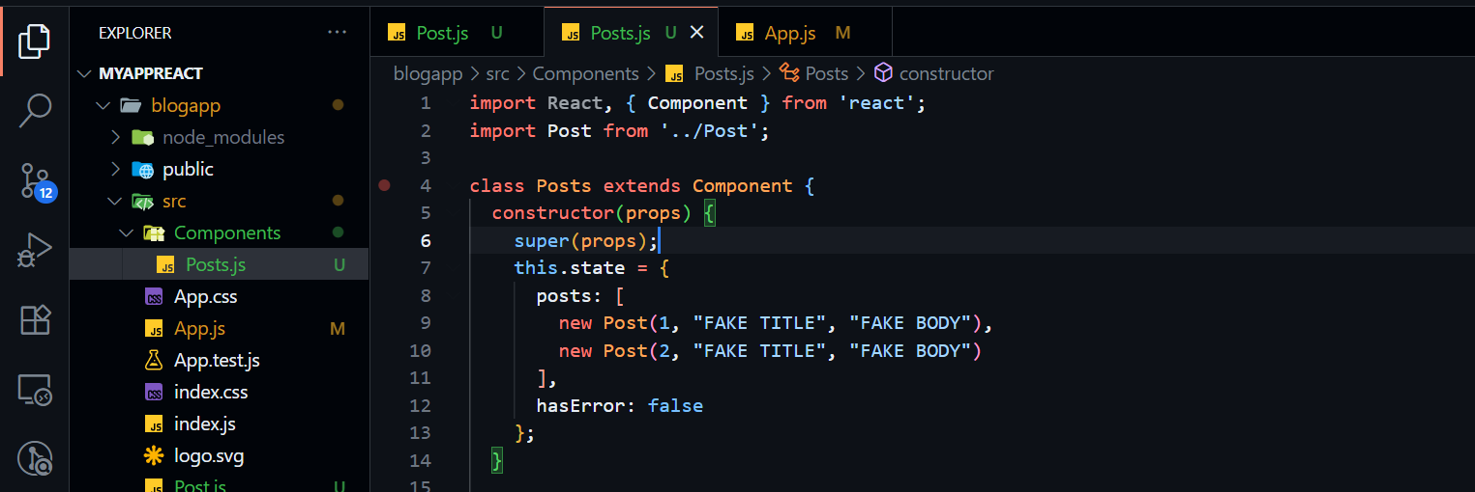

1. 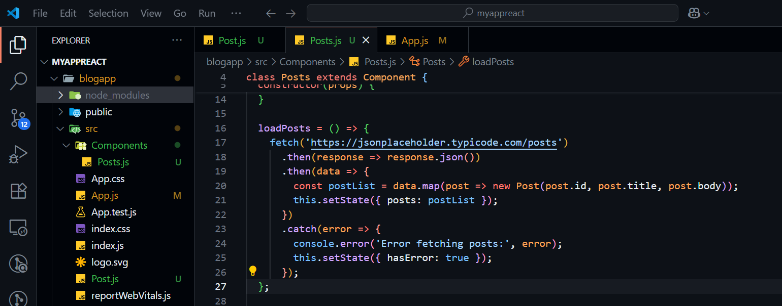Created the “loadPosts()” method to fetch api data, and assigning it to component state
2. Implemented componentDidMount() hook to make calls to loadPosts() when the component renders

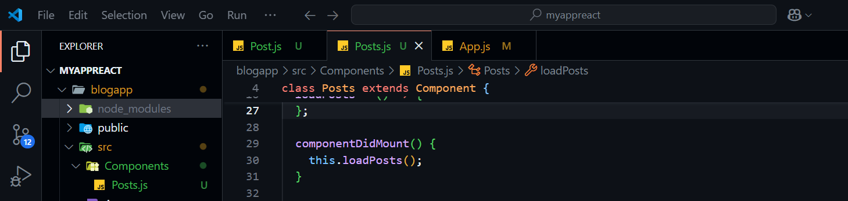

1. Implemented the render method

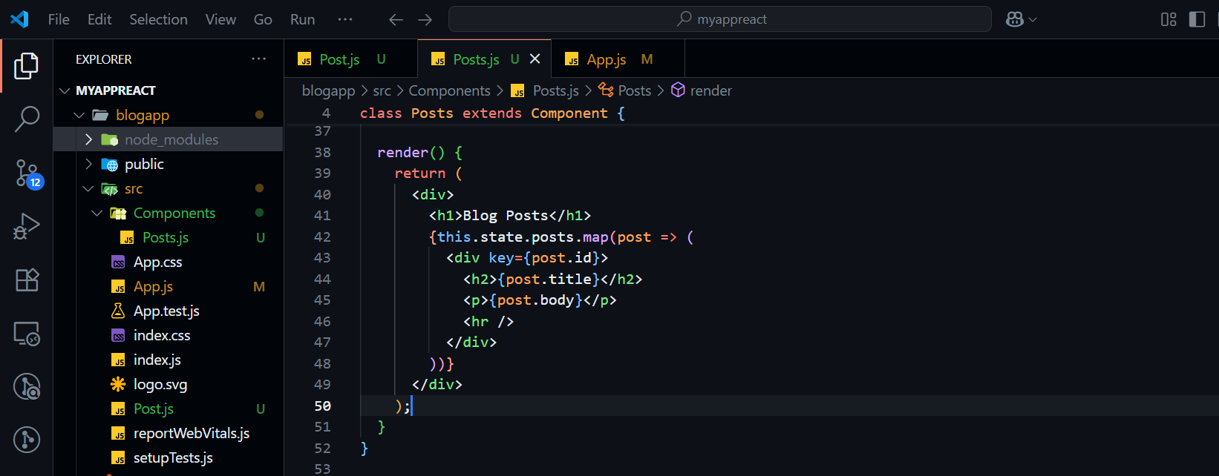

1. 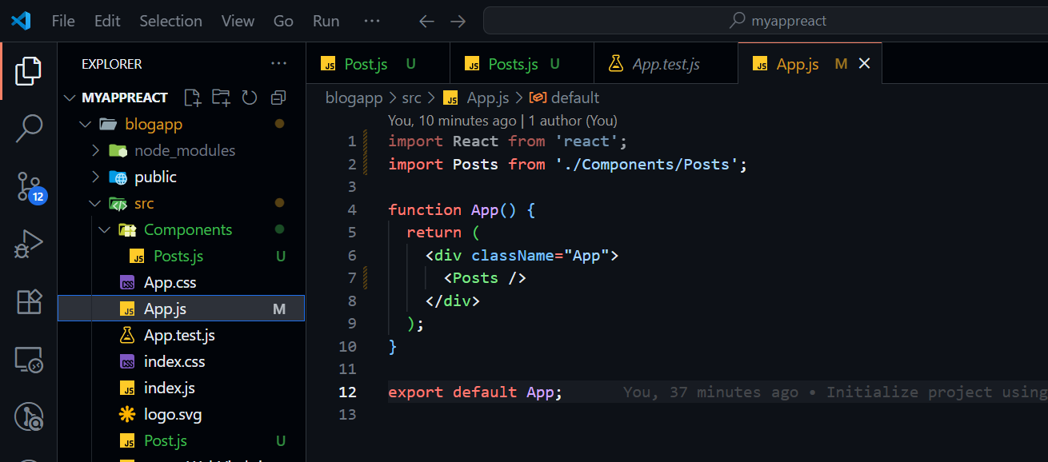Added Posts components to App component
2. Ran the server and it works as expected,

First it shows the default hardcoded posts created by us

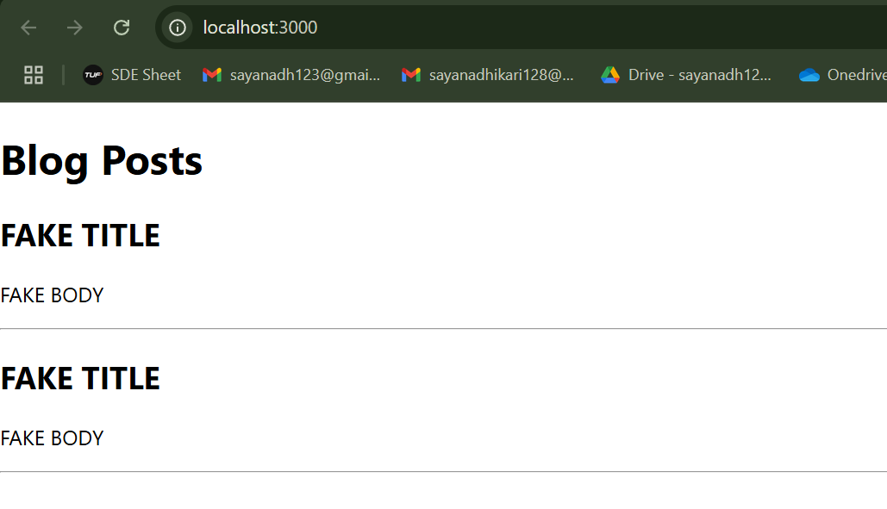

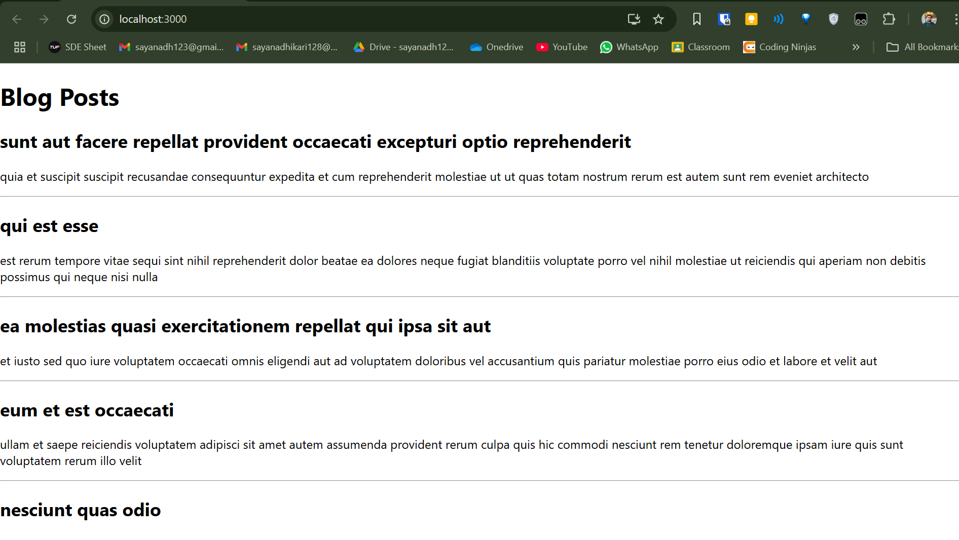Then when fetching is complete, it Updates the DOM with fetched posts

**React JS Assignments - 5,**

1. Downloaded and extracted the attached zip file into a folder
2. Restored the node packages using the given command

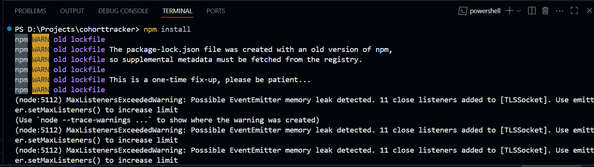

1. Created a file named CohrtDetails.module.css

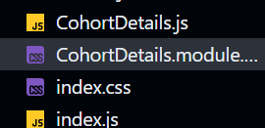

1. Added the css code as instructed,

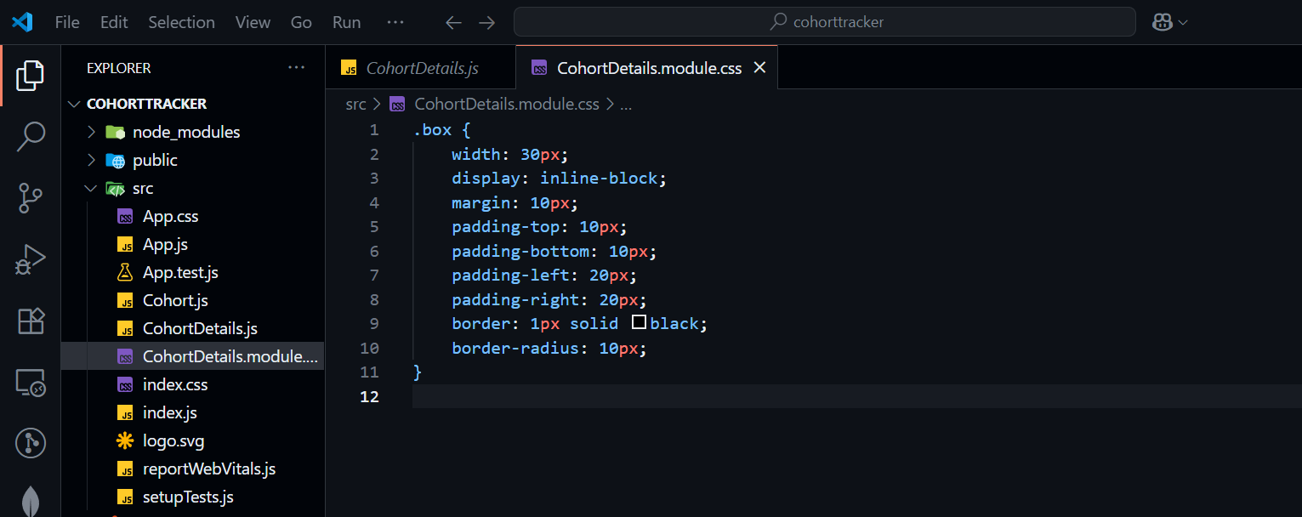

1. Defined style for <dt> tag using tag selector

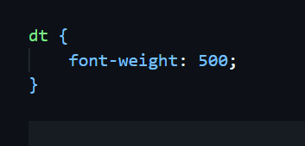

1. Imported this css module into cohort details file

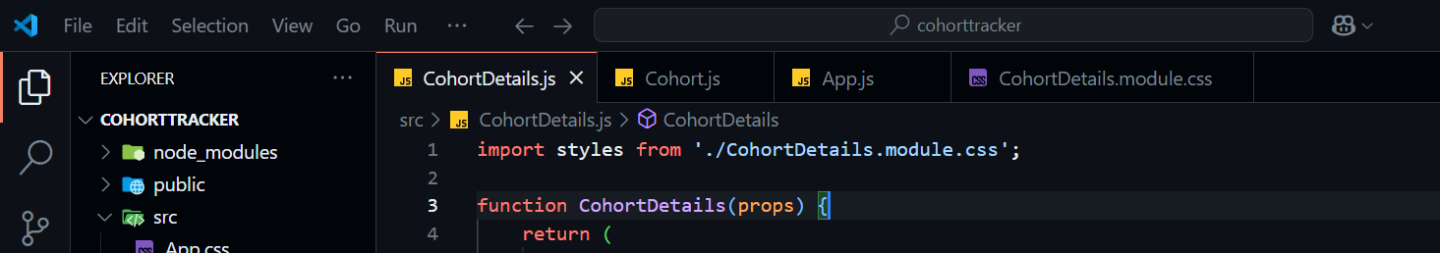

1. Applied “box” class to container div

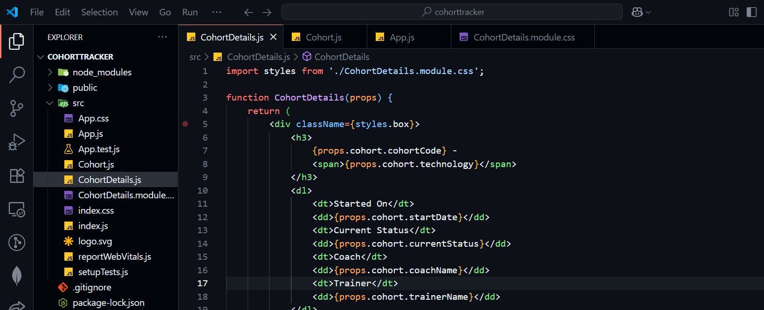

1. Defined the color accordingly for h3 element

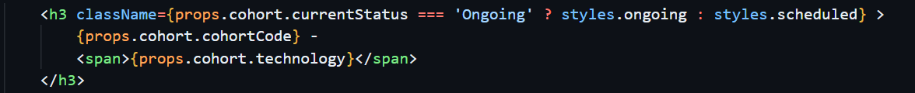

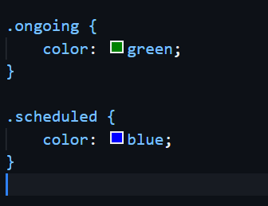

1. The server runs successfully

