***Linux Administration Essentials***

***Assignment Day 6***

***Name:- Sayan Mondal***

1. **Use ps to search for the “systemd” process by name.**

**Ans:- Use ps to search the process “system”.**

**# ps -e | grep systemd**

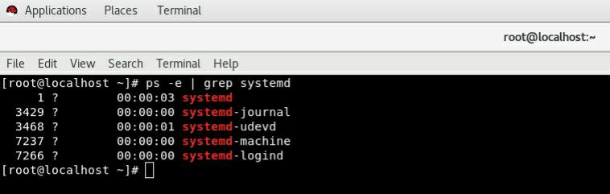

1. **Find out your terminal name.Using your terminal name, use ps to find all processes associated.**

**Ans:- Type who to check who am I. Then type tty. Then type ps -e | grep “pts/0”**

**# who**

**# tty**

**# ps -e | grep “pts/0”**

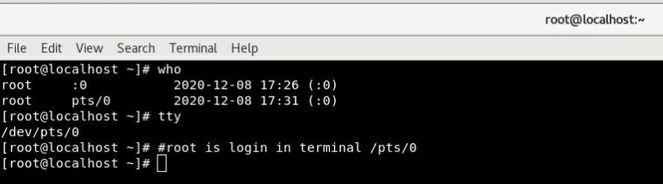**#/pts/0 is login terminal for root here**

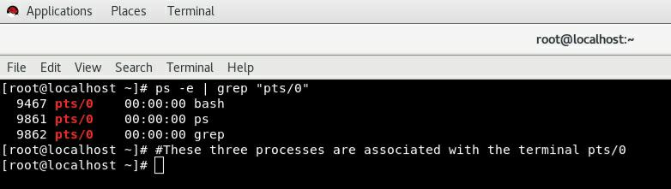

1. **Check and note the process id of your shell(from the output of the above command).**

**Ans:- Then check the process ID. The parent process Id is 9467 and the child process ID is 9460**

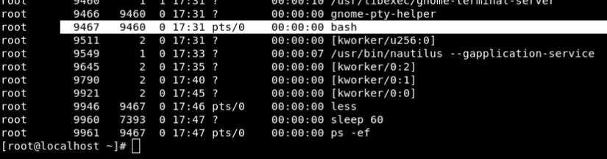

1. **Start 3 instances of “sleep 123” as background processes.**

**Ans:- Type sleep 123 to start 3 background process.**

**# sleep 123**

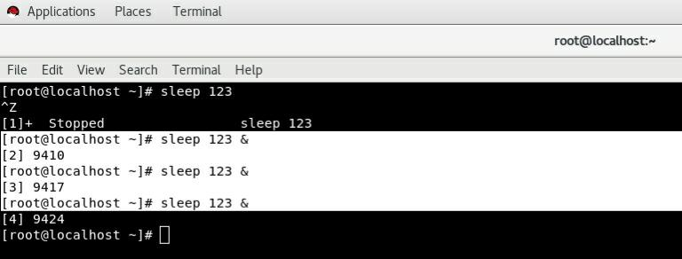

1. **Check and note the process id’s of all sleep processes.**

**Ans:- Check all the process id’s of all sleep processes.**

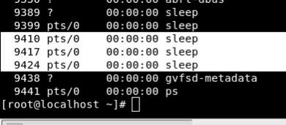

**6.Display only those three sleep processes in top. Then quit top.**

**Ans:- To display three sleep processes with top command and the quit top using ctrl+c.**

**# top -b | grep sleep**

