***Linux Administration Essentials***

***Assignment Day 8***

***Name:- Sayan Mondal***

1. Create a simple shell script to tell the user about their session – they need to know:

●What their username is

●What the current date is

●What the time is

●What their current working directory is

●How many files they have in that directory

●What is the biggest file in their current directory

Ans:- Create session.sh file with vi editor

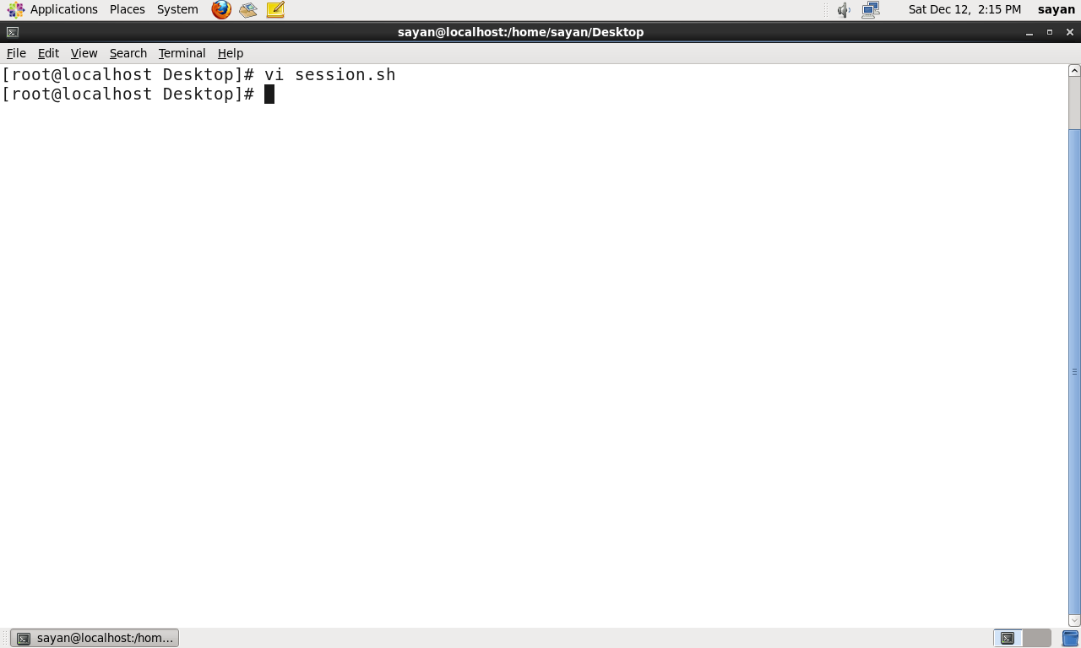

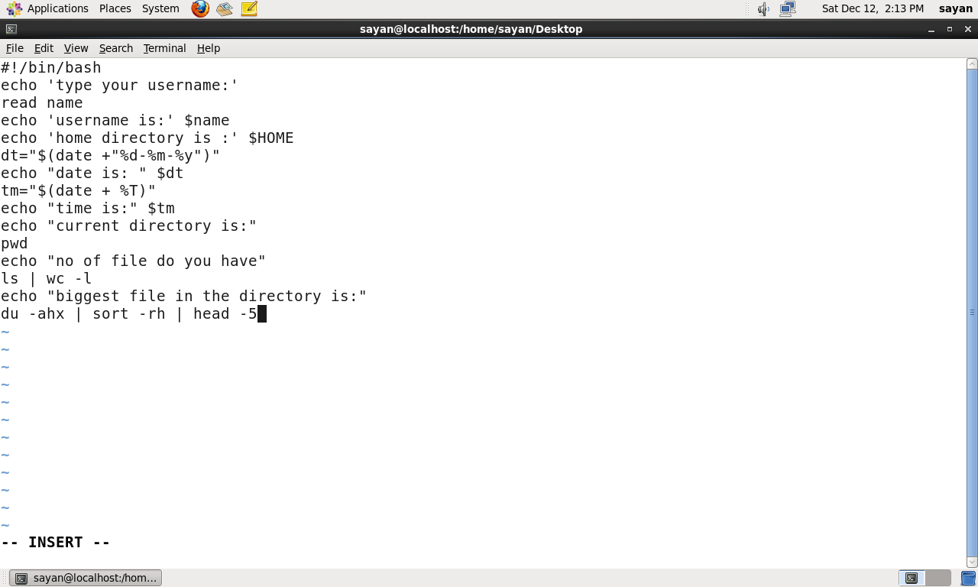

After writing the program give the permission of this file and execute it as a bash file.

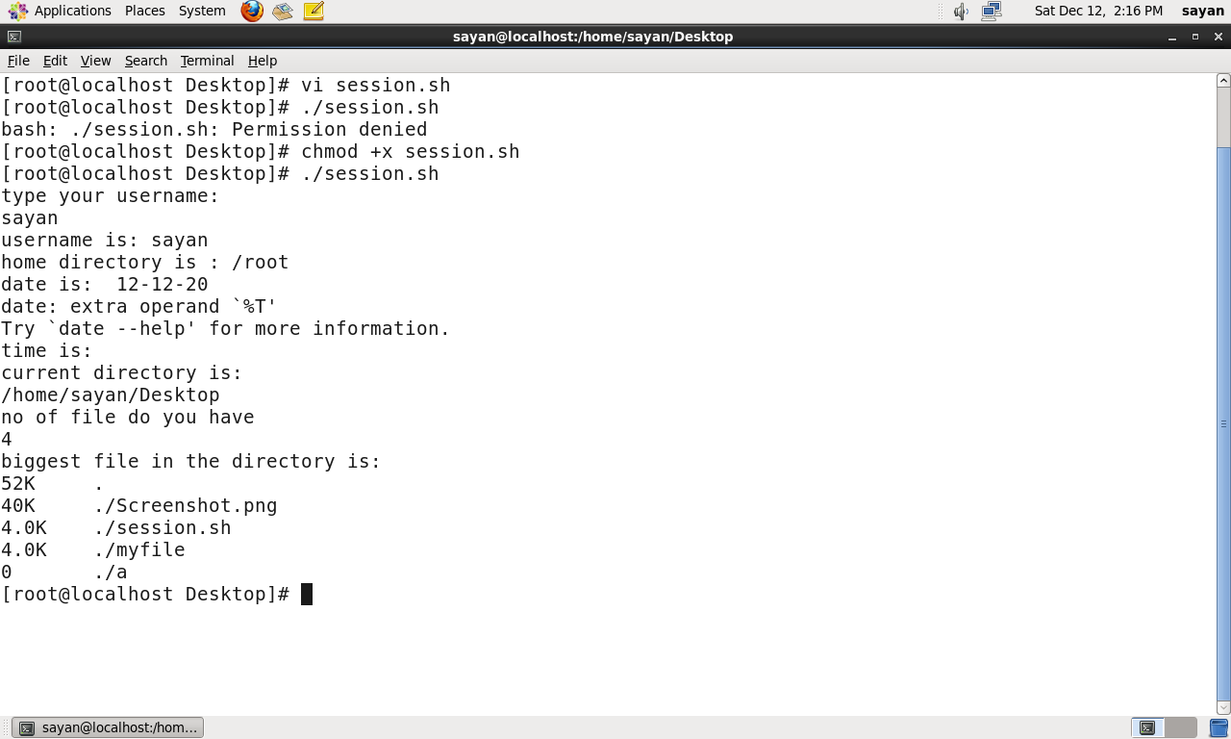

2. Create a directory with a few test files in it (the files can be empty). Now write a script that for every file in that directory you rename it to have an extension of today's date in YYYYMMDD format.

Ans:- Make a directory and into it create 3 files

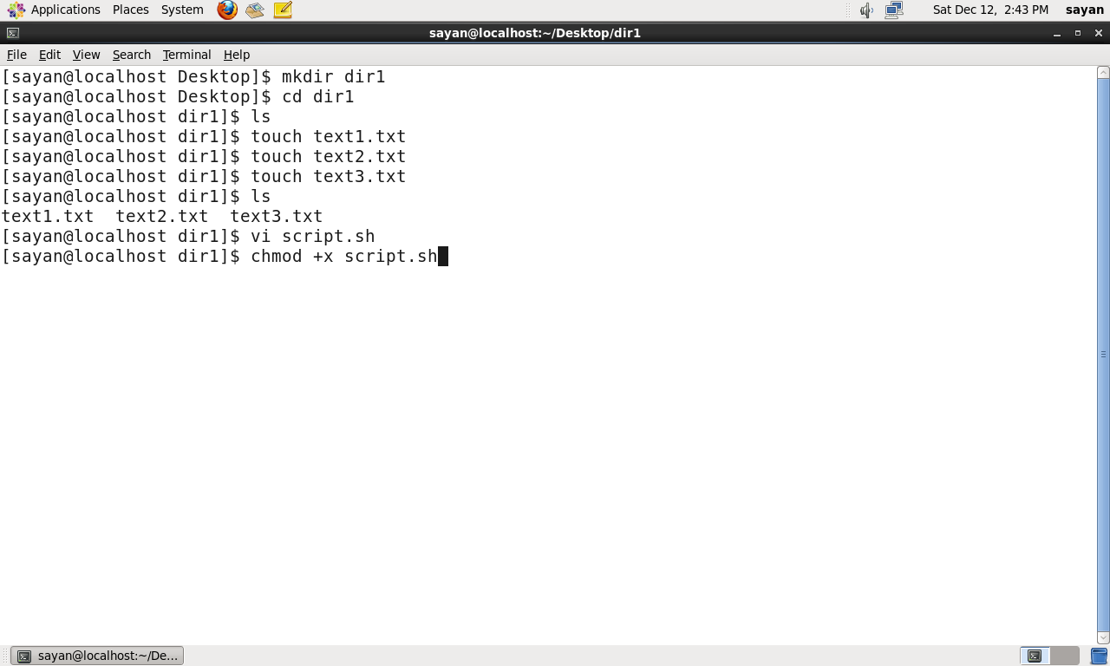

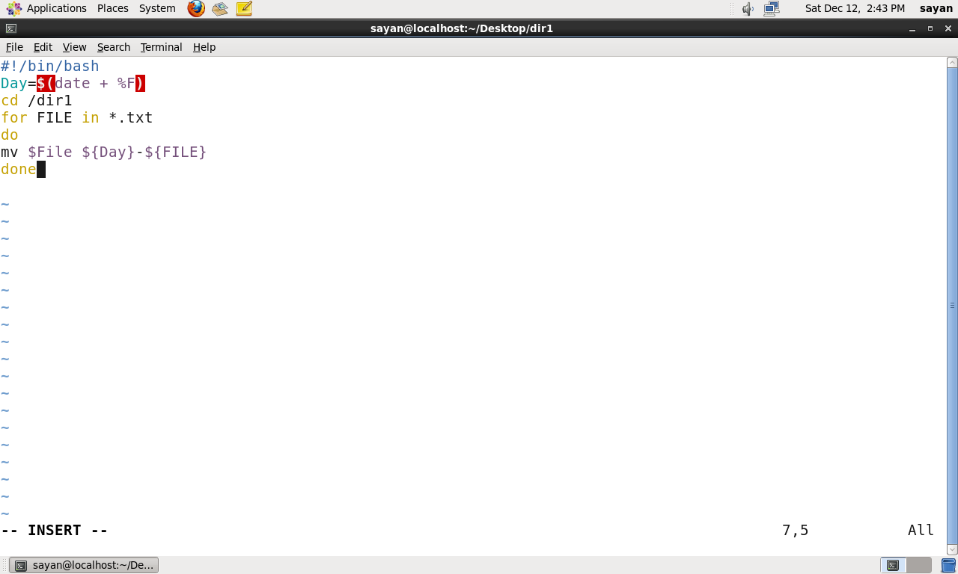

After writing the program give the permission of this file and execute it as a bash file.

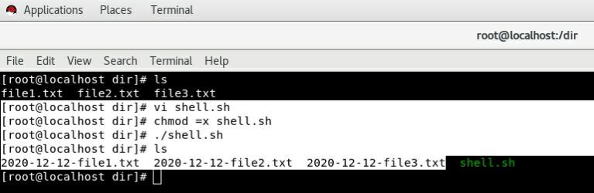

3. Write a script that takes a number as an input and reverses it out to the user. For example, if theoriginal number is 74985, the output should be 58947.

Ans:-

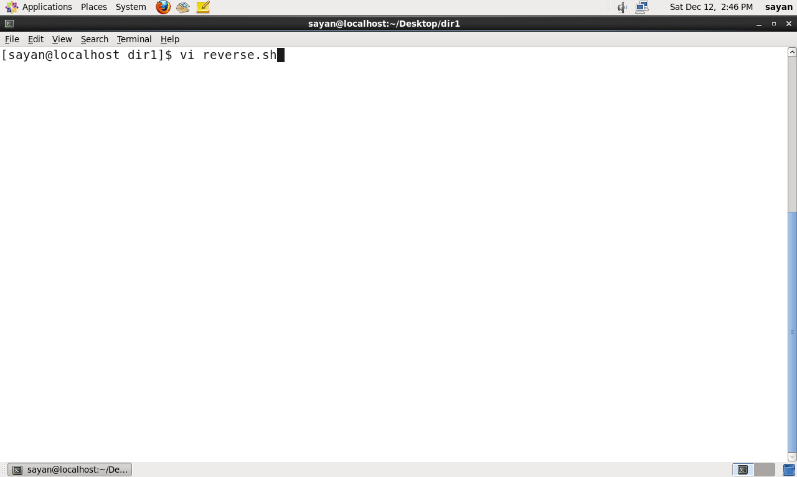

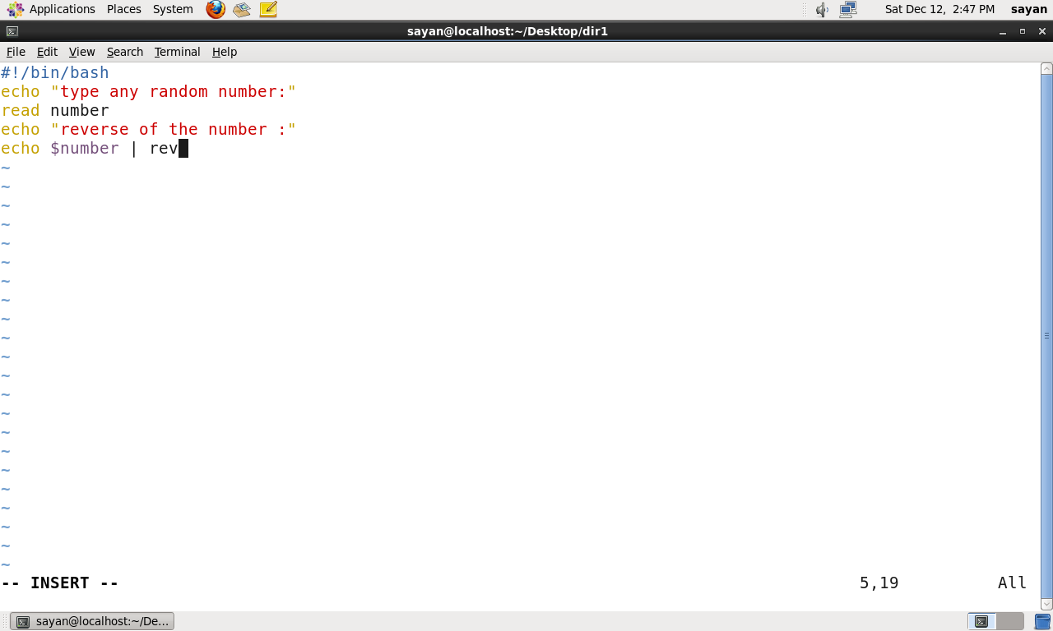

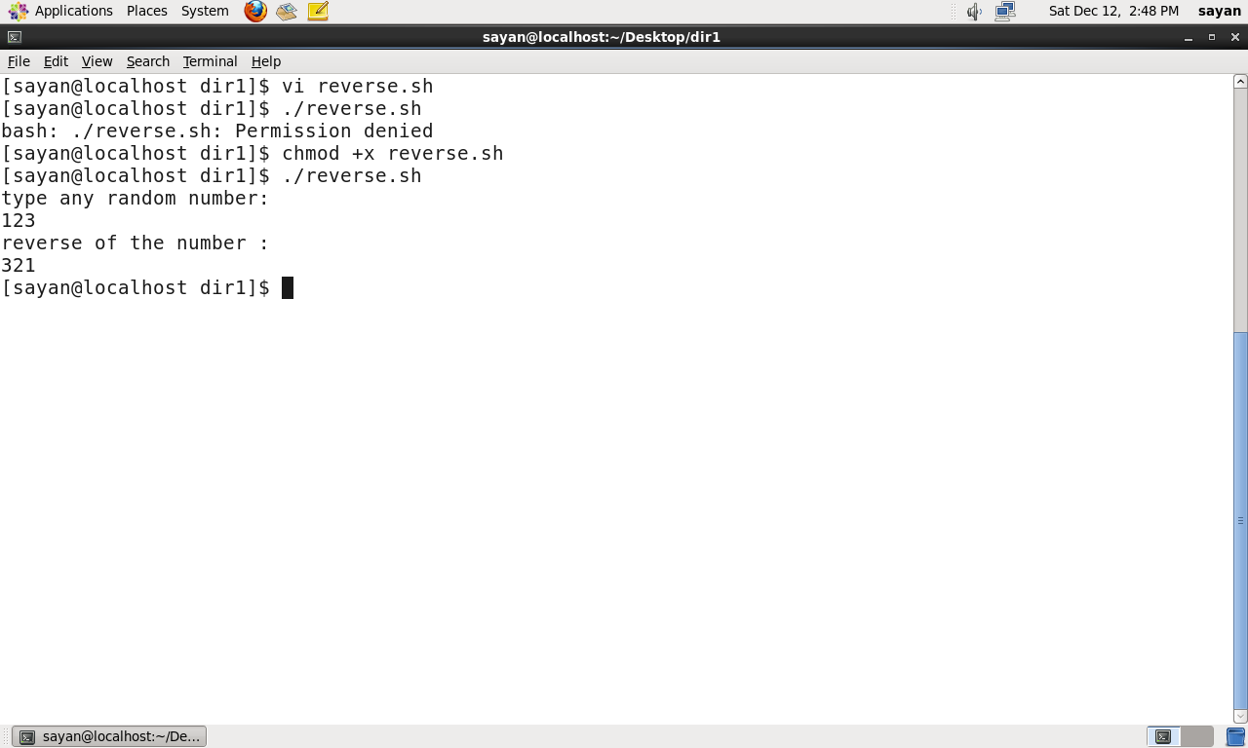

After writing the program give the permission of this file and execute it as a bash file.

4. Write a script to validate how secure someone's password is. Things you would care about:

●Length should be 8 or more characters

●The password should contain numbers and letters

●There should be both uppercase and lowercase letters

Ans:-

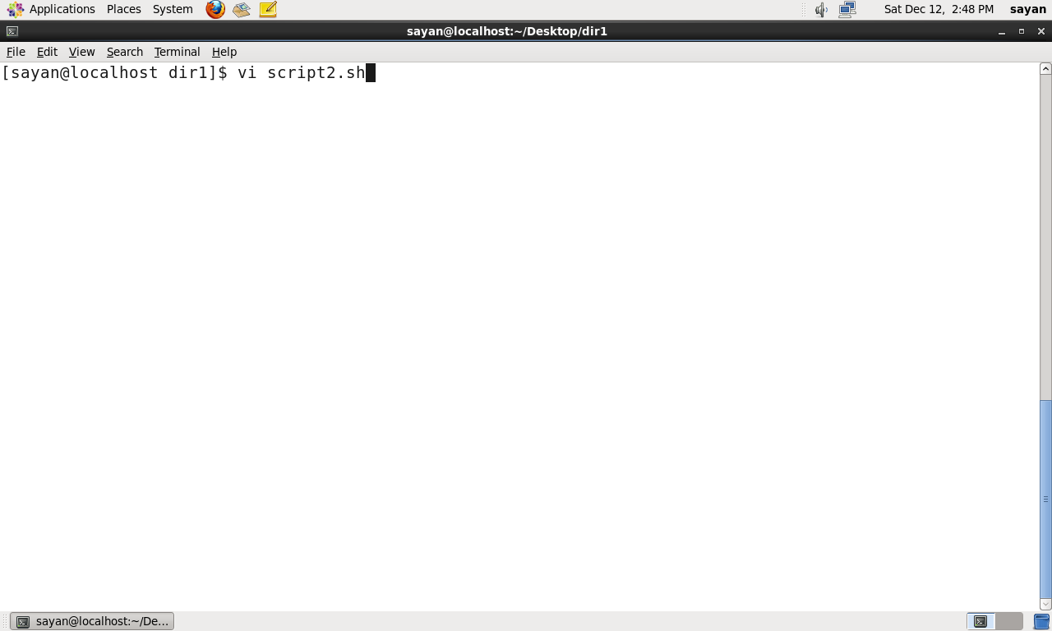

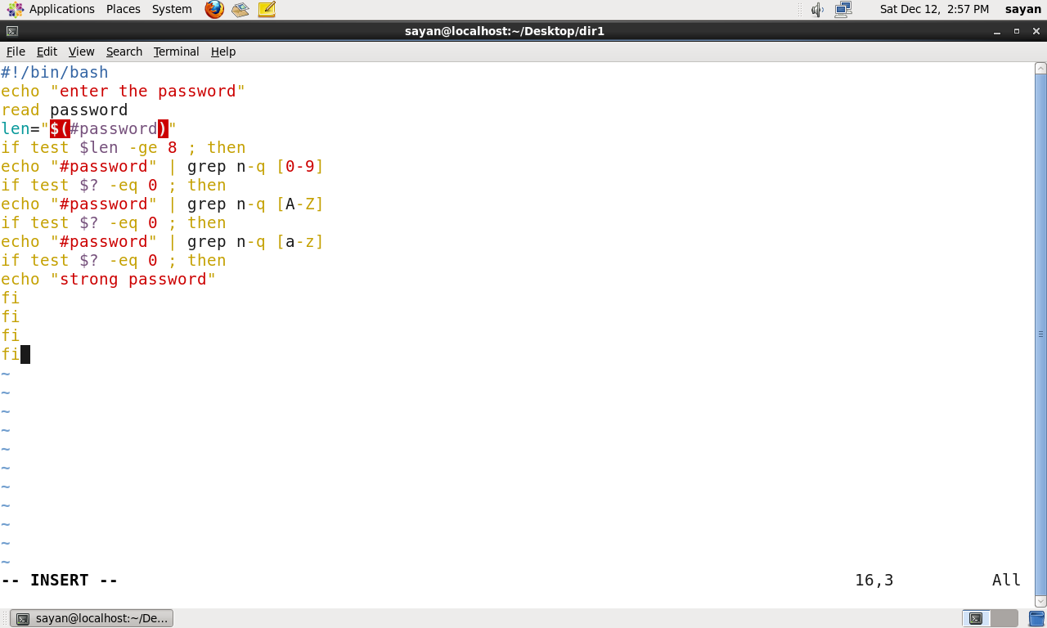

After writing the program give the permission of this file and execute it as a bash file.

