***Linux Administration Essentials***

***Assignment Day 3***

***Name:- Sayan Mondal***

1. Create a blank file named "myfile

Ans:- Frist of all we have to open any linux system like centos, ubuntu etc. Then open the terminal and set the path Desktop and then create a blank file named “myfile” with the touch command.

# Touch myfile

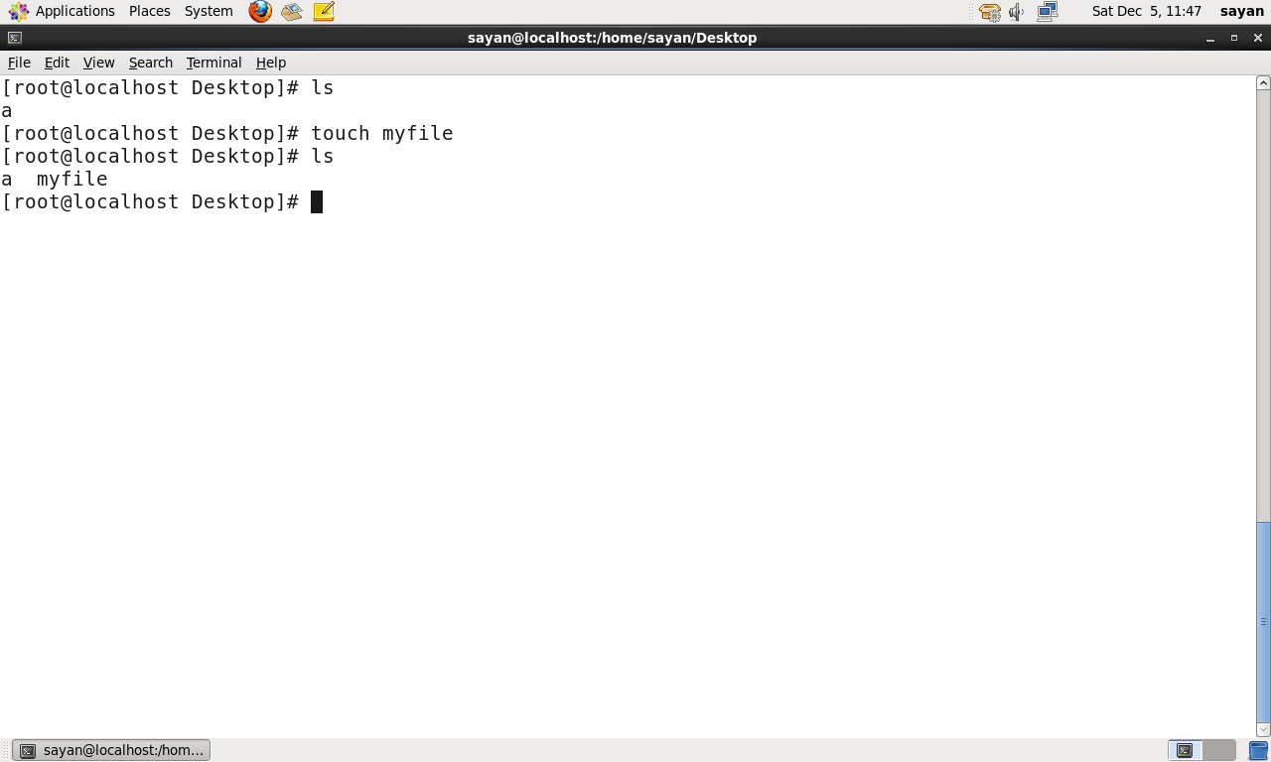

1. Open "myfile" in vi editor

Ans:- After creating the file open the blank file with vi editor.

# Vi myfile

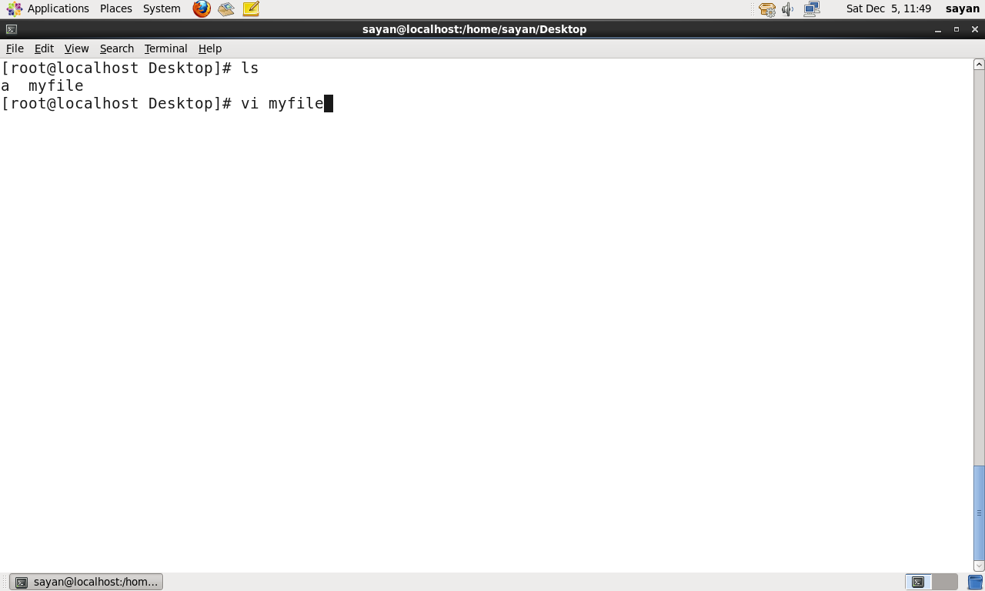

1. Write your name, address, email id, phone number and blood group in 5 different lines.

Ans:- Then I have to write something in the blank file so, for insert have to press i. and then start typing.

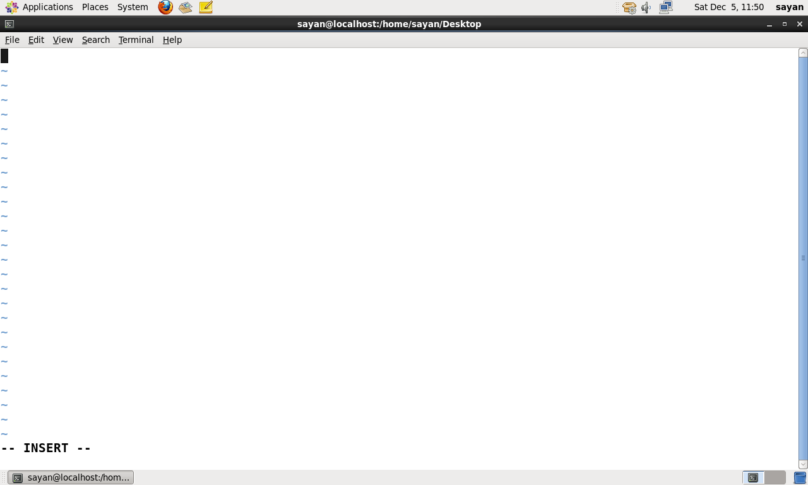

Then type name, address, email-id, phone-no., blood group in 5 different lines. And we have to press “esc + :wq!” for save and exit from the vi editor.

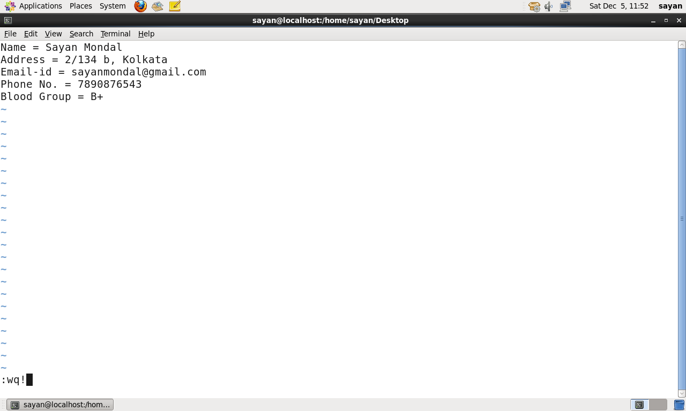

1. Build one single expression to see the line with your name and blood group in myfile.

Ans:- To build one single expression to se the line with my name and blood group in my file type .

# Head -n 1 myfile && tail -n 1 myfile

