***Linux Administration Essentials***

***Assignment Day 5***

***Name:- Sayan Mondal***

1. **Add a 10GB disk to the CentOS.**

Ans:- We have to add a hdd of 10GB using settings option in vmware. Clink on settings then click add hdd and add a hdd of 10GB and click store virtual device into a single file and then click finish.

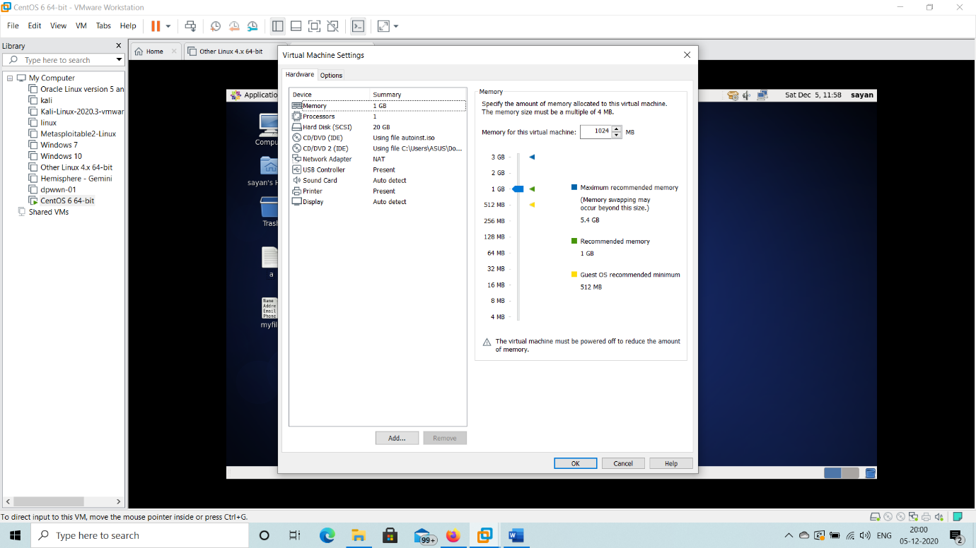

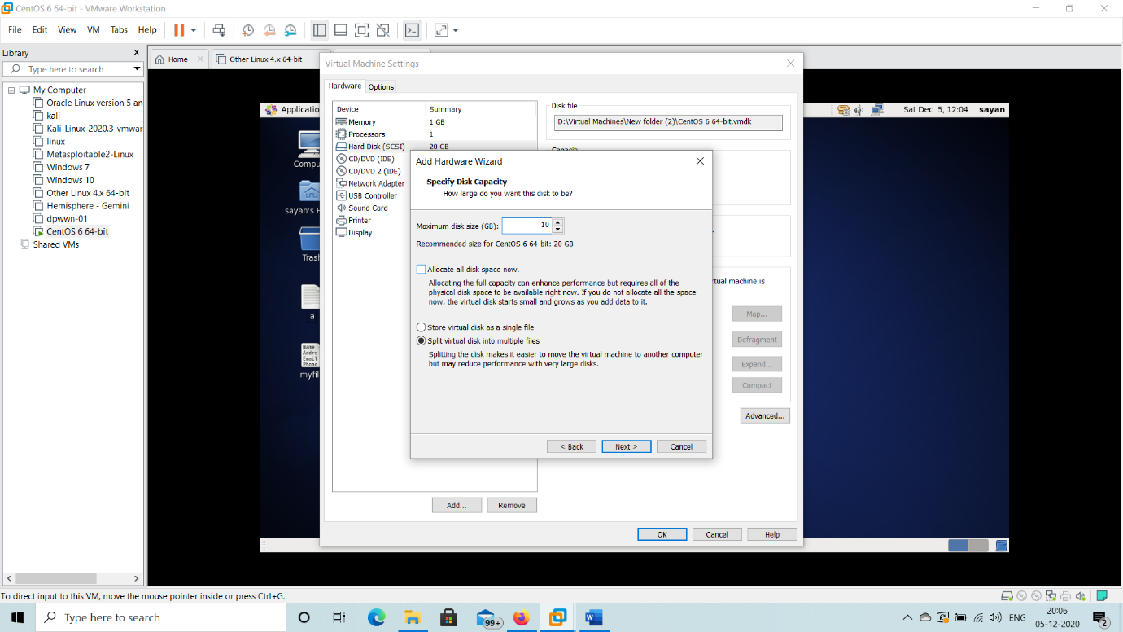

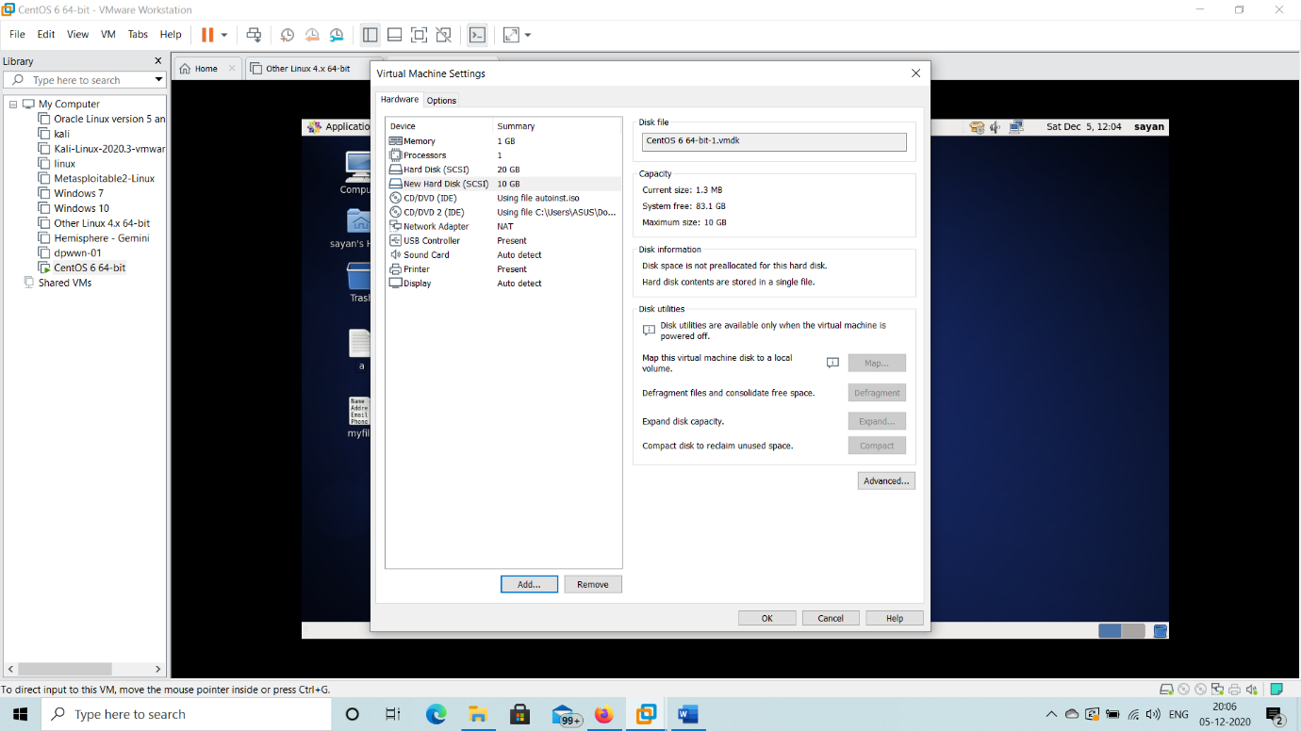

1. **Create 2 Partitions 4GB and 6GB of Space respectively**.

Ans:- Then check the disk available in the linux system using lsblk command.

# lsblk

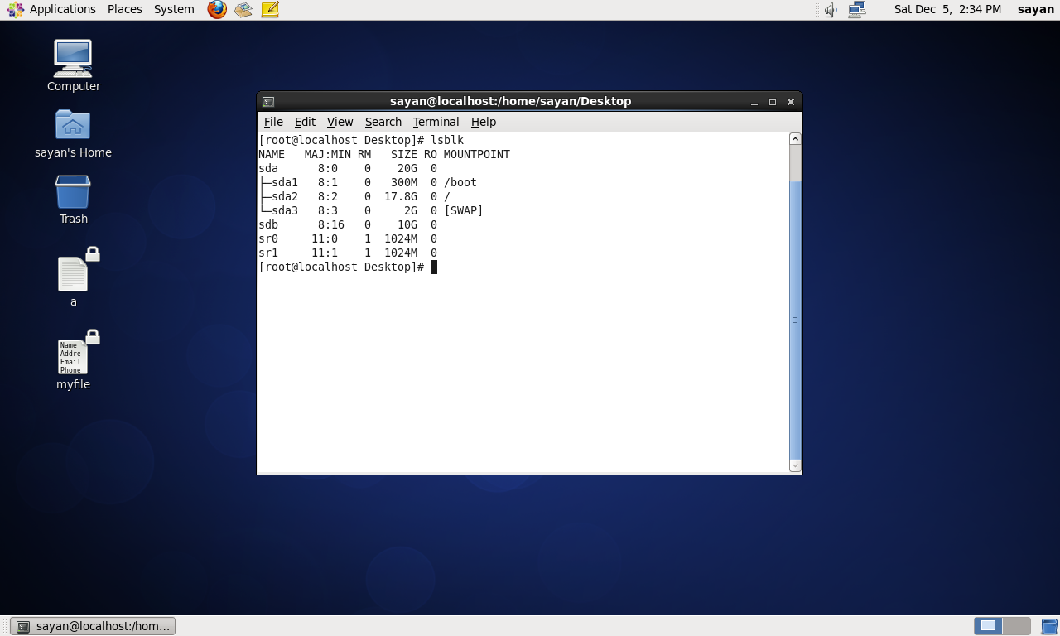

There are two disk one is sda and sdb. Sdb is the newly added disk. Now I have to create 2 partitions 4GB and 6GB space respectively using parted command.

# parted

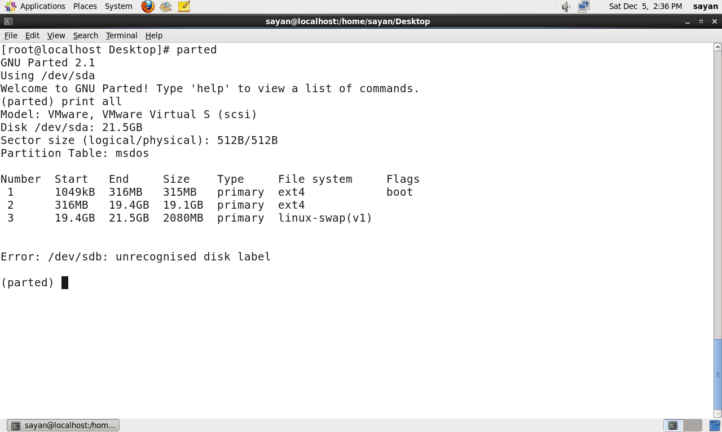

To make a partition table on sdb type mktable gpt

# mktable gpt

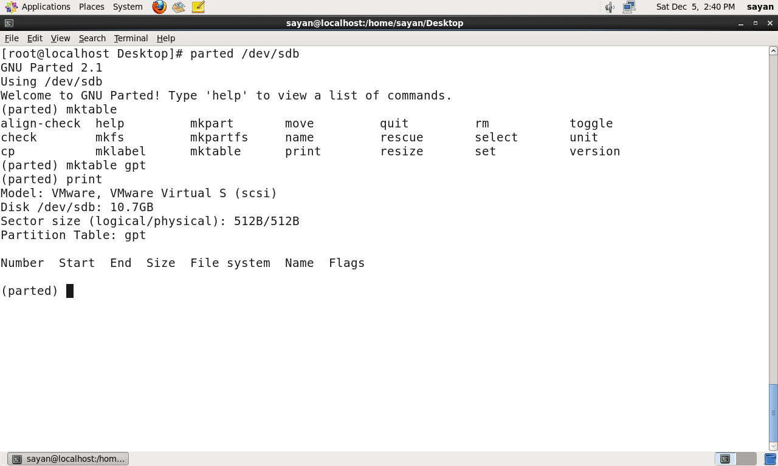

Then make 2 prtitions for sdb1 and sdb2

# mkpart primary xfs 1MB 4GB

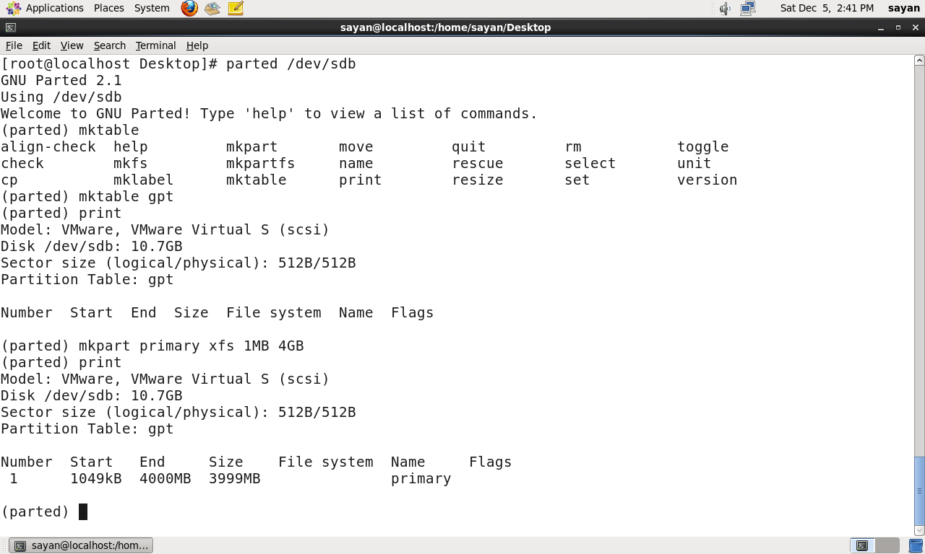

# mkpart primary xfs 4GB 10GB

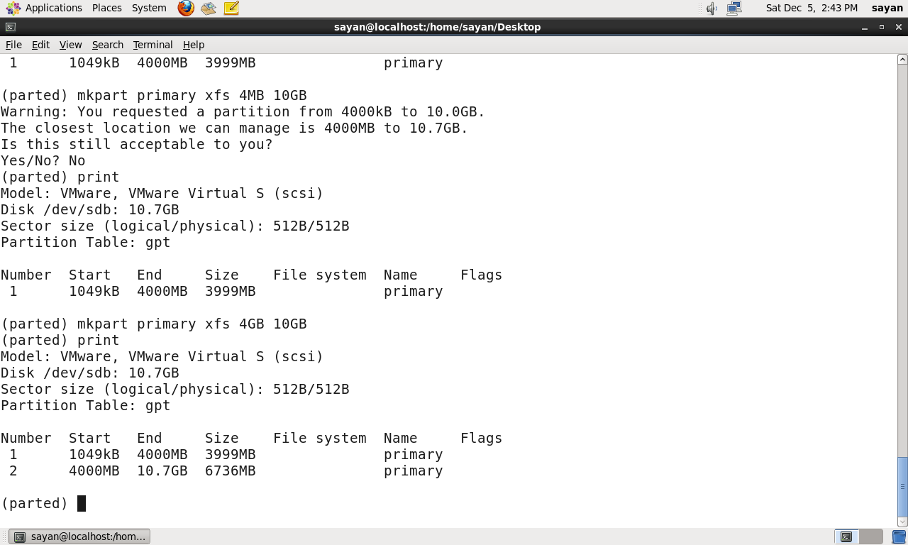

1. **Format 4GB with xfs and 6GB with ext4 file system.**

Ans:- Xfs file is not supported that’s why we ext4 for both the partitions.

# mkfs.ext4 /dev/sdb1

# mkfs.ext4 /dev/sdb2

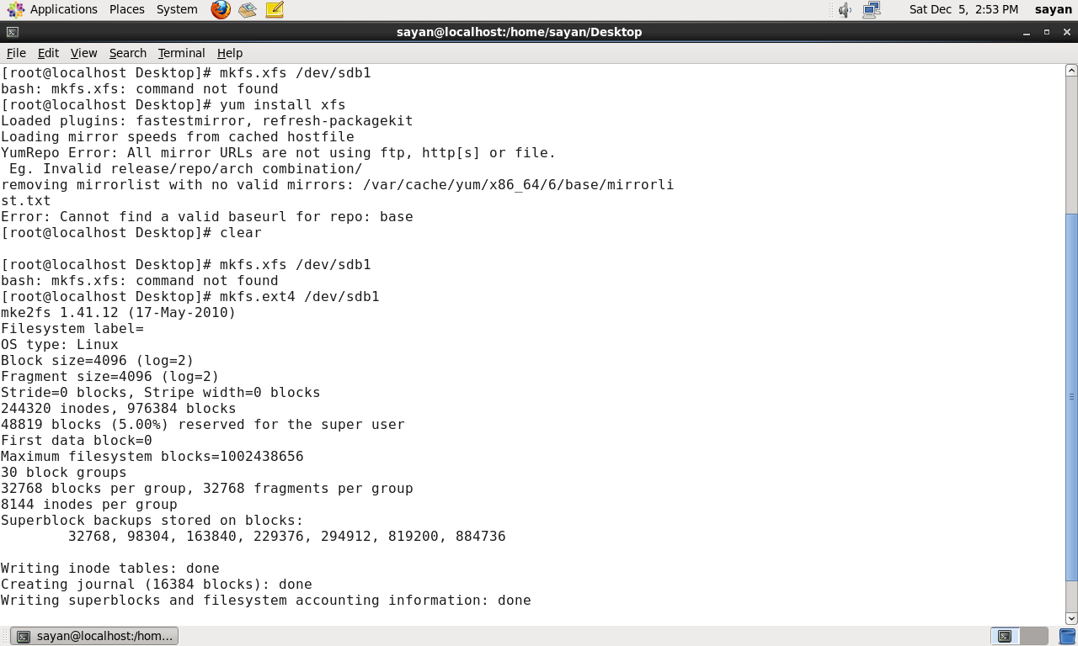

1. **Mount 4GB and 6GB in /data and /music directory respectively**.

Ans:- Create 2 directories using mkdir data and music

# mkdir /data

# mkdir /music

Then mound sdb1 to data and sdb2 to music

# mount /dev/sdb1 /data

# mount /dev/sdb2 /music

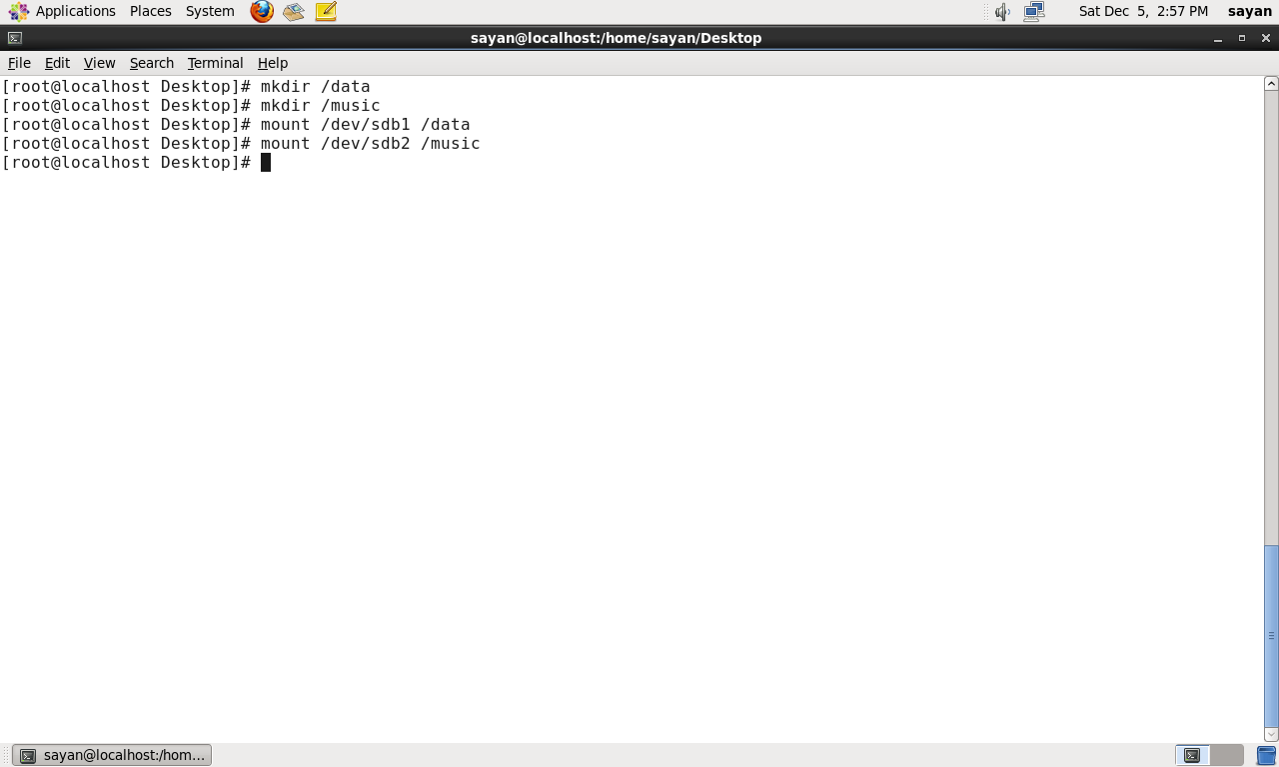

Edit the fstab file for the 2 partitions.

# vi /etc/fstab

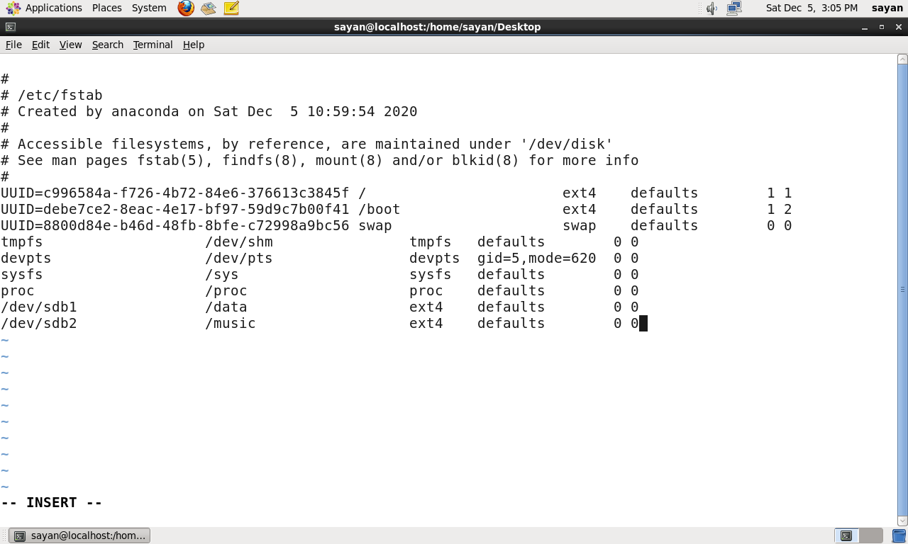

Check the disk consumption using df -hT

# df -hT

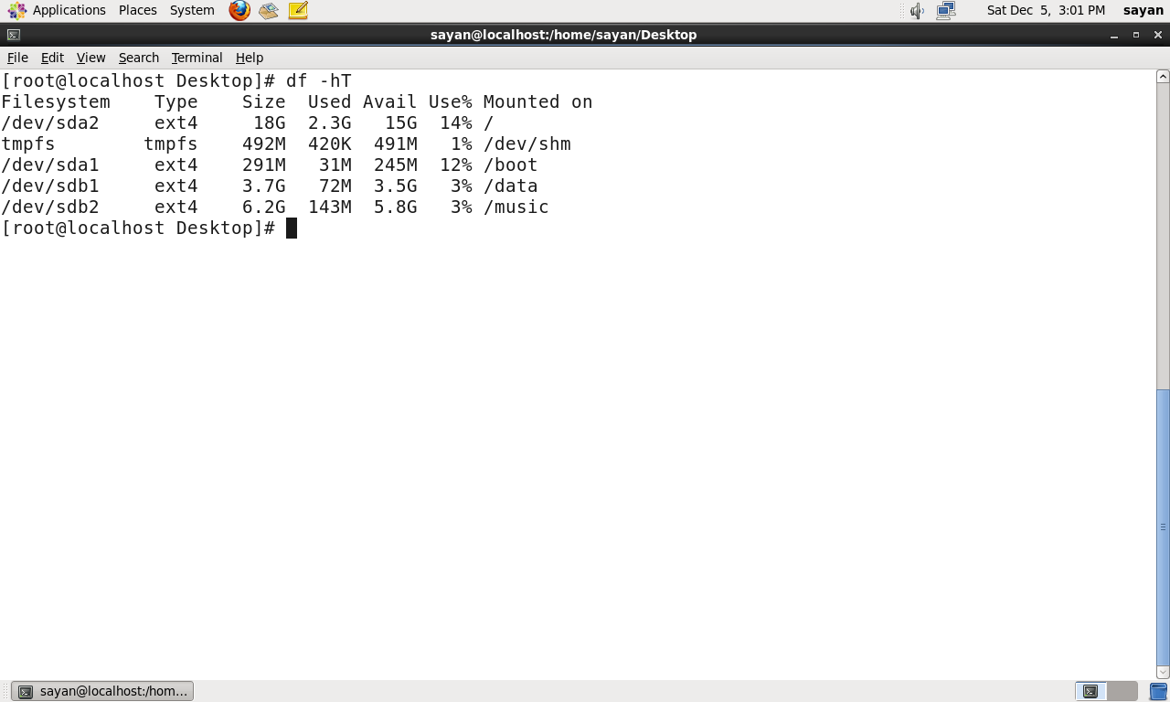

1. **Create one file of 1GB in each of the mount point created above**.

Ans:- create 1 GB file in each mountpoint

# seq 10000000000 > /data/sd1

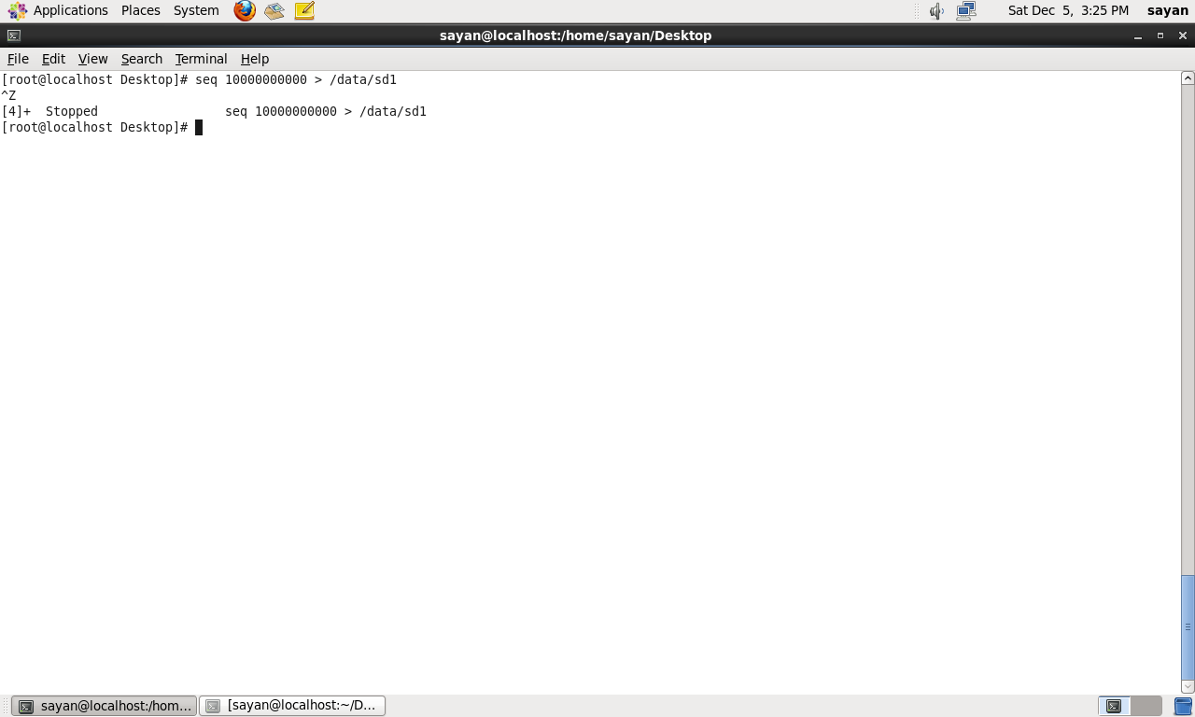

# seq 10000000000 > /music/sd2

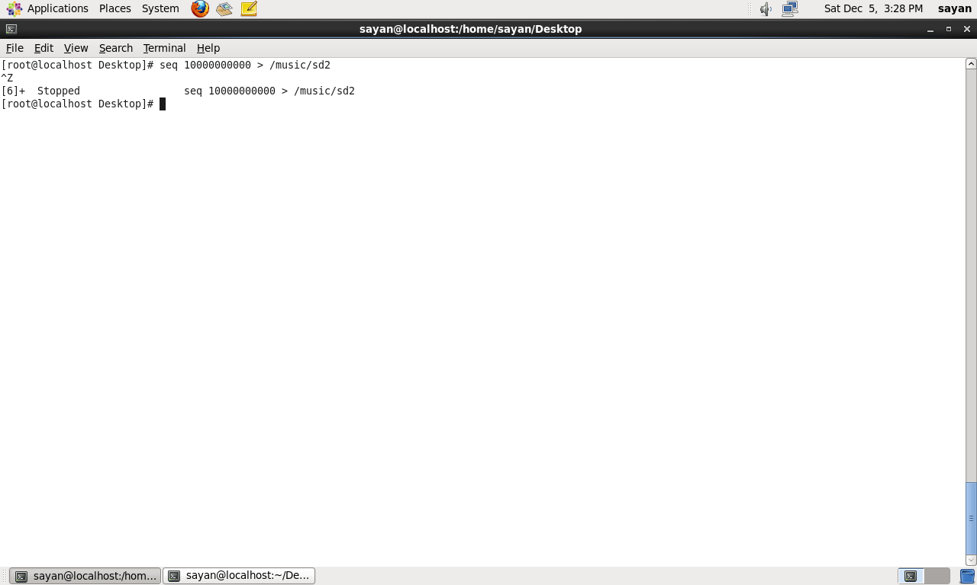

1. **Verify the disk Consumption and disk space free in the mounted partitions.**

Ans:- To check disk consumption type

# df -hT

