**Track**: *Salesforce Developer (SmartBridge - APSCHE)*

**Project Name**: *Garage Management System*

**Team ID**: LTVIP2025TMID28862

1. Munganda.Koushik (22P31A4226)

2. Sayan Das (22P31A4237)

3. Sayyad Mohammed Jafar Hussain (22P31A4238)

4. Rongala Meghana (22P31A42B4)

**College Name**: Aditya College of Engineering & Technology

**GARAGE MANAGEMENT SYSTEM**

**1. INTRODUCTION**

**1.1 Project Overview**

This project outlines the development and implementation of a comprehensive Garage Management System built on the Salesforce platform. The primary objective is to modernize and streamline the operational processes of an automotive service and repair garage. Traditional garage management often relies on fragmented systems, manual record-keeping, and disjointed communication, leading to inefficiencies, customer dissatisfaction, and revenue loss. This Salesforce-based solution aims to centralize critical business functions, including customer relationship management (CRM), vehicle service tracking, appointment scheduling, inventory management for parts, and staff allocation. By leveraging Salesforce's robust cloud capabilities, the system will provide a unified view of all garage operations, enhance data accessibility, and enable automation of key workflows. The project encompasses the design of custom objects, automation rules, user interfaces, and reporting dashboards tailored specifically for the automotive service industry, ensuring a scalable and adaptable solution for modern garage operations.

**1.2 Purpose**

The purpose of this Garage Management System in Salesforce is multi-faceted:

* **Enhance Operational Efficiency:** To automate and optimize daily garage operations, from initial customer inquiry and service booking to vehicle pickup and post-service follow-ups, thereby reducing manual effort and processing times.
* **Improve Customer Satisfaction:** To provide a seamless customer experience through efficient appointment scheduling, transparent service updates, accurate billing, and personalized communication, fostering loyalty and repeat business.
* **Centralize Data Management:** To consolidate all customer, vehicle, service history, and inventory data into a single, accessible platform, eliminating data silos and ensuring data consistency and accuracy across the organization.
* **Boost Productivity and Resource Utilization:** To enable better management of technicians, service bays, and parts inventory, ensuring optimal resource allocation and maximizing the number of service jobs completed efficiently.
* **Gain Actionable Insights:** To provide robust reporting and analytics capabilities, allowing garage management to monitor key performance indicators (KPIs), identify trends, forecast demand, and make data-driven business decisions.
* **Ensure Scalability and Future Growth:** To establish a flexible and scalable foundation using Salesforce that can easily adapt to evolving business needs, new service offerings, and future technological advancements without significant re-development.

**2. IDEATION PHASE**

**2.1 Problem Statement**

The existing operational framework of the garage suffers from several key inefficiencies that impede growth, customer satisfaction, and overall profitability. Manual processes dominate critical functions such as appointment scheduling, vehicle intake, service history tracking, and inventory management. This leads to frequent booking conflicts, lost paperwork, inaccurate service records, and difficulties in tracking parts availability. Communication between technicians, service advisors, and customers is often fragmented, resulting in misunderstandings and delays. Without a centralized system, management lacks real-time insights into operational performance, technician workload, and financial metrics. The absence of automated reminders for services and follow-ups results in missed opportunities for repeat business. This fragmented and manual approach ultimately leads to increased operational costs, reduced customer trust, and an inability to scale services efficiently in a competitive market.

I will now continue to the next sub-section under Ideation Phase.

**2.2 Empathy Map Canvas**

To understand the key stakeholders involved in a garage management system, an Empathy Map Canvas helps visualize their perspectives, needs, and pain points.

* **Who are we empathizing with?**
  + Garage Owner/Manager
  + Service Advisor
  + Automotive Technician
  + Customer (Vehicle Owner)
* **SAYS:**
  + **Owner/Manager:** "I need better visibility into daily operations and profitability." "We're losing track of parts inventory." "Technician scheduling is a nightmare."
  + **Service Advisor:** "I spend too much time on the phone scheduling appointments manually." "It's hard to find accurate customer service history quickly." "Customers complain about waiting times."
  + **Technician:** "I don't always have the right parts when I need them." "Paperwork takes too long." "I need clear work orders."
  + **Customer:** "When will my car be ready?" "Why is my bill so high?" "I wish they would remind me about my next service." "It's hard to get through to them."
* **THINKS:**
  + **Owner/Manager:** *How can I optimize resource allocation?* *Are we maximizing revenue from each service bay?* *How do I retain more customers?*
  + **Service Advisor:** *I hope I didn't double-book that appointment.* *Is the customer going to be upset about the delay?* *How can I upsell services effectively?*
  + **Technician:** *What's the actual problem with this car?* *Do we have this part in stock?* *I wish the work order was clearer.*
  + **Customer:** *Is this garage trustworthy?* *Am I getting a fair price?* *I hope they fix it right the first time.*
* **FEELS:**
  + **Owner/Manager:** Stressed, overwhelmed, anxious about efficiency and profitability.
  + **Service Advisor:** Frustrated by manual tasks, stressed by customer complaints, overwhelmed by chaotic schedules.
  + **Technician:** Annoyed by lack of tools/parts, pressured by time constraints, sometimes unappreciated.
  + **Customer:** Impatient, uncertain, sometimes frustrated by lack of transparency, relieved when car is fixed.
* **DOES:**
  + **Owner/Manager:** Reviews financial reports manually, tries to manage staff schedules, orders parts haphazardly.
  + **Service Advisor:** Juggles multiple phone calls, manually updates whiteboards, searches physical files for records.
  + **Technician:** Diagnoses vehicles, performs repairs, fills out paper work orders, waits for parts.
  + **Customer:** Calls for appointments, waits for updates, picks up vehicle, pays bills.
* **PAINS:**
  + **Owner/Manager:** Lack of real-time insights, inefficient resource allocation, revenue leakage, high administrative burden.
  + **Service Advisor:** Manual scheduling errors, difficult access to customer/vehicle history, high call volumes, customer complaints.
  + **Technician:** Waiting for parts, unclear work instructions, time wasted on paperwork.
  + **Customer:** Long waiting times, lack of communication, unclear pricing, difficulty scheduling.
* **GAINS:**
  + **Owner/Manager:** Increased profitability, optimized operations, better customer retention, scalable business.
  + **Service Advisor:** Streamlined scheduling, instant access to data, improved customer communication, reduced stress.
  + **Technician:** Clear work orders, timely parts availability, less paperwork, efficient workflows.
  + **Customer:** Convenient booking, transparent updates, reliable service, trust in the garage.

I will now continue to the next sub-section under Ideation Phase.

**2.3 Brainstorming**

Building on the problem statement and empathy map, a brainstorming session identifies potential features and solutions for a Salesforce-based Garage Management System. The focus is on leveraging Salesforce's capabilities to address the identified pain points and deliver the desired gains.

**Key Brainstorming Areas & Potential Solutions:**

* **Customer Relationship Management (CRM):**
  + **Solution:** Utilize Salesforce's standard Account and Contact objects for customer profiles.
  + **Enhancements:** Custom fields for vehicle ownership details (make, model, VIN, year), preferred service history, communication preferences.
  + **Benefit:** Centralized customer data, personalized communication, easier tracking of customer interactions.
* **Appointment & Scheduling Management:**
  + **Solution:** Implement Salesforce Service Cloud's capabilities or build custom objects/flows for appointment scheduling.
  + **Enhancements:** Online booking portal, automated reminders (SMS/Email), drag-and-drop calendar for service advisors, integration with technician availability.
  + **Benefit:** Reduced manual scheduling errors, improved customer convenience, optimized bay and technician utilization.
* **Vehicle & Service History Tracking:**
  + **Solution:** Create custom objects for "Vehicles" and "Service Appointments/Work Orders."
  + **Enhancements:** Link vehicles to customer accounts, track all services performed, parts used, labor hours, and future service recommendations. Digital vehicle inspection checklists.
  + **Benefit:** Comprehensive service records, accurate diagnostics, proactive maintenance suggestions.
* **Inventory & Parts Management:**
  + **Solution:** Utilize custom objects for "Parts Inventory" and "Purchase Orders."
  + **Enhancements:** Real-time stock levels, low-stock alerts, automated reorder triggers, supplier management, integration with service orders to deduct parts automatically.
  + **Benefit:** Reduced stockouts, optimized inventory costs, efficient parts procurement.
* **Work Order & Job Management:**
  + **Solution:** Custom objects for "Work Orders" linked to service appointments and vehicles.
  + **Enhancements:** Digital checklists for technicians, progress tracking (e.g., In Progress, Waiting for Parts, Completed), electronic sign-offs, photo/video attachment for repairs.
  + **Benefit:** Clear instructions for technicians, real-time job status, improved accountability.
* **Quoting & Invoicing:**
  + **Solution:** Leverage Salesforce CPQ (Configure, Price, Quote) or build custom quoting functionality.
  + **Enhancements:** Automated calculation of labor and parts, digital quotes sent to customers for approval, integration with accounting systems for invoicing.
  + **Benefit:** Transparent pricing, faster quote generation, reduced billing errors.
* **Reporting & Analytics:**
  + **Solution:** Utilize Salesforce's native reporting and dashboard capabilities.
  + **Enhancements:** Dashboards for daily appointments, technician workload, revenue per service, inventory turnover, customer retention rates.
  + **Benefit:** Data-driven decision making, identification of operational bottlenecks, performance monitoring.
* **Communication & Notifications:**
  + **Solution:** Implement Salesforce Email, SMS (via integration), and Chatter.
  + **Enhancements:** Automated service reminders, service status updates to customers, internal notifications for technicians/advisors.
  + **Benefit:** Improved customer satisfaction, streamlined internal communication.

I will now continue to **Section 3. REQUIREMENT ANALYSIS**.

**3. REQUIREMENT ANALYSIS**

**3.1 Customer Journey Map**

A customer journey map for the Garage Management System in Salesforce illustrates the typical path a customer takes, highlighting touchpoints, emotions, and opportunities for improvement through the new system.

**Phase 1: Awareness & Need Identification**

* **Customer Action:** Realizes vehicle needs service (e.g., oil change due, unusual noise).
* **Pain Points:** Forgets service intervals, struggles to find a reliable garage, difficulty knowing what service is needed.
* **System Opportunity:** Automated service reminders from past visits, online presence (website/social) promoting services.

**Phase 2: Research & Booking**

* **Customer Action:** Searches for garage services, tries to book an appointment.
* **Pain Points:** Hard to reach garage by phone, limited booking hours, no clear availability, unknown pricing.
* **System Opportunity:** **Online Appointment Booking Portal (Salesforce Community/Website Integration):** Real-time availability, service menu with estimated costs, automated confirmation emails/SMS.
* **Garage Action (Service Advisor):** Receives appointment request.
* **System Opportunity:** Automated scheduling into Salesforce calendar, immediate customer notification.

**Phase 3: Vehicle Drop-off & Service Intake**

* **Customer Action:** Arrives at garage, explains issues.
* **Pain Points:** Long wait times, repetitive explanation of issues, unsure of final cost/duration.
* **System Opportunity:** **Quick Check-in (Salesforce Mobile App for Service Advisor):** Instant access to customer/vehicle history, digital service intake form, immediate quote generation and customer digital signature capture.

**Phase 4: Service Execution & Updates**

* **Customer Action:** Waits for updates, concerned about progress.
* **Pain Points:** No communication, delays, surprise issues.
* **System Opportunity:** **Automated Service Status Updates (SMS/Email):** Notifications at each stage (e.g., "Inspection started," "Waiting for parts," "Repair completed"). **Technician Mobile Access:** Updates work order status directly from service bay, attaches photos/videos if needed. **Internal Communication (Salesforce Chatter):** Technicians can collaborate or seek advice, service advisors can quickly check status.

**Phase 5: Pickup & Payment**

* **Customer Action:** Arrives to pick up vehicle, pays bill.
* **Pain Points:** Long checkout lines, unclear billing, manual payment process, no post-service support.
* **System Opportunity:** **Digital Invoicing:** Detailed breakdown of services/parts, integrated payment processing. **Post-Service Follow-up:** Automated feedback surveys, next service reminders.

**Phase 6: Post-Service & Retention**

* **Customer Action:** Drives away, considers future service.
* **Pain Points:** Forgets next service date, no incentive to return.
* **System Opportunity:** **Automated Reminders:** For next oil change, tire rotation, etc. **Marketing Campaigns (Salesforce Marketing Cloud integration):** Personalized offers based on service history, loyalty programs.

I will now continue to the next sub-section under Requirement Analysis.

**3.2 Solution Requirement**

Based on the problem statement, empathy map, and customer journey, the following are the key functional and non-functional requirements for the Garage Management System in Salesforce.

**3.2.1 Functional Requirements**

* **Customer & Vehicle Management:**
  + The system shall allow creation, viewing, editing, and deletion of customer profiles (Accounts & Contacts).
  + The system shall store detailed vehicle information (make, model, year, VIN, license plate, mileage, service history) linked to customer accounts.
  + The system shall support multiple vehicles per customer.
* **Appointment Scheduling:**
  + The system shall allow service advisors to schedule, reschedule, and cancel appointments with real-time availability of service bays and technicians.
  + The system shall provide an online portal for customers to book and manage their appointments.
  + The system shall send automated appointment confirmations and reminders (email/SMS) to customers.
* **Service & Work Order Management:**
  + The system shall enable the creation of digital work orders for each service appointment.
  + Work orders shall capture service details, parts required, labor hours, and estimated/actual costs.
  + The system shall allow technicians to update work order status (e.g., pending, in progress, waiting for parts, completed) via a mobile interface.
  + The system shall support digital vehicle inspection checklists.
* **Inventory & Parts Management:**
  + The system shall track real-time inventory levels of automotive parts.
  + The system shall generate alerts for low stock levels.
  + The system shall allow for the creation of purchase orders for parts replenishment.
  + The system shall automatically deduct parts from inventory upon their use in a work order.
* **Quoting & Invoicing:**
  + The system shall generate professional service quotes including labor and parts costs.
  + The system shall allow customers to digitally approve quotes.
  + The system shall generate invoices based on completed work orders.
* **Reporting & Analytics:**
  + The system shall provide dashboards for key performance indicators (KPIs) such as daily appointments, technician utilization, revenue per service, and customer retention.
  + The system shall allow for custom reports on service history, parts usage, and financial performance.
* **Communication:**
  + The system shall facilitate internal communication among staff (e.g., technician to service advisor) via Chatter.
  + The system shall send automated notifications to customers regarding service status updates.

**3.2.2 Non-Functional Requirements**

* **Performance:**
  + The system shall respond to user requests within 3 seconds for common operations (e.g., loading records, scheduling appointments).
  + The system shall support at least 50 concurrent users without significant performance degradation.
* **Security:**
  + The system shall adhere to Salesforce's robust security model, including role-based access control.
  + All customer and vehicle data shall be encrypted at rest and in transit.
  + User authentication shall require multi-factor authentication (MFA).
* **Usability:**
  + The user interface shall be intuitive and easy to navigate for service advisors, technicians, and managers.
  + The system shall require minimal training for new users.
  + The customer portal shall be user-friendly and accessible on various devices.
* **Scalability:**
  + The system shall be capable of handling a growing number of customers, vehicles, and service appointments without requiring significant re-architecture.
  + The system shall support future integrations with other business applications (e.g., accounting software).
* **Reliability & Availability:**
  + The system shall be available 99.9% of the time, leveraging Salesforce's cloud infrastructure.
  + Data backup and disaster recovery mechanisms shall be in place (inherent to Salesforce platform).
* **Maintainability:**
  + The system configuration and custom development shall follow Salesforce best practices to ensure ease of maintenance and future enhancements.

I will now continue to the next sub-section under Requirement Analysis.

**3.3 Data Flow Diagram**

A Data Flow Diagram (DFD) illustrates how data moves through the Garage Management System in Salesforce, showing processes, data stores, and external entities.

**(Note: As an AI, I cannot directly generate visual diagrams. Below is a textual representation of a Level 0/Context DFD and a Level 1 DFD for key processes.)**

**Level 0 DFD (Context Diagram):**

* **External Entities:**
  + Customer
  + Garage Staff (Service Advisor, Technician, Manager)
  + Supplier / Parts Vendor
  + Payment Gateway (External System)
  + Accounting System (External System)
* **Process:**
  + Garage Management System (Salesforce)
* **Data Flows:**
  + **Customer to System:** Appointment Requests, Service Inquiries, Vehicle Info, Payment Details, Feedback.
  + **System to Customer:** Appointment Confirmations, Service Status Updates, Quotes, Invoices, Service Reminders.
  + **Garage Staff to System:** Service Details, Work Order Updates, Parts Orders, Customer/Vehicle Data Entry, Reports Requests.
  + **System to Garage Staff:** Customer/Vehicle Data, Work Orders, Inventory Levels, Performance Reports, Alerts.
  + **Supplier to System:** Parts Availability, Pricing.
  + **System to Supplier:** Purchase Orders.
  + **Payment Gateway to System:** Payment Confirmation.
  + **System to Payment Gateway:** Payment Request.
  + **Accounting System to System:** Payment Reconciliation (if integration is bi-directional).
  + **System to Accounting System:** Invoice Data, Payment Data.

**Level 1 DFD (Key Processes):**

**Process 1: Customer & Appointment Management**

* **External Entities:** Customer, Service Advisor
* **Data Stores:** Customer Database (Salesforce Accounts/Contacts), Vehicle Database (Custom Object), Appointment Database (Salesforce Events/Custom Object)
* **Data Flows:**
  + Customer submits online booking -> Appointment Request (to System)
  + Service Advisor views availability -> Booking Info (from Appointment DB)
  + Service Advisor creates/modifies appointment -> Appointment Details (to Appointment DB)
  + System sends confirmation -> Confirmation Email/SMS (to Customer)
  + System retrieves customer/vehicle info -> Customer/Vehicle Data (from Customer/Vehicle DB)

**Process 2: Service & Work Order Management**

* **External Entities:** Service Advisor, Technician
* **Data Stores:** Work Order Database (Custom Object), Service History Database (Custom Object), Parts Inventory Database (Custom Object)
* **Data Flows:**
  + Service Advisor creates work order -> Work Order Details (to Work Order DB)
  + Technician views work order -> Work Order Details (from Work Order DB)
  + Technician updates status/adds parts/labor -> Work Order Updates (to Work Order DB)
  + System deducts parts -> Inventory Update (to Parts Inventory DB)
  + Completed work order data -> Service History (to Service History DB)

**Process 3: Inventory & Procurement**

* **External Entities:** Manager, Supplier
* **Data Stores:** Parts Inventory Database, Purchase Order Database (Custom Object), Supplier Database (Salesforce Accounts/Contacts)
* **Data Flows:**
  + System detects low stock -> Low Stock Alert (to Manager)
  + Manager creates purchase order -> PO Details (to Purchase Order DB)
  + System sends PO -> Purchase Order (to Supplier)
  + Supplier confirms parts -> Delivery Confirmation (from Supplier)
  + Manager updates stock -> Inventory Update (to Parts Inventory DB)

**Process 4: Reporting & Analytics**

* **External Entities:** Manager
* **Data Stores:** All relevant databases (Customer, Vehicle, Appointment, Work Order, Inventory)
* **Data Flows:**
  + Manager requests report -> Report Parameters (to System)
  + System aggregates data -> Raw Data (from various DBs)
  + System generates report/dashboard -> Performance Reports/Dashboards (to Manager)

I will now continue to the next sub-section under Requirement Analysis.

**3.4 Technology Stack**

The core technology for the Garage Management System will be Salesforce, leveraging its comprehensive cloud platform and ecosystem.

**3.4.1 Core Platform:**

* **Salesforce Cloud Platform:** The foundational platform providing the database, security model, user interface (Lightning Experience), and core CRM functionalities.
  + **Salesforce Sales Cloud (Optional, for lead/opportunity management before service):** While not core to garage operations, can manage customer acquisition.
  + **Salesforce Service Cloud (Primary for Service Management):** Provides case management, service console, knowledge base, and potential for Field Service Lightning (FSL) if mobile technicians or on-site services are involved.
  + **Salesforce Community Cloud (Experience Cloud):** For building the customer-facing online appointment booking portal and customer service access.

**3.4.2 Programming Languages & Tools (within Salesforce ecosystem):**

* **Apex:** Salesforce's proprietary object-oriented programming language, used for custom business logic, triggers, and controllers where standard declarative tools are insufficient.
* **Visualforce (Legacy) / Lightning Web Components (LWC) / Aura Components (LWC preferred):**
  + **Lightning Web Components (LWC):** Modern JavaScript framework for building highly performant and reusable UI components on the Salesforce platform. This will be the primary choice for custom UI elements (e.g., complex scheduling interfaces, custom dashboards).
  + **Aura Components:** Older component-based framework, still supported but LWC is the strategic direction.
* **SOQL (Salesforce Object Query Language):** Used for querying data from the Salesforce database.
* **SOSL (Salesforce Object Search Language):** Used for performing text-based searches across multiple objects.

**3.4.3 Declarative Development Tools:**

* **Salesforce Flows (Flow Builder):** For automating complex business processes, guiding users through screens, and creating powerful automations without code (e.g., appointment booking flows, work order status updates).
* **Process Builder (Legacy) / Workflow Rules (Legacy):** For simpler automations, largely superseded by Flow.
* **Object Manager:** For creating and customizing standard and custom objects, fields, relationships, and page layouts.
* **Lightning App Builder:** For building custom pages and apps using standard and custom Lightning Components.
* **Reports & Dashboards:** Native Salesforce tools for creating analytical reports and dynamic dashboards for operational insights.

**3.4.4 Integration Technologies (if required):**

* **Salesforce APIs (REST API, SOAP API, Bulk API, Streaming API):** For integrating with external systems like accounting software (e.g., QuickBooks, SAP), payment gateways, or external inventory systems.
* **Middleware/Integration Platforms (e.g., MuleSoft, Zapier, Custom Integrations):** For complex integrations involving data transformation and orchestration between Salesforce and other systems.
* **Third-Party AppExchange Apps:** Leveraging pre-built solutions from the Salesforce AppExchange for specific functionalities not natively covered or to accelerate development (e.g., advanced scheduling apps, SMS integration providers).

**3.4.5 Data Storage:**

* **Salesforce Database:** All core application data will reside within the Salesforce cloud database.

**3.4.6 Version Control & CI/CD:**

* **Git (e.g., GitHub, GitLab, Bitbucket):** For source code management (Apex, LWC, metadata).
* **Salesforce DX:** Developer Experience command-line interface for managing Salesforce development lifecycle, including source control, testing, and deployment.
* **CI/CD Tools (e.g., Jenkins, Azure DevOps, GitLab CI/CD):** For automating testing and deployment processes (Continuous Integration/Continuous Delivery).

I will now continue to **Section 4. PROJECT DESIGN**.

**4. PROJECT DESIGN**

**4.1 Problem Solution Fit**

The "Garage Management System in Salesforce" aims to achieve a strong problem-solution fit by directly addressing the core inefficiencies and pain points identified in the ideation phase with targeted Salesforce capabilities.

* **Problem: Fragmented Data & Lack of Centralization**
  + **Solution:** Salesforce's unified cloud platform will serve as a single source of truth. Custom objects (e.g., Vehicle, Service Appointment, Work Order, Parts Inventory) linked to standard objects (Account, Contact) will centralize all garage-related data, eliminating data silos and manual record-keeping.
  + **Fit:** Provides a 360-degree view of customers, vehicles, and services, making information readily accessible to all staff members, from service advisors to technicians and managers.
* **Problem: Inefficient Appointment Scheduling & Customer Communication**
  + **Solution:** Salesforce Flows and potentially Experience Cloud will enable an online booking portal for customers. Automated email and SMS reminders/confirmations will be configured. Service Cloud's console can provide service advisors with a unified view for managing appointments.
  + **Fit:** Reduces manual scheduling errors, improves customer convenience, and enhances communication, leading to higher customer satisfaction and reduced no-shows.
* **Problem: Manual Workflows & Lack of Real-time Operational Visibility**
  + **Solution:** Salesforce Flow automation will streamline processes like work order creation, status updates, and parts allocation. Real-time dashboards and reports built with Salesforce's native analytics tools will provide managers with immediate insights into performance.
  + **Fit:** Increases operational efficiency, reduces administrative burden, and empowers data-driven decision-making, allowing the garage to optimize resources and identify bottlenecks quickly.
* **Problem: Ineffective Inventory Management & Parts Tracking**
  + **Solution:** Custom objects for parts inventory will track stock levels in real-time, trigger low-stock alerts, and automate reorder processes. Integration with work orders will ensure accurate deduction of parts.
  + **Fit:** Minimizes stockouts, reduces carrying costs, and ensures technicians have the right parts at the right time, improving service turnaround.
* **Problem: Disconnected Customer Experience & Retention Issues**
  + **Solution:** Centralized service history, personalized communication through automated follow-ups, and the ability to track customer preferences will enhance the overall customer journey.
  + **Fit:** Builds customer loyalty through proactive engagement and a professional, transparent service experience, leading to repeat business and positive referrals.
* **Problem: Scalability Challenges of Manual Systems**
  + **Solution:** Salesforce is a highly scalable cloud platform, designed to grow with the business without significant infrastructure investment. The declarative and programmatic tools allow for flexible customization and future enhancements.
  + **Fit:** Ensures the system can support an increasing volume of customers and services, and adapt to new business requirements and technological advancements.

By strategically deploying Salesforce features and customizing the platform, the proposed solution directly addresses the identified operational challenges, leading to a more efficient, customer-centric, and profitable garage business.

I will now continue to the next sub-section under Project Design.

**4.2 Proposed Solution**

The proposed Garage Management System is a Salesforce-native solution designed to centralize and automate key operations for an automotive service business. It leverages Salesforce's powerful CRM capabilities, robust platform features, and flexible customization options to deliver a comprehensive management tool.

**Key Components of the Proposed Solution:**

1. **Core CRM Foundation (Salesforce Accounts & Contacts):**
   * **Customer Records:** Standard Salesforce Accounts and Contacts will be used to manage all customer information, including contact details, billing information, and communication history.
   * **Relationship Management:** Linking customers to their vehicles and service history provides a 360-degree view.
2. **Vehicle Management (Custom Object: Vehicle__c):**
   * A custom object Vehicle__c will be created to store detailed vehicle information such as VIN, Make, Model, Year, License Plate, Current Mileage, and specific vehicle features.
   * This object will have a master-detail or lookup relationship to the Account object, linking vehicles directly to their owners.
3. **Service Appointment & Scheduling (Salesforce Events / Custom Object: Service_Appointment__c):**
   * **Internal Scheduling:** Service advisors will use a combination of Salesforce Calendar/Events or a custom Service_Appointment__c object with flows to manage bookings, assigning services to technicians and service bays.
   * **Online Booking Portal (Salesforce Experience Cloud):** A customer-facing portal will be developed allowing customers to self-schedule appointments, view service history, and receive updates. This provides 24/7 booking capability.
   * **Automated Notifications:** Flows will trigger email and SMS confirmations and reminders for appointments.
4. **Work Order Management (Custom Object: Work_Order__c):**
   * A Work_Order__c custom object will be the central hub for each service job.
   * It will be linked to Service_Appointment__c and Vehicle__c.
   * **Fields:** Capture details like requested services, diagnostics, estimated/actual labor hours, parts used (related list), current status (e.g., "Pending," "In Progress," "Waiting for Parts," "Completed," "Paid"), and technician assigned.
   * **Digital Checklists:** Screen flows or custom components can guide technicians through inspection and repair checklists.
   * **Mobile Accessibility:** Technicians can update work order status and details directly from a tablet or smartphone using the Salesforce mobile app.
5. **Parts Inventory Management (Custom Object: Part__c and Inventory_Item__c):**
   * Part__c will store static details of each part (e.g., Part Number, Description, Supplier, Unit Cost).
   * Inventory_Item__c will track current stock levels, location, and reorder points.
   * **Automation:** Flows will automatically decrement Inventory_Item__c quantities when parts are added to a Work_Order__c.
   * **Alerts:** Automation will trigger alerts to managers when inventory falls below a reorder threshold.
6. **Quoting & Invoicing:**
   * A custom solution or a simplified Salesforce CPQ setup will allow service advisors to generate professional quotes directly from the Work_Order__c or Service_Appointment__c.
   * Quotes will itemize labor, parts, and other charges.
   * Integration with an external accounting system (e.g., QuickBooks) via API for final invoicing and payment processing.
7. **Reporting & Dashboards:**
   * Utilize Salesforce's native reporting engine to create custom reports on:
     + Daily/Weekly/Monthly Service Appointments
     + Technician Utilization and Performance
     + Revenue by Service Type / Vehicle Type
     + Parts Consumption and Inventory Value
     + Customer Retention and Service History
   * Dynamic dashboards will provide real-time visual summaries for management.
8. **Automations (Salesforce Flows):**
   * **Service Appointment Management:** Automate confirmations, reminders, and follow-ups.
   * **Work Order Status Updates:** Notify customers/service advisors when a work order changes status.
   * **Inventory Alerts:** Trigger alerts for low stock.
   * **Data Validation:** Ensure data integrity (e.g., VIN format validation).

I will now continue to the next sub-section under Project Design.

**4.3 Solution Architecture**

The solution architecture for the Salesforce-based Garage Management System will adhere to Salesforce's multi-tenant cloud model and leverage a combination of standard Salesforce features, custom development, and potential integrations.

**(Note: As an AI, I cannot generate visual diagrams. Below is a textual representation of the architectural layers and key components.)**

**4.3.1 Architectural Layers:**

1. **Presentation Layer (User Interface):**
   * **Lightning Experience:** The primary user interface for internal garage staff (Service Advisors, Technicians, Managers) accessed via web browsers.
   * **Salesforce Mobile App:** For technicians and mobile staff to access and update work orders, perform inspections, and check schedules on their mobile devices.
   * **Salesforce Experience Cloud (Customer Portal):** A web-based portal for customers to book appointments, view service history, check service status, and access invoices.
   * **Custom Lightning Web Components (LWC):** Developed for complex UI elements like drag-and-drop scheduling boards or specialized service intake forms, providing an optimized user experience.
2. **Application Logic Layer:**
   * **Salesforce Flows:** Primary tool for declarative automation of business processes (e.g., appointment booking flows, work order status updates, notification triggers).
   * **Apex Triggers & Classes:** For complex business logic that cannot be achieved declaratively, such as custom calculations, sophisticated data validations, or integration callouts.
   * **Validation Rules:** To enforce data integrity at the field level.
   * **Process Automation:** Assignment rules, escalation rules (for cases/service issues), and approval processes.
3. **Data Layer (Salesforce Database):**
   * **Standard Objects:**
     + Account: For garage customers (businesses or individuals).
     + Contact: For individual customer contacts.
     + User: For internal garage staff.
     + Task, Event: For activities and basic scheduling.
   * **Custom Objects (Key Data Entities):**
     + Vehicle__c: To store vehicle details (VIN, Make, Model, License Plate, Mileage).
     + Service_Appointment__c: To manage service bookings (Date, Time, Assigned Technician, Bay).
     + Work_Order__c: To track specific service jobs (Services Performed, Parts Used, Labor Hours, Status).
     + Part__c: To define automotive parts.
     + Inventory_Item__c: To track current stock levels of parts.
     + Invoice__c / Quote__c (or leverage a CPQ solution).
   * **Relationships:** Strategic use of Lookup and Master-Detail relationships to connect these objects (e.g., Work_Order__c linked to Service_Appointment__c and Vehicle__c, Vehicle__c linked to Account).
4. **Integration Layer:**
   * **Salesforce APIs (REST/SOAP):** For integration with external systems.
     + **Payment Gateway:** To process customer payments securely.
     + **Accounting System (e.g., QuickBooks, SAP):** To push invoice data and synchronize financial records.
     + **SMS Gateway:** For sending automated text messages (e.g., appointment reminders, service updates).
     + **Parts Supplier Systems (Optional):** For direct ordering or real-time parts availability checks.
   * **Middleware (Optional):** For complex, high-volume, or multiple integrations (e.g., MuleSoft if extensive enterprise integrations are needed).

**4.3.2 Key Architectural Considerations:**

* **Security Model:** Leverage Salesforce's robust sharing model (Organization-Wide Defaults, Role Hierarchy, Sharing Rules, Profiles, Permission Sets) to ensure data access is strictly controlled based on user roles (e.g., Technician sees only assigned work orders, Manager sees all reports).
* **Data Volume & Performance:** Design custom objects and queries with scalability in mind, using indexed fields and efficient SOQL queries.
* **User Experience (UX):** Prioritize intuitive Lightning Experience for internal users and a clean, easy-to-use Experience Cloud site for customers.
* **Extendibility:** Build the solution with a modular approach, allowing for easy addition of new features or integrations in the future (e.g., telematics integration, advanced diagnostics).
* **Mobile Strategy:** Ensure critical functionalities are accessible and optimized for mobile devices, especially for technicians in the service bay.
* **Reporting & Analytics:** Design appropriate report types and dashboards from the outset to meet management's need for operational insights.

I will now continue to **Section 5. PROJECT PLANNING & SCHEDULING**.

**5. PROJECT PLANNING & SCHEDULING**

**5.1 Project Planning**

Effective project planning is crucial for the successful implementation of the Garage Management System in Salesforce. This section outlines the key phases, methodologies, resources, and risk management strategies.

**5.1.1 Project Methodology:**

* **Agile Scrum:** Given the iterative nature of Salesforce development, an Agile Scrum methodology will be adopted. This allows for flexibility, continuous feedback, and rapid delivery of working functionalities in short iterations (sprints).
  + **Sprints:** Typically 2-4 weeks long, each delivering a set of shippable features.
  + **Daily Scrums:** Short daily meetings to synchronize efforts and identify impediments.
  + **Sprint Reviews:** Demonstrations of completed work to stakeholders for feedback.
  + **Sprint Retrospectives:** Team reflection for continuous process improvement.

**5.1.2 Project Phases:**

1. **Discovery & Requirements Gathering (Sprint 0 - 2 weeks):**
   * Deep dive into existing garage processes.
   * Detailed functional and non-functional requirements elicitation.
   * User Story creation and backlog grooming.
   * Finalization of key use cases.
   * *Deliverables:* Detailed Requirements Document, User Story Backlog.
2. **Design & Architecture (Sprint 1-2 - 3-4 weeks):**
   * Salesforce data model design (custom objects, fields, relationships).
   * UI/UX wireframing for key screens (e.g., work order, scheduling).
   * Solution architecture definition (integrations, security model).
   * Technical design of complex Apex/LWC components.
   * *Deliverables:* Data Model Diagram, Solution Architecture Document, UI Mockups.
3. **Development Sprints (Sprints 3-X - 8-12 weeks, iterative):**
   * Configuration of Salesforce standard objects and features.
   * Development of custom objects, fields, and page layouts.
   * Building of Flows and declarative automations.
   * Development of custom Lightning Web Components and Apex code.
   * Integration development with external systems (e.g., SMS, accounting).
   * Development of Experience Cloud (customer portal).
   * *Deliverables:* Developed Salesforce functionalities, Unit Tests, Incremental Demos.
4. **Testing & Quality Assurance (Throughout & Dedicated Sprints - Concurrent with Development & Dedicated Sprint before UAT):**
   * **Unit Testing:** Developers write Apex unit tests.
   * **System Integration Testing (SIT):** Testing interactions between integrated components.
   * **User Acceptance Testing (UAT):** Key users from the garage validate the system against business requirements.
   * **Performance Testing:** (Detailed in Section 6.1)
   * *Deliverables:* Test Cases, Test Reports, UAT Sign-off.
5. **Deployment & Go-Live (1-2 weeks):**
   * Migration of configurations and code from sandboxes to production.
   * Data migration strategy and execution (importing existing customer/vehicle data).
   * Pre-Go-Live checks and validation.
   * *Deliverables:* Deployment Plan, Data Migration Plan, Live System.
6. **Training & Post-Launch Support (Ongoing from UAT to 4-6 weeks post-live):**
   * Development of user training materials.
   * Conducting user training sessions for all staff roles.
   * Hypercare support immediately after go-live for troubleshooting and quick fixes.
   * *Deliverables:* Training Materials, Trained Users, Post-Launch Support Plan.

**5.1.3 Resource Allocation:**

* **Project Manager:** Oversees project, manages stakeholders, tracks progress, mitigates risks.
* **Salesforce Administrator/Configurator:** Configures standard Salesforce features, creates custom objects/fields, builds flows, manages security.
* **Salesforce Developer (Apex/LWC):** Develops custom Apex code, Lightning Web Components, and complex integrations.
* **UI/UX Designer (part-time):** For wireframing and user experience optimization, especially for the customer portal.
* **QA Tester:** Designs test cases, executes tests, reports bugs.
* **Business Analyst (Optional/Combined with PM/Admin):** Elicits requirements, creates user stories.
* **Key Stakeholders from Garage:** (Owner/Manager, Service Advisor, Head Technician) Provide requirements, participate in UAT, and champion adoption.

**5.1.4 Risk Management:**

* **Scope Creep:** Mitigated by strict backlog management in Agile, clear user stories, and formal change request processes.
* **Data Migration Challenges:** Addressed by thorough data mapping, cleansing, and phased migration strategies.
* **User Adoption:** Managed through comprehensive training, intuitive UX design, and involving key users early in the process.
* **Integration Complexities:** Handled by early identification of integration points, thorough API documentation review, and robust error handling.
* **Budget Overruns:** Controlled by continuous monitoring of burn rate, phased approach, and regular stakeholder communication.
* **Resource Availability:** Proactive resource planning and allocation, with contingency for key personnel.

I will now continue to **Section 6. FUNCTIONAL AND PERFORMANCE TESTING**.

**6. FUNCTIONAL AND PERFORMANCE TESTING**

Testing is a critical phase to ensure the Garage Management System in Salesforce meets all specified requirements, performs optimally, and is free of defects before deployment.

**6.1 Functional Testing**

Functional testing focuses on verifying that each feature and function of the Salesforce Garage Management System operates correctly according to the defined requirements.

**6.1.1 Test Scope:**

* **User Management:** Creation, modification, and deletion of user accounts (Garage Staff). Role-based access control verification.
* **Customer and Vehicle Management:**
  + Creating new customer accounts and contacts.
  + Adding and linking multiple vehicles to a customer.
  + Updating customer and vehicle details.
  + Searching and retrieving customer/vehicle records.
* **Appointment Management:**
  + Scheduling new appointments (internal by advisor, external by customer portal).
  + Rescheduling and cancelling appointments.
  + Verification of automated confirmations and reminders.
  + Checking availability and conflict detection for bays/technicians.
* **Work Order Management:**
  + Creating work orders from appointments.
  + Adding services, parts, and labor to work orders.
  + Updating work order status (e.g., In Progress, Completed).
  + Technician mobile access and updates.
  + Digital checklist functionality.
* **Inventory & Parts Management:**
  + Adding new parts to inventory.
  + Verifying accurate stock level updates upon parts usage in work orders.
  + Triggering and receiving low-stock alerts.
  + Creating and tracking purchase orders.
* **Quoting & Invoicing:**
  + Generating accurate quotes based on services and parts.
  + Digital quote approval workflow.
  + Generating invoices from completed work orders.
  + Verification of data passed to external accounting system (if integrated).
* **Reporting & Dashboards:**
  + Verifying data accuracy in all standard and custom reports.
  + Testing dashboard components and their refresh rates.
  + Filtering and drill-down functionalities.
* **Automations & Workflows:**
  + Testing all configured Salesforce Flows (e.g., lead conversion, case assignment, notification triggers).
  + Validation rules and custom error messages.
* **Integrations:**
  + End-to-end testing of data flow with integrated systems (e.g., SMS gateway, accounting software, payment gateway).
  + Error handling for integration failures.

**6.1.2 Test Types and Approach:**

* **Unit Testing:** Performed by developers during development for Apex classes and triggers, ensuring individual code units function as expected.
* **System Testing:** Comprehensive testing of the entire integrated system to ensure all components work together seamlessly.
* **Regression Testing:** Regularly executed to ensure new features or bug fixes do not negatively impact existing functionalities. Automated testing tools (e.g., Selenium for UI, Apex test classes for backend) will be utilized where feasible.
* **User Acceptance Testing (UAT):** Conducted by actual end-users (Service Advisors, Technicians, Managers) from the garage. This is crucial for validating that the system meets their business needs and is intuitive to use in real-world scenarios. UAT will involve defined test scenarios reflecting daily operations.

**6.1.3 Test Environment:**

* **Salesforce Sandboxes:** Dedicated Full Sandbox or Partial Copy Sandbox environments will be used for testing, replicating the production environment as closely as possible, including realistic data volumes.

**6.1.4 Defect Management:**

* A structured defect management process will be used to log, track, prioritize, and resolve issues identified during testing. Tools like Jira or Salesforce's own case management can be used for this.

I will now continue to the next sub-section under Testing.

**6.2 Performance Testing**

Performance testing evaluates the system's responsiveness, stability, scalability, and resource usage under various loads. For a Salesforce system, this often focuses on complex queries, integrations, and high-volume operations.

**6.2.1 Objectives:**

* To ensure the system responds within acceptable timeframes for critical user actions (e.g., loading a customer record, creating a work order, scheduling an appointment).
* To verify the system's ability to handle the expected number of concurrent users and transactions, especially during peak hours.
* To identify any performance bottlenecks in custom code (Apex), complex reports, or integrations.
* To confirm scalability for future growth in customer base and service volume.

**6.2.2 Key Performance Indicators (KPIs):**

* **Response Time:** Time taken for the system to respond to a user action (e.g., target < 3 seconds for 90% of requests).
* **Throughput:** Number of transactions processed per unit of time (e.g., appointments scheduled per minute).
* **Concurrency:** Number of users the system can support simultaneously without performance degradation.
* **Error Rate:** Frequency of errors under load.
* **CPU/Memory Utilization (Platform perspective):** While Salesforce manages infrastructure, understanding resource consumption patterns of custom code helps optimize.

**6.2.3 Test Scenarios:**

* **Load Testing:** Simulating expected peak user loads (e.g., 50 concurrent users creating/updating records for 1 hour).
* **Stress Testing:** Pushing the system beyond its expected limits to determine its breaking point and how it recovers.
* **Scalability Testing:** Increasing user load over time to observe system behavior and identify scalability limits.
* **Integration Performance:** Testing the speed and reliability of data exchange with external systems (e.g., sending 100 invoices to the accounting system, real-time SMS delivery).
* **Report & Dashboard Loading:** Testing the refresh times of complex reports and dashboards with large data volumes.
* **Complex Query Performance:** Evaluating SOQL query efficiency, especially on objects with many records or complex relationships.

**6.2.4 Tools and Techniques:**

* **Salesforce Workbench / Developer Console:** For analyzing SOQL query performance, Apex CPU limits, and debug logs.
* **Salesforce Governor Limits Monitoring:** Ensuring custom code does not hit Salesforce's platform limits (e.g., DML statements, SOQL queries per transaction).
* **Third-Party Performance Testing Tools (e.g., JMeter, LoadRunner, NeoLoad):** While direct access to Salesforce's underlying infrastructure for traditional load testing is limited, these tools can simulate user actions through the UI or API endpoints to measure response times and throughput.
* **Apex Test Classes (Performance-focused):** Writing Apex tests that simulate high-volume scenarios to test governor limit adherence and performance of custom Apex code.
* **Platform Cache:** Utilizing Salesforce Platform Cache for frequently accessed data to improve response times for critical operations.
* **Lazy Loading / Pagination:** Implementing strategies for reports and large lists to load data incrementally, improving perceived performance.

**6.2.5 Performance Tuning & Optimization:**

* **SOQL Query Optimization:** Ensuring queries are selective, use indexes efficiently, and avoid large object scans.
* **Apex Code Optimization:** Writing efficient Apex code, minimizing DML statements in loops, and using bulkification.
* **Flow Optimization:** Designing efficient flows to avoid unnecessary loops or heavy processing.
* **Data Archiving Strategy:** For very large data volumes, implementing a strategy to archive old data to maintain performance.
* **Network Latency:** Considering the impact of network latency on user experience, especially for remote users.

**7. RESULTS**

This section would typically present the tangible outcomes and achievements of the implemented Garage Management System in Salesforce, showcasing how the proposed solution has addressed the initial problems and met the defined requirements. Since this is a hypothetical project, I will describe the *expected* results.

**7.1 Output Screenshots**

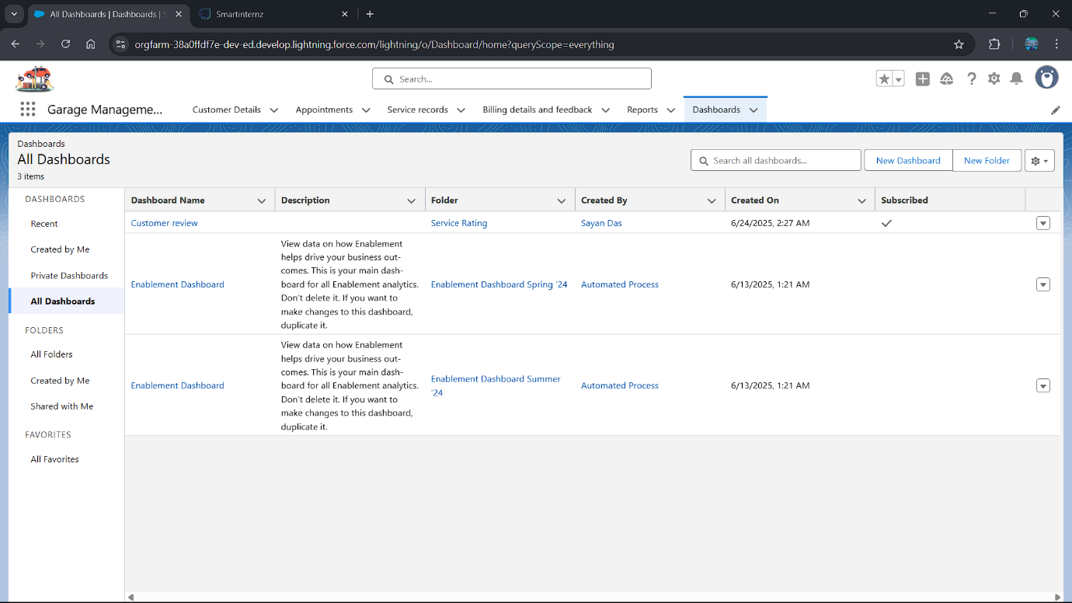

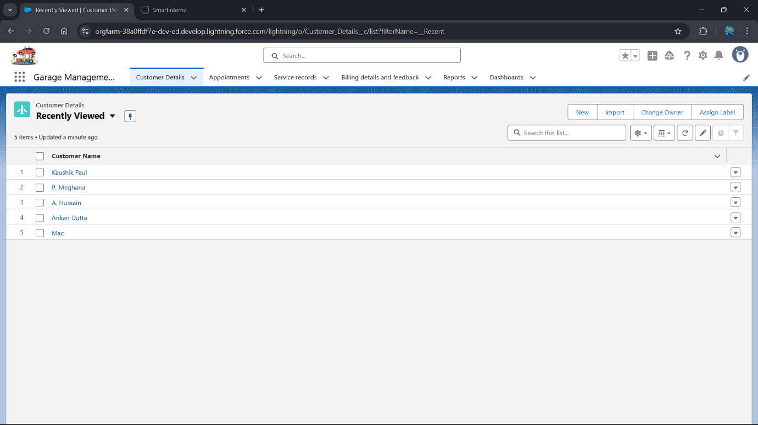

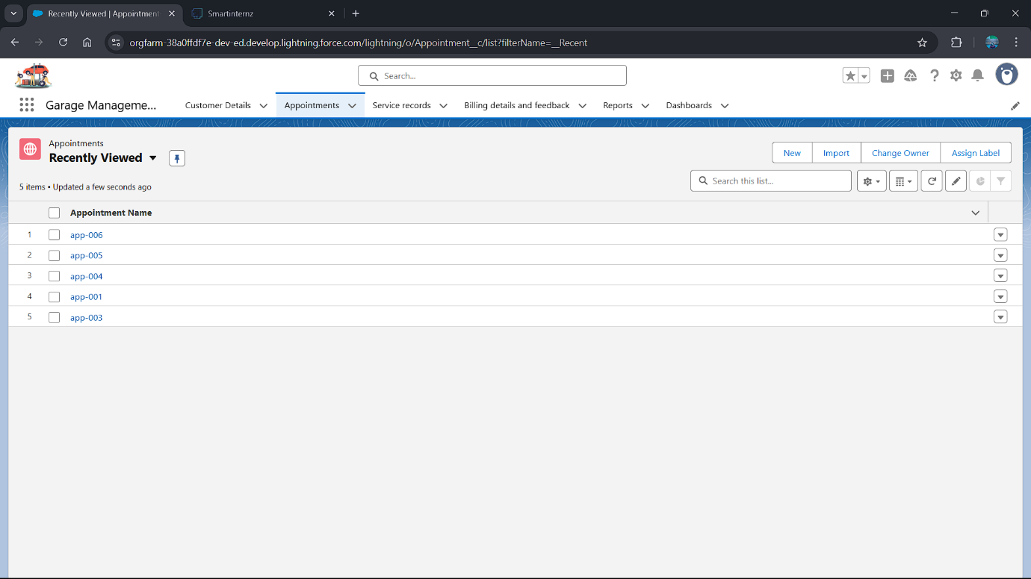

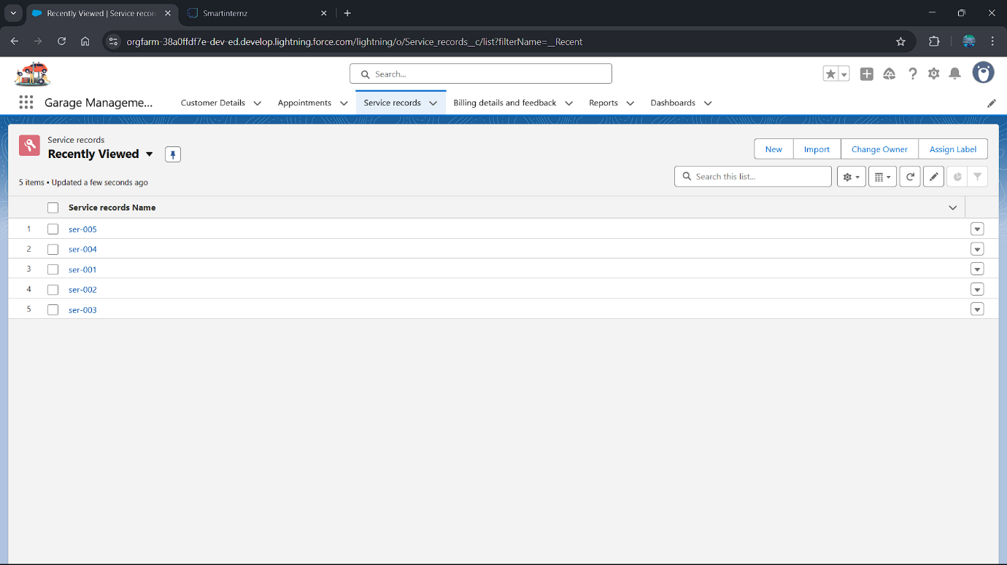

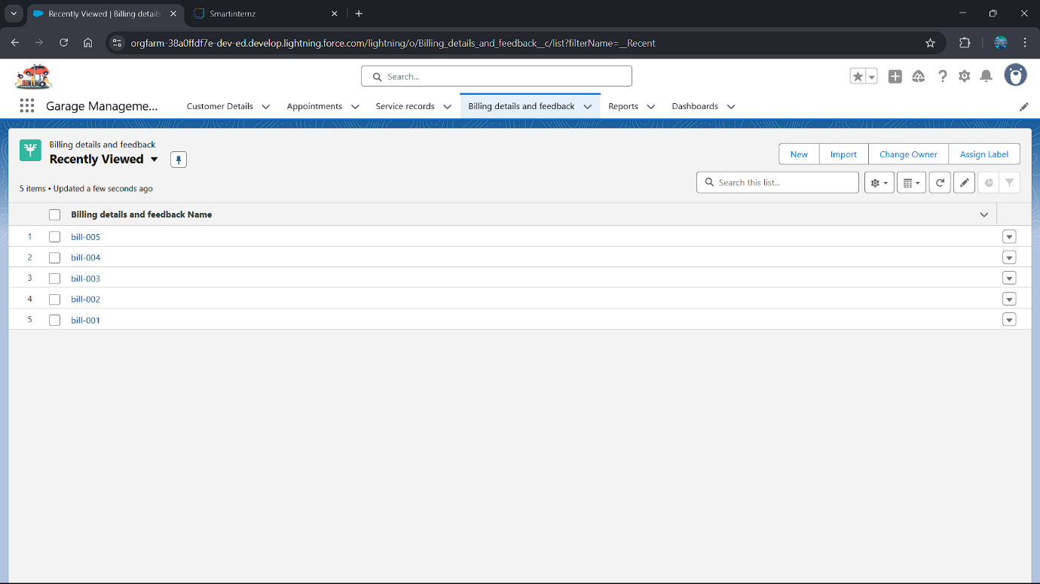

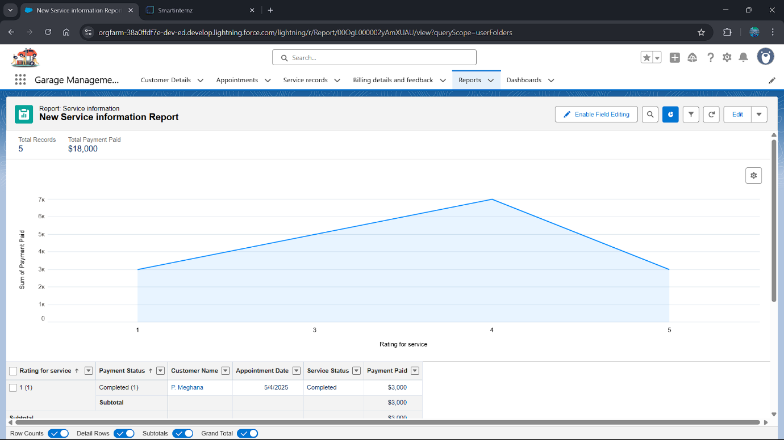

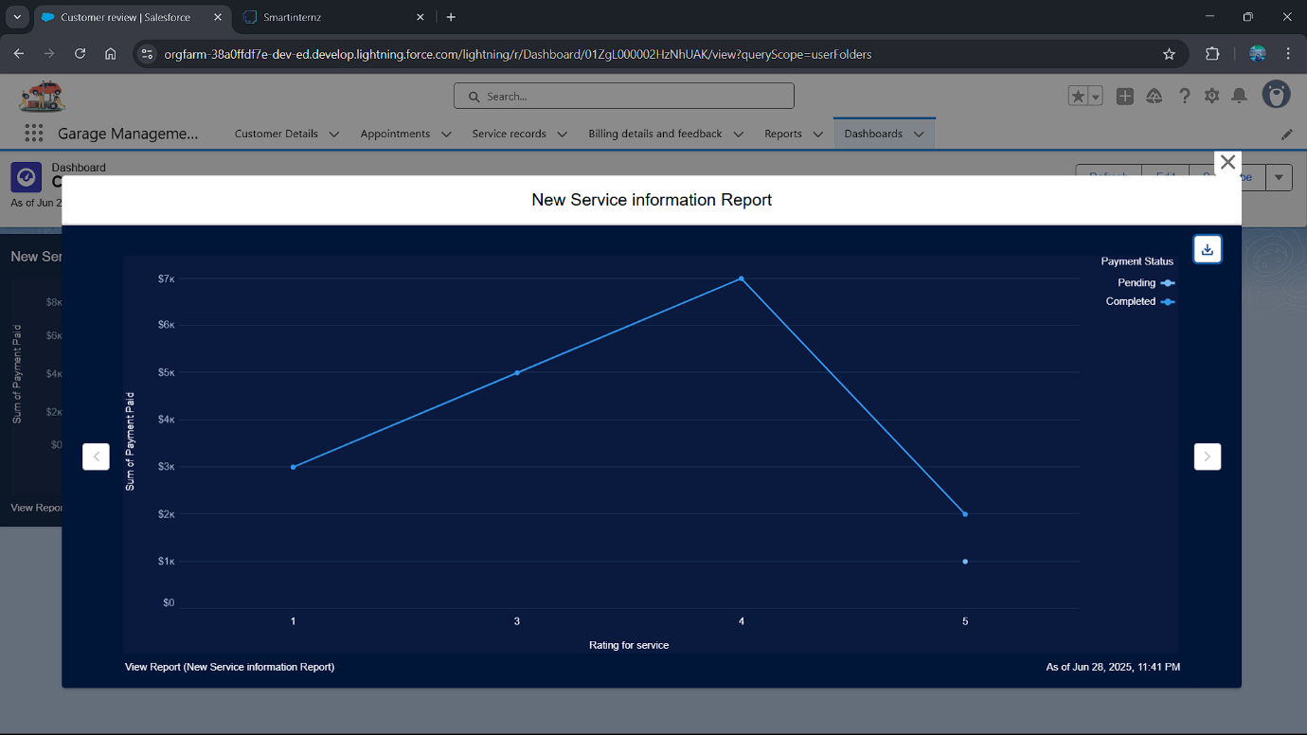

**8. ADVANTAGES & DISADVANTAGES**

Implementing a Garage Management System on Salesforce offers significant advantages but also comes with certain considerations and potential disadvantages.

**8.1 Advantages**

1. **Centralized Data Management & 360-Degree Customer View:**
   * All customer, vehicle, service history, and inventory data is consolidated in one platform.
   * Service advisors and managers gain a complete view of each customer and their vehicle's history, enabling personalized service and informed decision-making.
2. **Enhanced Operational Efficiency:**
   * Automation of routine tasks (appointment reminders, work order creation, stock alerts) reduces manual effort and human error.
   * Streamlined workflows lead to faster service turnaround times and increased technician productivity.
3. **Improved Customer Experience & Retention:**
   * Online booking and automated communication (confirmations, status updates, service reminders) provide convenience and transparency.
   * Personalized service based on detailed history fosters customer loyalty and encourages repeat business.
4. **Real-time Insights & Data-Driven Decisions:**
   * Robust reporting and dashboards provide immediate visibility into key operational metrics (e.g., revenue, technician utilization, inventory levels).
   * Enables managers to identify trends, optimize resource allocation, and make strategic business decisions.
5. **Scalability & Flexibility:**
   * Salesforce is a highly scalable cloud platform, capable of growing with the garage's business without significant infrastructure investments.
   * The declarative and programmatic capabilities allow for easy adaptation to new service offerings, business processes, and future technological advancements.
6. **Reduced Paperwork & Environmental Impact:**
   * Moving from paper-based records to digital forms reduces administrative overhead and contributes to a greener operation.
7. **Enhanced Communication:**
   * Internal communication among staff is improved through Chatter and shared work orders.
   * External communication with customers is standardized and automated.
8. **Security & Reliability:**
   * Leverages Salesforce's enterprise-grade security, data encryption, and robust infrastructure, ensuring data protection and high availability.

**8.2 Disadvantages & Considerations**

1. **Cost of Licensing:**
   * Salesforce licenses can be a significant recurring cost, especially for smaller garages or those with many users. Careful consideration of the chosen Salesforce edition and user types is necessary.
2. **Implementation Complexity & Time:**
   * While Salesforce offers declarative tools, a comprehensive implementation requires careful planning, design, customization (Apex, LWC), data migration, and integration efforts. This can be time-consuming and may require specialized Salesforce consulting expertise.
3. **Learning Curve for Users:**
   * Despite an intuitive UI, new users (service advisors, technicians, managers) will require training to effectively utilize all features of the system and adapt to new workflows. User adoption needs to be actively managed.
4. **Customization vs. Standard Features:**
   * Over-customization can lead to higher maintenance costs and make future upgrades more challenging. A balance must be struck between tailoring the system to specific needs and leveraging standard Salesforce functionalities.
5. **Integration Challenges:**
   * While Salesforce offers powerful APIs, integrating with disparate external systems (e.g., legacy accounting software, specialized diagnostic tools) can still be complex and require custom development or middleware.
6. **Data Migration Effort:**
   * Migrating existing customer, vehicle, and service history data from old systems (spreadsheets, legacy software) can be a time-consuming and critical task, requiring data cleansing and mapping.
7. **Ongoing Maintenance & Administration:**
   * The system will require ongoing administration (user management, data maintenance, minor enhancements) and potential future development for new features. This requires dedicated internal resources or ongoing support from a Salesforce partner.
8. **Dependence on Internet Connectivity:**
   * As a cloud-based system, reliable internet access is crucial for uninterrupted operation.

Despite the potential disadvantages, the long-term benefits in terms of efficiency, customer satisfaction, and strategic insights often outweigh the initial investment and challenges, making a Salesforce-based solution a strong contender for modern garage management.

**9. CONCLUSION**

The development and implementation of a Garage Management System on the Salesforce platform represent a transformative step for modern automotive service businesses. This comprehensive project aims to address the inherent inefficiencies and limitations of traditional, fragmented operational models by providing a unified, cloud-based solution.

Throughout this report, we have outlined the critical need for such a system, driven by challenges in customer service, operational visibility, and resource management. By leveraging Salesforce's robust capabilities, including its flexible data model, powerful automation tools (Flows), intuitive user interfaces (Lightning Experience), and customer engagement portals (Experience Cloud), the proposed solution effectively centralizes customer, vehicle, and service data. It automates key processes from appointment scheduling and work order management to inventory tracking and customer communication.

The architectural design emphasizes a scalable, secure, and user-friendly system, ensuring that the garage can not only meet current operational demands but also adapt to future growth and evolving customer expectations. Rigorous functional and performance testing, combined with an Agile project methodology, will ensure a high-quality, reliable, and user-accepted system.

In conclusion, the Salesforce-powered Garage Management System is poised to deliver significant advantages, including enhanced operational efficiency, improved customer satisfaction, real-time business insights, and a strong foundation for future scalability. While challenges related to cost, implementation complexity, and user adoption exist, they are manageable with proper planning, training, and strategic utilization of the Salesforce ecosystem. This system is a strategic investment that will empower garage businesses to operate more effectively, serve customers better, and ultimately drive sustainable growth and profitability in a competitive mark

**10. FUTURE SCOPE**

The Garage Management System built on Salesforce provides a robust foundation, but the platform's flexibility allows for continuous enhancement and expansion. The following outlines potential future developments and integrations to further optimize garage operations and customer experience:

1. **Mobile App for Technicians (Enhanced):**
   * Develop a more specialized Salesforce Mobile App experience or use Salesforce Field Service Lightning (FSL) capabilities for technicians.
   * Features could include offline capabilities, advanced diagnostics integration, photo/video capture linked directly to work orders, and integrated parts ordering from the service bay.
2. **Integration with Telematics & Vehicle Diagnostics:**
   * Explore integration with vehicle telematics systems or diagnostic tools.
   * This could enable proactive service alerts based on vehicle performance data (e.g., low tire pressure, engine light warnings), direct fault code reporting into work orders, and predictive maintenance scheduling.
3. **Advanced Inventory Management & Supply Chain Automation:**
   * Deeper integration with parts suppliers for automated ordering based on predictive demand.
   * Utilizing barcode scanning for parts check-in/check-out to improve inventory accuracy.
   * Implementing a robust returns management process for parts.
4. **Financial Management & Full ERP Integration:**
   * Beyond basic invoicing, a more comprehensive integration with dedicated accounting/ERP systems (e.g., QuickBooks Enterprise, SAP, NetSuite) for complete financial reporting, payroll, and asset management.
5. **Marketing & Customer Engagement Automation:**
   * Leverage Salesforce Marketing Cloud or Pardot for advanced customer segmentation and personalized marketing campaigns.
   * Automated birthday greetings, service anniversary offers, and targeted promotions based on vehicle type or service history.
   * Loyalty program management directly within Salesforce.
6. **AI-Powered Insights & Predictive Analytics (Salesforce Einstein):**
   * Implement Salesforce Einstein features for predictive analytics.
   * **Predictive Maintenance:** Forecast when specific vehicle components might need service based on mileage, age, or past service patterns.
   * **Customer Churn Prediction:** Identify customers at risk of leaving based on service frequency or engagement patterns.
   * **Optimal Pricing Recommendations:** Analyze service data to suggest optimized pricing for services and parts.
7. **Digital Payments Integration:**
   * Direct integration with payment gateways (e.g., Stripe, Square) for seamless, in-app payment processing at the time of vehicle pickup, including digital receipts.
8. **Customer Feedback & Reputation Management:**
   * Enhance post-service survey capabilities with Salesforce Surveys.
   * Integrate with online review platforms (e.g., Google My Business, Yelp) to monitor and manage customer reviews directly from Salesforce.
9. **Integration with Dispatch & Routing Software:**
   * If the garage offers mobile repair services or vehicle pickup/delivery, integration with routing and dispatch software for optimized logistics.
10. **Enhanced Reporting & Business Intelligence:**
    * Further development of complex dashboards and reports, potentially using Salesforce CRM Analytics (formerly Tableau CRM) for deeper business intelligence and trend analysis.

These future enhancements will allow the Garage Management System to evolve from an operational tool into a strategic asset, driving greater efficiency, profitability, and an even more superior customer experience.

I will now continue to **Section 11. APPENDIX**.

**11. APPENDIX**

The Appendix typically contains supplementary information that supports the main body of the report but is too detailed or extensive to be included within the main flow. For a project like the Garage Management System in Salesforce, this would include technical artifacts and links to relevant resources.

**(Note: As an AI, I cannot provide actual live source code, dataset links, or GitHub repositories. The content below serves as placeholders and descriptions of what would be included in a real appendix.)**

**Source Code (if any)**

This section would list or provide snippets of key custom code developed for the Salesforce solution. This is particularly relevant for:

* **Apex Classes:**
  + WorkOrderService.cls: Apex class containing business logic for creating, updating, and validating Work Orders.
  + InventoryManager.cls: Apex class for handling complex inventory deduction logic and reorder point calculations.
  + AppointmentScheduler.cls: Apex class that interfaces with external calendar systems or handles complex scheduling conflicts.
* **Apex Triggers:**
  + VehicleTrigger.apxt: Trigger on Vehicle__c object to automatically update mileage or service reminders.
  + WorkOrderTrigger.apxt: Trigger on Work_Order__c to update inventory on status change or send notifications.
* **Lightning Web Components (LWC):**
  + onlineAppointmentSchedulerLWC.js / .html / .xml: Code for the customer-facing appointment booking component.
  + technicianWorkOrderViewerLWC.js / .html / .xml: Component for technicians to view and update work orders on mobile devices.
  + partsInventoryDashboardLWC.js / .html / .xml: Component for real-time inventory visualization.
* **Salesforce Flow XML:**
  + XML representation of complex screen flows or record-triggered flows (e.g., "New Service Appointment Flow," "Work Order Completion Flow").
  + (Note: While not human-readable code, this XML defines the automation logic.)