Child Education Software
Pradyut Sarkar

Enrolment No:-085484610 BCA 6th Semester PROJECT

CS-76
Table of Contents
1. Introduction of the Project: 4
2. Objective of the Project: 6
3. Tools / Environment Used: 7
IDE Used (Visual Studio 2010): 7
Front End: WPF (Windows Presentation Framework) 8
Programming Framework (.NET 4): 8
Programming Language (C#): 9
Database Microsoft SQL Server 2008 9
Google App Engine (The webapp Framework) 10
Extensible Markup Language (XML) 10
Windows Communication FRAMEWORK (WCF) 11
Dia for Diagram Drawing & Modeling 12
VirtueMart (online store) 12
4. Analysis of the Project: 13
Child Education Software GUI: 14
Tutorial Selection Interface: 15
Text Pane: 15
Common Controls: 15
Engine Interaction: 15
Video Player / Image Viewer / Audio Player: 16
Drawing Pane: 16
Tutorial Navigator: 16
Online Store Interface: 16
Child Education Software Engine: 16
Tutorial Controller: 17
GUI Interactor: 20
Database Manager: 20
Image Controller: 20
Archive Manager: 20
Video /Audio Controller: 20
Online Store Controller: 20
Child Education Software Database: 20
Hardware & Software required for the application to run 21
Hardware Requirements 21
Software Requirements 21
E-R Diagram: 21
5. DESIGN DOCUMENT: 23
User Interface Design: 23
Engine Design: 24
Database Design: 24
6. PROGRAMME CODE: 25
7. TESTING: 25
UNIT TESTING: 25
INTEGRATION TESTING: 26
SYSTEM TESTING: 26
8. INPUT/OUTPUT SEREEN: 27
9. SECQURITY MEASYRES: 27
10. LIMITATION OF THE PROJECT: 28
11. Any Client/Industry: 29
12. Future Scope and Further enhancement of the project: 30
13. Bibliography: 31

Introduction of the Project:

Child Education Software will enable a new aspect of teaching children with the help of modern technology. It will incorporate audio visual teaching method with user friendly interface. Almost every family is having a computer now. We are used to computerized system in every walk of our life. So kids also will be attracted towards computer. We can use computer as a mean of teaching new things. Because of rich multi-media content kids will be happy to use computer for learning new topics.
In Child Education Software users can use the existing tutorial as well as they can download new tutorial from online store. It will be an eco-friendly option. Children wastes paper a lot and they get bored as the colour of the fades gradually. The child education software will make learning more efficient, attractive and tech-savvy for the children.
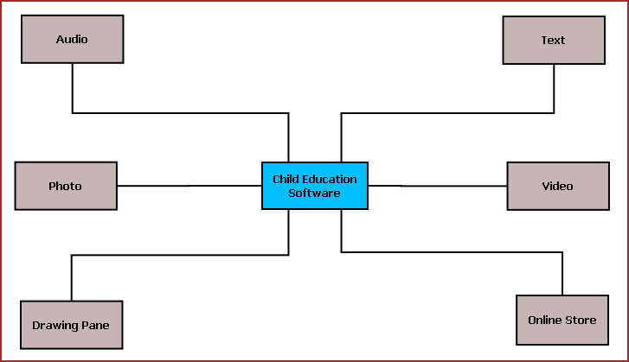
Figure: Overview of Child Education Software
The main features of this software are listed below:
  - Textual display of teaching material.
  - Video display for video tutorial.
  - Sound system to play audio clips.
  - Drawing Pane or Handwriting practice area.
  - Photo viewer.
  - Easy navigation.
  - Interactive UI.
  - Printing of selected content.
  - Online store for buying new tutorials and upgrades.

Objective of the Project:
The objectives of the projects are given below:
- To provide a new kind of medium for educating children
- To cop up with technological revolutions happening around us and to involve the kids with new technology
- To make education process more interesting to the kids
- To utilize our electronic gadgets to do more meaningful work like teaching children
- To save paper waste and to take more green initiatives
- By accomplishing this project I could learn new technologies like .NET, C#, XML and I am able to be involved with the complete software development lifecycle.

Tools / Environment Used:

This software will follow Object Oriented Programming Paradigm and use below mentioned areas.

IDE Used (Visual Studio 2010):

Microsoft Visual Studio is a powerful IDE that ensures quality code throughout the entire application lifecycle, from design to deployment. Whether we are developing applications for SharePoint, the web, Windows, Windows Phone, and beyond, Visual Studio is the ultimate all-in-one solution. Visual Studio includes a code editor supporting IntelliSense as well as code refactoring. The integrated debugger works both as a source-level debugger and a machine-level debugger. Other built-in tools include a forms designer for building GUI applications, web designer, class designer, and database schema designer. It accepts plug-ins that enhance the functionality at almost every level—including adding support for source-control systems (like Subversion and Visual SourceSafe) and adding new toolsets like editors and visual designers for domain-specific languages or toolsets for other aspects of the software development lifecycle (like the Team Foundation Server client: Team Explorer).

Front End: WPF (Windows Presentation Framework)
Windows Presentation Foundation (WPF) provides developers with a unified programming model for building rich Windows smart client user experiences that incorporate UI, media, and documents. Windows Presentation Foundation (WPF) is a next-generation presentation system for building Windows client applications with visually stunning user experiences. With WPF, you can create a wide range of both standalone and browser-hosted applications. The core of WPF is a resolution-independent and vector-based rendering engine that is built to take advantage of modern graphics hardware. WPF extends the core with a comprehensive set of application-development features that include Extensible Application Markup Language (XAML), controls, data binding, layout, 2-D and 3-D graphics, animation, styles, templates, documents, media, text, and typography. WPF is included in the Microsoft .NET Framework, so you can build applications that incorporate other elements of the .NET Framework class library.

Programming Framework (.NET 4):

The .NET 4 Framework is Microsoft's platform for building applications that have visually stunning user experiences, seamless and secure communication, and the ability to model a range of business processes. The .Net Framework consists of:
- Common Language Runtime – provides an abstraction layer over the operating system
- Base Class Libraries – pre-built code for common low-level programming tasks
- Development frameworks and technologies – reusable, customizable solutions for larger programming tasks.
The framework's Base Class Library provides user interface, data access, database connectivity, cryptography, web application development, numeric algorithms, and network communications. The class library is used by programmers, who combine it with their own code to produce applications.

Programming Language (C#):
C# is a type-safe, object-oriented language that is simple yet powerful, allowing programmers to build a breadth of applications. C# is a multi-paradigm programming language encompassing imperative, declarative, functional, generic, object-oriented(class-based), and component-oriented programming disciplines. It was developed by Microsoft within the .NET initiative and later approved as a standard by Ecma (ECMA-334) and ISO (ISO/IEC 23270). C# is one of the programming languages designed for the Common Language Infrastructure.
C# is intended to be a simple, modern, general-purpose, object-oriented programming language.

Database Microsoft SQL Server 2008

Microsoft SQL Server 2008 is a complete set of enterprise-ready technologies and tools that help people derive the most value from information at the lowest total-cost-of-ownership. Enjoy high levels of performance, availability, and security; employ more productive management and development tools; and deliver pervasive insight with self-service business intelligence (BI). Its main Highlights are
- Complete information platform for applications of all sizes.
- Managed, familiar self-service BI tools.
- Support for large-scale data centers and data warehouses.
- Opportunities to build and extend applications in the cloud.
- Integration with the Microsoft Application Platform.

Google App Engine (The webapp Framework)

The webapp framework is a simple web application framework you can use for developing Python web applications for App Engine. Webapp is compatible with the WSGI standard for Python web application containers. Webapp provides an easy way to get started developing apps for App Engine.
App Engine supports any Python application with a CGI interface. A web application framework can simplify development by taking care of the details of the interface, letting you focus development effort on your applications features. App Engine includes a simple web application framework called webapp.
Webapp is a WSGI-compatible framework. You can use webapp or any other WSGI framework with App Engine using a CGI adaptor, such as one provided by the Python standard library.

Extensible Markup Language (XML)
Extensible Markup Language (XML) is a simple, very flexible text format derived from SGML (ISO 8879). Originally designed to meet the challenges of large-scale electronic publishing, XML is also playing an increasingly important role in the exchange of a wide variety of data on the Web and elsewhere.
Extensible Markup Language (XML) is a set of rules for encoding documents in machine-readable form. It is defined in the XML 1.0 Specification produced by the W3C, and several other related specifications, all gratis open standards.
XML's design goals emphasize simplicity, generality, and usability over the Internet.[6] It is a textual data format with strong support via Unicode for the languages of the world. Although the design of XML focuses on documents, it is widely used for the representation of arbitrary data structures, for example in web services.
Many application programming interfaces (APIs) have been developed that software developers use to process XML data, and several schema systems exist to aid in the definition of XML-based languages.
As of 2009, hundreds of XML-based languages have been developed,[7] including RSS, Atom, SOAP, and XHTML. XML-based formats have become the default for most office-productivity tools, including Microsoft Office (Office Open XML), OpenOffice.org (OpenDocument), and Apple's iWork.
System.Xml is the core XML manipulation technology for .NET languages.

Windows Communication FRAMEWORK (WCF)
Windows Communication Foundation (WCF) is a framework for building service-oriented applications. Using WCF, you can send data as asynchronous messages from one service endpoint to another. A service endpoint can be part of a continuously available service hosted by IIS, or it can be a service hosted in an application. An endpoint can be a client of a service that requests data from a service endpoint. The messages can be as simple as a single character or word sent as XML, or as complex as a stream of binary data. A few sample scenarios include:
- A secure service to process business transactions.
- A service that supplies current data to others, such as a traffic report or other monitoring service.
- A chat service that allows two people to communicate or exchange data in real time.
- A dashboard application that polls one or more services for data and presents it in a logical presentation.
- Exposing a workflow implemented using Windows Workflow Foundation as a WCF service.
- A Silverlight application to poll a service for the latest data feeds.
While creating such applications was possible prior to the existence of WCF, WCF makes the development of endpoints easier than ever. In summary, WCF is designed to offer a manageable approach to creating Web services and Web service clients.

Dia for Diagram Drawing & Modeling
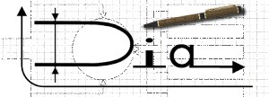
Dia is free and open source general-purpose diagramming software, developed as part of the GNOME project's office suite and was originally created by Alexander Larsson. Dia uses a controlled single document interface (CSDI) similar to GIMP and Sodipodi.
Dia has a modular design with several shape packages available for different needs: flowchart, network diagrams, circuit diagrams, and more. It does not restrict symbols and connectors from various categories from being placed together.
Dia is a gtk+ based diagram creation program released under the GPL license.
Dia is inspired by the commercial Windows program 'Visio', though more geared towards informal diagrams for casual use. It can be used to draw many different kinds of diagrams. It currently has special objects to help draw entity relationship diagrams, UML diagrams, flowcharts, network diagrams, and many other diagrams. It is also possible to add support for new shapes by writing simple XML files, using a subset of SVG to draw the shape.

It can load and save diagrams to a custom XML format (gzipped by default, to save space), can export diagrams to a number of formats, including EPS, SVG, XFIG, WMF and PNG, and can print diagrams (including ones that span multiple pages).

VirtueMart (online store)

VirtueMart is an Open Source E-Commerce solution to be used together with a Content Management System (CMS) called Joomla!. Joomla! and VirtueMart are written in PHP and can be used in typical PHP/MySQL environments. With its fully-featured eCommerce engine, VirtueMart is perfect to sell your Goods online and drive your Business to new Heights. Despite being Open Source Software it powers large Online Shops providing the Performance, Usability and Security you expect from professional Software.VirtueMart is the leading Online-Shop Solution for Joomla!

Archiving & Packaging Utility (7Z)

7-Zip is open source software. Most of the source code is under the GNU LGPL license. The unRAR code is under a mixed license: GNU LGPL + unRAR restrictions. Check license information here: 7-Zip license.
You can use 7-Zip on any computer, including a computer in a commercial organization. You don't need to register or pay for 7-Zip.

The main features of 7-Zip
- High compression ratio in 7z format with LZMA and LZMA2 compression
- Supported formats:
  - Packing / unpacking: 7z, XZ, BZIP2, GZIP, TAR, ZIP and WIM
  - Unpacking only: ARJ, CAB, CHM, CPIO, CramFS, DEB, DMG, FAT, HFS, ISO, LZH, LZMA, MBR, MSI, NSIS, NTFS, RAR, RPM, SquashFS, UDF, VHD, WIM, XAR and Z.
- For ZIP and GZIP formats, 7-Zip provides a compression ratio that is 2-10 % better than the ratio provided by PKZip and WinZip
- Strong AES-256 encryption in 7z and ZIP formats
- Self-extracting capability for 7z format
- Integration with Windows Shell
- Powerful File Manager
- Powerful command line version
- Plugin for FAR Manager
- Localizations for 79 languages

Analysis of the Project:
Child Education Software is divided into three main modules.
- GUI
- Engine
- Local Storage & Online Storage
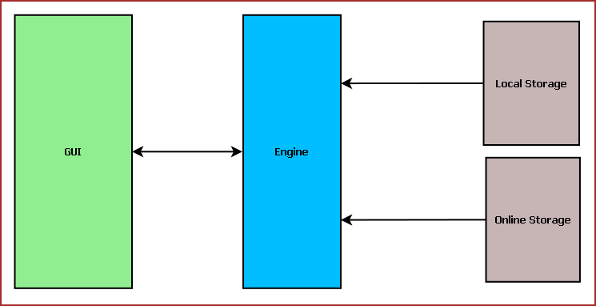
Figure: Child Education System Components

Child Education Software GUI:
Child Education Software GUI will display tutorial, navigator, online store interface. The main components of GUI are:
- Tutorial Selection Interface
- Text Pane
- Video Player / Image Viewer / Audio Player
- Drawing Pane
- Tutorial Navigator
- Common Application Control
- Online Store Interface
- Engine Interactor

Tutorial Selection Interface:
This interface will display the available tutorials from local storage and the tutorials bought from Online Store. From here the user will select the tutorial to be viewed. The tutorials will be displayed according to different category such as: Age, Subject, culture etc.

Text Pane:
This area will display the text portion of the tutorial. This will contain the description about the subject if different colors. Users can select text, copy and paste the text.
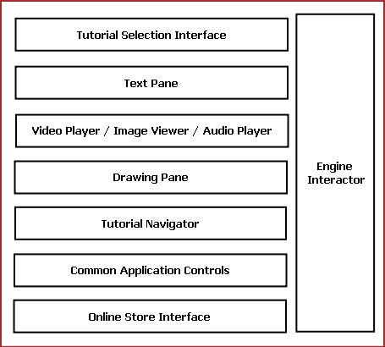
Fig: Components of Child Education Software GUI

Common Controls:
Common controls include several controls of the application. Such as: Menu Bar, Toolbar, status bar, Context Menu and progress bar.

Engine Interaction:
This module handles the interaction between GUI and Engine. This module defines all callback for the Engine events.

Video Player / Image Viewer / Audio Player:
This Pane displays the image, video & audio artwork associated with the tutorial content. This will have two components such as: Display Area & Control Pane. Display Area will display the content. Control Pane contains the control like Play, Pause, Previous, Next for controlling the displayed content.

Drawing Pane:
Drawing Pane allows user to draw, sketch & scribble. This will help the kids to draw and practice while learning. User can save the drawing as a Image or load a image to scribble.

Tutorial Navigator:
This pane contains the controls for navigating within the tutorial. It will have “Next”, “Previous” and “Go to Home” options.

Online Store Interface:
This pane allows user to login into Online Store. Then it will display the available tutorial online for download. User may need to purchase or download it for free.

Child Education Software Engine:
Child Education Software Engine provides multimedia framework for displaying Video/Image, tutorial controlling logic. It is mainly divided into following components:
- Tutorial Controller
- Image Controller
- Archive Manager
- Video /Audio Controller
- Online Store Controller
- GUI Interactor
- Database Manager

Tutorial Controller:
This module defines the tutorial format. It controls tutorial flow, content to be displayed. Every tutorial is internally a XML file mentioning the tutorial contents.
The xml follows the below mentioned format.
<?xml version="1.0" encoding="utf-8" ?>
<tutorial>
<page>
<Sequence>1</Sequence>
<text> A for Apple</text>
<video-path>.\\Videos\\apple.mp4</video-path>
<audio-path>null</audio-path>
<image-path>null</image-path>
<scribble-path>.\\Images\\apple.jpg</scribble-path>
</page>
<page>
<Sequence>2</Sequence>
<text>B for Ball</text>
<video-path>.\\Videos\\ball.mp4</video-path>
<audio-path>null</audio-path>
<image-path>null</image-path>
<scribble-path>.\\Images\\ball.jpg</scribble-path>
</page>
<page>
<Sequence>3</Sequence>
<text>C for Cat</text>
<video-path>null</video-path>
<audio-path>.\\Audios\\cat.mp4</audio-path>
<image-path>.\\Images\\cat.jpg</image-path>
<scribble-path>.\\Images\\cat.jpg</scribble-path>
</page>
</tutorial>

Tutorial controller has a XML parser to read the XML and load tutorial contents accordingly. Tutorial Controller controls the other engine components to coordinate tutorial display.
Different components of Child Education Software Engine and their interaction with other modules are displayed in the following diagram.
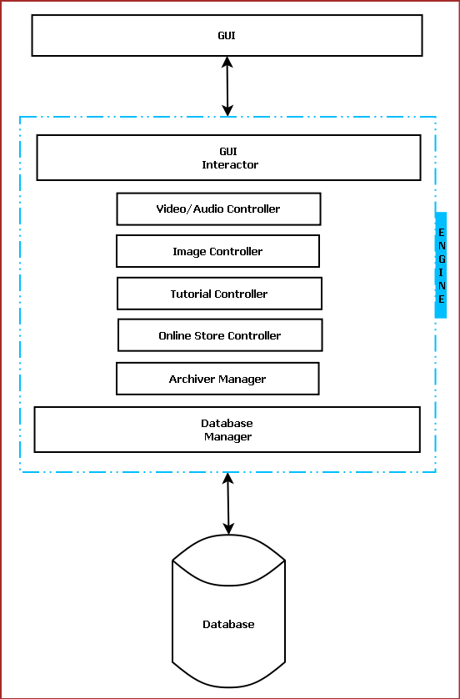
Figure: Interaction among different components of Child Education Software

GUI Interactor:
This module interacts with GUI module and serves GUI action request.

Database Manager:
This module manages the database. It handles information saving in database, retrieval of information from database.

Image Controller:
This module provides the framework to display an image and to save a drawing to as image. We will use Open Source JPEG library to decode and encode images.

Archive Manager:
This module archives old and less frequently used tutorials to save space. We will use Open Source 7z archive framework for archiving.

Video /Audio Controller:
Video/Audio Controller handles the encoding and decoding of video and audio files. We will use .NET MediaElement for video/audio playback features.

Online Store Controller:
This module controls the Online searching, purchasing and downloading of new tutorials. It allows the users to browse through available tutorial. We will use VirtueMart framework and Jhomla PHP framework to implement online store.

Child Education Software Database:
Child Education Software Database will be an optimized database which will save certain information about the tutorials. We will use RDBMS concept.

Hardware & Software required for the application to run

Hardware Requirements

- Computer that has a 1.6GHz or faster processor
- 1 GB (32 Bit) or 2 GB (64 Bit) RAM
- 10 MB of available hard disk space
- DVD-ROM Drive / USB Port

Software Requirements

- Windows XP (x86) with Service Pack 3 / Windows Vista (x86) with Service Pack 2 / Windows 7 (x86)
- Microsoft .NET 4.0

E-R Diagram:
We will design a RDBMS for Child Education Software. The entities and their attributes are listed below. Attributes in Bold letter is the unique key.
Entities | Attributes
Tutorial | Tutorial Id, Name, Base Path, Last Visit Time, Size, Thumbnail, video path, image path, audio path, scribble image path
Child Education Software | Software Id, Total tutorials , Occupied Size
User | User Id, Name, Social Network Data, password, Preferences.

Relationship between Entities:
- Child Education Software has Tutorials → 1 : N
- User uses tutorials → M : N
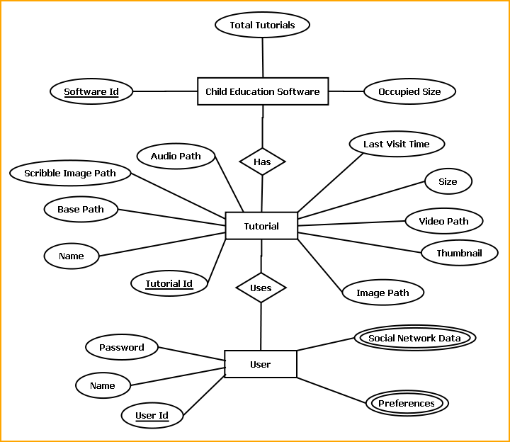
E-R Diagram of Child Education Software

DESIGN DOCUMENT:

User Interface Design:
The GUI layout of Child Education Software is shown below:
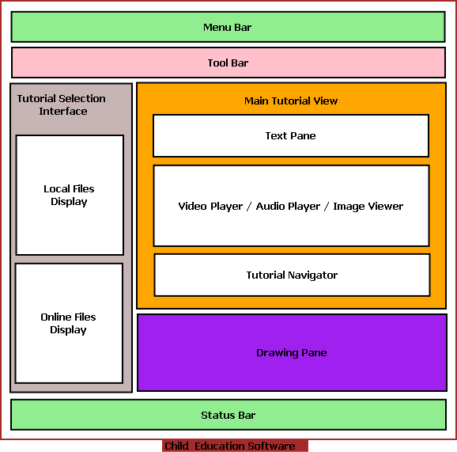
The user interface is developed using WPF.
Menu bar contains the important features which can be accessed by shortcuts too. It is implemented using Menu control.
System.Windows.Controls.Menu
Namespace: System.Windows.Controls
Assembly: PresentationFramework (in PresentationFramework.dll)
Represents a Windows menu control that enables you to hierarchically organize elements associated with commands and event handlers.

Toolbar lists down the mostly used features. It is implemented using ToolBar control.
System.Windows.Controls.ToolBar
Namespace: System.Windows.Controls
Assembly: PresentationFramework (in PresentationFramework.dll)
Provides a container for a group of commands or controls.

Left navigation bar displays the tutorials available locally and online. This navigation bar is hide- able. It is implemented using the Expander control.
System.Windows.Controls.Expander
Namespace: System.Windows.Controls
Assembly: PresentationFramework (in PresentationFramework.dll)
Represents the control that displays a header that has a collapsible window that displays content.

The local contents are displayed in a TreeView control. And every contents are displayed in in a TreeViewItem.
System.Windows.Controls.TreeView
Namespace: System.Windows.Controls
Assembly: PresentationFramework (in PresentationFramework.dll)
Represents a control that displays hierarchical data in a tree structure that has items that can expand and collapse.

Online contents are displayed in a WebBrowser control. Users can select the content and purchase it from there.
System.Windows.Controls.WebBrowser
Namespace: System.Windows.Controls
Assembly: PresentationFramework (in PresentationFramework.dll)
Hosts and navigates between HTML documents. Enables interoperability between WPF managed code and HTML script.

Textpane displays the Texts. This is implemented using a TextBlock control.
System.Windows.Controls.TextBlock
Namespace: System.Windows.Controls
Assembly: PresentationFramework (in PresentationFramework.dll)
Provides a lightweight control for displaying small amounts of flow content.

Video and audio playing is implemented using MediaElement control.
System.Windows.Controls.MediaElement
Namespace: System.Windows.Controls
Assembly: PresentationFramework (in PresentationFramework.dll)
Represents a control that contains audio and/or video.

Images are displayed using Image control.
System.Windows.Controls.Image
Namespace: System.Windows.Controls
Assembly: PresentationFramework (in PresentationFramework.dll)
Represents a control that displays an image.

Drawing pane is implemented using InkCanvas control.
System.Windows.Controls.InkCanvas
Namespace: System.Windows.Controls
Assembly: PresentationFramework (in PresentationFramework.dll)
Defines an area that receives and displays ink strokes.

Statusbar displays the information about the application and the tutorial currently running. Its implemented using StatusBar Class.
System.Windows.Controls.Primitives.StatusBar
Namespace: System.Windows.Controls.Primitives
Assembly: PresentationFramework (in PresentationFramework.dll)
Represents a control that displays items and information in a horizontal bar in an application window.

Engine Design:

Reading & Writing XML:
In this application the tutorials are saved as XML file. The application will process the XML and play the tutorial. So we have implemented XML reader and writer logic. XML operations are done using .NET XML parser. Every XML element is represented as a XElement control.
System.Xml.Linq.XElement
Namespace: System.Xml.Linq
Assembly: System.Xml.Linq (in System.Xml.Linq.dll)
Represents an XML element.

Tutorial Packaging
A tutorial package will contain a XML file along with media files. All the files of a tutorial will be compressed using 7z archiving utility. It will be password protected to ensure authorized use.

Online Store
User can traverse to online store available in the web and download the tutorials. And that tutorial can be played in the child management software. The shopping cart is implemented using VirtueMart ecommerce utility and Google App Engine.

Database Design:
This will have a MS SQL server database running for saving tutorial related information. It will handle the digital right management related issues. Database detailed design cannot be revealed here due to proprietary reasons of the company.

Installer:
This software is packaged using Visual studio Installer utility. It provides a MSI file to be installed on end user side.
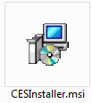

This installer will include all the required DLL to run this software and readily available tutorials.
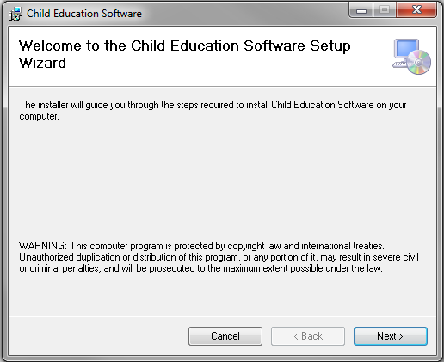

The users can browse the installation folder for this software and install the software in the desired path.
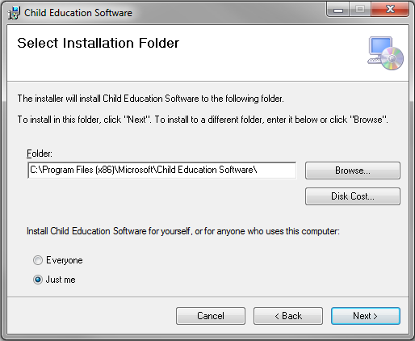
It will take some time to install the software in the PC and create shortcut icons on Desktop and program menus.
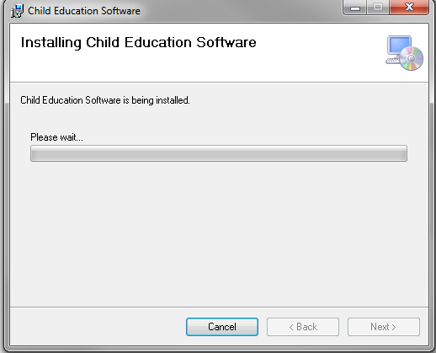

PROGRAMME CODE:
We cannot provide whole code base due to the company restrictions. The project structure looks like below mentioned image.
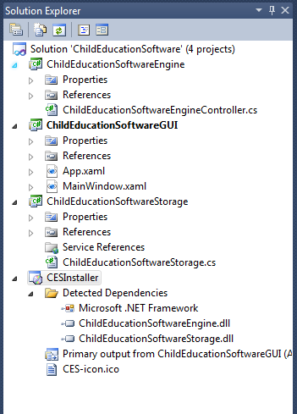
The subsequent sections will have excerpts of the main code of this software.

User Interface:
The user Interface is implemented in WPF and C#.
XAML
<Window x:Class="ChildEducationSoftwareGUI.MainWindow"
xmlns="http://schemas.microsoft.com/winfx/2006/xaml/presentation"
xmlns:x="http://schemas.microsoft.com/winfx/2006/xaml"
Title="Child Education Software" Height="700" Width="800">
<DockPanel LastChildFill="True">
<Menu DockPanel.Dock="Top">
<MenuItem Header="File"></MenuItem>
<MenuItem Header="Settings"></MenuItem>
<MenuItem Header="Help"></MenuItem>
</Menu>

<ToolBar Margin="5" DockPanel.Dock="Top">
<Button Margin="5">Home</Button>
<Separator></Separator>
<Button Margin="5">Prev</Button>
<Separator></Separator>
<Button Margin="5">Next</Button>
<Separator></Separator>
<Button Margin="5">Online Store</Button>
<Separator></Separator>
<Button Margin="5">Options</Button>
</ToolBar>

<StatusBar DockPanel.Dock="Bottom">
<UniformGrid Rows="1">
<Label>Lesson 1</Label>
<Button Margin="5" Content="Duration: 10:00"></Button>
<Button Margin="5" Content="Remaining: 9:00"></Button>
<Button Margin="5" Content="Page Number: 01"></Button>
<CheckBox VerticalAlignment="Center" IsChecked="True">Sound ON</CheckBox>
<ProgressBar Width="150" Margin="5" Value="20"></ProgressBar>
</UniformGrid>
</StatusBar>
<DockPanel DockPanel.Dock="Top">
<Expander IsExpanded="True" ExpandDirection="Right" Expanded="Expander_Expanded">
<DockPanel LastChildFill="True" Width="200" DockPanel.Dock="Left" Background="#FFA5DEAC">
<Label DockPanel.Dock="Top" FontWeight="Bold" FontSize="14" BorderThickness="2" Foreground="#FF13D428" Background="#FF4C47AD">Tutorials Available</Label>
<Separator DockPanel.Dock="Top"></Separator>
<UniformGrid Columns="1" DockPanel.Dock="Bottom">

<TreeView>
<TreeViewItem Header="Alphabets">
<TreeViewItem Header="Lesson 1"></TreeViewItem>
<TreeViewItem Header="Lesson 2"></TreeViewItem>
<TreeViewItem Header="Lesson 3"></TreeViewItem>
<TreeViewItem Header="Lesson 4"></TreeViewItem>
</TreeViewItem>

<TreeViewItem Header="Numbers">
<TreeViewItem Header="Lesson 1"></TreeViewItem>
<TreeViewItem Header="Lesson 2"></TreeViewItem>
<TreeViewItem Header="Lesson 3"></TreeViewItem>
<TreeViewItem Header="Lesson 4"></TreeViewItem>
</TreeViewItem>
<TreeViewItem Header="Rhymes">
<TreeViewItem Header="Lesson 1"></TreeViewItem>
<TreeViewItem Header="Lesson 2"></TreeViewItem>
<TreeViewItem Header="Lesson 3"></TreeViewItem>
<TreeViewItem Header="Lesson 4"></TreeViewItem>
</TreeViewItem>
</TreeView>
<WebBrowser Margin="5"></WebBrowser>
</UniformGrid>
</DockPanel>
</Expander>
<DockPanel LastChildFill="True" DockPanel.Dock="Right">
<UniformGrid Margin="5" DockPanel.Dock="Bottom" Rows="1">
<Button>Prev</Button>
<Button>Next</Button>
<Button>Home</Button>
<Button>Sound On/ Off</Button>
</UniformGrid>
<StackPanel DockPanel.Dock="Top" >
<Label Name="textAreaPane" FontSize="30" DockPanel.Dock="Top" Height="100" Background="Azure" VerticalContentAlignment="Center" HorizontalContentAlignment="Center" Foreground="#FFB33333" FontWeight="Bold" FontFamily="Monotype Corsiva" FontStretch="UltraCondensed" FontStyle="Italic">A for Apple ... A is the first character....</Label>
<TabControl Name="playerPane" TabStripPlacement="Right">
<TabItem Header="Video">
<Grid Height="270">
<Grid.RowDefinitions>
<RowDefinition Height="226*" />
<RowDefinition Height="36*" />
</Grid.RowDefinitions>
<MediaElement x:Name="MediaEL" Grid.RowSpan="1" LoadedBehavior="Manual" />
<StackPanel Orientation="Horizontal" Grid.Row="1" HorizontalAlignment="Center">
<Button x:Name="btnPlay" Content="Play" Click="btnPlay_Click"
Width="50" Height="25"/>
<Button x:Name="btnStop" Content="Stop" Click="btnStop_Click"
Width="50" Height="25"/>
<Button x:Name="btnMoveBackward" Content="Back" Click="btnMoveBackward_Click"
Width="50" Height="25"/>
<Button x:Name="btnMoveForward" Content="Forward" Click="btnMoveForward_Click"
Width="50" Height="25"/>
<Button x:Name="btnOpen" Content="Open" Click="btnOpen_Click"
Width="50" Height="25"/>
</StackPanel>
</Grid>
</TabItem>
<TabItem Header="Image">
<Image Source="/ChildEducationSoftwareGUI;component/Images/apple-img.png" Height="266" Width="433" />
</TabItem>
</TabControl>
<InkCanvas Name="drawingPane" DockPanel.Dock="Bottom" Background="#FFE9EEF2" EditingMode="InkAndGesture"></InkCanvas>
</StackPanel>
</DockPanel>
</DockPanel>
</DockPanel>
</Window>

Playing Audio & Video:
We have Implemented media player using the MediaElement control running in Independent mode.
XAML
XAML
<Window x:Class="VideoProject.Window1"
xmlns="http://schemas.microsoft.com/winfx/2006/xaml/presentation"
xmlns:x="http://schemas.microsoft.com/winfx/2006/xaml"
Title="VideoProject" Height="800" Width="600">
<Grid>
<StackPanel HorizontalAlignment="Center" VerticalAlignment="Center">
<MediaElement Name="myMedia" Source="myMedia.wmv"
LoadedBehavior="Manual" Width="320" Height="240" />
<StackPanel Orientation="Horizontal" Margin="0,10,0,0">
<Button Content="Play" Margin="0,0,10,0"
Padding="5" Click="mediaPlay" />
<Button Content="Pause" Margin="0,0,10,0"
Padding="5" Click="mediaPause" />
<Button x:Name="muteButt" Content="Mute"
Padding="5" Click="mediaMute" />
</StackPanel>
</StackPanel>
</Grid>
</Window>
C#
C#
using System;
using System.Windows;
using System.Windows.Controls;
using System.Windows.Data;
using System.Windows.Documents;
using System.Windows.Input;
using System.Windows.Media;
using System.Windows.Media.Imaging;
using System.Windows.Shapes;

namespace VideoProject
{
public partial class Window1 : System.Windows.Window
{
public Window1()
{
InitializeComponent();
myMedia.Volume = 100;
myMedia.Play();
}

void mediaPlay(Object sender, EventArgs e)
{
myMedia.Play();
}

void mediaPause(Object sender, EventArgs e)
{
myMedia.Pause();
}

void mediaMute(Object sender, EventArgs e)
{
if (myMedia.Volume == 100)
{
myMedia.Volume = 0;
muteButt.Content = "Listen";
}
else
{
myMedia.Volume = 100;
muteButt.Content = "Mute";
}
}
}
}

GUI Callback Functions:
C#
using System;
using System.Collections.Generic;
using System.Linq;
using System.Text;
using System.Windows;
using System.Windows.Controls;
using System.Windows.Data;
using System.Windows.Documents;
using System.Windows.Input;
using System.Windows.Media;
using System.Windows.Media.Imaging;
using System.Windows.Navigation;
using System.Windows.Shapes;

namespace ChildEducationSoftwareGUI
{
/// <summary>
/// Interaction logic for MainWindow.xaml
/// </summary>
public partial class MainWindow : Window
{
public MainWindow()
{
InitializeComponent();
IsPlaying(false);
}

private void Expander_Expanded(object sender, RoutedEventArgs e)
{

}
#region IsPlaying(bool)
private void IsPlaying(bool bValue)
{
btnStop.IsEnabled = bValue;
btnMoveBackward.IsEnabled = bValue;
btnMoveForward.IsEnabled = bValue;
btnPlay.IsEnabled = bValue;
}
#endregion

#region Play and Pause
private void btnPlay_Click(object sender, RoutedEventArgs e)
{
IsPlaying(true);
if (btnPlay.Content.ToString() == "Play")
{
MediaEL.Play();
btnPlay.Content = "Pause";
}
else
{
MediaEL.Pause();
btnPlay.Content = "Play";
}
}
#endregion

#region Stop
private void btnStop_Click(object sender, RoutedEventArgs e)
{
MediaEL.Stop();
btnPlay.Content = "Play";
IsPlaying(false);
btnPlay.IsEnabled = true;
}
#endregion

#region Back and Forward
private void btnMoveForward_Click(object sender, RoutedEventArgs e)
{
MediaEL.Position = MediaEL.Position + TimeSpan.FromSeconds(10);
}

private void btnMoveBackward_Click(object sender, RoutedEventArgs e)
{
MediaEL.Position = MediaEL.Position - TimeSpan.FromSeconds(10);
}
#endregion

#region Open Media
private void btnOpen_Click(object sender, RoutedEventArgs e)
{
Microsoft.Win32.OpenFileDialog ofd = new Microsoft.Win32.OpenFileDialog();
ofd.Filter = "Video Files (*.wmv)|*.wmv";
if (ofd.ShowDialog() == true)
{
MediaEL.Source = new Uri(ofd.FileName);
btnPlay.IsEnabled = true;
}
}
#endregion

}
}

Algorithm for Database Connection:
Step1: Create connection
try
{
string dbConnectionString = "Data Source=9.126.164.183;Initial Catalog=
BTT_MESSAGE_INTEGRATION_Dave;User ID=wtrkplusdev;Password=wtrkplus0123;";
SqlConnection connection = new SqlConnection(dbConnectionString);
connection.Open();
} catch (SqlException sqlException)
{
// message
}
step2: Create a stored procedure command
SqlCommand sqlCommand = new SqlCommand(commandName, connection);
sqlCommand.CommandType = System.Data.CommandType.StoredProcedure;
sqlCommand.Transaction = transaction;
Step3: provide necessary input and output params to the sql command
SqlParameter paymentScheduleIDParam
= new SqlParameter(PARAM_PAYMENT_SCHEDULE_ID, paymentScheduleID);
paymentScheduleIDParam.SqlDbType = SqlDbType.Int;
paymentScheduleIDParam.Direction = ParameterDirection.Input;
sqlCommand.Parameters.Add(paymentScheduleIDParam);
Step4: Execute the command to read a value
SqlDataReader sqlReader = sqlCommand.ExecuteReader();
OR Execute a command to insert a value

int rows = sqlCommand.ExecuteNonQuery();
Step5: For read operation create business objects from sqlreader by writing DataMapper functions
//Add data from data reader to the business object list
while (sqlDataReader.Read())
{
if (!Convert.IsDBNull(sqlDataReader["PaymentDate"]))
{
lastPaymentDate = Convert.ToDateTime(sqlDataReader["PaymentDate"]);
}
}

Reading & Writing XML
public void ReadData(string xmlPath,List<DeviceInfo> devList)
{

if (File.Exists(xmlPath))
{
XElement xmlDoc = XElement.Load(xmlPath);
if (xmlDoc != null)
{

XElement devices = xmlDoc.Element("DevicesSupported");

foreach (XElement device in devices.Elements("Device"))
{
DeviceInfo devInfo = new DeviceInfo();
XElement componentPath = device.Element("ComponentPath");
devInfo.componentPath = componentPath.Value;
XElement xmlFilePath = device.Element("XmlPath");
devInfo.deviceXmlPath = xmlFilePath.Value;
XElement feDllPath = device.Element("FeDllPath");
devInfo.feDllPath = feDllPath.Value;
XElement beDllPath = device.Element("BeDllPath");
devInfo.beDllPath = beDllPath.Value;
XElement deviceFamily = device.Element("DeviceFamily");
devInfo.deviceFamily = deviceFamily.Value;
devList.Add(devInfo);
}
}
}

}

public static void WriteData(string LogPath,List<ServerInfo> servers)

{

XElement m_XmlDoc = new XElement("servers");

if (servers != null)

{

foreach (ServerInfo sv in servers)

{

XElement serverInfo = new XElement("server", new XAttribute("name", sv.name),

new XAttribute("ip", sv.ipAddress));

//foreach (ServiceInfo si in sv.services)

//{

// XElement serviceInfo = new XElement(

// "service",

// new XAttribute("name", si.name),

// new XAttribute("port", si.port));

// serverInfo.Add(serviceInfo);

//}

m_XmlDoc.Add(serverInfo);

}

m_XmlDoc.Save(LogPath + CONFIG_FILE_NAME);

}

}

}

TESTING:

UNIT TESTCASES:
Test case Id | Description | Prerequisite | Test Data | Steps to produce
CES_UT_001 | Load a tutorial
CES_UT_002 | Display Text
CES_UT_003 | Display Image
CES_UT_004 | Display Video
 | Video Play
 | Video Pause
 | Video Stop
 | Video Fast Forward
 | Video Rewind
 | Video Open
 | Display Online Store
 | Go to Online Store Link
 | Sound On/Off
 | Local tutorial Display
 | Menu items functionality
 | Toolbar item functionality

INTEGRATION TESTCASES:
Test case Id | Description | Prerequisite | Test Data | Steps to produce
 | Completely Run a Tutorial
 | Run a Saved Tutorial
 | Run a downloaded Tutorial
 | Check the installer

SYSTEM TESTCASES:
Test case Id | Description | Prerequisite | Test Data | Steps to produce
 | Install the software
 | Launch the software from desktop shortcut
 | Launch the software from program menus
 | Run a tutorial
 | Close the Software
 | Uninstall the Software
 | Download a Tutorial
 | Run a Video tutorial
 | Run a Image Tutorial

UNIT TEST RESULT:
Test case Id | Expected Result | Actual Result | Comment | Status

INTEGRATION TEST RESULT:
Test case Id | Expected Result | Actual Result | Comment | Status

SYSTEM TEST RESULT:
Test case Id | Expected Result | Actual Result | Comment | Status

INPUT/OUTPUT SEREEN:

Desktop Icon & Program menu icon



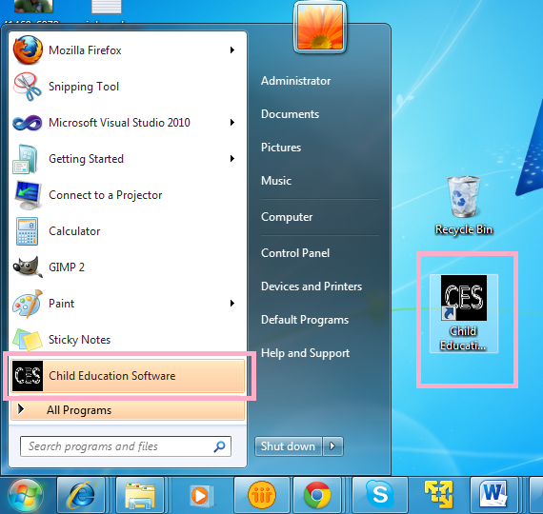

GUI with Video Screen:

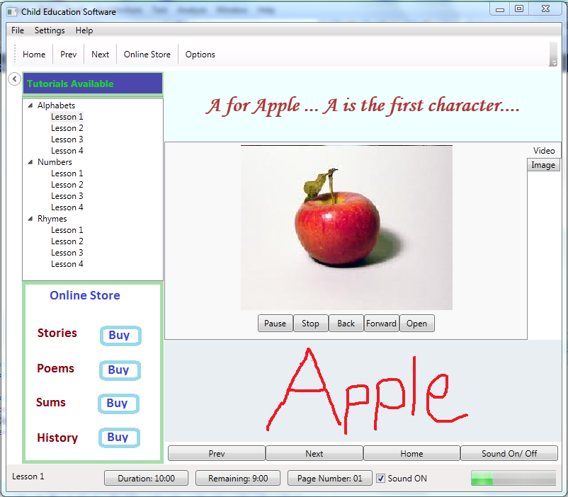

GUI with Image screen:

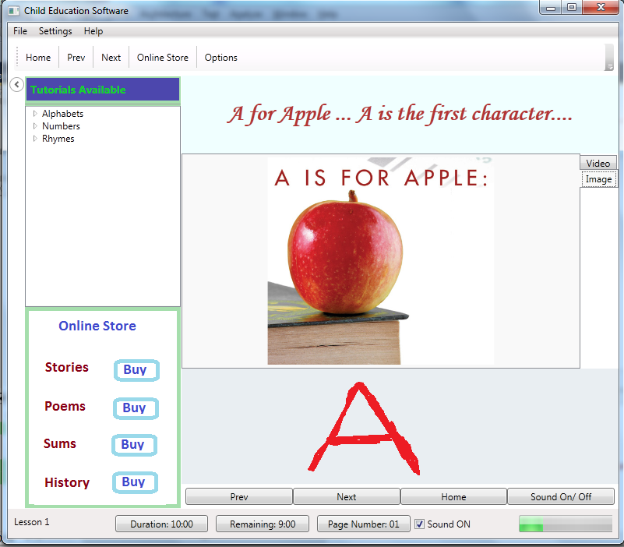

SECQURITY MEASURES:

LIMITATION OF THE PROJECT:
- Online store provides only static contents.
- Online store payment feature is not implemented
- All kinds of Media files are not supported.
- Tutorials are not visible without the CES software.

Any Client/Industry:

eKomfort Zone
Bamangachi Station Road,
P.O: Bamangachi, P.S: Barasat,
Dist: North 24 Pgs
West Bengal- 743706

Future Scope and Further enhancement of the project:

- To support UNIX / Linux based operating systems.
- To Support Mobile operating systems for Windows Mobile, Android.
- To port it on handheld device like iPad, Galaxy Tab & netbooks.
- Developing a dedicated website for purchasing tutorials.

Bibliography:
- http://www.google.co.in
- http://en.wikipedia.org
- http://msdn.microsoft.com/en-us/
- http://www.microsoft.com/en-us/default.aspx
- http://www.codeplex.com/
- http://stackoverflow.com/
- http://www.codeguru.com/
- http://www.w3schools.com
- http://www.thewpfblog.com/

----------------------------- Thank You-------------------------

