Daily Notebook & Social Networking Updater

MCA 6th Semester
MCSP-060(Project Synopsis)

Arindam Ghosh
Enrollment No-093052638

Table of Contents
Introduction & Objective of the Project: 4
Introduction 4
Objective 5
Project Category: 5
Project Structure: 6
Hardware and Software Specification 6
Hardware Requirement 6
Software Requirement 6
Tools/Platforms used (Hardware/Software): 6
Hardware: 6
Software: 6
REQUIREMENTS AND ANALYSIS 7
Problem Definition 7
Requirements Specification 7
Functional Requirement 7
Register User 7
Login User 7
Update Note or Event 8
Load Google Map 8
Share event in Google calendar 8
Search Event 9
Add Contact 9
Add To Do 9
Technical Specification 10
Planning and Scheduling 11
Gantt chart 11
Tracking Gantt 11
Pert Chart 12
Scope of the Solution 12
Analysis 13
Context Diagram 13
0-Level DFD 14
1-Level DFD 15
2-Level DFD 16
E-R Diagram 16
Class Diagram 18
Database & Table Details 19
Complete Structure 19
Module Description 19
Estimation 21
Data Structure 21
Implementation Methodology 25
List of Reports 25
Implementation of Security Mechanism at Various Levels 25
Future Scope and Further enhancement of the project: 25
Bibliography 26

Introduction & Objective of the Project:

Introduction
Nowadays social networking is the main trend among us. We like to share whatever is happening with us or around us and follow about others. We want to keep track of every possible thing in our life. Earlier day’s people used to maintain Notebook or Daily Diary to write down about their experiences. Now also we do same things but in different ways. With advent of new technologies we use twitter, facebook instead of maintaining a diary. As all of them are online services we cannot access them without an internet connection and sometimes it takes lots of time to load or query our own posts from the server.
Daily notebook & Social Networking Updater will provide a way to organize our daily notes and status updates for social networking sites. It will allow users to add notes and update it to most popular social networking sites. User can add notes anytime and mark it for update, and then whenever user comes online the pending updates will be uploaded to the destination sites. Users will be able to download the RSS feed of the websites and the Daily notebook & Social Networking Updater will automatically download the feeds and make it available for offline view also. The overview of this software is displayed below in the diagram.
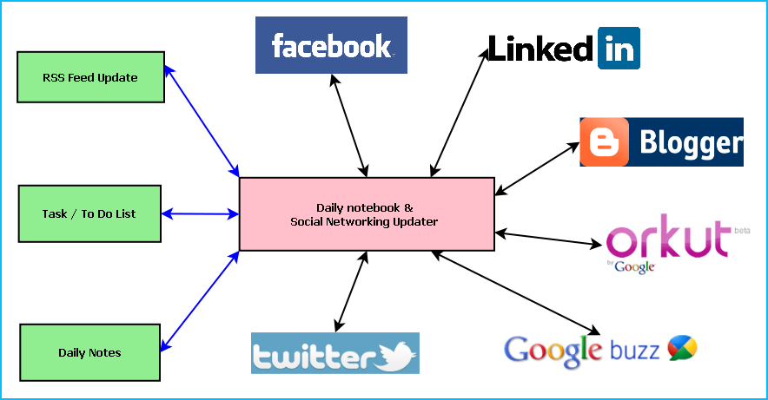
Figure: Overview of Daily notebook & Social Networking Updater
Main features of the Daily notebook & Social Networking Updater are:
- Maintaining daily notes
- Updating the status in Social Networking Sites and downloading the RSS feeds
- Facebook integration
- Twitter integration
- Google Calendar integration
- Linkedin integration
- Google plus integration
- Google Maps integration
- Maintaining To Do/Task list
- Reminder/ alarm for scheduled task
- Printing of Notes, To Do & Tasks
- Archiving old data
- Searching Updates

Objective
- Single solution for updating any social networking sites
- Keeping track of daily activities
- Timely update whenever internet is available
- To simulate similar experience of Daily notebook.
- To be involved with full-fledged software development
- To know about new technologies like .NET, WPF, Facebook, Twitter.

Project Category:
This software will follow Object Oriented Programming Paradigm and use below mentioned areas.
Front End/ GUI Tools: Visual Studio 2010, .NET 4, C#, WPF
Backend: MySQL 5.5.15
Internet Technologies: HTML, JavaScript, PHP, Google App Framework, facebook,SDK,twitterSDK,LinkedIn SDK.
Operating Systems: Windows XP, Windows 7
Applications: PC Utility application

Project Structure:

Hardware and Software Specification

Hardware Requirement
- Disc capacity : 10 MB of available hard disk space
- RAM : 1 GB (32 Bit) or 2 GB (64 Bit)
- Processor : 1.6GHz or faster
- DVD-ROM Drive / USB Port

Software Requirement
- Windows XP (x86) with Service Pack 3 / Windows Vista (x86 & x64) with
Service Pack 2 / Windows 7 (x86 & x64)
- Microsoft .NET 4.0

Tools/Platforms used (Hardware/Software):

Hardware:
- Laptop with 2GHZ processor
- 2 GB RAM
- 320 GB hard disk (NTFS File System)
- 8 GB USB Pen Drive (FAT File System)

Software:
- Windows XP (x86) with Service Pack 3 / Windows Vista (x86) with Service Pack 2 / Windows 7 (x86)
- Microsoft .NET 4.0
- Windows Presentation Framework(WPF)
- Windows Communication Framework(WCF)
- Visual Studio 2010 Express Edition (IDE)
- MySQL database
- Dia for Diagram Drawing & Modeling.
- Google App Framework
- Facebook Php Sdk & FBML
- Twitter Sdk
- LinkedIn Sdk
- RSS Feed Burner Sdk

REQUIREMENTS AND ANALYSIS

Problem Definition
Once we used to write diary for self evaluation and memory. We could ruminate them later. But in the age of digitalization, we are completely dependent on social networking sites. We regularly update them about our daily life. Still there are certain things which we do not like to share with others. So, such thoughts never get stored. The purpose of DNB is to store those memories digitally. With an attractive and easy to use GUI it will allows us to write down our daily status and thoughts. We could also share them with our friends through social networking sites as well whenever we wish.

Requirements Specification

Functional Requirement

Register User
Introduction:
Register a new User.
Input:
Relevant User data like name, user id, password, date of birth etc.
Processing:
The DNBSN will create a new user entry.
Output:
The DNBSN will generate a user to use the application.

Login User
Introduction:
Logging in as an existing User.
Input:
User will provide user id, password.
Processing:
The DNBSN will check the authorization of the particular user.
Output:
The DNBSN will allow accessing feature to the user if the given data match with the internal information, otherwise denying user.

Update Note or Event
Introduction:
User can add note or event.
Input:
User will compose note or event for update to note book or social site. And select the option where he wishes to update the event.
Processing:
The DNBSN will create a new event for note book and share the event to the selected social site.
Output:
The DNBSN will save event in note book and share it in social site.

Load Google Map
Introduction:
User can load Google map through DNBSN.
Input:
Current location
Processing:
The DNBSN will get location from google map.
Output:
The DNBSN will display the particular location.

Share event in Google calendar
Introduction:
User can share event in google calendar through DNBSN.
Input:
The user selects the event from note book to upload in google calendar.
Processing:
The DNBSN will upload event in calendar.
Output:
The google calendar will display the particular event.

Search Event
Introduction:
User can search event.
Input:
He will enter data like key word or date etc.
Processing:
The DNBSN will search for the requirement.
Output:
The DNBSN will display the search result.

Add Contact
Introduction:
The DNBSN will Store a new Contact.
Input:
Relevant contact data like name, e-mail id, mobile no, fax no. address, blood group etc.
Processing:
Admin will enter the data in the DNBSN and create a new Donor entry.
Output:
The DNBSN will generate a contact detail for future reference.

Add To Do
Introduction:
The DNBSN will Store a new task in To Do.
Input:
Relevant task data like task detail, priority etc.
Processing:
Admin will enter the data in the DNBSN and create a new task entry.
Output:
The DNBSN will generate a task detail.

Technical Specification
Front End/ GUI Tools: Windows Presentation Framework (WPF)
IDE: Visual Studio 2010
Framework: Microsoft .NET 4.0
Database: MySQL
Database Tool: MySQL workbench CE
Operating Systems: Windows XP, Windows 7
Others: MySQL .NET connector, Facebook/ Twitte/ LinkedIn SDK, Google Map
Cloud Technology: Google calendar, Google Drive

Planning and Scheduling

Gantt chart
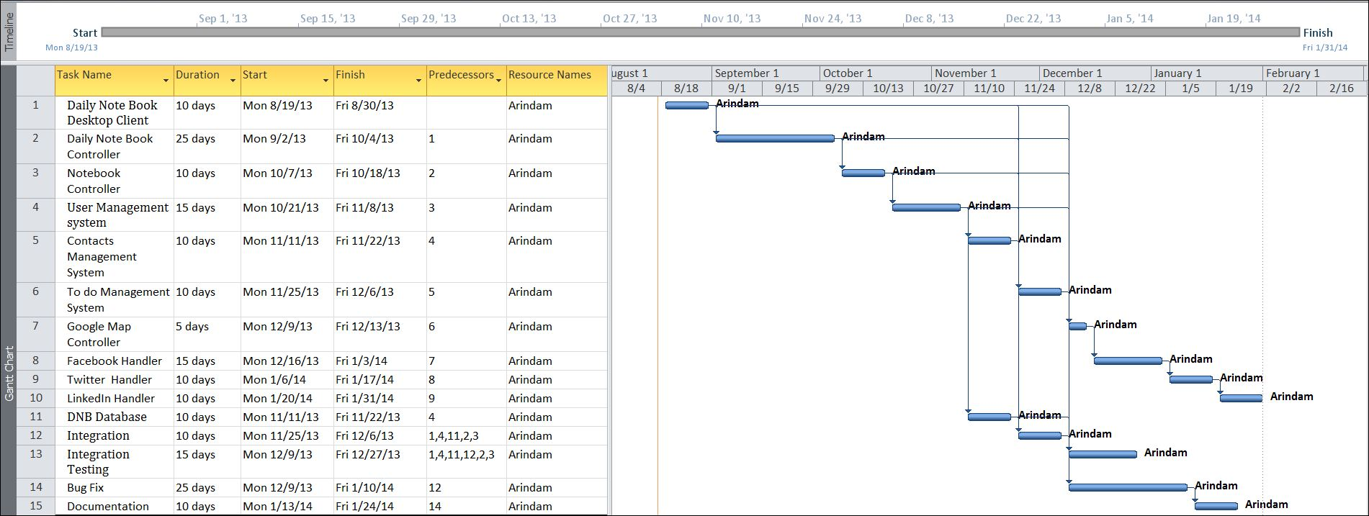

Tracking Gantt
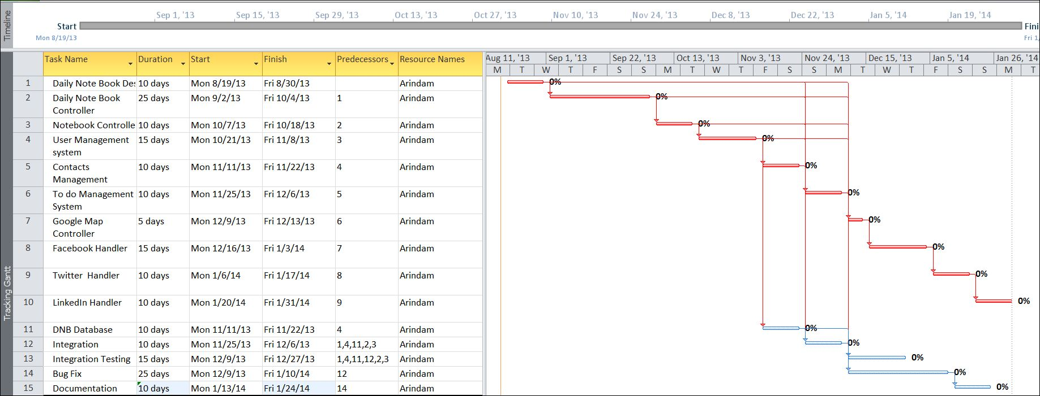

Pert Chart
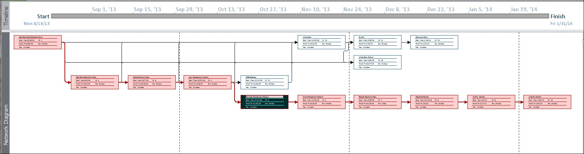

Scope of the Solution
Daily Notebook allows user to manage his entire updates and events of all the leading daily social networking sites. It allows us to note down our thoughts inside the application and update them whenever we want to single/ multiple social networking sites at once. They can keep track of the status updates and the response of his social networking website buddies. Not only that, it allows us to add remainder of various events and synchronize them with Google calendar later so that we could access them from anywhere.

Analysis

Context Diagram
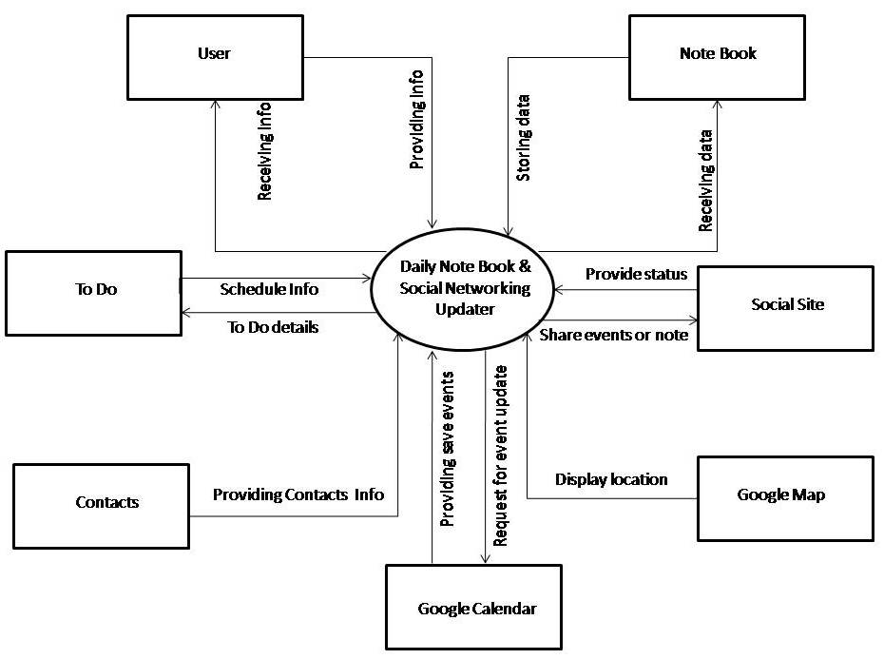

0-Level DFD
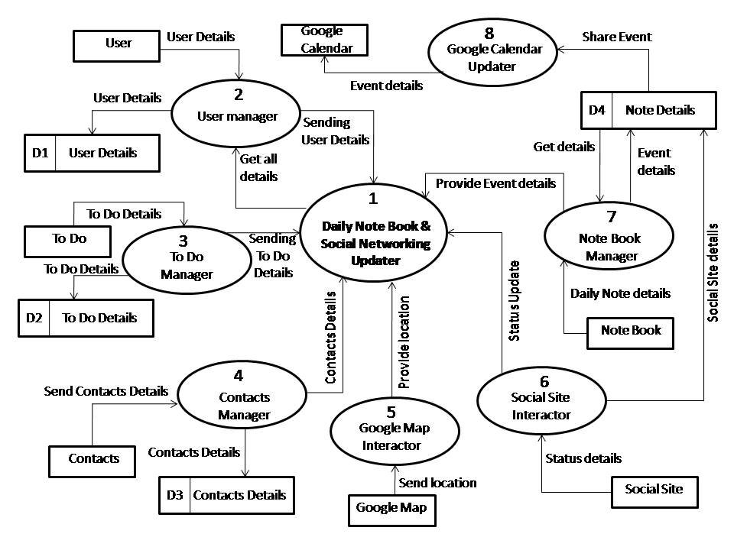

1-Level DFD
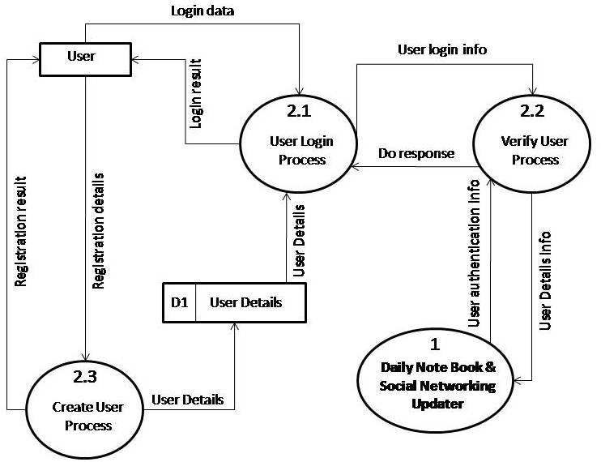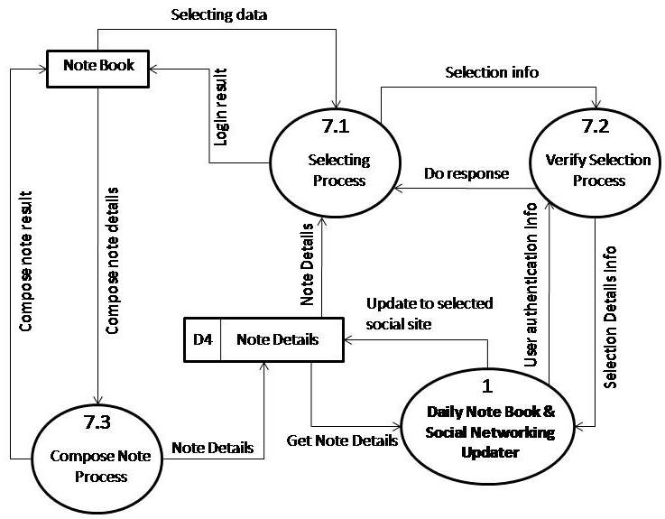

2-Level DFD
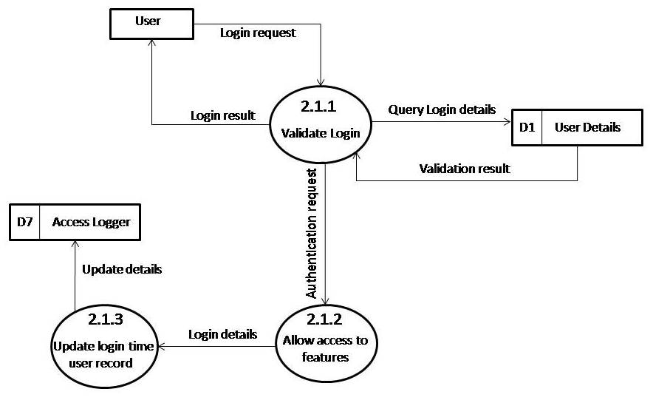

E-R Diagram
We will design a RDBMS for Daily notebook & Social Networking Updater. The entities and their attributes are listed below. Attributes in Bold letter is the unique key.
Entities | Attributes
Note | Note Id, Content, Time, Size, Web Service id, user
RSS Feed | RSS Feed Id , Web Service Id, Content, time, size
Daily notebook & Social Networking Updater | Sw Id, Web Services Supported, Users, Size
User | User Id, Name, Social Network Data, Preferences.
Web Service | Web Service Id, Authentication Data, Feed Data, Preferences.

Relationship between Entities:
- Daily notebook & Social Networking Updater has User → 1 : N
- Users post Notes → 1 : N
- Web Service generates Feeds → M : N

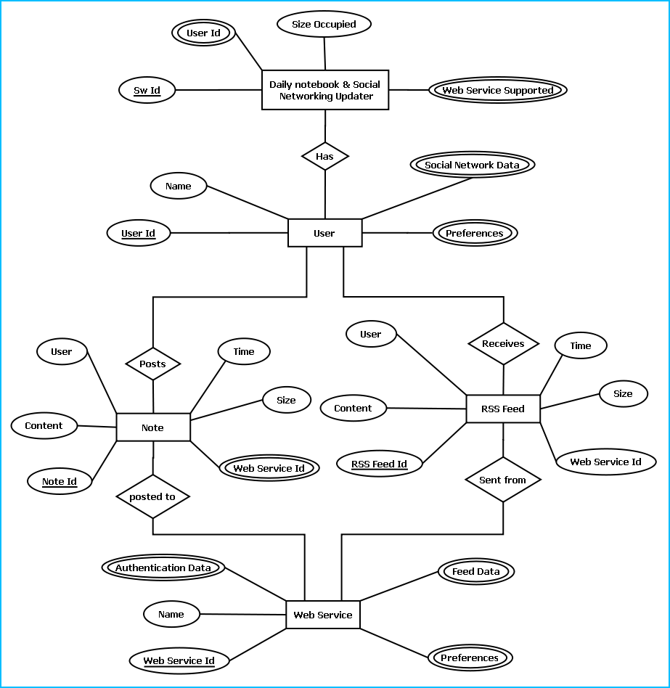
E-R Diagram of Daily notebook & Social Networking Updater

Class Diagram
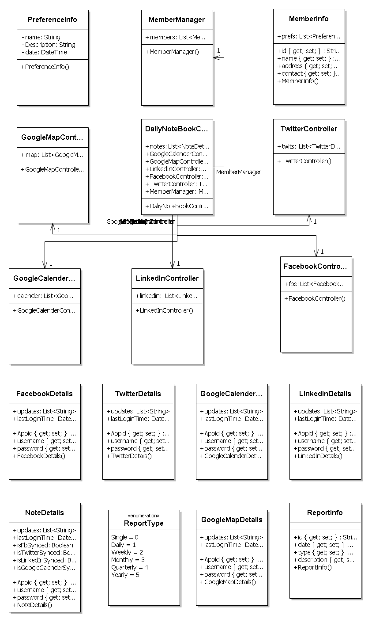

Database & Table Details
The database used for this software is called Dnbdb. Database tables and corresponding keys are shown in tabular form. It shows the tables and its columns. A key in Bold is the primary key.
Tables | Keys
Note | Note Id, Content, Time, Size, Web Service id, user
RSS Feed | RSS Feed Id , Web Service Id, Content, time, size
Daily notebook & Social Networking Updater | Sw Id, Web Services Supported, Users, Size
User | User Id, Name, Social Network Data, Preferences.
Web Service | Web Service Id, Authentication Data, Feed Data, Preferences.

Complete Structure

Module Description

The above picture represents various modules of Daily Notebook software. Their detailed description is written below:
DNB Engine: This module handles all the logical parts of DNB. It takes data from user through DNB GUI module and stores them to database using DNB Storage module. It sends the data to the user’s social networking account using corresponding site’s API. The data stored is taken from the DNB Storage and sent to the API. It saves the events details in the Google calendar.
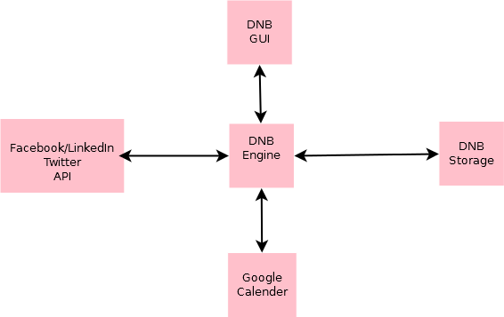
DNB GUI: This part is the place through which user interacts. This module contains all the designs which are visible and intractable by users. User provides input through it and gets the output through it. It is generally created by various tools like buttons and listviews.
DNB Storage: In this module all the data are stored. DNB Engine stores data in this module and fetches them for output through this module.
Google Calendar: This place gets input from the DNB engine. All the relevant data sent by user to Google calendar is stored here which could be accessed by user globally.
Facebook/Twitter/LinkedIn API: These modules provide news feed to user using the DNB engine through DNB GUI. It further gets the input, i.e. status update to the user’s account.

Estimation
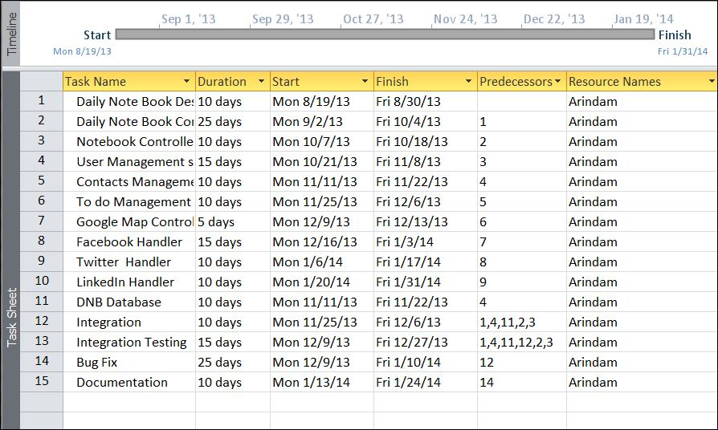

Data Structure

LinkedInDetails
public class LinkedInDetails
{
public string Appid { get; set; }
public string username { get; set; }
public string password { get; set; }
public List<string> updates;
public DateTime lastLoginTime;
}

GoogleCalenderDetails
public class GoogleCalenderDetails
{
public string Appid { get; set; }
public string username { get; set; }
public string password { get; set; }
public List<string> updates;
public DateTime lastLoginTime;
}

TwitterDetails
public class TwitterDetails
{
public string Appid { get; set; }
public string username { get; set; }
public string password { get; set; }
public List<string> updates;
public DateTime lastLoginTime;
}

FacebookDetails
public class FacebookDetails
{
public string Appid { get; set; }
public string username { get; set; }
public string password { get; set; }
public List<string> updates;
public DateTime lastLoginTime;
}

GoogleMapDetails
public class GoogleMapDetails
{
public string Appid { get; set; }
public string username { get; set; }
public string password { get; set; }
public List<string> updates;
public DateTime lastLoginTime;
}

NoteDetails
public class NoteDetails
{
public string Appid { get; set; }
public string username { get; set; }
public string password { get; set; }
public List<string> updates;
public DateTime lastLoginTime;
public bool isFbSynced;
public bool isTwitterSynced;
public bool isLinkedInSynced;
public bool isGoogleCalenderSynced;
}

FacebookController
public class FacebookController
{
public List<FacebookDetails> fbs;
}

TwitterController
public class TwitterController
{
public List<TwitterDetails> twits;
}

LinkedInController
public class LinkedInController
{
public List<LinkedInDetails> linkedin;
}

GoogleMapController
public class GoogleMapController
{
public List<GoogleMapDetails> map;
}

GoogleCalenderController
public class GoogleCalenderController
{
public List<GoogleCalenderDetails> calender;
}

ReportType
public enum ReportType
{
Single,
Daily,
Weekly,
Monthly,
Quarterly,
Yearly
}

ReportInfo
public class ReportInfo
{
public string id { get; set; }
public DateTime date { get; set; }
public ReportType type { get; set; }
public string description { get; set; }
}

DaliyNoteBookController
public class DaliyNoteBookController
{
public List<NoteDetails> notes;
public GoogleCalenderController GoogleCalenderController;
public GoogleMapController GoogleMapController;
public LinkedInController LinkedInController;
public FacebookController FacebookController;
public TwitterController TwitterController;
public MemberManager MemberManager;
}

MemberInfo
public class MemberInfo
{
public string id { get; set; }
public string name { get; set; }
public string address { get; set; }
public string contact { get; set; }
public List<PreferenceInfo> prefs;
}

MemberManager
public class MemberManager
{
public List<MemberInfo> members;
}

PreferenceInfo
public class PreferenceInfo
{
string name;
string Description;
DateTime date;
}

Implementation Methodology
- Facebook, LinkedIn, Twitter sdk has been used to develop the application.
- Object Oriented Programming methodology will be adopted
- User interface development will be done in MVC architecture using Windows Presentation Framework.
- Relational DBMS MySQL will be used to implement & execute SQL query to database.
- Agile Software Development model will be used while developing this software.

List of Reports
- List of Facebook updates could be generated.
- List of twitter update could be generated.
- A list of events could be generated.
- List of LinkedIn update could be generated.
- List of Google plus update could be generated.

Implementation of Security Mechanism at Various Levels
The software requires a predefined username and password to login.
It encrypts the data stored in the database so that even if someone succeeds to hack the database still not much harm could be done.
The application will use Google open-id authentication for web interface.

Future Scope and Further enhancement of the project:

- Now it will display the text based RSS feeds and link of the multimedia contents. We will display the Multimedia contents like Video, Audio & Image in future.
- To support UNIX / Linux Based Operating systems.
- To Support Mobile Operating systems for Symbian, Meego & Android.

Bibliography
- http://en.wikipedia.org
- http://msdn.microsoft.com/en-us/
- http://www.microsoft.com/en-us/default.aspx
- http://www.codeplex.com/
- http://stackoverflow.com/
- http://www.codeguru.com/
- http://www.w3schools.com
- www.mysql.org

----------------------------- Thank You-------------------------

