BCA 6th Semester CS-76 PROJECT
Expense Manager
PRITAM MANDAL

Table of Contents
Introduction of the Project: 4
Objective of the Project: 6
Tools / Environment Used 7
IDE Used (Visual Studio 2010): 7
Front End: WPF (Windows Presentation Framework) 8
Programming Framework (.NET 4): 8
Programming Language (C#): 9
Database Microsoft SQL Server 2008 9
Extensible Markup Language (XML) 10
Windows Communication FRAMEWORK (WCF) 10
Dia for Diagram Drawing & Modeling 11
Google Spreadsheet Interface: 12
Windows Mobile 6 Professional SDK 12
Analysis of the Project: 13
Desktop Application: 15
Desktop Application GUI: 16
Desktop Application Engine: 16
Desktop Application Storage 18
Mobile Application 18
Mobile Application GUI 19
Mobile Application Engine 19
Mobile Application Storage 19
Web Application 20
Web Application GUI 20
Web Application Engine 21
Web Application Storage 21
Hardware & Software for the application to run 21
Hardware Requirements 21
Software Requirements 21
E-R Diagram: 22
Any Client/Industry: 25
Future Scope and Further enhancement of the project: 26

Introduction of the Project:
Expense Manager Software will enable user to track expenses. This software will be useful to an individual as well as to a company. Users can add daily earnings & expenses. At any point of time he can review his total expenses and generate report. There will be three different User Interfaces to allow the user to use the software anywhere all the time. The User interfaces are Desktop Interface, Mobile Interface & Web Interface. The data from all the interfaces can be synced and merged to generate a final report.
The Desktop Interface is the main & fully featured version of the software. Users can add new data, browse old expenses and sync expenses from Mobile & Web Interfaces. The Mobile Interface will allow users to add data using their mobile and use customized feature set. While shopping people carry their mobile along with them and then they can add expenses and earnings instantly to avoid forgetting about certain expenses. The Web Interfaces provide the ultimate flexibility of login to the user accounts in the web and add/browse expenditures.

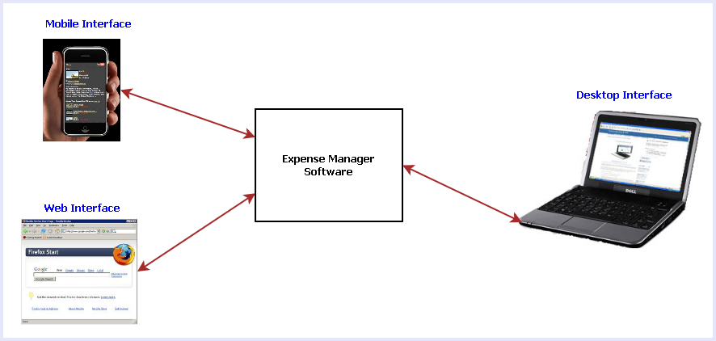
Fig 1: Different interfaces of Expense Manager Software
The main features of this software are listed below:
- Calendar view to select any date and add/view the expenses & earnings.
- Add tag with expenses so that user can remember the reason for spending
- View Available balance
- View Total expenses
- Generate a monthly/Weekly report.
- Online sync
- Reminder facility for future expenses.
- Searching the expenses.
- On the go expense tracking using Mobile & Web Interfaces
- Syncing data from all the interfaces such as: Desktop, Mobile & Web.

Objective of the Project:
The objectives of this project are given below:
- Expense manager will help user to track and manage his expenses & Income.
- It allows keeping multiple backup of the expense data from various kinds of digital devices.
- This software can be used anywhere using our handheld as well as desktop devices.
- This software helps us to become more eco-friendly by saving paper for writing expenses.
- By doing this project I am getting acquainted with the software development life-cycle.
- I am able to learn new cutting edge technologies like .NET 4 & WPF.

Tools / Environment Used

IDE Used (Visual Studio 2010):

Microsoft Visual Studio is a powerful IDE that ensures quality code throughout the entire application lifecycle, from design to deployment. Whether we are developing applications for SharePoint, the web, Windows, Windows Phone, and beyond, Visual Studio is the ultimate all-in-one solution. Visual Studio includes a code editor supporting IntelliSense as well as code refactoring. The integrated debugger works both as a source-level debugger and a machine-level debugger. Other built-in tools include a forms designer for building GUI applications, web designer, class designer, and database schema designer. It accepts plug-ins that enhance the functionality at almost every level—including adding support for source-control systems (like Subversion and Visual SourceSafe) and adding new toolsets like editors and visual designers for domain-specific languages or toolsets for other aspects of the software development lifecycle (like the Team Foundation Server client: Team Explorer).

Front End: WPF (Windows Presentation Framework)
Windows Presentation Foundation (WPF) provides developers with a unified programming model for building rich Windows smart client user experiences that incorporate UI, media, and documents. Windows Presentation Foundation (WPF) is a next-generation presentation system for building Windows client applications with visually stunning user experiences. With WPF, you can create a wide range of both standalone and browser-hosted applications. The core of WPF is a resolution-independent and vector-based rendering engine that is built to take advantage of modern graphics hardware. WPF extends the core with a comprehensive set of application-development features that include Extensible Application Markup Language (XAML), controls, data binding, layout, 2-D and 3-D graphics, animation, styles, templates, documents, media, text, and typography. WPF is included in the Microsoft .NET Framework, so you can build applications that incorporate other elements of the .NET Framework class library.

Programming Framework (.NET 4):

The .NET 4 Framework is Microsoft's platform for building applications that have visually stunning user experiences, seamless and secure communication, and the ability to model a range of business processes. The .Net Framework consists of:
- Common Language Runtime – provides an abstraction layer over the operating system
- Base Class Libraries – pre-built code for common low-level programming tasks
- Development frameworks and technologies – reusable, customizable solutions for larger programming tasks.
The framework's Base Class Library provides user interface, data access, database connectivity, cryptography, web application development, numeric algorithms, and network communications. The class library is used by programmers, who combine it with their own code to produce applications.

Programming Language (C#):
C# is a type-safe, object-oriented language that is simple yet powerful, allowing programmers to build a breadth of applications. C# is a multi-paradigm programming language encompassing imperative, declarative, functional, generic, object-oriented(class-based), and component-oriented programming disciplines. It was developed by Microsoft within the .NET initiative and later approved as a standard by Ecma (ECMA-334) and ISO (ISO/IEC 23270). C# is one of the programming languages designed for the Common Language Infrastructure.
C# is intended to be a simple, modern, general-purpose, object-oriented programming language.

Database Microsoft SQL Server 2008

Microsoft SQL Server 2008 is a complete set of enterprise-ready technologies and tools that help people derive the most value from information at the lowest total-cost-of-ownership. Enjoy high levels of performance, availability, and security; employ more productive management and development tools; and deliver pervasive insight with self-service business intelligence (BI). Its main Highlights are
- Complete information platform for applications of all sizes.
- Managed, familiar self-service BI tools.
- Support for large-scale data centers and data warehouses.
- Opportunities to build and extend applications in the cloud.
- Integration with the Microsoft Application Platform.

Extensible Markup Language (XML)
Extensible Markup Language (XML) is a simple, very flexible text format derived from SGML (ISO 8879). Originally designed to meet the challenges of large-scale electronic publishing, XML is also playing an increasingly important role in the exchange of a wide variety of data on the Web and elsewhere.
Extensible Markup Language (XML) is a set of rules for encoding documents in machine-readable form. It is defined in the XML 1.0 Specification produced by the W3C, and several other related specifications, all gratis open standards.
XML's design goals emphasize simplicity, generality, and usability over the Internet.[6] It is a textual data format with strong support via Unicode for the languages of the world. Although the design of XML focuses on documents, it is widely used for the representation of arbitrary data structures, for example in web services.
Many application programming interfaces (APIs) have been developed that software developers use to process XML data, and several schema systems exist to aid in the definition of XML-based languages.
As of 2009, hundreds of XML-based languages have been developed,[7] including RSS, Atom, SOAP, and XHTML. XML-based formats have become the default for most office-productivity tools, including Microsoft Office (Office Open XML), OpenOffice.org (OpenDocument), and Apple's iWork.
System.Xml is the core XML manipulation technology for .NET languages.

Windows Communication FRAMEWORK (WCF)
Windows Communication Foundation (WCF) is a framework for building service-oriented applications. Using WCF, you can send data as asynchronous messages from one service endpoint to another. A service endpoint can be part of a continuously available service hosted by IIS, or it can be a service hosted in an application. An endpoint can be a client of a service that requests data from a service endpoint. The messages can be as simple as a single character or word sent as XML, or as complex as a stream of binary data. A few sample scenarios include:
- A secure service to process business transactions.
- A service that supplies current data to others, such as a traffic report or other monitoring service.
- A chat service that allows two people to communicate or exchange data in real time.
- A dashboard application that polls one or more services for data and presents it in a logical presentation.
- Exposing a workflow implemented using Windows Workflow Foundation as a WCF service.
- A Silverlight application to poll a service for the latest data feeds.
While creating such applications was possible prior to the existence of WCF, WCF makes the development of endpoints easier than ever. In summary, WCF is designed to offer a manageable approach to creating Web services and Web service clients.

Dia for Diagram Drawing & Modeling
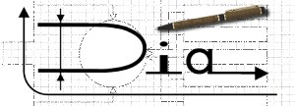
Dia is free and open source general-purpose diagramming software, developed as part of the GNOME project's office suite and was originally created by Alexander Larsson. Dia uses a controlled single document interface (CSDI) similar to GIMP and Sodipodi.
Dia has a modular design with several shape packages available for different needs: flowchart, network diagrams, circuit diagrams, and more. It does not restrict symbols and connectors from various categories from being placed together.
Dia is a gtk+ based diagram creation program released under the GPL license.
Dia is inspired by the commercial Windows program 'Visio', though more geared towards informal diagrams for casual use. It can be used to draw many different kinds of diagrams. It currently has special objects to help draw entity relationship diagrams, UML diagrams, flowcharts, network diagrams, and many other diagrams. It is also possible to add support for new shapes by writing simple XML files, using a subset of SVG to draw the shape.

It can load and save diagrams to a custom XML format (gzipped by default, to save space), can export diagrams to a number of formats, including EPS, SVG, XFIG, WMF and PNG, and can print diagrams (including ones that span multiple pages).

Google Spreadsheet Interface:

With Google Spreadsheets, we can easily create, share, and edit spreadsheets online. Here are a few specific things we can do:
- Import and export these file types: .xls, .csv, .txt and .ods. We can also export data to a PDF or an HTML file.
- Format cells and edit formulas so we can calculate results and make data look the way we want it.
- Chat in real time with others who are editing our spreadsheet.
- Embed a spreadsheet, or a section of a spreadsheet, in our blog or website.

Windows Mobile 6 Professional SDK

Windows Mobile is a mobile operating system developed by Microsoft that was used in smartphones and mobile devices. This features a suite of basic applications developed with the Microsoft Windows API. It is designed to be somewhat similar to desktop versions of Windows, feature-wise and aesthetically. Additionally, third-party software development is available for Windows Mobile, and software applications can be purchased via the Windows Marketplace for Mobile. Windows Mobile 6.1 was announced April 1, 2008. It is a minor upgrade to the existing Windows Mobile 6 platform which brings with it various performance enhancements, a redesigned Home screen featuring horizontal tiles that expand on clicking to display more information, although this new home screen is featured only on Windows Mobile Standard edition. This feature was inexplicably left out of the Professional edition. Several other changes such as threaded SMS, full page zooming in Internet Explorer and 'Domain Enroll' have also been added, along with a "mobile" version of the Microsoft OneNote program and an interactive "Getting Started" wizard. Windows Mobile 6.1 also featured improved bandwidth efficiency in its push-email protocol "Activesync" of "up to 40%", this reduced data usage was the cause of considerably improved battery life in many devices.

Analysis of the Project:
Expense Manager Software makes the user’s life easier by providing various applications to track user’s expense and earnings. Expense manager software consists of three different applications:
- Desktop Application
- Mobile Application
- Web Application
The figure below depicts how the user can use all the applications simultaneously and keep all his data synchronized.
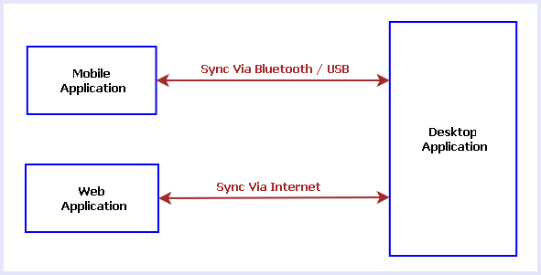
Fig: Expense Manager Applications
Mobile Application can sync its data with the Desktop Application by using Bluetooth or USB data transfer. Web Application can sync its data with the Desktop Application by downloading the data via internet.
Each application is internally divided into three main modules such as:
- Application Interface
- Application Engine
- Storage / Database ( Permanent or Temporary)

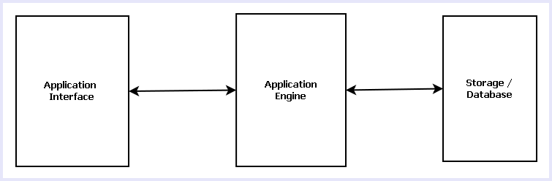
Application Interface is the GUI available for user to view & query saved data and add new data. Application Engine controls the whole application and it processes the user request, saves new data, answers the User queries and interacts with storage/database.
Storage/database saves all the user data for future use.
Desktop Application is the full featured application which contains the Permanent storage or bigger database where as Mobile and Web application has a small & temporary storage.

Desktop Application:
Desktop Application is the full featured application with a very user friendly and interactive GUI. It has mainly three modules like GUI, engine & storage. The modules of Desktop Application are displayed in the figure below.
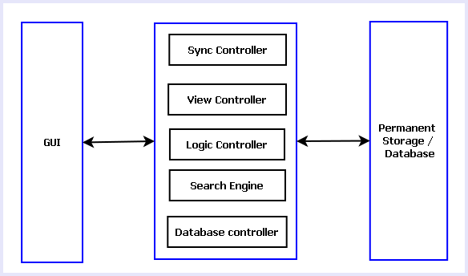
Fig: Modules of Desktop Application

Desktop Application GUI:
Desktop GUI will have several views like Calendar View, List View & Grid View. It will have option for Adding new expenses & earnings, searching data, adding reminder for future expenses, syncing with Mobile/Web application.

Desktop Application Engine:
Desktop Application Engine is the heart of the application. It controls the GUI interaction, logical calculations & database queries. It consists of 5 modules. Such as:

View Controller
It controls the look and feel of the GUI. The GUI will have three different views: Calendar View, List View & Grid View.
In calendar view user can select any date and the data associated with the date will displayed. Calendar view has three varieties like daily, weekly & monthly views.
List view will display the available data as a list with columns for Date, Tag Text & amount. List view can be sorted by the columns.
Grid View will display the available data in contiguous grids. Each Grid will display Tag Text, Amount & Date. The components of View controller are shown in the Diagram Below:

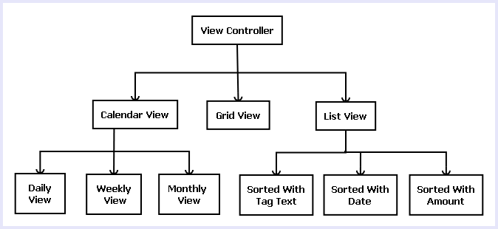

Sync Controller
Sync Controller handles the synchronization of data with Mobile & Web application. Sync Controller receives the data from other applications and then processes data and saves data for future use.

Logic Controller
Logic Controller manages all the modules of application engine. It handles the interaction between other modules. The instances of all other modules are created in Logic Controller. So it can control them. The application logic is written here in this module.

Search Engine
Search Engine helps the user to search available data. It will have option for searching by Tag Text, amount and date. Search Engine will form a query depending on the user input and fetch the result from the database.

Database Controller
Database controller handles the database interaction. It takes care of data addition, modification & retrieval from the database/storage.

Desktop Application Storage
Desktop Application Storage is the permanent storage/ database of the Expense Manager software. We will implement this module using MySQL. This module will store all the data related to this application. Users will be able to add, modify & view data on runtime.

Mobile Application
Mobile Application enables users to add and view data using their mobile. Mobile Application is a minimal feature application which only shows the data entered in the mobile and the total expenses & available balance. It does not allow user to do advanced operations like searching, sorting and various GUI options. Modules of the mobile application displayed below:
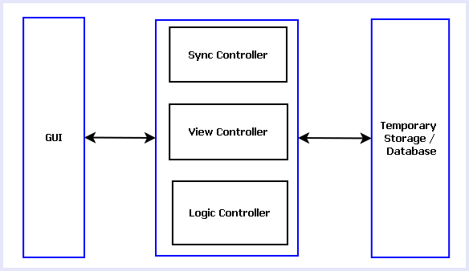
Fig: Modules of Mobile Application

Mobile Application GUI
It will have a simple and user friendly GUI. Initially the GUI will display the current date’s expenses and earnings. It also has options to add earnings & expenses and to choose other dates from a calendar view. User can initiate sync with desktop application from the GUI.

Mobile Application Engine
Mobile Application Engine provides the business logic for the application. It has mainly three modules:
- Logic Controller: It provides the logic for adding, searching data and saving, retrieving data from temporary storage.
- Sync Controller: It handles the data sync with Desktop application via Bluetooth or USB cable.
- View Controller: It controls the GUI and view related operations.

Mobile Application Storage
Mobile application storage is a temporary storage or file which is saved in phone memory or memory card of a mobile depending on user preference. Mobile application storage is designed to design maximum of one month’s user data.

Web Application
Web application helps users to use this application anywhere any point of time. Web application will enable user to enter his expense data even when he does not have his personal computer or mobile. Web application will use Google app framework, so user can login using his gmail id and use the application. Web application will be limited feature set like mobile app. User can enter expense data, browse through the data entered in web application earlier, view total expense and available balance.
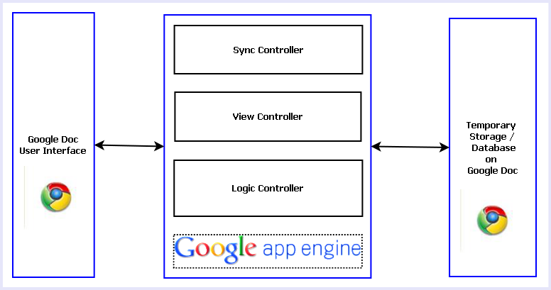

Web Application GUI
Web application GUI will be implemented using Google doc interface. Users will login using their gmail and then the Google doc interface will appear where user can enter expense data and earnings in a calendar view. User also can browse data entered earlier, view total expenses and available balance.

Web Application Engine
This module will be implemented using Google App Engine. It has three main modules:
- Logic Controller: It takes care of the logic behind saving, retrieving and searching data.
- Sync Controller: This module handles sync with Desktop application.
- View Controller: This module controls the data display and user interaction.
- Google App Engine: We will utilize Google App Engine framework as a base.

Web Application Storage
Google doc storage will be used as storage for this web application. Any Google user has 1 GB of free storage. So we will use the same as storage.

Hardware & Software for the application to run

Hardware Requirements

- Computer that has a 1.6GHz or faster processor
- 1 GB (32 Bit) or 2 GB (64 Bit) RAM
- 10 MB of available hard disk space
- DVD-ROM Drive / USB Port
- Mobile Phone running on Windows Mobile 7.0.

Software Requirements

- Windows XP (x86) with Service Pack 3 / Windows Vista (x86 & x64) with Service Pack 2 / Windows 7 (x86 & x64)
- Microsoft .NET 4.0
- Windows Mobile 7.0.

E-R Diagram:

Expense Manager Database will be an optimized database which will save certain information about every expenses and earnings logged by User.
We will design a RDBMS for Expense Manager. The entities and their attributes are listed below. Attributes in Bold letter is the unique key.

Entities | Attributes
Expenses | Expense Id, Amount, Text
Earnings | Earning Id, Amount, Text
Monthly Calculation | Month-Year, Total Expense, Total Earning
Day | Date, Total Expense, Total Earning
User | User Id, Name, password, Backup Path, Preferences.

Relationship between Entities:
- Monthly Calculation has Day → 1 : N
- In a Day happens Expenses→ 1 : N
- In a Day happens Earnings→ 1 : N
- User does Expenses → M : N
- User does Earnings → M : N

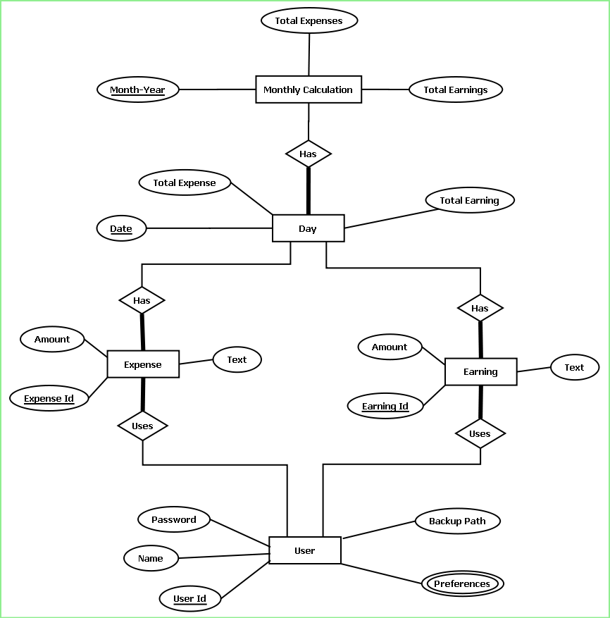 E-R Diagram of Expense Manager

DESIGN DOCUMENT:

User Interface Design:
The user interface is developed using WPF.
Menu bar contains the important features which can be accessed by shortcuts too. It is implemented using Menu control.
System.Windows.Controls.Menu
Namespace: System.Windows.Controls
Assembly: PresentationFramework (in PresentationFramework.dll)
Represents a Windows menu control that enables you to hierarchically organize elements associated with commands and event handlers.

Toolbar lists down the mostly used features. It is implemented using ToolBar control.
System.Windows.Controls.ToolBar
Namespace: System.Windows.Controls
Assembly: PresentationFramework (in PresentationFramework.dll)
Provides a container for a group of commands or controls.
Textpane displays the Texts. This is implemented using a TextBlock control.
System.Windows.Controls.TextBlock
Namespace: System.Windows.Controls
Assembly: PresentationFramework (in PresentationFramework.dll)
Provides a lightweight control for displaying small amounts of flow content.

Calender is implemented using Calendar Control.
System.Windows.Controls.Calendar
Namespace: System.Windows.Controls
Assembly: PresentationFramework (in PresentationFramework.dll)
Represents a control that enables a user to select a date by using a visual calendar display.

GridViews are implemented Using UniformGrid Control.
System.Windows.Controls.Primitives.UniformGrid
Namespace: System.Windows.Controls.Primitives
Assembly: PresentationFramework (in PresentationFramework.dll)
Provides a way to arrange content in a grid where all the cells in the grid have the same size.

List views are implemented using ListView Control.
System.Windows.Controls.ListView
Namespace: System.Windows.Controls
Assembly: PresentationFramework (in PresentationFramework.dll)
Represents a Windows list view control, which displays a collection of items that can be displayed using one of four different views.

Statusbar displays the information about the application and the tutorial currently running. Its implemented using StatusBar Class.
System.Windows.Controls.Primitives.StatusBar
Namespace: System.Windows.Controls.Primitives
Assembly: PresentationFramework (in PresentationFramework.dll)
Represents a control that displays items and information in a horizontal bar in an application window.

Engine Design:

Reading & Writing XML:
In this application the tutorials are saved as XML file. The application will process the XML and play the tutorial. So we have implemented XML reader and writer logic. XML operations are done using .NET XML parser. Every XML element is represented as a XElement control.
System.Xml.Linq.XElement
Namespace: System.Xml.Linq
Assembly: System.Xml.Linq (in System.Xml.Linq.dll)
Represents an XML element.

View controller
View controller is consists of Tab control and associated logic around it. It has different views in different tabs.

Logic controller
It has a very simple logic for adding data to a particular date and retrieving it from the database.

Sync Manager
Sync manager will take care of sync among desktop, web and mobile platform. It is basically sharing a XML file with each other.

Database Design
This database is implemented using MS SQL server. The algorithm for implementing it is given in later section.

Installer:
This software is packaged using Visual studio Installer utility. It provides a MSI file to be installed on end user side.
This installer will include all the required DLL to run this software and readily available tutorials.
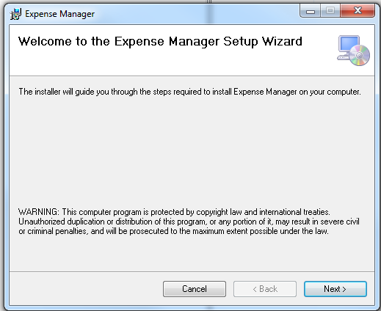

The users can browse the installation folder for this software and install the software in the desired path.
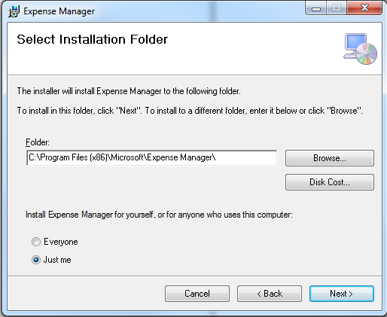
It will take some time to install the software in the PC and create shortcut icons on Desktop and program menus.
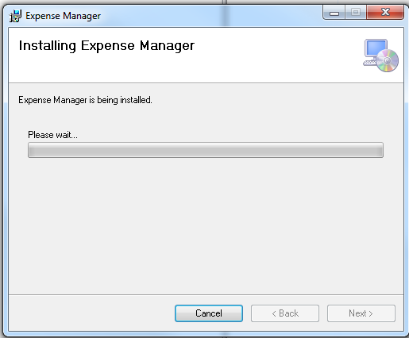

PROGRAMME CODE:
Expense manager has mainly three interfaces: Desktop, Mobile & Web.

Desktop:
The desktop code tree is shown below:
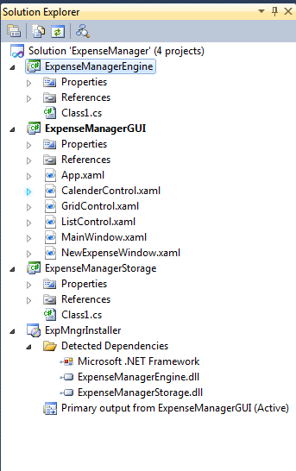
MainWindow.xaml
<Window xmlns:my="clr-namespace:ExpenseManagerGUI" x:Class="ExpenseManagerGUI.MainWindow"
xmlns="http://schemas.microsoft.com/winfx/2006/xaml/presentation"
xmlns:x="http://schemas.microsoft.com/winfx/2006/xaml"
Title="ExpenseManager" Height="600" Width="800">
<DockPanel LastChildFill="True">
<Menu DockPanel.Dock="Top">
<MenuItem Header="file" >
<MenuItem Name="newMenuItem" Header="new" Click="newMenuItem_Click"></MenuItem>
<MenuItem Name="saveMonthlyReportMenuItem" Header="Save Monthly Report" Click="saveMonthlyReportMenuItem_Click"></MenuItem>
<MenuItem Name="closeMenuItem" Header="close" Click="closeMenuItem_Click"></MenuItem>
</MenuItem>
<MenuItem Header="Edit" >
<MenuItem Name="changeNameMenuItem" Header="Change Name" Click="changeNameMenuItem_Click"></MenuItem>
<MenuItem Name="changeSalaryDateMenuItem" Header="Change Salary Date" Click="changeSalaryDateMenuItem_Click"></MenuItem>
<MenuItem Name="changeUnitMenuItem" Header="Change Money Unit" Click="changeUnitMenuItem_Click"></MenuItem>
</MenuItem>
<MenuItem Header="View">
<MenuItem Name="calMenuItem" Click="calMenuItem_Click" Header="Calender"></MenuItem>
<MenuItem Name="gridMenuItem" Click="gridMenuItem_Click" Header="Grid"></MenuItem>
<MenuItem Name="listMenuItem" Click="listMenuItem_Click" Header="List"></MenuItem>
</MenuItem>
<MenuItem Header="Tools">
<MenuItem Name="webSyncMenuItem" Click="webSyncMenuItem_Click" Header="Sync to Web"></MenuItem>
<MenuItem Name="mobSyncMenuItem" Click="mobSyncMenuItem_Click" Header="Sync to Mobile"></MenuItem>
<MenuItem Name="localBackupMenuItem" Click="localBackupMenuItem_Click" Header="Save Local backup"></MenuItem>
</MenuItem>
<MenuItem Header="Help">
<MenuItem Header="About" Name="abtMenuItem" Click="abtMenuItem_Click"></MenuItem>
<MenuItem Header="Help" Name="helpMenuItem" Click="helpMenuItem_Click"></MenuItem>
</MenuItem>

</Menu>
<ToolBar Height="40" DockPanel.Dock="Top">
<Button Name="newToolBarBtn" Click="newMenuItem_Click">New Expense</Button>
<Separator></Separator>

<Button>New Credit</Button>
<Separator></Separator>
<Button Click="calMenuItem_Click">Calender view</Button>
<Separator></Separator>
<Button Click="gridMenuItem_Click">Grid View</Button>
<Separator></Separator>
<Button Click="listMenuItem_Click">List View</Button>
<Separator></Separator>
<Button> Mobile Sync</Button>
<Separator></Separator>
<Button>Web Sync</Button>
<Separator></Separator>
<Button>Save Monthly Report</Button>
</ToolBar>
<StatusBar DockPanel.Dock="Bottom">
<Label>Not connected to Internet</Label>
</StatusBar>

<TabControl Name="viewTabControl" TabStripPlacement="Right">
<TabItem Header="Calender" Name="calenderTabItem">
<my:CalenderControl />
</TabItem>
<TabItem Header="Grid" Name="gridTabitem">
<my:GridControl />
</TabItem>
<TabItem Header="List" Name="listTabItem">
<my:ListControl />
</TabItem>
</TabControl>

</DockPanel>
</Window>

NewExpenseWindow.xaml
<Window x:Class="ExpenseManagerGUI.NewExpenseWindow"
xmlns="http://schemas.microsoft.com/winfx/2006/xaml/presentation"
xmlns:x="http://schemas.microsoft.com/winfx/2006/xaml"
Title="New Expense" Height="300" Width="465">
<Grid>
<Popup Name="dateSelectionPopup" Placement="MousePoint" StaysOpen="False">
<Calendar />
</Popup>
<Label Content="Date:" Height="28" HorizontalAlignment="Left" Margin="26,30,0,0" Name="label1" VerticalAlignment="Top" />
<TextBox Height="23" HorizontalAlignment="Left" Margin="134,32,0,0" Name="textBox1" VerticalAlignment="Top" Width="147" />
<Button Name="browseDateBtn" Click="browseDateBtn_Click" Content="Browse" Height="23" HorizontalAlignment="Left" Margin="295,32,0,0" VerticalAlignment="Top" Width="75" />
<Label Content="Descritption" Height="28" HorizontalAlignment="Left" Margin="26,87,0,0" Name="label2" VerticalAlignment="Top" />
<TextBox Height="23" HorizontalAlignment="Left" Margin="134,92,0,0" Name="textBox2" VerticalAlignment="Top" Width="236" />
<Label Content="Amount" Height="28" HorizontalAlignment="Left" Margin="26,155,0,0" Name="label3" VerticalAlignment="Top" Width="58" />
<TextBox Height="23" HorizontalAlignment="Left" Margin="134,157,0,0" Name="textBox3" VerticalAlignment="Top" Width="236" />
<Button Content="Add" Height="23" HorizontalAlignment="Left" Margin="26,226,0,0" Name="addButton" VerticalAlignment="Top" Width="161" Click="addButton_Click" />
<Button Content="Cancel" Height="23" HorizontalAlignment="Left" Margin="223,226,0,0" Name="cancelBtn" VerticalAlignment="Top" Width="147" Click="cancelBtn_Click" />
</Grid>
</Window>

ListControl.xaml
<UserControl x:Class="ExpenseManagerGUI.ListControl"
xmlns="http://schemas.microsoft.com/winfx/2006/xaml/presentation"
xmlns:x="http://schemas.microsoft.com/winfx/2006/xaml"
xmlns:mc="http://schemas.openxmlformats.org/markup-compatibility/2006"
xmlns:d="http://schemas.microsoft.com/expression/blend/2008"
mc:Ignorable="d"
d:DesignHeight="300" d:DesignWidth="300">
<DockPanel LastChildFill="True">
<ListView Background="DarkOliveGreen" Name="listDataLV">
<ListViewItem />
<ListViewItem />
<ListViewItem />
<ListViewItem />
<ListViewItem />
<ListViewItem />
<ListViewItem />
<ListViewItem />
</ListView>
</DockPanel>
</UserControl>

GridControl.xaml
<UserControl x:Class="ExpenseManagerGUI.GridControl"
xmlns="http://schemas.microsoft.com/winfx/2006/xaml/presentation"
xmlns:x="http://schemas.microsoft.com/winfx/2006/xaml"
xmlns:mc="http://schemas.openxmlformats.org/markup-compatibility/2006"
xmlns:d="http://schemas.microsoft.com/expression/blend/2008"
mc:Ignorable="d"
d:DesignHeight="300" d:DesignWidth="400">
<DockPanel LastChildFill="True">
<UniformGrid Columns="7" Rows="5" Background="Coral" Name="monthGrid"></UniformGrid>
</DockPanel>
</UserControl>

CalenderControl.xaml
<UserControl x:Class="ExpenseManagerGUI.CalenderControl"
xmlns="http://schemas.microsoft.com/winfx/2006/xaml/presentation"
xmlns:x="http://schemas.microsoft.com/winfx/2006/xaml"
xmlns:mc="http://schemas.openxmlformats.org/markup-compatibility/2006"
xmlns:d="http://schemas.microsoft.com/expression/blend/2008"
mc:Ignorable="d"
d:DesignHeight="300" d:DesignWidth="651">
<DockPanel LastChildFill="True">
<DockPanel Name="calenderSideBar" DockPanel.Dock="Left">
<Calendar DockPanel.Dock="Top"></Calendar>
<UniformGrid DockPanel.Dock="Bottom" Columns="1">
<Button>Daily View</Button>
<Button>Weekly View</Button>
<Button>Monthly View</Button>
</UniformGrid>
</DockPanel>
<DockPanel Name="calenderMainViewDP"></DockPanel>
</DockPanel>
</UserControl>
MainWindow.xaml.cs
using System;
using System.Collections.Generic;
using System.Linq;
using System.Text;
using System.Windows;
using System.Windows.Controls;
using System.Windows.Data;
using System.Windows.Documents;
using System.Windows.Input;
using System.Windows.Media;
using System.Windows.Media.Imaging;
using System.Windows.Navigation;
using System.Windows.Shapes;
using System.Threading;

namespace ExpenseManagerGUI
{
/// <summary>
/// Interaction logic for MainWindow.xaml
/// </summary>
public partial class MainWindow : Window
{
public MainWindow()
{
InitializeComponent();
}

private void newMenuItem_Click(object sender, RoutedEventArgs e)
{
//this.WindowState = System.Windows.WindowState.Minimized;
NewExpenseWindow nwExpWindw = new NewExpenseWindow();
nwExpWindw.ShowDialog();
}

private void closeMenuItem_Click(object sender, RoutedEventArgs e)
{
//this.WindowState = System.Windows.WindowState.Maximized;
//Thread.Sleep(10000);
this.Close();
}

private void calMenuItem_Click(object sender, RoutedEventArgs e)
{
viewTabControl.SelectedIndex = 0;
}

private void gridMenuItem_Click(object sender, RoutedEventArgs e)
{
viewTabControl.SelectedIndex = 1;
}

private void listMenuItem_Click(object sender, RoutedEventArgs e)
{
viewTabControl.SelectedIndex = 2;
}

private void abtMenuItem_Click(object sender, RoutedEventArgs e)
{
MessageBox.Show(" Expense Manager V 1.0... \n Developed by Pritam Mandal...");
}

private void helpMenuItem_Click(object sender, RoutedEventArgs e)
{

}

private void changeNameMenuItem_Click(object sender, RoutedEventArgs e)
{

}

private void changeSalaryDateMenuItem_Click(object sender, RoutedEventArgs e)
{

}

private void changeUnitMenuItem_Click(object sender, RoutedEventArgs e)
{

}

private void saveMonthlyReportMenuItem_Click(object sender, RoutedEventArgs e)
{

}

private void webSyncMenuItem_Click(object sender, RoutedEventArgs e)
{

}

private void mobSyncMenuItem_Click(object sender, RoutedEventArgs e)
{

}

private void localBackupMenuItem_Click(object sender, RoutedEventArgs e)
{

}
}
}

Mobile
Add1Data.cs
using System;
using System.Linq;
using System.Collections.Generic;
using System.ComponentModel;
using System.Data;
using System.Drawing;
using System.Text;
using System.Windows.Forms;

namespace ExpenseManager
{
public delegate void delegateNewDataAdded(string data);
public partial class AddData : Form
{
public event delegateNewDataAdded OnNewDataAdded;

public AddData(string wndTxt1,string lblTxt1)
{
InitializeComponent();
this.Text = wndTxt1;
this.textLabel.Text = lblTxt1;
}

private void menuItem1_Click(object sender, EventArgs e)
{
this.OnNewDataAdded(this.dataTextBox.Text);
this.Close();
}

private void menuItem2_Click(object sender, EventArgs e)
{
this.Close();
}
}
}

DisplayText.cs
using System;
using System.Linq;
using System.Collections.Generic;
using System.ComponentModel;
using System.Data;
using System.Drawing;
using System.Text;
using System.Windows.Forms;

namespace ExpenseManager
{
public partial class DisplayText : Form
{
public DisplayText(string wndTxt,string lblTxt)
{
InitializeComponent();
this.Text = wndTxt;
this.label1.Text = lblTxt;
}

private void menuItem1_Click(object sender, EventArgs e)
{
this.Close();
}
}
}
ExpenseManager.cs
using System;
using System.Linq;
using System.Collections.Generic;
using System.ComponentModel;
using System.Data;
using System.Drawing;
using System.Text;
using System.Windows.Forms;

namespace ExpenseManager
{
public partial class ExpnsMngr : Form
{
int salaryDate;
string moneyUnit;
List<YearData> yearList;

public ExpnsMngr()
{
InitializeComponent();
yearList = ReadSavedData();
}

List<YearData> ReadSavedData()
{
List<YearData> years = new List<YearData>();
return years;
}

private void QuitMenuItem_Click(object sender, EventArgs e)
{
this.Close();
}

private void changeNameMenuItem_Click(object sender, EventArgs e)
{
AddData nameAddData = new AddData("Change Name", "Add your name to display on window Text");
nameAddData.OnNewDataAdded += new delegateNewDataAdded(nameAddData_OnNewDataAdded);
nameAddData.ShowDialog();
}

void nameAddData_OnNewDataAdded(string data)
{
this.Text = data + "'s Expense Manager";
}

private void changeSalDateMenuItem_Click(object sender, EventArgs e)
{
AddData salDateData = new AddData("Change Salary Date","Insert your salary date to calculate remaining dates & avg spenditure");
salDateData.OnNewDataAdded += new delegateNewDataAdded(salDateData_OnNewDataAdded);
salDateData.ShowDialog();
}

void salDateData_OnNewDataAdded(string data)
{
salaryDate = Convert.ToInt32(data);
}

private void changeUnitMenuItem_Click(object sender, EventArgs e)
{
AddData unitData = new AddData("Change Unit", "Insert a valid money Unit (Max 3 Chars)");
unitData.OnNewDataAdded += new delegateNewDataAdded(unitData_OnNewDataAdded);
unitData.ShowDialog();
}

void unitData_OnNewDataAdded(string data)
{
moneyUnit = data.Remove(3,data.Length-3);
this.label2.Text = "Total Expenses: " + moneyUnit;
this.label1.Text = "Available Balance: " + moneyUnit;
}

private void aboutenuItem_Click(object sender, EventArgs e)
{
DisplayText abt = new DisplayText("About", " Version 1.0. \r\n\r\n All rights reserved by \r\n Chandra Shekhar Sengupta.");
abt.ShowDialog();
}

private void helpMenuItem_Click(object sender, EventArgs e)
{
DisplayText help = new DisplayText("Help", "##1 Add expenses,credits by pressing \"Add Expense\",\"Add Credit\".\r\n##2 To see a daily report click on date & the report will appear on right side.\r\n##3 Press Menu for more features.");
help.ShowDialog();
}

private void monthCalendar1_DateChanged(object sender, DateRangeEventArgs e)
{
if (e.Start.CompareTo(DateTime.Now) > 0)
{
infoLabel.Text = "This is a future date";
expenseDetailsLabel.Text = "No future expenses.. ;-)";
addCreditBtn.Enabled = false;
addExpenseBtn.Enabled = false;
}
else
{
addCreditBtn.Enabled = true;
addExpenseBtn.Enabled = true;

infoLabel.Text = e.Start.ToString();

DateData tempDate = null;
DateTime selDateTime = this.monthCalendar1.SelectionStart;
MonthData tempMonth = null;
YearData tempYear = yearList.Find(item => item.year == selDateTime.Year);
if (tempYear != null)
{
tempMonth = tempYear.monthList.Find(item => item.month == selDateTime.Month);
if (tempMonth != null)
{
tempDate = tempMonth.dateList.Find(item => item.date.Day == selDateTime.Day);
if (tempDate == null)
{
expenseDetailsLabel.Text = "No Details added yet.";
}
else
{
string dbtStr = null;
foreach (Data dt in tempDate.debitList)
{
dbtStr += dt.note + "-" + dt.amount.ToString();
}
if (dbtStr == null)
dbtStr = "0";

string crdtStr = null;
foreach (Data dt in tempDate.creditList)
{
crdtStr += dt.note + "-" + dt.amount.ToString();
}
if (crdtStr == null)
crdtStr = "0";

expenseDetailsLabel.Text = "Debit= " + dbtStr + "\r\n" + "Credit= " + crdtStr;
}

}
else
{
expenseDetailsLabel.Text = "No Details added yet.";
}
}
else
{
expenseDetailsLabel.Text = "No Details added yet.";
}
}
}

private void googleDocMenuItem_Click(object sender, EventArgs e)
{

}

private void saveMonthlyReportMenuItem_Click(object sender, EventArgs e)
{

}

private void addExpenseBtn_Click(object sender, EventArgs e)
{
AddData2 expnseData = new AddData2("Add Expense Data","Note:","Amount:");
expnseData.OnNewDataAdded2 += new delegateNewDataAdded2(expnseData_OnNewDataAdded2);
expnseData.ShowDialog();
}

void expnseData_OnNewDataAdded2(string note, string amnt)
{
DateData tempDate = null;
DateTime selDateTime = this.monthCalendar1.SelectionStart;
MonthData tempMonth = null;
YearData tempYear = yearList.Find(item => item.year == selDateTime.Year);
if (tempYear != null)
{
tempMonth = tempYear.monthList.Find(item => item.month == selDateTime.Month);
if (tempMonth != null)
{
tempDate = tempMonth.dateList.Find(item => item.date.Day == selDateTime.Day);
if (tempDate == null)
{
tempDate = new DateData(selDateTime);
tempMonth.dateList.Add(tempDate);
}
}
else
{
tempMonth = new MonthData(selDateTime.Month);
tempYear.monthList.Add(tempMonth);
tempDate = new DateData(selDateTime);
tempMonth.dateList.Add(tempDate);
}
}
else
{
tempYear = new YearData(selDateTime.Year);
yearList.Add(tempYear);
tempMonth = new MonthData(selDateTime.Month);
tempYear.monthList.Add(tempMonth);
tempDate = new DateData(selDateTime);
tempMonth.dateList.Add(tempDate);
}
Data newData = new Data(note,amnt);
tempDate.debitList.Add(newData);
tempMonth.totalExpense += newData.amount;
this.totExpLabel.Text = tempMonth.totalExpense.ToString();
this.availBalLabel.Text = (-tempMonth.totalExpense + tempMonth.totalCredit).ToString();
this.monthCalendar1.SelectionStart = selDateTime;
}

private void addCreditBtn_Click(object sender, EventArgs e)
{
AddData2 creditData = new AddData2("Add Credit Data", "Note:", "Amount:");
creditData.OnNewDataAdded2 += new delegateNewDataAdded2(creditData_OnNewDataAdded2);
creditData.ShowDialog();
}

void creditData_OnNewDataAdded2(string note, string amnt)
{
DateData tempDate = null;
DateTime selDateTime = this.monthCalendar1.SelectionStart;
MonthData tempMonth = null;
YearData tempYear = yearList.Find(item => item.year == selDateTime.Year);
if (tempYear != null)
{
tempMonth = tempYear.monthList.Find(item => item.month == selDateTime.Month);
if (tempMonth != null)
{
tempDate = tempMonth.dateList.Find(item => item.date.Day == selDateTime.Day);
if (tempDate == null)
{
tempDate = new DateData(selDateTime);
tempMonth.dateList.Add(tempDate);
}
}
else
{
tempMonth = new MonthData(selDateTime.Month);
tempYear.monthList.Add(tempMonth);
tempDate = new DateData(selDateTime);
tempMonth.dateList.Add(tempDate);
}
}
else
{
tempYear = new YearData(selDateTime.Year);
yearList.Add(tempYear);
tempMonth = new MonthData(selDateTime.Month);
tempYear.monthList.Add(tempMonth);
tempDate = new DateData(selDateTime);
tempMonth.dateList.Add(tempDate);
}

Data newData = new Data(note, amnt);
tempDate.creditList.Add(newData);
tempMonth.totalCredit += newData.amount;
this.availBalLabel.Text = (-tempMonth.totalExpense + tempMonth.totalCredit).ToString();
this.monthCalendar1.SelectionStart = selDateTime;
}

}
}

Algorithm for Database Connection:
Step1: Create connection
try
{
string dbConnectionString = "Data Source=9.126.164.183;Initial Catalog=
BTT_MESSAGE_INTEGRATION_Dave;User ID=wtrkplusdev;Password=wtrkplus0123;";
SqlConnection connection = new SqlConnection(dbConnectionString);
connection.Open();
} catch (SqlException sqlException)
{
// message
}
step2: Create a stored procedure command
SqlCommand sqlCommand = new SqlCommand(commandName, connection);
sqlCommand.CommandType = System.Data.CommandType.StoredProcedure;
sqlCommand.Transaction = transaction;
Step3: provide necessary input and output params to the sql command
SqlParameter paymentScheduleIDParam
= new SqlParameter(PARAM_PAYMENT_SCHEDULE_ID, paymentScheduleID);
paymentScheduleIDParam.SqlDbType = SqlDbType.Int;
paymentScheduleIDParam.Direction = ParameterDirection.Input;
sqlCommand.Parameters.Add(paymentScheduleIDParam);
Step4: Execute the command to read a value
SqlDataReader sqlReader = sqlCommand.ExecuteReader();
OR Execute a command to insert a value

int rows = sqlCommand.ExecuteNonQuery();
Step5: For read operation create business objects from sqlreader by writing DataMapper functions
//Add data from data reader to the business object list
while (sqlDataReader.Read())
{
if (!Convert.IsDBNull(sqlDataReader["PaymentDate"]))
{
lastPaymentDate = Convert.ToDateTime(sqlDataReader["PaymentDate"]);
}
}

Reading & Writing XML
public void ReadData(string xmlPath,List<DeviceInfo> devList)
{

if (File.Exists(xmlPath))
{
XElement xmlDoc = XElement.Load(xmlPath);
if (xmlDoc != null)
{

XElement devices = xmlDoc.Element("DevicesSupported");

foreach (XElement device in devices.Elements("Device"))
{
DeviceInfo devInfo = new DeviceInfo();
XElement componentPath = device.Element("ComponentPath");
devInfo.componentPath = componentPath.Value;
XElement xmlFilePath = device.Element("XmlPath");
devInfo.deviceXmlPath = xmlFilePath.Value;
XElement feDllPath = device.Element("FeDllPath");
devInfo.feDllPath = feDllPath.Value;
XElement beDllPath = device.Element("BeDllPath");
devInfo.beDllPath = beDllPath.Value;
XElement deviceFamily = device.Element("DeviceFamily");
devInfo.deviceFamily = deviceFamily.Value;
devList.Add(devInfo);
}
}
}

}

public static void WriteData(string LogPath,List<ServerInfo> servers)
{
XElement m_XmlDoc = new XElement("servers");

if (servers != null)
{

foreach (ServerInfo sv in servers)
{
XElement serverInfo = new XElement("server", new XAttribute("name", sv.name),
new XAttribute("ip", sv.ipAddress));

//foreach (ServiceInfo si in sv.services)
//{
// XElement serviceInfo = new XElement(
// "service",
// new XAttribute("name", si.name),
// new XAttribute("port", si.port));

// serverInfo.Add(serviceInfo);
//}
m_XmlDoc.Add(serverInfo);
}

m_XmlDoc.Save(LogPath + CONFIG_FILE_NAME);
}

}
}

TESTING:

INPUT/OUTPUT SEREEN:

Mobile
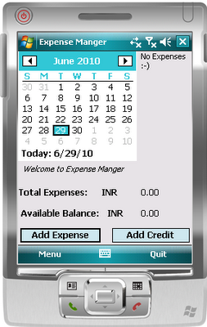
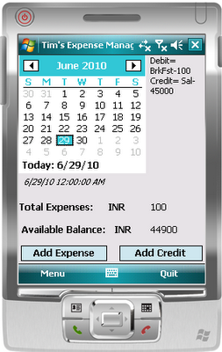
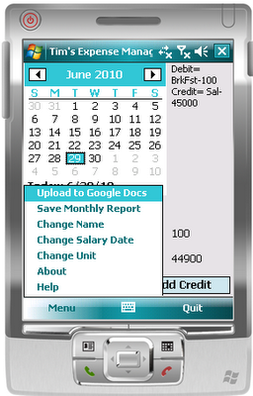

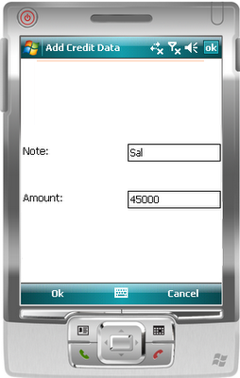
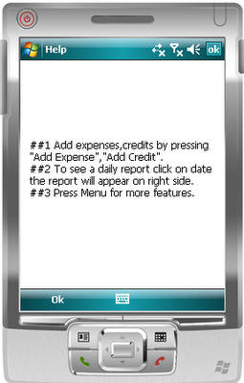

Desktop:

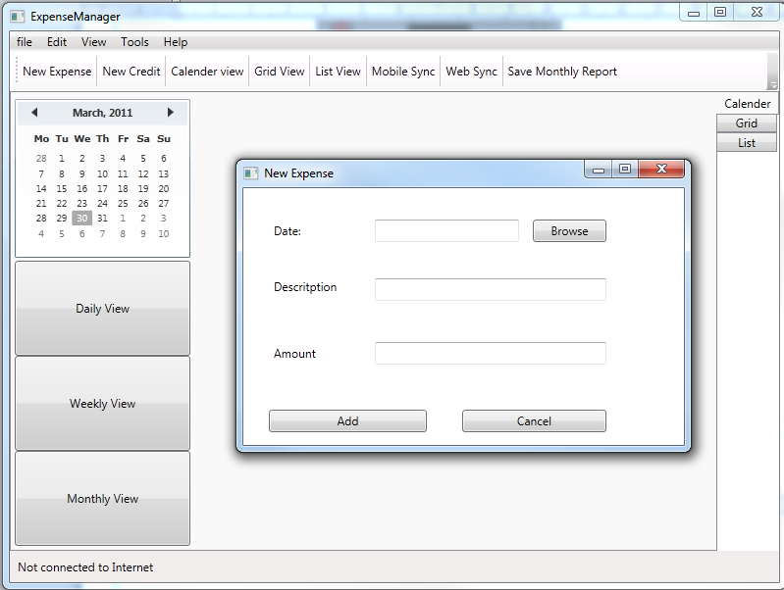

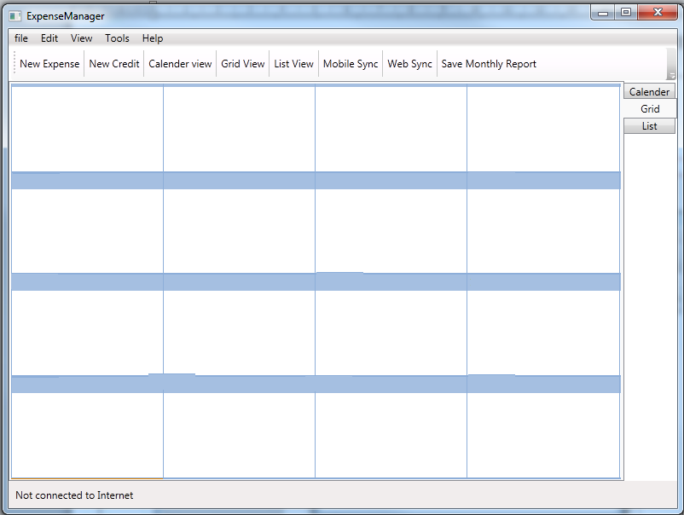
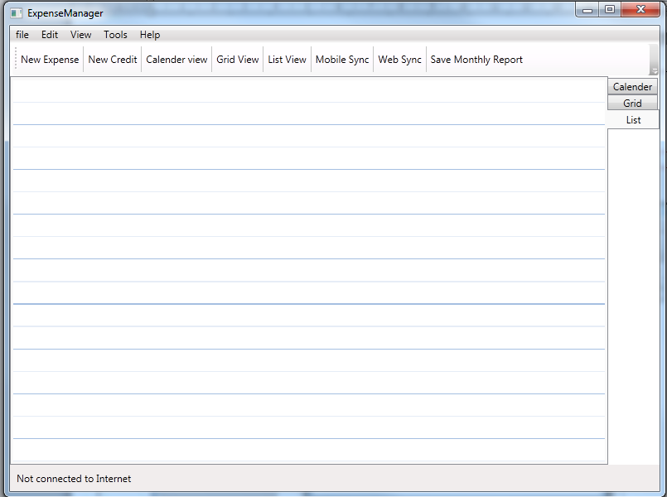

SECQURITY MEASURES:
- Security measures has been taken ensure that the data from web interface is secured , that is protected by Google web mail id and password.
- Data saved by this software is encrypted to avoid misuse.

LIMITATION OF THE PROJECT:

- It does not support UNIX / Linux Operating systems.
- It does not Support Mobile Operating systems for Symbian, Meego & Android.

Any Client/Industry:

eKomfort Zone
Bamangachi Station Road,
P.O: Bamangachi, P.S: Barasat,
Dist: North 24 Pgs
West Bengal- 743706

Future Scope and Further enhancement of the project:

- To support UNIX / Linux based operating systems.
- To Support Mobile operating systems for Windows Mobile, Android.
- To port it on handheld device like iPad, Galaxy Tab & netbooks.
- To enhance the web interface

Bibliography:
- http://www.google.co.in
- http://en.wikipedia.org
- http://msdn.microsoft.com/en-us/
- http://www.microsoft.com/en-us/default.aspx
- http://www.codeplex.com/
- http://stackoverflow.com/
- http://www.codeguru.com/
- http://www.w3schools.com
- http://www.thewpfblog.com/

----------------------------- Thank You-------------------------

