Expense Manager

PRITAM MANDAL

Table of Contents
Objective: 2
Brief Description of the Modules: 2
Scope & Design of the Project: 2
Constraints of the Project: 2
Tools used (Hardware/Software): 2
Plan of Analysis/Performance Measurement: 2
Testing Methodology: 2

Introduction & Objective of the Project:

Expense Manager Software will enable user to track expenses. This software will be useful to an individual as well as to a company. Users can add daily earnings & expenses. At any point of time he can review his total expenses and generate report. There will be three different User Interfaces to allow the user to use the software anywhere all the time. The User interfaces are Desktop Interface, Mobile Interface & Web Interface. The data from all the interfaces can be synced and merged to generate a final report.

The Desktop Interface is the main & fully featured version of the software. Users can add new data, browse old expenses and sync expenses from Mobile & Web Interfaces. The Mobile Interface will allow users to add data using their mobile and use customized feature set. While shopping people carry their mobile along with them and then they can add expenses and earnings instantly to avoid forgetting about certain expenses. The Web Interfaces provide the ultimate flexibility of login to the user accounts in the web and add/browse expenditures.

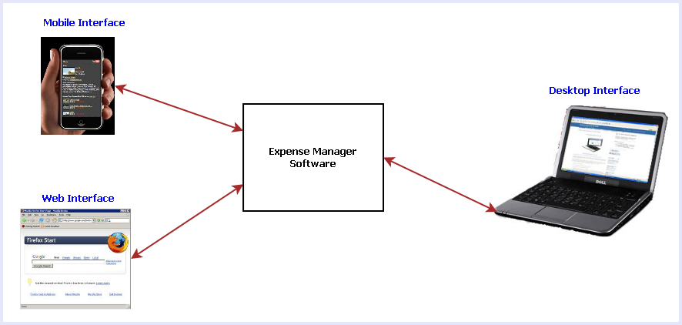
Fig 1: Different interfaces of Expense Manager Software

The main features of this software are listed below:
- Calendar view to select any date and add/view the expenses & earnings.
- Add tag with expenses so that user can remember the reason for spending
- View Available balance
- View Total expenses
- Generate a monthly/Weekly report.
- Online sync
- Reminder facility for future expenses.
- Searching the expenses.
- On the go expense tracking using Mobile & Web Interfaces
- Syncing data from all the interfaces such as: Desktop, Mobile & Web.

Project Category:

This software will follow Object Oriented Programming Paradigm and use below mentioned areas.

Front End/ GUI Tools: Visual Studio 2008, .NET 3.5, C#
Backend: MySQL
Internet Technologies: HTML, JavaScript, PHP, Google App Framework
Networking Technologies: TCP/IP
Wireless Technologies: Bluetooth
Operating Systems: Windows XP, Windows 7, Windows Mobile
Applications: Financial application

Analysis of the Project:
Expense manager software consists of three different applications:
  - Desktop Application
  - Mobile Application
  - Web Application

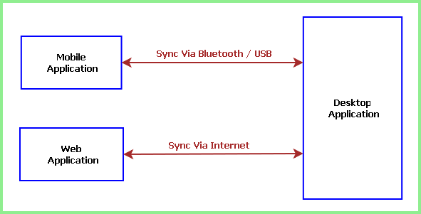

Each application is internally divided into three main modules such as:
- Application Interface
- Application Engine
- Storage / Database

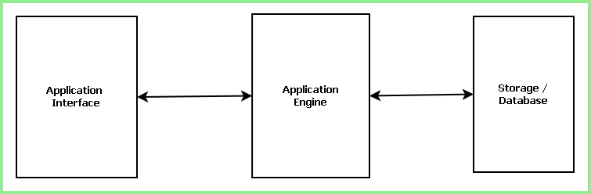

Desktop Application is the full featured application which contains the Permanent storage or bigger database where as Mobile and Web application has a small & temporary storage.

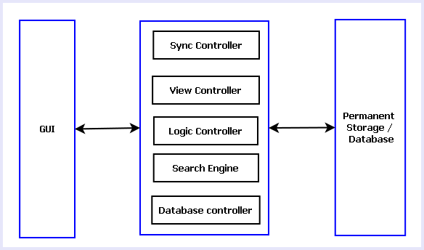
Fig: Modules of Desktop Application

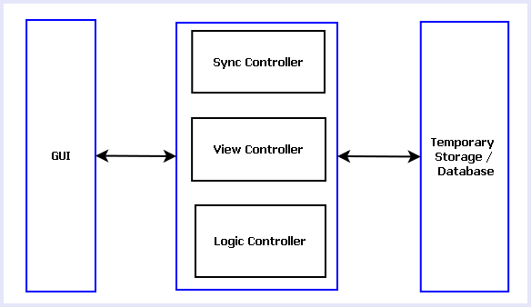
Fig: Modules of Mobile & Web Application

Overview of the Project:
- Data Flow of Desktop Application
- Data Flow of Web Application
- Data Flow of Mobile Application
- Database design Desktop Application

Tools/Platforms used (Hardware/Software):

Any Client/Industry:

Future Scope and Further enhancement of the project:

