Hospital Management System

Manoj

Enrollment No:

BCA

6thSemester CS-76

PROJECT

Table of Contents
Introduction of the Project: 4
Objective of the Project: 6
Tools / Environment Used: 7
IDE Used (Visual Studio 2010):
Front End:
Google Spreadsheet Interface:
Programming Framework (.NET 4):
Database Microsoft SQL Server 2008
Google App Engine (The webapp Framework)
Windows Communication FRAMEWORK (WCF)
Dia for Diagram Drawing & Modeling
VirtueMart (online store)
Archiving & Packaging Utility (7Z)
Programming Language (C#):
Analysis of the Project: 7
Hospital Management System GUI
Visitor Register
Member Registration
Member Database Browser
Employee Management
Hospital Training
Video Surveillance Window
Alarm System
Emergency Handler
Hospital Management System Engine
Engine controller:
GUI Interactor:
Database Controller:
Photo & Video Surveillance Controller:
Visitor Controller:
Member Controller:
Employee Controller:
Alarm Controller:
Data Entry Controller:
Training Controller:
Search Engine:
Emergency Controller:
Hospital Management System Database
Hardware & Software Requirements for the application to run 25
E-R Diagram:
DESIGN DOCUMENT: 26
PROGRAMME CODE:
Upload to Web
Algorithm for Database Connection:
TESTING: 57
INPUT/OUTPUT SEREEN: 62
SECQURITY MEASYRES: 65
LIMITATION OF THE PROJECT:
Any Client/Industry: 66
Future Scope and Further enhancement of the Project: 67
BIBLOGRAPHY: 68

Introduction of the Project:

Hospital Management System is meant for managing and maintaining the activities of a Hospital. Hospital management system helps to manage patients, doctors and hospital resources. It helps to utilize the hospital resources in an efficient manner.
This software will installed on every machine of the Hospital and one of the machines will act as a controller. The IT admin of the Hospital uses the Hospital controller machine to control other machines. Following diagram displays the interaction between Hospital controller and the user machines.
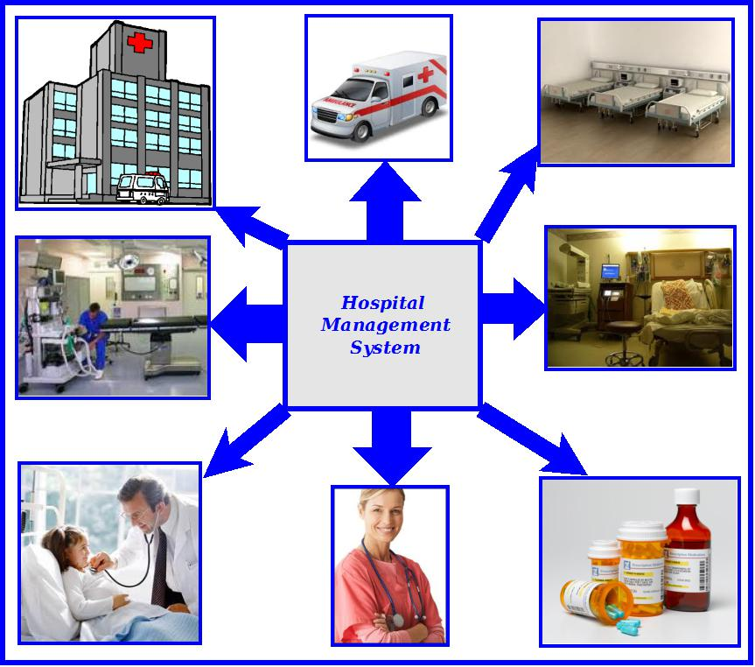
The main features of this software are given below:
• Resource Usage tracking
• Patient management.
• Patient Identity info saving
• Security management
• Medicine stock & pricing information query.
• Bill preparation
• Monthly / daily report
• Supply management & payment tracking.
• Centralized Report Printing Facility
• Video Surveillance.

The feature and user of the Hospital Management System are displayed in the diagram below.

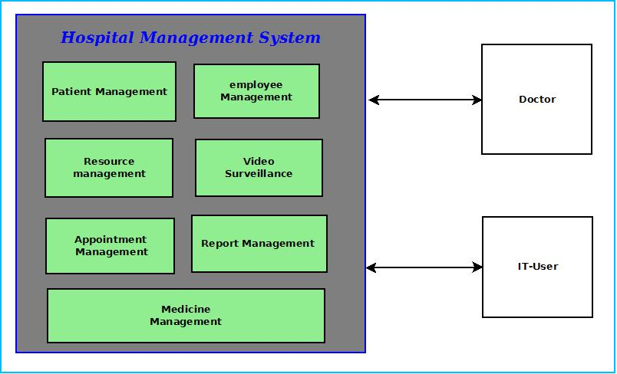

The Hospital management software will be used by the employee of the Hospital to control the Hospital and the doctors have to use the Hospital management software interface to access/use patient related information.

Objective of the Project:

The objectives of this project are given below:
- Hospital management system will provide a software solution for managing Hospital more efficiently and effectively.
- It will enable Hospital administrator to implement an automatic Hospital management system by which a centralized system can keep track of activities happening in hospital.
- Hospital management system will track the Hospital patients, employees & resources.
- To provide a faster & more organized way of serving patients.
- Hospital management system will provide better ways for validating patient data and searching patient‘s previous treatment history which will replace cumbersome paper work with efficient computerized datasheets.
- By accomplishing this project I could learn new technologies like .NET, C#, MySQL, XML and I am able to be involved with the complete software development lifecycle.

Tools / Environment Used:
This software will follow Object Oriented Programming Paradigm and use below mentioned areas.

IDE Used ( Visual Studio 2010):

Microsoft Visual Studio is a powerful IDE that ensures quality code throughout the entire application lifecycle, from design to deployment. Whether we are developing applications for SharePoint, the web, Windows, Windows Phone, and beyond, Visual Studio is the ultimate all-in-one solution. Visual Studio includes a code editor supporting IntelliSense as well as code refactoring.
The integrated debugger works both as a source-level debugger and a machine-level debugger. Other built-in tools include a forms designer for building GUI applications, web designer, class designer, and database schema designer. It accepts plug-ins that enhance the functionality at almost every level—including adding support for source-control systems (like Subversion and Visual SourceSafe) and adding new toolsets like editors and visual designers for domain-specific languages or toolsets for other aspects of the software development lifecycle (like the Team Foundation Server client: Team Explorer).

Front End: WPF (Windows Presentation Framework):
Windows Presentation Foundation (WPF) provides developers with a unified programming model for building rich Windows smart client user experiences that incorporate UI, media, and documents. Windows Presentation Foundation (WPF) is a next-generation presentation system for building Windows client applications with visually stunning user experiences. With WPF, you can create a wide range of both standalone and browser-hosted applications. The core of WPF is a resolution-independent and vector-based rendering engine that is built to take advantage of modern graphics hardware. WPF extends the core with a comprehensive set of application-development features that include Extensible Application Markup Language (XAML), controls, data binding, layout, 2-D and 3-D graphics, animation, styles, templates, documents, media, text, and typography. WPF is included in the Microsoft .NET Framework, so you can build applications that incorporate other elements of the .NET Framework class library.

Programming Framework(.NET 4) :

The .NET 4 Framework is Microsoft's platform for building applications that have visually stunning user experiences, seamless and secure communication, and the ability to model a range of business processes. The .Net Framework consists of:
- Common Language Runtime – provides an abstraction layer over the operating system
- Base Class Libraries – pre-built code for common low-level programming tasks
- Development frameworks and technologies – reusable, customizable solutions for larger programming tasks.
The framework's Base Class Hospital provides user interface, data access, database connectivity, cryptography, web application development, numeric algorithms, and network communications. The class library is used by programmers, who combine it with their own code to produce applications.

Programming Language ( C#) :
C# is a type-safe, object-oriented language that is simple yet powerful, allowing programmers to build a breadth of applications.
C# is a multi-paradigm programming language encompassing imperative, declarative, functional, generic, object-oriented(class-based), and component-oriented programming disciplines.
It was developed by Microsoft within the .NET initiative and later approved as a standard by Ecma (ECMA-334) and ISO (ISO/IEC 23270). C# is one of the programming languages designed for the Common Language Infrastructure.
C# is intended to be a simple, modern, general-purpose, object-oriented programming language.

EXTENSIBLE MARKUP LANGUAGE (XML)
Extensible Markup Language (XML) is a simple, very flexible text format derived from SGML (ISO 8879). Originally designed to meet the challenges of large-scale electronic publishing, XML is also playing an increasingly important role in the exchange of a wide variety of data on the Web and elsewhere.
Extensible Markup Language (XML) is a set of rules for encoding documents in machine-readable form. It is defined in the XML 1.0 Specification produced by the W3C, and several other related specifications, all gratis open standards.
XML's design goals emphasize simplicity, generality, and usability over the Internet.[6] It is a textual data format with strong support via Unicode for the languages of the world. Although the design of XML focuses on documents, it is widely used for the representation of arbitrary data structures, for example in web services.
Many application programming interfaces (APIs) have been developed that software developers use to process XML data, and several schema systems exist to aid in the definition of XML-based languages.
As of 2009, hundreds of XML-based languages have been developed,[7] including RSS, Atom, SOAP, and XHTML. XML-based formats have become the default for most office-productivity tools, including Microsoft Office (Office Open XML), OpenOffice.org (OpenDocument), and Apple's iWork.
System.Xml is the core XML manipulation technology for .NET languages.

DIA – diagraming tool

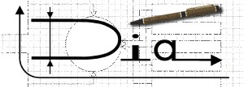
Dia is a GTK+ based diagram creation program for GNU/Linux, Mac OS X, Unix, and Windows. Dia is roughly inspired by the commercial Windows program 'Visio,' though more geared towards informal diagrams for casual use. It can be used to draw many different kinds of diagrams. It currently has special objects to help draw entity relationship diagrams, UML diagrams, flowcharts, network diagrams, and many other diagrams. It is also possible to add support for new shapes by writing simple XML files, using a subset of SVG to draw the shape.
It can load and save diagrams to a custom XML format (gzipped by default, to save space), can export diagrams to a number of formats, including EPS, SVG, XFIG, WMF and PNG, and can print diagrams (including ones that span multiple pages).

NClass – UML diagraming tool

NClass is a free tool to easily create UML class diagrams with full C# and Java language support. The user interface is designed to be simple and user-friendly for easy and fast development. Properties, enums, delegates and other language specific elements are fully supported with strict syntactical and semantical verification.

Design your application with just a few clicks - the main goal is to provide a simple but powerful class designer that is very intuitive to use. Diagram styles help you to create professional looking diagrams, just like in Visual Studio or other commercial products. Furthermore, you can generate code from your models or you can also import classes from existing .NET assemblies.
Features
- Full C# and Java support with many language specific elements
- Simple and easy to use user interface
- Inline class editors with syntactic parsers for easy and fast editing
- Source code generation
- Reverse engineering from .NET assemblies (thanks to Malte Ried)
- Configurable diagram styles
- Printing / saving to image
- Multilingual user interface
- Mono support for non-Windows users

Database - MySQL

MySQL is the world's most popular open source database software, with over 100 million copies of its software downloaded or distributed throughout its history. With its superior speed, reliability, and ease of use, MySQL has become the preferred choice for Web, Web 2.0, SaaS, ISV, Telecom companies and forward-thinking corporate IT Managers because it eliminates the major problems associated with downtime, maintenance and administration for modern, online applications.
MySQL is a key part of LAMP (Linux, Apache, MySQL, PHP / Perl / Python), the fast-growing open source enterprise software stack. More and more companies are using LAMP as an alternative to expensive proprietary software stacks because of its lower cost and freedom from platform lock-in.
MySQL Community Edition is the freely downloadable version of the world's most popular open source database. It is available under the GPL license and is supported by a huge and active community of open source developers.
The MySQL Community Edition includes:
- Pluggable Storage Engine Architecture
- Multiple Storage Engines: InnoDB , MyISAM, NDB (MySQL Cluster),Memory ,Merge , Archive, CSV
- MySQL Replication to improve application performance and scalability
- MySQL Partitioning to improve performance and management of large database applications
- Stored Procedures to improve developer productivity
- Triggers to enforce complex business rules at the database level
- Views to ensure sensitive information is not compromised
- Information Schema to provide easy access to metadata
- MySQL Connectors (ODBC, JDBC, .NET) for building applications in multiple languages
- MySQL Workbench for visual modeling, SQL development and administration

MySQL Workbench
MySQL Workbench is a unified visual tool for database architects, developers, and DBAs. MySQL Workbench provides data modeling, SQL development, and comprehensive administration tools for server configuration, user administration, and much more. MySQL Workbench is available on Windows, Linux and Mac OS.
- Design
MySQL Workbench enables a DBA, developer, or data architect to visually design, model, generate, and manage databases. It includes everything a data modeler needs for creating complex ER models, forward and reverse engineering, and also delivers key features for performing difficult change management and documentation tasks that normally require much time and effort.
- Develop
MySQL Workbench delivers visual tools for creating, executing, and optimizing SQL queries. The SQL Editor provides color syntax highlighting, reuse of SQL snippets, and execution history of SQL. The Database Connections Panel enables developers to easily manage database connections. The Object Browser provides instant access to database schema and objects.
- Administer
MySQL Workbench provides a visual console to easily administer MySQL environments and gain better visibility into databases. Developers and DBAs can use the visual tools for configuring servers, administering users, and viewing database health.

Front End/ GUI Tools: Visual Studio 2010, .NET 4, C#
Backend: MySQL, MySQL .NET Connector, XML
Internet Technologies: HTML, JavaScript, PHP, Google App Framework
Networking Technologies: TCP/IP
Operating Systems: Windows XP, Windows 7
Applications: ERP application, Database Management System.

Analysis of the Project:
Hospital Management System caters different types of employees of hospital. There will be IT-Users like receptionist, data entry operator, doctor, nurses and IT-Admin like hospital superintendent. Hospital Management System will provide a cost effective & efficient software solution for managing everything about Hospital. Different components of Hospital Management System area are depicted below.
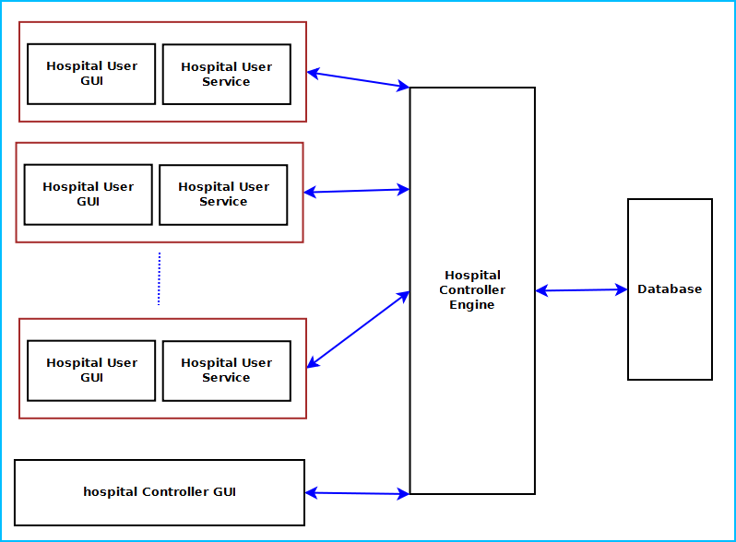
Figure: Components of Hospital Management System

Hospital Management System is divided into five main components. Such as:
- Hospital User GUI
- Hospital User Service
- Hospital Controller GUI
- Hospital Controller Engine
- Hospital Management System Database

Hospital User GUI & Service will be installed in IT-Users machine. Hospital controller GUI, engine & database will be installed in the IT-Admin’s machine and user machines will be connected to the controller machine.

Hospital User GUI
Hospital User GUI will display User login, Patient information & billing information, information search, appointment interface and report management interface. It is divided into five modules. Such as:
- Login Interface
- Patient Info Interface
- Payment Interface
- Appointment Management Interface
- Resource Management Interface
- Report Management Interface

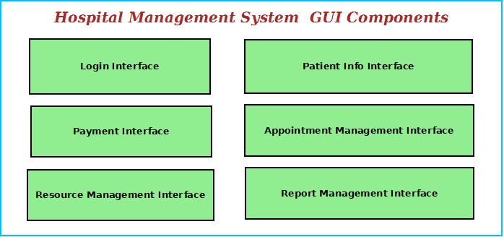
Figure: User GUI Components

Login Interface
Hospital User GUI can be used by variety of hospital employees. So user need to login using user id, password to access their registered account. It is mandatory to login to use the machine.

Patient Info Interface
This interface will allow IT-users to register new patients information, add new entries regarding patient current status. Patient Info Interface will have multiple forms to filled for adding required information.
It also allows printing in the centralized printer.

Appointment Management Interface
This interface will allow IT-user to search for appointment of a doctor of the Hospital and view fees information, time and location details.

Payment Interface
Payment interface enables bill generation for patients. IT-Users will inquire for services required by the patient. Then the Hospital Management System will search the fees and prepare the bill for printing. It will allow user to pay the bill by cash or credit/debit card.

Report Management Interface
This module will help to generate various reports about patients like diagonis reports, release letter, medical certificates. IT-Users will use this interface to generate and print the reports on demand..

Resource Management Interface
This module will maintain information about available resources like operation theater, machines for use. Patients can book them prior to use. IT-Users will use this interface to book this.

Hospital User Service:
This is a windows service utility running on every user’s machine to control users activity and access rights. This component is divided into five modules:
- Feature Usage Logger
- Usage Timer
- Access rights controller
- Connectivity controller
- Hospital Controller Engine Interactor

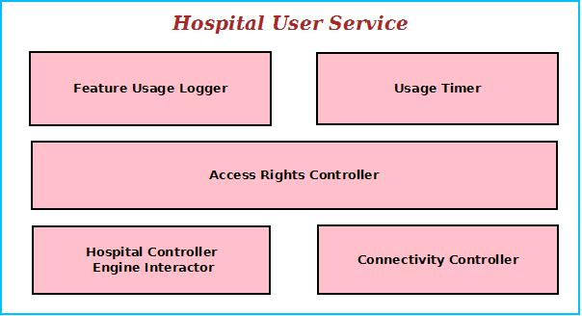
Figure: User Service Components

Feature Usage Logger
It logs the name of the Features and Resources used by the IT-user. It helps the Hospital Admin to realize the usage trend.

Usage Timer
This module logs the Users start time and runs a timer to display the elapsed time of the user. It also keeps the session information and remaining balance to avail next sessions.

Access rights controller
It controls the user’s access rights like installing /uninstalling softwares, using external drives. User has to seek permission from the admin to perform certain actions. This module controls this kind of access right mechanism.

Connectivity controller
This module handles the internet connectivity and LAN connections in case of LAN Gaming. It tracks the user download and upload quantity and requests for billing if it exceeds the permitted amount.

Hospital Controller Engine Interactor
This module interacts with centralized Hospital controller engine to get certain information about user and perform actions accordingly.

Hospital Controller GUI
Hospital Controller GUI will display User information, usage & billing information, product information search, Product selection browser, security management interface, video surveillance window and Doctor account management browser. The Hospital can monitor and control whole Hospital from a single machine.
It is divided into eleven modules. Such as:
- Login Interface
- Access Right Interface
- Resource Management Interface
- Appointment Interface
- Billing Interface
- Medicine Stock & Price Info browser
- Patient Management Interface
- Report Interface
- Security Management Interface
- Video Surveillance Interface
- Controller Engine Interactor

Login Interface
This interface will allow the owner/admin to login and control other users. This will authenticate the admin and enable him to give access the admin features and approve user requests.

Access Right Interface
The users will ask for several access requests like installing new software, use external drive, and connect with other machine on LAN. The admin get this request as a popup and he can approve or reject them.

Billing Interface
This interface will display the usage of all the patients’ available. It will also help generate bill for a patient's usage and purchase. This interface will allow viewing bulk purchase amounts, approvals for the higher management.

Medicine Stock & Price Info browser
This module will allow the IT-Admin to view the medicine stocks, price information.

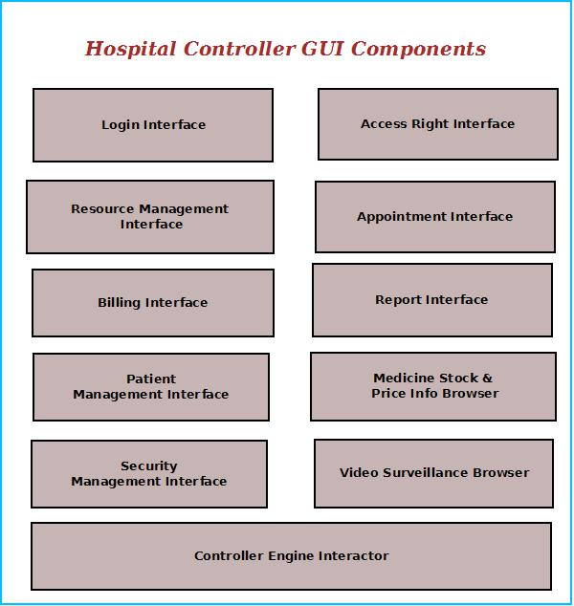
Figure: Controller GUI Components

Patient Management Interface
This interface will enable the admin to browse existing patients and add new patients. It will allow the admin to manage different aspects of patients of the Hospital.

Resource Management Interface
This interface will enable the admin to browse existing resources and approve resource allocation requests.

Appointment Management Interface
This interface will enable the admin to appointment of existing patients and resolve appointment conflicts.

Report Interface
This interface is for managing the report generation, centralized printer setup and to approve the print requests, prepare bill for the request.

Security Management Interface
Hospitals need to maintain the patient data, photo identity card number. This interface will allow managing security measures to taken about the patients. It will have a interface for entering the patient's security data, photo and scan the photo identity card of the user.

Video Surveillance Interface
This interface will display the video of specific areas of the Hospital and save the video for future reference. The admin can monitor from video surveillance window.

Controller Engine Interactor
This interface will interact with centralized controller engine and fetch the required data.

Hospital Controller Engine
Hospital Controller Engine controls the overall system. It provides logical and tactical solutions for managing the whole system. The Hospital Management System is divided into 12 divided modular components. Such as:
- Engine controller | - Access Controller
- GUI Interactor | - Connectivity Controller
- Database Controller | - Billing Handler
- Information Controller | - Search Engine
- Employee Controller | - Patient Controller
- Usage Handler | - Security Controller

Engine controller:
This controls the overall interaction between all the backend modules. It schedules the priority of the actions in case of overlapping.

GUI Interactor:
It interacts with the GUI and polls GUI calls. It exposes APIs and events for GUI to use. GUI Interactor helps Engine to maintain wrapper around the Engine modules so that the GUI can be ported to any other framework without much changes in Engine code.

Database Controller:
It controls the database interactions. It forms query to fetch information from the database. It also sends data to be saved in database for future use.

Information Controller:
This module processes patient and other information. It also archives the data to save space.

Patient Controller:
It keeps track of patient information. It has an algorithm for maintaining patient's treatment, disease history. Depending on those patient's care will be taken accordingly.

Security Controller:
It saves information for security measures. It can send it to the authority or police whenever required.

Usage Controller:
It controls the usage of the users depending on the balance available and informs the user about remaining time line.

Access Controller:
Access controller manages user login and features to be accessed by them. It will validate user’s login and block access & inform management if any access violation attempts happen.

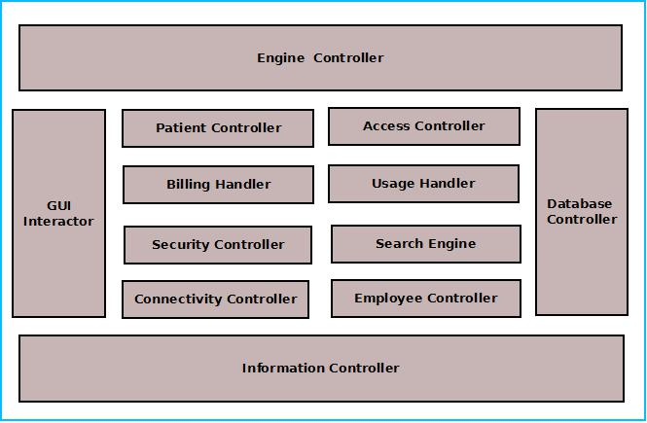
Figure: Components of Engine

Employee Controller:
This module will maintain the information about employees such as doctor, nurse, support stuff. It will save the information in database and retrieve them when required.

Search Engine:
Search engine enables rapid and efficient searching of data about doctors, products and suppliers. Search Engine prepares search indexes depending most accessed data. It improves the efficiency and performance of the software.

Billing Handler:
Billing Handler allows generating the bill for Patient's usage & purchases. It will get the pricing information from the database depending on user data and admin input about product type and quantity. It will add discounts, special offer and VAT amounts on the purchase amount and calculate the amount payable.

Connectivity Controller:
Web controller handles the interaction with Internet and LAN. It allows connecting to the internet depending users credit balance. It has the logic for connection handling between machines and controller.

Hospital Management System Database
Hospital Management System will maintain a centralized database for storing information. We will design a RDBMS to manage the database and engine interaction. It will have optimized design and archive older data to save space and increase performance.

Hardware & Software Requirements for the application to run

Hardware Requirements
Computer that has a 1.6GHz or faster processor
1 GB (32 Bit) or 2 GB (64 Bit) RAM
10 MB of available hard disk space
DVD-ROM Drive / USB Port
Webcam
GPS Trackers
NFC Id Cards
Hospital Cameras

Software Requirements

Windows XP (x86) with Service Pack 3 / Windows Vista (x86 & x64) with Service Pack 2 / Windows 7 (x86 & x64)
Microsoft .NET 4.0

DESIGN DOCUMENT:

Class Diagram

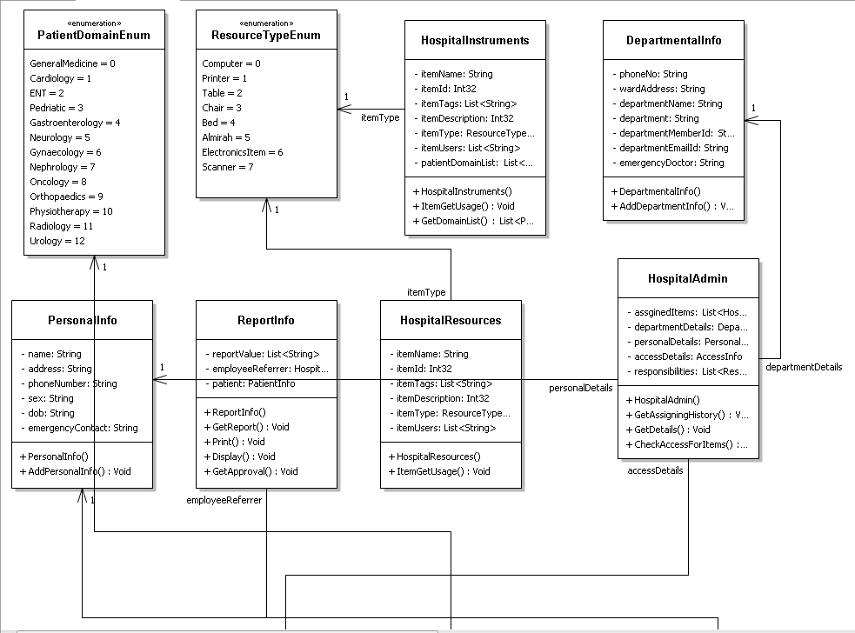
Figure 1:-Class Diagram 1
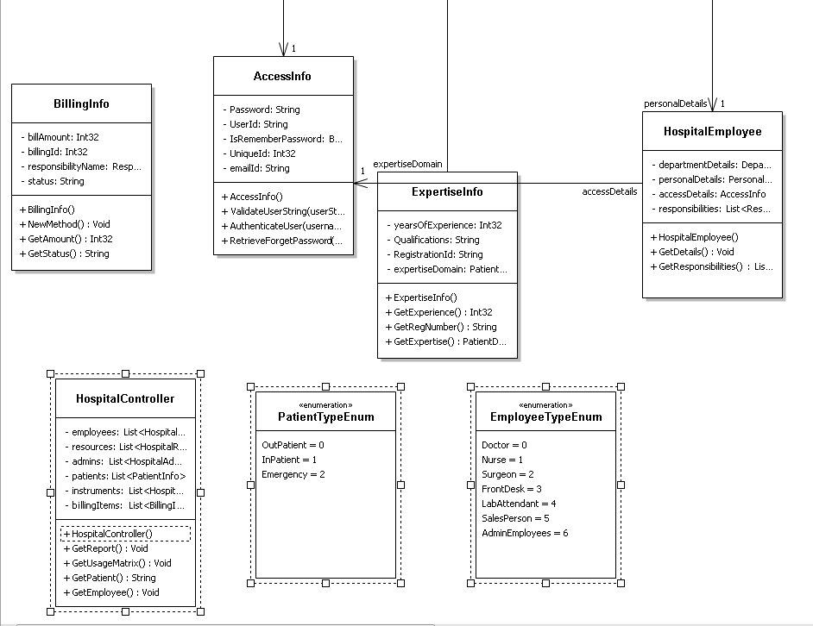
Figure 2:-Class Diagram2
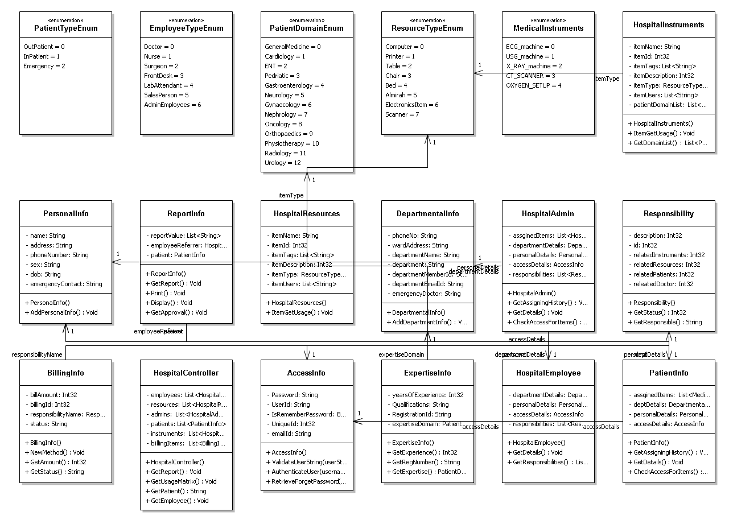
Figure 3:-Class Diagram (overall)

Data flow diagram

DFD-level 0

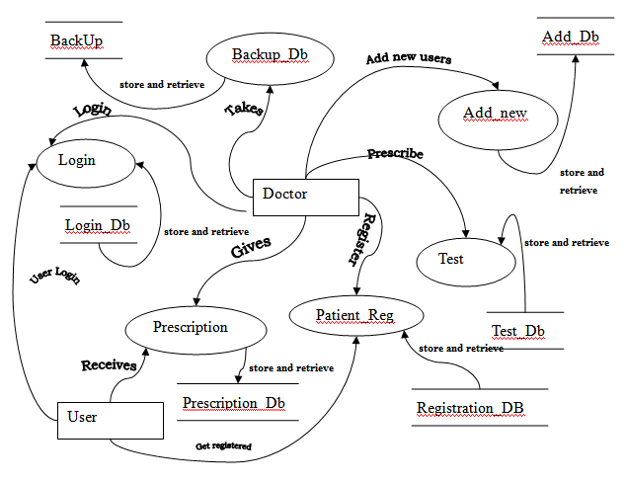
User Login
Figure 4 DFD-level 0

DFD level 1

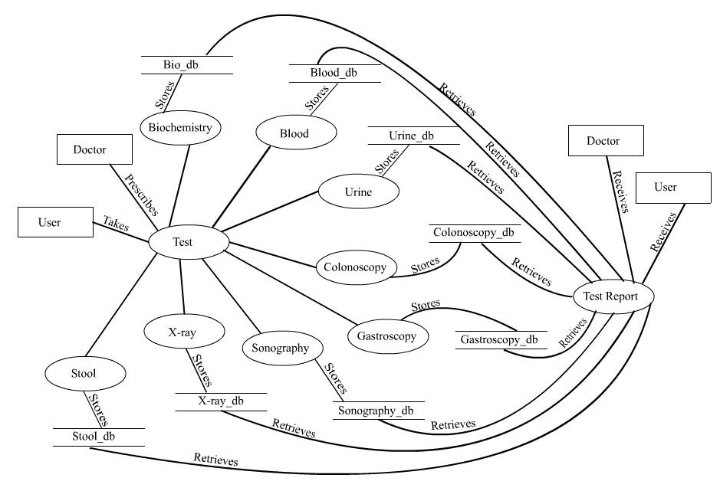
Figure 5 DFD level 1

DFD level 2

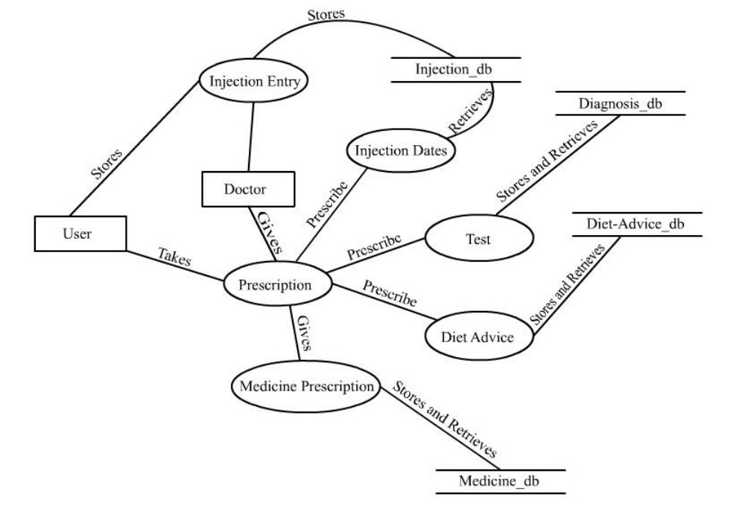
Figure 6 DFD level 2

DFD - level 3
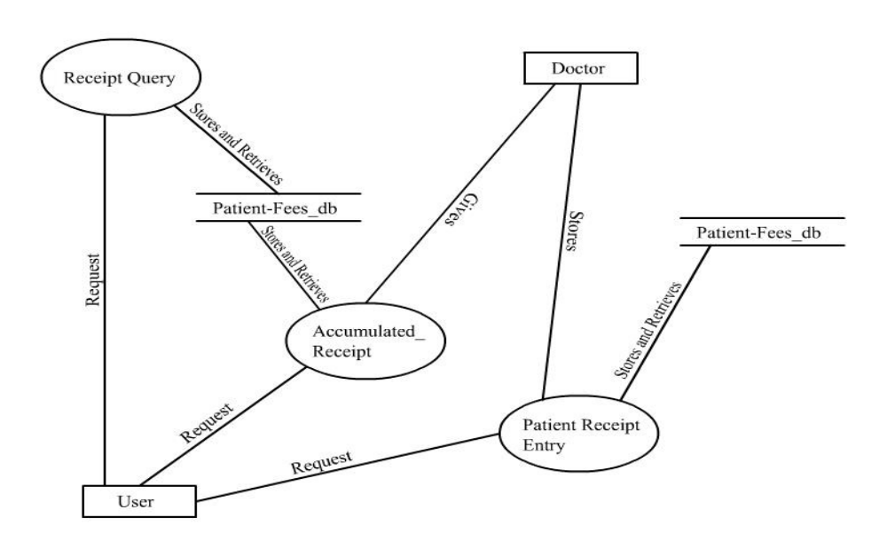
Figure 7 DFD level 3

E-R Diagram:

We will design a RDBMS for File Management System. The entities and their attributes are listed below. Attributes in Bold letter is the unique key.
Entities | Attributes
Patient | User Id, Name, Address , Contact Number,  password, Photo ID Num, Photo
Hospital Management System | Hospital Id , Name, Address, Registered no
Hospital Machine | Machine Id, Name, Software
Session | Session Id, User Id, Time, Billing amount
Doctor | Doctor Id, Name, address, contact number
User Preference | Preference Id, Type, Description
Admin | Admin id, name, price

Relationship between Entities:
- Hospital Management System has Doctors→ 1 : N
- Hospital Management System has Machine→ 1 : N
- Patient System uses Session→ 1 : 1
- Hospital Management System Cures patients → 1 : N
- Users provide Preferences → M : N
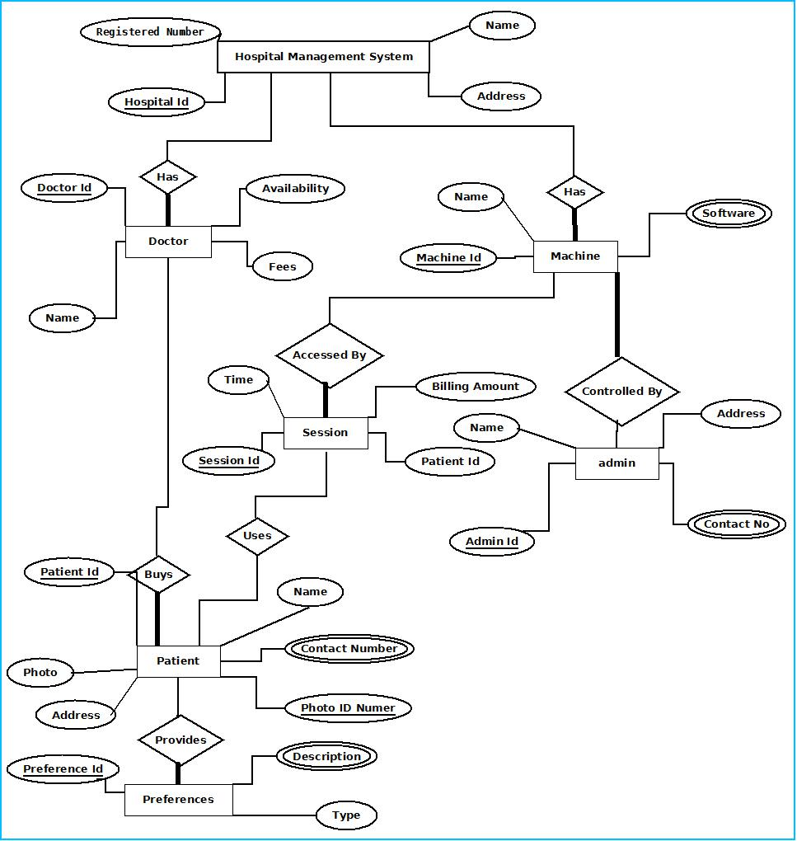
E-R Diagram of Hospital management system

The user interface:
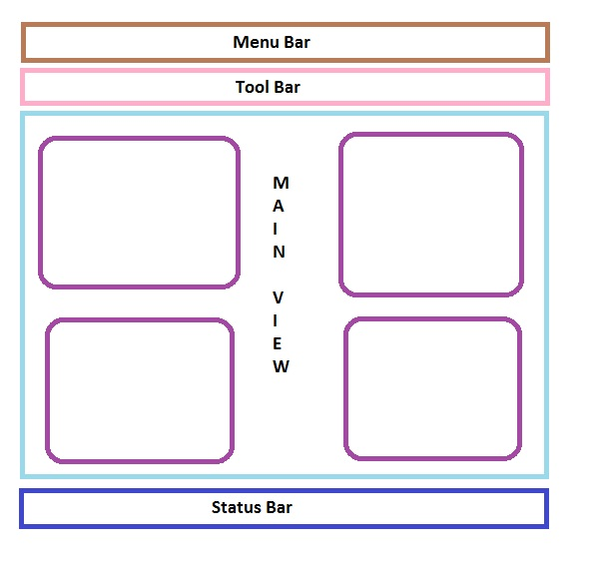

PROGRAMME CODE:

API Used for GUI
Menu bar contains the important features which can be accessed by shortcuts too. It is implemented using Menu control.
System.Windows.Controls.Menu
Namespace: System.Windows.Controls
Assembly: PresentationFramework (in PresentationFramework.dll)
Represents a Windows menu control that enables you to hierarchically organize elements associated with commands and event handlers.

Toolbar lists down the mostly used features. It is implemented using ToolBar control.
System.Windows.Controls.ToolBar
Namespace: System.Windows.Controls
Assembly: PresentationFramework (in PresentationFramework.dll)
Provides a container for a group of commands or controls.

Left navigation bar displays the tutorials available locally and online. This navigation bar is hide- able. It is implemented using the Expander control.
System.Windows.Controls.Expander
Namespace: System.Windows.Controls
Assembly: PresentationFramework (in PresentationFramework.dll)
Represents the control that displays a header that has a collapsible window that displays content.

The local contents are displayed in a TreeView control. And every contents are displayed in in a TreeViewItem.
System.Windows.Controls.TreeView
Namespace: System.Windows.Controls
Assembly: PresentationFramework (in PresentationFramework.dll)
Represents a control that displays hierarchical data in a tree structure that has items that can expand and collapse.

Online contents are displayed in a WebBrowser control. Users can select the content and purchase it from there.
System.Windows.Controls.WebBrowser
Namespace: System.Windows.Controls
Assembly: PresentationFramework (in PresentationFramework.dll)
Hosts and navigates between HTML documents. Enables interoperability between WPF managed code and HTML script.

Textpane displays the Texts. This is implemented using a TextBlock control.
System.Windows.Controls.TextBlock
Namespace: System.Windows.Controls
Assembly: PresentationFramework (in PresentationFramework.dll)
Provides a lightweight control for displaying small amounts of flow content.

Video and audio playing is implemented using MediaElement control.
System.Windows.Controls.MediaElement
Namespace: System.Windows.Controls
Assembly: PresentationFramework (in PresentationFramework.dll)
Represents a control that contains audio and/or video.

Images are displayed using Image control.
System.Windows.Controls.Image
Namespace: System.Windows.Controls
Assembly: PresentationFramework (in PresentationFramework.dll)
Represents a control that displays an image.

Drawing pane is implemented using InkCanvas control.
System.Windows.Controls.InkCanvas
Namespace: System.Windows.Controls
Assembly: PresentationFramework (in PresentationFramework.dll)
Defines an area that receives and displays ink strokes.

Statusbar displays the information about the application and the tutorial currently running. It’s implemented using StatusBar Class.
System.Windows.Controls.Primitives.StatusBar
Namespace: System.Windows.Controls.Primitives
Assembly: PresentationFramework (in PresentationFramework.dll)
Represents a control that displays items and information in a horizontal bar in an application window.

API Used For Engine:
Reading & Writing XML:
In this application the tutorials are saved as XML file. The application will process the XML and play the tutorial. So we have implemented XML reader and writer logic. XML operations are done using .NET XML parser. Every XML element is represented as a XElement control.
System.Xml.Linq.XElement
Namespace: System.Xml.Linq
Assembly: System.Xml.Linq (in System.Xml.Linq.dll)
Represents an XML element.

It has a well-designed Database in MSSQL to save all the information.

Source Code

Source Code Hierarchy
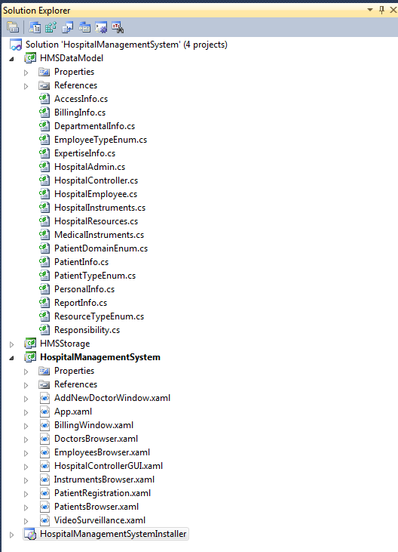

AccessInfo.cs
using System;
using System.Collections.Generic;
using System.Text;

namespace HospitalManagementSystem.HospitalUserGUI
{
public class AccessInfo
{
string Password;
string UserId;
bool IsRememberPassword;
int UniqueId;
string emailId;

public void ValidateUserString(string userString)
{
}

public void AuthenticateUser(string username, string password)
{
}

public void RetrieveForgetPassword(string username, string password)
{
}
}
}

BillingInfo.cs
using System;
using System.Collections.Generic;
using System.Text;

namespace HospitalManagementSystem.HmsDesign
{
public class BillingInfo
{
int billAmount;
int billingId;
Responsibility responsibilityName;
string status;

public void NewMethod()
{
throw new NotImplementedException();
}

public int GetAmount()
{
throw new NotImplementedException();
}

public string GetStatus()
{
throw new NotImplementedException();
}
}
}

DepartmentalInfo.cs
using System;
using System.Collections.Generic;
using System.Text;

namespace HospitalManagementSystem.HmsDesign
{
public class DepartmentalInfo
{
string phoneNo;
string wardAddress;
string departmentName;
string department;
string departmentMemberId;
string departmentEmailId;
string emergencyDoctor;

public void AddDepartmentInfo()
{
throw new NotImplementedException();
}
}
}

EmployeeTypeEnum.cs
using System;
using System.Collections.Generic;
using System.Text;

namespace HospitalManagementSystem.HmsDesign
{
public enum EmployeeTypeEnum
{
Doctor,
Nurse,
Surgeon,
FrontDesk,
LabAttendant,
SalesPerson,
AdminEmployees
}
}

ExpertiseInfo.cs
using System;
using System.Collections.Generic;
using System.Text;

namespace HospitalManagementSystem.HmsDesign
{
public class ExpertiseInfo
{
int yearsOfExperience;
string Qualifications;
string RegistrationId;
PatientDomainEnum expertiseDomain;

public int GetExperience()
{
throw new NotImplementedException();
}

public string GetRegNumber()
{
throw new NotImplementedException();
}

public PatientDomainEnum GetExpertise()
{
throw new NotImplementedException();
}
}
}

HospitalAdmin.cs
using System;
using System.Collections.Generic;
using System.Text;

namespace HospitalManagementSystem.HmsDesign
{
public class HospitalAdmin
{
List<HospitalInstruments> assginedItems;
DepartmentalInfo departmentDetails;
PersonalInfo personalDetails;
AccessInfo accessDetails;
List<Responsibility> responsibilities;

public void GetAssigningHistory()
{
throw new NotImplementedException();
}

public void GetDetails()
{
throw new NotImplementedException();
}

public void CheckAccessForItems()
{
throw new NotImplementedException();
}
}
}

HospitalController.cs
using System;
using System.Collections.Generic;
using System.Text;

namespace HospitalManagementSystem.HmsDesign
{
public class HospitalController
{
List<HospitalEmployee> employees;
List<HospitalResources> resources;
List<HospitalAdmin> admins;
List<PatientInfo> patients;
List<HospitalInstruments> instruments;
List<BillingInfo> billingItems;

public void GetReport()
{
throw new NotImplementedException();
}

public void GetUsageMatrix()
{
throw new NotImplementedException();
}

public string GetPatient()
{
throw new NotImplementedException();
}

public void GetEmployee()
{
throw new NotImplementedException();
}
}
}

HospitalEmployee.cs
using System;
using System.Collections.Generic;
using System.Text;

namespace HospitalManagementSystem.HmsDesign
{
public class HospitalEmployee
{
DepartmentalInfo departmentDetails;
PersonalInfo personalDetails;
AccessInfo accessDetails;
List<Responsibility> responsibilities;

public void GetDetails()
{
throw new NotImplementedException();
}

public List<Responsibility> GetResponsibilities()
{
throw new NotImplementedException();
}
}
}

HospitalInstruments.cs
using System;
using System.Collections.Generic;
using System.Text;

namespace HospitalManagementSystem.HmsDesign
{
public class HospitalInstruments
{
string itemName;
int itemId;
List<string> itemTags;
int itemDescription;
ResourceTypeEnum itemType;
List<string> itemUsers;
List<PatientDomainEnum> patientDomainList;

public void ItemGetUsage()
{
throw new NotImplementedException();
}

public List<PatientDomainEnum> GetDomainList()
{
throw new NotImplementedException();
}
}
}

HospitalResources.cs
using System;
using System.Collections.Generic;
using System.Text;

namespace HospitalManagementSystem.HmsDesign
{
public class HospitalResources
{
string itemName;
int itemId;
List<string> itemTags;
int itemDescription;
ResourceTypeEnum itemType;
List<string> itemUsers;

public void ItemGetUsage()
{
throw new NotImplementedException();
}
}
}

MedicalInstruments.cs
using System;
using System.Collections.Generic;
using System.Text;

namespace HospitalManagementSystem.HmsDesign
{
public enum MedicalInstruments
{
ECG_machine,
USG_machine,
X_RAY_machine,
CT_SCANNER,
OXYGEN_SETUP
}
}

PatientDomainEnum.cs
using System;
using System.Collections.Generic;
using System.Text;

namespace HospitalManagementSystem.HmsDesign
{
public enum PatientDomainEnum
{
GeneralMedicine,
Cardiology,
ENT,
Pedriatic,
Gastroenterology,
Neurology,
Gynaecology,
Nephrology,
Oncology,
Orthopaedics,
Physiotherapy,
Radiology,
Urology
}
}

PatientInfo.cs
using System;
using System.Collections.Generic;
using System.Text;

namespace HospitalManagementSystem.HmsDesign
{
public class PatientInfo
{
List<MedicalInstruments> assginedItems;
DepartmentalInfo deptDetails;
PersonalInfo personalDetails;
AccessInfo accessDetails;

public void GetAssigningHistory()
{
throw new NotImplementedException();
}

public void GetDetails()
{
throw new NotImplementedException();
}

public void CheckAccessForItems()
{
throw new NotImplementedException();
}
}
}

>

PatientTypeEnum.cs
using System;
using System.Collections.Generic;
using System.Text;

namespace HospitalManagementSystem.HmsDesign
{
public enum PatientTypeEnum
{
OutPatient,
InPatient,
Emergency
}
}

PersonalInfo.cs
using System;
using System.Collections.Generic;
using System.Text;

namespace HospitalManagementSystem.HmsDesign
{
public class PersonalInfo
{
string name;
string address;
string phoneNumber;
string sex;
string dob;
string emergencyContact;

public void AddPersonalInfo()
{
throw new NotImplementedException();
}
}
}

ReportInfo.cs
using System;
using System.Collections.Generic;
using System.Text;

namespace HospitalManagementSystem.HmsDesign
{
public class ReportInfo
{
List<string> reportValue;
HospitalEmployee employeeReferrer;
PatientInfo patient;

public void GetReport()
{
throw new NotImplementedException();
}

public void Print()
{
throw new NotImplementedException();
}

public void Display()
{
throw new NotImplementedException();
}

public void GetApproval()
{
throw new NotImplementedException();
}
}
}

ResourceTypeEnum.cs
using System;
using System.Collections.Generic;
using System.Text;

namespace HospitalManagementSystem.HmsDesign
{
public enum ResourceTypeEnum
{
Computer,
Printer,
Table,
Chair,
Bed,
Almirah,
ElectronicsItem,
Scanner
}
}

Responsibility.cs
using System;
using System.Collections.Generic;
using System.Text;

namespace HospitalManagementSystem.HmsDesign
{
public class Responsibility
{
int description;
int id;
int relatedInstruments;
int relatedResources;
int relatedPatients;
int releatedDoctor;

public int GetStatus()
{
throw new NotImplementedException();
}

public string GetResponsible()
{
throw new NotImplementedException();
}
}
}

VideoSurveillance.xaml
<Window x:Class="CyberCafeController.VideoSurveillance"
xmlns="http://schemas.microsoft.com/winfx/2006/xaml/presentation"
xmlns:x="http://schemas.microsoft.com/winfx/2006/xaml"
Title="VideoSurveillance" Height="307" Width="339">
<Grid Height="270">
<Grid.RowDefinitions>
<RowDefinition Height="226*" />
<RowDefinition Height="36*" />
</Grid.RowDefinitions>
<MediaElement x:Name="MediaEL" Grid.RowSpan="1" LoadedBehavior="Manual" />
<StackPanel Orientation="Horizontal" Grid.Row="1" HorizontalAlignment="Center" Margin="8,0,8,5" Width="301">
<Button x:Name="btnRec" Content="Record" Click="btnRec_Click"
Width="50" Height="25"/>
<Button x:Name="btnPlay" Content="Play" Click="btnPlay_Click"
Width="50" Height="25"/>
<Button x:Name="btnStop" Content="Stop" Click="btnStop_Click"
Width="50" Height="25"/>
<Button x:Name="btnMoveBackward" Content="Back" Click="btnMoveBackward_Click"
Width="50" Height="25"/>
<Button x:Name="btnMoveForward" Content="Forward" Click="btnMoveForward_Click"
Width="50" Height="25"/>
<Button x:Name="btnOpen" Content="Open" Click="btnOpen_Click"
Width="50" Height="25"/>
</StackPanel>
</Grid>
</Window>

VideoSurveillance.xaml.cs
using System;
using System.Collections.Generic;
using System.Linq;
using System.Text;
using System.Windows;
using System.Windows.Controls;
using System.Windows.Data;
using System.Windows.Documents;
using System.Windows.Input;
using System.Windows.Media;
using System.Windows.Media.Imaging;
using System.Windows.Shapes;

namespace HospitalController
{
/// <summary>
/// Interaction logic for VideoSurveillance.xaml
/// </summary>
public partial class VideoSurveillance : Window
{
public VideoSurveillance()
{
InitializeComponent();
IsPlaying(false);
}

private void btnRec_Click(object sender, RoutedEventArgs e)
{

}
#region IsPlaying(bool)
private void IsPlaying(bool bValue)
{
btnStop.IsEnabled = bValue;
btnMoveBackward.IsEnabled = bValue;
btnMoveForward.IsEnabled = bValue;
btnPlay.IsEnabled = bValue;
}
#endregion

#region Play and Pause
private void btnPlay_Click(object sender, RoutedEventArgs e)
{
IsPlaying(true);
if (btnPlay.Content.ToString() == "Play")
{
MediaEL.Play();
btnPlay.Content = "Pause";
}
else
{
MediaEL.Pause();
btnPlay.Content = "Play";
}
}
#endregion

#region Stop
private void btnStop_Click(object sender, RoutedEventArgs e)
{
MediaEL.Stop();
btnPlay.Content = "Play";
IsPlaying(false);
btnPlay.IsEnabled = true;
}
#endregion

#region Back and Forward
private void btnMoveForward_Click(object sender, RoutedEventArgs e)
{
MediaEL.Position = MediaEL.Position + TimeSpan.FromSeconds(10);
}

private void btnMoveBackward_Click(object sender, RoutedEventArgs e)
{
MediaEL.Position = MediaEL.Position - TimeSpan.FromSeconds(10);
}
#endregion

#region Open Media
private void btnOpen_Click(object sender, RoutedEventArgs e)
{
Microsoft.Win32.OpenFileDialog ofd = new Microsoft.Win32.OpenFileDialog();
ofd.Filter = "Video Files (*.wmv)|*.wmv";
if (ofd.ShowDialog() == true)
{
MediaEL.Source = new Uri(ofd.FileName);
btnPlay.IsEnabled = true;
}
}
#endregion
}
}

HospitalStorage.cs
using System;
using System.Collections.Generic;
using System.Linq;
using System.Text;

namespace HospitalStorage
{
public class HospitalStorage
{

#region database interction data fetching

MySql.Data.MySqlClient.MySqlConnection msqlConnection = null;

private void fetcheUserData()
{
msqlConnection = new MySql.Data.MySqlClient.MySqlConnection("server=localhost;user id=root;Password=technicise;database=sptdb;persist security info=False");
try
{ //define the command reference
MySql.Data.MySqlClient.MySqlCommand msqlCommand = new MySql.Data.MySqlClient.MySqlCommand();
msqlCommand.Connection = msqlConnection;

msqlConnection.Open();

msqlCommand.CommandText = "Select * from Users;";
MySql.Data.MySqlClient.MySqlDataReader msqlReader = msqlCommand.ExecuteReader();
_UsersCollection.Clear();

while (msqlReader.Read())
{
UsersData UsersDataObject = new UsersData();

//UsersDataObject.serialNo = msqlReader.GetString("sl_no");
UsersDataObject.UserAdress = msqlReader.GetString("address");
UsersDataObject.phoneNumber = msqlReader.GetString("ph_no");
UsersDataObject.UserName = msqlReader.GetString("User_name");
UsersDataObject.UserVatNo = msqlReader.GetString("vat_no");
UsersDataObject.UserId = msqlReader.GetString("id");
UsersDataObject.UserTurnOver = msqlReader.GetString("turn_over");
UsersDataObject.UserDue = msqlReader.GetString("due");
_UsersCollection.Add(UsersDataObject);

}

}
catch (Exception er)
{
MessageBox.Show(er.Message);
}
finally
{
//always close the connection
msqlConnection.Close();
}
}
#endregion

#region User table update

private void UpdateUserTable()
{

//define the connection reference and initialize it
msqlConnection = new MySql.Data.MySqlClient.MySqlConnection("server=localhost;user id=root;Password=technicise;database=sptdb;persist security info=False");

try
{
//define the command reference
MySql.Data.MySqlClient.MySqlCommand msqlCommand = new MySql.Data.MySqlClient.MySqlCommand();

//define the connection used by the command object
msqlCommand.Connection = msqlConnection;

double dbDue = 0.0;
double dbTurnOver = 0.0;

//open the connection
if (msqlConnection.State != System.Data.ConnectionState.Open)
msqlConnection.Open();
string cusIdKey = UserInfoTb.SelectedValue.ToString();
string cmdStr = "SELECT turn_over,due FROM Users WHERE id='" + cusIdKey + "';";
msqlCommand.CommandText = cmdStr;

MySql.Data.MySqlClient.MySqlDataReader msqlReader = msqlCommand.ExecuteReader();

while (msqlReader.Read())
{
dbDue = double.Parse(msqlReader.GetString("due"));
dbTurnOver = double.Parse(msqlReader.GetString("turn_over"));
}

if (msqlConnection.State == System.Data.ConnectionState.Open)
msqlConnection.Close();

//updating the value
if (msqlConnection.State != System.Data.ConnectionState.Open)
msqlConnection.Open();

double totalBilledAmount = CalculateTotalAmount() + CalculateVAT();

double newDueDouble = dbDue + totalBilledAmount - double.Parse(paymentAmountTB.Text);
String newDue = newDueDouble.ToString();
String newTurnOver = (dbTurnOver + totalBilledAmount).ToString();
msqlCommand.CommandText = "UPDATE Users SET due='" + newDue + "', turn_over='" + newTurnOver + "' WHERE id='" + cusIdKey + "'; ";

msqlCommand.ExecuteNonQuery();

}
catch (Exception er)
{
MessageBox.Show(er.Message);
}
finally
{
if (msqlConnection.State == System.Data.ConnectionState.Open)
msqlConnection.Close();
}

}

#endregion
}
}

AddNewDoctorWindow.xaml
<Window x:Class="doctors.AddNewDoctorWindow"
xmlns="http://schemas.microsoft.com/winfx/2006/xaml/presentation"
xmlns:x="http://schemas.microsoft.com/winfx/2006/xaml"
xmlns:sys="clr-namespace:System;assembly=mscorlib"
Title="Add New Doctor" Height="223" Width="596">
<DockPanel LastChildFill="True">
<UniformGrid Rows="1" DockPanel.Dock="Bottom" Height="40">
<Button Width="100" Margin="0 5" Name="cancelBtn" KeyboardNavigation.TabIndex="5" Click="cancelBtn_Click">Cancel</Button>
<Button Width="100" Margin="0 5" Name="addBtn" KeyboardNavigation.TabIndex="4" Click="addBtn_Click">Add</Button>
</UniformGrid>
<UniformGrid Columns="4" Rows="2" DockPanel.Dock="Top">
<Button Name="doctorNameBtn" KeyboardNavigation.IsTabStop="False">Name</Button>
<Button Name="addressBtn" KeyboardNavigation.IsTabStop="False">Address</Button>
<Button Name="phNumberBtn" KeyboardNavigation.IsTabStop="False">Phone Number</Button>
<Button Name="vatBtn" KeyboardNavigation.IsTabStop="False">Reg No</Button>
<TextBox Name="NameDataTB" KeyboardNavigation.TabIndex="0" HorizontalContentAlignment="Center" VerticalContentAlignment="Center" PreviewTextInput="NameDataTB_PreviewTextInput"></TextBox>
<TextBox Name="AddrDataTB" KeyboardNavigation.TabIndex="1" HorizontalContentAlignment="Center" VerticalContentAlignment="Center" PreviewTextInput="AddrDataTB_PreviewTextInput"></TextBox>
<TextBox Name="phDataTB" KeyboardNavigation.TabIndex="2" VerticalContentAlignment="Center" HorizontalContentAlignment="Center" PreviewTextInput="phDataTB_PreviewTextInput"></TextBox>
<TextBox Name="vatdataTB" KeyboardNavigation.TabIndex="3" VerticalContentAlignment="Center" HorizontalContentAlignment="Center" PreviewTextInput="vatdataTB_PreviewTextInput"></TextBox>
</UniformGrid>
</DockPanel>
</Window>

AddNewDoctorWindow.xaml.cs
using System;
using System.Collections.Generic;
using System.Linq;
using System.Text;
using System.Windows;
using System.Windows.Controls;
using System.Windows.Data;
using System.Windows.Documents;
using System.Windows.Input;
using System.Windows.Media;
using System.Windows.Media.Imaging;
using System.Windows.Shapes;

using System.Text.RegularExpressions;

namespace doctors
{
/// <summary>
/// Interaction logic for AddNewDoctorWindow.xaml
/// </summary>
public partial class AddNewDoctorWindow : Window
{

public AddNewDoctorWindow()
{
InitializeComponent();
}

#region validation
private static bool onlyNumeric(string text)
{
Regex regex = new Regex("[^0-9.-]+"); //regex that matches disallowed text
return !regex.IsMatch(text);
}
private static bool onlyAlphabet(string text)
{
Regex regex = new Regex("[^A-Z|^a-z|^ |^\t]"); //regex that matches disallowed text
return !regex.IsMatch(text);
}

private static bool onlyAlphaNumeric(string text)
{
Regex regex = new Regex("^[a-zA-Z0-9]*$"); //regex that matches disallowed text
return !regex.IsMatch(text);
}

private void NameDataTB_PreviewTextInput(object sender, TextCompositionEventArgs e)
{
e.Handled = !onlyAlphabet(e.Text);
}

private void AddrDataTB_PreviewTextInput(object sender, TextCompositionEventArgs e)
{
//e.Handled = !onlyAlphaNumeric(e.Text);
}

private void phDataTB_PreviewTextInput(object sender, TextCompositionEventArgs e)
{
e.Handled = !onlyNumeric(e.Text);
}

private void vatdataTB_PreviewTextInput(object sender, TextCompositionEventArgs e)
{
e.Handled = onlyAlphaNumeric(e.Text);
}
#endregion

private void cancelBtn_Click(object sender, RoutedEventArgs e)
{

}

private void addBtn_Click(object sender, RoutedEventArgs e)
{

}
}
}

App.xaml
<Application x:Class="HospitalManagementSystem.App"
xmlns="http://schemas.microsoft.com/winfx/2006/xaml/presentation"
xmlns:x="http://schemas.microsoft.com/winfx/2006/xaml"
StartupUri="HospitalControllerGUI.xaml">
<Application.Resources>

</Application.Resources>
</Application>

BillingWindow.xaml
<Window x:Class="HospitalManagementSystem.BillingWindow"
xmlns="http://schemas.microsoft.com/winfx/2006/xaml/presentation"
xmlns:x="http://schemas.microsoft.com/winfx/2006/xaml"
xmlns:sys="clr-namespace:System;assembly=mscorlib"
Title="Billing Window" Height="857" Width="864">
<DockPanel>
<UniformGrid DockPanel.Dock="Top" Rows="1">
<Label Content="Date:"></Label>
<DatePicker Height="25" Name="datePicker" Background="#FFA39797" SelectedDate="{x:Static sys:DateTime.Now}" />
<Label Content="Invoice Number:"></Label>
<TextBlock Name="invoiceNumberTB" Background="#FFA39797"></TextBlock>
</UniformGrid>
<UniformGrid Rows="1" Height="30" DockPanel.Dock="Top">
<Button Content="Patient" Name="PatientSelectBtn"></Button>
<Button Content="Seller" ></Button>
</UniformGrid>
<UniformGrid Height="80" DockPanel.Dock="Top" Rows="1">
<TextBox Name="PatientInfoTb" VerticalAlignment="Center" VerticalContentAlignment="Center" HorizontalContentAlignment="Center" Margin="3" Height="57">Patient 001</TextBox>
<TextBlock Name="sellerInfoTb" Margin="3" TextWrapping="Wrap"></TextBlock>
</UniformGrid>
<UniformGrid Height="160" DockPanel.Dock="Bottom" Rows="2">
<TextBlock Background="#FFE5E2E2" TextWrapping="Wrap">This invoice shows the actual price of the items , decribed in are true and correct</TextBlock>
<Label></Label>
<Label HorizontalContentAlignment="Center" VerticalContentAlignment="Center">Payment Amount</Label>
<TextBox Name="paymentAmountTB" HorizontalContentAlignment="Center" VerticalContentAlignment="Center">0.0</TextBox>

</UniformGrid>
<UniformGrid DockPanel.Dock="Bottom" Rows="1">
<Label>Declaration</Label>
<Label HorizontalContentAlignment="Right">Authorized Signature</Label>
</UniformGrid>
<DockPanel DockPanel.Dock="Bottom" LastChildFill="True">
<Label>Price in Words:</Label>
<Label></Label>
</DockPanel>

<DockPanel DockPanel.Dock="Bottom" Height="40">
<Button DockPanel.Dock="Left" Name="calculateTotalBtn" Content="Total" Width="260" HorizontalContentAlignment="Right" FontWeight="Bold"></Button>
<Label DockPanel.Dock="Left" Name="totalNoOfItems" Width="100"></Label>
<Label DockPanel.Dock="Left" Name="itemUnit" Width="300" HorizontalAlignment="Left" ></Label>
<Label DockPanel.Dock="Left" Name="totalAmountLabel" Width="100"></Label>
</DockPanel>
<DockPanel DockPanel.Dock="Bottom" Height="40">
<Button DockPanel.Dock="Left" Content="VAT" Name="calculateVATBtn" Width="260" HorizontalContentAlignment="Right" FontWeight="Bold"></Button>
<Label DockPanel.Dock="Left" Width="100"></Label>
<Label DockPanel.Dock="Left" Width="300" HorizontalAlignment="Left" ></Label>
<Label DockPanel.Dock="Left" Name="vatAmount" Width="100"></Label>
</DockPanel>
<ListView Name="billingItemListView" DockPanel.Dock="Bottom" ItemsSource="{Binding billingCollection}">
<ListView.View>
<GridView>
<GridViewColumn Width="50" Header="Sl No" DisplayMemberBinding="{Binding serialNo}" />
<GridViewColumn Width="260" Header="Description" DisplayMemberBinding="{Binding description}" />
<GridViewColumn Width="100" Header="Quantity" DisplayMemberBinding="{Binding quantity}" />
<GridViewColumn Width="100" Header="VAT" DisplayMemberBinding="{Binding vat}" />
<GridViewColumn Width="100" Header="Rate" DisplayMemberBinding="{Binding rate}" />
<GridViewColumn Width="180" Header="Amount" DisplayMemberBinding="{Binding amount}" />
</GridView>
</ListView.View>
</ListView>

</DockPanel>
</Window>

BillingWindow.xaml.cs
using System;
using System.Collections.Generic;
using System.Linq;
using System.Text;
using System.Windows;
using System.Windows.Controls;
using System.Windows.Data;
using System.Windows.Documents;
using System.Windows.Input;
using System.Windows.Media;
using System.Windows.Media.Imaging;
using System.Windows.Shapes;

namespace HospitalManagementSystem
{
/// <summary>
/// Interaction logic for BillingWindow.xaml
/// </summary>
public partial class BillingWindow : Window
{
public BillingWindow()
{
InitializeComponent();
}
}
}

DoctorsBrowser.xaml
<Window x:Class="HospitalManagementSystem.DoctorsBrowser"
xmlns="http://schemas.microsoft.com/winfx/2006/xaml/presentation"
xmlns:x="http://schemas.microsoft.com/winfx/2006/xaml"
Title="DoctorsBrowser" Height="418" Width="1008">
<DockPanel LastChildFill="True">
<UniformGrid Height="30" DockPanel.Dock="Top" Rows="1">
<Button Content="Show doctors" Name="showPaymentsBtn" Click="showPaymentsBtn_Click" Margin="10 0" ></Button>
<Button Content="Add New" Name="addBtn" Click="addBtn_Click" Margin="10 0" ></Button>
<Button Content="Delete" Margin="10 0" Name="deleteBtn" Click="deleteBtn_Click"></Button>
<Button Content="Print" Margin="10 0" Name="printBtn" IsEnabled="True" Click="printBtn_Click"></Button>
</UniformGrid>
<ListView Name="businessPersonListView" DockPanel.Dock="Bottom"
IsSynchronizedWithCurrentItem="True">
<ListView.View>
<GridView>
<!-- GridViewColumn Width="50" Header="Sl No" DisplayMemberBinding="{Binding serialNo}" /-->
<GridViewColumn Width="150" Header="Id" DisplayMemberBinding="{Binding doctorId}" />
<GridViewColumn Width="260" Header="Name" DisplayMemberBinding="{Binding doctorName}"/>
<GridViewColumn Width="160" Header="Address" DisplayMemberBinding="{Binding doctorAdress}" />
<GridViewColumn Width="100" Header="Ph no." DisplayMemberBinding="{Binding phoneNumber}" />
<GridViewColumn Width="100" Header="Manager" DisplayMemberBinding="{Binding doctorVatNo}" />
<GridViewColumn Width="100" Header="Expertise" DisplayMemberBinding="{Binding doctorTurnOver}" />
<GridViewColumn Width="100" Header="Duty Cycle" DisplayMemberBinding="{Binding doctorDue}" />
</GridView>
</ListView.View>
</ListView>
</DockPanel>
</Window>

DoctorsBrowser.xaml.cs
using System;
using System.Collections.Generic;
using System.Linq;
using System.Text;
using System.Windows;
using System.Windows.Controls;
using System.Windows.Data;
using System.Windows.Documents;
using System.Windows.Input;
using System.Windows.Media;
using System.Windows.Media.Imaging;
using System.Windows.Shapes;

namespace HospitalManagementSystem
{
/// <summary>
/// Interaction logic for DoctorsBrowser.xaml
/// </summary>
public partial class DoctorsBrowser : Window
{
public DoctorsBrowser()
{
InitializeComponent();
}

private void showPaymentsBtn_Click(object sender, RoutedEventArgs e)
{

}

private void deleteBtn_Click(object sender, RoutedEventArgs e)
{

}

private void printBtn_Click(object sender, RoutedEventArgs e)
{

}

private void addBtn_Click(object sender, RoutedEventArgs e)
{

}
}
}

EmployeesBrowser.xaml
<Window x:Class="HospitalManagementSystem.EmployeesBrowser"
xmlns="http://schemas.microsoft.com/winfx/2006/xaml/presentation"
xmlns:x="http://schemas.microsoft.com/winfx/2006/xaml"
Title="Employees Browser" Height="695" Width="986">
<DockPanel LastChildFill="True">
<UniformGrid Height="30" DockPanel.Dock="Top" Rows="1">
<Button Content="Show employees" Name="showPaymentsBtn" Click="showPaymentsBtn_Click" Margin="10 0" ></Button>
<Button Content="Add New" Name="addBtn" Click="addBtn_Click" Margin="10 0" ></Button>
<Button Content="Delete" Margin="10 0" Name="deleteBtn" Click="deleteBtn_Click"></Button>
<Button Content="Print" Margin="10 0" Name="printBtn" IsEnabled="True" Click="showPaymentsBtn_Click"></Button>
</UniformGrid>
<ListView Name="businessPersonListView" DockPanel.Dock="Bottom"
IsSynchronizedWithCurrentItem="True">
<ListView.View>
<GridView>
<!-- GridViewColumn Width="50" Header="Sl No" DisplayMemberBinding="{Binding serialNo}" /-->
<GridViewColumn Width="150" Header="Id" DisplayMemberBinding="{Binding employeeId}" />
<GridViewColumn Width="260" Header="Name" DisplayMemberBinding="{Binding employeeName}"/>
<GridViewColumn Width="160" Header="Address" DisplayMemberBinding="{Binding employeeAdress}" />
<GridViewColumn Width="100" Header="Ph no." DisplayMemberBinding="{Binding phoneNumber}" />
<GridViewColumn Width="100" Header="Manager" DisplayMemberBinding="{Binding employeeVatNo}" />
<GridViewColumn Width="100" Header="Expertise" DisplayMemberBinding="{Binding employeeTurnOver}" />
<GridViewColumn Width="100" Header="Duty Cycle" DisplayMemberBinding="{Binding employeeDue}" />
</GridView>
</ListView.View>
</ListView>
</DockPanel>
</Window>

EmployeesBrowser.xaml.cs
using System;
using System.Collections.Generic;
using System.Linq;
using System.Text;
using System.Windows;
using System.Windows.Controls;
using System.Windows.Data;
using System.Windows.Documents;
using System.Windows.Input;
using System.Windows.Media;
using System.Windows.Media.Imaging;
using System.Windows.Shapes;

namespace HospitalManagementSystem
{
/// <summary>
/// Interaction logic for EmployeesBrowser.xaml
/// </summary>
public partial class EmployeesBrowser : Window
{
public EmployeesBrowser()
{
InitializeComponent();
}

private void showPaymentsBtn_Click(object sender, RoutedEventArgs e)
{

}

private void deleteBtn_Click(object sender, RoutedEventArgs e)
{

}

private void addBtn_Click(object sender, RoutedEventArgs e)
{

}
}
}

HospitalControllerGUI.xaml
<Window x:Class="HospitalManagementSystem.MainWindow"
xmlns="http://schemas.microsoft.com/winfx/2006/xaml/presentation"
xmlns:x="http://schemas.microsoft.com/winfx/2006/xaml"
Title="Hospital Controller" Height="372" Width="1066">
<DockPanel>
<Expander IsExpanded="True" Background="Gray" Header="Login" Name="expander1" DockPanel.Dock="Left" Expanded="expander1_Expanded" Height="486" Width="476">
<UniformGrid Rows="6" HorizontalAlignment="Stretch" VerticalAlignment="Stretch">
<Label>Name</Label>
<TextBox Width="200" Height="40"></TextBox>
<Label>Password</Label>
<PasswordBox Width="200" Height="40"></PasswordBox>
<UniformGrid Columns="1">
<CheckBox>Remember Password</CheckBox>
<Label Hyperlink.Click="Label_Click">Forgot Password</Label>
</UniformGrid>

<Button Width="200" Height="40">Login</Button>
<Button Click="Button_Click_6">Print Report</Button>
<Button Click="Button_Click_7">Settings</Button>
</UniformGrid>
</Expander>
<Expander Header="Features Access" IsExpanded="True" DockPanel.Dock="Right">
<UniformGrid Columns="2">
<Button Click="Button_Click">Patients</Button>
<Button Click="Button_Click_5">Doctors</Button>
<Button Click="Button_Click_6">Billing</Button>
<Button Click="Button_Click">Employees</Button>
<Button Click="Button_Click_1">Resources</Button>
<Button Click="Button_Click_2">Instruments</Button>
<Button Click="Button_Click_3">Patient Registration</Button>
<Button Click="Button_Click_4">Video Surveilance</Button>
</UniformGrid>
</Expander>
</DockPanel>
</Window>

HospitalControllerGUI.xaml.cs
using System;
using System.Collections.Generic;
using System.Linq;
using System.Text;
using System.Windows;
using System.Windows.Controls;
using System.Windows.Data;
using System.Windows.Documents;
using System.Windows.Input;
using System.Windows.Media;
using System.Windows.Media.Imaging;
using System.Windows.Navigation;
using System.Windows.Shapes;

namespace HospitalManagementSystem
{
/// <summary>
/// Interaction logic for MainWindow.xaml
/// </summary>
public partial class MainWindow : Window
{
public MainWindow()
{
InitializeComponent();
}

private void expander1_Expanded(object sender, RoutedEventArgs e)
{

}

private void Button_Click(object sender, RoutedEventArgs e)
{
PatientsBrowser pb = new PatientsBrowser();
pb.ShowDialog();
}

private void Button_Click_1(object sender, RoutedEventArgs e)
{

}

private void Button_Click_2(object sender, RoutedEventArgs e)
{
InstrumentsBrowser ib = new InstrumentsBrowser();
ib.ShowDialog();
}

private void Button_Click_3(object sender, RoutedEventArgs e)
{
PatientRegistration pr = new PatientRegistration();
pr.ShowDialog();
}

private void Button_Click_4(object sender, RoutedEventArgs e)
{

}

private void Button_Click_5(object sender, RoutedEventArgs e)
{
DoctorsBrowser db = new DoctorsBrowser();
db.ShowDialog();
}

private void Button_Click_6(object sender, RoutedEventArgs e)
{
BillingWindow bw = new BillingWindow();
bw.ShowDialog();
}

private void Label_Click(object sender, RoutedEventArgs e)
{

}

private void Button_Click_7(object sender, RoutedEventArgs e)
{

}

private void Button_Click_8(object sender, RoutedEventArgs e)
{
EmployeesBrowser eb = new EmployeesBrowser();
eb.ShowDialog();
}
}
}

InstrumentsBrowser.xaml
<Window x:Class="HospitalManagementSystem.InstrumentsBrowser"
xmlns="http://schemas.microsoft.com/winfx/2006/xaml/presentation"
xmlns:x="http://schemas.microsoft.com/winfx/2006/xaml"
Title="Instruments Browser" Height="494" Width="1002">
<DockPanel LastChildFill="True">
<UniformGrid Height="30" DockPanel.Dock="Top" Rows="1">
<Button Content="Show instruments" Name="showPaymentsBtn" Click="showPaymentsBtn_Click" Margin="10 0" ></Button>
<Button Content="Add New" Name="addBtn" Click="addBtn_Click" Margin="10 0" ></Button>
<Button Content="Delete" Margin="10 0" Name="deleteBtn" Click="deleteBtn_Click_1"></Button>
<Button Content="Print" Margin="10 0" Name="printBtn" IsEnabled="True" Click="printBtn_Click_1"></Button>
</UniformGrid>
<ListView Name="businessPersonListView" DockPanel.Dock="Bottom"
IsSynchronizedWithCurrentItem="True">
<ListView.View>
<GridView>
<!-- GridViewColumn Width="50" Header="Sl No" DisplayMemberBinding="{Binding serialNo}" /-->
<GridViewColumn Width="150" Header="Id" DisplayMemberBinding="{Binding instrumentId}" />
<GridViewColumn Width="260" Header="Name" DisplayMemberBinding="{Binding instrumentName}"/>
<GridViewColumn Width="160" Header="Location" DisplayMemberBinding="{Binding instrumentAdress}" />
<GridViewColumn Width="100" Header="Ph no." DisplayMemberBinding="{Binding phoneNumber}" />
<GridViewColumn Width="100" Header="Admin" DisplayMemberBinding="{Binding instrumentVatNo}" />
<GridViewColumn Width="100" Header="Usage" DisplayMemberBinding="{Binding instrumentTurnOver}" />
</GridView>
</ListView.View>
</ListView>
</DockPanel>
</Window>

InstrumentsBrowser.xaml.cs
using System;
using System.Collections.Generic;
using System.Linq;
using System.Text;
using System.Windows;
using System.Windows.Controls;
using System.Windows.Data;
using System.Windows.Documents;
using System.Windows.Input;
using System.Windows.Media;
using System.Windows.Media.Imaging;
using System.Windows.Shapes;

namespace HospitalManagementSystem
{
/// <summary>
/// Interaction logic for InstrumentsBrowser.xaml
/// </summary>
public partial class InstrumentsBrowser : Window
{
public InstrumentsBrowser()
{
InitializeComponent();
}

private void showPaymentsBtn_Click(object sender, RoutedEventArgs e)
{

}

private void deleteBtn_Click(object sender, RoutedEventArgs e)
{

}

private void printBtn_Click(object sender, RoutedEventArgs e)
{

}

private void addBtn_Click(object sender, RoutedEventArgs e)
{

}

private void deleteBtn_Click_1(object sender, RoutedEventArgs e)
{

}

private void printBtn_Click_1(object sender, RoutedEventArgs e)
{

}
}
}

PatientRegistration.xaml
<Window x:Class="HospitalManagementSystem.PatientRegistration"
xmlns="http://schemas.microsoft.com/winfx/2006/xaml/presentation"
xmlns:x="http://schemas.microsoft.com/winfx/2006/xaml"
Title="Patient Registration" Height="303" Width="660">
<DockPanel LastChildFill="True">
<UniformGrid Rows="1" DockPanel.Dock="Bottom" Height="40">
<Button Width="100" Margin="0 5" Name="cancelBtn" KeyboardNavigation.TabIndex="5" Click="cancelBtn_Click">Cancel</Button>
<Button Width="100" Margin="0 5" Name="addBtn" KeyboardNavigation.TabIndex="4" Click="addBtn_Click">Add</Button>
</UniformGrid>
<UniformGrid Columns="4" Rows="2" DockPanel.Dock="Top">
<Button Name="doctorNameBtn" KeyboardNavigation.IsTabStop="False">Name</Button>
<Button Name="addressBtn" KeyboardNavigation.IsTabStop="False">Address</Button>
<Button Name="phNumberBtn" KeyboardNavigation.IsTabStop="False">Phone Number</Button>
<Button Name="vatBtn" KeyboardNavigation.IsTabStop="False">Problems</Button>
<TextBox Name="NameDataTB" KeyboardNavigation.TabIndex="0" HorizontalContentAlignment="Center" VerticalContentAlignment="Center" ></TextBox>
<TextBox Name="AddrDataTB" KeyboardNavigation.TabIndex="1" HorizontalContentAlignment="Center" VerticalContentAlignment="Center" ></TextBox>
<TextBox Name="phDataTB" KeyboardNavigation.TabIndex="2" VerticalContentAlignment="Center" HorizontalContentAlignment="Center" ></TextBox>
<TextBox Name="vatdataTB" KeyboardNavigation.TabIndex="3" VerticalContentAlignment="Center" HorizontalContentAlignment="Center" ></TextBox>
</UniformGrid>
</DockPanel>

</Window>

PatientRegistration.xaml.cs
using System;
using System.Collections.Generic;
using System.Linq;
using System.Text;
using System.Windows;
using System.Windows.Controls;
using System.Windows.Data;
using System.Windows.Documents;
using System.Windows.Input;
using System.Windows.Media;
using System.Windows.Media.Imaging;
using System.Windows.Shapes;

namespace HospitalManagementSystem
{
/// <summary>
/// Interaction logic for PatientRegistration.xaml
/// </summary>
public partial class PatientRegistration : Window
{
public PatientRegistration()
{
InitializeComponent();
}

private void cancelBtn_Click(object sender, RoutedEventArgs e)
{

}

private void addBtn_Click(object sender, RoutedEventArgs e)
{

}
}
}

PatientsBrowser.xaml
<Window x:Class="HospitalManagementSystem.PatientsBrowser"
xmlns="http://schemas.microsoft.com/winfx/2006/xaml/presentation"
xmlns:x="http://schemas.microsoft.com/winfx/2006/xaml"
Title="Patients Browser" Height="635" Width="1020">
<DockPanel LastChildFill="True">
<UniformGrid Height="30" DockPanel.Dock="Top" Rows="1">
<Button Content="Show patients" Name="showPaymentsBtn" Click="showPaymentsBtn_Click" Margin="10 0" ></Button>
<Button Content="Add New" Name="addBtn" Click="addBtn_Click" Margin="10 0" ></Button>
<Button Content="Delete" Margin="10 0" Name="deleteBtn" Click="deleteBtn_Click"></Button>
<Button Content="Print" Margin="10 0" Name="printBtn" IsEnabled="True" Click="printBtn_Click_1"></Button>
</UniformGrid>
<ListView Name="businessPersonListView" DockPanel.Dock="Bottom"
IsSynchronizedWithCurrentItem="True">
<ListView.View>
<GridView>
<!-- GridViewColumn Width="50" Header="Sl No" DisplayMemberBinding="{Binding serialNo}" /-->
<GridViewColumn Width="150" Header="Id" DisplayMemberBinding="{Binding patientId}" />
<GridViewColumn Width="260" Header="Name" DisplayMemberBinding="{Binding patientName}"/>
<GridViewColumn Width="160" Header="Address" DisplayMemberBinding="{Binding patientAdress}" />
<GridViewColumn Width="100" Header="Ph no." DisplayMemberBinding="{Binding phoneNumber}" />
<GridViewColumn Width="100" Header="Doctor" DisplayMemberBinding="{Binding patientVatNo}" />
<GridViewColumn Width="100" Header="Problems" DisplayMemberBinding="{Binding patientTurnOver}" />
<GridViewColumn Width="100" Header="Bill Amount" DisplayMemberBinding="{Binding patientDue}" />
</GridView>
</ListView.View>
</ListView>
</DockPanel>
</Window>

PatientsBrowser.xaml.cs
using System;
using System.Collections.Generic;
using System.Linq;
using System.Text;
using System.Windows;
using System.Windows.Controls;
using System.Windows.Data;
using System.Windows.Documents;
using System.Windows.Input;
using System.Windows.Media;
using System.Windows.Media.Imaging;
using System.Windows.Shapes;

namespace HospitalManagementSystem
{
/// <summary>
/// Interaction logic for PatientsBrowser.xaml
/// </summary>
public partial class PatientsBrowser : Window
{
public PatientsBrowser()
{
InitializeComponent();
}

private void printBtn_Click(object sender, RoutedEventArgs e)
{

}

private void showPaymentsBtn_Click(object sender, RoutedEventArgs e)
{

}

private void deleteBtn_Click(object sender, RoutedEventArgs e)
{

}

private void printBtn_Click_1(object sender, RoutedEventArgs e)
{

}

private void addBtn_Click(object sender, RoutedEventArgs e)
{

}
}
}

TESTING:

UNIT TESTCASES:
Test case Id | Description | Prerequisite | Steps to produce
HMS_UT_001 | Load a Prescription | Valid prescription and a software | Launch the software  double click on left navigation pan
HMS_UT_002 | Login as a doctor | Valid user and a software | Launch the software  double click on left navigation pan
HMS_UT_003 | Display Image | Valid user with Image and ID and a software | Launch the software  double click on left navigation pan
HMS_UT_004 | Display Video | Valid prescription with video and a software | Launch the software  click on video tab
HMS_UT_005 | Video Play | Valid prescription with video and a software | Launch the software  click on video tab
HMS_UT_006 | Video Pause | Valid prescription and a software | Launch the software  click once
HMS_UT_007 | Video Stop | Valid prescription and a software | Launch the software  click on stop button
HMS_UT_008 | Video Fast Forward | Valid prescription and a software | Launch the software  click on fast forward button
HMS_UT_009 | Video Rewind | Valid prescription and a software | Launch the software  click on back button
HMS_UT_010 | Video Open | Valid prescription and a software | Launch the software  click on open button
HMS_UT_011 | Display Online Prescription | Valid prescription and a software | Launch the software.click on online button (Online prescription Navigation pan)
HMS_UT_013 | Go to Online prescription Link | Valid prescription and a software | Launch the software  click on buy button left navigation pan
HMS_UT_014 | Sound On/Off | Valid prescription and a software | Launch the software  click on sound on/off button
HMS_UT_015 | Local prescription Display | Valid prescription and a software | Launch the software  click on open button to browse the saved prescriptions.
HMS_UT_016 | Menu items functionality | Valid prescription and a software | Launch the software  click on menubar
HMS_UT_017 | Toolbar item functionality | Valid prescription and a software | Launch the software  click on toolbar buttons
HMS_UT_018 | Register as a new user | Valid ID and a software | Launch the software  click on toolbar and register buttons(create an account)
HMS_UT_019 | Login as a User | Valid ID and a software | Launch the software  click on login buttons
HMS_UT_020 | Register as a new User | Valid ID and a software | Launch the software  click on toolbar and register buttons(create an account) at admin section
HMS_UT_021 | Membership card issuing | Valid ID and a software | Launch the software  click on toolbar and register buttons(create an account)and click to issue membership.
HMS_UT_022 | Check Data Usages | Valid ID and a software | Launch the software  click on Data Usage toolbar
HMS_UT_023 | Print report from Local site | Valid ID and a software | Launch the software  click on print button
HMS_UT_024 | Print report from Central site | Valid ID and a software | Launch the software.click on print button from central machine
HMS_UT_025 | Check availability information | Valid ID and a software | Launch the software  click on navigation menu
HMS_UT_026 | Search a item | Valid ID and a software | Launch the software  click on search
HMS_UT_027 | Arrangement of searching items | Valid ID and a software | Launch the software  click on search

INTEGRATION TESTCASES:
Test case Id | Description | Prerequisite | Steps to produce
HMS_IT_001 | Completely Run a prescription online | Installed software and a valid and prescription | Launch the software  double click on left navigation pan
HMS_IT_002 | Run a Saved Prescription | Installed software and a valid and prescription | Launch the software  double click on left navigation pan and click on open button to browse the saved prescription
HMS_IT_003 | Run a downloaded Prescription | Installed software and a valid and prescription and an internet connection | Launch the software  Download a prescription from online store.
HMS_IT_004 | Check the installer | Installed software | Launch the software  double click on icon
HMS_IT_005 | Track resource usage | Installed software and a ID ,prescription and an internet connection | Launch the software  double click on icon
HMS_IT_006 | Check membership | Installed software  And logged in as a valid user | Launch the software  Click on login button
HMS_IT_007 | Check admin authentication | Installed software  And logged in as a valid admin | Launch the software  Click on login button
HMS_IT_008 | Local machine connectivity with central machine | Installed software  With a configured LAN connection | Launch the software  Click the connect button
HMS_IT_009 | Check data usage | Installed software  With a configured LAN connection | Launch the software  Click the connect button and Data usage button
HMS_IT_010 | Search an user or prescription | Installed software  And logged in as a valid user | Launch the software  Click on search menu

SYSTEM TESTCASES:
Test case Id | Description | Prerequisite | Steps to produce
HMS_ST_001 | Install the software | HMS installer,.net frame work | Double click on the setup file
HMS_ST_002 | Launch the software from desktop shortcut | HMS installed ,.net frame work | Double click on the HMS icon
HMS_ST_003 | Launch the software from program menus | HMS installed,.net frame work | Navigate from start and click on HMS icon
HMS_ST_004 | Run a prescription | HMS installed,.net frame work | Launch the software  double click on left navigation pan and click on open button to browse the saved prescription
HMS_ST_005 | Close the Software | HMS installed,.net frame work , launched software | Press alt+f4 or click on close button
HMS_ST_006 | Uninstall the Software | HMS installed,.net frame work | Open control panel and uninstall the program.
HMS_ST_007 | Download a prescription | HMS installed,.net frame work,valid prescription | Launch the software  Download a prescription from online store.
HMS_ST_008 | Run a Video report | HMS installed,.net frame work, valid prescription with video | Launch the software  click on open button
HMS_ST_009 | Run a Image Prescription | HMS installed,.net frame work, valid prescription with image | Launch the software  click on open button
HMS_ST_010 | Run a search | HMS installed,.net frame work, valid prescription with image video text | Launch the software  click on open button

UNIT TEST RESULT:
UNIT TESTID | Expected Result | Actual Result | Comment | Status
HMS_UT_001 | Load a prescription | Load a prescription | NA | PASS
HMS_UT_002 | Logged in as a user | Logged in successfully | NA | PASS
HMS_UT_003 | Display Image | Display Image | NA | PASS
HMS_UT_004 | Display Video | Display Video | NA | PASS
HMS_UT_005 | Video Play | Video Play | NA | PASS
HMS_UT_006 | Video Pause | Video Pause | NA | PASS
HMS_UT_007 | Video Stop | Video Stop | NA | PASS
HMS_UT_008 | Video Fast Forward | Video Fast Forward | NA | PASS
HMS_UT_009 | Video Rewind | Video Rewind | NA | PASS
HMS_UT_010 | Video Open | Video Open | NA | PASS
HMS_UT_011 | Display Online Prescription or prescription | Display Online Prescription or prescription | NA | PASS
HMS_UT_013 | Go to Online prescription Link | Go to Online prescription Link | NA | PASS
HMS_UT_014 | Sound On/Off | Sound On/Off | NA | PASS
HMS_UT_015 | Local prescription Display | Local prescription Display | NA | PASS
HMS_UT_016 | Menu items functionality working properly | Menu items functionality working properly | NA | PASS
HMS_UT_017 | Toolbar item functionality | Toolbar item functionality working properly | NA | PASS
HMS_UT_018 | Registered as a new user | Registered as a new user | NA | PASS
HMS_UT_019 | Logged in as a employee | Logged in as a employee | NA | PASS
HMS_UT_020 | Registered as a new employee | Registered as a new employee | NA | PASS
HMS_UT_021 | Membership card issued | Membership card issued | NA | PASS
HMS_UT_022 | Display Data Usages | Display Data Usages | NA | PASS
HMS_UT_023 | Print report from Local site | Print report from Local site | NA | PASS
HMS_UT_024 | Print report from Central site | Print report from Central site | NA | PASS
HMS_UT_025 | Show availability information | Show availability information | NA | PASS
HMS_UT_026 | Found a item | Found a item | NA | PASS
HMS_UT_027 | Arranged in an ascending order | Arranged in an ascending order | NA | PASS

INTEGRATION TEST RESULT:
Test case Id | Expected Result | Actual Result | Comment | Status
HMS_IT_001 | Completely Run a prescription online | Completely Run a Prescription | NA | PASS
HMS_IT_002 | Run a Saved Prescription | Run a Saved Prescription | NA | PASS
HMS_IT_003 | Run a downloaded Prescription | Run a downloaded Prescription | NA | PASS
HMS_IT_004 | Check the installer | Check the installer | NA | PASS
HMS_IT_005 | Track resource usage | Track resource usage | NA | PASS
HMS_IT_006 | Validated membership | Validated membership | NA | PASS
HMS_IT_007 | admin authenticated successfully | admin authenticated successfully | NA | PASS
HMS_IT_008 | Local machine connected with central machine | Local machine connected with central machine | NA | PASS
HMS_IT_009 | Show data usage | Show data usage | NA | PASS
HMS_IT_010 | Found a valid user or prescription | Found a valid user or prescription | NA | PASS

SYSTEM TEST RESULT:
Test case Id | Expected Result | Actual Result | Comment | Status
HMS_ST_001 | Install the software | Install the software | NA | PASS
HMS_ST_002 | Launch the software from desktop shortcut | Launch the software from desktop shortcut | NA | PASS
HMS_ST_003 | Launch the software from program menus | Launch the software from program menus | NA | PASS
HMS_ST_004 | Run a prescription | Run a prescription | NA | PASS
HMS_ST_005 | Uninstall the Software | Uninstall the Software | NA | PASS
HMS_ST_006 | Download a Prescription | Download a Prescription | NA | PASS
HMS_ST_007 | Run a Video prescription | Run a Video prescription | NA | PASS
HMS_ST_008 | Run a Image Prescription | Run a Image Prescription | NA | PASS
HMS_ST_010 | Run a search | Run a search | NA | PASS

INPUT/OUTPUT SEREEN:

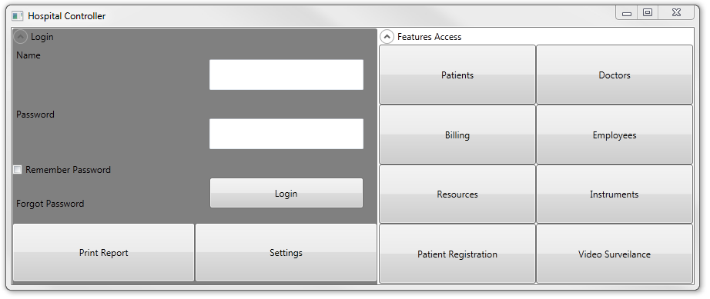

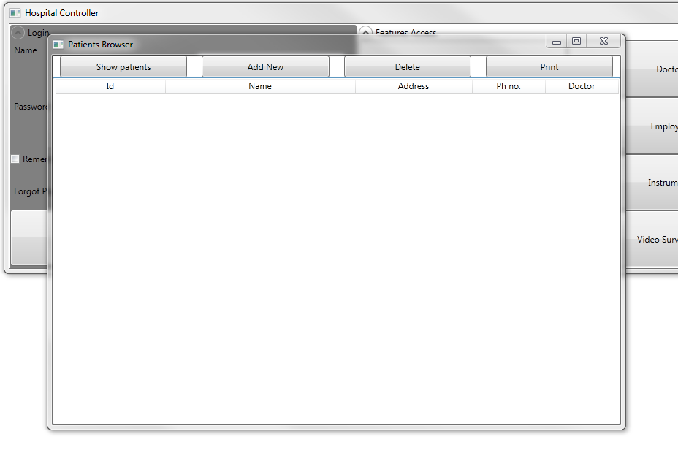
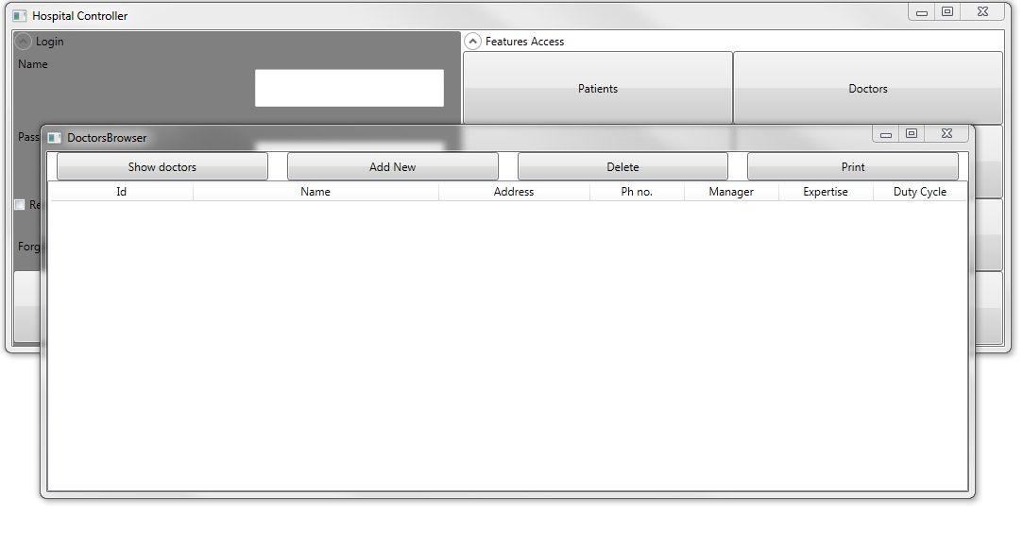

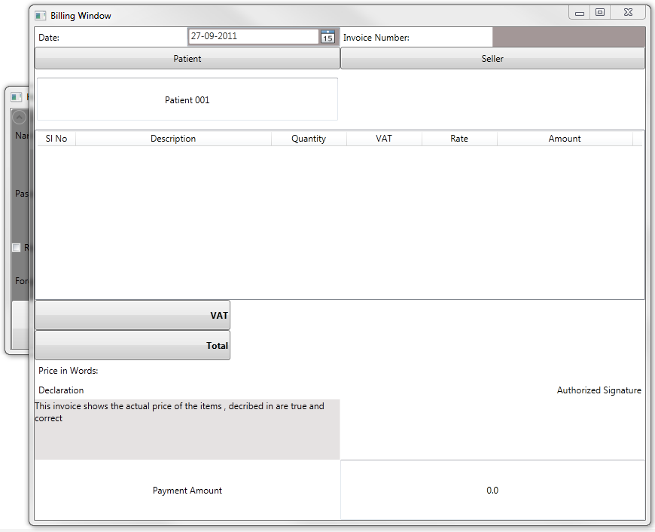

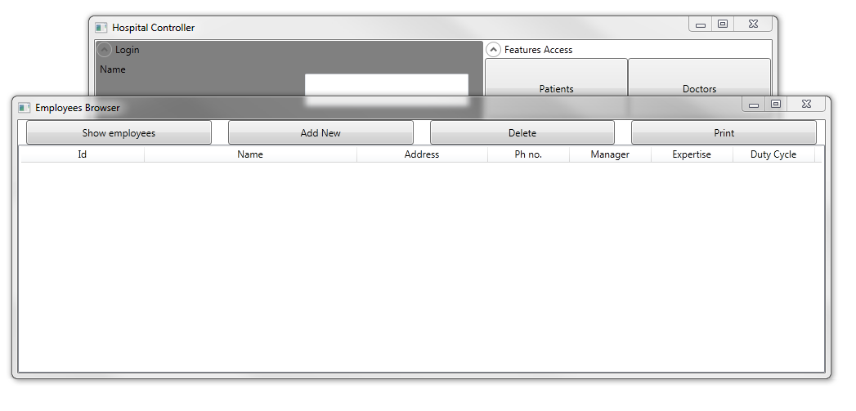

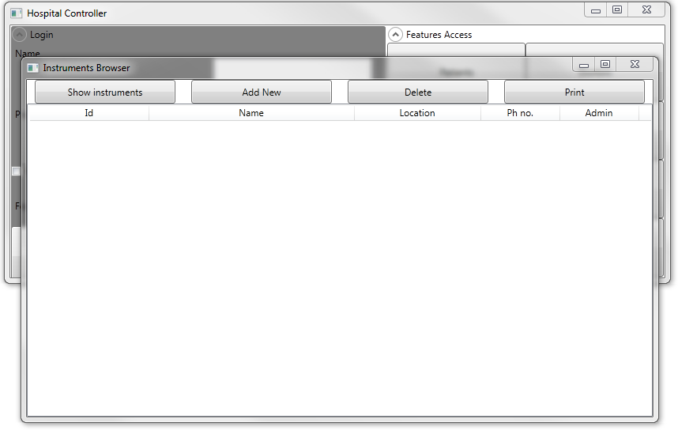
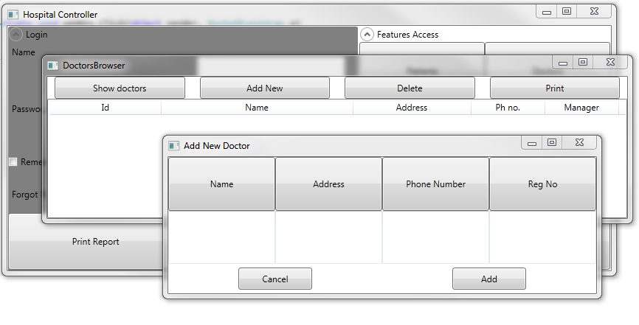

Installer Design:
We are Using Visual Studio Installer to package this software.
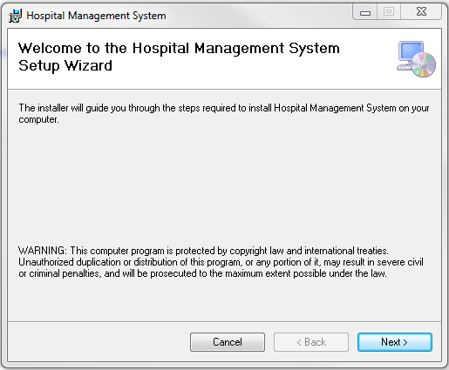
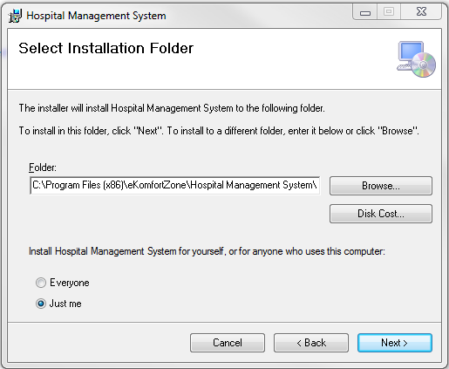
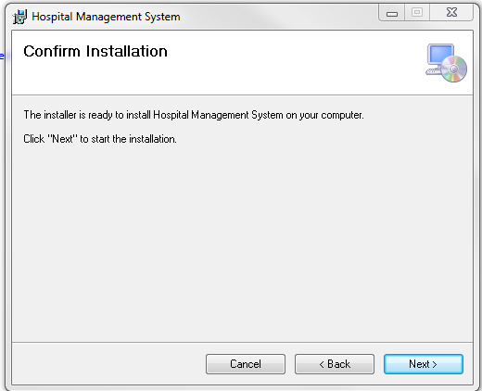
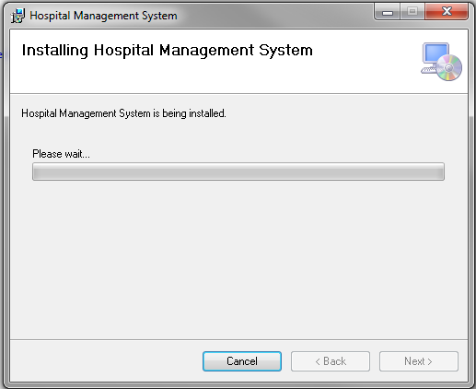
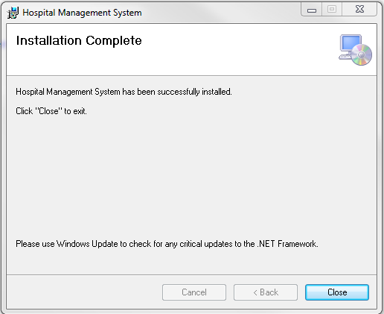

Any Client/Industry:

E-Komfort Zone
Bamangachi Station Road,
P.O: Bamangachi, P.S: Barasat,
Dist: North 24 Pgs
West Bengal- 743706

Future Scope and Further enhancement of the Project:

- To extend it for multiple organization with a centralized database.
- To support UNIX / Linux, MAC OSX Operating systems.

BIBLOGRAPHY:

http://www.google.co.in
http://en.wikipedia.org
http://msdn.microsoft.com/en-us/
http://www.microsoft.com/en-us/default.aspx
http://www.codeplex.com/
http://stackoverflow.com/
http://www.codeguru.com/
http://www.w3schools.com

----------------------------- Thank You-------------------------

