Hospital Management System

Tumpa Das

Table of Contents

Introduction & Objective of the Project: 4
Project Category: 7
Analysis of the Project: 8
Hospital User GUI 11
Login Interface 11
Patient Info Interface 11
Product Stock & Price Info browser 12
Usage & Billing Information Viewer 12
Customer Management Interface 12
Hospital User Service: 12
Product Usage Logger 13
Usage Timer 13
Access rights controller 13
Connectivity controller 13
Hospital Controller Engine Interactor 13
Hospital Controller GUI 13
Login Interface 14
Access Right Interface 14
Usage & Billing Interface 14
Product Stock & Price Info browser 14
Customer Management Interface 15
Printer Interface 15
Security Management Interface 15
Video Surveillance Interface 16
Controller Engine Interactor 16
Hospital Controller Engine 16
Engine controller: 16
GUI Interactor: 16
Database Controller: 16
Multimedia Controller: 16
Customer Controller: 17
Security Controller: 17
Usage Controller: 17
Access Controller: 17
Product Controller: 18
Search Engine: 18
Billing Handler: 18
Connectivity Controller: 18
Hospital Management System Database 18
Hardware & Software Requirements for the application to run 18
Hardware Requirements 18
Software Requirements 19
Project Structure: 19
Project Estimation: 19
E-R Diagram: 20
Tools/Platforms used (Hardware/Software): 23
Hardware: 23
Software: 23
Any Client/Industry: 24
Future Scope and Further enhancement of the project: 25

Introduction & Objective of the Project:

Hospital Management System is meant for managing and maintaining the activities of a Hospital. Hospital management system helps to manage patients, doctors and hospital resources. It helps to utilize the hospital resources in a efficient manner.

This software will installed on every machine of the Hospital and one of the machines will act as a controller. The IT admin of the Hospital uses the Hospital controller machine to control other machines. Following diagram displays the interaction between Hospital controller and the user machines.

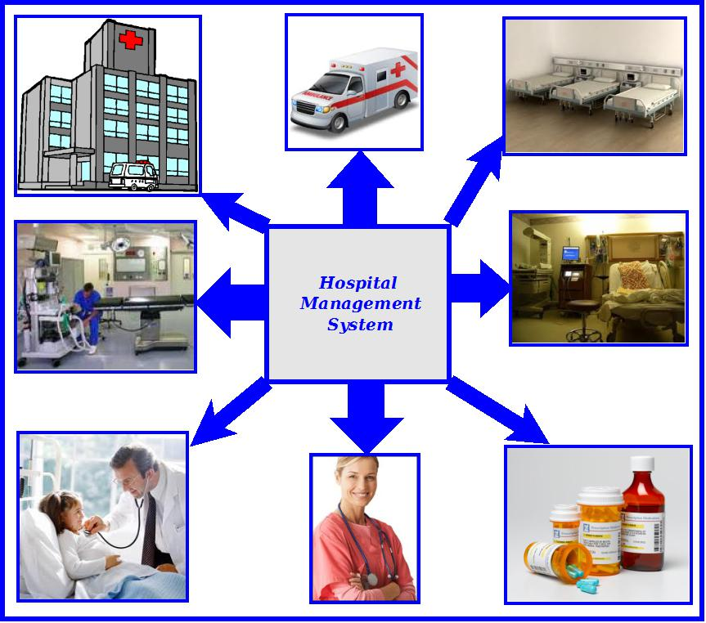
Figure: Overview of Hospital Management System

The main features of this software are given below:
  - Resource Usage tracking
  - Patient management.
  - Patient Identity info saving
  - security management
  - Medicine stock & pricing information query.
  - Bill preparation
  - Monthly / daily report
  - Supply management & payment tracking.
  - Centralized Report Printing Facility
  - Video Surveillance.

The feature and user of the Hospital Management System are displayed in the diagram below.

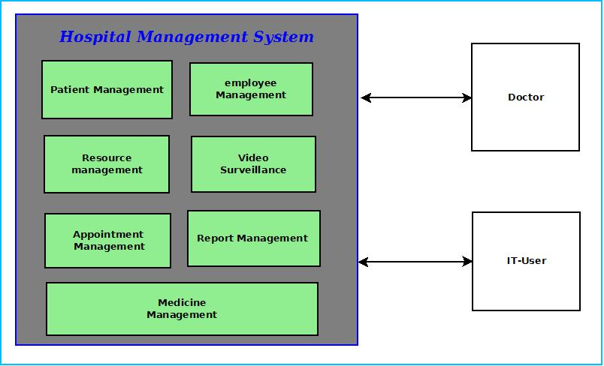

The Hospital management software will be used by the employee of the Hospital to control the Hospital and the doctors have to use the Hospital management software interface to access/use patient related informations.

Project Category:

This software will follow Object Oriented Programming Paradigm and use below mentioned areas.

Front End/ GUI Tools: Visual Studio 2010, .NET 4, C#
Backend: MySQL
Networking Technologies: TCP/IP
Wireless Technologies: Bluetooth
Operating Systems: Windows XP, Windows 7
Applications: Content Management System.

Analysis of the Project:
Hospital Management System caters different types of employees of hospital. There will be IT-Users like receptionist, data entry operator, doctor, nurses and IT-Admin like hospital superintendent. Hospital Management System will provide a cost effective & efficient software solution for managing everything about Hospital. Different components of Hospital Management System area are depicted below.

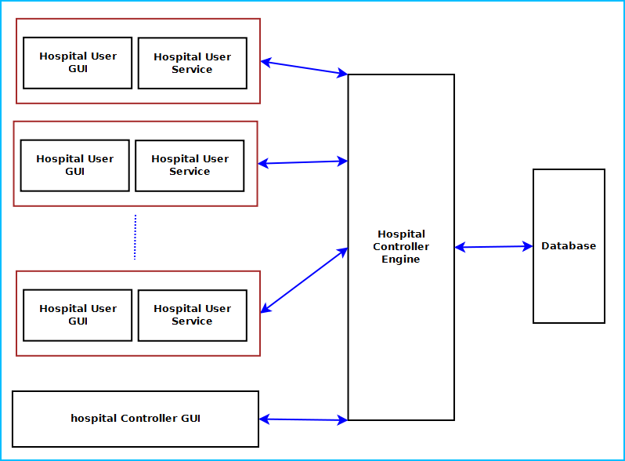
Figure: Components of Hospital Management System

Hospital Management System is divided into five main components. Such as:
- Hospital User GUI
- Hospital User Service
- Hospital Controller GUI
- Hospital Controller Engine
- Hospital Management System Database

Hospital User GUI & Service will be installed in IT-Users machine. Hospital controller GUI, engine & database will be installed in the IT-Admin’s machine and user machines will be connected to the controller machine.

Hospital User GUI
Hospital User GUI will display User login, Patient information & billing information, information search, appointment interface and report management interface. It is divided into five modules. Such as:
- Login Interface
- Patient Info Interface
- Payment Interface
- Appointment Management Interface
- Resource Management Interface
- Report Management Interface

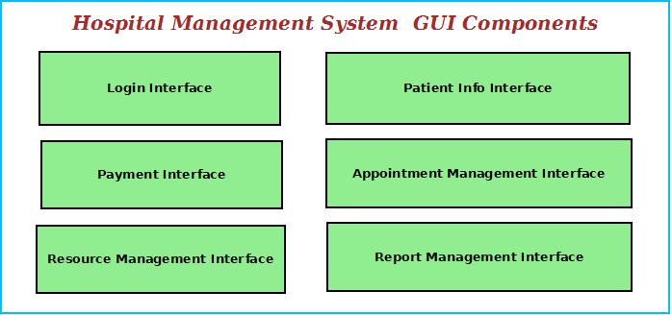
Figure: User GUI Components

Login Interface
Hospital User GUI can be used by variety of hospital employees. So user need to login using user id, password to access their registered account. It is mandatory to login to use the machine.

Patient Info Interface
This interface will allow IT-users to register new patients information, add new entries regarding patient current status. Patient Info Interface will have multiple forms to filled for adding required information.
It also allows to print in the centralized printer .

Appointment Management Interface
This interface will allow IT-user to search for appointment of a doctor of the Hospital and view fees information,time and location details.

Payment Interface
Payment interface enables bill generation for patients. IT-Users will inquire for services required by the patient . Then the Hospital Management System will search the fees and prepare the bill for printing. It will allow user to pay the bill by cash or credit/debit card.

Report Management Interface
This module will help to generate various reports about patients like diagonis reports, release letter, medical certificates. IT-Users will use this interface to generate and print the reports on demand..

Resource Management Interface
This module will maintain information about available resources like operation theater, machines for use. Patients can book them prior to use. IT-Users will use this interface to book this.

Hospital User Service:
This is a windows service utility running on every user’s machine to control users activity and access rights. This component is divided into five modules:
- Feature Usage Logger
- Usage Timer
- Access rights controller
- Connectivity controller
- Hospital Controller Engine Interactor

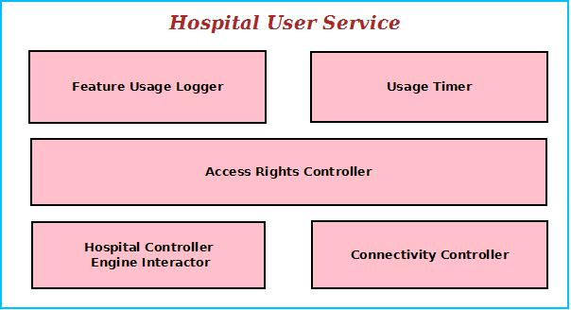
Figure: User Service Components

Feature Usage Logger
It logs the name of the Features and Resources used by the IT-user. It helps the Hospital Admin to realize the usage trend.

Usage Timer
This module logs the Users start time and runs a timer to display the elapsed time of the user. It also keeps the session information and remaining balance to avail next sessions.

Access rights controller
It controls the user’s access rights like installing /uninstalling softwares, using external drives. User has to seek permission from the admin to perform certain actions. This module controls this kind of access right mechanism.

Connectivity controller
This module handles the internet connectivity and LAN connections in case of LAN Gaming. It tracks the user download and upload quantity and requests for billing if it exceeds the permitted amount.

Hospital Controller Engine Interactor
This module interacts with centralized Hospital controller engine to get certain information about user and perform actions accordingly.

Hospital Controller GUI
Hospital Controller GUI will display User information, usage & billing information, product information search, Product selection browser, security management interface, video surveillance window and Customer account management browser. The Hospital can monitor and control whole Hospital from a single machine.
It is divided into eleven modules. Such as:
- Login Interface
- Access Right Interface
- Resource Management Interface
- Appointment Interface
- Billing Interface
- Medicine Stock & Price Info browser
- Patient Management Interface
- Report Interface
- Security Management Interface
- Video Surveillance Interface
- Controller Engine Interactor

Login Interface
This interface will allow the owner/admin to login and control other users. This will authenticate the admin and enable him to give access the admin features and approve user requests.

Access Right Interface
The users will ask for several access requests like installing new software, use external drive, and connect with other machine on LAN. The admin get this request as a popup and he can approve or reject them.

Billing Interface
This interface will display the usage of all the patients’ available. It will also help generate bill for a patient's usage and purchase. This interface will allow viewing bulk purchase amounts, approvals for the higher management.

Medicine Stock & Price Info browser
This module will allow the IT-Admin to view the medicine stocks, price information.

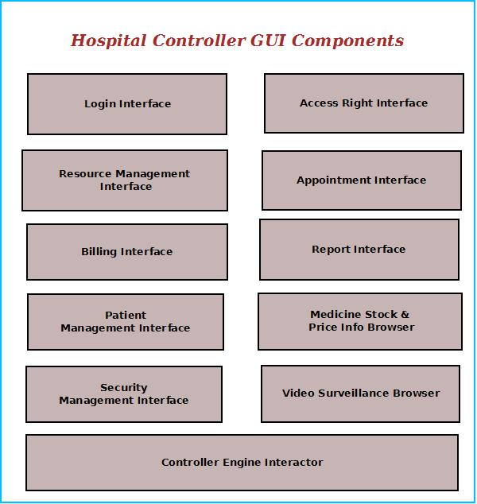
Figure: Controller GUI Components

Patient Management Interface
This interface will enable the admin to browse existing patients and add new patients. It will allow the admin to manage different aspects of patients of the Hospital.

Resource Management Interface
This interface will enable the admin to browse existing resources and approve resource allocation requests.

Appointment Management Interface
This interface will enable the admin to appointment of existing patients and resolve appointment conflicts.

Report Interface
This interface is for managing the report generation,centralized printer setup and to approve the print requests, prepare bill for the request.

Security Management Interface
Hospitals need to maintain the patient data, photo identity card number . This interface will allow managing security measures to taken about the patients. It will have a interface for entering the patient's security data, photo and scan the photo identity card of the user.

Video Surveillance Interface
This interface will display the video of specific areas of the Hospital and save the video for future reference. The admin can monitor from video surveillance window.

Controller Engine Interactor
This interface will interact with centralized controller engine and fetch the required data.

Hospital Controller Engine
Hospital Controller Engine controls the overall system. It provides logical and tactical solutions for managing the whole system. The Hospital Management System is divided into 12 divided modular components. Such as:
- Engine controller | - Access Controller
- GUI Interactor | - Connectivity Controller
- Database Controller | - Billing Handler
- Information Controller | - Search Engine
- Employee Controller | - Patient Controller
- Usage Handler | - Security Controller

Engine controller:
This controls the overall interaction between all the backend modules. It schedules the priority of the actions in case of overlapping.

GUI Interactor:
It interacts with the GUI and polls GUI calls. It exposes APIs and events for GUI to use. GUI Interactor helps Engine to maintain wrapper around the Engine modules so that the GUI can be ported to any other framework without much changes in Engine code.

Database Controller:
It controls the database interactions. It forms query to fetch information from the database. It also sends data to be saved in database for future use.

Information Controller:
This module processes patient and other information. It also archives the data to save space.

Patient Controller:
It keeps track of patient information. It has an algorithm for maintaining patient's treatment, disease history. Depending on those patient's care will be taken accordingly.

Security Controller:
It saves information for security measures. It can send it to the authority or police whenever required.

Usage Controller:
It controls the usage of the users depending on the balance available and informs the user about remaining time line.

Access Controller:
Access controller manages user login and features to be accessed by them. It will validate user’s login and block access & inform management if any access violation attempts happen.

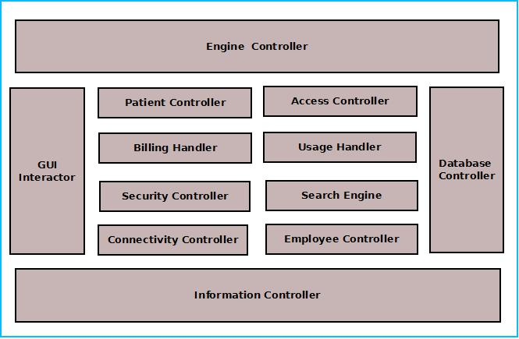
Figure: Components of Engine

Employee Controller:
This module will maintain the information about employees such as doctor, nurse, support stuff. It will save the information in database and retrieve them when required.

Search Engine:
Search engine enables rapid and efficient searching of data about customers, products and suppliers. Search Engine prepares search indexes depending most accessed data. It improves the efficiency and performance of the software.

Billing Handler:
Billing Handler allows generating the bill for Patient's usage & purchases. It will get the pricing information from the database depending on user data and admin input about product type and quantity. It will add discounts, special offer and VAT amounts on the purchase amount and calculate the amount payable.

Connectivity Controller:
Web controller handles the interaction with Internet and LAN. It allows connecting to the internet depending users credit balance. It has the logic for connection handling between machines and controller.

Hospital Management System Database
Hospital Management System will maintain a centralized database for storing information. We will design a RDBMS to manage the database and engine interaction. It will have optimized design and archive older data to save space and increase performance.

Hardware & Software Requirements for the application to run

Hardware Requirements
Computer that has a 1.6GHz or faster processor | Security Cameras
1 GB (32 Bit) or 2 GB (64 Bit) RAM | Barcode Reader
10 MB of available hard disk space | Bill Printing Machine
DVD-ROM Drive / USB Port | Webcam
Credit Card Swipe Machine

Software Requirements
Windows XP (x86) with Service Pack 3 / Windows Vista (x86 & x64) with Service Pack 2 / Windows 7 (x86 & x64)
Microsoft .NET 4.0
Windows WPF & WCF

Project Structure:

Project Estimation:
Task Group | Task | Duration ( Man-Days)
User GUI | Login Interface | 15 days
User GUI | Patient Information Browser | 15 days
User GUI | Billing Interface | 15 days
User GUI | Appointment Management Interface | 15 days
User GUI | Report Management Interface | 15 days
User GUI | Resource Management Interface | 15 days
User Service | Feature Usage Logger | 15 days
User Service | Usage Timer | 15 days
User Service | Access rights controller | 15 days
User Service | Connectivity controller | 15 days
User Service | Hospital Controller Engine Interactor | 15 days
Controller GUI | Login Interface | 20 days
Controller GUI | Access Right Interface | 20 days
Controller GUI | Billing Interface | 20 days
Controller GUI | Product Stock & Price Info browser | 20 days
Controller GUI | Patient Management Interface | 20 days
Controller GUI | Report Interface | 20 days
Controller GUI | Security Management Interface | 20 days
Controller GUI | Video Surveillance Interface | 20 days
Controller GUI | Controller Engine Interactor | 20 days
Controller Engine | Engine controller | 40 days
Controller Engine | GUI Interactor | 40 days
Controller Engine | Database Controller | 40 days
Controller Engine | Multimedia Controller | 40 days
Controller Engine | Patient Controller | 40 days
Controller Engine | Usage Handler | 40 days
Controller Engine | Access Controller | 40 days
Controller Engine | Connectivity Controller | 40 days
Controller Engine | Billing Handler | 40 days
Controller Engine | Search Engine | 40 days
Controller Engine | Employee Controller | 40 days
Controller Engine | Security Controller | 40 days
Database | Database Design | 30 days
Database | Database Implementation | 30 days
Database | Optimization | 30 days
Integration | Application Integration | 20 days
Integration | Creating Installer | 20 days
Testing | Unit Testing | 20 days
Testing | Integration Testing | 20 days
Testing | Regression Testing | 20 days
Testing | System Testing | 20 days
Documentation | Synopsis | 20 days
Documentation | Design Document | 20 days
Documentation | Help Document | 20 days

E-R Diagram:

We will design a RDBMS for File Management System. The entities and their attributes are listed below. Attributes in Bold letter is the unique key.

Entities | Attributes
Patient | User Id, Name, Address , Contact Number,  password, Photo ID Num, Photo
Hospital Management System | Hospital Id , Name, Address, Registered no
Hospital Machine | Machine Id, Name, Software
Session | Session Id, User Id, Time, Billing amount
Doctor | Doctor Id, Name, address, contact number
User Preference | Preference Id, Type, Description
Admin | Admin id, name, price

Relationship between Entities:

- Hospital Management System has Doctors→ 1 : N
- Hospital Management System has Machine→ 1 : N
- Patient System uses Session→ 1 : 1
- Hospital Management System Cures patients → 1 : N
- Users provide Preferences → M : N
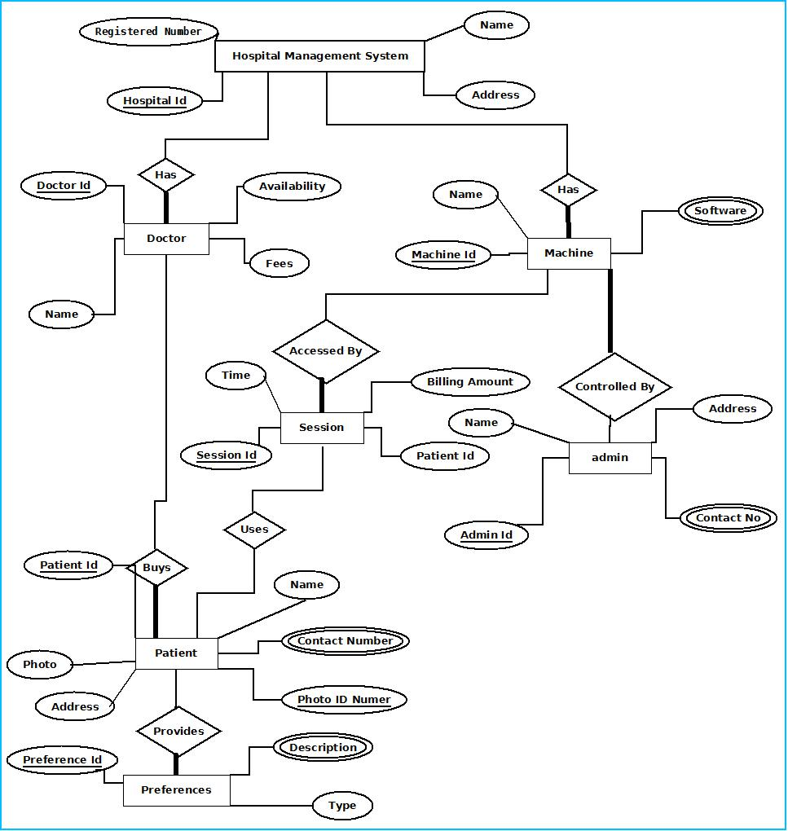

E-R Diagram of Hospital management system

Tools/Platforms used (Hardware/Software):

Hardware:
- Laptop with 2GHZ processor
- 2 GB RAM
- 320 GB hard disk (NTFS File System)

Software:
- Windows XP (x86) with Service Pack 3 / Windows Vista (x86) with Service Pack 2 / Windows 7 (x86)
- Microsoft .NET 4.0
- Windows Presentation Framework(WPF)
- Windows Communication Framework(WCF)
- Visual Studio 2010 Express Edition (IDE)
- MySQL database
- Dia for Diagram Drawing & Modelling.

Any Client/Industry:

E-Komfort Zone
Bamangachi Station Road,
P.O: Bamangachi, P.S: Barasat,
Dist: North 24 Pgs
West Bengal- 743706

Future Scope and Further enhancement of the project:

    - To sink with multiple branch of a Hospital with a centralized database.
    - To support UNIX / Linux, MAC OSX Operating systems.

----------------------------- Thank You-------------------------

