Security Management System

Dipanjan Banerjee

Enrollment No:- 085482839

BCA

6thSemester CS-76

PROJECT

Table of Contents
1. Introduction of the Project: 3
2. Objective of the Project: 5
3. Tools / Environment Used: 6
4. Analysis of the Project: 14
5. Hardware & Software Requirements for the application to run 21
6. E-R Diagram: 22
7. Tools/Platforms used (Hardware/Software): Error! Bookmark not defined.
8. DESIGN DOCUMENT: 24
9. PROGRAMME CODE: 30
10. TESTING: 30
11. INPUT/OUTPUT SEREEN: 33
12. SECQURITY MEASYRES: 33
13. LIMITATION OF THE PROJECT: 34
14. Any Client/Industry: 36
15. Future Scope and Further enhancement of the Project: 37
16. BIBLOGRAPHY: 39

Introduction of the Project:
Security management system will provide a software solution for enhancing security measures in housing complexes, Apartments, companies and other organizations. Security is a foremost concern in every walk of our life. Every day lots of new and unknown people visits the organizations. We want to restrict some specific people from entering the premises and track the people entering and leaving the premises.
Now in most of the places paper book registers are used for tracking visitors. But it is not an efficient system. There are no proper ways of validating the data provided by visitor and searching a visitor’s entry history is a cumbersome job. Security management system will provide better ways validating visitor data and searching visitor’s previous entry history.
Security management system will track the security guards and other servants who enter premises for various reasons. Following diagram displays the users and coverage of the security management system.
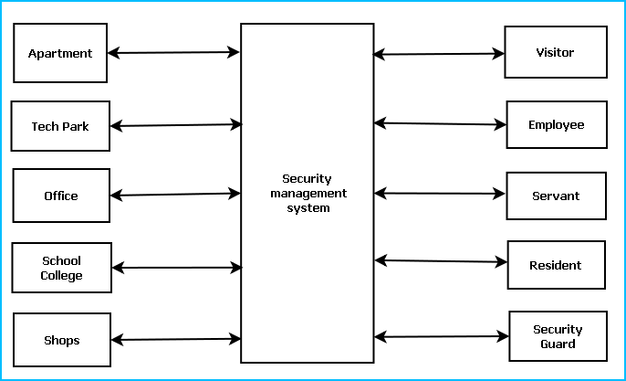

To ensure better security, Security Management System will provide the following features:
Residents or employee information database
Video Surveillance
Photo identity card generation
GPS Tracker
In time and out time registry, Visitor Traffic and History
Visitor tracking and contact person confirmation
Distress calling system
Emergency action System
Do Not Disturb criteria
Visitor time out alert
Security Guard Management
Security training & Tutorial

Objective of the Project:

The objectives of this project are given below:
- Security management system will provide a software solution for enhancing security measures in various organizations.
- System will facilitate to restrict some specific people from entering the premises and track the people entering and leaving the premises.
- It will enable inhabitants to implement a automatic security system by which a centralized system can keep track with trace passers.
- Security management system will track the security guards and other servants who enter premises for various reasons.
- Security management system will provide better ways for validating visitor data and searching visitor’s previous entry history which will replace cumbersome paper work with efficient computerized datasheets.
- By accomplishing this project I could learn new technologies like .NET, C#, DirectX, XML and I am able to be involved with the complete software development lifecycle.

Tools / Environment Used:
This software will follow Object Oriented Programming Paradigm and use below mentioned areas.

IDE Used (Visual Studio 2010):



Microsoft Visual Studio is a powerful IDE that ensures quality code throughout the entire application lifecycle, from design to deployment. Whether we are developing applications for SharePoint, the web, Windows, Windows Phone, and beyond, Visual Studio is the ultimate all-in-one solution. Visual Studio includes a code editor supporting IntelliSense as well as code refactoring. The integrated debugger works both as a source-level debugger and a machine-level debugger. Other built-in tools include a forms designer for building GUI applications, web designer, class designer, and database schema designer. It accepts plug-ins that enhance the functionality at almost every level—including adding support for source-control systems (like Subversion and Visual SourceSafe) and adding new toolsets like editors and visual designers for domain-specific languages or toolsets for other aspects of the software development lifecycle (like the Team Foundation Server client: Team Explorer).

Front End:

WPF (Windows Presentation Framework):
Windows Presentation Foundation (WPF) provides developers with a unified programming model for building rich Windows smart client user experiences that incorporate UI, media, and documents. Windows Presentation Foundation (WPF) is a next-generation presentation system for building Windows client applications with visually stunning user experiences. With WPF, you can create a wide range of both standalone and browser-hosted applications. The core of WPF is a resolution-independent and vector-based rendering engine that is built to take advantage of modern graphics hardware. WPF extends the core with a comprehensive set of application-development features that include Extensible Application Markup Language (XAML), controls, data binding, layout, 2-D and 3-D graphics, animation, styles, templates, documents, media, text, and typography. WPF is included in the Microsoft .NET Framework, so you can build applications that incorporate other elements of the .NET Framework class library.

Google Spreadsheet Interface:


With Google Spreadsheets, we can easily create, share, and edit spreadsheets online. Here are a few specific things we can do:
Import and export these file types: .xls, .csv, .txt and .ods. We can also export data to a PDF or an HTML file.
Format cells and edit formulas so we can calculate results and make data look the way we want it.
Chat in real time with others who are editing our spreadsheet.
Embed a spreadsheet, or a section of a spreadsheet, in our blog or website.

Programming Framework (.NET 4):


The .NET 4 Framework is Microsoft's platform for building applications that have visually stunning user experiences, seamless and secure communication, and the ability to model a range of business processes. The .Net Framework consists of:
Common Language Runtime – provides an abstraction layer over the operating system
Base Class Libraries – pre-built code for common low-level programming tasks
Development frameworks and technologies – reusable, customizable solutions for larger programming tasks.
The framework's Base Class Library provides user interface, data access, database connectivity, cryptography, web application development, numeric algorithms, and network communications. The class library is used by programmers, who combine it with their own code to produce applications.

Database Microsoft SQL Server 2008

Microsoft SQL Server 2008 is a complete set of enterprise-ready technologies and tools that help people derive the most value from information at the lowest total-cost-of-ownership. Enjoy high levels of performance, availability, and security; employ more productive management and development tools; and deliver pervasive insight with self-service business intelligence (BI). Its main Highlights are
- Complete information platform for applications of all sizes.
- Managed, familiar self-service BI tools.
- Support for large-scale data centers and data warehouses.
- Opportunities to build and extend applications in the cloud.
- Integration with the Microsoft Application Platform.

Google App Engine (The webapp Framework)

The webapp framework is a simple web application framework you can use for developing Python web applications for App Engine. Webapp is compatible with the WSGI standard for Python web application containers. Webapp provides an easy way to get started developing apps for App Engine.
App Engine supports any Python application with a CGI interface. A web application framework can simplify development by taking care of the details of the interface, letting you focus development effort on your applications features. App Engine includes a simple web application framework called webapp.
Webapp is a WSGI-compatible framework. You can use webapp or any other WSGI framework with App Engine using a CGI adaptor, such as one provided by the Python standard library.
Extensible Markup Language (XML)
Extensible Markup Language (XML) is a simple, very flexible text format derived from SGML (ISO 8879). Originally designed to meet the challenges of large-scale electronic publishing, XML is also playing an increasingly important role in the exchange of a wide variety of data on the Web and elsewhere.
Extensible Markup Language (XML) is a set of rules for encoding documents in machine-readable form. It is defined in the XML 1.0 Specification produced by the W3C, and several other related specifications, all gratis open standards.
XML's design goals emphasize simplicity, generality, and usability over the Internet.[6] It is a textual data format with strong support via Unicode for the languages of the world. Although the design of XML focuses on documents, it is widely used for the representation of arbitrary data structures, for example in web services.
Many application programming interfaces (APIs) have been developed that software developers use to process XML data, and several schema systems exist to aid in the definition of XML-based languages.
As of 2009, hundreds of XML-based languages have been developed,[7] including RSS, Atom, SOAP, and XHTML. XML-based formats have become the default for most office-productivity tools, including Microsoft Office (Office Open XML), OpenOffice.org (OpenDocument), and Apple's iWork.
System.Xml is the core XML manipulation technology for .NET languages.

Windows Communication FRAMEWORK (WCF)
Windows Communication Foundation (WCF) is a framework for building service-oriented applications. Using WCF, you can send data as asynchronous messages from one service endpoint to another. A service endpoint can be part of a continuously available service hosted by IIS, or it can be a service hosted in an application. An endpoint can be a client of a service that requests data from a service endpoint. The messages can be as simple as a single character or word sent as XML, or as complex as a stream of binary data. A few sample scenarios include:
- A secure service to process business transactions.
- A service that supplies current data to others, such as a traffic report or other monitoring service.
- A chat service that allows two people to communicate or exchange data in real time.
- A dashboard application that polls one or more services for data and presents it in a logical presentation.
- Exposing a workflow implemented using Windows Workflow Foundation as a WCF service.
- A Silverlight application to poll a service for the latest data feeds.
While creating such applications was possible prior to the existence of WCF, WCF makes the development of endpoints easier than ever. In summary, WCF is designed to offer a manageable approach to creating Web services and Web service clients.

Dia for Diagram Drawing & Modeling
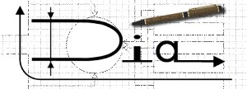
Dia is free and open source general-purpose diagramming software, developed as part of the GNOME project's office suite and was originally created by Alexander Larsson. Dia uses a controlled single document interface (CSDI) similar to GIMP and Sodipodi.
Dia has a modular design with several shape packages available for different needs: flowchart, network diagrams, circuit diagrams, and more. It does not restrict symbols and connectors from various categories from being placed together.
Dia is a gtk+ based diagram creation program released under the GPL license.
Dia is inspired by the commercial Windows program 'Visio', though more geared towards informal diagrams for casual use. It can be used to draw many different kinds of diagrams. It currently has special objects to help draw entity relationship diagrams, UML diagrams, flowcharts, network diagrams, and many other diagrams. It is also possible to add support for new shapes by writing simple XML files, using a subset of SVG to draw the shape.

It can load and save diagrams to a custom XML format (gzipped by default, to save space), can export diagrams to a number of formats, including EPS, SVG, XFIG, WMF and PNG, and can print diagrams (including ones that span multiple pages).

VirtueMart (online store)

VirtueMart is an Open Source E-Commerce solution to be used together with a Content Management System (CMS) called Joomla!. Joomla! and VirtueMart are written in PHP and can be used in typical PHP/MySQL environments. With its fully-featured eCommerce engine, VirtueMart is perfect to sell your Goods online and drive your Business to new Heights. Despite being Open Source Software it powers large Online Shops providing the Performance, Usability and Security you expect from professional Software.VirtueMart is the leading Online-Shop Solution for Joomla!

Archiving & Packaging Utility (7Z)

7-Zip is open source software. Most of the source code is under the GNU LGPL license. The unRAR code is under a mixed license: GNU LGPL + unRAR restrictions. Check license information here: 7-Zip license.
You can use 7-Zip on any computer, including a computer in a commercial organization. You don't need to register or pay for 7-Zip.
The main features of 7-Zip
- High compression ratio in 7z format with LZMA and LZMA2 compression
- Supported formats:
  - Packing / unpacking: 7z, XZ, BZIP2, GZIP, TAR, ZIP and WIM
  - Unpacking only: ARJ, CAB, CHM, CPIO, CramFS, DEB, DMG, FAT, HFS, ISO, LZH, LZMA, MBR, MSI, NSIS, NTFS, RAR, RPM, SquashFS, UDF, VHD, WIM, XAR and Z.
- For ZIP and GZIP formats, 7-Zip provides a compression ratio that is 2-10 % better than the ratio provided by PKZip and WinZip
- Strong AES-256 encryption in 7z and ZIP formats
- Self-extracting capability for 7z format
- Integration with Windows Shell
- Powerful File Manager
- Powerful command line version
- Plugin for FAR Manager
- Localizations for 79 languages

Programming Language (C#):
C# is a type-safe, object-oriented language that is simple yet powerful, allowing programmers to build a breadth of applications. C# is a multi-paradigm programming language encompassing imperative, declarative, functional, generic, object-oriented(class-based), and component-oriented programming disciplines. It was developed by Microsoft within the .NET initiative and later approved as a standard by Ecma (ECMA-334) and ISO (ISO/IEC 23270). C# is one of the programming languages designed for the Common Language Infrastructure.
C# is intended to be a simple, modern, general-purpose, object-oriented programming language.

Backend:
MySQL

Internet Technologies:
HTML, JavaScript, PHP, Google App Framework

Networking Technologies:
TCP/IP

Wireless Technologies:
Bluetooth

Operating Systems:
Windows XP, Windows 7

Applications:
ERP application, Database Management System.

Analysis of the Project:
Security Management System will enhance the security of apartments, offices, schools and business centers by providing an efficient system for tracking incoming & outgoing traffic.
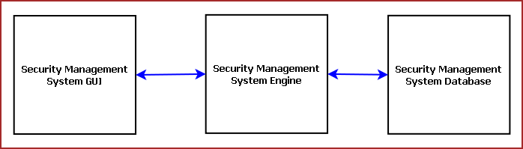
Figure: Components of Security Management System
Security Management System is divided into three main components. Such as:
Security Management System GUI
Security Management System Engine
Security Management System Database

Security Management System GUI

Security Management System GUI will display existing user data, log visitor data, generate ID card. It is divided into eight modules. Such as:
Visitor Register
Member Registration
Member Database Browser
Employee Management
Security Training
Video Surveillance Window
Alarm System
Emergency Handler

Visitor Register
Visitor Register allows tracking visitors. It provides an interface to enter visitor details, purpose of visit, tentative time of stay, contact person. It will take the photograph of visitor and generate a photo ID card. The earlier visit histories can be browsed and it will suggest whether the visitor was blocked earlier in this organization.

Member Registration
This module provides an interface for registering the members of the organization, residents of the apartment etc. This data helps validate the visitor provided inputs. Security management system will contact the member before allowing the access. If the visitor stays more than specified time limit then Security management system will enquire the reason.

Member Database Browser
Member Database Browser will provide information about the existing members of the organization and their contact information. It will help validating visitor data and handling emergency situations.
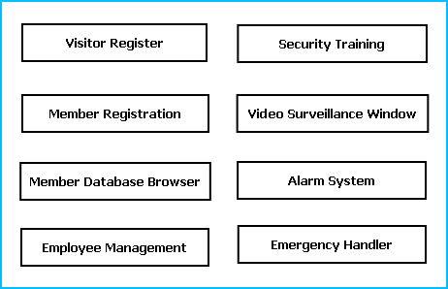
Figure: GUI Components

Employee Management
This module will manage the employees responsible for security operations. It will keep track of employee attendance, duty hours, customer support quality and feedbacks.

Security Training
This module is responsible for making the employees and members aware about security guidelines and actions to be taken on emergency situations. It will provide guideline booklet, presentation & video tutorials.

Video Surveillance Window
Video Surveillance window displays the video of the area where the security cameras are installed. It can record the video for a specified time limit.

Alarm System
Alarm system is meant for alerting security guards on specific emergency situations or to notify members about some information. All the major locations will have sound system installed and the roaming security guards also carry wireless devices.

Emergency Handler
Emergency Handler takes appropriate actions on emergency situations. It will notify police, medical services or fire fighter depending on the emergency situations. It will can enable/ disable some services like lift service or power supply depending on the need.

Security Management System Engine
Security Management Engine controls the overall system. It provides logical and tactical solutions for managing the whole system. The Security Management System is divided into 12 divided modular components. Such as:

Engine controller | Employee Controller
GUI Interactor | Alarm Controller
Database Controller | Data Entry Controller
Photo & Video Surveillance Controller | Training Controller
Visitor Controller | Search Engine
Member Controller | Emergency Controller

Engine controller:
This controls the overall interaction between all the backend modules. It schedules the priority of the actions in case of overlapping.

GUI Interactor:
It interacts with the GUI and polls GUI calls. It exposes APIs and events for GUI to use. GUI Interactor helps Engine to maintain wrapper around the Engine modules so that the GUI can be ported to any other framework without much changes in Engine code.

Database Controller:
It controls the database interactions. It forms query to fetch information from the database. It also sends data to be saved in database for future use.

Photo & Video Surveillance Controller:
This module processes the images and videos taken while surveillance and exposes APIs for viewing and Playing back. It also archives the video and images to save space.

Visitor Controller:
It keeps track of visitor information. It has an algorithm for maintaining Visitor history and rating the visitor’s trustworthiness. Visitor controller will trigger alarm if it senses any mismatch in visitor provided data.

Member Controller:
It saves information about the members of the organization. It validates the Visitor data and takes confirmation from the member to allow the visitor inside. Members can set DO NOT DISTURB mode, Preferred Visiting Time & Preferred visitors. It controls access to information of the members depending on the admin right of the user.

Employee Controller:
It controls the employee attendance, employee information and duty hours & duty locations. It can generate monthly reports on employee details to provide it to the security agencies for performance evaluation.

Alarm Controller:
Alarm controller manages the alert messages to be passed among Security Guards and Members. The situations when the alarm system will work are mentioned below:
If the visitor has exceeded the specific time limit the alarm will alert
If the ID card has GPS tracker and visitor has entered the restricted area it will alert the security guards in their wireless device.
If any member ask for emergency help.To alert the members about some declaration.
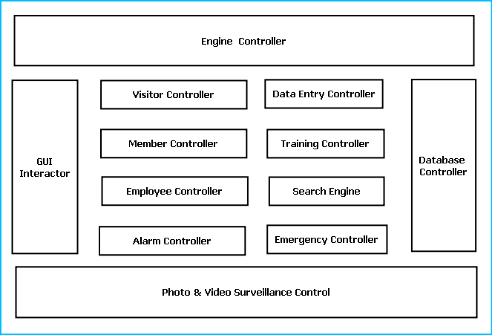
Figure: Components of Engine

Data Entry Controller:
It controls the data entered and passed to the engine. It validates the data depending on predefined inputs. If validation is failed it generates warning messages.

Training Controller:
This module provides the contents for Security Training and awareness campaigns. It provides audio visual output display to view them. It also allows printing security info flyers and booklets.

Search Engine:
Search engine enables rapid and efficient searching of data about visitors, employees and members. Search Engine prepares search indexes depending most accessed data. It improves the efficiency and performance of the software.

Emergency Controller:
Emergency controller provides the algorithm for action to be taken on emergency situations. It will store emergency contacts, police station, hospital, ambulance & fire fighter contact number. And it will alert them via call, sms and email during emergency situations. It will also include intelligence to enable & disable critical services like opening exit doors, stopping lift services, shutting down power supply or starting emergency power backups.

Security Management System Database
Security Management System will maintain a medium sized centralized database for storing information. We will design a RDBMS to manage the database and engine interaction. It will have optimized design and archive older data to save space and increase performance.

Hardware & Software Requirements for the application to run

Hardware Requirements
Computer that has a 1.6GHz or faster processor
1 GB (32 Bit) or 2 GB (64 Bit) RAM
10 MB of available hard disk space
DVD-ROM Drive / USB Port
Webcam
GPS Trackers
NFC Id Cards
Security Cameras

Software Requirements

Windows XP (x86) with Service Pack 3 / Windows Vista (x86 & x64) with Service Pack 2 / Windows 7 (x86 & x64)
Microsoft .NET 4.0

E-R Diagram:
We will design a RDBMS for File Management System. The entities and their attributes are listed below. Attributes in Bold letter is the unique key.
Entities | Attributes
Visitor | Visitor Id, Name, Address , Contact Number
Visit Request | Request Id, type, purpose, time, duration, member id
Security Management System | Organization Id , Name, Address, Total member
Employee | Employee Id, Name, Admin Right
Member | Member Id, Name, address, contact number, emergency contact number
Member Preference | Preference Id, Type, Description

4.2.1 RELATIONSHIP BETWEEN ENTITIES:
Security Management System has Members→ 1 : N
Security Management System has Visitors→ 1 : N
Security Management System has Employees→ 1 : N
Visitor does Requests → 1 : N
Security Management System serves Requests → 1 : N
Members provides Preferences → M : N

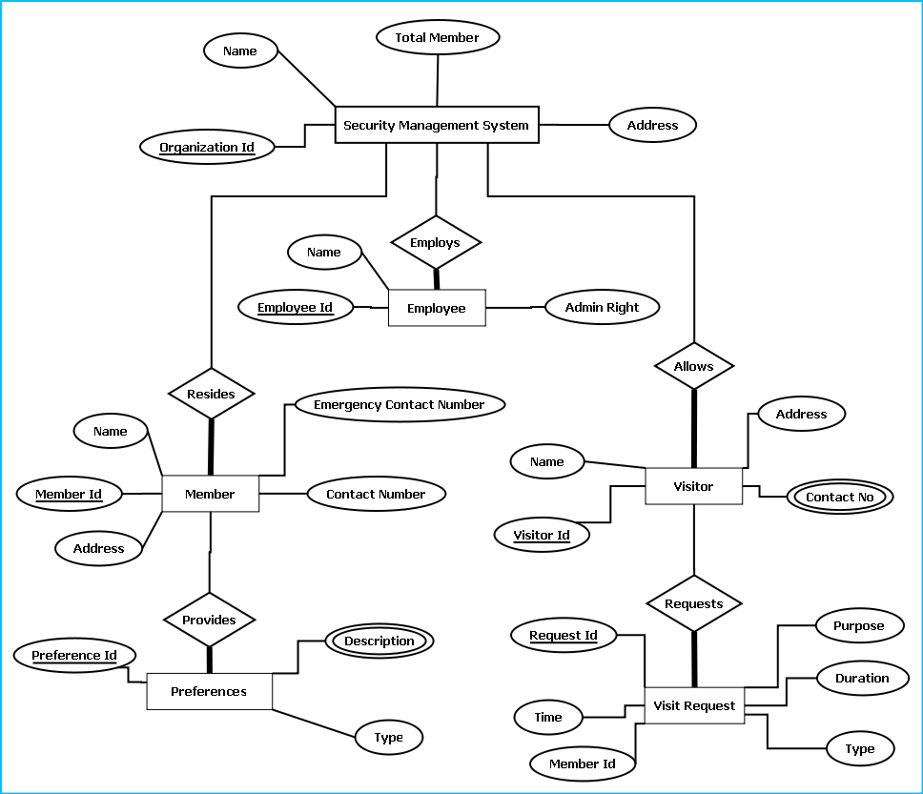
E-R Diagram of Security Management System

DESIGN DOCUMENT:
The user interface is developed using WPF.
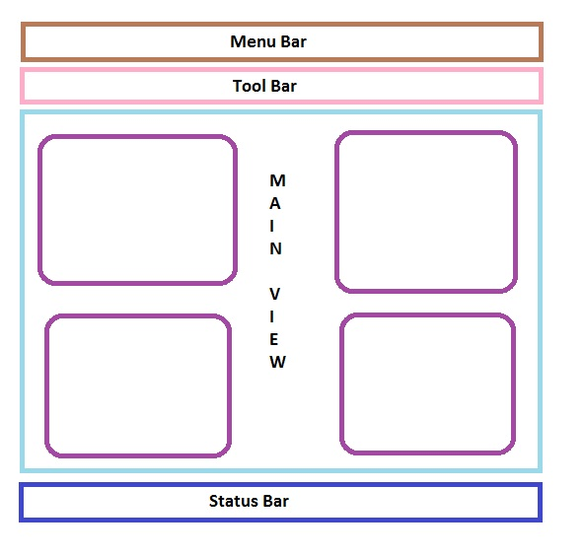
Menu bar contains the important features which can be accessed by shortcuts too. It is implemented using Menu control.
System.Windows.Controls.Menu
Namespace: System.Windows.Controls
Assembly: PresentationFramework (in PresentationFramework.dll)
Represents a Windows menu control that enables you to hierarchically organize elements associated with commands and event handlers.

Toolbar lists down the mostly used features. It is implemented using ToolBar control.
System.Windows.Controls.ToolBar
Namespace: System.Windows.Controls
Assembly: PresentationFramework (in PresentationFramework.dll)
Provides a container for a group of commands or controls.

Left navigation bar displays the tutorials available locally and online. This navigation bar is hide- able. It is implemented using the Expander control.
System.Windows.Controls.Expander
Namespace: System.Windows.Controls
Assembly: PresentationFramework (in PresentationFramework.dll)
Represents the control that displays a header that has a collapsible window that displays content.

The local contents are displayed in a TreeView control. And every contents are displayed in in a TreeViewItem.
System.Windows.Controls.TreeView
Namespace: System.Windows.Controls
Assembly: PresentationFramework (in PresentationFramework.dll)
Represents a control that displays hierarchical data in a tree structure that has items that can expand and collapse.

Online contents are displayed in a WebBrowser control. Users can select the content and purchase it from there.
System.Windows.Controls.WebBrowser
Namespace: System.Windows.Controls
Assembly: PresentationFramework (in PresentationFramework.dll)
Hosts and navigates between HTML documents. Enables interoperability between WPF managed code and HTML script.

Textpane displays the Texts. This is implemented using a TextBlock control.
System.Windows.Controls.TextBlock
Namespace: System.Windows.Controls
Assembly: PresentationFramework (in PresentationFramework.dll)
Provides a lightweight control for displaying small amounts of flow content.

Video and audio playing is implemented using MediaElement control.
System.Windows.Controls.MediaElement
Namespace: System.Windows.Controls
Assembly: PresentationFramework (in PresentationFramework.dll)
Represents a control that contains audio and/or video.

Images are displayed using Image control.
System.Windows.Controls.Image
Namespace: System.Windows.Controls
Assembly: PresentationFramework (in PresentationFramework.dll)
Represents a control that displays an image.

Drawing pane is implemented using InkCanvas control.
System.Windows.Controls.InkCanvas
Namespace: System.Windows.Controls
Assembly: PresentationFramework (in PresentationFramework.dll)
Defines an area that receives and displays ink strokes.

Statusbar displays the information about the application and the tutorial currently running. Its implemented using StatusBar Class.
System.Windows.Controls.Primitives.StatusBar
Namespace: System.Windows.Controls.Primitives
Assembly: PresentationFramework (in PresentationFramework.dll)
Represents a control that displays items and information in a horizontal bar in an application window.

Engine Design:
Reading & Writing XML:
In this application the tutorials are saved as XML file. The application will process the XML and play the tutorial. So we have implemented XML reader and writer logic. XML operations are done using .NET XML parser. Every XML element is represented as a XElement control.
System.Xml.Linq.XElement
Namespace: System.Xml.Linq
Assembly: System.Xml.Linq (in System.Xml.Linq.dll)
Represents an XML element.

Installer:
We are using visual studio installer package to generate a MSI.
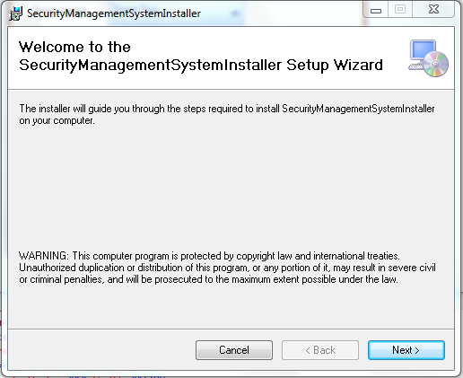
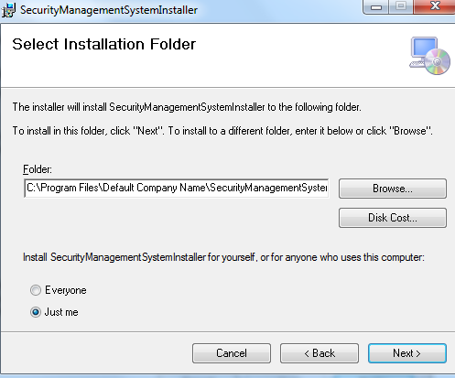
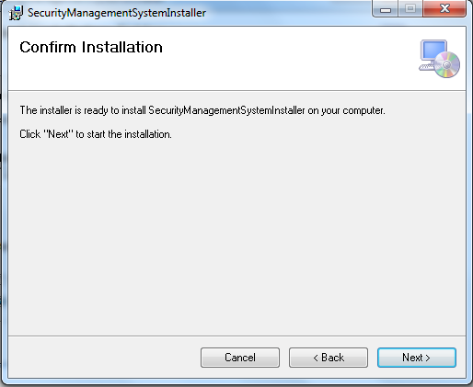
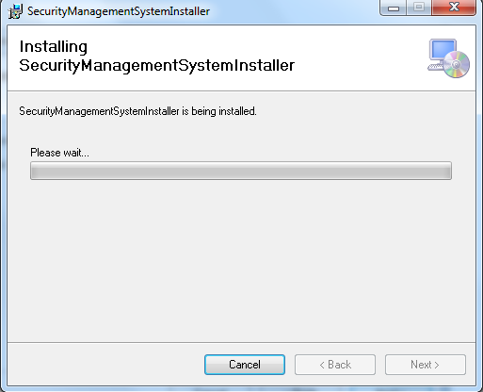

PROGRAMME CODE:
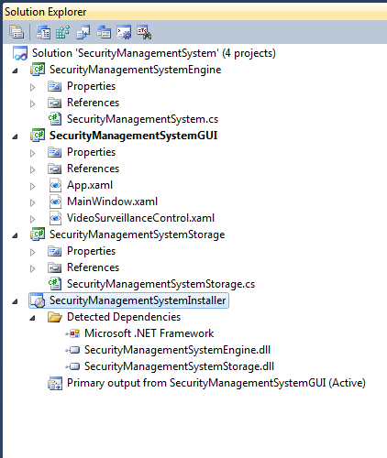
Mainwindow.xaml
<Window x:Class="SecurityManagementSystem.MainWindow"
xmlns="http://schemas.microsoft.com/winfx/2006/xaml/presentation"
xmlns:x="http://schemas.microsoft.com/winfx/2006/xaml"
Title="Security Management" Height="848" Width="862" xmlns:my="clr-namespace:SecurityManagementSystem">
<DockPanel LastChildFill="True">
<Menu DockPanel.Dock="Top">
<MenuItem Header="File"></MenuItem>
<MenuItem Header="Settings"></MenuItem>
<MenuItem Header="Help"></MenuItem>
</Menu>
<ToolBar Margin="5" DockPanel.Dock="Top">
<Button Name="loginBtn" Click="loginBtn_Click" Margin="5">Login</Button>
<Separator></Separator>
<Button Name="permBtn" Click="permBtn_Click" Margin="5">Permission</Button>
<Separator></Separator>
<Button Name="reportBtn" Click="reportBtn_Click" Margin="5">Reporting</Button>
<Separator></Separator>
<Button Name="regBtn" Click="regBtn_Click" Margin="5">Register Visitor</Button>
<Separator></Separator>
<Button Name="visitorBtn" Click="visitorBtn_Click" Margin="5">Manage Visitors</Button>
<Separator></Separator>
<Button Margin="5">Print</Button>
<Separator></Separator>
<Button Margin="5">Security</Button>
<Separator></Separator>
<Button Name="vidBtn" Click="vidBtn_Click" Margin="5">Video Surveillance</Button>
<Separator></Separator>
<Button Margin="5">Internet</Button>
</ToolBar>

<StatusBar DockPanel.Dock="Bottom">
<UniformGrid Rows="1">

<Button Margin="5" Content="Total Zone Online: 4"></Button>
<Button Margin="5" Content="Visitors: 12"></Button>
<Button Margin="5" Content="Employees: 810"></Button>
<Button Margin="5" Content="Total Area: 12560 Sq Ft"></Button>
<Button Margin="5" Content="Time: 12:00"></Button>

</UniformGrid>
</StatusBar>
<UniformGrid>
<my:VideoSurveillanceControl x:Name="videoSurveillanceControl1" Margin="5"/><my:VideoSurveillanceControl />
<my:VideoSurveillanceControl x:Name="videoSurveillanceControl2" Margin="5"/>
<my:VideoSurveillanceControl x:Name="videoSurveillanceControl3" Margin="5"/>
</UniformGrid>
</DockPanel>
</Window>

MainWindow.xaml.cs
using System;
using System.Collections.Generic;
using System.Linq;
using System.Text;
using System.Windows;
using System.Windows.Controls;
using System.Windows.Data;
using System.Windows.Documents;
using System.Windows.Input;
using System.Windows.Media;
using System.Windows.Media.Imaging;
using System.Windows.Navigation;
using System.Windows.Shapes;

namespace SecurityManagementSystem
{
/// <summary>
/// Interaction logic for MainWindow.xaml
/// </summary>
public partial class MainWindow : Window
{
public MainWindow()
{
InitializeComponent();
}

private void visitorBtn_Click(object sender, RoutedEventArgs e)
{

}

private void reportBtn_Click(object sender, RoutedEventArgs e)
{

}

private void permBtn_Click(object sender, RoutedEventArgs e)
{

}

private void regBtn_Click(object sender, RoutedEventArgs e)
{

}

private void loginBtn_Click(object sender, RoutedEventArgs e)
{

}

private void vidBtn_Click(object sender, RoutedEventArgs e)
{

}
}
}

VideoSurveillance.xaml
<UserControl x:Class="SecurityManagementSystem.VideoSurveillanceControl"
xmlns="http://schemas.microsoft.com/winfx/2006/xaml/presentation"
xmlns:x="http://schemas.microsoft.com/winfx/2006/xaml"
xmlns:mc="http://schemas.openxmlformats.org/markup-compatibility/2006"
xmlns:d="http://schemas.microsoft.com/expression/blend/2008"
mc:Ignorable="d"
d:DesignHeight="338" d:DesignWidth="402">
<Border CornerRadius="25" Background="Bisque" BorderBrush="Chocolate" BorderThickness="4">
<Grid Height="270" >
<Grid.RowDefinitions>
<RowDefinition Height="36*" />
<RowDefinition Height="226*" />
<RowDefinition Height="36*" />
</Grid.RowDefinitions>
<StackPanel Orientation="Horizontal">
<Label Margin="20 0">Zone name</Label>
<ComboBox SelectedIndex="1" Width="150">
<ComboBoxItem> Zone One</ComboBoxItem>
<ComboBoxItem>Zone Two</ComboBoxItem>
<ComboBoxItem>Zone Three</ComboBoxItem>
<ComboBoxItem>Zone Four</ComboBoxItem>
</ComboBox>
</StackPanel>
<MediaElement x:Name="MediaEL" Grid.RowSpan="1" Grid.Row="1" LoadedBehavior="Manual" />
<StackPanel Orientation="Horizontal" Grid.Row="2" HorizontalAlignment="Center" Margin="8,0,8,5" Width="301">
<Button x:Name="btnRec" Content="Record" Click="btnRec_Click"
Width="50" Height="25"/>
<Button x:Name="btnPlay" Content="Play" Click="btnPlay_Click"
Width="50" Height="25"/>
<Button x:Name="btnStop" Content="Stop" Click="btnStop_Click"
Width="50" Height="25"/>
<Button x:Name="btnMoveBackward" Content="Back" Click="btnMoveBackward_Click"
Width="50" Height="25"/>
<Button x:Name="btnMoveForward" Content="Forward" Click="btnMoveForward_Click"
Width="50" Height="25"/>
<Button x:Name="btnOpen" Content="Open" Click="btnOpen_Click"
Width="50" Height="25"/>
</StackPanel>
</Grid>
</Border>
</UserControl>

videoSurveilance.xaml.cs
using System;
using System.Collections.Generic;
using System.Linq;
using System.Text;
using System.Windows;
using System.Windows.Controls;
using System.Windows.Data;
using System.Windows.Documents;
using System.Windows.Input;
using System.Windows.Media;
using System.Windows.Media.Imaging;
using System.Windows.Navigation;
using System.Windows.Shapes;

namespace SecurityManagementSystem
{
/// <summary>
/// Interaction logic for VideoSurveillanceControl.xaml
/// </summary>
public partial class VideoSurveillanceControl : UserControl
{
public VideoSurveillanceControl()
{
InitializeComponent();
IsPlaying(false);
}
private void btnRec_Click(object sender, RoutedEventArgs e)
{

}
#region IsPlaying(bool)
private void IsPlaying(bool bValue)
{
btnStop.IsEnabled = bValue;
btnMoveBackward.IsEnabled = bValue;
btnMoveForward.IsEnabled = bValue;
btnPlay.IsEnabled = bValue;
}
#endregion

#region Play and Pause
private void btnPlay_Click(object sender, RoutedEventArgs e)
{
IsPlaying(true);
if (btnPlay.Content.ToString() == "Play")
{
MediaEL.Play();
btnPlay.Content = "Pause";
}
else
{
MediaEL.Pause();
btnPlay.Content = "Play";
}
}
#endregion

#region Stop
private void btnStop_Click(object sender, RoutedEventArgs e)
{
MediaEL.Stop();
btnPlay.Content = "Play";
IsPlaying(false);
btnPlay.IsEnabled = true;
}
#endregion

#region Back and Forward
private void btnMoveForward_Click(object sender, RoutedEventArgs e)
{
MediaEL.Position = MediaEL.Position + TimeSpan.FromSeconds(10);
}

private void btnMoveBackward_Click(object sender, RoutedEventArgs e)
{
MediaEL.Position = MediaEL.Position - TimeSpan.FromSeconds(10);
}
#endregion

#region Open Media
private void btnOpen_Click(object sender, RoutedEventArgs e)
{
Microsoft.Win32.OpenFileDialog ofd = new Microsoft.Win32.OpenFileDialog();
ofd.Filter = "Video Files (*.wmv)|*.wmv";
if (ofd.ShowDialog() == true)
{
MediaEL.Source = new Uri(ofd.FileName);
btnPlay.IsEnabled = true;
}
}
#endregion

}
}

Upload to Web
/* Copyright (c) 2007 Google Inc.
*
* Licensed under the Apache License, Version 2.0 (the "License");
* you may not use this file except in compliance with the License.
* You may obtain a copy of the License at
*
* http://www.apache.org/licenses/LICENSE-2.0
*
* Unless required by applicable law or agreed to in writing, software
* distributed under the License is distributed on an "AS IS" BASIS,
* WITHOUT WARRANTIES OR CONDITIONS OF ANY KIND, either express or implied.
* See the License for the specific language governing permissions and
* limitations under the License.
*/

using System;
using System.Collections.Generic;
using System.ComponentModel;
using System.Data;
using System.Drawing;
using System.Diagnostics;
using System.Text;
using System.Windows.Forms;
using Google.GData.Client;
using Google.GData.Documents;

namespace DocListUploader
{
public partial class OptionsForm : Form
{
private bool lastToolTipWasUpload = false;
public bool loggedIn = false;
private string file = "c:\\testfile.txt";
private DocumentsService service;
private DocumentEntry lastUploadEntry = null;
/// <summary>
/// Constructor for the OptionsForm.
/// </summary>
/// <param name="mainForm">The parent form that created this one.</param>
public OptionsForm()
{
InitializeComponent();
}

private void LoginButton_Click(object sender, EventArgs e)
{
if (Username.Text == "")
{
MessageBox.Show("Please specify a username", "No user name", MessageBoxButtons.OK, MessageBoxIcon.Error);
return;
}
if (Password.Text == "")
{
MessageBox.Show("Please specify a password", "No password", MessageBoxButtons.OK, MessageBoxIcon.Error);
return;
}

try
{
LoginButton.Text = "Logging In";

LoginButton.Enabled = false;
LogoutButton.Enabled = true;

Username.Enabled = false;
Password.Enabled = false;
Login(Username.Text, Password.Text);
LoginButton.Text = "Logged In";

}
catch (Exception ex)
{
LoginButton.Enabled = true;
LogoutButton.Enabled = false;
Username.Enabled = true;
Password.Enabled = true;

LoginButton.Text = "Login";

MessageBox.Show("Error logging into Google Docs: " + ex.Message, "Login Error", MessageBoxButtons.OK, MessageBoxIcon.Error);
}
}

private void Username_KeyPress(object sender, KeyPressEventArgs e)
{
//If the user hits enter, skip to the next field.
if (e.KeyChar == (char) 13)
{
Password.Focus();
}
}

/// <summary>
/// Authenticates to Google servers
/// </summary>
/// <param name="username">The user's username (e-mail)</param>
/// <param name="password">The user's password</param>
/// <exception cref="AuthenticationException">Thrown on invalid credentials.</exception>
public void Login(string username, string password)
{
if (loggedIn)
{
throw new ApplicationException("Already logged in.");
}
try
{
service = new DocumentsService("DocListUploader");
((GDataRequestFactory)service.RequestFactory).KeepAlive = false;
service.setUserCredentials(username, password);
//force the service to authenticate
DocumentsListQuery query = new DocumentsListQuery();
query.NumberToRetrieve = 1;
service.Query(query);
loggedIn = true;
}
catch (AuthenticationException e)
{
loggedIn = false;
service = null;
throw e;
}
}

/// <summary>
/// Logs the user out of Google Docs.
/// </summary>
public void Logout()
{
loggedIn = false;
service = null;
}

/// <summary>
/// Some error handling around the file upload method. Used for handling files from the context menu.
/// </summary>
/// <param name="file">The file to upload.</param>
public void HandleUpload(string file)
{
if (!loggedIn)
{
MessageBox.Show("Please log in before uploading documents", "Upload Error", MessageBoxButtons.OK, MessageBoxIcon.Error);
return;
}
try
{
lastToolTipWasUpload = false;
UploadFile(file);
lastToolTipWasUpload = true;

}
catch (ArgumentException)
{
//DocListNotifyIcon.ShowBalloonTip(BALLOON_TIMER, "Upload Error", "Error: unable to upload the file: '" + file + "'. It is not one of the valid types.", ToolTipIcon.Error);
lastToolTipWasUpload = false;
}
catch (Exception ex)
{
//DocListNotifyIcon.ShowBalloonTip(BALLOON_TIMER, "Upload Error", "Error: unable to upload the file: '" + file + "'. " + ex.Message, ToolTipIcon.Error);
lastToolTipWasUpload = false;
}
}

/// <summary>
/// Uploads the file to Google Docs
/// </summary>
/// <param name="fileName">The file with path to upload</param>
/// <exception cref="ApplicationException">Thrown when user isn't logged in.</exception>
public void UploadFile(string fileName)
{
if (!loggedIn)
{
throw new ApplicationException("Need to be logged in to upload documents.");
}
else
{
lastUploadEntry = service.UploadDocument(fileName, null);
}
}

private void Password_KeyPress(object sender, KeyPressEventArgs e)
{
//If the user hits enter, try to log in.
if (e.KeyChar == (char) 13)
{
LoginButton_Click(null, null);
}
}

private void button1_Click(object sender, EventArgs e)
{
if (!mainForm.loggedIn)
{
MessageBox.Show("Please log in before uploading documents", "Upload Error", MessageBoxButtons.OK, MessageBoxIcon.Error);
return;
}

try
{
statusLabel.Text = "Uploading " + file;
this.Refresh();
mainForm.UploadFile(file);
statusLabel.Text = "Successfully uploaded " + file;

}
catch (ArgumentException)
{
DialogResult result = MessageBox.Show("Error, unable to upload the file: '" + file + "'. It is not one of the valid types.", "Upload Error", MessageBoxButtons.OKCancel, MessageBoxIcon.Error);
statusLabel.Text = "Problems uploading";
if (result == DialogResult.Cancel)
{
return;
}
}
catch (Exception ex)
{
DialogResult result = MessageBox.Show("Error, unable to upload the file: '" + file + "'. " + ex.Message, "Upload Error", MessageBoxButtons.OKCancel, MessageBoxIcon.Error);
statusLabel.Text = "Problems uploading";
if (result == DialogResult.Cancel)
{
return;
}
}
}

private void LogoutButton_Click(object sender, EventArgs e)
{
mainForm.Logout();
LoginButton.Enabled = true;
LogoutButton.Enabled = false;
Username.Enabled = true;
Password.Enabled = true;
LoginButton.Text = "Login";
}
}
}
/* Copyright (c) 2007 Google Inc.
*
* Licensed under the Apache License, Version 2.0 (the "License");
* you may not use this file except in compliance with the License.
* You may obtain a copy of the License at
*
* http://www.apache.org/licenses/LICENSE-2.0
*
* Unless required by applicable law or agreed to in writing, software
* distributed under the License is distributed on an "AS IS" BASIS,
* WITHOUT WARRANTIES OR CONDITIONS OF ANY KIND, either express or implied.
* See the License for the specific language governing permissions and
* limitations under the License.
*/

using System;
using System.Collections.Generic;
using System.ComponentModel;
using System.Data;
using System.Drawing;
using System.Diagnostics;
using System.IO;
using System.Text;
using System.Windows.Forms;
using System.Threading;
using System.Runtime.Remoting;
using System.Runtime.Remoting.Channels;
using System.Runtime.Remoting.Channels.Ipc;
using Microsoft.Win32;
using Google.GData.Documents;
using Google.GData.Client;

namespace DocListUploader
{
/// <summary>
/// The main form of the uploader, controls most of the service interaction.
/// It is not actually displayed to the user.
/// </summary>
public partial class HiddenForm : Form
{
//A child form for the user to interact with.
private OptionsForm optionsForm;
//Keeps track of our logged in state.

//A connection with the DocList API.

//The name of the shell context menu option.
private const string KEY_NAME = "Send to Google Docs";
//Keeps track of if we've minimized the OptionsForm before.
private bool firstMinimize = true;
//The timer in milliseconds to display balloon tips.
private const int BALLOON_TIMER = 10000;
//The most recently uploaded document.

//Keeps track of if the last balloon tip was an upload complete message.

/// <summary>
/// Constructor for the form.
/// </summary>
public HiddenForm()
{
InitializeComponent();
optionsForm = new OptionsForm(this);
ListenForSuccessor();
}

/// <summary>
/// The main entry point for the application.
/// </summary>
[STAThread]
static void Main(string[] args)
{
bool firstInstance;
Mutex mutex = new Mutex(true, "Local\\DocListUploader", out firstInstance);
if (!firstInstance)
{
//If we have an argument, we were most likely called by
//the shell context menu
if (args.Length == 1)
{
NotifyPredecessor(args[0]);
}
return;
}
Application.EnableVisualStyles();
Application.SetCompatibleTextRenderingDefault(false);
Application.Run(new HiddenForm());
}

/// <summary>
/// This is run by the first instance of the program in order
/// to accept information from later instances using the
/// .NET Framework's IPC mechanism.
/// </summary>
public void ListenForSuccessor()
{
IpcServerChannel serverChannel = new IpcServerChannel("DocListUploader");
ChannelServices.RegisterChannel(serverChannel, false);

RemoteMessage remoteMessage = new RemoteMessage(this);
RemotingServices.Marshal(remoteMessage,"FirstInstance");

}

/// <summary>
/// This is used by later instances of the program when
/// executed from the shell's context menu to pass along
/// the path of a file that will be uploaded. This message
/// is passed using the .NET Framework's IPC mechanism.
/// </summary>
/// <param name="file">The file to be uploaded</param>
public static void NotifyPredecessor(string file)
{
IpcClientChannel clientChannel = new IpcClientChannel();
ChannelServices.RegisterChannel(clientChannel, false);

RemoteMessage message = (RemoteMessage) Activator.GetObject(typeof(RemoteMessage), "ipc://DocListUploader/FirstInstance");

if (!message.Equals(null))
{
message.SendMessage(file);
}
}

/// <summary>
/// Retrieves a list of documents from the server.
/// </summary>
/// <returns>The list of documents as a DocumentsFeed.</returns>
public DocumentsFeed GetDocs()
{
DocumentsListQuery query = new DocumentsListQuery();
DocumentsFeed feed = service.Query(query);
return feed;
}

}
}

Algorithm for Database Connection:
Step1: Create connection
try
{
string dbConnectionString = "Data Source=9.126.164.183;Initial Catalog=
BTT_MESSAGE_INTEGRATION_Dave;User ID=wtrkplusdev;Password=wtrkplus0123;";
SqlConnection connection = new SqlConnection(dbConnectionString);
connection.Open();
} catch (SqlException sqlException)
{
// message
}
step2: Create a stored procedure command
SqlCommand sqlCommand = new SqlCommand(commandName, connection);
sqlCommand.CommandType = System.Data.CommandType.StoredProcedure;
sqlCommand.Transaction = transaction;
Step3: provide necessary input and output params to the sql command
SqlParameter paymentScheduleIDParam
= new SqlParameter(PARAM_PAYMENT_SCHEDULE_ID, paymentScheduleID);
paymentScheduleIDParam.SqlDbType = SqlDbType.Int;
paymentScheduleIDParam.Direction = ParameterDirection.Input;
sqlCommand.Parameters.Add(paymentScheduleIDParam);
Step4: Execute the command to read a value
SqlDataReader sqlReader = sqlCommand.ExecuteReader();
OR Execute a command to insert a value

int rows = sqlCommand.ExecuteNonQuery();
Step5: For read operation create business objects from sqlreader by writing DataMapper functions
//Add data from data reader to the business object list
while (sqlDataReader.Read())
{
if (!Convert.IsDBNull(sqlDataReader["PaymentDate"]))
{
lastPaymentDate = Convert.ToDateTime(sqlDataReader["PaymentDate"]);
}
}

TESTING:

UNIT TESTING:
Test case Id | Description | Prerequisite | Test Data | Steps to produce | Result | Comments

INTEGRATION TESTING:
Test case Id | Description | Prerequisite | Test Data | Steps to produce | Result | Comments

SYSTEM TESTING:
Test case Id | Description | Prerequisite | Test Data | Steps to produce | Result | Comments

INPUT/OUTPUT SEREEN:

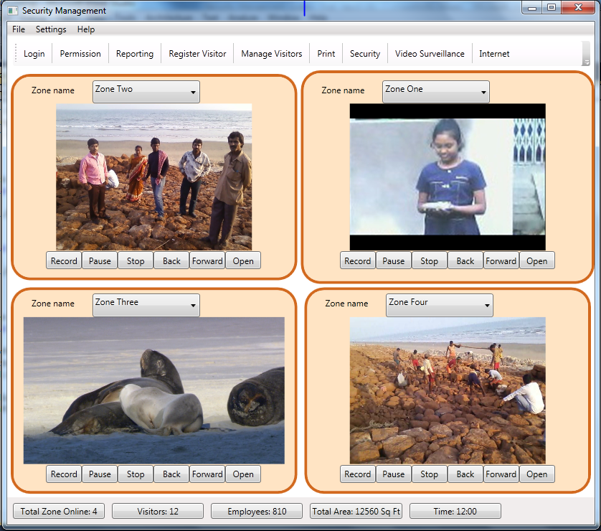

SECQURITY MEASYRES:

LIMITATION OF THE PROJECT:

Any Client/Industry:

E-Komfort Zone
Bamangachi Station Road,
P.O: Bamangachi, P.S: Barasat,
Dist: North 24 Pgs
West Bengal- 743706

Future Scope and Further enhancement of the Project:

To extend it for multiple organization with a centralized database.
To support UNIX / Linux, MAC OSX Operating systems.

BIBLOGRAPHY:

http://www.google.co.in
http://en.wikipedia.org
http://msdn.microsoft.com/en-us/
http://www.microsoft.com/en-us/default.aspx
http://www.codeplex.com/
http://stackoverflow.com/
http://www.codeguru.com/
http://www.w3schools.com

----------------------------- Thank You-------------------------

