Security Management System

Partha Sarkar

Table of Contents
1. Introduction & Objective of the Project: 4
2. Project Category: 5
3 Tools/Platform, Hardware and Software Specification 5
3.1 Hardware and Software Specification 5
3.1.1 Hardware Requirements 5
3.1.2 Hardware Requirements 6
3.2 Tools/Platforms used (Hardware/Software): 6
3.2.1 Hardware Used 6
3.2.2 Software Used 6
3 REQUIREMENTS AND ANALYSIS 6
4.1 Problem Definition 6
4.2 Requirements Specification 7
4.2.1 Functional Requirement 7
4.2.2 TechnicalSpecification 10
4.3 Planning and Scheduling 11
4.3.1 Gantt chart 11
4.3.2 Tracking Gantt 11
4.3.3 Pert Chart 12
5 Scope of the Solution 13
6 Analysis 13
6.1 Context Diagram 13
6.2 Data Flow Diagram 14
6.2.1 Level 0 DFD 14
6.2.2 Level 1 DFD 14
6.2.3 Level 2 DFD 16
6.3 E-R Diagram 17
6.4 Class Diagram 20
7 Database & Table Details 21
8 COMPLETE DATA STRUCTURE 21
8.1 Module Description 21
8.1.1 Security Management System GUI 22
8.1.2 Security Management System Engine 24
8.2 Security Management System Database 26
8.3 Estimation 26
8.4 Data Structure 28
8.5 Implementation Methodology 31
8.6 List of Reports 31
9 SECURITY MECHANISM 32
10 Future Scope and Further enhancement of the project: 32
11 BIBLIOGRAPHY 32

Introduction & Objective of the Project:

Security management system will provide a software solution for enhancing security measures in housing complexes, Apartments, companies and other organizations. Security is a foremost concern in every walk of our life. Every day lots of new and unknown people visits the organizations. We want to restrict some specific people from entering the premises and track the people entering and leaving the premises.
Now in most of the places paper book registers are used for tracking visitors. But it is not an efficient system. There are no proper ways of validating the data provided by visitor and searching a visitor’s entry history is a cumbersome job. Security management system will provide better ways validating visitor data and searching visitor’s previous entry history.
Security management system will track the security guards and other servants who enter premises for various reasons. Following diagram displays the users and coverage of the security management system.
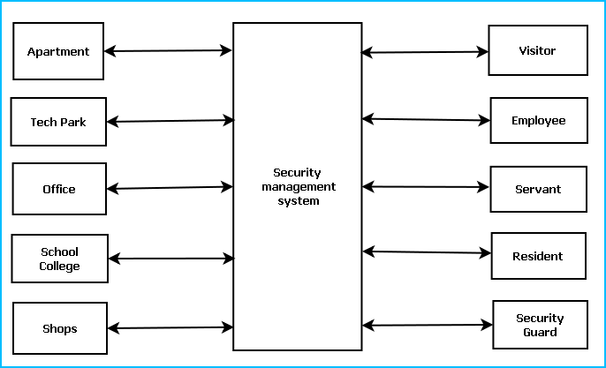
To ensure better security, Security Management System will provide the following features:
- Residents or employee information database
- Video Surveillance
- Photo identity card generation
- GPS Tracker
- In time and out time registry, Visitor Traffic and History
- Visitor tracking and contact person confirmation
- Distress calling system
- Emergency action System
- Do Not Disturb criteria
- Visitor time out alert
- Security Guard Management
- Security training & Tutorial

Project Category:
This software will follow Object Oriented Programming Paradigm and use below mentioned areas.
OOP Language: Php
RDBMS: MySQL 5.5.15
Networking: TCP/IP
Applications: Expert Systems

Tools/Platform, Hardware and Software Specification

Hardware and Software Specification

Hardware Requirements
- Computer that has a 1.6GHz or faster processor
- 1 GB (32 Bit) or 2 GB (64 Bit) RAM
- 10 MB of available hard disk space
- DVD-ROM Drive / USB Port
- Webcam
- GPS Trackers
- NFC Id Cards
- Security Cameras

Software Requirements
- Windows XP (x86) with Service Pack 3 / Windows Vista (x86 & x64) with Service Pack 2 / Windows 7 (x86 & x64)
- Microsoft .NET 4.0

Tools/Platforms used (Hardware/Software):

Hardware Used
- Laptop with 2GHZ processor
- 2 GB RAM
- 320 GB hard disk (NTFS File System)

Software Used
- Windows XP (x86) with Service Pack 3 / Windows Vista (x86) with Service Pack 2 / Windows 7 (x86)
- Microsoft .NET 4.0
- Windows Presentation Framework(WPF)
- Windows Communication Framework(WCF)
- Visual Studio 2010 Express Edition (IDE)
- MySQL Workbench
- Dia for Diagram Drawing & Modeling.

REQUIREMENTS AND ANALYSIS

Problem Definition

Now in most of the places paper book registers are used for tracking visitors. But it is not an efficient system. There are no proper ways of validating the data provided by visitor and searching a visitor’s entry history is a cumbersome job. Security management system will provide better ways validating visitor data and searching visitor’s previous entry history.
Security management system will track the security guards and other servants who enter premises for various reasons. The SMS will help us to avail following facilities:

- Security management system will provide a software solution for enhancing security measures in various organizations.
- System will facilitate to restrict some specific people from entering the premises and track the people entering and leaving the premises.
- It will enable inhabitants to implement a automatic security system by which a centralized system can keep track with trace passers.
- Security management system will track the security guards and other servants who enter premises for various reasons.
- Security management system will provide better ways for validating visitor data and searching visitor’s previous entry history which will replace cumbersome paper work with efficient computerized datasheets.

Requirements Specification

Functional Requirement

Add Visitor

Introduction:
Register a new visitor to a particular member.
Input:
Relevant visitor data like name, address, contact number, blood group, date of birth.
Processing:
Admin will enter the data in the SMS and create a new visitor entry.
Output:
The SMS will allow a visitor I for visit the member and generate a temporary identity card.

Add Member
Introduction:
Anew resident can register as a member of the security system.
Input:
Member will enter data like name, address, job profile, emergency contact details.
Processing:
The SMS will check for availability and create the registration confirmation.
Output:
The SMS will generate a permanent ID for future reference.

Search member
Introduction:
Anyone can search for member.
Input:
He will enter data like name, job profile.
Processing:
The SMS will search for the requirement.
Output:
The SMS will display the search result.

Make an appointment with a member
Introduction:
A visitor can ask for an appointment with an existing member and member will confirm the appointment with an admin approval.
Input:
Admin will enter the name, time and duration of appointment, address and details of visitor etc. data in the SMS.
Processing:
The SMS will create a new appointment with a member approval and entry details to the scheduler.
Output:
The SMS will generate the appointment approval to the visitor and appointment details.

Create an Preference
Introduction:
A preference is meant for alerting security guards on specific emergency situations or to notify members about some information. It also restrict availability of a member.
Input:
Admin will enter the Event name, venue, requirements, availability of a member and date etc. data in the SMS.
Processing:
The SMS will create a new event entry.
Output:
The SMS will generate preference ID and details.

Distress calling
Introduction:
SMS will facilitate distress calling functionality to the members when they are in critical situations.
Input:
Member will initiate a request for help.
Processing:
SMS will receive and accept the request and check the privilege of the member. It will search for the available resources for taking action
Output:
SMS will send the securities to help and resolve the issue.

Emergency action
Introduction:
SMS will facilitate emergency action functionality to the members when they are in problem.
Input:
Member will initiate a request for help.
Processing:
SMS will receive and accept the request and check the privilege of the member. It will search for the available resources for taking action
Output:
SMS will send the securities to help and resolve the issue.

TechnicalSpecification
Front End/ GUI Tools: Windows Presentation Framework (WPF)
IDE: Visual Studio 2010
Framework:Microsoft .NET 4.0
Database:MySQL
Database Tool: MySQL workbench CE
Operating Systems: Windows XP, Windows 7
Cloud Technology: Google Drive, Google forms

Planning and Scheduling

Gantt chart
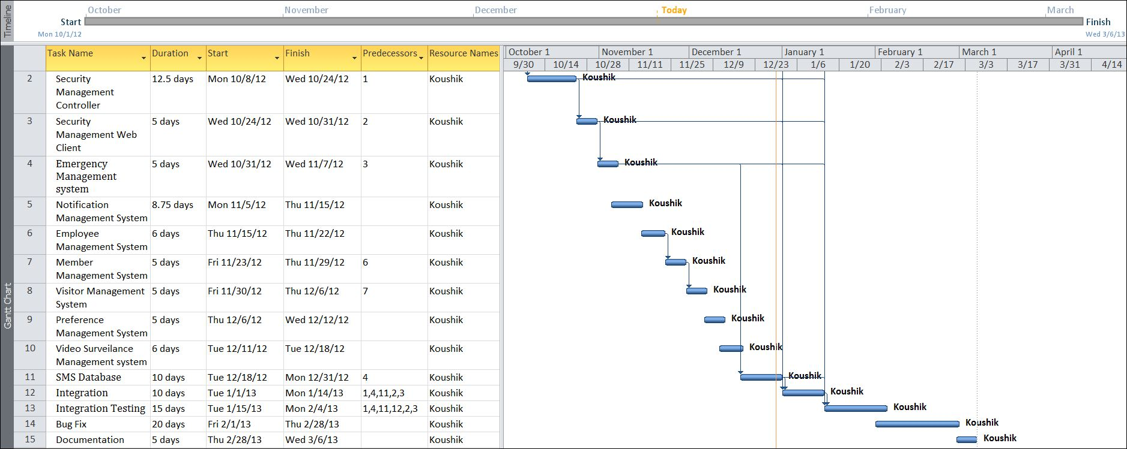

Tracking Gantt
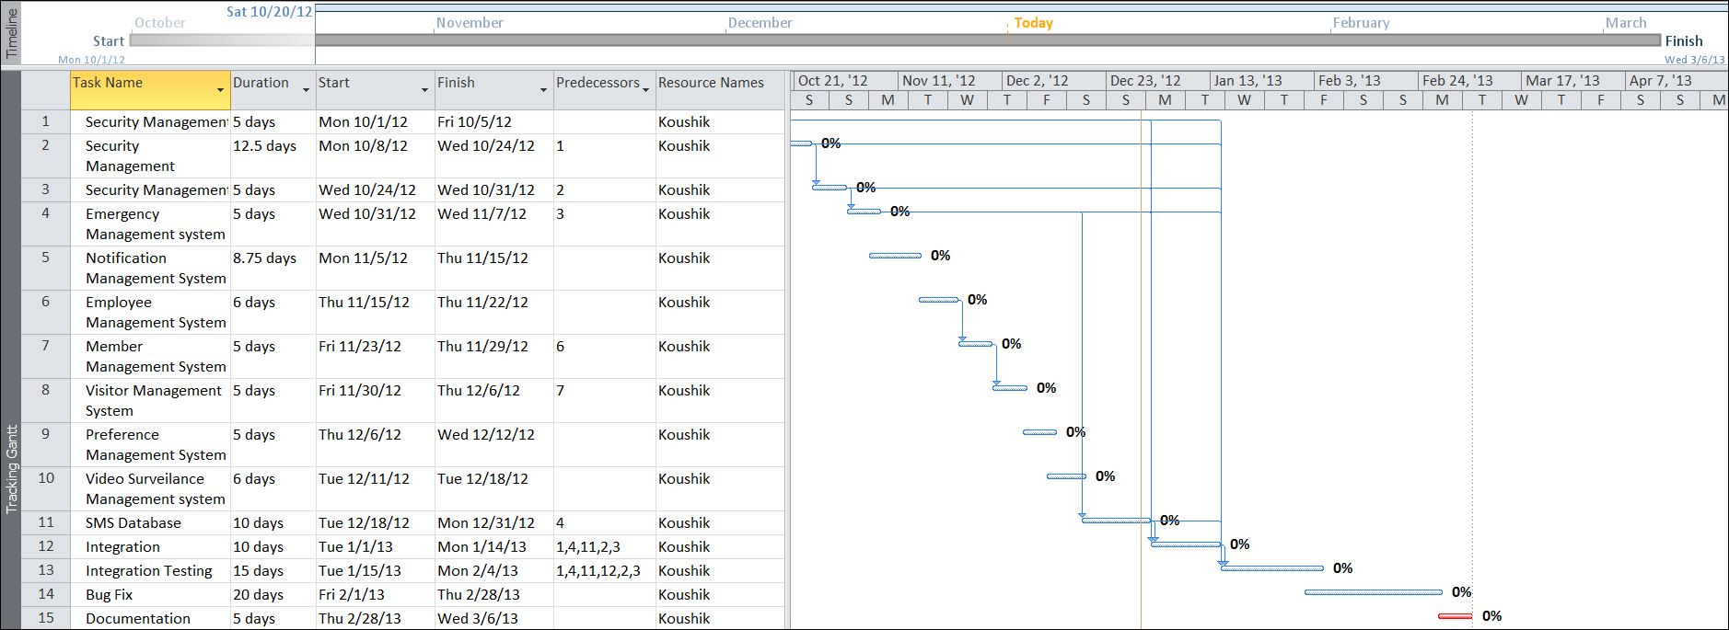

Pert Chart
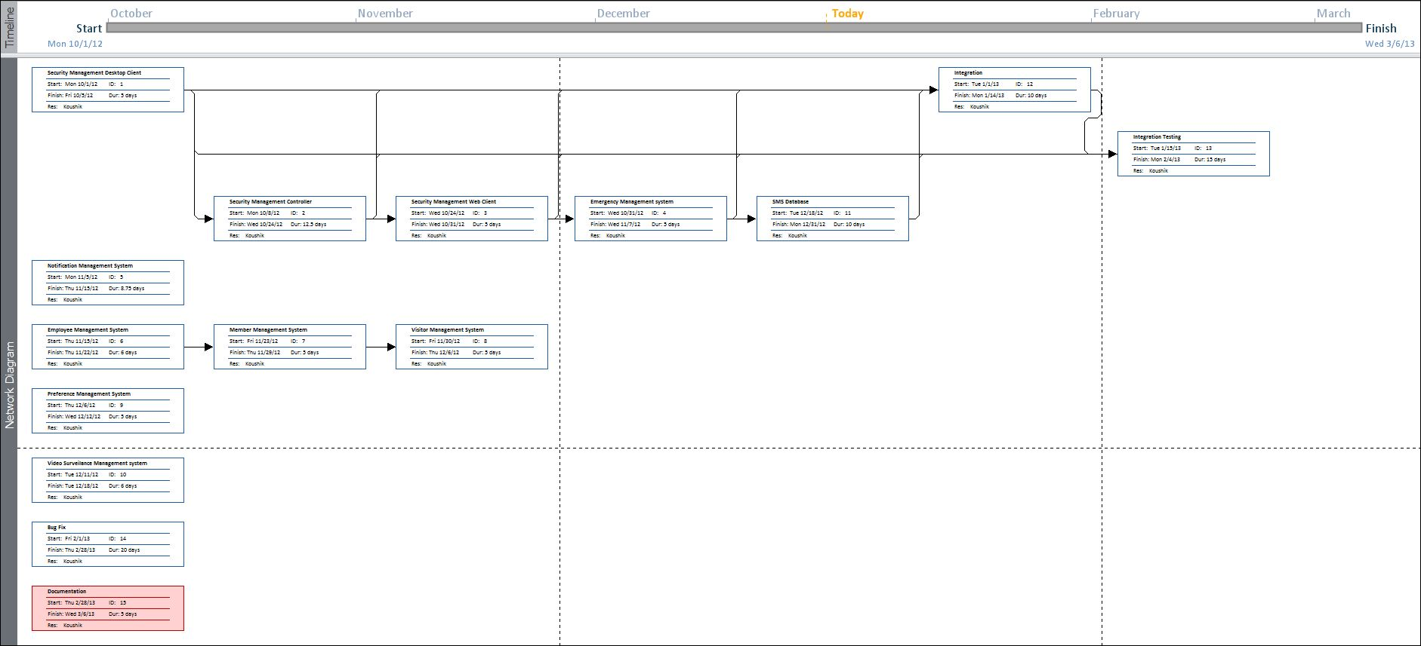

Scope of the Solution
Currently this software is aimed for a single school management. It can be extended to support networked multiple school and have a centralized database and to serve wider range of students of different branches of same School around the country.
We have developed this for Desktop Computers running on Windows Operating System. It can be enhanced to support UNIX / Linux, MAC OSX Operating systems.
Our software will not be integrated with Mobile Application right now. But in future we can easily extend to support that.

Analysis

Context Diagram
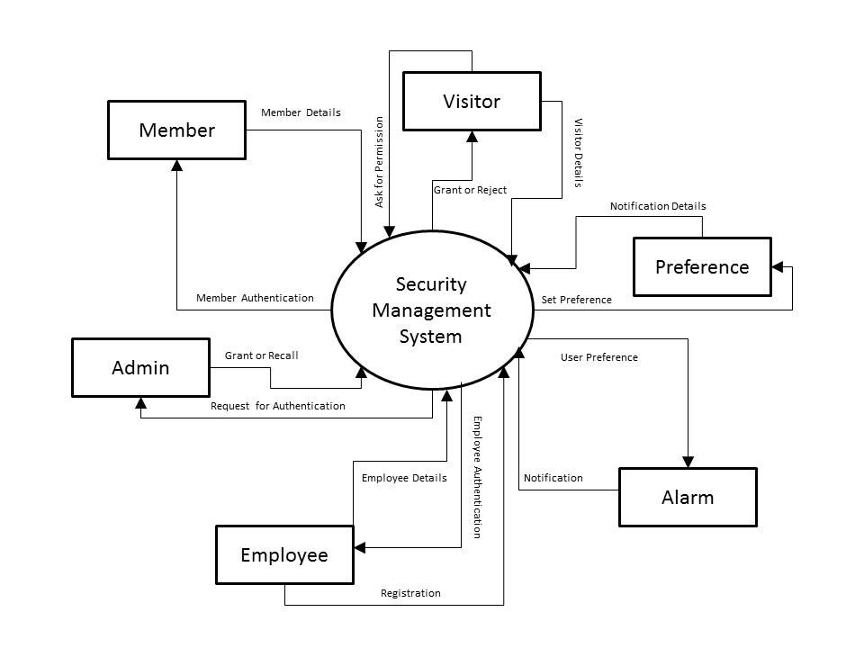
Figure 1: Context level diagram of SMS

Data Flow Diagram

Level 0 DFD
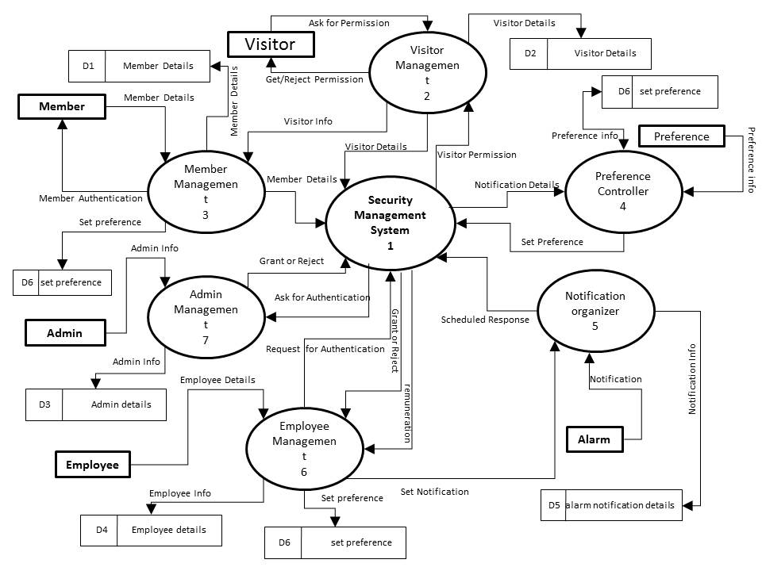
Figure 2: DFD level 0 of SMS

Level 1 DFD
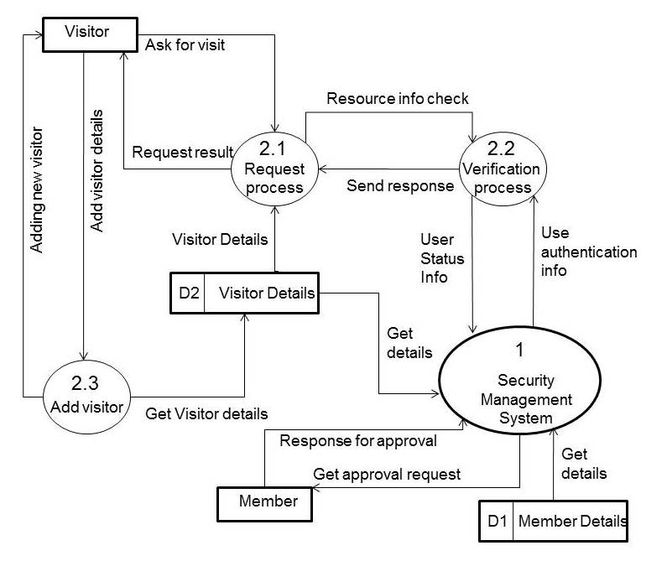
Figure 3: DFD level 1 of SMS
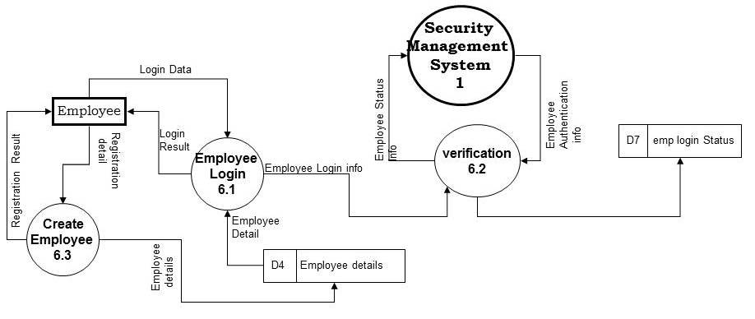
Figure 4: DFD level 1 of SMS
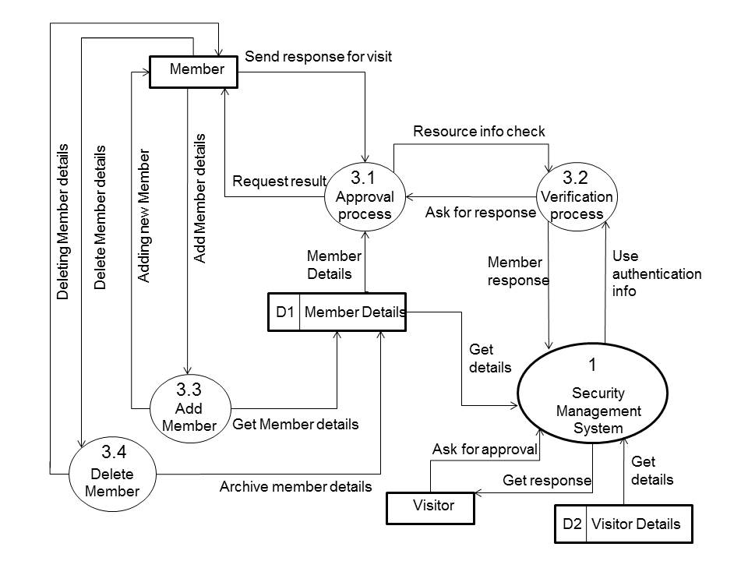
Figure 5: DFD level 1 of SMS

Level 2 DFD
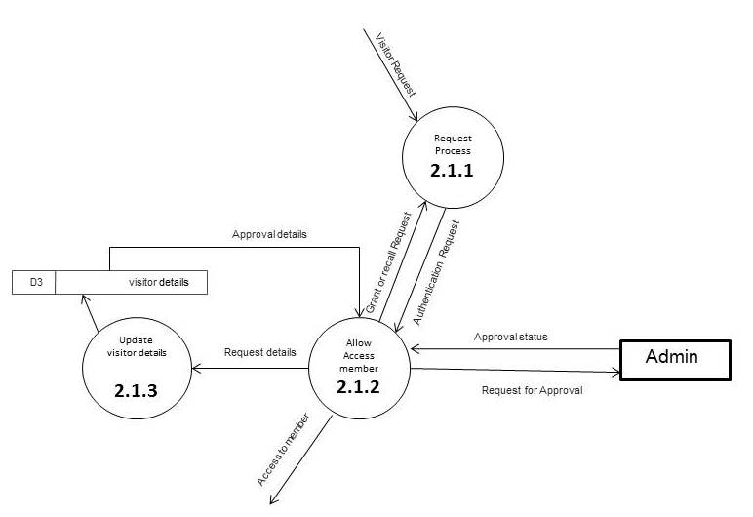
Figure 6: DFD level 2 of SMS

E-R Diagram
We will design a RDBMS for File Management System. The entities and their attributes are listed below. Attributes in Bold letter is the unique key.
Entities | Attributes
Visitor | Visitor Id, Name, Address , Contact Number
Visit Request | Request Id, type, purpose, time, duration, member id
Security Management System | Organization Id , Name, Address, Total member
Employee | Employee Id, Name, Admin Right
Member | Member Id, Name, address, contact number, emergency contact number
Member Preference | Preference Id, Type, Description

Relationship between Entities:
- Security Management System has Members→ 1 : N
- Security Management System has Visitors→ 1 : N
- Security Management System has Employees→ 1 : N
- Visitor does Requests → 1 : N
- Security Management System serves Requests → 1 : N
- Members provides Preferences → M : N

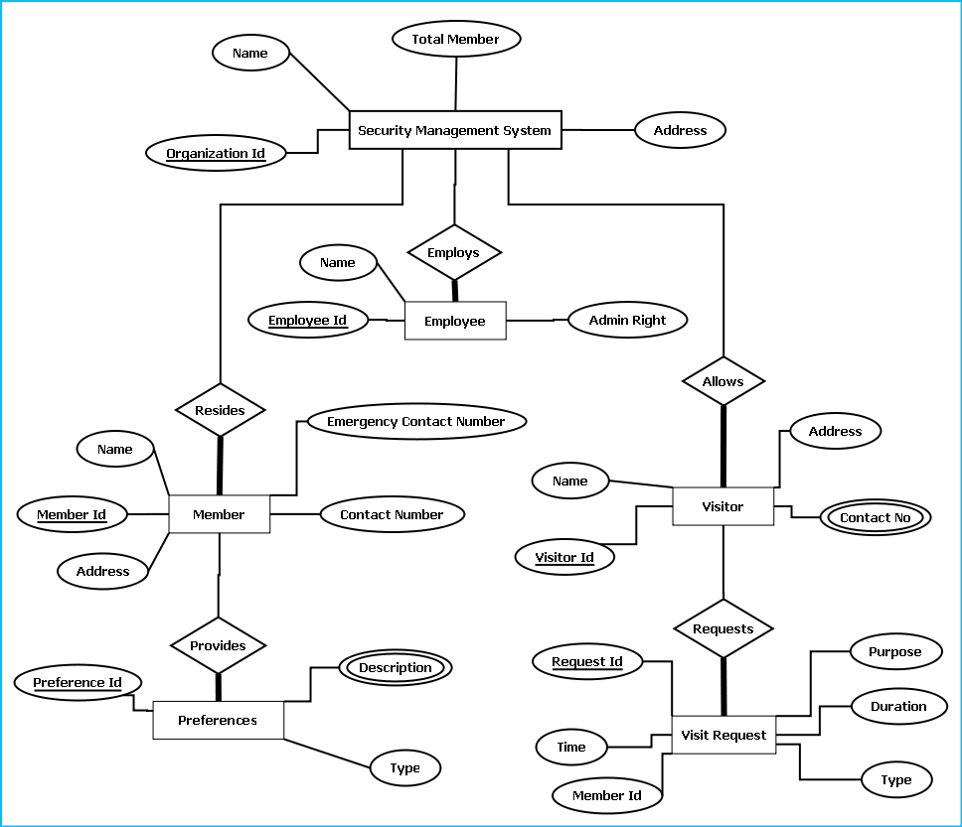

E-R Diagram of Security Management System

Class Diagram
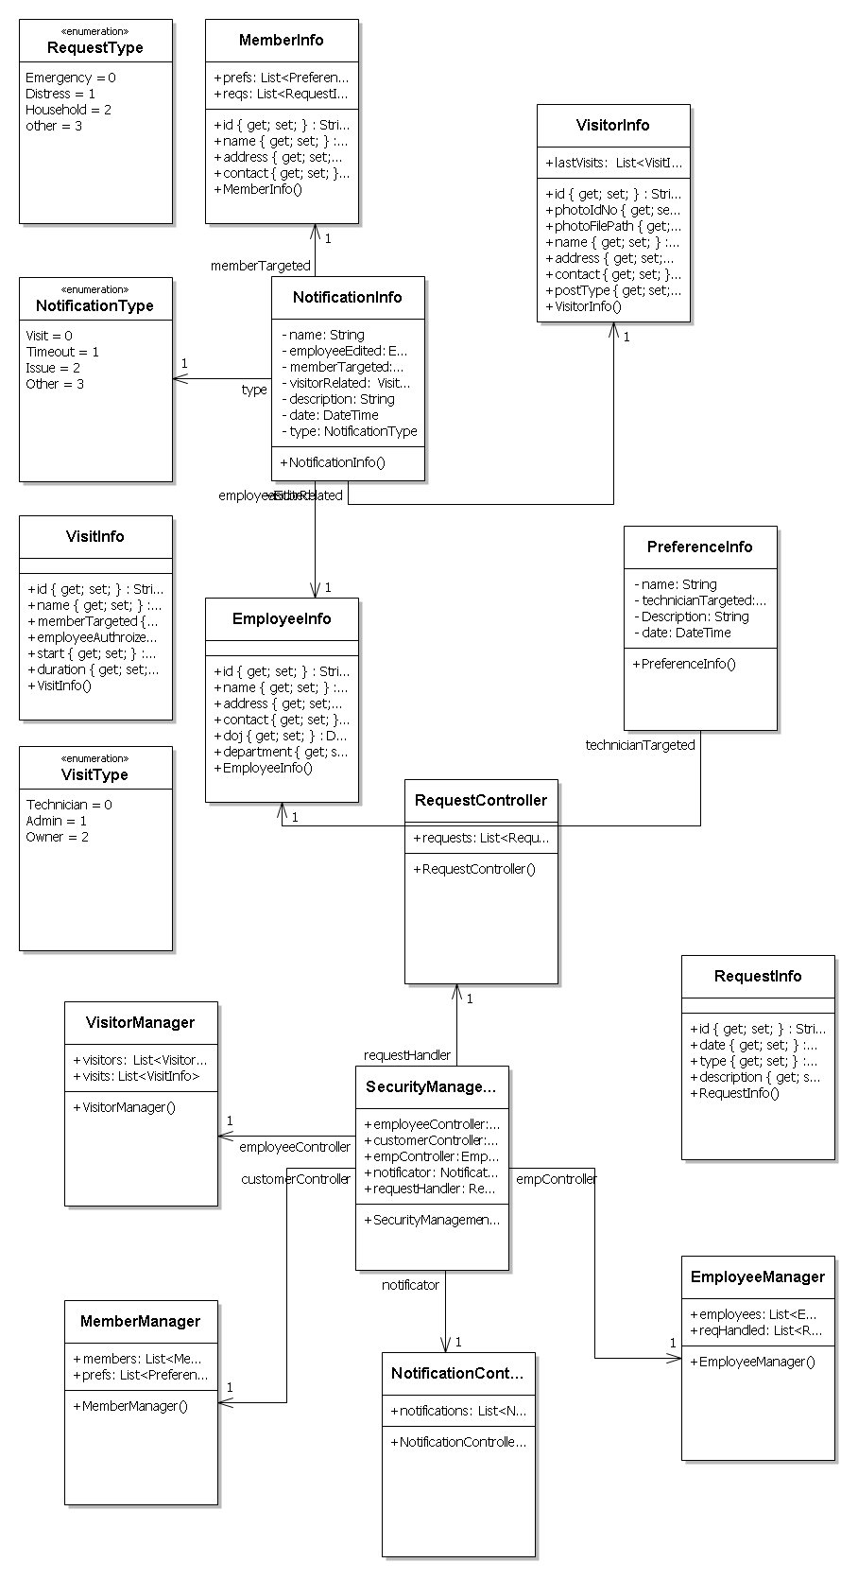

Database & Table Details
The database used for this software is called SMSdb. Database tables and corresponding keys are shown in tabular form. It shows the tables and its columns. A key in Bold is the primary key.
Tables | Keys
Visitor | Visitor Id, Name, Address , Contact Number
Visit Request | Request Id, type, purpose, time, duration, member id
Security Management System | Organization Id , Name, Address, Total member
Employee | Employee Id, Name, Admin Right
Member | Member Id, Name, address, contact number, emergency contact number
Member Preference | Preference Id, Type, Description

COMPLETE DATA STRUCTURE

Module Description
Security Management System will enhance the security of apartments, offices, schools and business centers by providing an efficient system for tracking incoming & outgoing traffic.

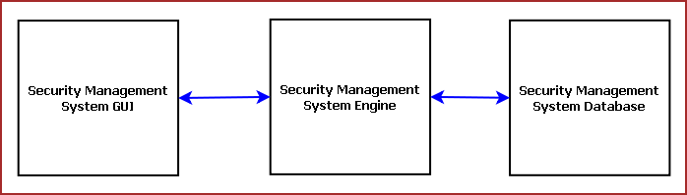
Figure: Components of Security Management System

Security Management System is divided into three main components. Such as:
- Security Management System GUI
- Security Management System Engine
- Security Management System Database

8.1.1 Security Management System GUI
Security Management System GUI will display existing user data, log visitor data, generate ID card. It is divided into eight modules. Such as:
- Visitor Register
- Member Registration
- Member Database Browser
- Employee Management
- Security Training
- Video Surveillance Window
- Alarm System
- Emergency Handler

Visitor Register
Visitor Register allows tracking visitors. It provides an interface to enter visitor details, purpose of visit, tentative time of stay, contact person. It will take the photograph of visitor and generate a photo ID card. The earlier visit histories can be browsed and it will suggest whether the visitor was blocked earlier in this organization.

Member Registration
This module provides an interface for registering the members of the organization, residents of the apartment etc. This data helps validate the visitor provided inputs. Security management system will contact the member before allowing the access. If the visitor stays more than specified time limit then Security management system will enquire the reason.

Member Database Browser
Member Database Browser will provide information about the existing members of the organization and their contact information. It will help validating visitor data and handling emergency situations.

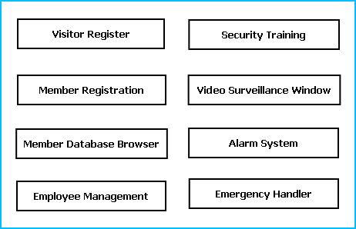
Figure: GUI Components

Employee Management
This module will manage the employees responsible for security operations. It will keep track of employee attendance, duty hours, customer support quality and feedbacks.

Security Training
This module is responsible for making the employees and members aware about security guidelines and actions to be taken on emergency situations. It will provide guideline booklet, presentation & video tutorials.

Video Surveillance Window
Video Surveillance window displays the video of the area where the security cameras are installed. It can record the video for a specified time limit.

Alarm System
Alarm system is meant for alerting security guards on specific emergency situations or to notify members about some information. All the major locations will have sound system installed and the roaming security guards also carry wireless devices.

Emergency Handler
Emergency Handler takes appropriate actions on emergency situations. It will notify police, medical services or fire fighter depending on the emergency situations. It will can enable/ disable some services like lift service or power supply depending on the need.

Security Management System Engine
Security Management Engine controls the overall system. It provides logical and tactical solutions for managing the whole system. The Security Management System is divided into 12 divided modular components. Such as:

- Engine controller | - Employee Controller
- GUI Interactor | - Alarm Controller
- Database Controller | - Data Entry Controller
- Photo & Video Surveillance Controller | - Training Controller
- Visitor Controller | - Search Engine
- Member Controller | - Emergency Controller

Engine controller:
This controls the overall interaction between all the backend modules. It schedules the priority of the actions in case of overlapping.

GUI Interactor:
It interacts with the GUI and polls GUI calls. It exposes APIs and events for GUI to use. GUI Interactor helps Engine to maintain wrapper around the Engine modules so that the GUI can be ported to any other framework without much changes in Engine code.

Database Controller:
It controls the database interactions. It forms query to fetch information from the database. It also sends data to be saved in database for future use.

Photo & Video Surveillance Controller:
This module processes the images and videos taken while surveillance and exposes APIs for viewing and Playing back. It also archives the video and images to save space.

Visitor Controller:
It keeps track of visitor information. It has an algorithm for maintaining Visitor history and rating the visitor’s trustworthiness. Visitor controller will trigger alarm if it senses any mismatch in visitor provided data.

Member Controller:
It saves information about the members of the organization. It validates the Visitor data and takes confirmation from the member to allow the visitor inside. Members can set DO NOT DISTURB mode, Preferred Visiting Time & Preferred visitors. It controls access to information of the members depending on the admin right of the user.

Employee Controller:
It controls the employee attendance, employee information and duty hours & duty locations. It can generate monthly reports on employee details to provide it to the security agencies for performance evaluation.

Alarm Controller:
Alarm controller manages the alert messages to be passed among Security Guards and Members. The situations when the alarm system will work are mentioned below:
- If the visitor has exceeded the specific time limit the alarm will alert
- If the ID card has GPS tracker and visitor has entered the restricted area it will alert the security guards in their wireless device.
- If any member ask for emergency help.
- To alert the members about some declaration.

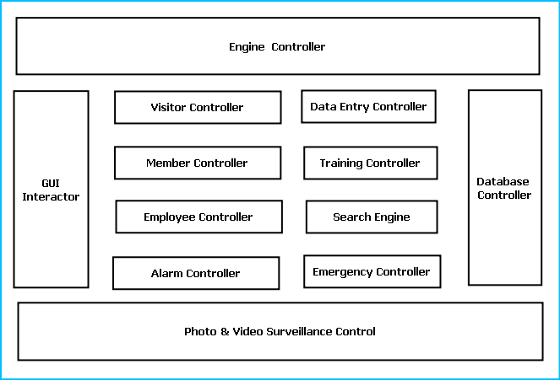
Figure: Components of Engine

Data Entry Controller:
It controls the data entered and passed to the engine. It validates the data depending on predefined inputs. If validation is failed it generates warning messages.

Training Controller:
This module provides the contents for Security Training and awareness campaigns. It provides audio visual output display to view them. It also allows printing security info flyers and booklets.

Search Engine:
Search engine enables rapid and efficient searching of data about visitors, employees and members. Search Engine prepares search indexes depending most accessed data. It improves the efficiency and performance of the software.

Emergency Controller:
Emergency controller provides the algorithm for action to be taken on emergency situations. It will store emergency contacts, police station, hospital, ambulance & fire fighter contact number. And it will alert them via call, sms and email during emergency situations. It will also include intelligence to enable & disable critical services like opening exit doors, stopping lift services, shutting down power supply or starting emergency power backups.

Security Management System Database
Security Management System will maintain a medium sized centralized database for storing information. We will design a RDBMS to manage the database and engine interaction. It will have optimized design and archive older data to save space and increase performance.

Estimation
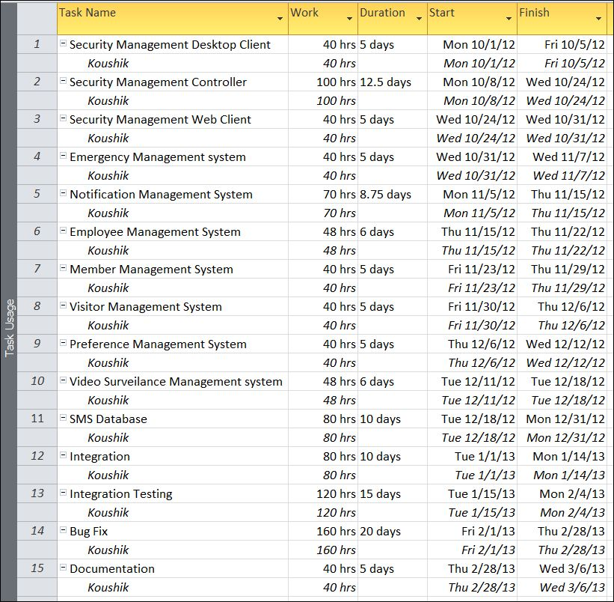

Data Structure

MemberInfo
public class MemberInfo
{
public string id { get; set; }
public string name { get; set; }
public string address { get; set; }
public string contact { get; set; }
public List<PreferenceInfo> prefs;
public List<RequestInfo> reqs;
}

EmployeeInfo
public class EmployeeInfo
{
public string id { get; set; }
public string name { get; set; }
public string address { get; set; }
public string contact { get; set; }
public DateTime doj { get; set; }
public string department { get; set; }
}

VisitorInfo
public class VisitorInfo
{
public string id { get; set; }
public string photoIdNo { get; set; }
public string photoFilePath { get; set; }
public string name { get; set; }
public string address { get; set; }
public string contact { get; set; }
public VisitType postType { get; set; }
public List<VisitInfo> lastVisits;
}

VisitInfo
public class VisitInfo
{
public string id { get; set; }
public string name { get; set; }
public MemberInfo memberTargeted { get; set; }
public EmployeeInfo employeeAuthroized { get; set; }
public DateTime start { get; set; }
public DateTime duration { get; set; }
}

PreferenceInfo
public class PreferenceInfo
{
string name;
EmployeeInfo technicianTargeted;
string Description;
DateTime date;
}

NotificationType
public enum NotificationType
{
Visit,
Timeout,
Issue,
Other
}

NotificationInfo
public class NotificationInfo
{
string name;
EmployeeInfo employeeEdited;
MemberInfo memberTargeted;
VisitorInfo visitorRelated;
string description;
DateTime date;
NotificationType type;
}

RequestType
public enum RequestType
{
Emergency,
Distress,
Household,
other
}

RequestInfo
public class RequestInfo
{
public string id { get; set; }
public DateTime date { get; set; }
public RequestType type { get; set; }
public string description { get; set; }
}

SecurityManagementController
public class SecurityManagementController
{
public VisitorManager employeeController;
public MemberManager customerController;
public EmployeeManager empController;
public NotificationController notificator;
public RequestController requestHandler;

}

EmployeeManager
public class EmployeeManager
{
public List<EmployeeInfo> employees;
public List<RequestInfo> reqHandled;
}

MemberManager
public class MemberManager
{
public List<MemberInfo> members;
public List<PreferenceInfo> prefs;
}

VisitorManager
public class VisitorManager
{
public List<VisitorInfo> visitors;
public List<VisitInfo> visits;
}

NotificationController
public class NotificationController
{
public List<NotificationInfo> notifications;
}

RequestController
public class RequestController
{
public List<RequestInfo> requests;
}

VisitType
public enum VisitType
{
Technician,
Admin,
Owner
}

Implementation Methodology
- Object Oriented Programming methodology will be adopted
- User interface development will be done in MVC architecture using Windows Presentation Framework.
- Relational DBMS MySQL will be used to implement & execute SQL query to database.
- Agile Software Development model will be used while developing this software.

List of Reports

List of reports that are likely to be generated in this software are given below:

- Every visitor will be given a temporary identity number as a token of authentication to entry.
- List of visitor can be generated
- List of member who have visitors can be generated
- List of members can be generated
- List of on duty securities can be generated
- List of preference can be generated
- Details of scheduled notification can be generated

SECURITY MECHANISM
- Security Management System is password protected software. It will be developed such a way that the admin will have complete control on the member’s data.
- Admin can create account with various permission levels, like member, visitor, employee admin etc. so that the users have access to relevant data only.
- The contacts details of the members will be stored in the database with an encrypted format so even if someone hacks the database somehow still he can make no real harm.
- The software will provide a backup and restore feature in case of loss of data.

Future Scope and Further enhancement of the project:
    - To extend it for multiple organization with a centralized database.
    - To support UNIX / Linux, MAC OSX Operating systems.

BIBLIOGRAPHY
- http://en.wikipedia.org
- http://msdn.microsoft.com/en-us/
- http://www.microsoft.com/en-us/default.aspx
- http://www.codeplex.com/
- http://stackoverflow.com/
- http://www.codeguru.com/
- http://www.w3schools.com
- www.mysql.org
- School Professionals

