Project Synopsis
Shopping mall Management System
MCA 6th Semester MCSP-060
SAYED ARIFUR RAHMAN
Enrollment No:105057693

Table of Contents
Introduction & Objective of the Project: 5
Introduction 5
Objective 5
Project Category: 6
Project Structure: 6
Tools/Platforms used (Hardware/Software): 6
Hardware: 6
Software: 6
REQUIREMENTS AND ANALYSIS 7
Problem Definition. 7
Requirements Specification 7
Functional Requirements 7
Enter new Shop information 7
Introduction 7
Input 7
Processing 7
Output 7
Enter new Product information 8
Introduction 8
Input 8
Processing 8
Output 8
Send feedback about experience in shopping mall 8
Introduction 8
Input 8
Processing 8
Output 8
Changing Password and Username 8
Introduction 8
Input 8
Processing 8
Output 9
Show Shop Details 9
Introduction 9
Input 9
Processing 9
Output 9
Show Product Details 9
Introduction 9
Input 9
Processing 9
Output 9
Show Contact US Details 9
Introduction 9
Input 9
Processing 10
Output 10
Sorting of information 10
Introduction 10
Input 10
Processing 10
Output 10
Searching of information 10
Introduction 10
Input 10
Processing 10
Output 10
Web sync 10
Introduction 10
Input 11
Processing 11
Output 11
Send feedback about in website 11
Introduction 11
Input 11
Processing 11
Output 11
Give rating 11
Introduction 11
Input 11
Processing 11
Output 11
Nonfunctional Requirements 12
Technical Specification 12
Planning and Scheduling 13
Gantt chart 13
Tracking Gantt 13
Pert Chart 14
Scope of the Solution 14
Analysis 14
Context Diagram 15
1st-Level DFD 15
2nd-Level DFD ORDER PROCESS 15
ENTITY RELATIONSHIP MODEL 16
Class Diagram 17
Database & Table Details 18
Complete Structure 18
Module Description 18
SYSTEM DESIGN 18
MODULARISATION DETAILS 18
SHOPPING mall UI 19
SHOPPING Mall data 19
SHOPPING Mall db 19
Website UI 19
SHOPPING Mall web data 19
Data Structure 20
Implementation Methodology 21
List of Reports 21
Implementation of Security Mechanism at Various Levels 22
Future Scope and Further enhancement of the project: 22
Bibliography 22
Websites 22
Books 23

Introduction & Objective of the Project:

Introduction

Rapid advancement of both Information Technology & Civil Engineering has taken the urban life style of our country to another level. Huge flats are replacing small huts and large malls and multiplexes are eliminating small, medium and even large stationary shops. Even the common people are now going for shopping to the big huge shopping malls. Most of us often find it confusing to understand what or which things are available in these places as these places contain uncountable shops selling uncountable products. So, obviously it is the modern technology again that could eliminate these sorts of problems.
We could easily use latest software and technologies available in the world to provide a proper guideline to the visitors. May be an application containing all the information about the shops and products available in the shopping mall could to the trick. We could develop something that would easily let a visitor find whatever he is looking for in the mall, from a single place and a website for gathering all the information about all shopping mall including its product and shop.

Objective

Shopping mall Management System is a versatile and complete end-to-end shopping management software which provides user friendly interface to browse the information about available products along with the shop locations. Also the corresponding website provides the related information globally. Following are the objectives of this application:
- Provide complete details of the shopping mall.
- Provide complete details of the shops of the shopping mall & its locations in the shopping mall.
- Details of the products available in the shopping mall.
- User review and rating of shops, products and prices.
- Search for a shop or a product.
- Search for the location(s) where a particular product is available.
- Website provides all the shopping mall related information.
- Via website gather customer review and rating from everywhere.
- Last but not least, provide overall rating and review/experience for other customers.

Project Category:
This software will follow Object Oriented Programming Paradigm and use below mentioned areas.
Front End/ GUI Tools | : | WPF
Backend | : | MySQL 5.5.15
Internet Technologies | : | HTML, JavaScript, PHP, WordPress, CSS, Bootstrap
Operating Systems | : | Windows XP, Windows 7
Applications | : | PC Utility application, Web Application

Project Structure:

Tools/Platforms used (Hardware/Software):

Hardware:
- Laptop with 2GHZ processor
- 2 GB RAM
- 320 GB hard disk (NTFS File System)
- 8 GB USB Pen Drive (FAT File System)

Software:
- Windows XP (x86) with Service Pack 3 / Windows Vista (x86) with Service Pack 2 / Windows 7 (x86)
- Microsoft .NET 4.5
- Windows Presentation Framework(WPF)
- Visual Studio 2010 Express Edition (IDE)
- MySQL database
- NetBeans IDE 7.3
- WampServer
- Github
- Dia for Diagram Drawing & Modeling.

REQUIREMENTS AND ANALYSIS

Problem Definition.
Currently, People are very keen to know about the electronics’ gadgets and hence for purchasing too. So, due to improper guidelines they are unable to purchase those items and face following problems in the current system:
- With an increase in number of customers, it is difficult to maintain their details manually.
- There is often delay in updating any changes of charges or any description.
- Customers are feeling reluctant to have viewing in such time consuming process.
- Sometimes trusted website is hard to find for authentic information related to shopping mall or product.
- With an increase in number of shopping mall and resources, it is also difficult to find out optimum product according to customers requirement
- Sometimes finding out the location of the shop where the desired product is available is also become difficult.
The Shopping Mall Management System aims to automate online shopping system and accumulate several shopping information in order to resolve above mentioned problems.

Requirements Specification

Functional Requirements

Enter new Shop information

Introduction
A person with proper authority (a person from the shopping mall admin) can enter details of a shop that is located in the shopping mall.

Input
Relevant shop data like name, category, description and floor are written in the text fields.

Processing
Details provided by the admin are stored in MySQL database along with an auto generated id.

Output
Visitors can see shop details from the application.

Enter new Product information

Introduction
A person with proper authority (a person from the shopping mall admin) can enter details of a product that is available in a shop.

Input
Relevant product data like product name, brand, category, description are written in enter product details window.

Processing
Details provided by the admin are stored in MySQL database along with a auto generated id.

Output
Visitors can see shop details from the shop details window.

Send feedback about experience in shopping mall

Introduction
Customer can send their feedback about their experience in shopping mall

Input
Customers write down experience in the feedback window and click on send button.

Processing
The data provided by the customers are stored in the corresponding table at the database.

Output
The details can be seen by other customers in that particular product details.

Changing Password and Username

Introduction
Admin will be able to change existing username and password

Input
New username and password along with the old password are provided.

Processing
Old username and password will be replaced by user provided new username and password after authenticating.

Output
Password and Username can be changed according to the higher authority requirement whenever they want to change for better security of the System.

Show Shop Details

Introduction
Every shop details are available for customers.

Input
Customers click on show shop details button.

Processing
All details of a shop along with rating and review are fetched from database.

Output
All the details are shown to the customer in a list view.

Show Product Details

Introduction
Details of each product are available and customer can also view new product that are available in market

Input
A customer clicks on product details window.

Processing
All the details of products are fetched from database along with user rating and reviews.

Output
Customer can see product details

Show Contact US Details

Introduction
Every customer details are stored in database at the time of complain.

Input
Date, name, address, mobile no, email id, type, complain/feedback of customer at complain area.

Processing
The data provided by the customers are stored in the corresponding table at the database.

Output
Each customer’s feedback or complain are viewed by other customer.

Sorting of information

Introduction
A user should be able to sort the information provided in the list view.

Input
A user clicks on the top of a particular column.

Processing
The application sorts the items according to the data type.

Output
The user can see all the data sorted alphabetically or numerically according to the data type.

Searching of information

Introduction
A user should be able to search a particular item inside the list view

Input
A user writes some product/shop name in the provided text fields and press search.

Processing
Application searches the information inside the database’s particular table.

Output
All the available result that matches the name of the text provided in the text field are shown in the list view.

Web sync

Introduction
Web sync helps to share local data from local computer to web server.

Input
Admin click on web sync button.

Processing
All details of shopping mall, shop, product along with rating and review are synced to web from local database.

Output
All the details are shown to the customer in the web site.

Send feedback about in website

Introduction
Customer can send their feedback about their experience in shopping mall via website

Input
Customers write down experience in the feedback window and click on submit button.

Processing
The data provided by the customers are stored in the web server.

Output
The details can be seen by other customers globally in website.

Give rating

Introduction
Customer can put their rating related to shopping mall, shop, product etc.

Input
Customers put rating via web site.

Processing
The rating data provided by the user are stored in the corresponding table at the database.

Output
The rating can be seen by other customers via web site.

Nonfunctional Requirements
- The software must have a guideline for a shopping mall that help user to shop from it.
- User can give feedback about their experience by which the administrative department of the shopping mall can overcome their drawbacks
- The software should be password protected to secure confidential data.
- The application must be fast and flexible so that it reduces the time to get information.
- There must be a backup and restore feature so that the valuable data stays secure forever.
- The website must be light weight and must be load very fast.

Technical Specification

Front End/ GUI Tools | : | Windows Presentation Framework (WPF)
IDE | : | Visual Studio 2010
Framework | : | Microsoft .NET 4.0
Database | : | MySQL
Database Tool | : | MySQL workbench CE
Internet Technologies | : | HTML, JavaScript, PHP, WordPress, CSS, Bootstrap
Local Server | : | Wamp Server
Operating Systems | : | Windows XP, Windows 7
Others | : | MySQL .NET connector

Planning and Scheduling

Gantt chart
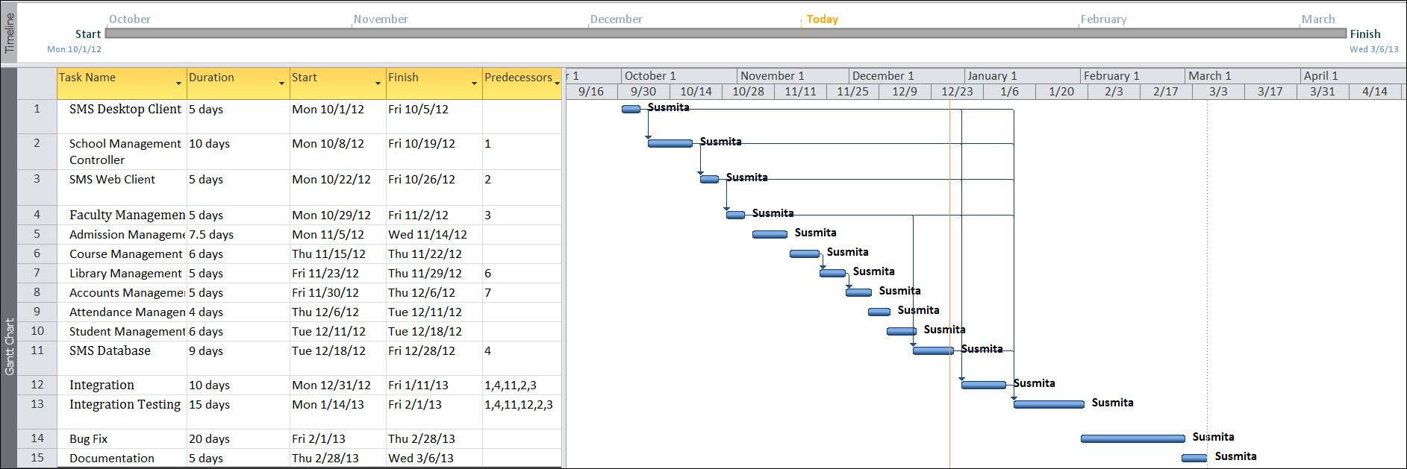

Tracking Gantt
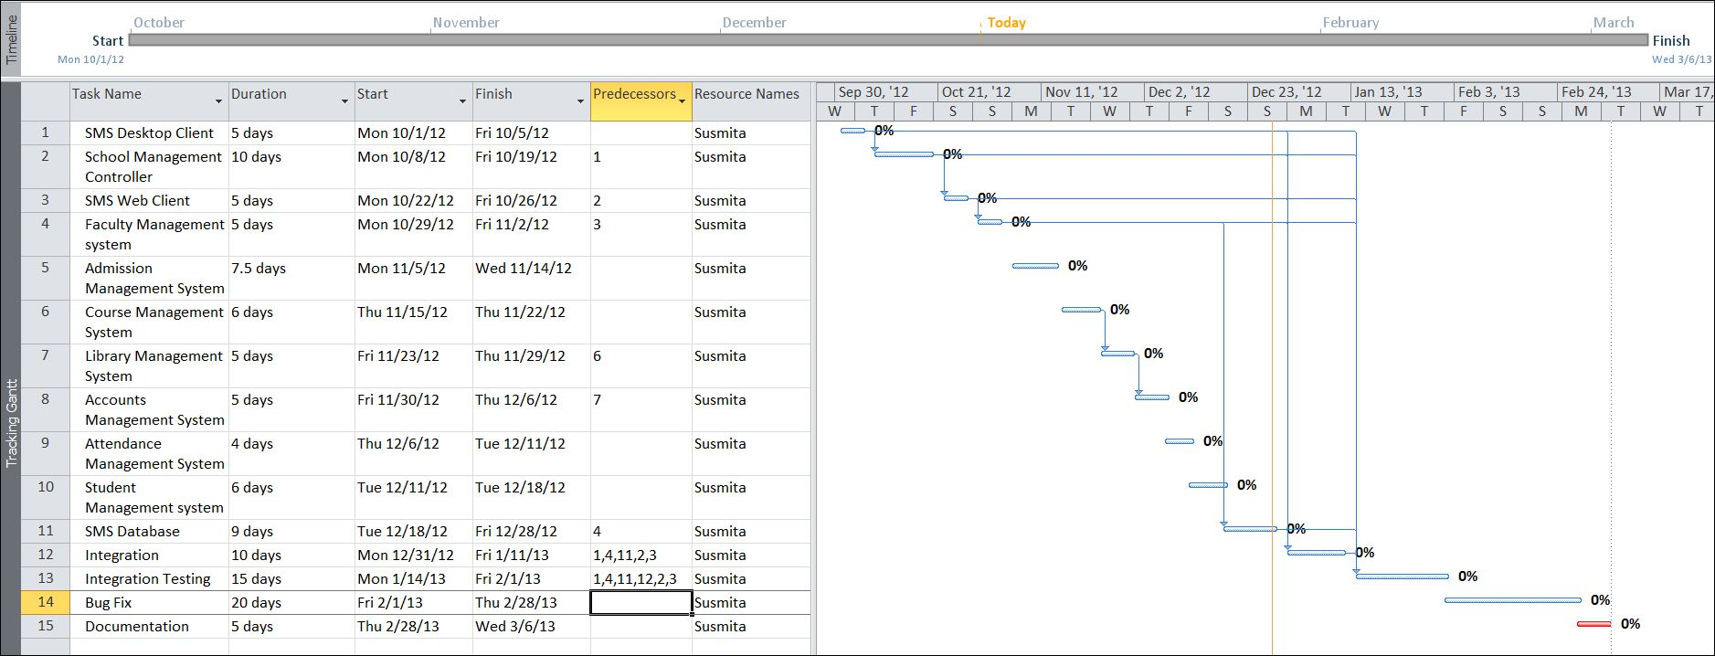

Pert Chart
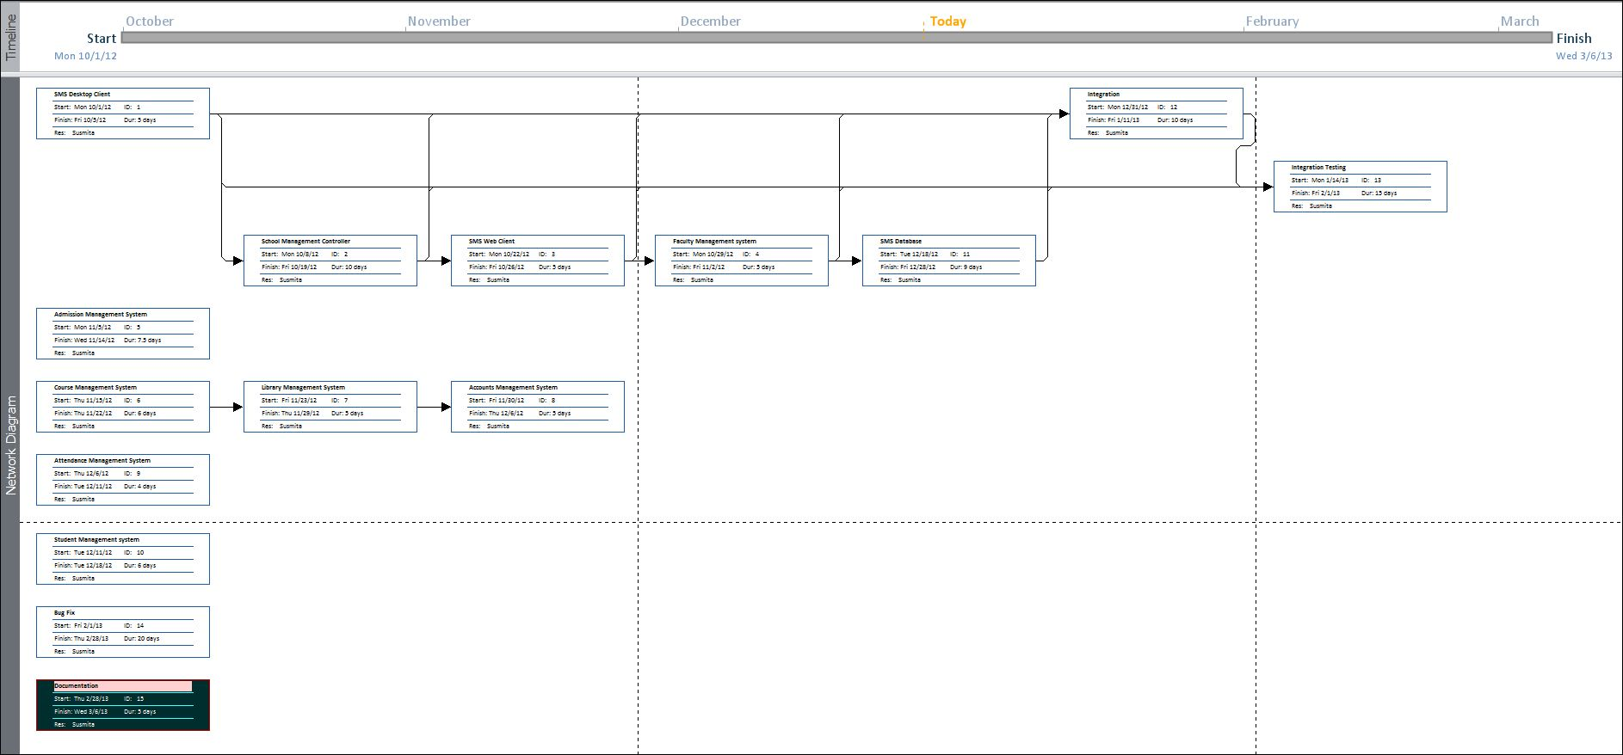

Scope of the Solution

Shopping mall Management System allows user to share their experience, rating, feedback etc. related to shopping mall, product, shop etc. via websites and offline computer. It allows user to get details globally from website and the shopping mall kiosk. User can get proper feedback or information about shopping mall, product or shop from website buddies.

Analysis

Context Diagram
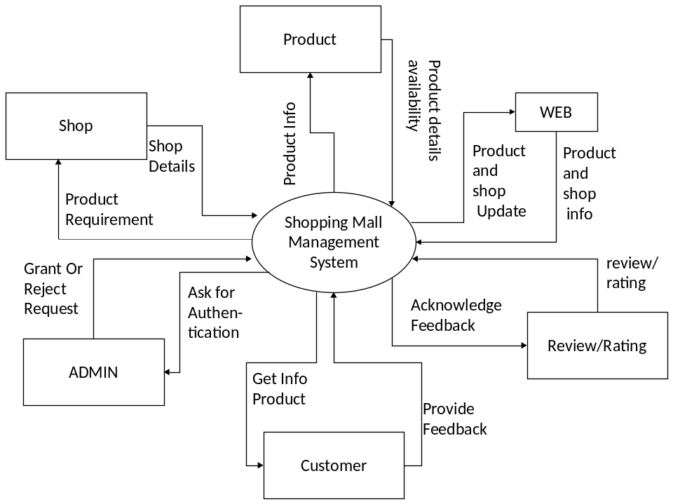

1st-Level DFD
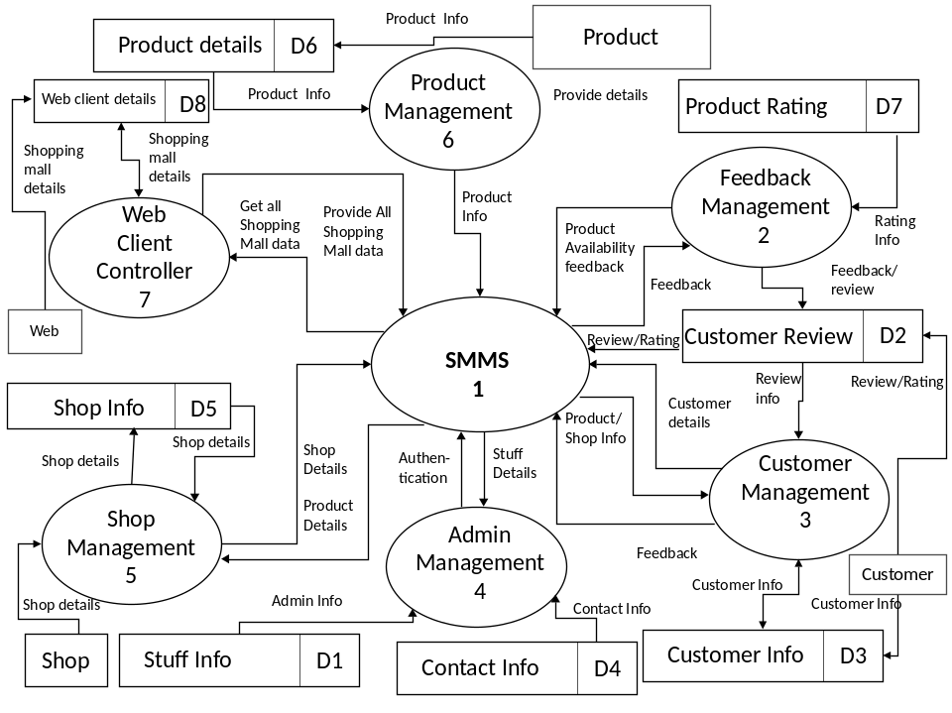

2nd-Level DFD ORDER PROCESS
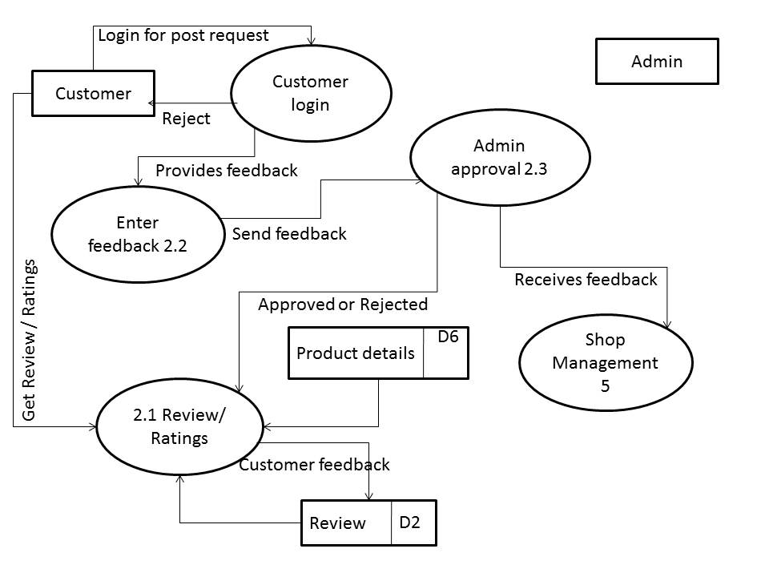

ENTITY RELATIONSHIP MODEL
We will design a RDBMS for Shopping Mall Management System. The entities and their attributes are listed below. Attributes in Bold letter is the primary key.
Entities | Attributes
Admin | Id, Name, Password, Admin Type
Shops | Id, Name, Tag, Type, Available In Floor, Rating, Description
Products | Id, Name, Brand, Type, Description, Image
feedback | Id, item, feedback Date, Name, Email, Rate, Feedback
Contact Details | Id, Name, Email
Relationship between Entities:

Shopping Management System has Shops 1: N
Shopping Management System has admin 1: 1
Shops sell products 1: N
Admin manages shops 1: N
Products get feedbacks N: N
Admin supervises feedbacks 1: N

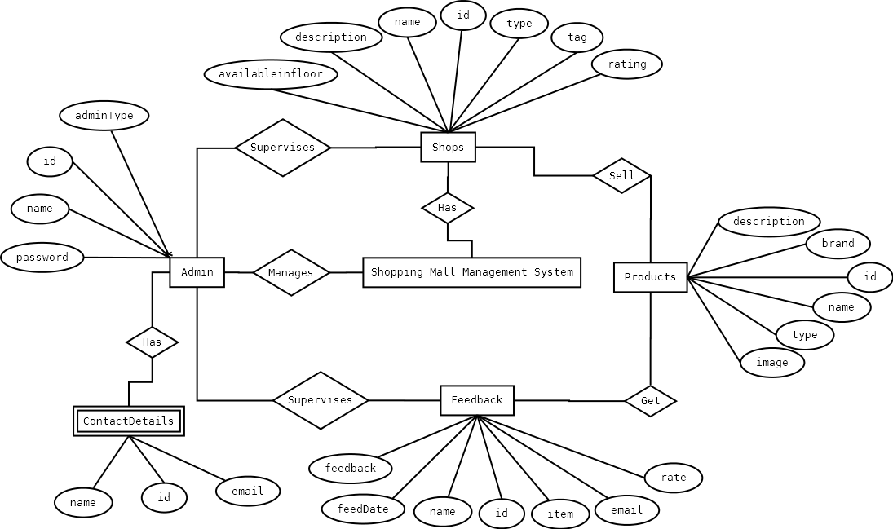

Class Diagram

Database & Table Details
The database used for this software is called shoppingdb. Database tables and corresponding keys are shown in tabular form. It shows the tables and its columns. A key in Bold is the primary key.
Entities | Attributes
Admin | Id, name, password, adminType
Shops | Id, name, tag, type, availableinfloor, rating, description
Products | Id, name, brand, type, description, image
feedback | Id, item, feedDate, name, email, rate, feedback
Contact Details | Id, name, email

Complete Structure

Module Description

SYSTEM DESIGN

MODULARISATION DETAILS
Shopping Mall Management System is divided three main modules such as:
- ShoppingMallUI
- ShoppingMallData
- ShoppingMallDb
And the web portion is divided in two modules as:
- WebsiteUI
- ShoppingMallWebData

SHOPPING mall UI
This module consists on all the Graphical User Interface related codes. We first added this module and started designing the UI according to the requirement. All the codes are done using WPF and XAML. This module is able to connect with the ShoppingMallData module to send the data to ShoppingMallDb.
The cs pages in this module control the logical codes of inputs and outputs.

SHOPPING Mall data
This module does one and one task only, it carries the data. All the data or inputs taken from user are sent to this module and it further sends the data to the ShoppingMallDb. On the other hand, the outputs sent by the ShoppingMallDb are carried by this module and those are sent to the UI to show them to the user. This module consists on c sharp logics

SHOPPING Mall db
In this module, we write database queries to store and fetched data from database. It takes inputs and stores in database and sends those data as output to user according to their query.
Shopping Management System will have a unified database for storing all the information. It can be a networked database or a database situated in the server machine. In our project, we are using local database.
The cs pages in this module control the logical codes of inputs and outputs.

Website UI
This module consists on all the Graphical User Interface related to webside. We first added this module and started designing the UI according to the requirement. All the codes are done using HTML, Java script, Twitter Bootstrap, WordPress, Php etc. This module is able to connect with the Shopping Mall Database module to send the data to server.

SHOPPING Mall web data
This module used to store data of shopping mall. All the data or inputs taken from website user or from local computer are sent to this module. On the other hand, the outputs sent by the ShoppingMallDb are carried by this module and those are sent to the Web UI to show them to the user. This module consists on Php logics.

Data Structure

AdminInfo
public class AdminInfo
{
public string id { get; set; }
public string name { get; set; }
public string password { get; set; }
public string adminType { get; set; }
}

ShopInfo
public class ShopInfo
{
public string id { get; set; }
public string name { get; set; }
public string tag { get; set; }
public string type { get; set; }
public string availableinfloor { get; set; }
public string rating { get; set; }
public string description { get; set; }
public string availableProduct { get; set; }
}

ProductInfo
public class ProductInfo
{
public string id { get; set; }
public string name { get; set; }
public string brand { get; set; }
public string type { get; set; }
public string description { get; set; }
public string availableinshop { get; set; }
}

FeedbackInfo
public class FeedbackInfo
{
public string id { get; set; }
public string item { get; set; }
public DateTime feedDate { get; set; }
public string name { get; set; }
public string email { get; set; }
public string rate { get; set; }
public string feedback { get; set; }
}

ContactusInfo
public class ContactusInfo
{
public string id { get; set; }
public DateTime feedDate { get; set; }
public string name { get; set; }
public string address { get; set; }
public string mobileno { get; set; }
public string email { get; set; }
public string type { get; set; }
public string feedback { get; set; }

}

Implementation Methodology
- Object Oriented Programming methodology will be adopted.
- User interface development will be done in MVC architecture using Windows Presentation Framework.
- Relational DBMS MySQL will be used to implement & execute SQL query to database.
- Web User interface development will be done in WordPress.
- Agile Software Development model will be used while developing this software.

List of Reports
- List of product details could be generated.
- List of shop details could be generated.
- A list of feedback could be generated.
- List of floor details could be generated.
- Shopping mall related feedback could be shared via website.
- Rating could be shared via website.

Implementation of Security Mechanism at Various Levels
- The data of the SMMS will be stored in the database with an encrypted format so even if someone hacks the database somehow still he can make no real harm.
- The software will provide a backup and restore feature in case of loss of data.

Future Scope and Further enhancement of the project:

- Android/windows phone/ I-OS application of the system could be developed to make the system available to the entire world.
- A computerized voice guide of the mall could be added to make the application more user friendly.

Bibliography

Websites
- http://en.wikipedia.org/wiki/Windows_Presentation_Foundation
- http://msdn.microsoft.com/en-us/
- http://www.c-sharpcorner.com/beginners/
- http://www.microsoft.com/en-us/default.aspx
- http://www.codeplex.com/
- http://searchitchannel.techtarget.com/
- http://stackoverflow.com/
- http://www.codeguru.com/
- http://www.roseindia.net/
- http://www.csharpcourse.com/
- http://blogs.technicise.com/
- http://www.mysql.com/support/
- http://www.homeandlearn.co.uk/csharp/csharp.html
- http://www.wpftutorial.net/Home.html
- https://developers.facebook.com/apps
- https://www.facebook.com/creatormyapp
- http://www.youtube.com/?gl=IN
- http://blendinsider.com/
- https://github.com/
- http://www.vogella.com/articles/Git/article.html
- https://enterprise.github.com/support
- https://support.enterprise.github.com/home

Books

- BLACK BOOK C# 2010 Programming Covers .Net 4
- Fundamentals of software engineering by Rajib Mall.
- Pro C# 2010 and the .NET 4.0 Platform by Andrew Troselen.
- C# Programming by Rob Miles.

----------------------------- Thank You-------------------------

