|  |
| --- |
|  |
| Face Recognition System |
| Synopsis |
|  |
|  |
|  |

|  |
| --- |
|  |

Table of Contents

Introduction & OBJECTIve 3

INTRODUCTION 3

Objective 3

PROJECT CATEGORY 3

Hardware and Software Specification 3

Hardware Requirement 4

Software Requirement 4

REQUIREMENTS AND ANALYSIS 4

Problem Definition 4

Existing System 4

Documents maintained 6

Work To Be Done 7

Requirements Specification 7

Functional Requirements 7

Database Update 7

Create User 7

Face Recognition 7

Non Functional Requirements 7

technical specification 10

Planning and Scheduling 10

Gantt chart 10

Tracking Gantt 11

Pert chart (Network Diagram) 12

Scope of the Solution 12

Analysis 13

Context Diagram 13

Data Flow Diagram 13

Level 0 DFD 13

Level 1 DFD 14

Level 2 DFD 16

E-R Diagram 16

Class Diagram 20

Database & Table Details 20

COMPLETE DATA STRUCTURE 22

Module Description 22

Face Recognigation Server 22

Face Recognigation Database 23

estimation 23

Data Structure 24

Implementation Methodology 27

List of Reports 27

SECURITY MECHANISM 27

FUTURE SCOPE AND FURTHER REQUIREMENTS 28

bIBLIOGRAPHY 28

# Introduction& OBJECTIVE

## Introduction

Face modeling for recognition of people is a challenging problem which has received much attention during recent years due to its many applications in different fields. Face recognition has become a very active area of research in recent years mainly due to increasing security demands and its potential commercial and law enforcement applications. The last decade has shown dramatic progress in this area, with emphasis on such applications as human-computer interaction (HCI), biometric analysis, content-based coding of images and videos, and surveillance.

Face recognition and detection is a reliable technique to authenticate a user’s identification. So facial recognition system and detection is a [computer application](https://en.wikipedia.org/wiki/Application_software) for automatically  [identifying](https://en.wikipedia.org/wiki/Identification_of_human_individuals) or [verifying](https://en.wikipedia.org/wiki/Authentication) a [person](https://en.wikipedia.org/wiki/Person) from a [digital image](https://en.wikipedia.org/wiki/Digital_image) or a [video frame](https://en.wikipedia.org/wiki/Film_frame) from a [video](https://en.wikipedia.org/wiki/Video) source any source. One of the ways to do this is by comparing selected [facial features](https://en.wikipedia.org/wiki/Face) from the image and a facial [database](https://en.wikipedia.org/wiki/Database_management_system).

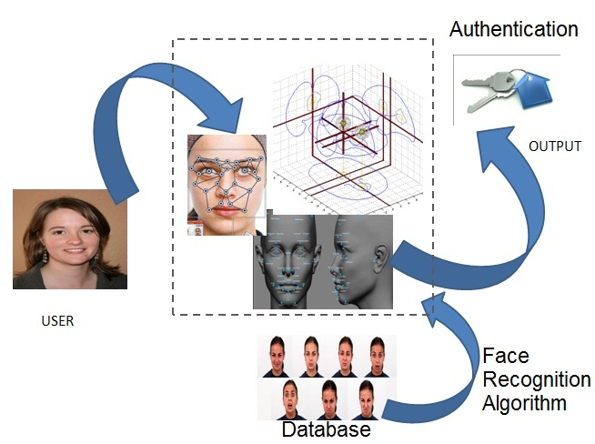

Fig: Overview of Face Recognition System

Face Recognition System will enable users to authenticate themselves using their facial images which will be compared to existing database using Gabor Analysis Algorithm. Face Recognition Algorithm will follow below mentioned steps to identify the face.

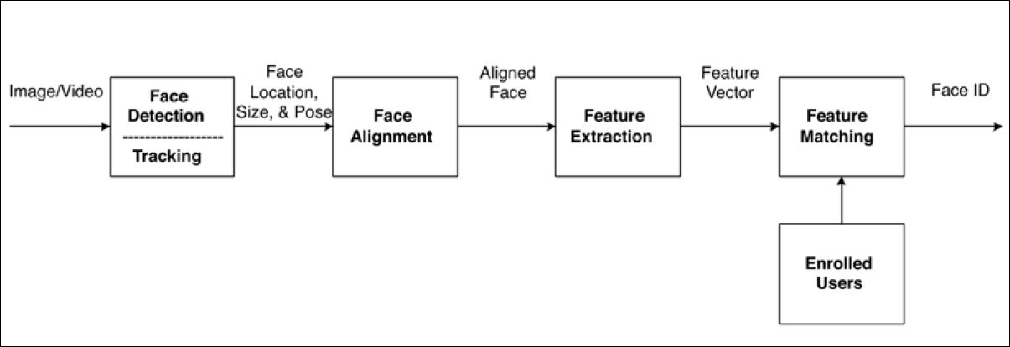

Fig: Flow of Face Recognition Process

## Objective

It’s a true challenge to build an automated system which equals human ability to recognize faces. Although humans are quite good identifying known faces, we are not very skilled when we must deal with a large amount of unknown faces. The computers, with an almost limitless memory and computational speed, should overcome human limitations. Face Recognition System will facilitate face recognition and enable user authentication using this.

Face recognition and detection typically used in security system and can be compared to other biometrics such as face or eye iris recognition systems.

Admin has to register their face images from different angel and images will be stored in database. Whenever a user wants to authenticate, the Face Recognition System will take picture of the user and compare with existing database using Gabor Analysis Algorithm

Face Recognition is versatile and complete end-to-end Face Recognition software. There are following feature in face recognition:

* Recognition from outdoor facial images.
* Recognition from non-frontal facial images.
* Greater understanding of the effects of demographic factors on performance.
* Development of better statistical methods for understanding performance.
* Develop improved models for predicting identification performance on very large galleries.
* Effect of algorithm and system training on covariate performance.
* Integration of morphable models into face recognition performance.
* Preprocesses the captured images (removes background, scales size, and so on)

# PROJECT CATEGORY

This software will follow Object Oriented Programming Paradigm and use below mentioned areas:

OOP Language: Matlab, Java, C#.

RDBMS: MySQL 5.5.15

Networking: TCP/IP

Applications: Expert Systems

 Images : A set of training images in 'gif' format.

# Hardware and Software Specification

## Hardware Requirement

* **Disc capacity :** 10 MB of available hard disk space
* **RAM :** 1 GB (32 Bit) or 2 GB (64 Bit)
* **Processor :** 1.6GHz or faster
* DVD-ROM Drive / USB **Port**

## Software Requirement

* Windows XP (x86) with Service Pack 3 / Windows Vista (x86 & x64) with

Service Pack 2 / Windows 7 (x86 & x64)

# REQUIREMENTS AND ANALYSIS

## Problem Definition

### Existing System

The existing system is traditional paper books and ledger system where several records are stored and to track other details about the human.

### Work To Be Done

We will incorporate the above mentioned workflow of a Face Recognition System in an automatic computerized way.

## Requirements Specification

### Functional Requirements

After getting valuable information we reached to the following important conclusions: -

* It should meet the functional requirements as mentioned in Objectives.
* It should be able to handle 'gif' and 'jpeg' images.

#### Database update

##### Introduction

Admin has to register their face images from different angel and images will be stored in database.

##### Input

Admin will be storing ten photos for each person from different predefined angles.

##### Processing

These images will be stored in database for processing.

##### Output

Images stored successfully to the database and ready to be accessed by face recognition system.

#### Create user

##### Introduction:

Create account for a new User.

##### Input:

Relevant User data like user name, images, etc.

Processing:

The Face Recognition will create a new user entry.

Output:

The face recognition will generate a user to reach his face identification.

#### Face recognition

##### Introduction:

Face recognition users has to provide a image which will be matched with existing image stored in database using face recognition techniques.

##### Input:

User images captured from different resources like video, images.

##### Process:

Input image which will be matched with existing image stored in database using face recognition techniques.

##### Output:

User images will be matched and authenticated by admin.

### NON- Functional Requirements

This project is intended to meet the following nonfunctional requirements: -

* This face recognition software should be available on the Internet, to enable the users to use , download it any time.
* The program should be platform independent.

### Technical specification

**Front End/ GUI Tools:** Windows Presentation Framework (WPF)

**IDE:**Matlab

**Framework:** Microsoft .NET 4.0

**Database:** MySQL

**Database Tool:** MySQL workbench CE

**Operating Systems**: Windows XP, Windows 7

**Cloud Technology**: Google Drive, Google forms

## Planning and Scheduling

### Gantt chart

### Tracking Gantt

### Pert chart (Network Diagram)

# Scope of the Solution

Currently this software is aimed for a human Face Recognition. It can be extended to support images and have a centralized database and to serve wider range of humans of different branches of same face around the images.

We have developed this for Desktop Computers running on Windows Operating System. It can be enhanced to support UNIX / Linux, MAC OSX Operating systems.

Our software will not be integrated with Mobile Application right now. But in future we can easily extend to support that.

# Analysis

## Context Diagram

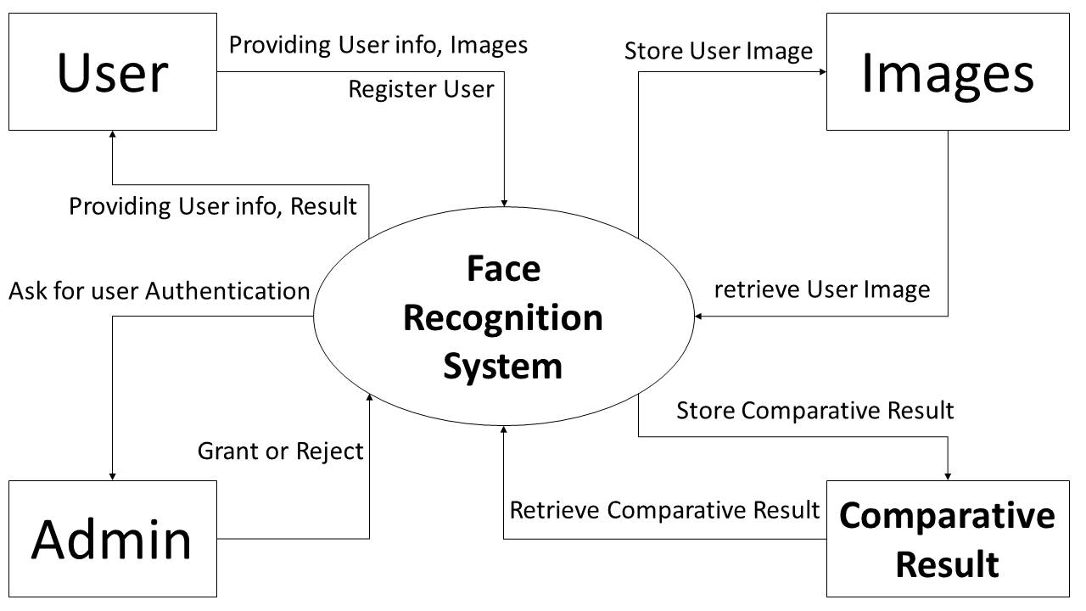

## Data Flow Diagram

### Level 0 DFD

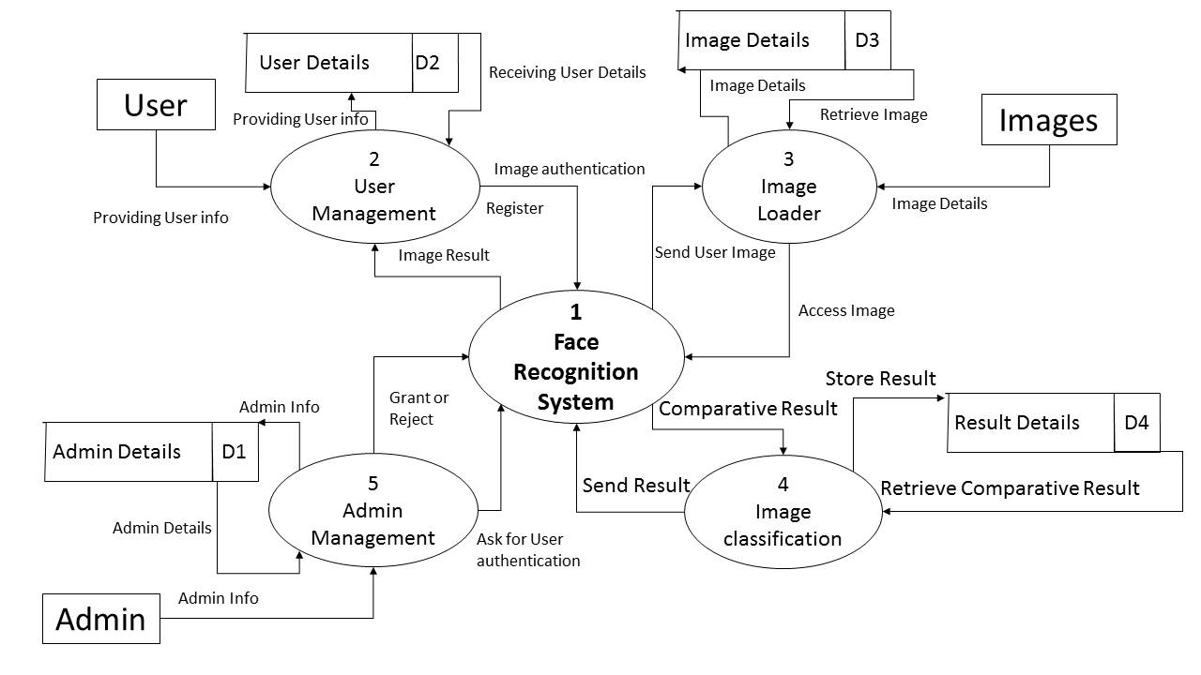

### Level 1 DFD

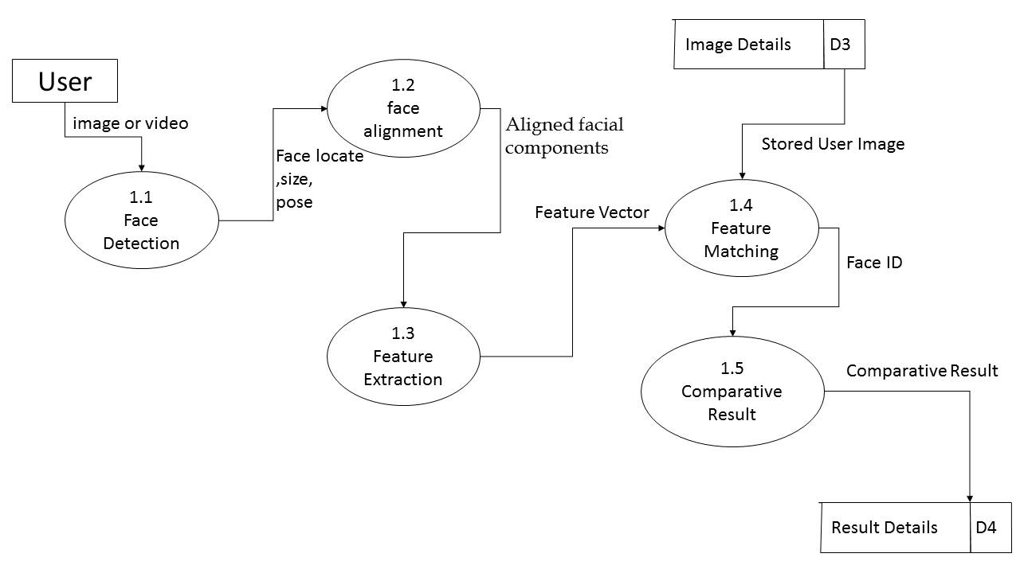

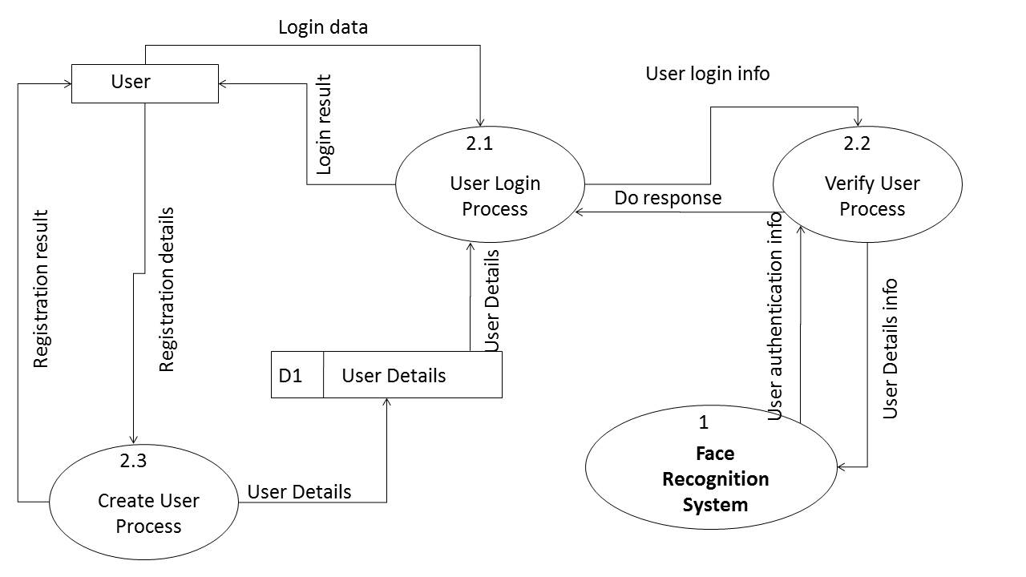

### Level 2 DFD

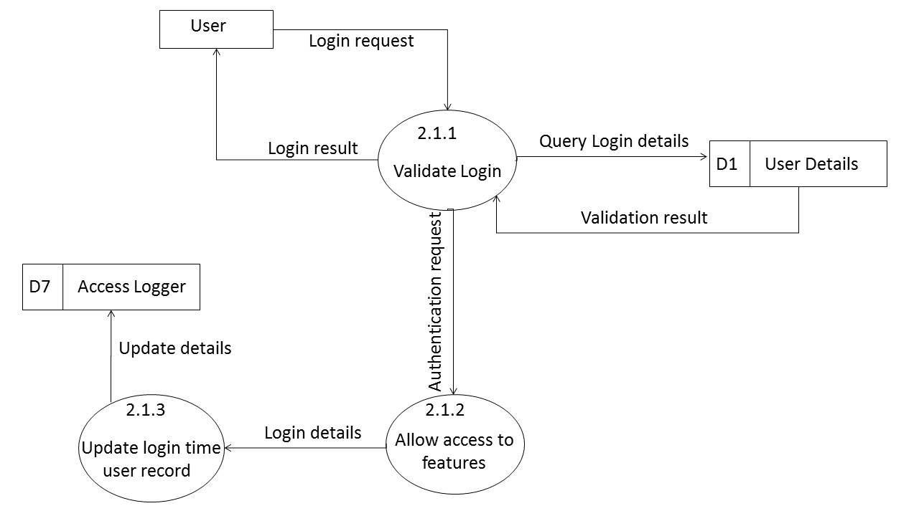

## E-R Diagram

## Class Diagram

# Database & Table Details

The database used for this software is called **frsdb**. A screenshot from the MySQl workbench is given below. It shows the tables and its columns. The first row is the primary key.

# COMPLETE DATA STRUCTURE

## Module Description

Face Recognition System is divided three main modules such as:

1. Face Recognition Server
2. Face Recognition Database

### Face recognition Server

Face Recognition server is a singleton server designed provide services for Face Recognition system. It controls various activities required for the Face Recognition system. To manage these activities it has several sub modules such as:

* Admission Management
* User Management

### face recognition Database

Face Recognition System will have a unified database for storing all the information. It can be a networked database or a database situated in the server machine.

## Estimation

## Data Structure

## Implementation Methodology

* Object Oriented Programming methodology will be adopted and Java will be used as programming language.
* Apache tomcat web server will be used to implement the server
* User interface development will be done in MVC architecture using SWT (Standard Widget Toolkit).
* Relational FRSS MySQL will be used to implement & execute SQL query to database.
* Agile Software Development model will be used while developing this software.

# SECURITY MECHANISM

* Face Recognition software is password protected software. It will be developed such a way that the admin will have complete control data.
* Admin create account can register new faces in to database.
* The data of the face will be stored in the database with an encrypted format so even if someone hacks the database somehow still he can make no real harm.
* The software will provide a backup and restore feature in case of loss of data.

# bIBLIOGRAPHY

1. P. Belhumeur and D. Kriegman. What is the set of images of an object under all possible illumination conditions? *Int. J. Computer Vision*, 28(3):245–260, July 1998.
2. D. Beymer. Face recognition under varying pose. In *IEEE Conf. on Comp.*

*Vision and Patt. Recog.*, pages756–761, 1994

* <http://en.wikipedia.org>
* <http://msdn.microsoft.com/en-us/>
* <http://www.microsoft.com/en-us/default.aspx>
* <http://www.codeplex.com/>
* <http://stackoverflow.com/>
* <http://www.codeguru.com/>
* [http://www.w3schools.com](http://www.w3schools.com/)
* [www.mysql.org](http://www.mysql.org)
* School Professionals
* **Programming Java** - E. R. Balaguruswamy