ORC table created;

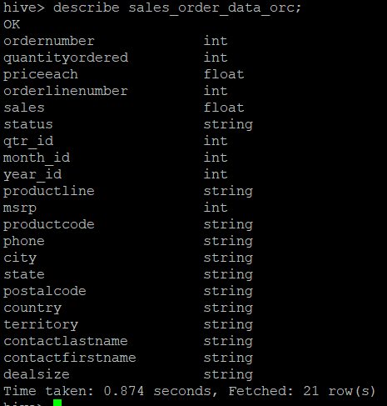

1. Calculate total sales per year

HQL: select sum(sales) as Total_Sales,year_id from sales_order_data_orc group by year_id order by year_id desc;

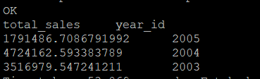

1. Find a product for which maximum orders were placed

HQL: select productcode, sum(quantityordered)as NoOfOrders from sales_order_data_orc group by productcode order by NoOfOrders desc limit 1;

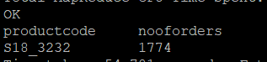

1. Calculate the total sales for each quarter

HQL: select sum(sales) as Total_Sales,qtr_id from sales_order_data_orc group by qtr_id order by qtr_id;

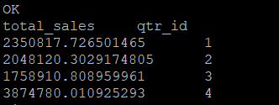

1. In which quarter sales was minimum

HQL: select sum(sales) as Min_Total_Sales,qtr_id from sales_order_data_orc group by qtr_id order by Min_Total_Sales limit 1;

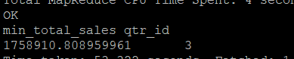

1. In which country sales was maximum and in which country sales was minimum

HQL: select A.Total_Sales_Country_max, A.max_sale_country ,B.Total_Sales_Country_min,B.min_sale_country from (select sum(sales) as Total_Sales_Country_max ,country as max_sale_country,'a' as tcol from sales_order_data_orc group by country order by Total_Sales_Country_max desc limit 1)A inner join (select sum(sales) as Total_Sales_Country_min ,country as min_sale_country,'a'as tcol from sales_order_data_orc group by country order by Total_Sales_Country_min limit 1)B on A.tcol=B.tcol;



1. Calculate quarterly sales for each city

HQL: select sum(sales) as Total_Sales,qtr_id,city from sales_order_data_orc group by qtr_id,city;

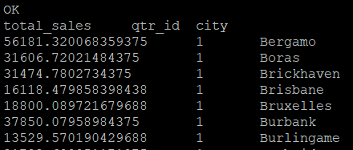

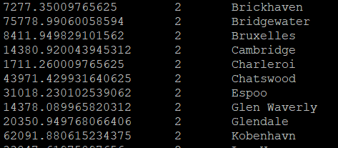

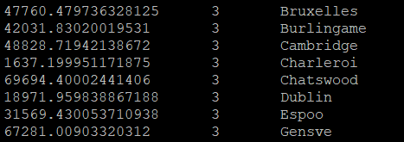

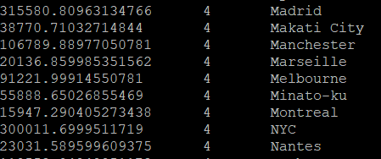

1. Find a month for each year in which maximum number of quantities were sold

HQL: select distinct M.month_id monthValue,M.year_id as yearValue,M.quantityordered as Totalsales from hive_class_b1.sales_order_data_orc M where

cast(concat(cast(M.quantityordered as string),cast(M.year_id as string))as int) in (

select sub.datav from (select cast(concat(cast(max(a.quantityordered) as string),cast(a.year_id as string)) as int)datav

from hive_class_b1.sales_order_data_orc a Where a.year_id in

(select distinct year_id from hive_class_b1.sales_order_data_orc) group by a.year_id)as sub) order by M.year_id,M.month_id;

