**Kelompok 3 - GIS**

1201190017 Aqil Mustaqim

1201192036 Diana Puspita

1201190004 Zulkarnain

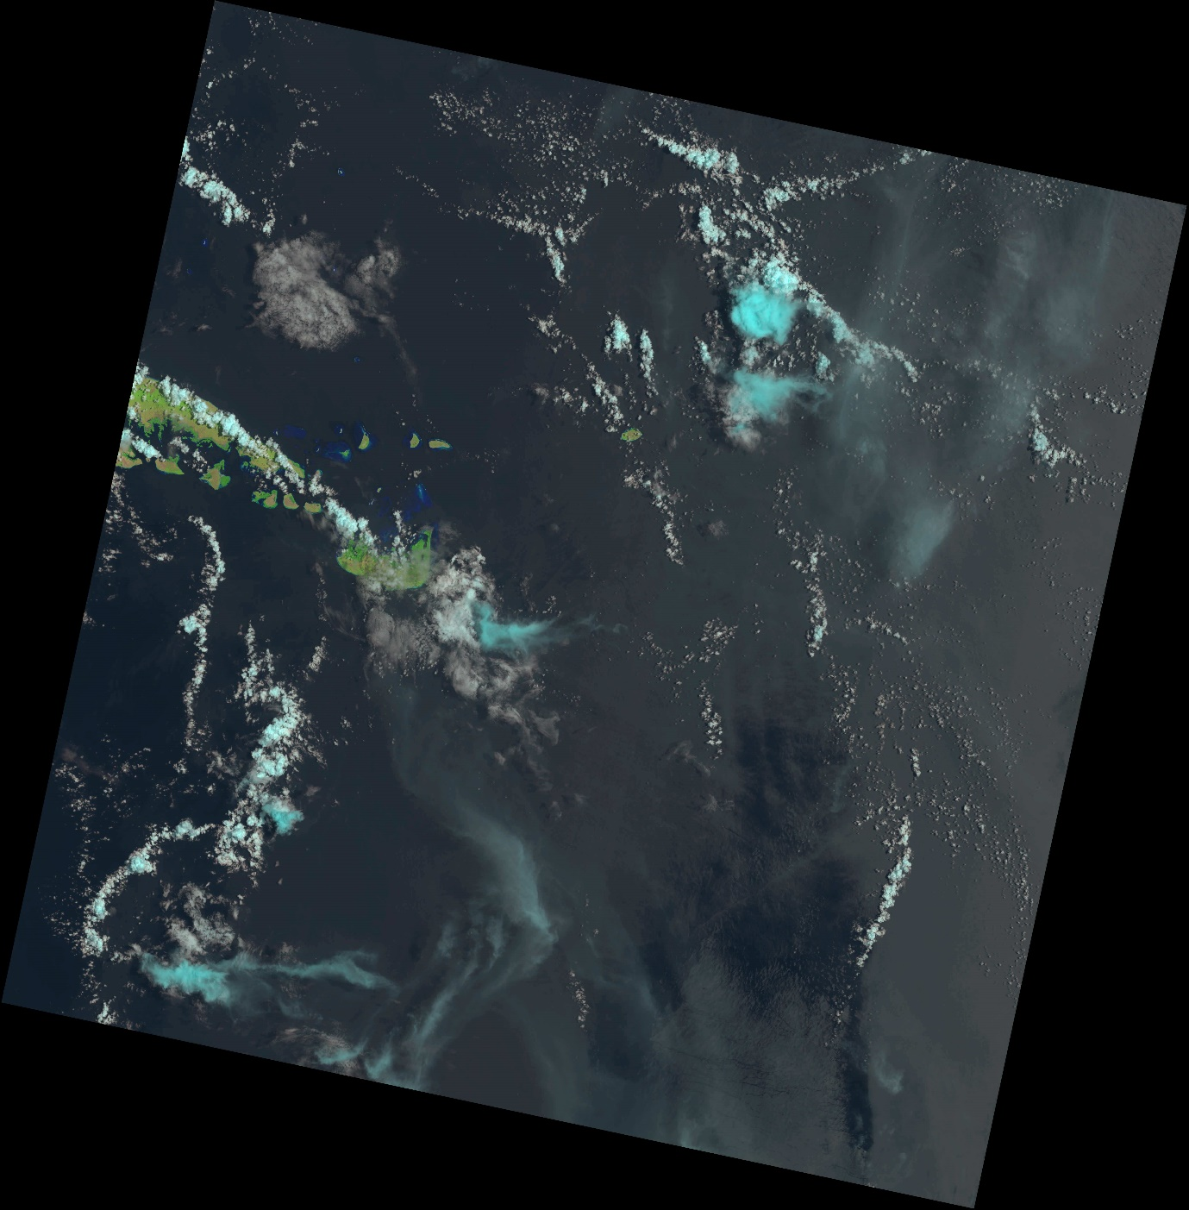

Address/Place : Pulau Sepanjang, Sepanjang, Sapeken, Sumenep Regency, East Java, Indonesia

Lat/Long : -7.1751 / 115.8410

Dataset : Landsat 8-9 OLI/TIRS C2 L1

ID : LC09_L1TP_116065_20221003_20221003_02_T1

Date Acquired : 2022/10/03

Path : 116

Row : 065