Graded Assignment on Serverless Architecture

Table of Contents

Assignment 1: Automated Instance Management Using AWS Lambda and Boto3 1

1. Setup: 1

2. Lambda Function Creation 2

Setting up an IAM role 2

Setting up a Lambda function 4

3. Coding: 5

4. Testing 6

# **Assignment 1: Automated Instance Management Using AWS Lambda and Boto3**

## Setup:

1. We need to create 2 instances as shown below and name the tags under actions as Auto-Start and Auto-Stop respectively.

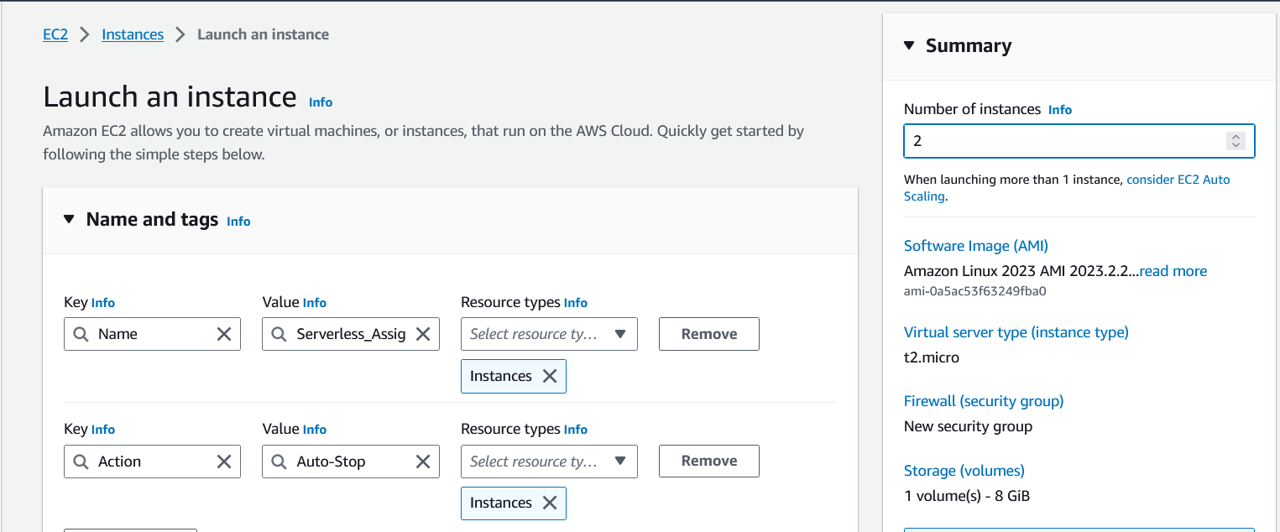

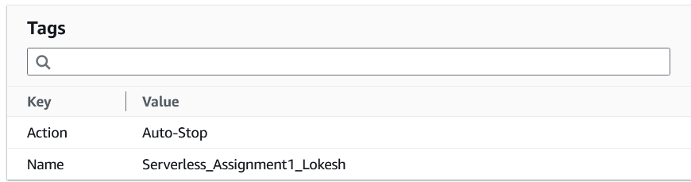

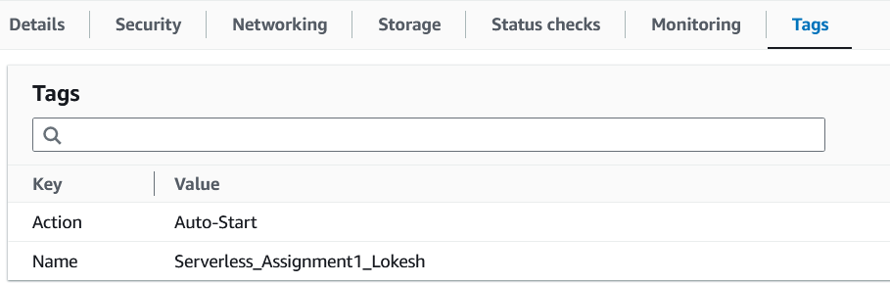

## Lambda Function Creation

### Setting up an IAM role

* 1. We need to create an IAM role first before creating a Lambda function. Please follow the below steps to create an IAM role for the Lambda function.
  2. We need to go to AWS console and select IAM. We can find Roles under Access Management and click on **create role.**
  3. 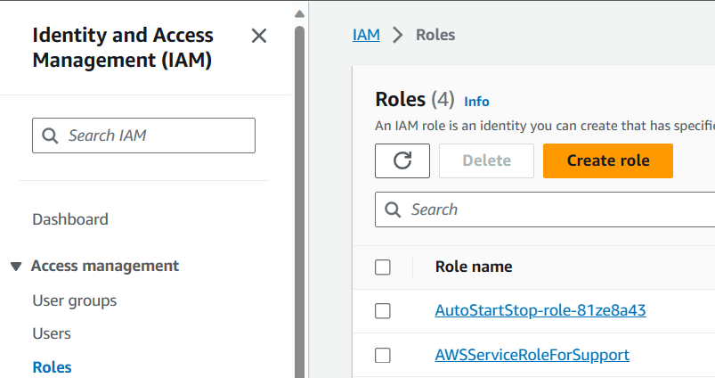
  4. Select Lambda from the services and click next.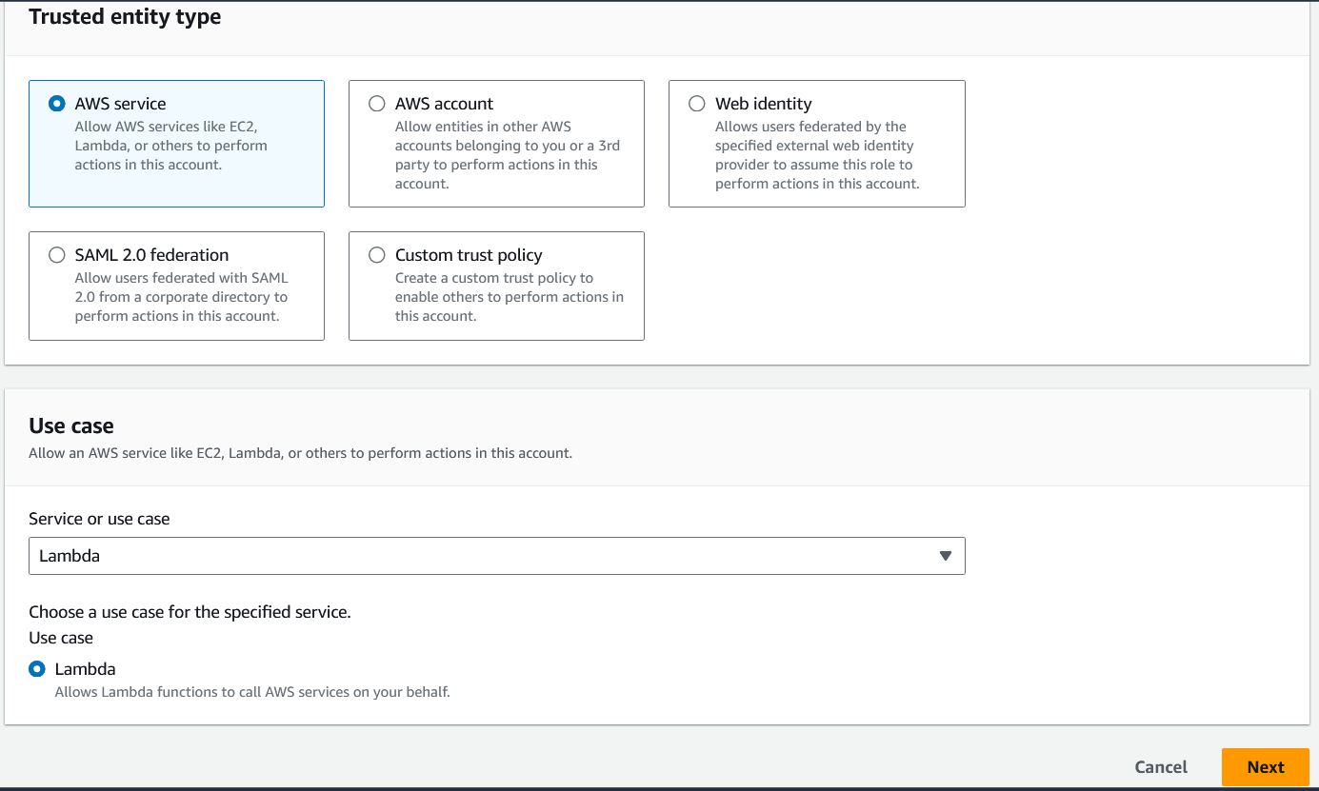
  5. Type EC2full in the search bar and select AmazonEC2FullAccess then click next.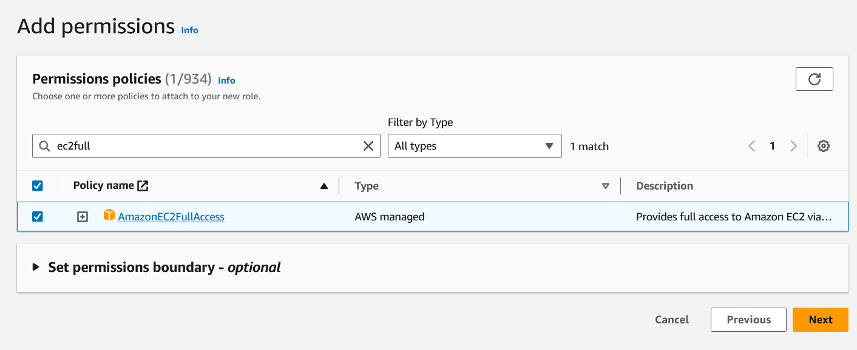
  6. Give a name for the Role and scroll down and click on create role.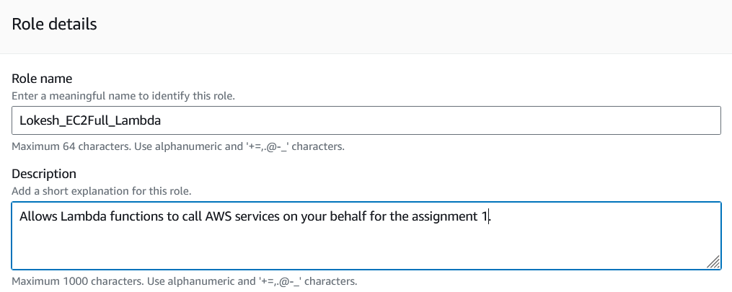
  7. 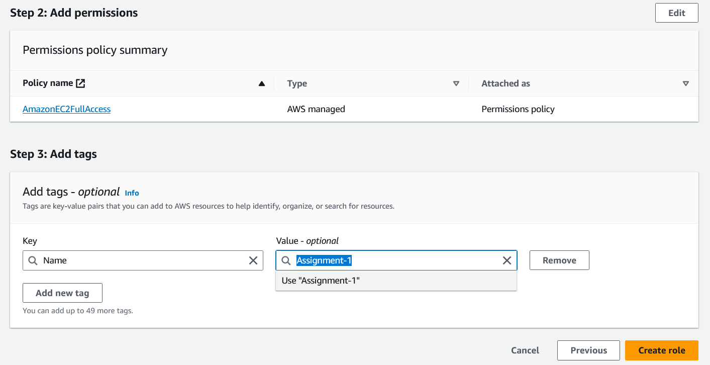
  8. A role will be created and you can see the same in the dashboard.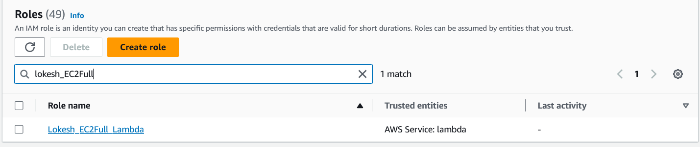

### Setting up a Lambda function

1. We need to create a Lambda function using the IAM role to execute the task.
2. 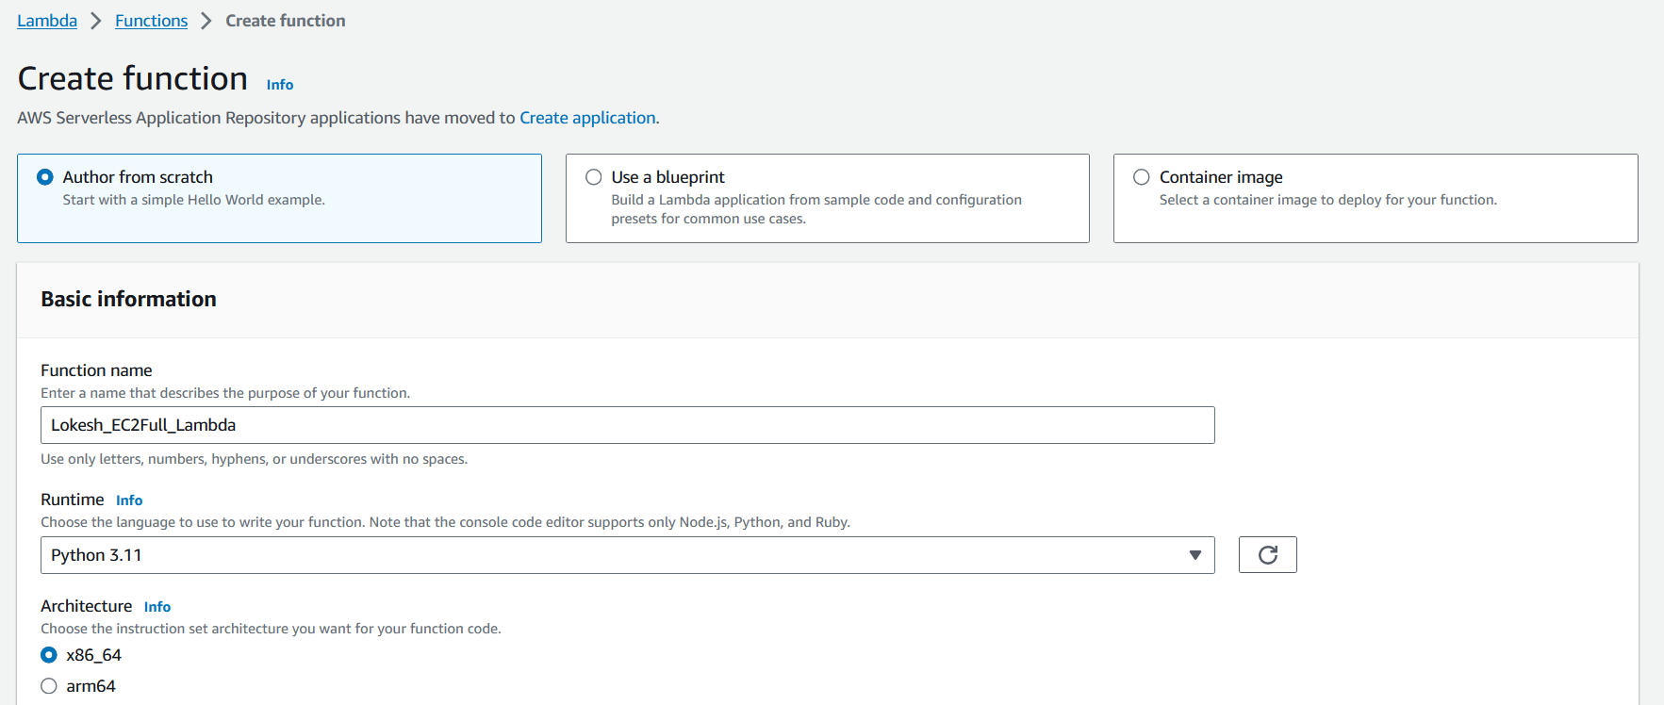
3. Once we select the execution role, we need to click on create function.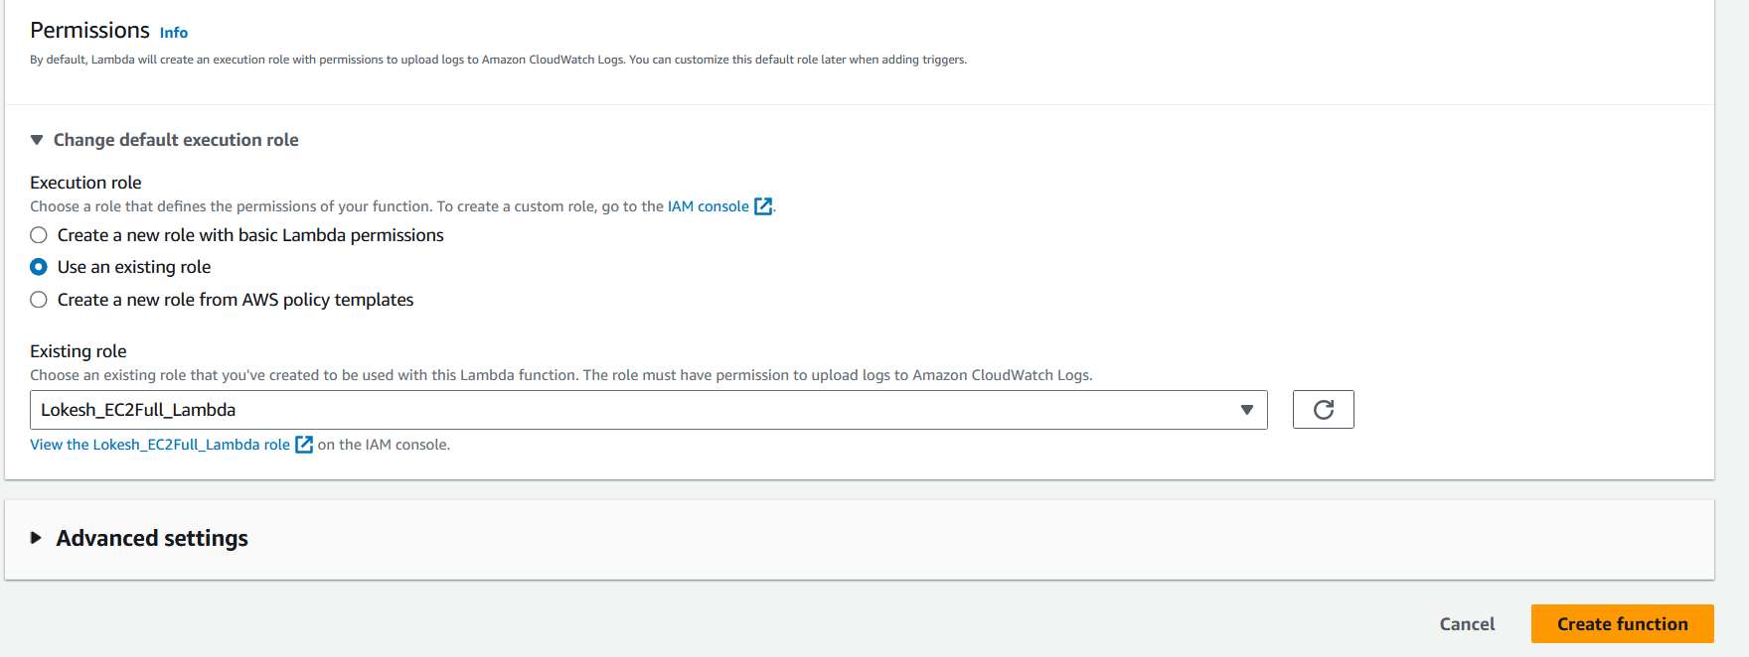
4. Once the function is created, it will appear as below.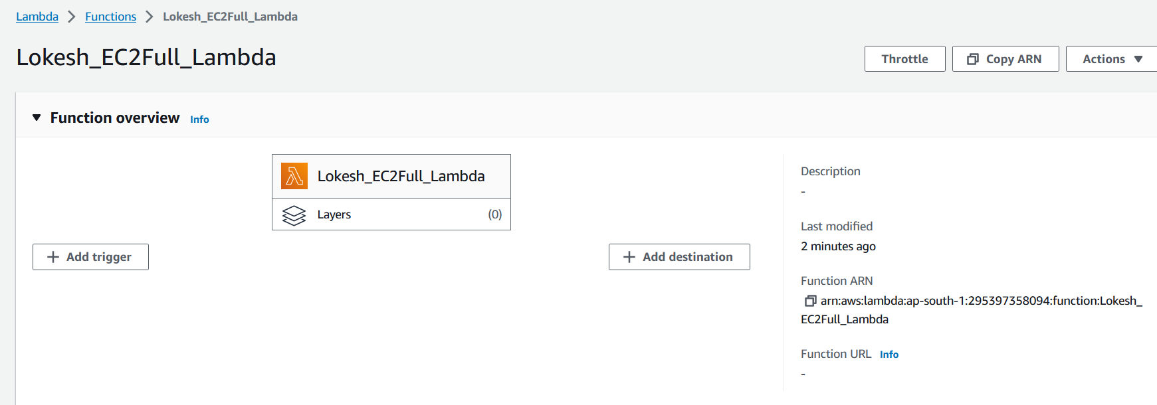

## Coding:

1. Once it is done, we need to scroll down and write a code to finish the task. This code will check the tags we assign at the very beginning. Once the code identifies the tags, it will stop the instance if the tag identifies as **Auto-Stop** and start the instance if it finds as **Auto-Start**.
2. 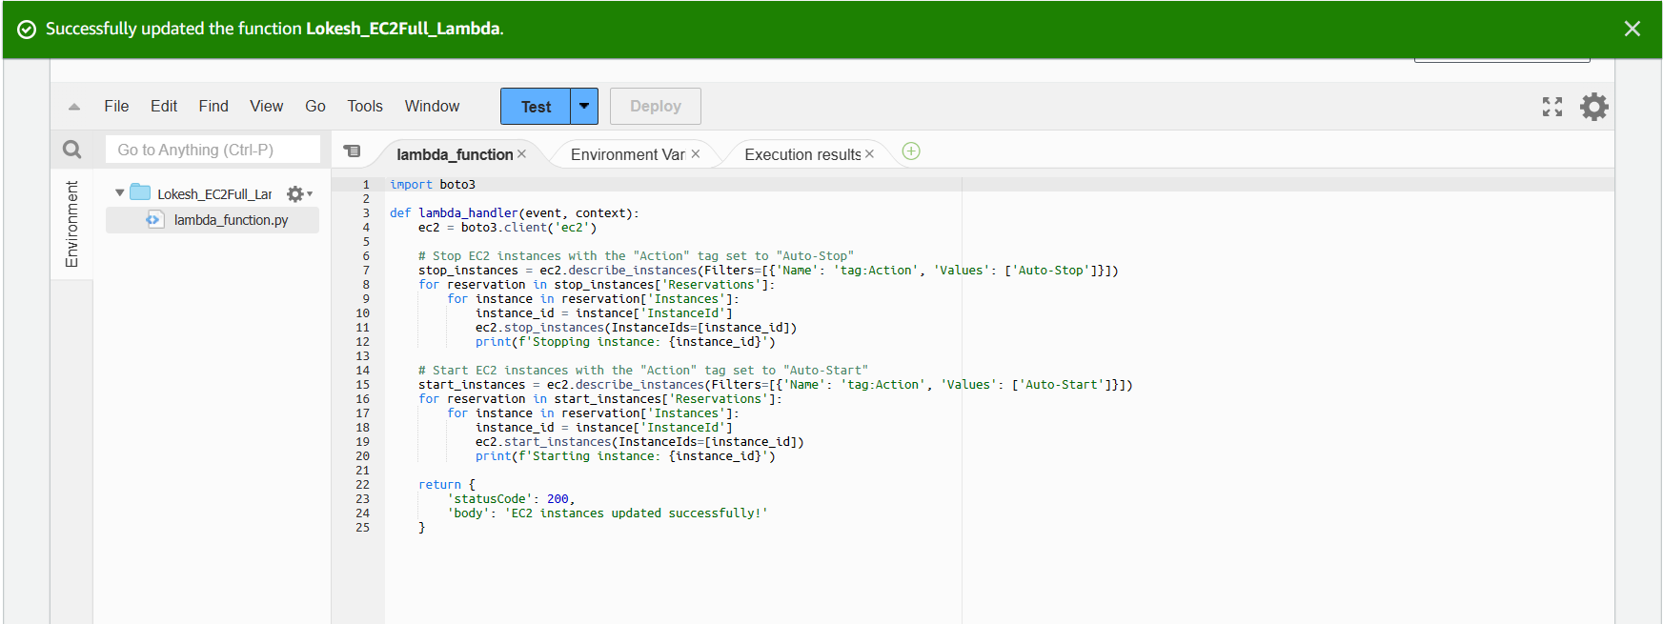

## Testing

1. The test results shows that the code worked fine and stopped the instance with the tag **Auto-Stop** and started the instance with the tag **Auto-Start**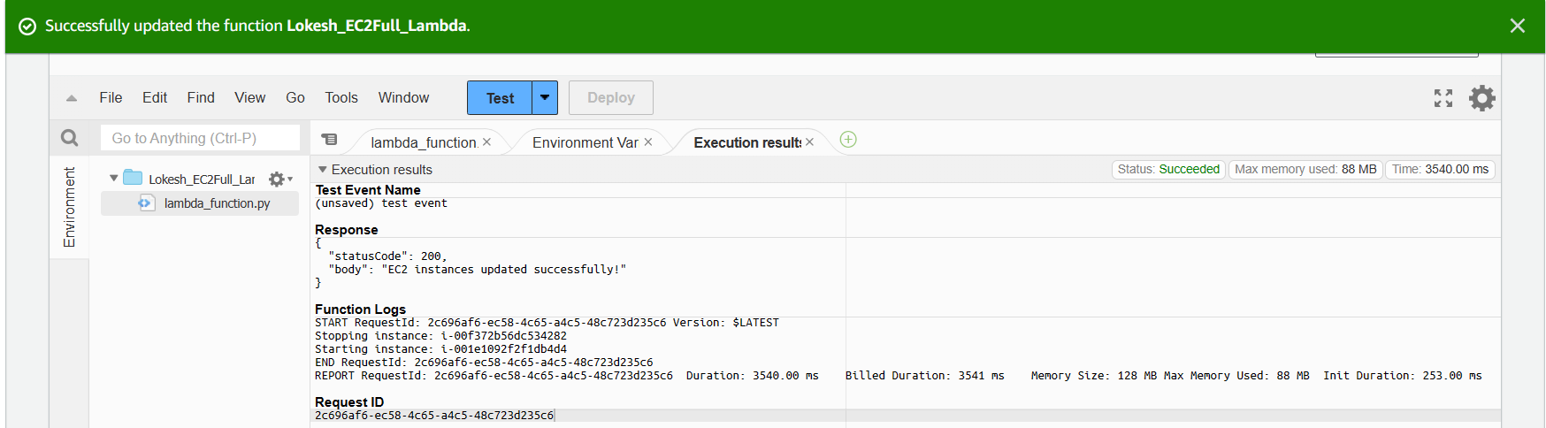
2. 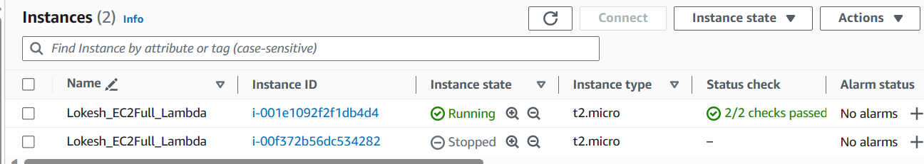
3. 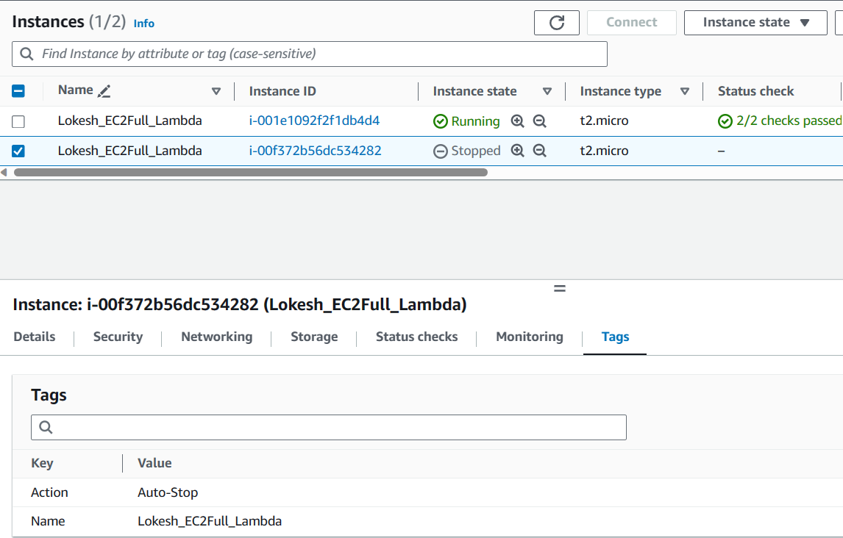
4. 