Graded Assignment on Serverless Architecture

Table of Contents

1. SNS Setup: 1

2. Lambda IAM Role 3

3. Lambda Function: 5

4. Testing 10

Assignment 15: Monitor EC2 Instance State Changes Using AWS Lambda, Boto3, and SNS

**Objective:** Automatically monitor changes in EC2 instance states and send notifications whenever an instance is started or stopped.

**Task:** Set up a Lambda function that listens to EC2 state change events and sends SNS notifications detailing the state changes.

# SNS Setup:

* Navigate to the SNS dashboard and create a new topic.
* 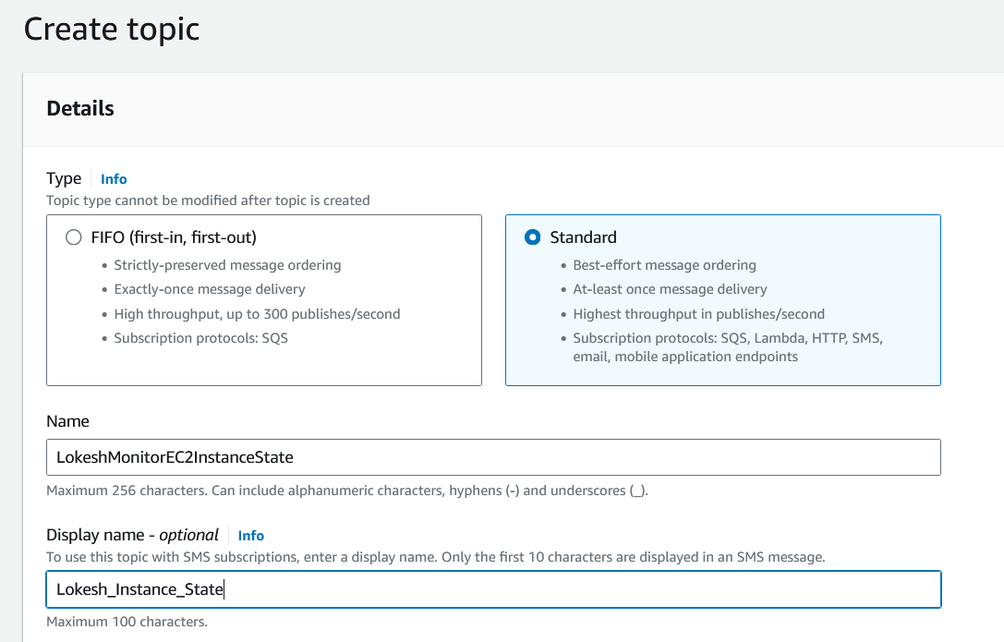
* 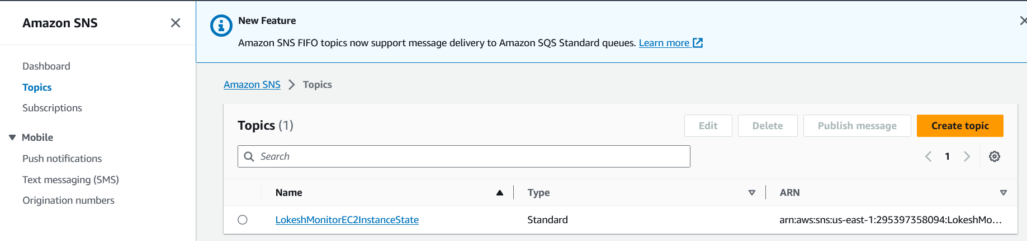
* Subscribe to this topic with your email.
* 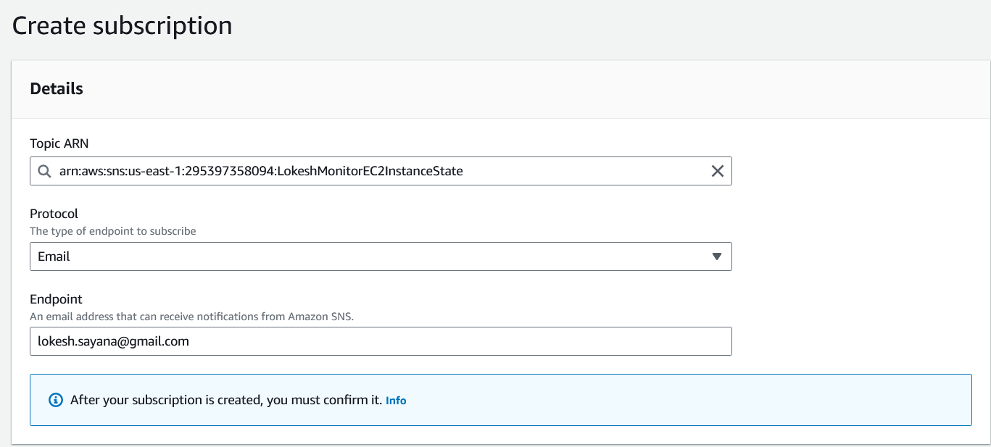
* 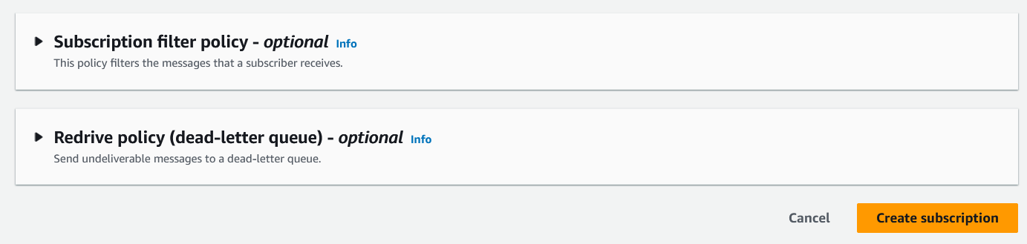
* Once you create a Subscription, you will receive an email stating to confirm the subscription. You will find that email in your spam/inbox.
* 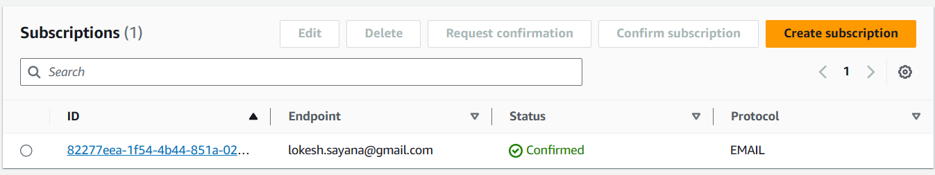
* 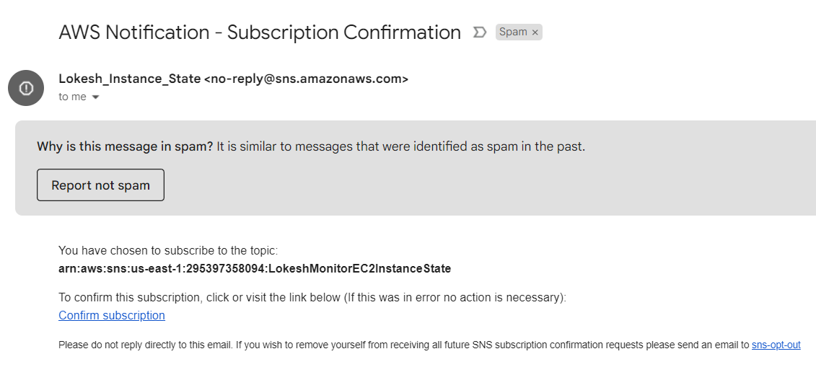
* 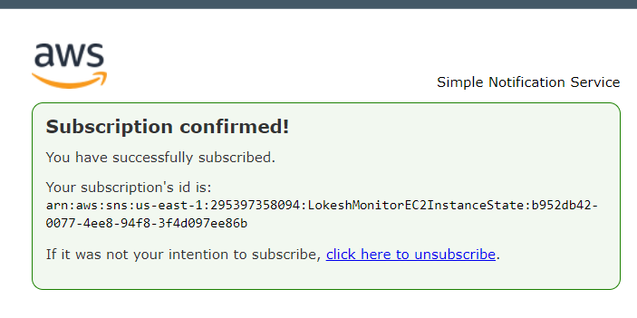

# Lambda IAM Role

* Create a role with permissions to read EC2 instance states and send SNS notifications.
* 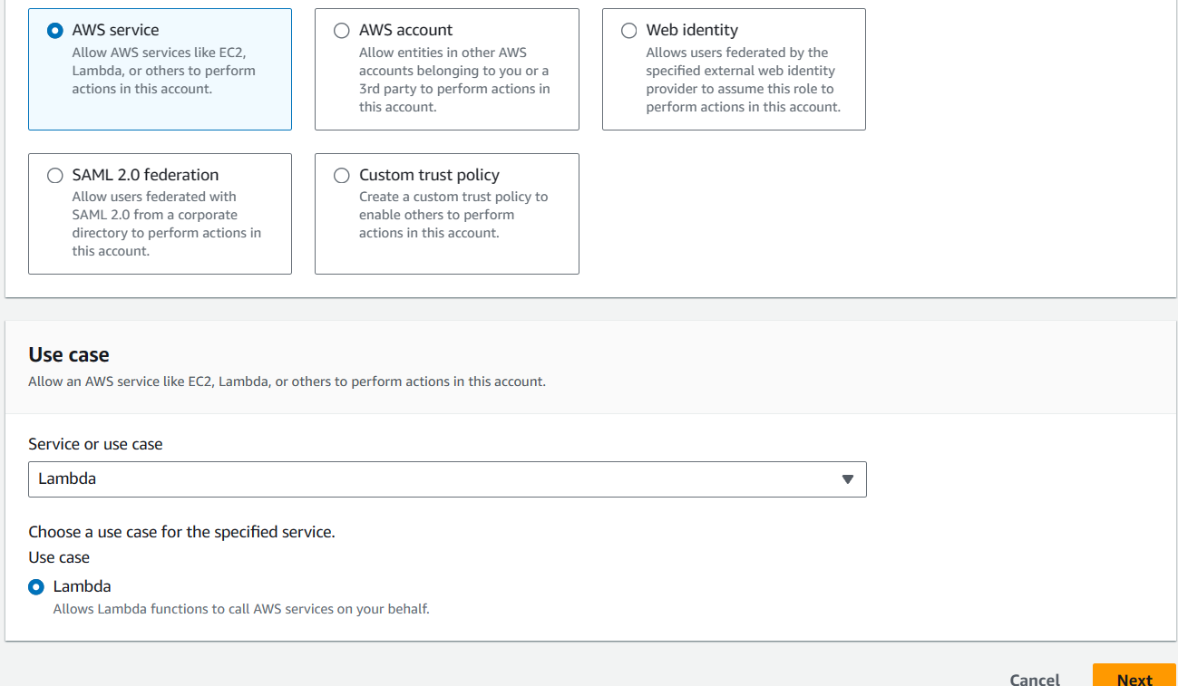
* Give the permissions to SNS and EC2.
* 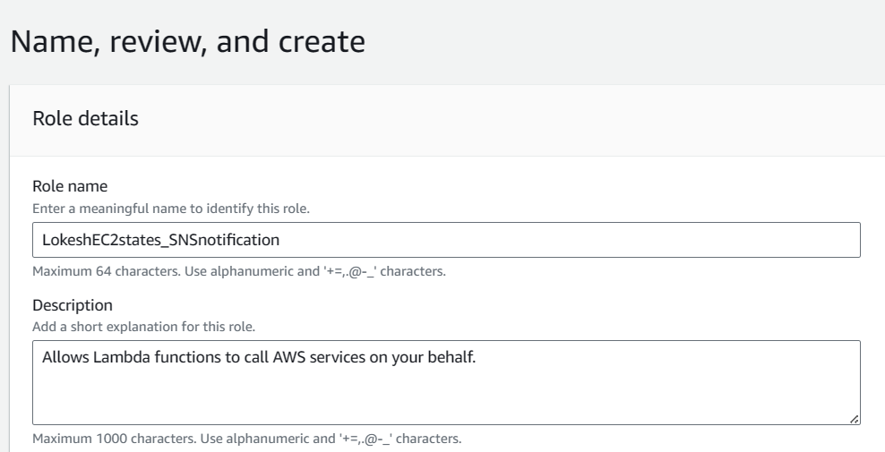
* 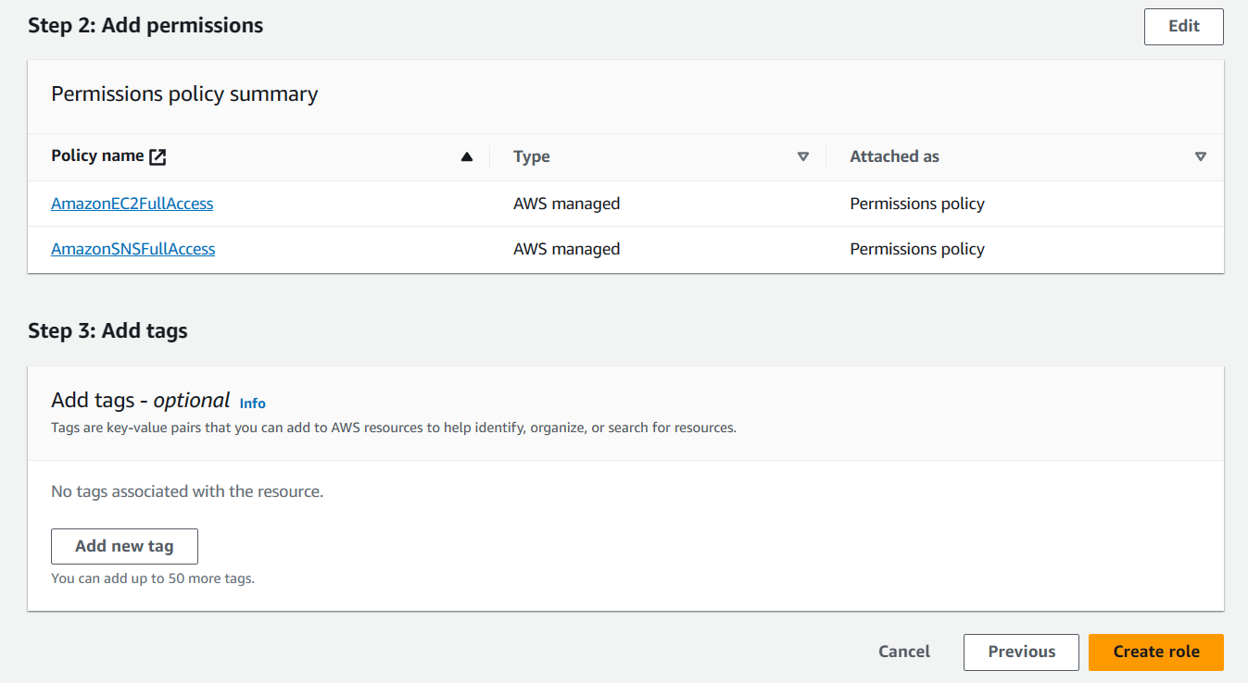
* 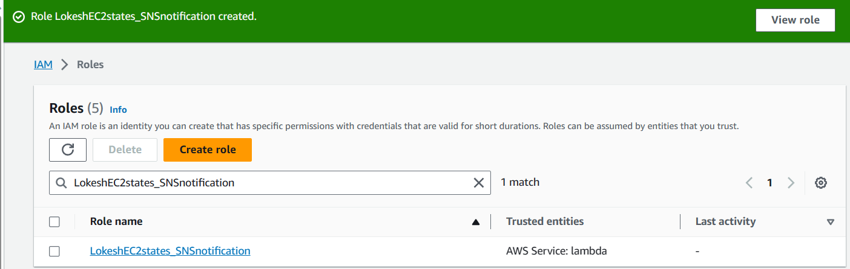

# Lambda Function:

* Create a function and assign the above IAM role.
* 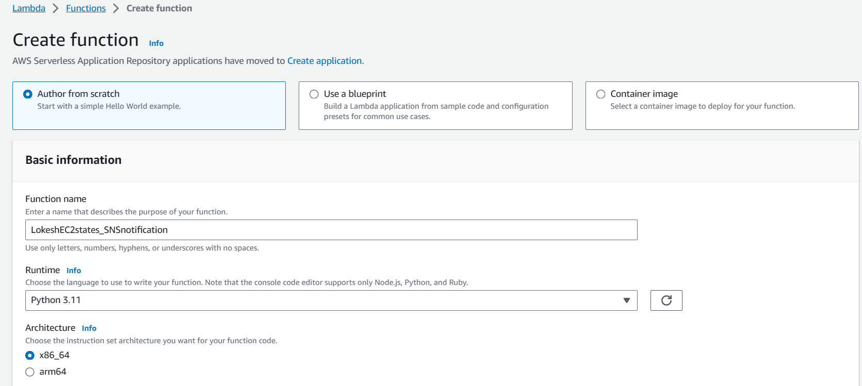
* Select the above role and attach to the Lambda function.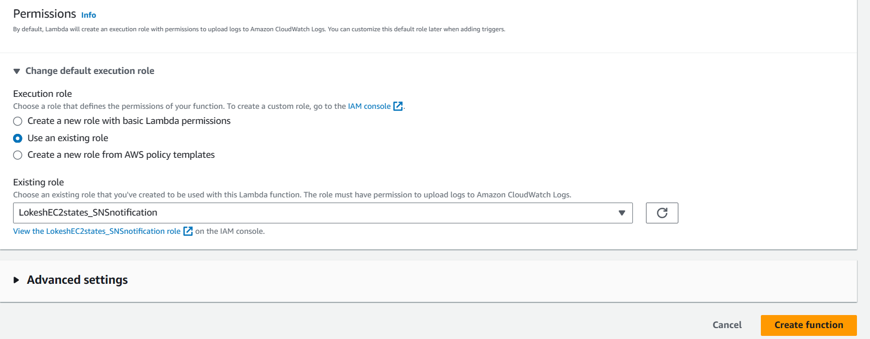
* A Lambda function has been created and you can find the same in the below screenshot.
* 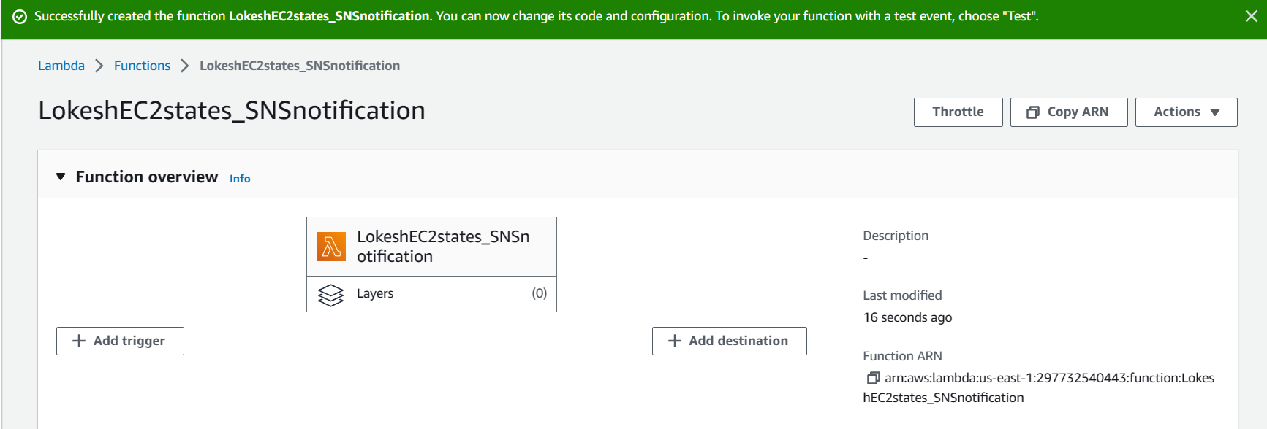
* We have created a function, now we need to configure the Events. The detailed steps have been shown in the below screenshots.
* 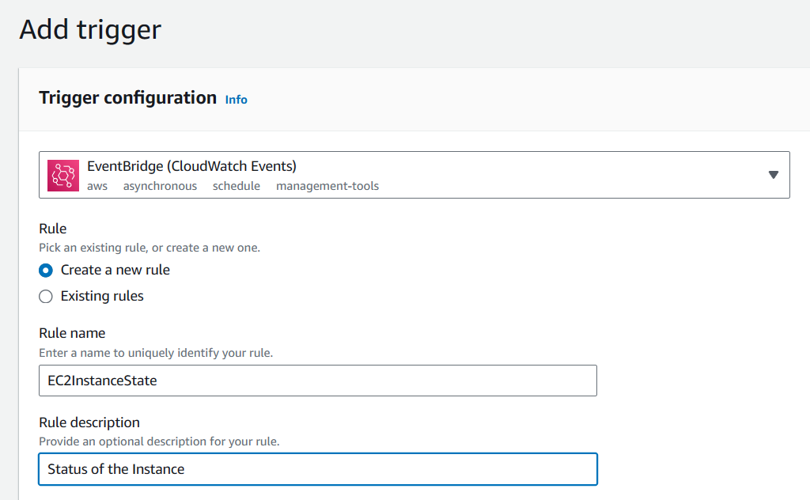
* 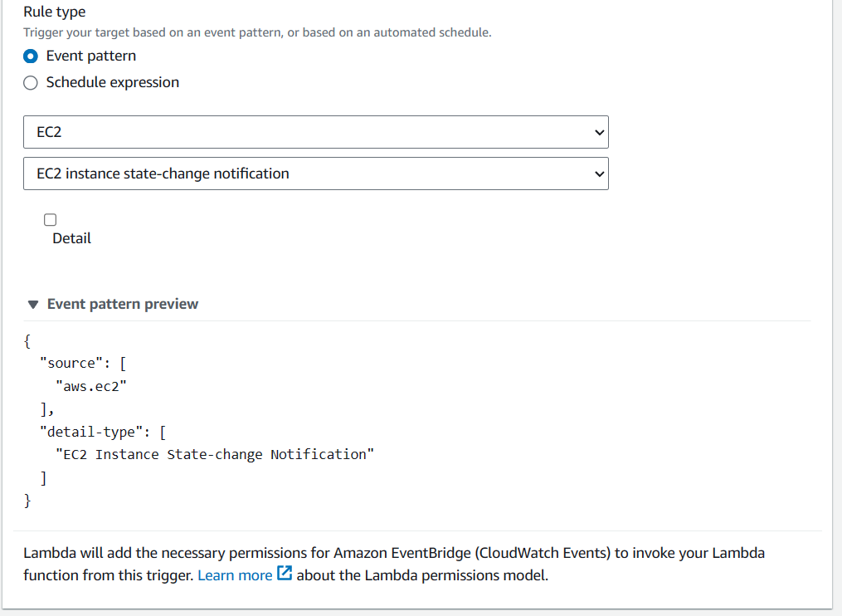
* 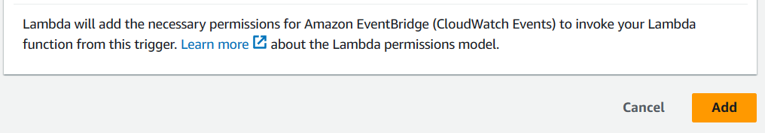
* Now we need to configure the destination and steps are shown in the below screenshots.
* 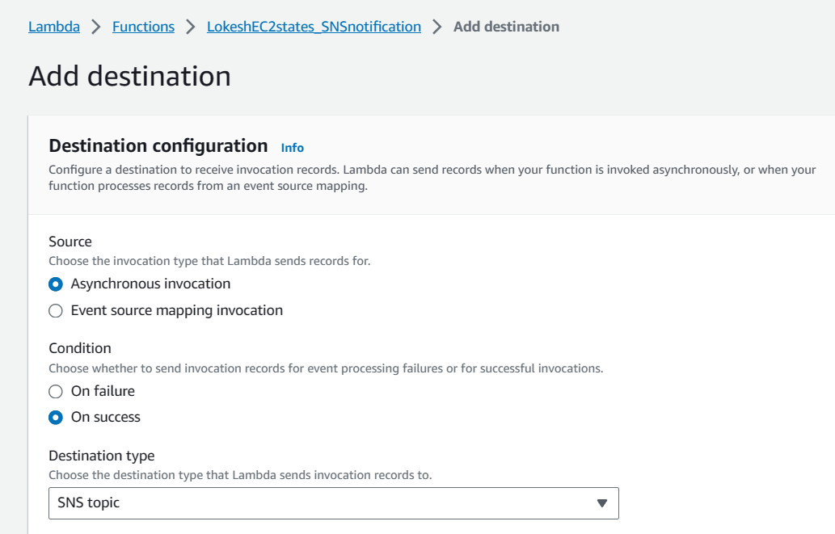
* 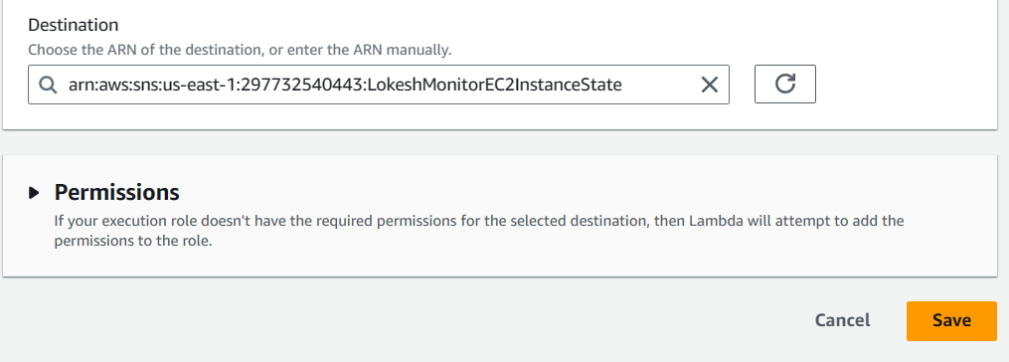
* 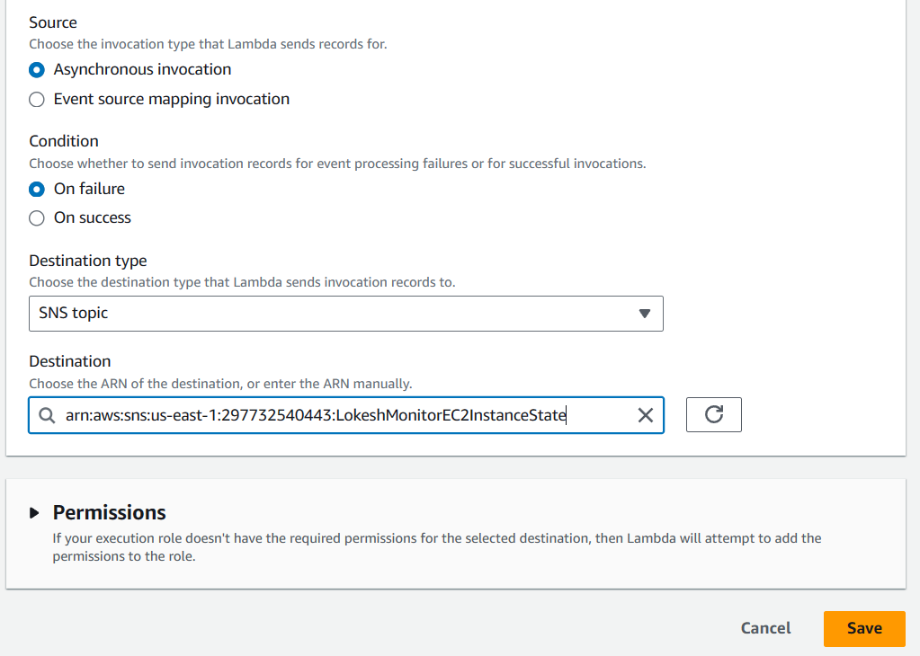
* Once we configure, the results will be show as in the below screenshot.
* 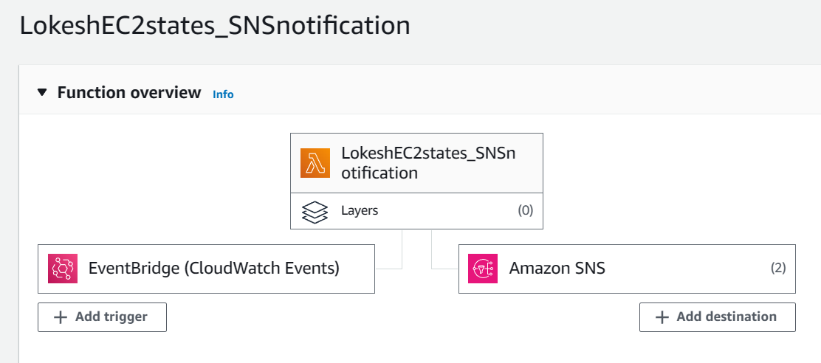

# Testing

* We have written the code and 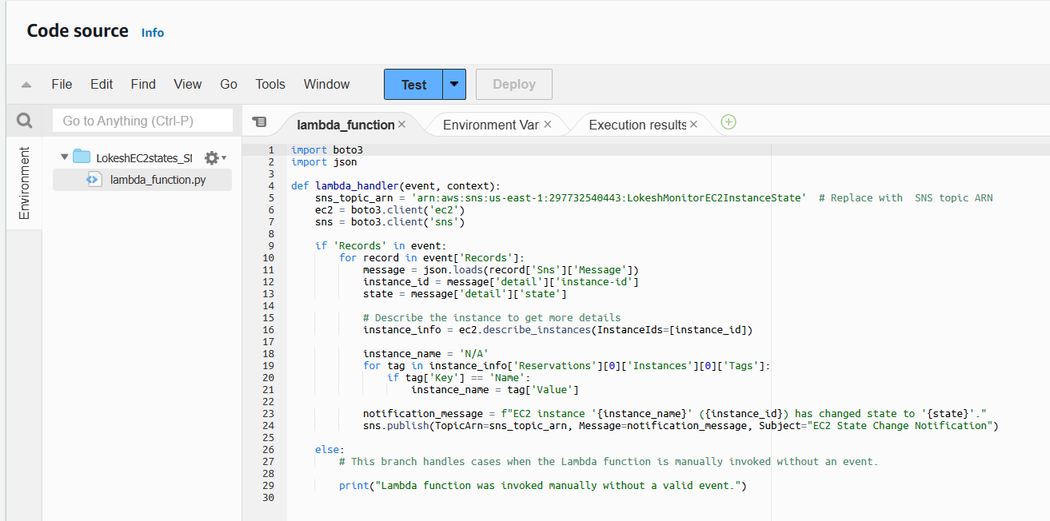
* I manually started the Instances.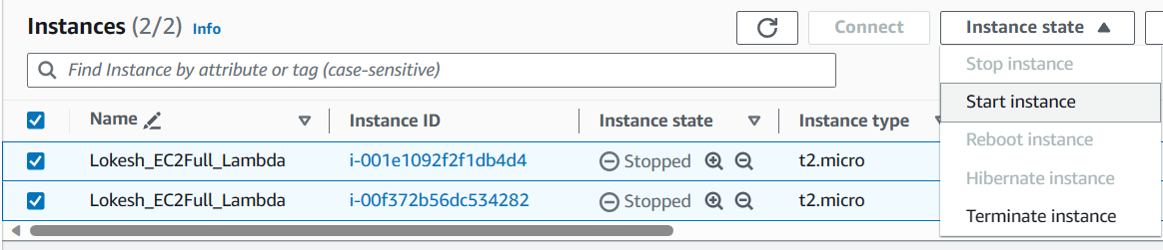
* 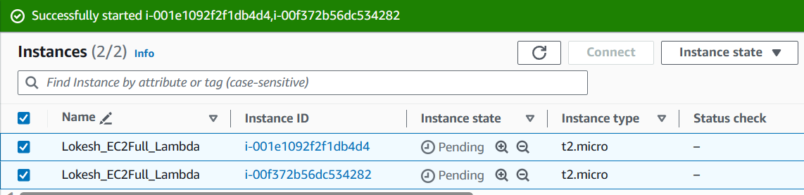
* 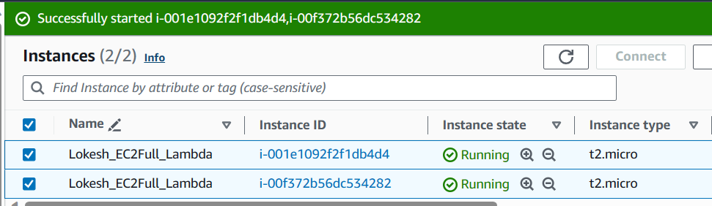
* As soon as I started the Instance, SNS triggered the Lambda and sent below email.
* 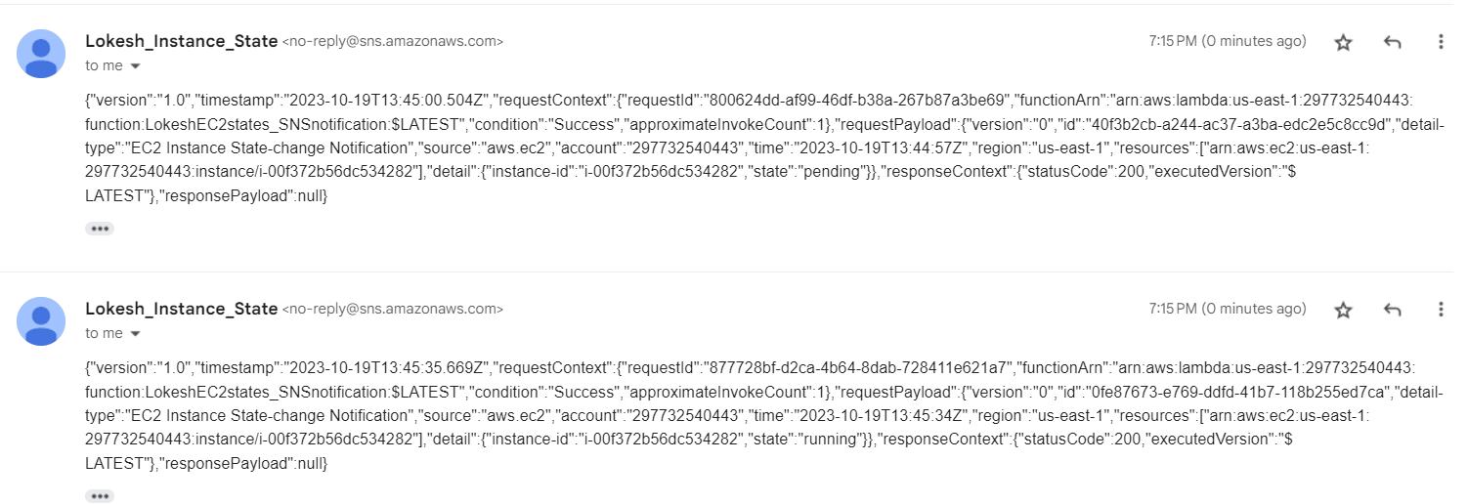
* I have stopped the Instance and SNS sent an email regarding the status.
* 