Graded Assignment on Serverless Architecture

Table of Contents

1. EC2 Instance creation 1

2. IAM Role for Lambda Function 5

3. Creation of Lambda Function 6

4. SNS Creation 7

5. Adding SNS to Lambda as a Trigger 9

6. Adding EventBridge (CloudWatch) to Lambda as a Trigger 9

7. Testing the Code 11

**Assignment 20: Load Balancer Health Checker**

# EC2 Instance creation

* Create 2 EC2 instances with the same security Group and configuration.
* 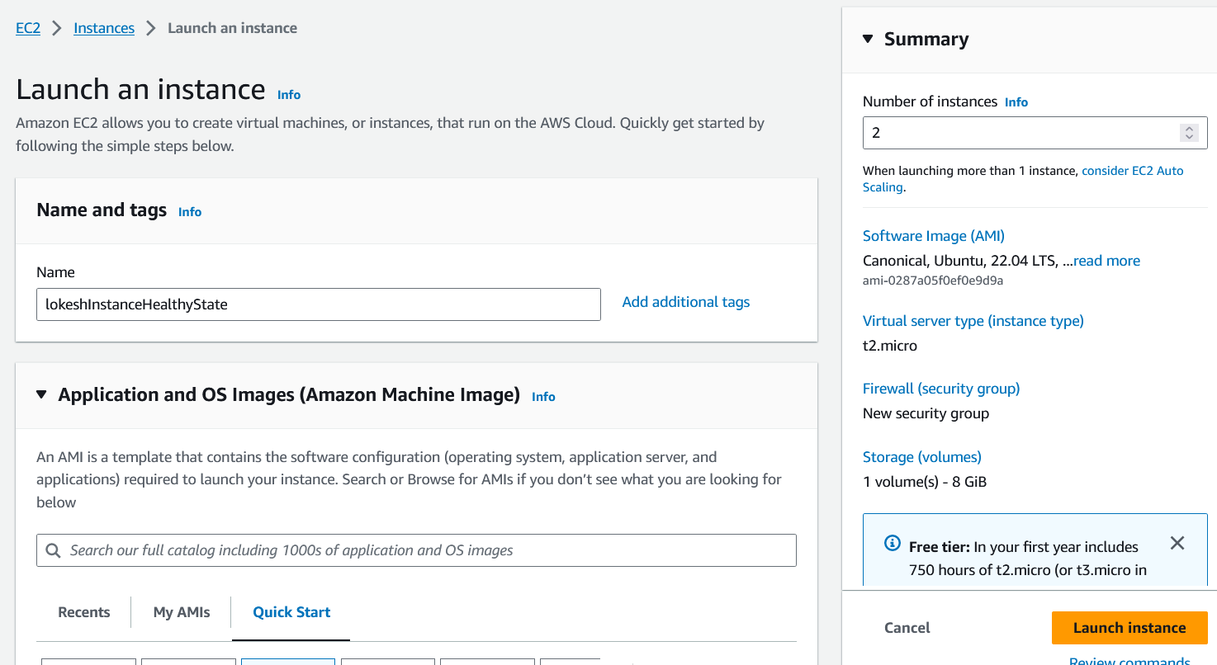
* 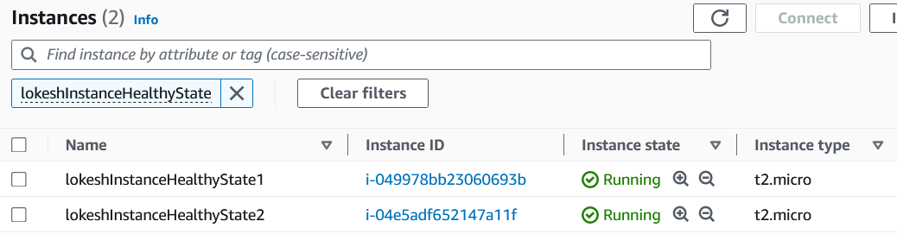
* Scroll bit down till you find Target Groups and create a Target Group as shown below.
* 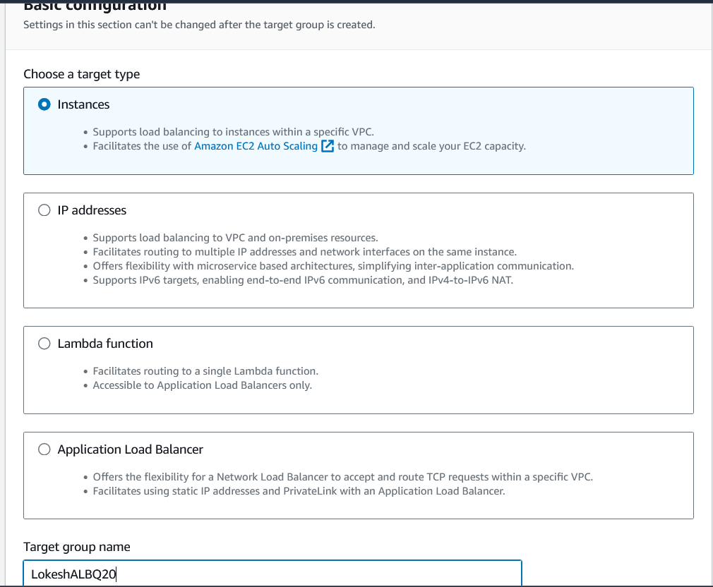
* 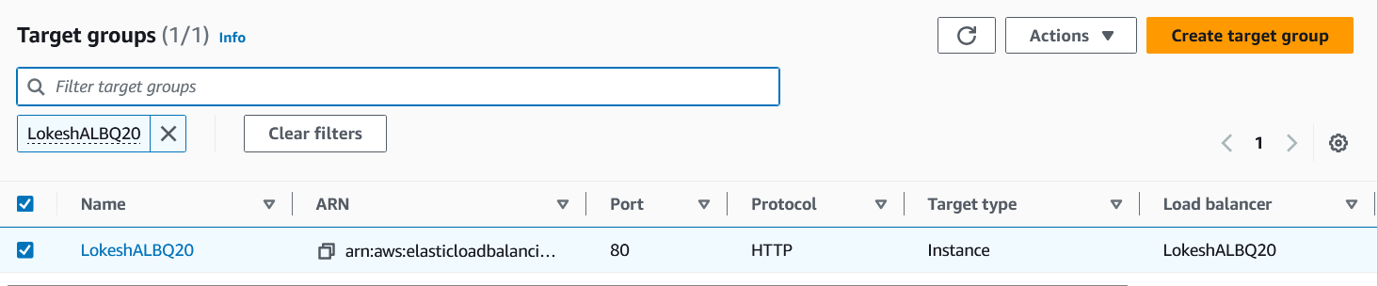
* Next create a Load Balancer by clicking on Application Load Balancer as show below.
* 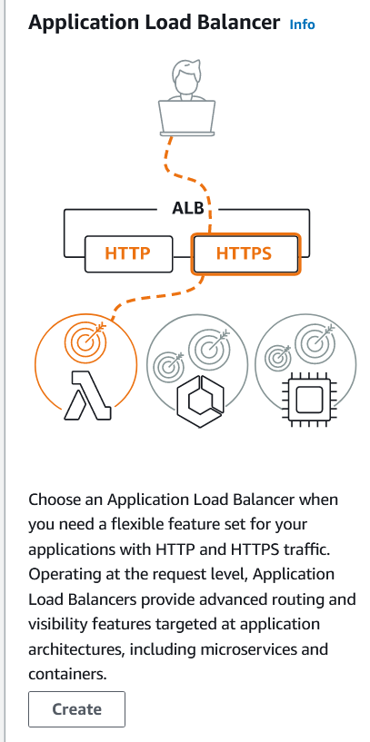
* 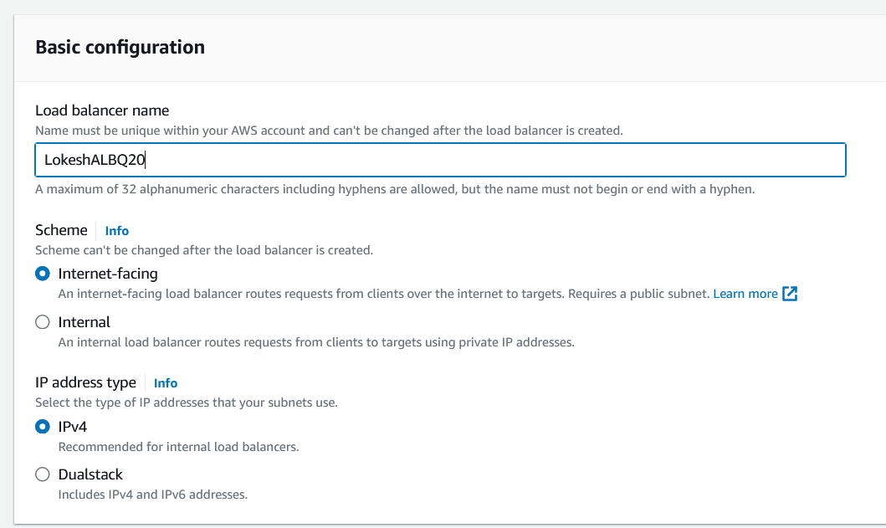
* 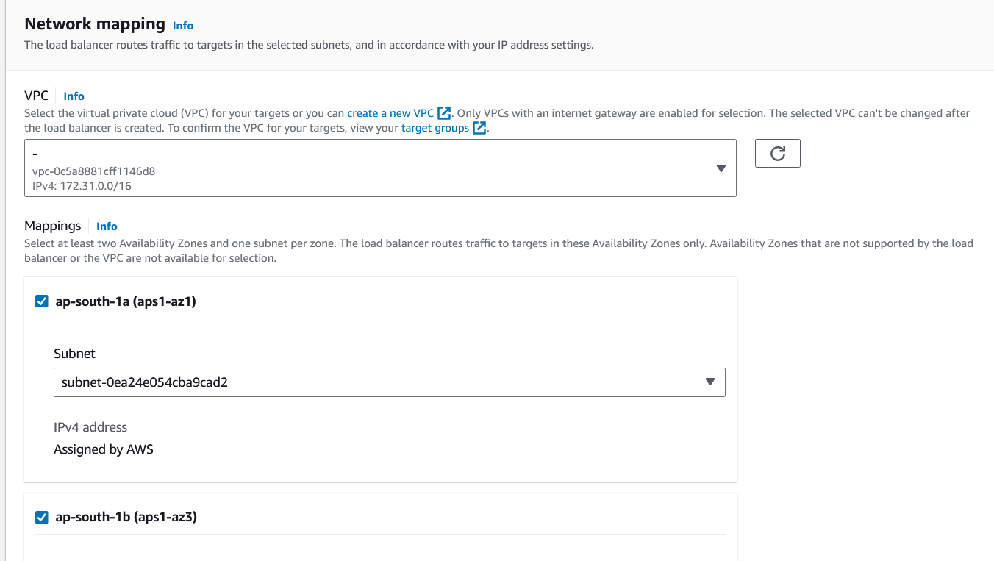
* Leave all the other options as it is and click on create Load Balancer.
* 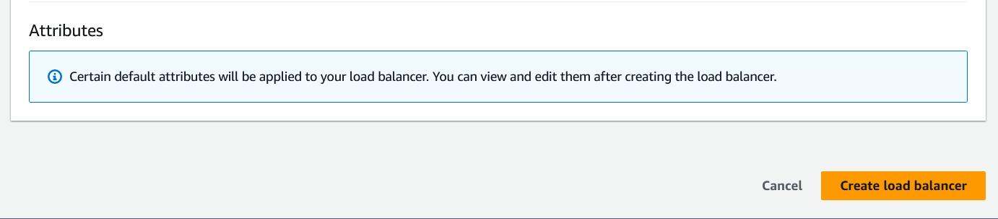
* 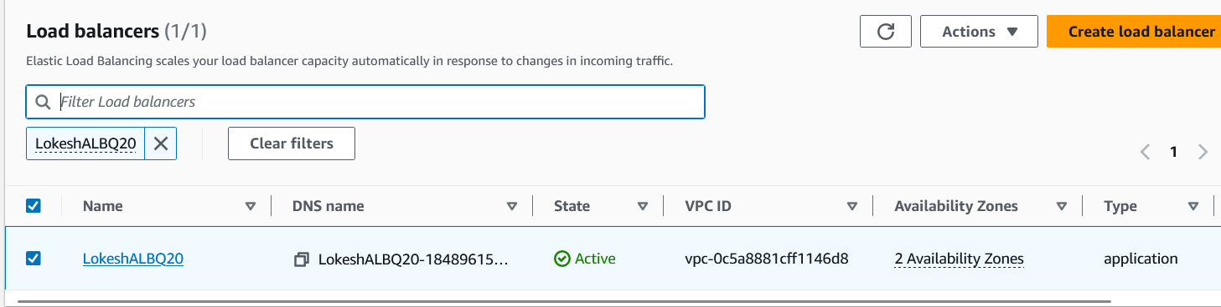

# IAM Role for Lambda Function

* We need to create a role for the Lambda function with all necessary permissions like EC2, S3, ELB, and SNS. The permissions and steps are as follow.
* 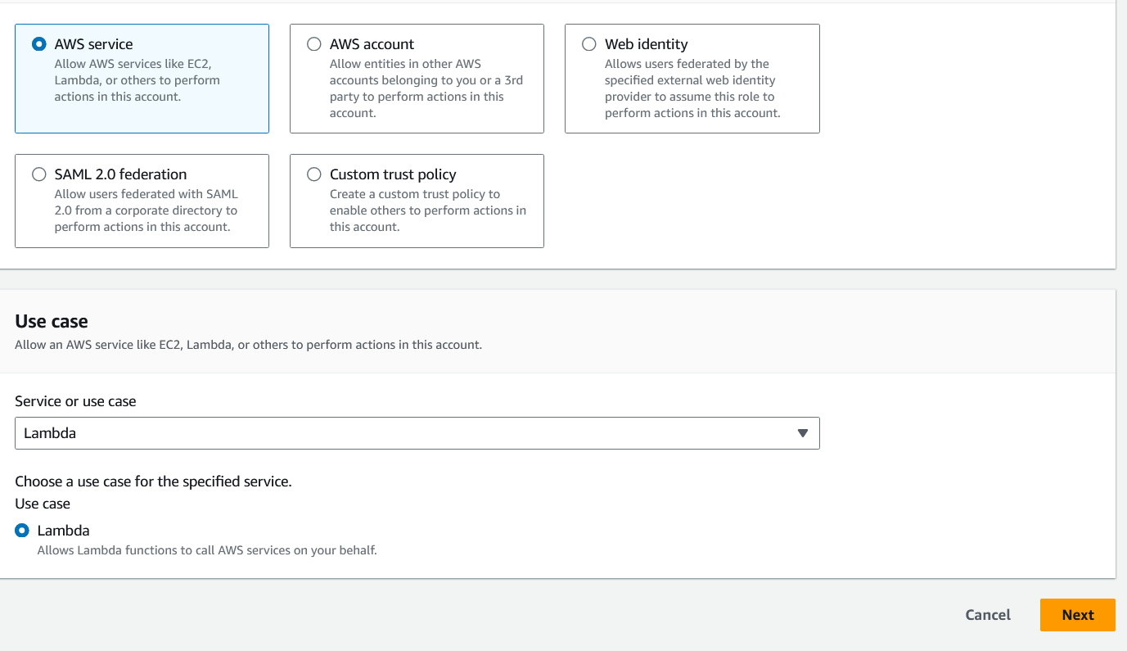
* 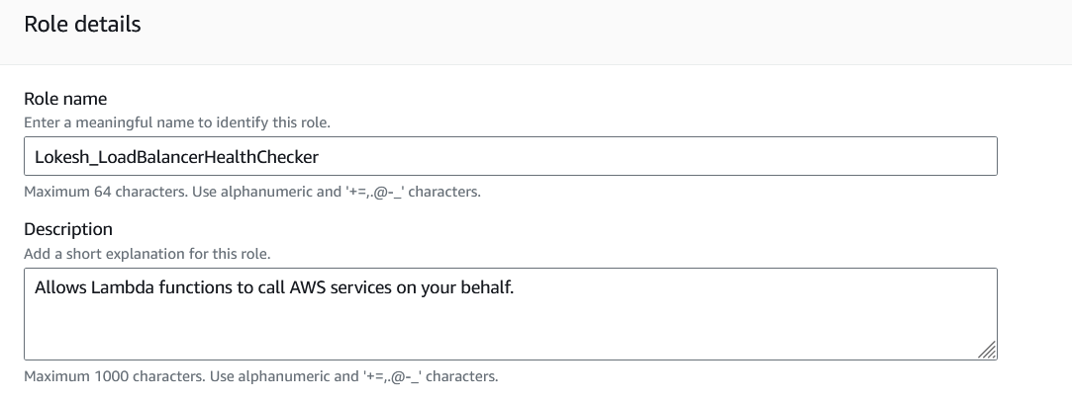
* 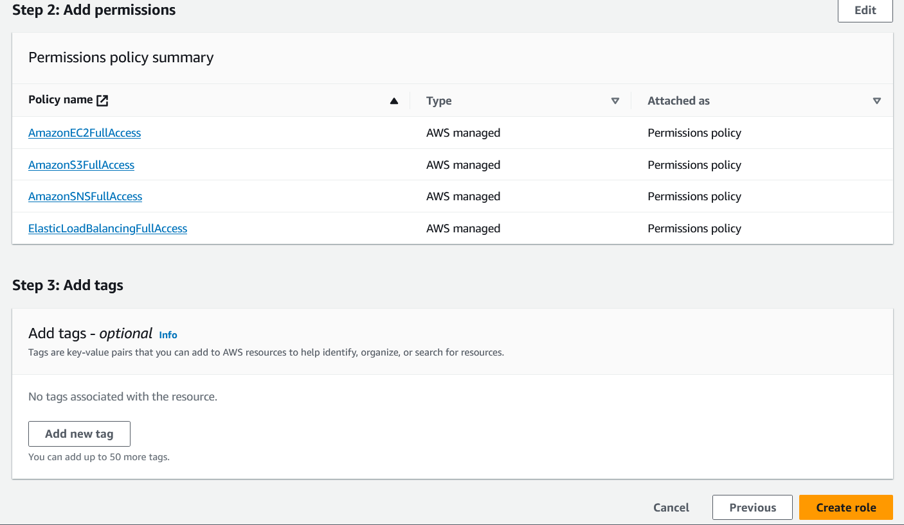
* 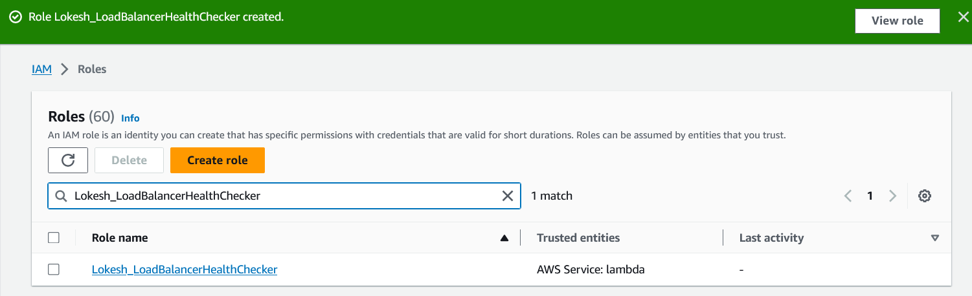

# Creation of Lambda Function

* We need to create a Lambda function with an IAM role which was created earlier. The steps are as follow.
* 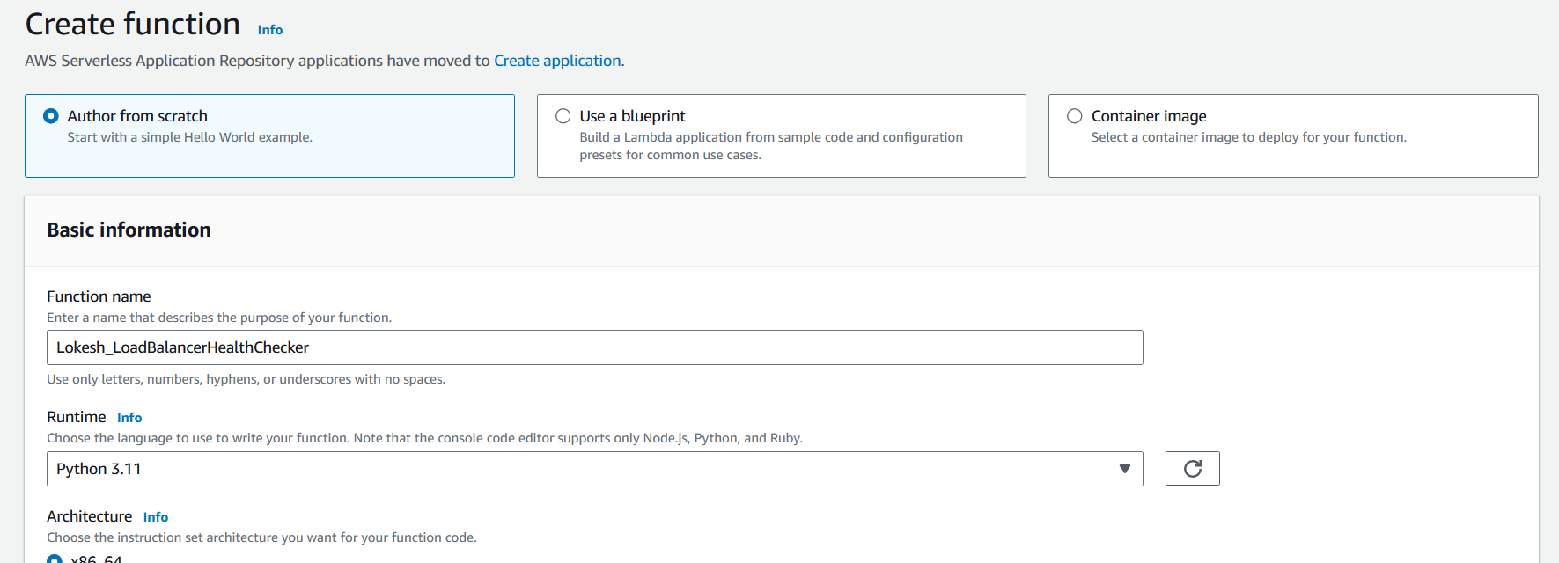
* 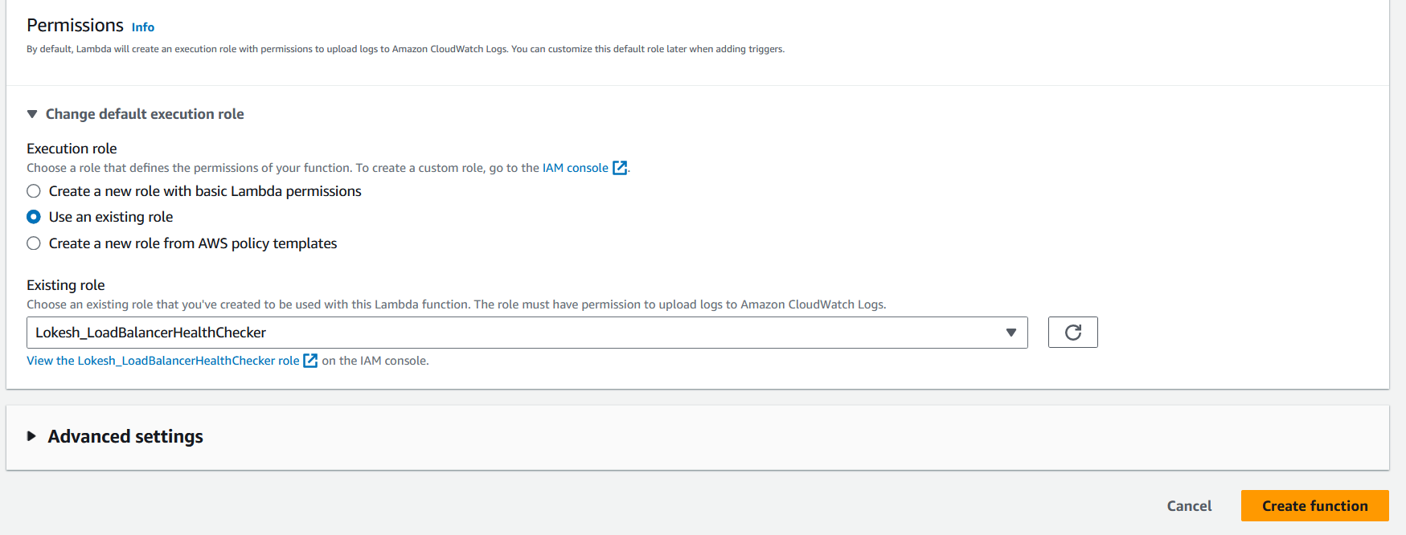
* 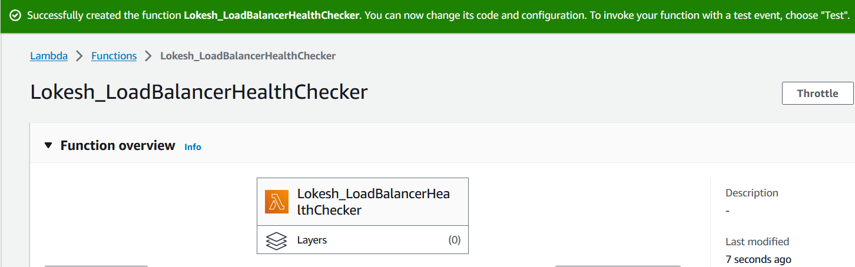

# SNS Creation

* Navigate to SNS from the console and click on Create Topic. Add the details and click on Create Topic.
* 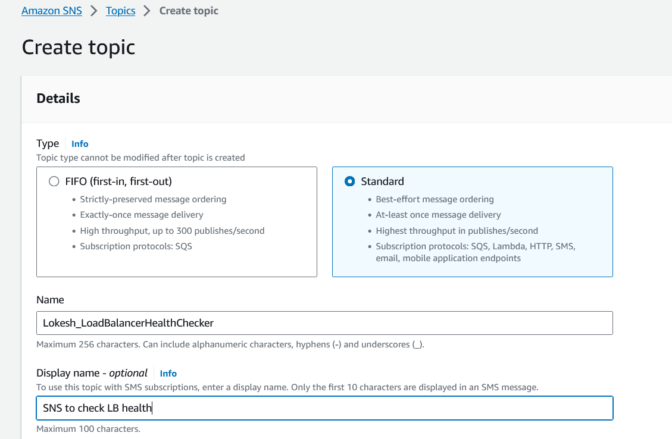
* 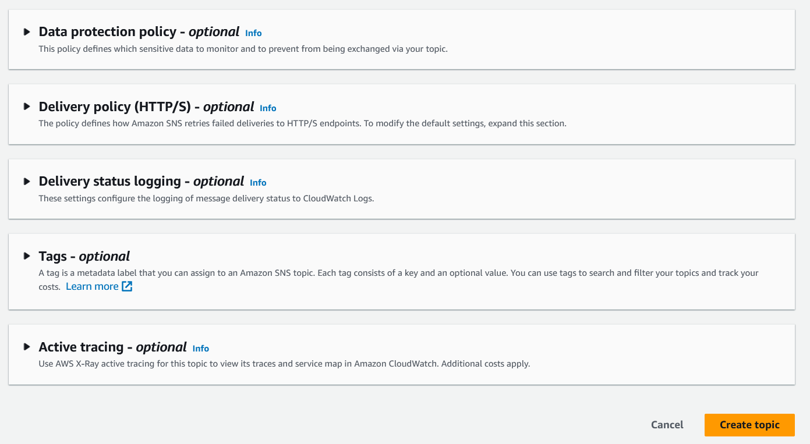
* 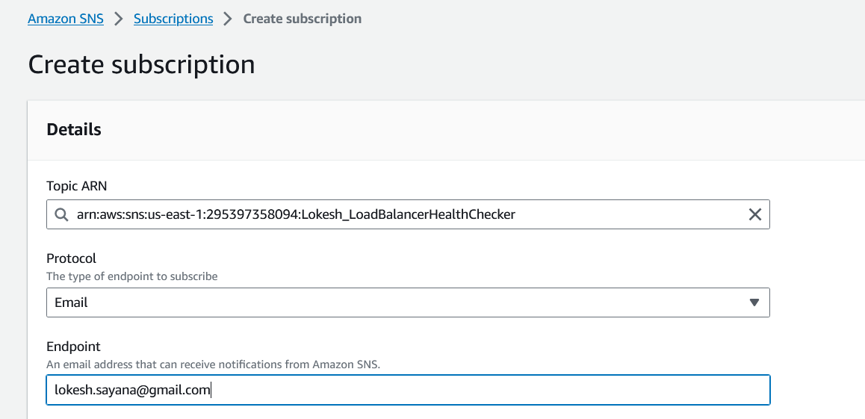
* 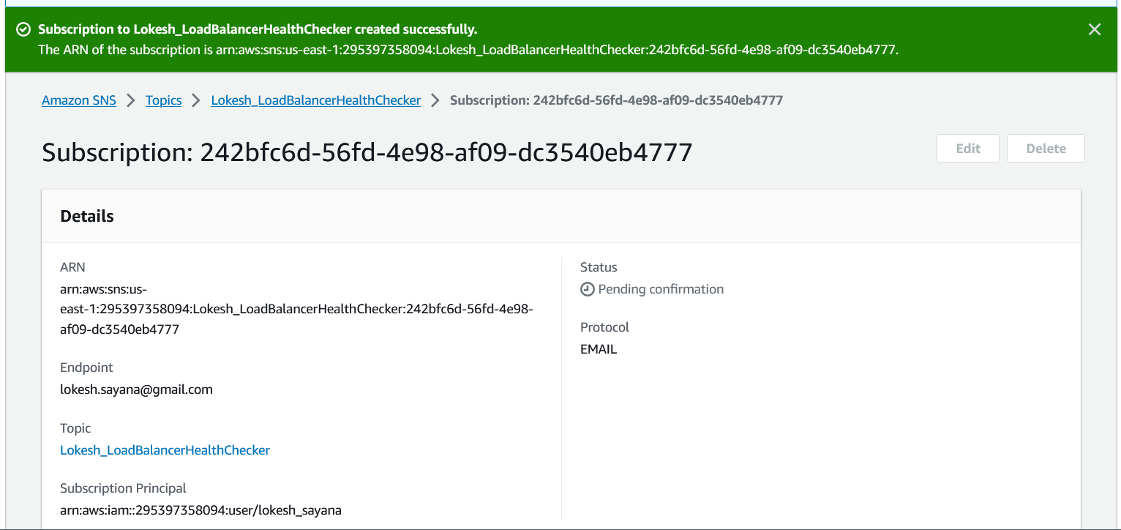

# Adding SNS to Lambda as a Trigger

* Need to click on Add Trigger and select SNS from the drop-down.
* 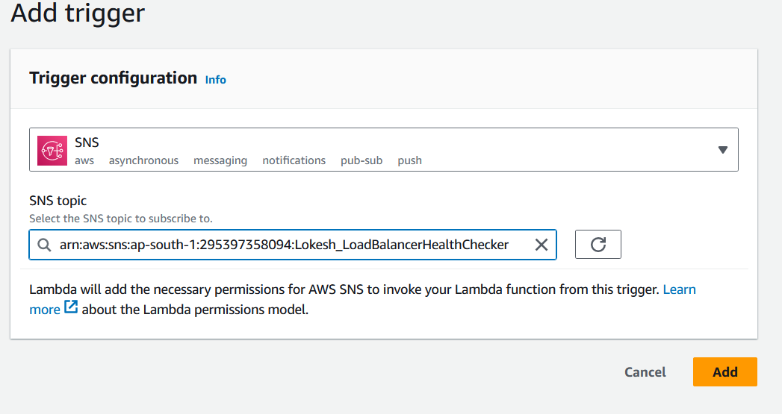
* 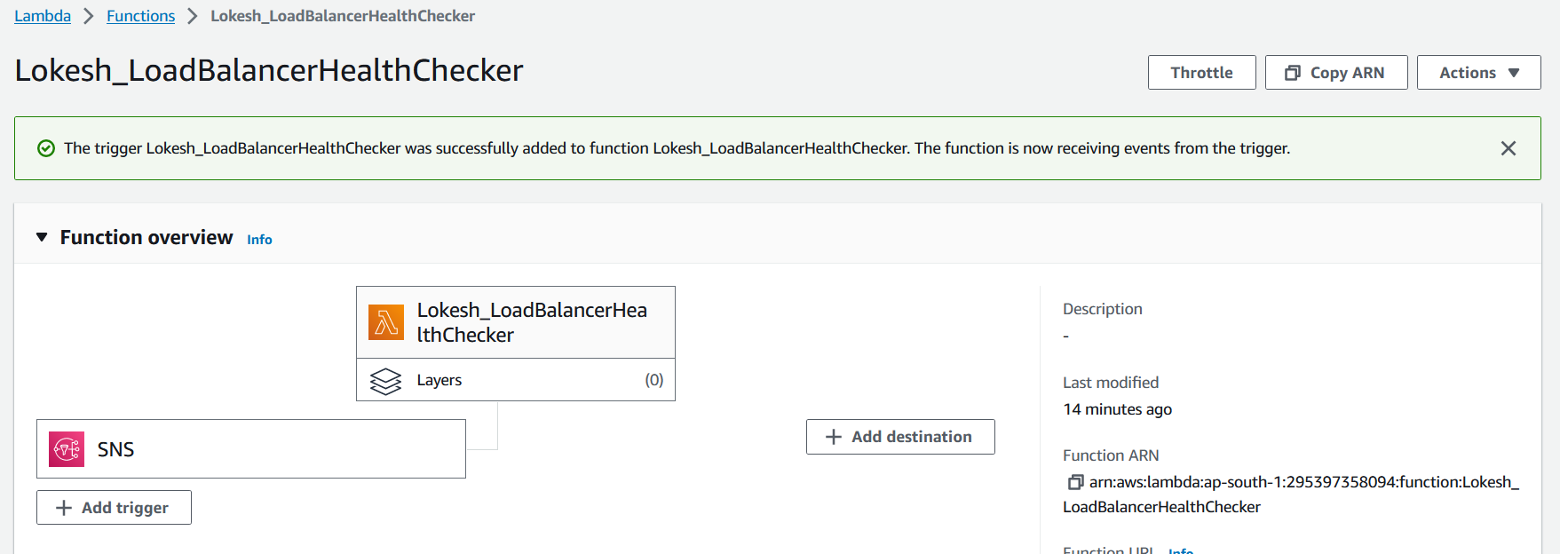
* Once you add the SNS, you will be able to see the same under configuration Triggers.
* 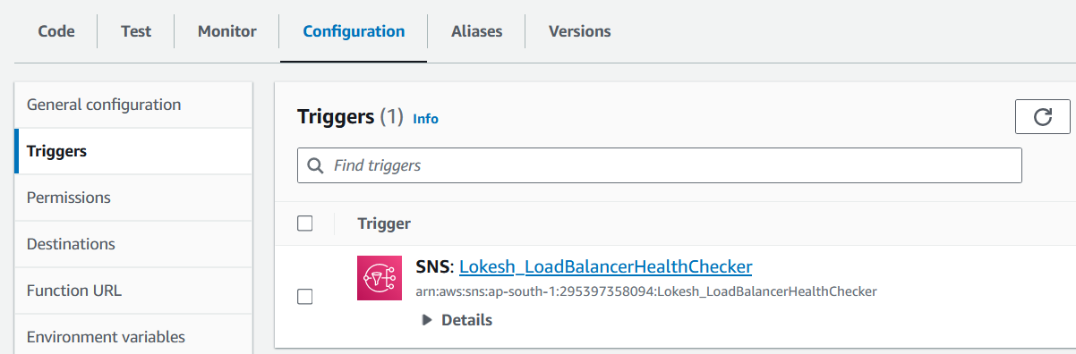

# Adding EventBridge (CloudWatch) to Lambda as a Trigger

* Set up a CloudWatch event to trigger this Lambda function every 10 minutes.
* 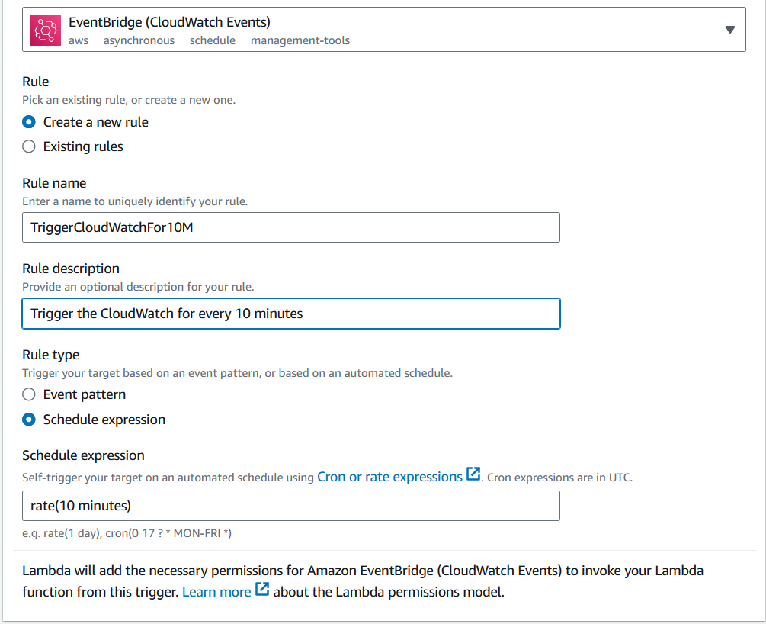
* 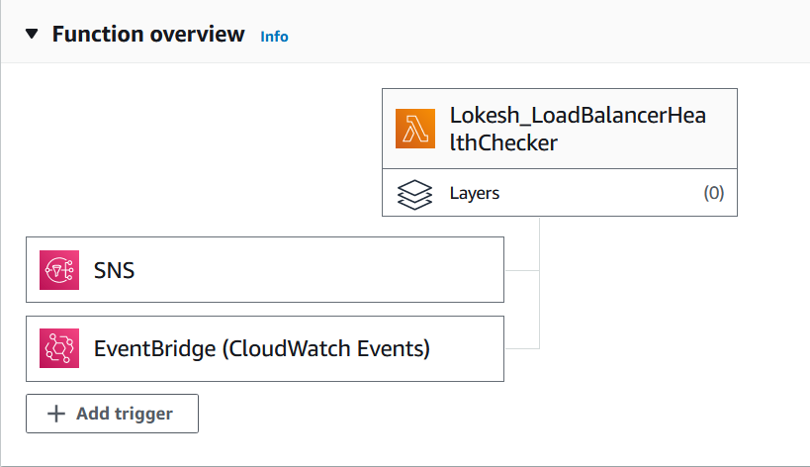
* 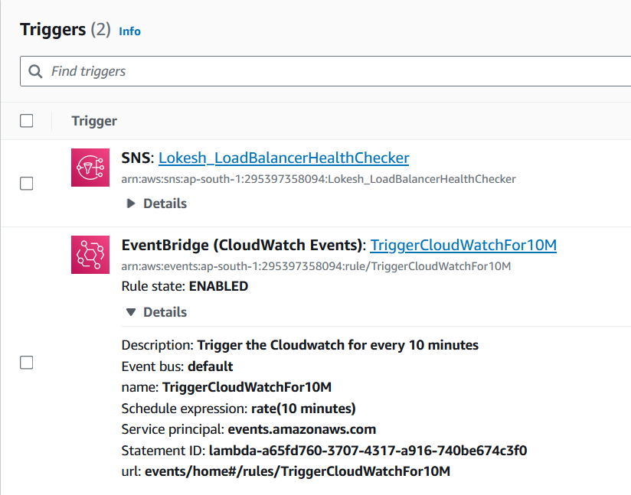

# Testing the Code

* 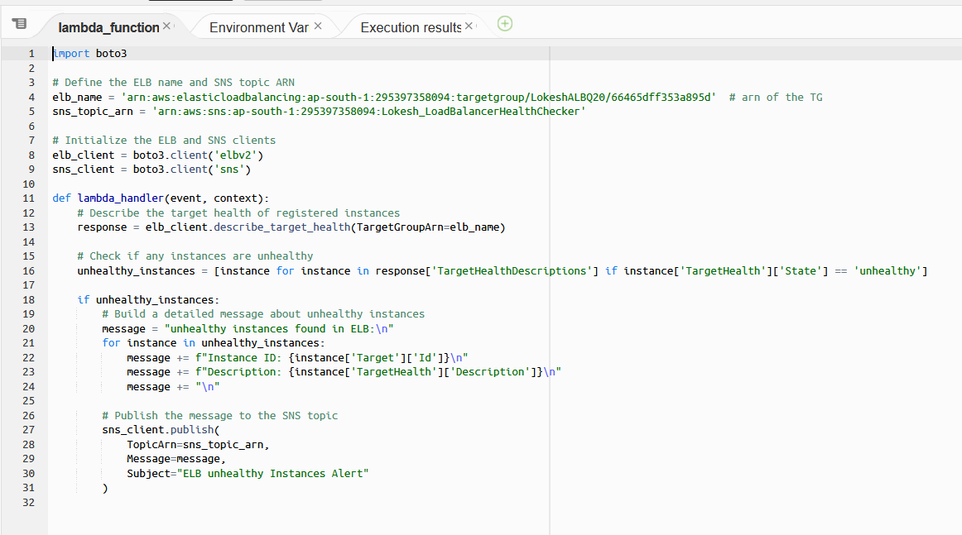
* Successfully Deployed the code and manually invoked without setting 10 minutes timer.
* 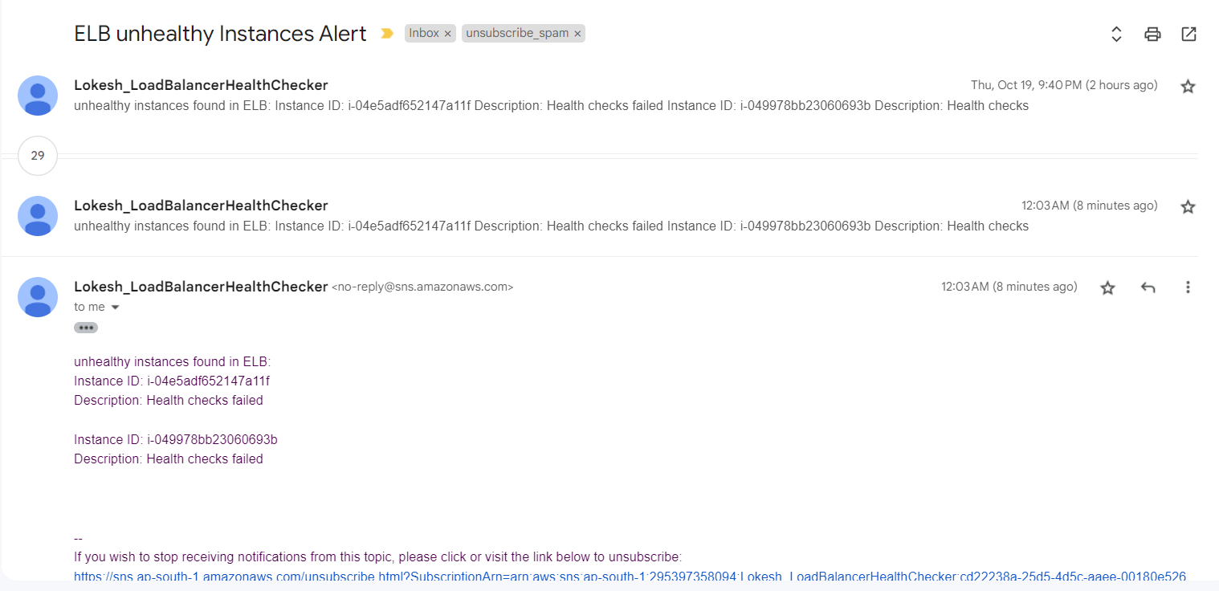
* I’ve configured to trigger the EventBridge for 10 minutes and it is working well.
* 